|  |
| --- |
| 1. **Employee:** **Start Date:**     (Optional) Employee contact information: ________________________________________________________ |
| 1. **Legal name of employer: Main office/principal place of business address:** |
| **Operating name of employer (if different): Mailing address (if different):** |
|  |
| **Phone number:**  (Optional) Additional contact information: _______________________________________________________ |
| 1. **Is Employee exempt (from protections under Minn. Stat. ch. 177)?**   **No, non-exempt** (i.e. employee is entitled to overtime and other provisions of Minn. Stat. ch 177)  **Yes, employee is exempt** (from ☐ overtime ☐ min. wage ☐ other provisions of Minn. Stat. ch 177) |
| If yes, exempt, identify **legal basis for exemption:** |
|  |
| 1. **Rate or rates of pay: __________________** |
| **Paid by:  Hour  Shift  Day  Week  Salary  Piece  Commission  Other method ___________** |
| (If applicable) **Overtime is owed after: ____ hours per workweek Overtime rate(s) is calculated as: _______________**  (If applicable to the position) **– Tips are property of the employee(s). Sharing is voluntary. (Minn. Stat. ch. 177)** |
| Allowances claimed (if any): |
| $ **_____** per meal for meal allowance (max = 60% of 1 hour of State of MN adult minimum wage) |
| $ **_____** per day for lodging allowance (max = 75% of 1 hour of State of MN adult minimum wage) (or fair market value) |
| 1. **Leave benefits available (check all that apply):**   Sick and Safe Time/sick leave  Other paid time off Paid vacation |
| How benefits are accrued (include all applicable types):  **Sick and Safe Tim**e**:** _______ hours accrue per ________ (OR ________ hours frontloaded per year)  **Paid vacation:** _________ hours/days per ____________  **Other paid time off:** _________ hours/days per ____________  Terms of use: ________________________________________________________________________________________  A **new year** for Sick and Safe Time* accrual or frontloading begins on this date: ____________  Employee may ***not* use** accruedSick and Safe Time* ***before*** this date(s): [no later than 90 calendar days after start date]  *An employer fulfilling Sick and Safe Time (access) requirements with a vacation or other paid time off plan(s) should provide information about that plan(s). |
| **6. Deductions that may be made from employee’s pay (and amounts if known): __________________________________**  ___________________________________________________________________________________________________ |
| **7. Number of days in the pay period:** ______________ **Regularly scheduled payday:** ______________ |
| **Date employee will receive first payment of wages earned:**_______________ |
| **8.** (Optional) Other relevant notice or information:   |  | | --- | |  | |
| I, the employee, have received a copy of this notice:  Yes  No |
| **Employee Signature** **Date** (Optional) **Employer Signature** **Date** |

This document contains important information about your employment. Check the box at left to receive this information in this language.

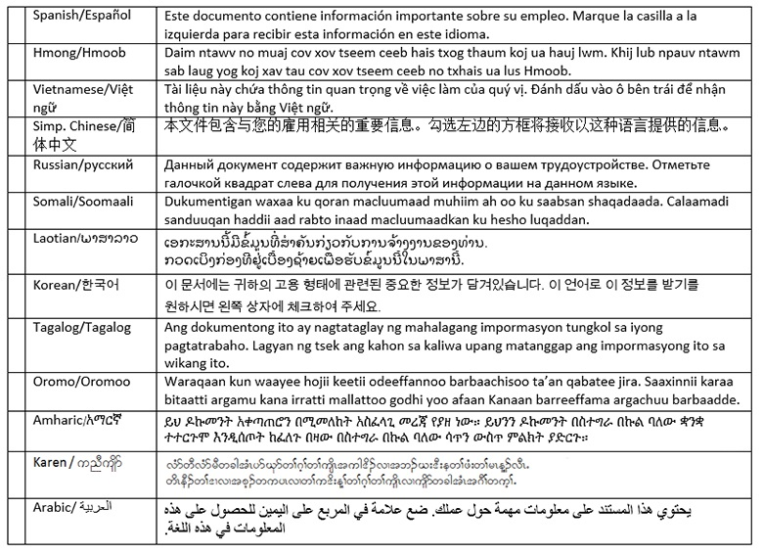

## Translation providers approved by the Minnesota Department of Administration

| **Betmar Languages, Inc.** 6260 Hwy. 65 N.E. Minneapolis, MN 55432 763-572-9711 [best@betmar.com](mailto:best@betmar.com) | **The Bridge World Language Center, Inc.**  110 Second Street S., #308  Waite Park, MN 56387  320-259-9239  [mini@bridgelanguage.com](mailto:mini@bridgelanguage.com) | **Fox Translation Services**  1152 Mae Street, #122  Hummelstown, PA 17033  866-369-1646 or 407-733-3720  [dina@foxfoxcasemanagement.com](mailto:dina@foxfoxcasemanagement.com) |
| --- | --- | --- |
| **Global Translation and Interpreter**  913 E. Franklin Ave., #206  Minneapolis, MN 55404  612-722-1244  [sandor@globaltranslations.com](mailto:sandor@globaltranslations.com) | **Latin American Translators Network, Inc.**  1720 Peachtree Street N.W., #532  Atlanta, GA 30309  800-943-5286, ext. 8641, [translations@latn.com](mailto:translations@latn.com)  800-943-5286, ext. 8620, [idenis@latn.com](mailto:idenis@latn.com) | **Latitude Prime, LLC**  80 S. Eighth Street, #900  Minneapolis, MN 55402  888-341-9080, ext. 501  [elle@latitude.com](mailto:elle@latitude.com) |
| **Lingualinx Language Solutions, Inc.**  433 River Street, #6001  Troy, NY 12180  518-388-9000  [abartlett@lingualinx.com](mailto:abartlett@lingualinx.com) | **Prisma International, Inc.**  1128 Harmon Place, #310  Minneapolis, MN 55403  612-349-3111  [jromano@prisma.com](mailto:jromano@prisma.com) | **Swits, LTD**  110 S. Third Street  Delavan, WI 53115  262-740-2590  [translations@swits.us](mailto:translations@swits.us) |