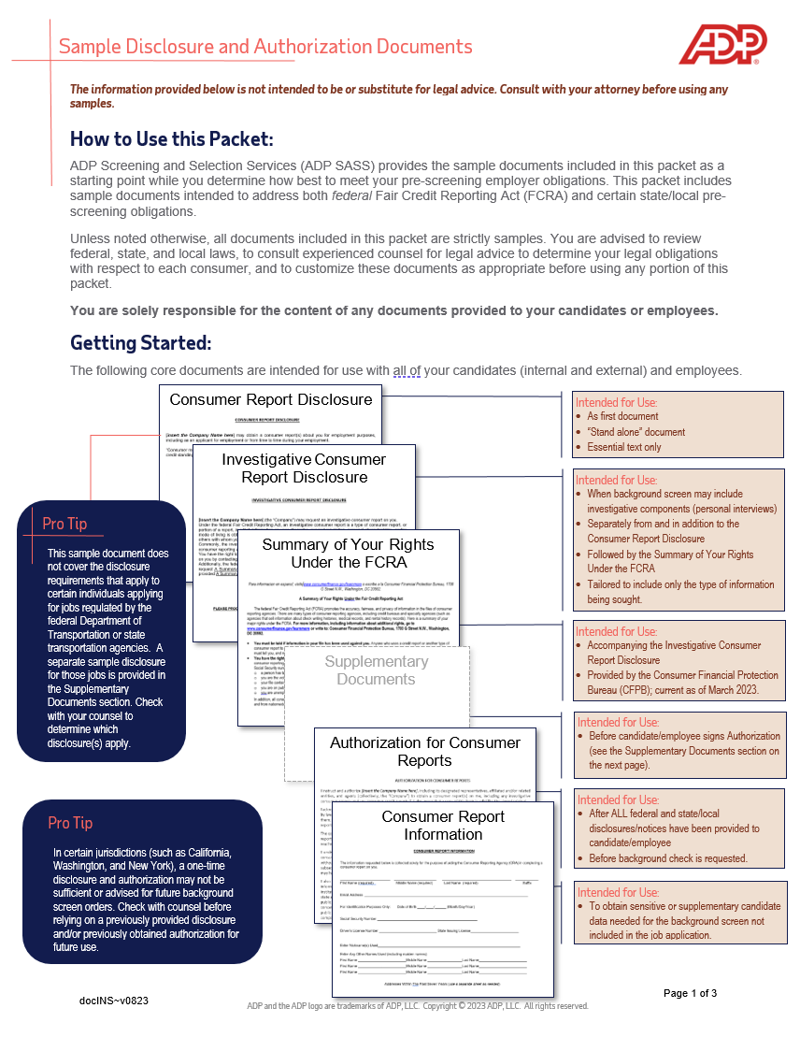

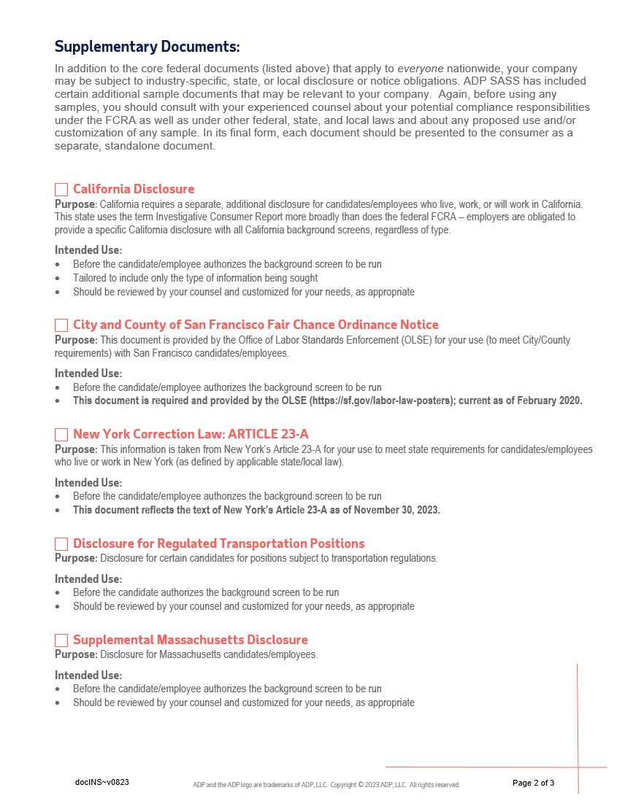

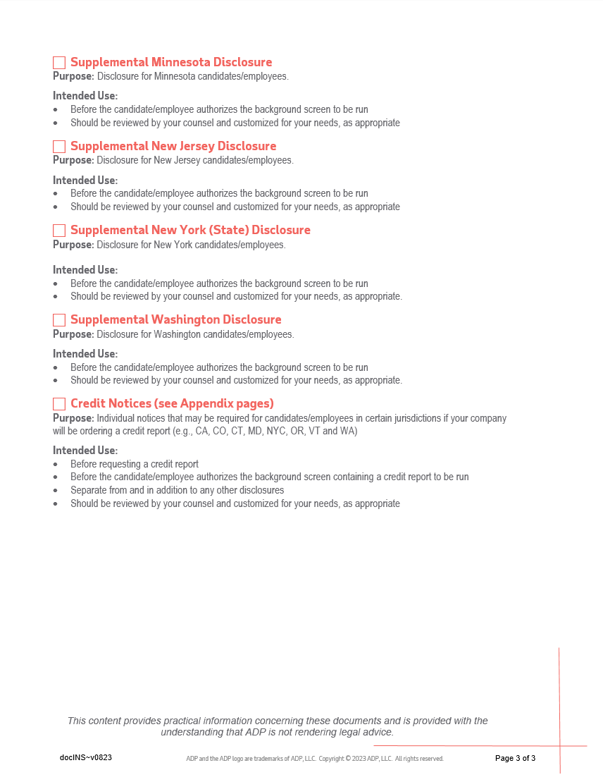

**- - - - - - - - - - - - - - - - - - - - - - - - - - - - - - - - - - - - - - - - - - - - - - - - - - - - -**

***SAMPLE DOCUMENT***

***Sample documents are provided for educational purposes ONLY and should NOT be construed as legal advice. You are advised to review the federal Fair Credit Reporting Act as well as other federal, state, and local laws and are advised to consult with your own attorney(s) about your compliance responsibilities under all such laws. ADP SASS expressly disclaims any warranties, responsibility, or damages associated with or arising out of information or samples provided. Your company is responsible for the content of any documents provided to your candidates or employees.***

**- - - - - - - - - - - - - - - - - - - - - - - - - - - - - - - - - - - - - - - - - - - - - - - - - - - - -**

**CONSUMER REPORT DISCLOSURE**

[***insert the Company Name here***] may obtain a consumer report(s) about you for employment purposes, including as an applicant for employment or from time to time during your employment.

“Consumer reports” are reports from consumer reporting agencies bearing on an individual’s credit worthiness, credit standing, credit capacity, character, general reputation, personal characteristics, or mode of living.

**THE REMAINDER OF THIS DOCUMENT IS INTENTIONALLY LEFT BLANK.**

*Page 1 of 1*

docDIS~v0823

**- - - - - - - - - - - - - - - - - - - - - - - - - - - - - - - - - - - - - - - - - - - - - - - - - - - - -**

***SAMPLE DOCUMENT***

***Sample documents are provided for educational purposes ONLY and should NOT be construed as legal advice. You are advised to review the federal Fair Credit Reporting Act as well as other federal, state, and local laws and are advised to consult with your own attorney(s) about your compliance responsibilities under all such laws. ADP SASS expressly disclaims any warranties, responsibility, or damages associated with or arising out of information or samples provided. Your company is responsible for the content of any documents provided to your candidates or employees.***

**- - - - - - - - - - - - - - - - - - - - - - - - - - - - - - - - - - - - - - - - - - - - - - - - - - - - -**

**INVESTIGATIVE CONSUMER REPORT DISCLOSURE**

[**insert the Company Name here**] (the “Company”) may request an investigative consumer report on you.

Under the federal Fair Credit Reporting Act, an investigative consumer report is a type of consumer report, or portion of a report, in which information on your character, general reputation, personal characteristics, and/or mode of living is obtained through personal interviews with neighbors, friends, prior employers, associates or others with whom you are acquainted or who may have knowledge concerning any such items of information. Commonly, the investigative consumer report involves personal interviews conducted for the Company, by a consumer reporting agency, with an individual’s prior employers or references.

You have the right to request disclosure of the nature and scope of any investigative consumer report obtained on you by contacting the Company.

Additionally, the federal Fair Credit Reporting Act gives you specific rights. Therefore, you also have a right to request A Summary of Your Rights Under the Fair Credit Reporting Act. For your convenience, you will be provided A Summary of Your Rights Under the Fair Credit Reporting Act as a separate document.

**THE REMAINDER OF THIS DOCUMENT IS INTENTIONALLY LEFT BLANK.**

**PLEASE PROCEED TO THE NEXT DOCUMENT: “A SUMMARY OF YOUR RIGHTS UNDER THE FAIR CREDIT REPORTING ACT”**

docICR~v0823

*Page 1 of 1*

*Para información en español, visite* [*www.consumerfinance.gov/learnmore*](http://www.consumerfinance.gov/learnmore) *o escribe a la Consumer Financial Protection Bureau, 1700 G Street NW, Washington, DC 20552.*

**A Summary of Your Rights Under the Fair Credit Reporting Act**

The federal Fair Credit Reporting Act (FCRA) promotes the accuracy, fairness, and privacy of information in the files of consumer reporting agencies. There are many types of consumer reporting agencies, including credit bureaus and specialty agencies (such as agencies that sell information about check writing histories, medical records, and rental history records). Here is a summary of your major rights under the FCRA. **For more information, including information about additional rights, go to** [**www.consumerfinance.gov/learnmore**](http://www.consumerfinance.gov/learnmore) **or write to: Consumer Financial Protection Bureau, 1700 G Street NW, Washington, DC 20552.**

* **You must be told if information in your file has been used against you.** Anyone who uses a credit report or another type of consumer report to deny your application for credit, insurance, or employment – or to take another adverse action against you – must tell you, and must give you the name, address, and phone number of the agency that provided the information.
* **You have the right to know what is in your file.** You may request and obtain all the information about you in the files of a consumer reporting agency (your “file disclosure”). You will be required to provide proper identification, which may include your Social Security number. In many cases, the disclosure will be free. You are entitled to a free file disclosure if:
* a person has taken adverse action against you because of information in your credit report;
* you are the victim of identity theft and place a fraud alert in your file;
* your file contains inaccurate information as a result of fraud;
* you are on public assistance;
* you are unemployed but expect to apply for employment within 60 days.

In addition, all consumers are entitled to one free disclosure every 12 months upon request from each nationwide credit bureau and from nationwide specialty consumer reporting agencies. See [www.consumerfinance.gov/learnmore](http://www.consumerfinance.gov/learnmore) for additional information.

* **You have the right to ask for a credit score.** Credit scores are numerical summaries of your credit-worthiness based on information from credit bureaus. You may request a credit score from consumer reporting agencies that create scores or distribute scores used in residential real property loans, but you will have to pay for it. In some mortgage transactions, you will receive credit score information for free from the mortgage lender.
* **You have the right to dispute incomplete or inaccurate information.** If you identify information in your file that is incomplete or inaccurate, and report it to the consumer reporting agency, the agency must investigate unless your dispute is frivolous. See [www.consumerfinance.gov/learnmore](http://www.consumerfinance.gov/learnmore) for an explanation of dispute procedures.
* **Consumer reporting agencies must correct or delete inaccurate, incomplete, or unverifiable information.** Inaccurate, incomplete or unverifiable information must be removed or corrected, usually within 30 days. However, a consumer reporting agency may continue to report information it has verified as accurate.
* **Consumer reporting agencies may not report outdated negative information.** In most cases, a consumer reporting agency may not report negative information that is more than seven years old, or bankruptcies that are more than 10 years old.
* **Access to your file is limited.** A consumer reporting agency may provide information about you only to people with a valid need -- usually to consider an application with a creditor, insurer, employer, landlord, or other business. The FCRA specifies those with a valid need for access.
* **You must give your consent for reports to be provided to employers.** A consumer reporting agency may not give out information about you to your employer, or a potential employer, without your written consent given to the employer. Written consent generally is not required in the trucking industry. For more information, go to [www.consumerfinance.gov/learnmore](http://www.consumerfinance.gov/learnmore).
* **You may limit “prescreened” offers of credit and insurance you get based on information in your credit report.** Unsolicited “prescreened” offers for credit and insurance must include a toll-free phone number you can call if you choose to remove your name and address from the lists these offers are based on. You may opt-out with the nationwide credit bureaus at 1-888-567-8688.
* The following FCRA right applies with respect to nationwide consumer reporting agencies:

**CONSUMERS HAVE THE RIGHT TO OBTAIN A SECURITY FREEZE**

**You have a right to place a “security freeze” on your credit report, which will prohibit a consumer reporting agency from releasing information in your credit report without your express authorization**. The security freeze is designed to prevent credit, loans, and services from being approved in your name without your consent. However, you should be aware that using a security freeze to take control over who gets access to the personal and financial information in your credit report may delay, interfere with, or prohibit the timely approval of any subsequent request or application you make regarding a new loan, credit, mortgage, or any other account involving the extension of credit.

v0423

1

As an alternative to a security freeze, you have the right to place an initial or extended fraud alert on your credit file at no cost. An initial fraud alert is a 1-year alert that is placed on a consumer’s credit file. Upon seeing a fraud alert display on a consumer’s credit file, a business is required to take steps to verify the consumer’s identity before extending new credit. If you are a victim of identity theft, you are entitled to an extended fraud alert, which is a fraud alert lasting 7 years.

A security freeze does not apply to a person or entity, or its affiliates, or collection agencies acting on behalf of the person or entity, with which you have an existing account that requests information in your credit report for the purposes of reviewing or collecting the account. Reviewing the account includes activities related to account maintenance, monitoring, credit line increases, and account upgrades and enhancements.

* **You may seek damages from violators.** If a consumer reporting agency, or, in some cases, a user of consumer reports or a furnisher of information to a consumer reporting agency violates the FCRA, you may be able to sue in state or federal court.
* **Identity theft victims and active duty military personnel have additional rights.** For more information, visit [www.consumerfinance.gov/learnmore](http://www.consumerfinance.gov/learnmore).

**States may enforce the FCRA, and many states have their own consumer reporting laws. In some cases, you may have more rights under state law. For more information, contact your state or local consumer protection agency or your state Attorney General. For information about your federal rights, contact:**

v0423

2

|  |  |
| --- | --- |
| **TYPE OF BUSINESS:** | **CONTACT:** |
| 1.a. Banks, savings associations, and credit unions with total assets of over $10 billion and their affiliates.  b. Such affiliates that are not banks, savings associations, or credit unions also should list, in addition to the CFPB: | 1. Consumer Financial Protection Bureau   1700 G Street, NW  Washington, DC 20552   1. Federal Trade Commission: Consumer Response Center   600 Pennsylvania Avenue, NW  Washington, DC 20580  (877) 382-4357 |
| 2. To the extent not included in item 1 above:   1. National banks, federal savings associations, and federal branches and federal agencies of foreign banks 2. State member banks, branches and agencies of foreign banks (other than federal branches, federal agencies, and Insured State Branches of Foreign Banks), commercial lending companies owned or controlled by foreign banks, and organizations operating under section 25 or 25A of the Federal Reserve Act 3. Nonmember Insured Banks, Insured State Branches of Foreign Banks, and insured state savings associations 4. Federal Credit Unions | 1. Office of the Comptroller of the Currency   Customer Assistance Group  P.O. Box 53570  Houston, TX 77052   1. Federal Reserve Consumer Help Center   P.O. Box 1200  Minneapolis, MN 55480   1. Division of Depositor and Consumer Protection   National Center for Consumer and Depositor Assistance Federal Deposit Insurance Corporation  1100 Walnut Street, Box # 11  Kansas City, MO 64106   1. National Credit Union Administration   Office of Consumer Financial Protection  1775 Duke Street  Alexandria, VA 22314 |
| 3. Air carriers | Assistant General Counsel for Office of Aviation Consumer Protection  Department of Transportation  1200 New Jersey Avenue, SE  Washington, DC 20590 |
| 4. Creditors Subject to the Surface Transportation Board | Office of Public Assistance, Governmental Affairs, and Compliance  Surface Transportation Board  Department of Transportation  395 E Street, SW  Washington, DC 20423 |
| 5. Creditors Subject to the Packers and Stockyards Act, 1921 | Nearest Packers and Stockyards Division Regional Office |
| 6. Small Business Investment Companies | Associate Administrator, Office of Capital Access  United States Small Business Administration  409 Third Street, SW, Suite 8200  Washington, DC 20416 |
| 7. Brokers and Dealers | Securities and Exchange Commission  100 F Street, NE  Washington, DC 20549 |
| 8. Institutions that are members of the Farm Credit System | Farm Credit Administration  1501 Farm Credit Drive  McLean, VA 22102-5090 |
| 9. Retailers, Finance Companies, and All Other Creditors Not Listed Above | Federal Trade Commission  Consumer Response Center  600 Pennsylvania Avenue, NW  Washington, DC 20580  (877) 382-4357 |

v0423

3

**- - - - - - - - - - - - - - - - - - - - - - - - - - - - - - - - - - - - - - - - - - - - - - - - - - - - -**

***SAMPLE DOCUMENT***

***Sample documents are provided for educational purposes ONLY and should NOT be construed as legal advice. You are advised to review the federal Fair Credit Reporting Act as well as other federal, state, and local laws and are advised to consult with your own attorney(s) about your compliance responsibilities under all such laws. ADP SASS expressly disclaims any warranties, responsibility, or damages associated with or arising out of information or samples provided. Your company is responsible for the content of any documents provided to your candidates or employees.***

**- - - - - - - - - - - - - - - - - - - - - - - - - - - - - - - - - - - - - - - - - - - - - - - - - - - - -**

**CALIFORNIA DISCLOSURE DOCUMENT**

[***insert the Company Name here***] (the “Company”) may order an “investigative consumer report” (a background check report) on you in connection with your employment or application for employment. The investigative consumer report may contain information about your character, general reputation, personal characteristics, and mode of living.

The agency conducting the investigation and preparing the investigative consumer report for the Company is ADP Screening and Selection Services, Inc., at 2950 East Harmony Road, Suite 130, Fort Collins, CO, 80528; phone number 800-367-5933; website, <http://www.adpselect.com>. This website contains information concerning the agency’s privacy practices.

Regarding the nature and scope of the investigation, as allowed by law and depending on the position, such reports may contain the following information pertaining to you: criminal history; credit history; public records; driving records; military service; credentials/certifications; a Social Security number verification; and verification of prior employment and education. Additionally, in some cases, the Company may request that the agency interview former employers, business references, personal references, and/or others for information regarding prior employment, work experience and performance, reasons for employment termination, and other information as to character, general reputation, personal characteristics, or mode of living.

The Company may not order an investigative consumer report about you without your written authorization (which you may provide through a separate document called the Authorization for Consumer Report).

**A Summary of Your Rights Under the Provisions of California Civil Code Section 1786.22**

(a) The agency will supply files and information required under California Civil Code Section 1786.10 during normal business hours and on reasonable notice.

(b) Files maintained on you will be made available for your visual inspection, as follows:

(1) In person, if you appear in person and furnish proper identification. A copy of the file will also be available to you for a fee not to exceed the actual costs of duplication services provided.

(2) By certified mail, if you make a written request, with proper identification, for copies to be sent to a specified addressee. However, agencies complying with a request for certified mailings are not liable for disclosures to third parties caused by mishandling of mail after such mailings leave the agency.

(3) A summary of all information contained in your file and required to be provided by California Civil Code Section 1786.10 will be provided by telephone, if you have made a written request, with proper identification for telephone disclosure, and the toll charge, if any, for the telephone call is prepaid by or charged directly to you.

*Page 1 of 2*

docCAD~v0823

(c) The term "proper identification" as used above, includes information generally deemed sufficient to identify a person. Such information includes documents such as a valid driver’s license, social security account number, military identification card, and credit cards. Only if you are unable to reasonably identify yourself with the information described above, may the agency require additional information concerning your employment and personal or family history, to verify your identity.

(d) The agency will provide trained personnel to explain any information furnished to you, pursuant to California Civil Code Section 1786.10.

(e) The agency will provide a written explanation of any coded information contained in files maintained on you. This written explanation will be distributed whenever a file is provided to you for visual inspection, as required under California Civil Code Section 1786.22.

(f) You may be accompanied by one other person of your choosing, who will furnish reasonable identification. The agency may require you to furnish a written statement granting permission to the agency to discuss your file in such person's presence.

If you wish to receive a free copy of any Consumer Report, Consumer Investigative Report and/or Consumer Credit Report obtained by the Company, please indicate by checking this box:

*Page 2 of 2*

**

docCAD~v0823

**- - - - - - - - - - - - - - - - - - - - - - - - - - - - - - - - - - - - - - - - - - - - - - - - - - - - -**

***SAMPLE DOCUMENT***

***Sample documents are provided for educational purposes ONLY and should NOT be construed as legal advice. You are advised to review the federal Fair Credit Reporting Act as well as other federal, state, and local laws and are advised to consult with your own attorney(s) about your compliance responsibilities under all such laws. ADP SASS expressly disclaims any warranties, responsibility, or damages associated with or arising out of information or samples provided. Your company is responsible for the content of any documents provided to your candidates or employees.***

**- - - - - - - - - - - - - - - - - - - - - - - - - - - - - - - - - - - - - - - - - - - - - - - - - - - - -**

**NEW YORK CORRECTION LAW**

**ARTICLE 23-A**

**LICENSURE AND EMPLOYMENT OF PERSONS PREVIOUSLY**

**CONVICTED OF ONE OR MORE CRIMINAL OFFENSES**

**Section 750. Definitions.**

**751. Applicability.**

**752. Unfair discrimination against persons previously convicted of one or more criminal offenses prohibited.**

**753. Factors to be considered concerning a previous criminal conviction; presumption.**

**754. Written statement upon denial of license or employment.**

**755. Enforcement.**

**§750. Definitions.** For the purposes of this article, the following terms shall have the following meanings:

(1) "Public agency" means the state or any local subdivision thereof, or any state or local department, agency, board or commission.

(2) "Private employer" means any person, company, corporation, labor organization or association which employs ten or more persons.

(3) "Direct relationship" means that the nature of criminal conduct for which the person was convicted has a direct bearing on his fitness or ability to perform one or more of the duties or responsibilities necessarily related to the license, opportunity, or job in question.

(4) "License" means any certificate, license, permit or grant of permission required by the laws of this state, its political subdivisions or instrumentalities as a condition for the lawful practice of any occupation, employment, trade, vocation, business, or profession. Provided, however, that "license" shall not, for the purposes of this article, include any license or permit to own, possess, carry, or fire any explosive, pistol, handgun, rifle, shotgun, or other firearm.

(5) "Employment" means any occupation, vocation or employment, or any form of vocational or educational training. Provided, however, that "employment" shall not, for the purposes of this article, include membership in any law enforcement agency.

**§751. Applicability**. The provisions of this article shall apply to any application by any person for a license or employment at any public or private employer, who has previously been convicted of one or more criminal offenses in this state or in any other jurisdiction, and to any license or employment held by any person whose conviction of one or more criminal offenses in this state or in any other jurisdiction preceded such employment or granting of a license, except where a mandatory forfeiture, disability or bar to employment is imposed by law, and has not been removed by an executive pardon, certificate of relief from disabilities or certificate of good conduct. Nothing in this article shall be construed to affect any right an employer may have with respect to an intentional misrepresentation in connection with an application for employment made by a prospective employee or previously made by a current employee.

**§752. Unfair discrimination against persons previously convicted of one or more criminal offenses prohibited.** No application for any license or employment, and no employment or license held by an individual, to which the provisions of this article are applicable, shall be denied or acted upon adversely by reason of the individual's having been previously convicted of one or more criminal offenses, or by reason of a finding of lack of "good moral character" when such finding is based upon the fact that the individual has previously been convicted of one or more criminal offenses, unless:

docNY23A~v0823

Page 1 of 2

(1) There is a direct relationship between one or more of the previous criminal offenses and the specific license or employment sought or held by the individual; or

(2) the issuance or continuation of the license or the granting or continuation of the employment would involve an unreasonable risk to property or to the safety or welfare of specific individuals or the general public.

**§753. Factors to be considered concerning a previous criminal conviction; presumption.**

1. In making a determination pursuant to section seven hundred fifty-two of this chapter, the public agency or private employer shall consider the following factors:

(a) The public policy of this state, as expressed in this act, to encourage the licensure and employment of persons previously convicted of one or more criminal offenses. (b) The specific duties and responsibilities necessarily related to the license or employment sought or held by the person. (c) The bearing, if any, the criminal offense or offenses for which the person was previously convicted will have on his fitness or ability to perform one or more such duties or responsibilities.

(d) The time which has elapsed since the occurrence of the criminal offense or offenses.

(e) The age of the person at the time of occurrence of the criminal offense or offenses.

(f) The seriousness of the offense or offenses.

(g) Any information produced by the person, or produced on his behalf, in regard to his rehabilitation and good conduct.

(h) The legitimate interest of the public agency or private employer in protecting property, and the safety and welfare of specific individuals or the general public.

2. In making a determination pursuant to section seven hundred fifty-two of this chapter, the public agency or private employer shall also give consideration to a certificate of relief from disabilities or a certificate of good conduct issued to the applicant, which certificate shall create a presumption of rehabilitation in regard to the offense or offenses specified therein.

**§754. Written statement upon denial of license or employment.** At the request of any person previously convicted of one or more criminal offenses who has been denied a license or employment, a public agency or private employer shall provide, within thirty days of a request, a written statement setting forth the reasons for such denial.

**§755. Enforcement.**

1. In relation to actions by public agencies, the provisions of this article shall be enforceable by a proceeding brought pursuant to article seventy-eight of the civil practice law and rules.

2. In relation to actions by private employers, the provisions of this article shall be enforceable by the division of human rights pursuant to the powers and procedures set forth in article fifteen of the executive law, and, concurrently, by the New York city commission on human rights.

Page 2 of 2

docNY23A~v0823

**- - - - - - - - - - - - - - - - - - - - - - - - - - - - - - - - - - - - - - - - - - - - - - - - - - - - -**

***SAMPLE DOCUMENT***

***Sample documents are provided for educational purposes ONLY and should NOT be construed as legal advice. You are advised to review the federal Fair Credit Reporting Act as well as other federal, state, and local laws and are advised to consult with your own attorney(s) about your compliance responsibilities under all such laws. ADP SASS expressly disclaims any warranties, responsibility, or damages associated with or arising out of information or samples provided. Your company is responsible for the content of any documents provided to your candidates or employees.***

**- - - - - - - - - - - - - - - - - - - - - - - - - - - - - - - - - - - - - - - - - - - - - - - - - - - - -**

**DISCLOSURE FOR REGULATED TRANSPORTATION POSITIONS**

[***Insert the Company Name here***] (the “Company”) may obtain a consumer report about you for employment purposes in connection with your application for employment.

The consumer reporting agency, ADP Screening and Selection Services, Inc. (“ADP SASS”), will prepare the consumer report for the Company. ADP SASS is located at 2950 East Harmony Road, Suite 130, Fort Collins, CO, 80528, and can be reached by phone at 800-367-5933 or at www.adpselect.com. ADP SASS does not make any decisions to take adverse action. If the Company makes a decision to take adverse action based in whole or in part on the consumer report, ADP SASS will not be able to provide specific reasons why the adverse action was taken.

You have the right to obtain a free copy of a consumer report on you from the consumer reporting agency which prepared your consumer report, under various circumstances, including, but not limited to, where you receive notice that an adverse action has been taken toward you based on the consumer report. In that instance, you have the right to a free copy of the report provided that you make the request within 60 days of the date that you received the notice of adverse action. You have the right to dispute, with the consumer reporting agency, the accuracy or completeness of any information in a consumer report furnished by the agency.

docDRD~v0823

*Page 1 of 1*

**- - - - - - - - - - - - - - - - - - - - - - - - - - - - - - - - - - - - - - - - - - - - - - - - - - - - -**

***SAMPLE DOCUMENT***

***Sample documents are provided for educational purposes ONLY and should NOT be construed as legal advice. You are advised to review the federal Fair Credit Reporting Act as well as other federal, state, and local laws and are advised to consult with your own attorney(s) about your compliance responsibilities under all such laws. ADP SASS expressly disclaims any warranties, responsibility, or damages associated with or arising out of information or samples provided. Your company is responsible for the content of any documents provided to your candidates or employees.***

**- - - - - - - - - - - - - - - - - - - - - - - - - - - - - - - - - - - - - - - - - - - - - - - - - - - - -**

**SUPPLEMENTAL MASSACHUSETTS DISCLOSURE DOCUMENT**

If you submit a request to [***insert the Company Name here***] (the “Company”) in writing, you have the right to know whether the Company ordered an investigative consumer report from ADP Screening and Selection Services, Inc. (“ADP SASS” or the “agency”). An investigative consumer report commonly includes information as to an individual’s character, general reputation, personal characteristics, and mode of living. The precise nature and scope of an investigative consumer report may include any or all of the following pertaining to you, as allowed by law: criminal history; credit history; public records; a Social Security number verification; driving records; military service; credentials/certifications; and verification of prior employment and education. Additionally, in some cases, the Company may request that the agency interview former employers, business references, personal references, and/or others for information regarding prior employment, work experience and performance, reasons for employment termination, and other information as to character, general reputation, personal characteristics, or mode of living. You may inspect and order a free copy of the report by contacting ADP SASS at: 2950 East Harmony Road, Suite 130, Fort Collins, CO, 80528; (telephone) 800-367-5933; or www.adpselect.com.

docMAD~v0823

*Page 1 of 1*

**- - - - - - - - - - - - - - - - - - - - - - - - - - - - - - - - - - - - - - - - - - - - - - - - - - - - -**

***SAMPLE DOCUMENT***

***Sample documents are provided for educational purposes ONLY and should NOT be construed as legal advice. You are advised to review the federal Fair Credit Reporting Act as well as other federal, state, and local laws and are advised to consult with your own attorney(s) about your compliance responsibilities under all such laws. ADP SASS expressly disclaims any warranties, responsibility, or damages associated with or arising out of information or samples provided. Your company is responsible for the content of any documents provided to your candidates or employees.***

**- - - - - - - - - - - - - - - - - - - - - - - - - - - - - - - - - - - - - - - - - - - - - - - - - - - - -**

**SUPPLEMENTAL MINNESOTA DISCLOSURE DOCUMENT**

If you submit a request to ADP Screening and Selection Services, Inc. (“ADP SASS”) in writing, you have the right to receive a complete and accurate disclosure of the nature and scope of the consumer report or investigative consumer report ordered by [***insert the Company Name here***] (the “Company”) from ADP SASS. ADP SASS must make this disclosure in writing and must mail or deliver the disclosure within five (5) days of the date the request for disclosure was received or the consumer report was requested, whichever date is later. ADP SASS can be reached at: 2950 East Harmony Road, Suite 130, Fort Collins, CO, 80528; (telephone) 800-367-5933; or www.adpselect.com.

If you wish to receive a free copy of any Consumer Report, Consumer Investigative Report and/or Consumer Credit Report obtained by the Company, please indicate by checking this box:

docMND~v0823

*Page 1 of 1*

**- - - - - - - - - - - - - - - - - - - - - - - - - - - - - - - - - - - - - - - - - - - - - - - - - - - - -**

***SAMPLE DOCUMENT***

***Sample documents are provided for educational purposes ONLY and should NOT be construed as legal advice. You are advised to review the federal Fair Credit Reporting Act as well as other federal, state, and local laws and are advised to consult with your own attorney(s) about your compliance responsibilities under all such laws. ADP SASS expressly disclaims any warranties, responsibility, or damages associated with or arising out of information or samples provided. Your company is responsible for the content of any documents provided to your candidates or employees.***

**- - - - - - - - - - - - - - - - - - - - - - - - - - - - - - - - - - - - - - - - - - - - - - - - - - - - -**

**SUPPLEMENTAL NEW JERSEY DISCLOSURE DOCUMENT**

If you submit a request to [***insert the Company Name here***] (the “Company”) in writing, you have the right to know whether the Company ordered an investigative consumer report from ADP Screening and Selection Services, Inc. (“ADP SASS” or the “agency”). An investigative consumer report commonly includes information regarding an individual’s character, general reputation, personal characteristics, and mode of living. The precise nature and scope of an investigative consumer report may contain the following information pertaining to you, as applicable: criminal history; credit history; public records; a Social Security number verification; driving records; military service; credentials/certifications; and verification of prior employment and education. Additionally, in some cases, the Company may request that the agency interview former employers, business references, personal references, and/or others for information regarding prior employment, work experience and performance, reasons for employment termination, and other information as to character, general reputation, personal characteristics, or mode of living. You may inspect and order a free copy of the report by contacting ADP SASS at: 2950 East Harmony Road, Suite 130, Fort Collins, CO, 80528; (telephone) 800-367-5933; or www.adpselect.com.

*Page 1 of 1*

docNJD~v0823

**- - - - - - - - - - - - - - - - - - - - - - - - - - - - - - - - - - - - - - - - - - - - - - - - - - - - -**

***SAMPLE DOCUMENT***

***Sample documents are provided for educational purposes ONLY and should NOT be construed as legal advice. You are advised to review the federal Fair Credit Reporting Act as well as other federal, state, and local laws and are advised to consult with your own attorney(s) about your compliance responsibilities under all such laws. ADP SASS expressly disclaims any warranties, responsibility, or damages associated with or arising out of information or samples provided. Your company is responsible for the content of any documents provided to your candidates or employees.***

**- - - - - - - - - - - - - - - - - - - - - - - - - - - - - - - - - - - - - - - - - - - - - - - - - - - - -**

**SUPPLEMENTAL NEW YORK (STATE) DISCLOSURE DOCUMENT**

If you submit a request to [***insert the Company Name here***] (the “Company”) in writing, you have the right to know whether the Company ordered a consumer report or an investigative consumer report from ADP Screening and Selection Services, Inc. (“ADP SASS”) that may contain the following information pertaining to you: credit history; public records; a Social Security number verification; driving records; military service; credentials/certifications; and verification of prior employment and education. You may inspect and order a free copy of the report(s) by contacting ADP SASS. ADP SASS can be reached at: 2950 East Harmony Road, Suite 130, Fort Collins, CO, 80528; (telephone) 800-367-5933; or www.adpselect.com. Subsequent consumer reports, other than investigative consumer reports, may be requested or utilized in connection with your employment. In addition, attached is a copy of Article 23-A of the New York Correction Law governing the licensure and employment of persons previously convicted of one or more criminal offenses.

docNYD~v0823

*Page 1 of 1*

**- - - - - - - - - - - - - - - - - - - - - - - - - - - - - - - - - - - - - - - - - - - - - - - - - - - - -**

***SAMPLE DOCUMENT***

***Sample documents are provided for educational purposes ONLY and should NOT be construed as legal advice. You are advised to review the federal Fair Credit Reporting Act as well as other federal, state, and local laws and are advised to consult with your own attorney(s) about your compliance responsibilities under all such laws. ADP SASS expressly disclaims any warranties, responsibility, or damages associated with or arising out of information or samples provided. Your company is responsible for the content of any documents provided to your candidates or employees.***

**- - - - - - - - - - - - - - - - - - - - - - - - - - - - - - - - - - - - - - - - - - - - - - - - - - - - -**

**SUPPLEMENTAL WASHINGTON DISCLOSURE DOCUMENT**

You have the right to ask ADP Screening and Selection Services, Inc. for a written summary of your rights under the Washington Fair Credit Reporting Act.

docWAD~v0823

*Page 1 of 1*

**- - - - - - - - - - - - - - - - - - - - - - - - - - - - - - - - - - - - - - - - - - - - - - - - - - - - -**

***SAMPLE DOCUMENT***

***Sample documents are provided for educational purposes ONLY and should NOT be construed as legal advice. You are advised to review the federal Fair Credit Reporting Act as well as other federal, state, and local laws and are advised to consult with your own attorney(s) about your compliance responsibilities under all such laws. ADP SASS expressly disclaims any warranties, responsibility, or damages associated with or arising out of information or samples provided. Your company is responsible for the content of any documents provided to your candidates or employees.***

**- - - - - - - - - - - - - - - - - - - - - - - - - - - - - - - - - - - - - - - - - - - - - - - - - - - - -**

**AUTHORIZATION for CONSUMER REPORTS**

I instruct and authorize ***[insert the Company Name here****]*, including its designated representatives, affiliated and/or related entities, and agents (collectively, the “Company”) to obtain a consumer report(s) on me, including any investigative consumer reports and any consumer credit reports.* I also agree that a copy of this form is valid like the signed original.

I acknowledge that: (a) I have received the Consumer Report Disclosure and any additional disclosures and notices required by law; (b) each document is clear, conspicuous, and separate from any other document(s); (c) I have read and understood them; and (d) the Company may rely on them to obtain one or more consumer reports and/or investigative consumer reports on me.

The consumer reporting agency (“CRA”) ADP Screening and Selection Services, Inc. (“ADP SASS”) will prepare the consumer report for the Company. ADP SASS is located at 2950 East Harmony Road, Suite 130, Fort Collins, CO, 80528, and can be reached by phone at 800-367-5933, or at [www.adpselect.com](http://www.adpselect.com).

I understand that, where allowed by applicable law, the Company may rely on this authorization to order additional consumer reports, including investigative consumer reports and any consumer credit reports**\*** during my employment, without asking me for my authorization again. Where allowed by law, I authorize the Company to procure any such subsequent reports. I understand the Company may order consumer report(s) under my legal name and any other names I may have used.

I also instruct and authorize the following persons, agencies, and entities to disclose to ADP SASS and its agents all information about or concerning me, as allowed by law, including but not limited to: my past or present employers; learning institutions, including colleges and universities; law enforcement and all other federal, state and local agencies; federal, state and local courts; the military; credit bureaus; testing facilities; motor vehicle records agencies; all other private and public sector repositories of information; and any other person, organization, or agency with any information about or concerning me. As allowed by law, such disclosures may contain the following information pertaining to me: credit history**\***; public records; a Social Security number verification; driving records; military service; credentials/certifications; worker’s compensation injuries; and verification of prior employment and education.

**\*I understand that I am instructing and authorizing the Company to obtain a consumer credit report only to the extent permitted by law. If I reside or anticipate being employed in New York City, I understand that I am not being asked to authorize a consumer credit report by signing this document.**

**By signing below, I understand that I am agreeing to the terms contained in this document.**

**If you live, work, or are applying to work for the Company in California, Minnesota or Oklahoma**: Check this box if you would like a free copy of your consumer report, credit report, or investigative consumer report:

Please print your full legal name:

Last Name ________________________First __________________________ Middle ___________________________

_____________________________________________________________________ ______/_______/________

Signature Today’s Date (Month/Day/Year)

docAUT~v0823

*Page 1 of 1*

**Consumer Report INFORMATION**

The information requested below is collected solely for the purpose of aiding the Consumer Reporting Agency (CRA) in completing a consumer report on you.

__________________________ ______________________ ____________________________________ ____________

First Name (required) Middle Name (required) Last Name (required) Suffix

Email Address: _____________________________________________________________________________________

For Identification Purposes Only: Date of Birth ____/____/______ (Month/Day/Year)

Social Security Number ____________________________________________________

Driver’s License Number ______________________________ State Issuing License_________________________

Enter Nickname(s) Used__________________________________________________________________________

Enter Any Other Names Used (including maiden names):

First Name _________________________Middle Name __________________Last Name_________________________

First Name _________________________Middle Name __________________Last Name_________________________

First Name _________________________Middle Name __________________Last Name_________________________

Addresses Within The Past Seven Years (*use a separate sheet as needed*)

*Current Address:*

Street Address ___________________________________________________________

City/State/ZIP ___________________________________________________________________________

From _____/_______/______ (Month/Day/Year)

*Previous Address:*

Street Address _________________________________________________________________

Prior City/State/ZIP __________________________________________________________________________

From _____/_______/______ (Month/Day/Year) To _____/_______/______ (Month/Day/Year)

*Previous Address:*

Street Address _________________________________________________________________

Prior City/State/ZIP __________________________________________________________________________

From _____/_______/______ (Month/Day/Year) To _____/_______/______ (Month/Day/Year)

docBI~v1018

*Page 1 of 1*

Appendix:

Credit Notices

docINS~v0619

**- - - - - - - - - - - - - - - - - - - - - - - - - - - - - - - - - - - - - - - - - - - - - - - - - - - - -**

***SAMPLE DOCUMENT***

***Sample documents are provided for educational purposes ONLY and should NOT be construed as legal advice. You are advised to review the federal Fair Credit Reporting Act as well as other federal, state, and local laws and are advised to consult with your own attorney(s) about your compliance responsibilities under all such laws. ADP SASS expressly disclaims any warranties, responsibility, or damages associated with or arising out of information or samples provided. Your company is responsible for the content of any documents provided to your candidates or employees.***

**- - - - - - - - - - - - - - - - - - - - - - - - - - - - - - - - - - - - - - - - - - - - - - - - - - - - -**

**CALIFORNIA CREDIT NOTICE**

Pursuant to Section 1785.20.5 of the California Civil Code, [***insert the Company Name here***] (the “Company”) informs you that it intends to obtain a consumer credit report about you from ADP Screening and Selection Services, Inc., 2950 East Harmony Road, Suite 130, Fort Collins, CO, 80528; website, <http://www.adpselect.com> (includes privacy practices)**,** in order to evaluate your suitability for employment, or continued employment, in a position falling within one of the following categories, as indicated:

A position for which the information contained in the report is required by law to be disclosed or obtained;

A position in the state Department of Justice;

A position as a sworn peace officer or other law enforcement position;

A managerial position covered by the executive exemption set forth in subparagraph (1) of paragraph (A) of Section 1 of Wage Order 4 of California’s Industrial Welfare Commission;

A position that involves regular access to bank or credit card account information, Social Security numbers, **and** dates of birth for any purpose other than the routine solicitation and processing of credit card applications in a retail establishment;

A position where the individual is, or will be, authorized to transfer money;

A position where the individual is, or will be, authorized to enter into financial contracts on behalf of the Company;

A position where the individual is, or will be, a named signatory on the Company’s bank account or credit card account;

A position that involves access to confidential or proprietary information; or

A position that involves regular access to cash totaling $10,000 or more of the employer, a customer, or client, during the workday.

If you wish to receive a free copy of any Consumer Credit Report obtained by the Company, please indicate by checking this box:

docCACN~v0823

*Page 1 of 1*

**- - - - - - - - - - - - - - - - - - - - - - - - - - - - - - - - - - - - - - - - - - - - - - - - - - - - -**

***SAMPLE DOCUMENT***

***Sample documents are provided for educational purposes ONLY and should NOT be construed as legal advice. You are advised to review the federal Fair Credit Reporting Act as well as other federal, state, and local laws and are advised to consult with your own attorney(s) about your compliance responsibilities under all such laws. ADP SASS expressly disclaims any warranties, responsibility, or damages associated with or arising out of information or samples provided. Your company is responsible for the content of any documents provided to your candidates or employees.***

**- - - - - - - - - - - - - - - - - - - - - - - - - - - - - - - - - - - - - - - - - - - - - - - - - - - - -**

**COLORADO CREDIT NOTICE**

Pursuant to Colorado Revised Statutes Section 8-2-126, [***insert the Company Name here***] (the “Company”) informs you that it intends to obtain consumer credit information about you because you are seeking work in a position that:

Constitutes executive or management personnel or professional staff to executive or management personnel, and the position involves one or more of the following (check each box that is applicable):

A position for which a credit report is required by law;

Setting the direction or control of the Company, a division, a unit, or an agency of the Company;

A fiduciary relationship to the Company;

Access to customers’, employees’, or the Company’s personal or financial information other than information customarily provided in a retail transaction;

The authority to issue payments, collect debts, or enter into contracts; OR

Involves contracts with defense, intelligence, national security, or space agencies of the federal government; OR

Is with a bank or financial institution.

docCOCN~v0823

*Page 1 of 1*

**- - - - - - - - - - - - - - - - - - - - - - - - - - - - - - - - - - - - - - - - - - - - - - - - - - - - -**

***SAMPLE DOCUMENT***

***Sample documents are provided for educational purposes ONLY and should NOT be construed as legal advice. You are advised to review the federal Fair Credit Reporting Act as well as other federal, state, and local laws and are advised to consult with your own attorney(s) about your compliance responsibilities under all such laws. ADP SASS expressly disclaims any warranties, responsibility, or damages associated with or arising out of information or samples provided. Your company is responsible for the content of any documents provided to your candidates or employees.***

**- - - - - - - - - - - - - - - - - - - - - - - - - - - - - - - - - - - - - - - - - - - - - - - - - - - - -**

**CONNECTICUT CREDIT NOTICE**

Pursuant to Connecticut General Statutes Section 31-51tt, [***insert the Company Name here***] (the “Company”) informs you that it intends to obtain a credit report about you because you are seeking work in a position falling within one of the following categories, as indicated:

A position that is with a financial institution;

A position for which a credit report is required by law;

A position that is managerial and involves setting the direction or control of the Company, a division, a unit, or an agency of the Company;

A position that involves access to customers’, employees’ or the Company’s personal or financial information other than information customarily provided in a retail transaction;

A position that involves a fiduciary responsibility to the Company, including, but not limited to, the authority to issue payments, collect debts, transfer money or enter into contracts;

A position that is provided an expense account or corporate debit or credit card;

A position that provides access to confidential or proprietary business information or trade secrets; or

A position that involves access to the Company’s nonfinancial assets valued at $2,005 or more, including, but not limited to, museum and library collections and to prescription drugs and other pharmaceuticals.

docCNCN~v0823

*Page 1 of 1*

**- - - - - - - - - - - - - - - - - - - - - - - - - - - - - - - - - - - - - - - - - - - - - - - - - - - - -**

***SAMPLE DOCUMENT***

***Sample documents are provided for educational purposes ONLY and should NOT be construed as legal advice. You are advised to review the federal Fair Credit Reporting Act as well as other federal, state, and local laws and are advised to consult with your own attorney(s) about your compliance responsibilities under all such laws. ADP SASS expressly disclaims any warranties, responsibility, or damages associated with or arising out of information or samples provided. Your company is responsible for the content of any documents provided to your candidates or employees.***

**- - - - - - - - - - - - - - - - - - - - - - - - - - - - - - - - - - - - - - - - - - - - - - - - - - - - -**

**MARYLAND CREDIT NOTICE**

Pursuant to Maryland Labor & Employment Code Section 3-711, [***insert the Company Name here***] (the “Company”) informs you that it intends to obtain a credit report about you and/or information about your credit history because you are seeking to work:

For a business/entity that is expressly exempt from Maryland Labor & Employment Code Section 3-711;

In a position that is managerial and involves setting the direction or control of a business, or a department, division, unit, or agency of a business;

In a position that involves access to personal information, as defined in § 14-3501 of the Commercial Law Article, of a customer, employee, or the Company, except for personal information customarily provided in a retail transaction;

In a position that involves a fiduciary responsibility to the Company, including the authority to issue payments, collect debts, transfer money, or enter into contracts;

In a position that is provided an expense account or a corporate debit or credit card; or

In a position that involves access to confidential business information or trade secrets.

docMDCN~v0823

*Page 1 of 1*

**- - - - - - - - - - - - - - - - - - - - - - - - - - - - - - - - - - - - - - - - - - - - - - - - - - - - -**

***SAMPLE DOCUMENT***

***Sample documents are provided for educational purposes ONLY and should NOT be construed as legal advice. You are advised to review the federal Fair Credit Reporting Act as well as other federal, state, and local laws and are advised to consult with your own attorney(s) about your compliance responsibilities under all such laws. ADP SASS expressly disclaims any warranties, responsibility, or damages associated with or arising out of information or samples provided. Your company is responsible for the content of any documents provided to your candidates or employees.***

**- - - - - - - - - - - - - - - - - - - - - - - - - - - - - - - - - - - - - - - - - - - - - - - - - - - - -**

**NEW YORK CITY CREDIT NOTICE**

Pursuant to N.Y.C. Admin Code 8-107.24, [***insert the Company Name here***] (the “Company”) informs you that it intends to obtain consumer credit history about you because you are seeking to work in a position:

Required by state or federal law or regulations or by a self-regulatory organization to use an individual’s consumer credit history for employment decisions;

Of police officer, peace officer or with a law enforcement or investigative function at the Department of Investigation;

That is subject to background investigation by the Department of Investigation;

That requires bonding under federal, state, or City law or regulation;

That requires security clearance under federal or state law;

That is non-clerical and requires regular access to trade secrets, intelligence information, or national security information;

That involves having signatory authority over third party funds or assets valued at $10,000 or more;

That involves a fiduciary responsibility to the employer with the authority to enter financial agreements valued at $10,000 or more on behalf of the employer; or

That has regular duties that allow the employee to modify digital security systems established to prevent the unauthorized use of the employer’s or client’s networks or databases.

docNYCCN~v0823

*Page 1 of 1*

**- - - - - - - - - - - - - - - - - - - - - - - - - - - - - - - - - - - - - - - - - - - - - - - - - - - - -**

***SAMPLE DOCUMENT***

***Sample documents are provided for educational purposes ONLY and should NOT be construed as legal advice. You are advised to review the federal Fair Credit Reporting Act as well as other federal, state, and local laws and are advised to consult with your own attorney(s) about your compliance responsibilities under all such laws. ADP SASS expressly disclaims any warranties, responsibility, or damages associated with or arising out of information or samples provided. Your company is responsible for the content of any documents provided to your candidates or employees.***

**- - - - - - - - - - - - - - - - - - - - - - - - - - - - - - - - - - - - - - - - - - - - - - - - - - - - -**

**OREGON CREDIT NOTICE**

Pursuant to Oregon Revised Statutes Section 659.A.320 and Oregon Administrative Rules Section 839-005-0080, [***insert the Company Name here***] (the “Company”) informs you that it intends to obtain information about your credit history because you are seeking to work:

For a business/entity that is expressly exempt from Oregon Revised Statutes Section 659A.320;

As a public safety officer who will be or who is: a member of a law enforcement unit; employed as a peace officer (or employed as a regulatory specialist by the Oregon Liquor and Cannabis Commission); and responsible for enforcing the criminal laws of Oregon or laws or ordinances related to airport security;

In a position that requires, as an essential function, access to financial information not customarily provided in a retail transaction that is not a loan or extension of credit; or

In a position that requires the Company to obtain credit history as a condition of obtaining insurance or a surety or fidelity bond.

docORCN~v0823

*Page 1 of 1*

**- - - - - - - - - - - - - - - - - - - - - - - - - - - - - - - - - - - - - - - - - - - - - - - - - - - - -**

***SAMPLE DOCUMENT***

***Sample documents are provided for educational purposes ONLY and should NOT be construed as legal advice. You are advised to review the federal Fair Credit Reporting Act as well as other federal, state, and local laws and are advised to consult with your own attorney(s) about your compliance responsibilities under all such laws. ADP SASS expressly disclaims any warranties, responsibility, or damages associated with or arising out of information or samples provided. Your company is responsible for the content of any documents provided to your candidates or employees.***

**- - - - - - - - - - - - - - - - - - - - - - - - - - - - - - - - - - - - - - - - - - - - - - - - - - - - -**

**VERMONT CREDIT NOTICE**

Pursuant to Vermont Statutes Annotated Chapter 21, Section 495i (21 V.S.A. §495i), [***insert the Company Name here***] (the “Company”) informs you that it may obtain a credit report about you and/or information about your credit history for the following reason(s), as indicated:

The information is required by state or federal law or regulation;

You seek to be/are retained in a position that involves access to “confidential financial information” (defined as “sensitive financial information of commercial value that a customer or client of the Company gives explicit authorization for the Company to obtain, process, and store and that the Company entrusts only to managers or employees as a necessary function of their job duties”);

The Company is a financial institution as defined in 8 V.S.A. §11101(32) or a credit union as defined in 8 V.S.A. §30101(5);

You seek to be/are retained in a position as a law enforcement officer, emergency medical personnel, or firefighter as these terms are respectively defined in 20 V.S.A. §2351a, 24 V.S.A. §2651(6), and 20 V.S.A. §3151(3);

You seek to be/are retained in a position that requires a financial fiduciary responsibility to the Company or the Company’s clients, including the authority to issue payments, collect debts, transfer money, or enter into contracts;

You seek to be/are retained in a position that involves access to the Company’s payroll information; or

The Company can demonstrate that credit information is a valid and reliable predictor of performance in your specific position.

*Page 1 of 1*

docVTCN~v0823

**- - - - - - - - - - - - - - - - - - - - - - - - - - - - - - - - - - - - - - - - - - - - - - - - - - - - -**

***SAMPLE DOCUMENT***

***Sample documents are provided for educational purposes ONLY and should NOT be construed as legal advice. You are advised to review the federal Fair Credit Reporting Act as well as other federal, state, and local laws and are advised to consult with your own attorney(s) about your compliance responsibilities under all such laws. ADP SASS expressly disclaims any warranties, responsibility, or damages associated with or arising out of information or samples provided. Your company is responsible for the content of any documents provided to your candidates or employees.***

**- - - - - - - - - - - - - - - - - - - - - - - - - - - - - - - - - - - - - - - - - - - - - - - - - - - - -**

**WASHINGTON CREDIT NOTICE**

Pursuant to the Revised Code of Washington Section 19.182.020, [***insert the Company Name here***] (the “Company”) informs you that it may obtain information bearing on your credit worthiness, credit standing, and/or credit capacity because the Company believes such information is substantially job related, for at least the following reasons:

______________________________________________________________________________________________

______________________________________________________________________________________________

______________________________________________________________________________________________

docWACN~v0823

*Page 1 of 1*