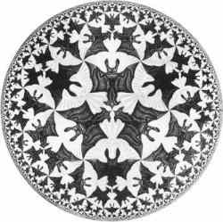Visual representation of an arithmetic group in
Escher’s tiling of hyperbolic plane.

