**Sample Inner Class**

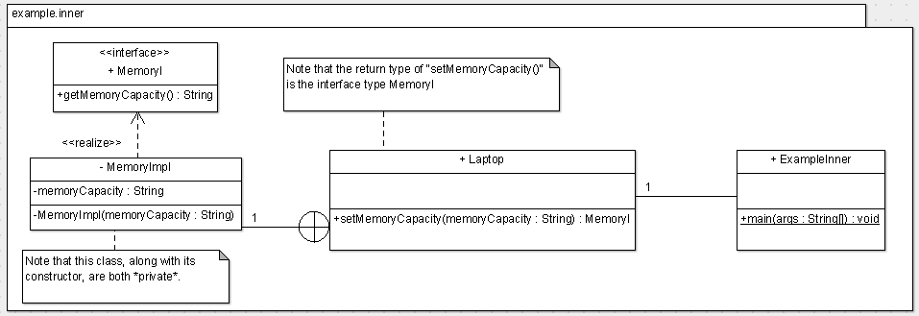

**Instructions**:

* in *main()*, create a *Laptop* reference, namely *laptop*
* invoke the *setMemoryCapacity()* passing in “4MB”; store the reference returned into an identifier named *memory*
* output, “The memory capacity is: “ and append on the result on invoking the *getMemoryCapacity()* on the *MemoryI* reference initialised above