Ase Take home exam Gift app finder pandalavenkatanaveen

Class diagram

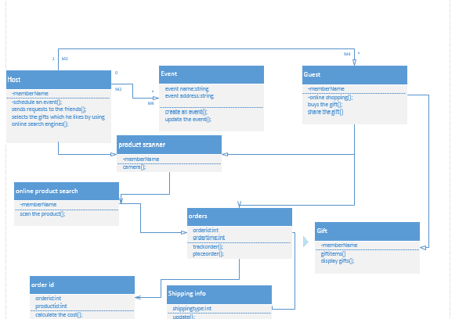

Architecture diagram

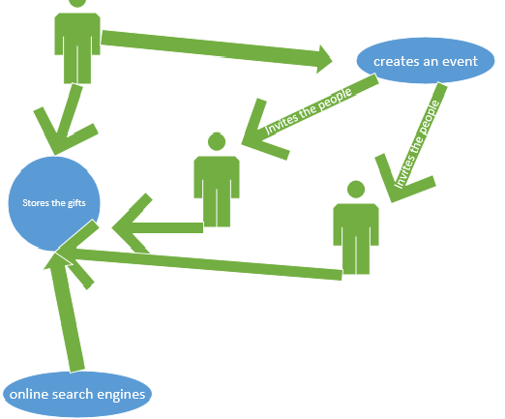

Explanation of the giftappfinder

As many more occasions are happeneing in todays life.Many people are invited but instead of buying the same gift or two or more people unknowingly buys the same gift.so to avoid this situations an host who cretaes an first sends an invitaion to all the friends and close relations after that by using online product serach engines he puts some of the gifts by scanning using bar code technology he inserts them in his local database.He shares also to his friends an dfamily relation ship also.Some every user who buys an gift share that gift to all the friends expect to the host so each and every individual can bring an different gift while attending to the event.

The tasks that are to be done are

1.host should login or otherwise he has to signup first.

2.he by using the barcode scanner he inserts the gifts into database.

3.after that user signup and login an event is to be created and it is to be shared to the all his friends

Default login page of our application

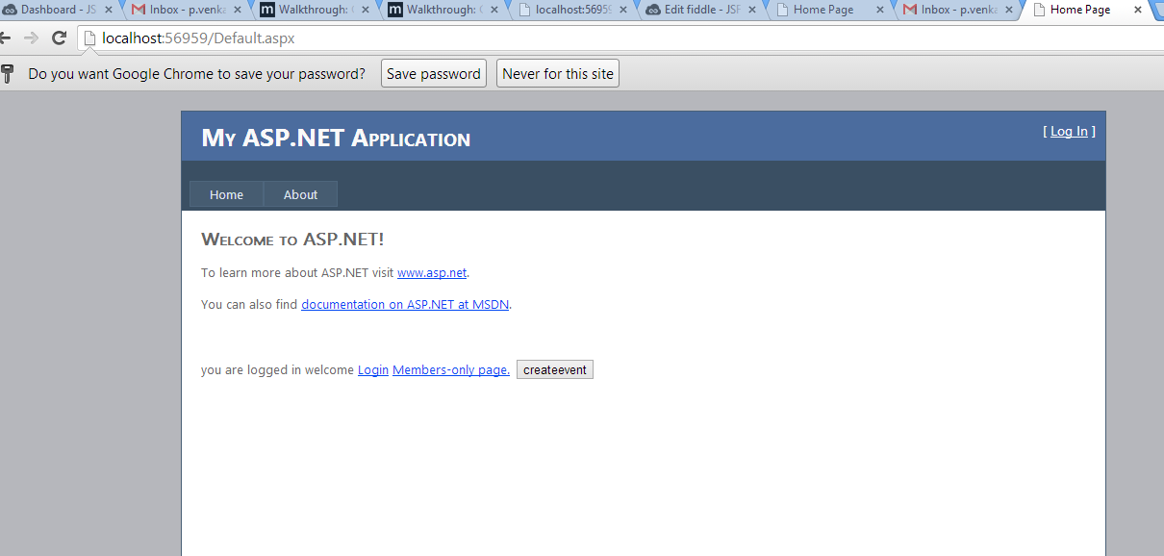

Login page for an user to login

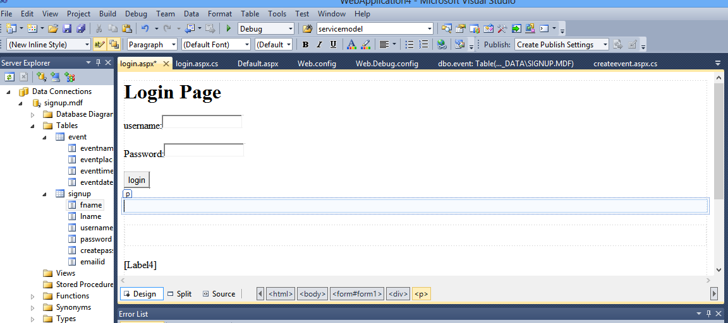

Signup page for an user lo register.

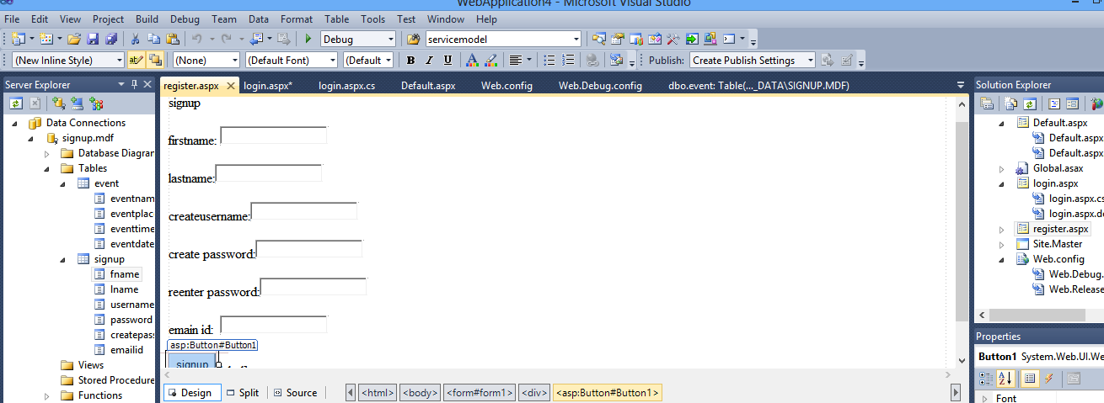

In local host user entering the values.

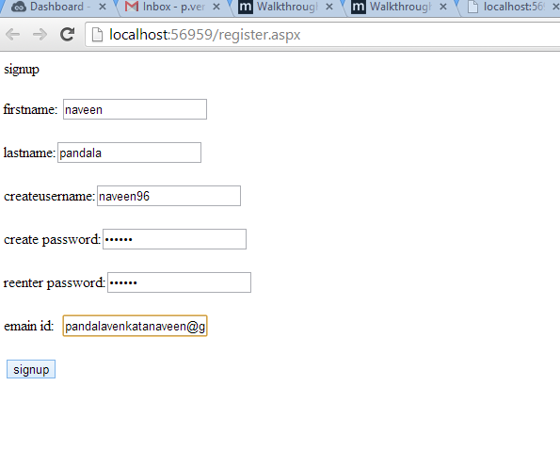

Successfully registration of the user.

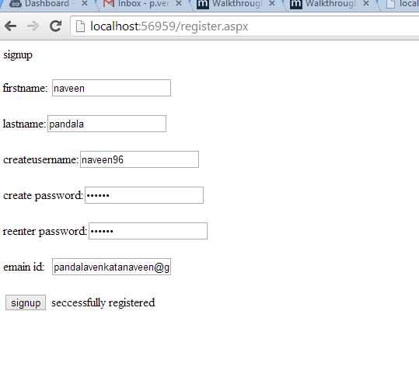Creation of event

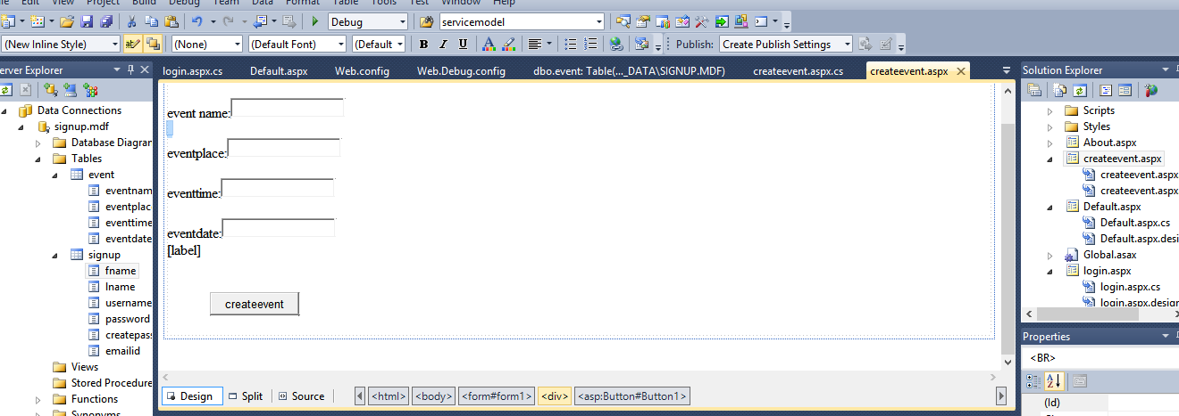

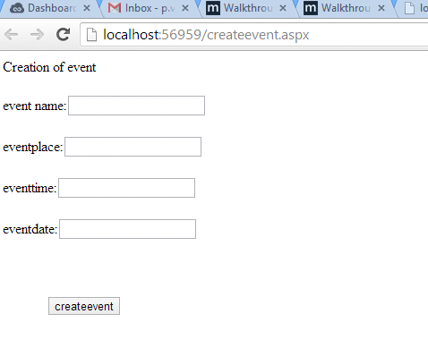

entering the details of the event

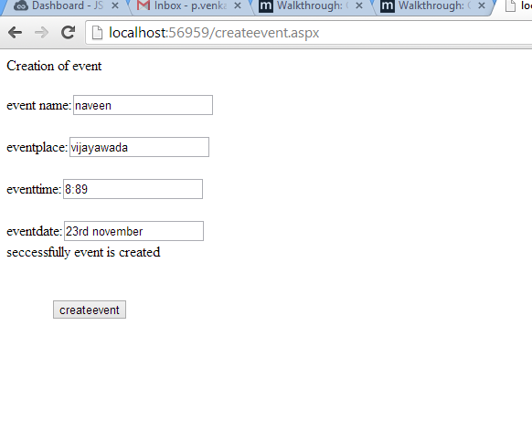

After this creation of an event the host should send the invitation to the friends and relatives.

Database:

I created an sql server database and added an table for a signup form and creation of event.

Limitations

I tried hard to implement the api of bar code scanner but I couldn't get I also search for many apis also

I also tried capture of image from various websites but couldn’t get that one.