Lab 3 Assignment

IN this Google api is used and yahoo finance chart is used to display the content of the information.After that twitter twet button is used to tweet the application and facebook like is also usd to post the comments.

1. Html code for Google chart and finanace chart and twitter api and facebook like posts

<iframe src="http://chart.finance.yahoo.com/z?s=GOOG&t=6m&q=l&l=on&z=l&p=m50,e200,v&a=p12,p&c=%5EDJI,EURUSD=X&region=DE" style="width:600px;height:700px;"></iframe>

<a href="https://twitter.com/share" class="twitter-share-button" data-lang="en">Tweet</a>

<iframe src="//www.facebook.com/plugins/like.php?href=http%3A%2F%2Fjsfiddle.net%2Fhx34P%2F10%2F&amp;width=450&amp;height=80&amp;colorscheme=light&amp;layout=standard&amp;action=like&amp;show_faces=true&amp;send=true" scrolling="no" frameborder="0" style="border:none; overflow:hidden; width:450px; height:80px;" allowTransparency="true"></iframe>

Script for the Twitter tag to open

!function(d,s,id){var js,fjs=d.getElementsByTagName(s)[0];if(!d.getElementById(id)){js=d.createElement(s);js.id=id;js.src="https://platform.twitter.com/widgets.js";fjs.parentNode.insertBefore(js,fjs);}}(document,"script","twitter-wjs");

Google API

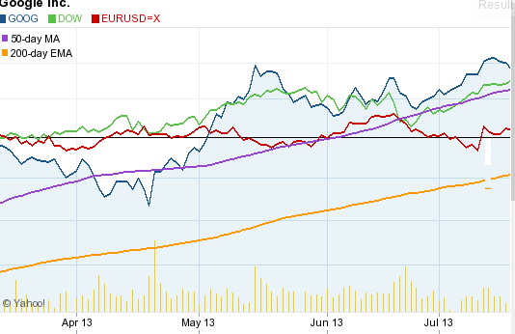

1. Twitter and facebook account

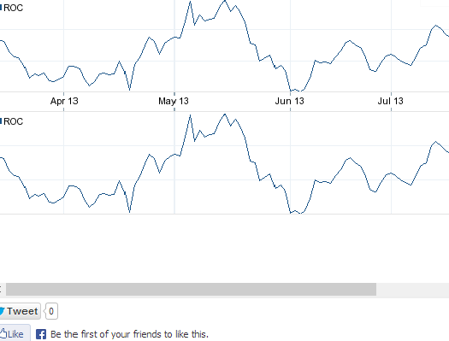

Here is jsfiddle link: <http://jsfiddle.net/hx34P/12/embedded/result/>