Hacknathon Pandalavenkatanaveen

on jsfiddle i executed how to take an picture by using phone.

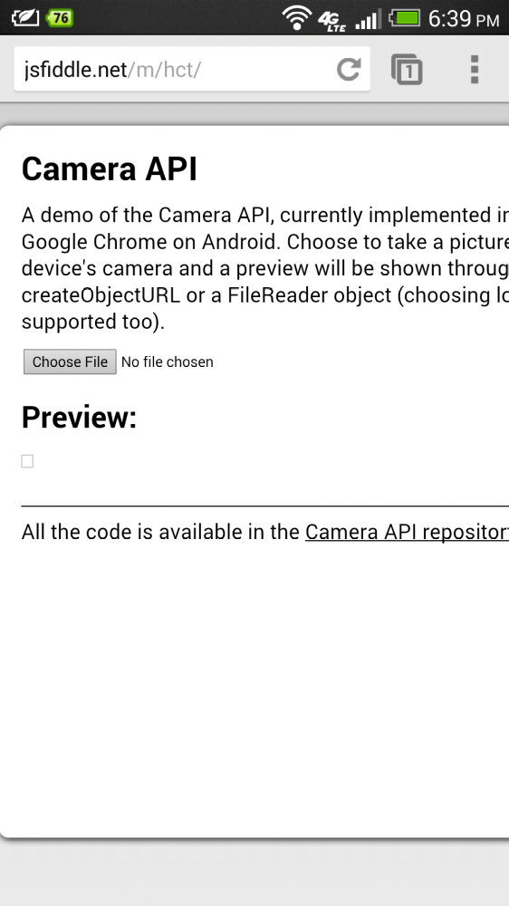

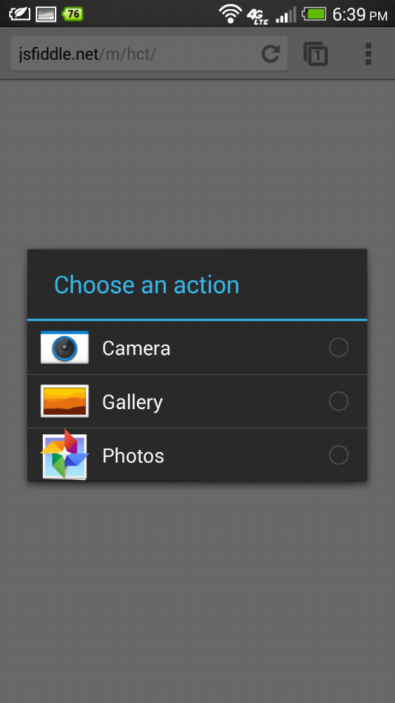
here i taken photo also.
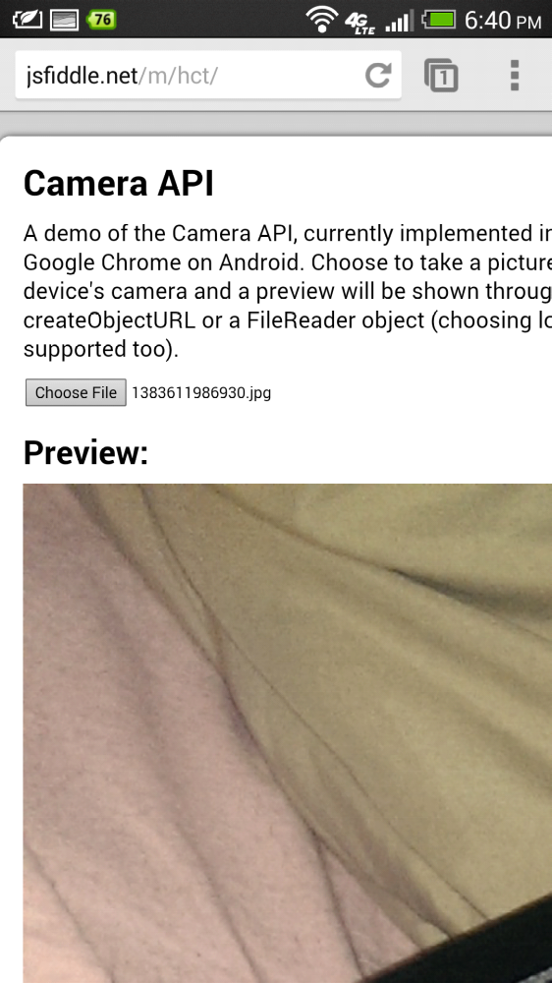
Limitations:
I am not very much good in programming as after completing my undergraduate in india i came directly to do my masters so i am not good in coding part.I am trying to learn more here.

To do a camera api i also referred to http://www.scriptcam.com/
to take an snapshop of the images but i could not succeeded in doing this.

