Introduction to the ArcGIS Engine Application for RCW Foraging Analysis

The ArcGIS Engine Application for RCW Foraging Analysis is designed to demonstrate the capabilities of the ArcGIS Engine software with regard to habitat management for the red-cockaded woodpecker. The source code has been included with the application for demonstration purposes. Individuals may modify the source code, but approval for modification as it relates to regulatory oversight must be obtained from the RCW Recovery Coordinator. Any modifications to the source code should be submitted to the Recovery Coordinator and may be used in subsequent iterations of the application.

Overview of the Sample RCW Data Model
- If you have ArcView 9, open ArcCatalog and browse to the installation location.
- Expand the Data\RCWDataModel.mdb

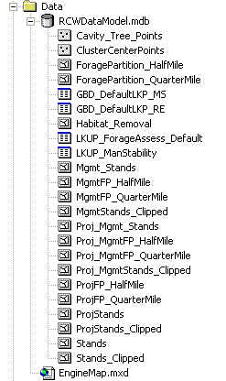

- The geodatabase contains two feature classes that are required to use the RCW foraging application. All fields present in these feature classes are required though some of the fields will be calculated by the application.
  - Cavity_Tree_Points – contains locations (X,Y coordinates) of RCW cavity trees as well as the cluster to which each tree has been assigned
  - Stands – contains timber stand data collected during foraging habitat analysis or timber inventory (See Procedures for Determining Foraging Habitat Availability, included on the installation cd)
- The remaining feature classes are empty at the onset and will be populated by the RCW foraging application. All fields present in these feature classes are required and will be calculated by the application.
  - ClusterCenterPoints – contains cluster center calculated as the mean location of all cavity trees in a cluster (Step 1)
  - ForagePartition_HalfMile – contains ½ mile foraging partitions calculated by buffering each cluster center by ½ mile and constraining that buffer, where appropriate, due to neighboring clusters (Step 3)
  - ForagePartition_QuarterMile – contains ¼ mile foraging partitions calculated by buffering each cluster center by ¼ mile and constraining that buffer, where appropriate, due to neighboring clusters (Step 2)
  - Habitat_Removal – contains the footprint of proposed projects that will require complete clearing of the outlined area (Step 8)
  - Mgmt_Stands – contains Stands feature class data that has been altered by the program based on user input regarding proposed management changes such as thinning or midstory control (Step 7)
  - MgmtFP_HalfMile – contains the ForagePartition_HalfMile feature class, calculated as above, for partitions that will be affected by proposed management changes (Step 7)
  - MgmtFP_QuarterMile – contains the ForagePartition_QuarterMile feature class, calculated as above, for partitions that will be affected by proposed management changes (Step 7)
  - MgmtStands_Clipped – contains the data in the Mgmt_Stands feature class, clipped to the MgmtFP_HalfMile partitions (Step 7)
  - Proj_Mgmt_Stands – contains the Stands feature class data for those partitions that will be impacted by the project(s) outlined in the Habitat_Removal feature class and the management changes outlined in the Mgmt_Stands feature class (Step 8)
  - Proj_MgmtFP_HalfMile – contains the ForagePartition_HalfMile for those partitions that will be impacted by the project(s) outlined in the Habitat_Removal feature class and the management changes outlined in the Mgmt_Stands feature class (Step 8)
  - Proj_MgmtFP_QuarterMile – contains the ForagePartition_QuarterMile for those partitions that will be impacted by the project(s) outlined in the Habitat_Removal feature class and the management changes outlined in the Mgmt_Stands feature class (Step 8)
  - Proj_MgmtStands_Clipped – contains the data in the Proj_Mgmt_Stands feature class, clipped to the ½ mile foraging partitions for those partitions affected by the project(s) in the Habitat_Removal feature class and the management changes outlined in the Mgmt_Stands feature class (Step 8)
  - ProjFP_HalfMile – contains the ForagePartition_HalfMile feature class, calculated as above, for partitions that will be affected by the project(s) outlined in the Habitat_Removal feature class (Step 8)
  - ProjFP_QuarterMile – contains the Forage Partition_QuarterMile feature class, calculated as above, for partitions that will be affected by the project(s) outlined in the Habitat_Removal feature class (Step 8)
  - ProjStands – contains timber stand data collected during foraging habitat analysis or timber inventory for those stands that will be affected by the project(s) outlined in the Habitat_Removal feature class (Step 8)
  - ProjStands_Clipped – contains the data in the ProjStands feature class, clipped to the ½ mile foraging partitions for those partitions affected by the project(s) outlined in the Habitat_Removal feature class (Step 8)
  - Stands_Clipped – contains timber stand data collected during foraging habitat analysis or timber inventory that have been clipped to the ½ mile partitions
- The geodatabase contains two look up tables.
  - LKUP_ForageAssess_Default – contains the upper and lower limits for each scoring category for the characteristics used in evaluations of foraging habitat against the Recovery Standard, the weight assigned to each characteristic, and management recommendations to improve scores for each characteristic
  - LKUP_ManStability – contains the values determining pass/fail for each characteristic used in evaluations of foraging habitat against the Standard for Managed Stability, management recommendations to improve scores in each category, and indicator variables for which characteristics are used in the evaluation as well as which characteristics are required in the evaluation
- The geodatabase also contains two tables for internal use of the application. These tables should not be modified.
  - GBD_DefaultLKP_MS
  - GBD_DefaultLKP_RE
- The geodatabase MUST be an ArcGIS 9.0 geodatabase.
- Notice that the data are in State Plane coordinates with the units in feet. The application will also work with data in other projects, but all data must be in the same projection and have a projection file.

**To use your own data instead of the sample data model, please refer to the “Loading data into the RCW Model” section of the APPENDIX.

Authoring your Map using ArcView 9 and the ArcMap application
- A sample map, using data from the sample data model, has been provided for you and can be found at \Data\EngineMap.mxd. The application will load this map upon start up.
- You may alter the symbology, selectable layers, layout, etc using ArcView 9 as long as the following conditions are met:
  - You must have one layer for each of the core feature classes.
  - The layer names must match the feature class names exactly (ex: “Cavity_Tree_Points”)
- Your symbology, layout, labels, etc will be displayed exactly as they are in ArcView by the RCW Engine application.
- Your selectable layers will also remain the same in the RCW Engine Application; therefore, a layer must be identified as selectable in ArcView if it is to be selectable in the RCW Engine application.
- The data frame in your map document MUST be in the same projection as the feature classes in your geodatabase. If necessary, use the Coordinate System Tab in the Data Frame Properties dialog box to change the projection of the data frame.
- Save the map as \Data\EngineMap.mxd
- If you wish to save the map elsewhere, you need to update the parameter file with your new map location. See the section on Updating Your Parameters in the APPENDIX.

Starting the Engine Application
- Access the application executable file from the Start > Programs > RCW Analysis > RCW Analysis
- You may also start the application from your install location \Tools\RCWEngine\RCWAnalysis.exe or through the shortcut on the desktop.
- If the application cannot find the EngineMap.mxd, you will be prompted to set the RCW Setup Parameters. See the section on Updating Your Parameters in the APPENDIX.
- Once the application loads, maximize the application window.
- Your map should appear with the same symbology, layers and legend as when you saved it last or with the default symbology if you did not modify the map.
- Note: A toolbar is loaded during installation for use in ArcMap for those users running ArcGIS. The same analysis tools are available in the engine application and the ArcMap toolbar.

Navigation Tools
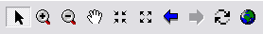

- Explore the Navigation tools (top left) to pan and zoom in the map window.
- Turn layers on and off in the Table of Contents by clicking the box next to the layer name.
- Two of the feature classes have scale range set. Cavity_Tree_Points and ForagePartition_HalfMile will not display when zoomed out beyond a certain extent. If they are not displayed, check to see if the box next to the layer name has a gray check mark. If so, zooming in will cause that layer to be displayed once you pass the scale range specified in the layer properties. You can change this scale range in ArcMap by right clicking on the layer in the table of contents, choosing properties, and changing the properties in the Scale Range section on the general tab.
- Go to View > View Layout to switch to a layout view. This view will give you a preview of how the map in your reports will look. Click this again to go back to your map display.

- Go to File > Export Image. 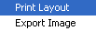 Exports the current display (map or layout view) as a PDF or a JPG file in the location of your choice.

- Go to File > Print Layout. 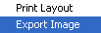 Prints the layout view to your default printer.

Identify Tool

- Use the Identify tool to identify some features. This is a custom tool and may appear slightly different than the Identify tool in ArcMap.

Matrix Options
- Use the Matrix Options tool to change values for characteristics used in the evaluation.
- There are tabs for the Recovery Standard and the Standard for Managed Stability.
  - Recovery Standard: All criteria are required for this analysis except the number of GQFH within ¼ mile of the cluster center. However, because all data may not be available at the time the analysis is run, the program allows you the flexibility to exclude criteria and still run the analysis. Clicking the box next to “Use this category” for each characteristic will toggle between inclusion (checked) and exclusion (unchecked) for the analysis. If you exclude criteria from the analysis, you will get a message reminding you that the analysis is not complete and is not valid for the regulatory review process. The Recovery Standard characteristics have weighted values that reflect relative importance; therefore, if you exclude a characteristic from the evaluation, you will be required to enter new weight values for each of the remaining characteristics so that they sum to 1 or the application will not continue.
  - Standard for Managed Stability: This standard includes both requirements and recommendations. At the stand level, % herbaceous groundcover, fire return interval, and season of last prescribed burn have recommended values. At the partition level, the total acres of foraging habitat within ¼ mile and the number of contiguous foraging acres have recommended values. Data on all characteristics will be required as part of a regulatory review. Because all data may not be available at the time the analysis is run, the program allows you the flexibility to exclude criteria and still run the analysis. If you exclude criteria from the analysis, you will get a message reminding you that the analysis is not complete and is not valid for the regulatory review process.
- Below the list of categories, you can click Stand Level or Partition Level to view or change items associated with each level of each standard.
- In this dialog box, you can change the minimum and maximum values used for each category, 1-5, for each characteristic in the recovery standard. Changing the values should, in most cases, only be done based on recommendations by the RCW recovery coordinator for specific recovery units.
- You may also change the pass/fail values used in the Standard for Managed Stability. Again, changing the values should, in most cases, only be done based on recommendations by the RCW recovery coordinator for specific recovery units.
- All characteristics that are required for full evaluation of foraging habitat are listed in red and those that are recommended are listed in blue. A green check mark next to a characteristic means that characteristic will be used in the evaluation (i.e., the “Use this category” box for this characteristic has been checked) whereas those with a red X will not be used.
- Any changes made to these minimum and maximum values, the weights, or to which characteristics were used in the evaluations will be documented in the report generated by the application.

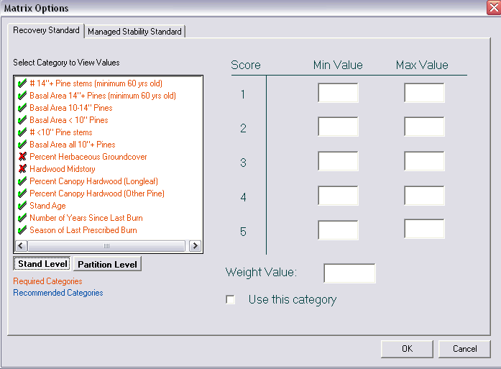

Foraging Assessment Report Wizard
- The Foraging Assessment Report Wizard will guide you through the steps to create a foraging assessment report.

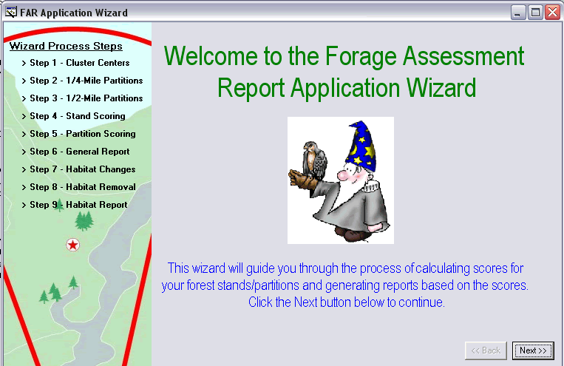

Step 1
- The Wizard will first check to see if you have cluster centers calculated. If so, you have the option to “Skip this Step”. If not, the application will calculate them for you using the cluster number as a grouping variable.
- Use the Select Features Tool to select a subset of trees for which you would like to calculate the cluster center(s). If not, the application will calculate centers based on all trees in your geodatabase.

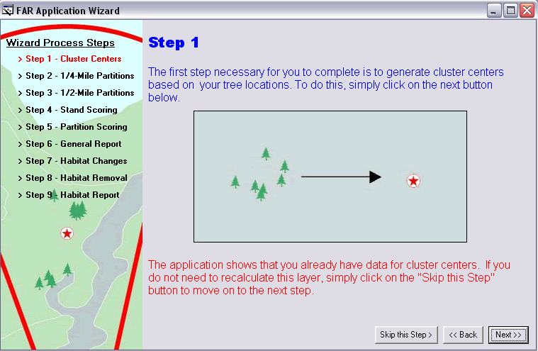

Step 2
- Next, the Wizard will check to see if you have ¼ mile partitions calculated. If so, you have the option to “Skip this Step”. If not, the application will calculate them based on the cluster center(s). Because partitions are modified based on the proximity of other groups (i.e., territorial partitioning), it is most appropriate to generate all ¼ and ½ mile partitions for your management area at one time. Otherwise, partition sizes may not reflect constraints from surrounding groups.

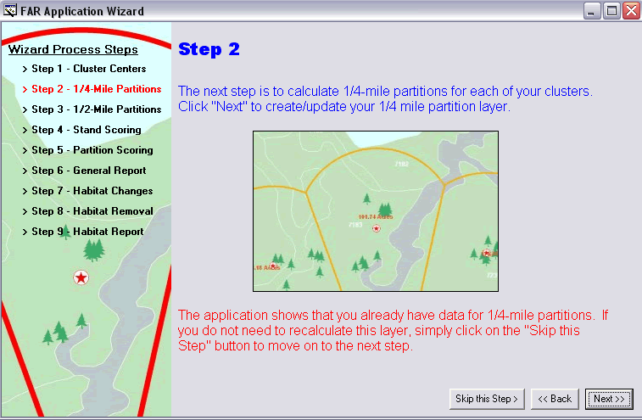

Step 3
- Next, the Wizard will check to see if you have ½ mile partitions calculated. If so, you have the option to “Skip this Step”. If not, the application will calculate them based on the cluster center(s). Because partitions are modified based on the proximity of other groups (i.e., territorial partitioning), it is most appropriate to generate all ¼ and ½ mile partitions for your management area at one time. Otherwise, partition sizes may not reflect constraints from surrounding groups.

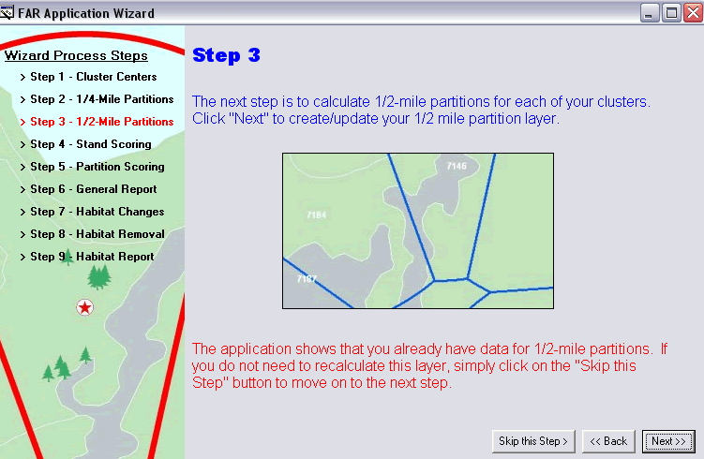

Step 4
- Next, the Wizard will score the stands against the matrix criteria. It will compare values for each characteristic against the values in the matrix and add the appropriate score to the geodatabase. If you have previously scored your stands and have not made any changes, you have the option to “Skip this Step”.
- More detail on the calculation process can be found in the Appendix under Behind the Scenes: How Stand Scores are Calculated.

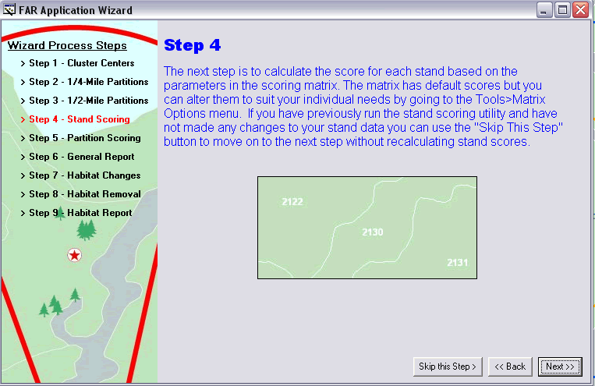

Step 5
- Next, the Wizard will calculate the partition scores. Using the stands scores and the ¼ and ½ mile partitions created in earlier steps, the application will score the partitions against the matrix. Use the select feature tool to select a ½ mile partition to score before clicking the Next button.

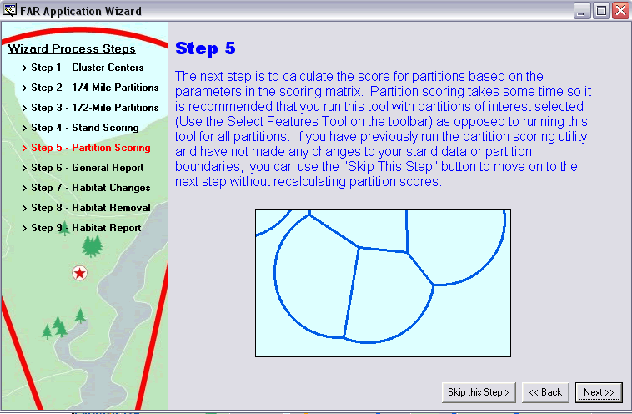

- While calculating partition scores, the application will automatically assign as score of 1 (contiguous) or 0 (not contiguous) for each stand. To be contiguous, as stand must be within 200 feet of another foraging stand that is also contiguous with the stand containing the cluster center. Foraging stands are all pine stands in the partition that are at least 30 years old. The application will then give you the option to manually change the contiguity score for each stand.

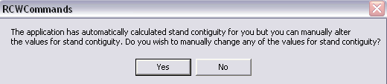

  - If you click yes, you will see the dialog box below:

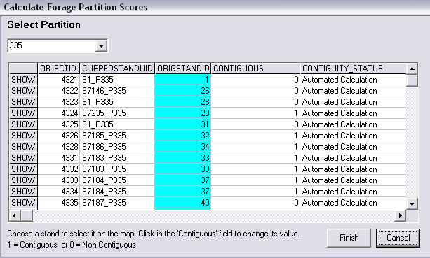

  - If multiple partitions are being evaluated, you can choose which partition you are viewing in the drop down menu under Select Partition in the upper left corner of the dialog box.
  - Clicking the word “Show” next to the stand number will highlight that stand in the map.
  - You can use the Measure Tool to determine distances separating stands. After clicking on the Measure Tool, click at the edge of the stand in question and then drag the pointer to the opposite edge. The distance is displayed over the line connecting the two points.
  - To change a stand from contiguous to not contiguous (or vice versa), click on the value in the “Contiguous” field for the stand in question. You will be able to choose 0 (not contiguous) or 1 (contiguous). Notice that the Contiguity-Status field will change to “Manual Calculation” as documentation that the contiguity of the stand was changed by the user.
  - Click “Finish” to finish calculating partition score.

Step 6
- Next, the Wizard will give you the opportunity to generate reports based on the calculations performed in the preceding steps or to assess the impact of a proposed habitat changes or removals. Click Next to assess habitat changes or Finish to close the Wizard and view the reports.
- If you choose Finish, you will then have the option to choose which reports and maps you would like to generate. Click the box next the each standard, page, and map to include in your final report.

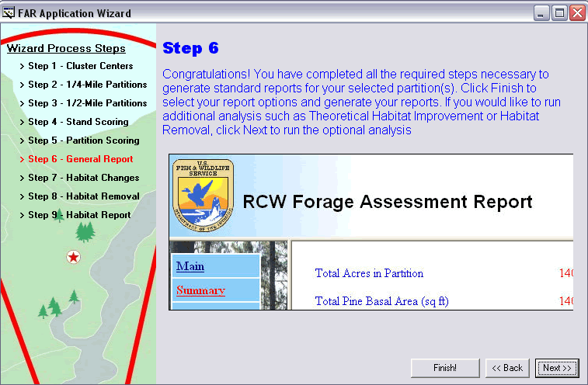

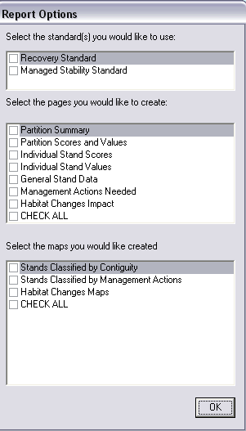
Step 7
- This step will allow you to change values for characteristics from one or multiple stands to see what impact the proposed management change(s) will have on the foraging assessment report.
- Select the partition(s) that will be affected by the change and click the “Next” button. You may choose to “Skip this Step” if you do not wish to evaluate the impact of any proposed management changes.

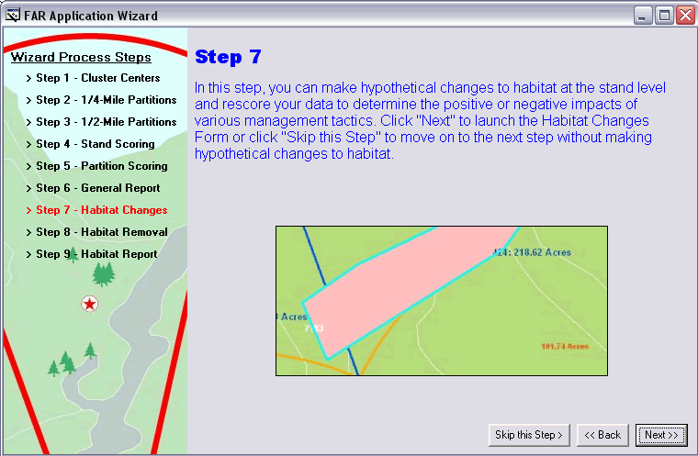

- Select the Recovery Standard Tab or the Managed Stability Standard tab to display the characteristics used for the selected standard.
- The stand for which you are viewing the characteristics is in the drop down menu immediately below the characteristics. Characteristics that are red do not meet the standard in question whereas characteristics that are in green meet the standard in their current state.
- Use the drop down menu to select the stand that will be affected by the change.
- Highlight the characteristic you wish to change. The current value will be displayed as well as the score that value gets when compared to the foraging matrix. The optimal value range will also be displayed for reference.
- Enter a value in the “Enter New Value” box, click the Calculator icon, and see the resulting score You may change the value as many times as you like since the change will not be added to the geodatabase until you click the Save icon.
- Once you have decided upon a new value for the stand, click the save icon to change the value associated with that stand. Note: The value will be changed in a new feature class and will NOT affect your original data.
- Repeat the process for each characteristic in each stand you wish to change.
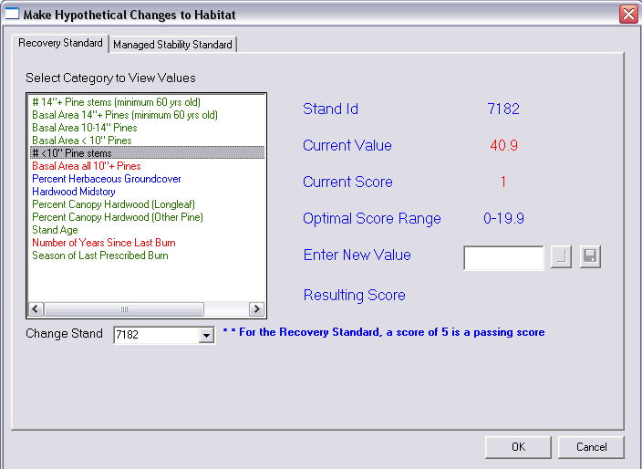

Step 8
- To assess the impact of habitat removal, first make sure that the Habitat_Removals feature class is turned on as indicated by a check mark beside the name (Habitat_Removals) in the Table of Contents.
- Use the Draw Habitat Removal Polygon Tool to draw the outline of the proposed project area. Click once on the Draw Habitat Removal Polygon Tool then click once on the map at a point in the project outline. Click at each of the remaining vertices in the project outline. Double click on the last vertex to finish drawing the project outline. The polygon of the project outline will then be displayed.
- Use the Select Habitat Removal Polygon Tool to select the project for which you wish to evaluate impacts. Even if there is only one project, you must still select it using the Select Habitat Removal Polygon Tool before proceeding.
- Click Finish to evaluate the impact of the proposed project and have that assessment added to the partition report. The assessment recalculates the partition scoring and gives you the opportunity to change contiguity status, as in Step 5, based on project impacts.
- You may choose to “Skip this Step” if you do not wish to evaluate any habitat removals.
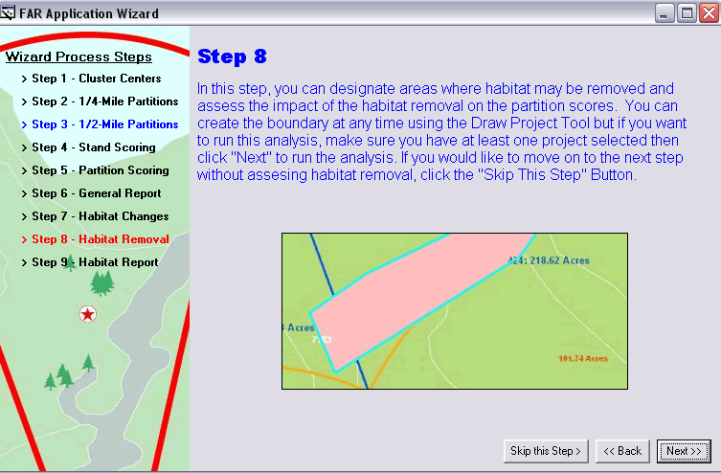

Step 9
- To generate reports that now include habitat changes and/or habitat removals, click “Finish” in the dialog box for Step 9.
- You will then have the option to choose which reports and maps you would like to generate. Click the box next the each standard, page, and map to include in your final report.

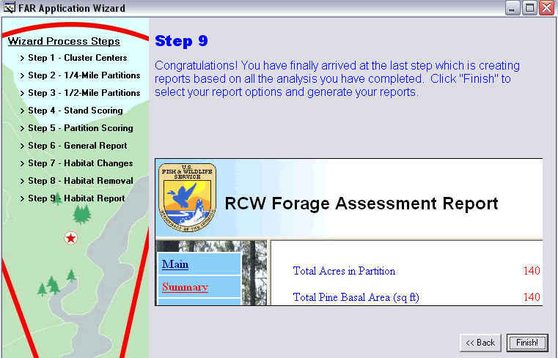

The following tools are included as buttons and can be used independent of the wizard. The data must still be in an ArcGIS 9.x geodatabase, and the geodatabase must still have all of the default feature classes and tables listed on page 1.

- Generating Cluster Centers
- This tool will generate the mean center locations for the selected set of tree locations in the feature class Cavity_Tree_Points.
- For example, there are 4 groups of RCW trees shown below with each set of trees represented by a different color. The points are symbolized based on the Cluster Number field in the attribute table of the Cavity_Tree_Points feature class.

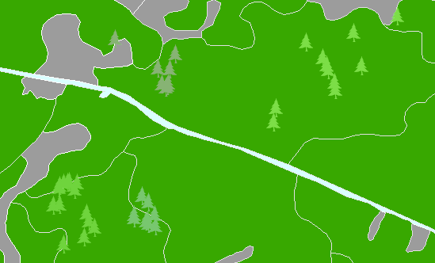

- Use the Select Features Tool to select a subset of trees for which you want to calculate cluster centers. Otherwise, the Create Cluster Center Tool will create cluster centers for all cavity trees in your geodatabase.

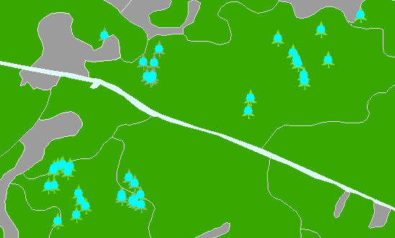

- This example shows the same area AFTER the Cluster Centers, symbolized by the red stars, have been calculated. Each Cluster Center represents the mean X, Y location for each cluster of RCW trees.

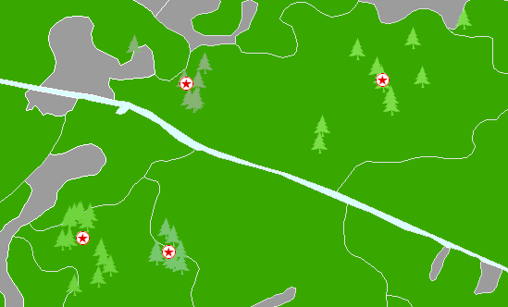

2. Create Quarter Mile Partitions
- This tool will create ¼ mile buffers around each selected cluster center. The calculations can be re-run any time your cluster centers change or new cluster centers are added to your data. You may also choose to skip this step if your partitions have been generated and remain static.
- At least one cluster center must exist. You may choose to apply the calculation to a selected set or all of your cluster centers.
- The partition will be created around each cluster center. The new features are stored inside the ForagePartition_QuarterMile feature class.
- The partition ID will equal the ClusterCenter ID.
- The application will check each partition to see where it may intersect another partition.
- If an intersection is found, the application will modify the boundary of the partition to split the difference of the intersection (i.e., territorial partitioning).
- If a selected cluster center already has a quarter mile buffer in the ForagePartition_QuarterMile feature class, this buffer will be recalculated.
- The acreage is calculated for each of the resulting partitions after the intersections are calculated.
- Because partitions are modified based on the proximity of other groups, it is most appropriate to generate all partitions for your management area at one time. Otherwise, partitions sizes may not reflect constraints from surrounding groups.

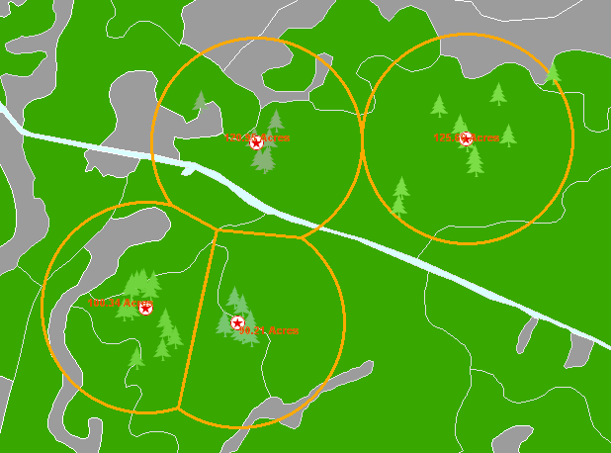

3. Create Half Mile Partitions
- The half mile partition tool works the same way as the Create Quarter Mile Partition tool; however, the buffer distance is ½ mile instead of ¼ mile.
- Because partitions are modified based on the proximity of other groups, it is most appropriate to generate all partitions for your management area at one time. Otherwise, partitions sizes may not reflect constraints from surrounding groups.

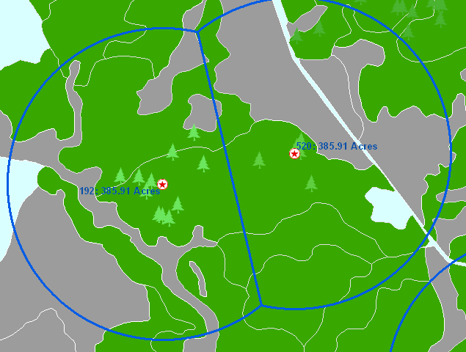

4. View Existing Reports
- This tool will allow you to select which report you would like to view. You must first select which list of reports to view, either the current reports generated during this session or all reports that have been generated. Highlight the report you wish to view and click “View”.

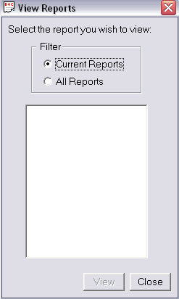

APPENDIX

Updating Your Parameters
- Several parameters are required for the application to run. These parameters are established in the RCW Parameter Setup dialog. This dialog can be launched using C:\RCW\Tools\RCWEngine\RCWCommands\RCWParameterSetup.exe.

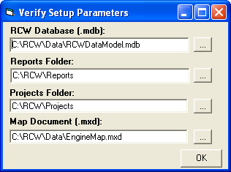
  - RCW Database (.mdb) – A 9.0 personal geodatabase that must contain the same feature classes and fields as the sample RCWDataModel geodatabase.
  - Reports Folder – A folder on your system where you have write access. Any reports will be created in this location.
  - Projects Folder – A folder on your system where you have write access. Any projects will be created in this location.
  - Map Document (.mxd) – The ArcGIS map document that you wish to use in the RCW Application.

- Use the ellipsis button if you need to browse to select another file for any of the parameters.
- Clicking OK will write your settings to the parameter file (\Tools\Code\RCWEngine\RCWCommands\RCW.ini).
- You may change your settings at any time. Go to Start > Programs > RCW Analysis > RCW Parameter Setup to bring up the dialog box.

Loading your data into the RCW Data Model

Creating a Blank Geodatabase
To create a geodatabase for use with the RCW Foraging Matrix application, follow these steps. Note: These instructions assume the application was installed in the default location (C:\RCW).

- Open ArcCatalog.
- Create a connection to the C:\RCW folder.
  - Click on the Connect to Colder icon.
  - In the dialog box that appears, navigate to C:\RCW and click ok.
  - Expand the folder in the table of contents by clicking on the plus sign next to C:\RCW.
- Rename the existing sample geodatabase.
  - Right click on the existing geodatabase (RCWDataModel.mdb), and choose Rename.
  - Rename the sample geodatabase to “sampleRCWDataModel.mdb”.
- Create a new geodatabase.
  - Right click on the folder C:\RCW and choose New >> Personal Geodatabase.
  - Right click on the newly created geodatabase and choose Rename.
  - Rename the newly created geodatabase “RCWDataModel.mdb”
- Digitize a shapefile to cover your area of interest.
  - In ArcCatalog, right click on C:\RCW and choose New >> Shapefile.
  - In the dialog box that appears,
    - Name the shapefile something appropriate for your area (e.g., RCW_extent).
    - From the dropdown menu for Feature Type, choose Polygon.
    - Define the projection by clicking the Edit button and choosing the projection that matches your existing data.
    - Click OK.
  - In ArcMap, start editing the new feature class and digitize a rectangle large enough to cover your area of interest and beyond. This rectangle should encompass a half a mile from your cluster centers plus a GENEROUS buffer. NOTE: You will not be able to add anything to your geodatabase that extends beyond this shapefile’s extent, so be GENEROUS with the buffer!
    - Open a new, empty .mxd in ArcMap.
    - Use the Add Data button to add RCW_extent and a shapefile of your data. This shapefile could be your cavity trees, cluster centers, partitions, or property boundary.
    - Click on the Zoom Out button five or six times to account for the GENEROUS buffer needed when creating the extent rectangle.
    - From the Editor toolbar, click on Editor and choose Start Editing.
    - If necessary, choose to edit files in the directory that contains RCW_extent.shp. If this shapefile is in the same directory as your other data, you will not need to specify which directory you will be editing.
    - Use the drop down boxes on the Editor toolbar to make sure that “Task:” is followed by “Create New Feature” and “Target:” is followed by “RCW_extent”.
    - Click once on the pencil tool on the Editor toolbar to select this tool.
    - With the pencil tool selected, click once in each of the four corners of the data window to create a rectangle around your data. Double click on the last point to end the draw task. The rectangle does not need to be a perfect square or rectangle.
    - On the Editor toolbar, click Edit and choose to Save Edits.
    - On the Editor toolbar, click Edit and choose to Stop Editing.
    - Close ArcMap and do not save the changes to the .mxd.
- Reproject the feature classes in the EmptyDataModel.mdb to match your existing data.
  - Open ArcToolbox.
  - Navigate to Data Management Tools >> Projections and Transformations >> Feature >> Batch Project.
  - Double click on the Batch Project Tool.
  - In the dialog box that appears, click the folder icon next to Input Feature Class or Dataset.
  - Navigate to C:\RCW\Data\EmptyDataModel.mdb and then double click on that geodatabase.
  - Click once on the feature class in the upper left, hold down the shift button, and click once on the feature class in the lower right of the dialog box.
  - Click Add.
  - Click the folder icon next to Output Workspace.
  - Navigate to C:\RCW\Data\EmptyDataModel.
  - Click once on that geodatabase and click Add.
  - Click the icon next to Output Coordinate System.
  - Click the Select button and navigate to the coordinate system into which you want to project the data.
  - Double click on that coordinate system and then click ok.
  - Click OK to run the Batch Project Tool.
  - NOTE: The geodatabase will now contain the sample data feature classes as well as a copy of the feature classes projected into the coordinate system you specified. The feature classes you just created will all have “_1” at the end of the feature class name.
- Import the newly projected feature classes into your data model.
  - In ArcCatalog, right click on C:\RCW\Data\RCWDataModel.mdb.
  - Choose Import >> Feature Class (multiple).
  - In the dialog box that appears, click on the folder icon next to Input Features.
  - Navigate to C:\RCW\Data\EmptyRCWDataModel.mdb and double click on the geodatabase.
  - In the dialog box that appears, hold down the CTRL button on your keyboard while you click on each feature class with an “_1” at the end of the name. Each of 19 feature class ending in “_1” should be highlighted before you click Add.
  - Click the folder icon next to Output Geodatabase.
  - Navigate to C:\RCW\Data and click once on RCWDataModel.mdb.
  - DO NOT CLICK OK YET!
  - Click on the Environments tab.
  - In the dialog box that appears, click on Geodatabase Settings.
  - Click the folder next to Output XY Domain.
  - Navigate to the shapefile you created in step 5 above and double click it.
  - Click OK to close that dialog box.
  - Click OK to run the Import Feature Class tool.
- In ArcCatalog, rename each of the newly imported feature classes. That is, remove the “_1” from each feature class in RCWDataModel.mdb. Alternatively, a model has been built that will rename the feature classes for you.
  - In ArcCatalog, click on the ArcToolbox button, if necessary, to open ArcToolbox.
  - If you do not have a toolbox named “Matrix”, then:
    - Right click anywhere on the white space within the ArcToolbox window.
    - Choose Add Toolbox…
    - In the dialog box that appears, navigate to C:\RCW\Tools.
    - Click once on the Matrix toolbox.
    - Click Open.
  - In ArcToolbox, click the plus sign next to the Matrix toolbox to expand the toolbox.
  - Right click on “Rename FCs” and click Edit.
  - In the dialog box that opens, choose Model > Run Entire Model.
  - When the model has finished running, close any open dialog boxes to return to ArcCatalog.
- Import the look-up tables to the geodatabase.
  - In ArcCatalog, click once on SampleRCWDataModel.mdb in the left hand table of contents.
  - In the right hand window, click on the Contents tab.
  - Hold down the CTRL key on your keyboard and click once on each of four tables in the right hand window:
    - GBD_DefaultLKUP_MS
    - GBD_DefaultLKUP_RE
    - LKUP_ForageAssess_Default
    - LKUP_ManStability
  - With those four tables highlighted, right click on one of them and choose Copy.
  - Right click on RCWDataModel.mdb in the left hand table of contents.
  - Click Paste.
  - In the dialog box that appears, click OK.

That’s it! Your new geodatabase is now ready for you to begin importing your data!

Cavity Tree Data
If you have an existing shapefile of cavity trees, skip to Step 2.

- Convert the database table (*.dbf) containing your x,y tree coordinates to a shapefile.
  - Your *.dbf file MUST have the fields for the following data Field names are limited to 10 characters in shapefiles but you will be able to change your existing field names to match the data model when you import the shapefile to the geodatabase as a feature class. See step 2.e. below.
    - Tree_Number (text field)
    - Cluster_Number (double field)
    - Easting (double field)
    - Northing (double field)
  - Additional fields (such as tree or cavity status) may be included without affecting the functionality of the matrix application.
  - In ArcCatalog, right click on the *.dbf file and choose Create Feature Class > From XY table.
  - Choose “Easting” from the drop down box for the X field and “Northing” from the drop down box for the Y field. Note that Eastings and Northings can be UTMs or State Plane coordinates.
  - Click “Spatial Reference of Input Coordinates” to identify the coordinate system of your data.
  - Click the folder button to choose where to save the shapefile. Name the shapefile Cavity_Trees and save it in the C:\RCW\Data folder.
  - Your dialog box should look like the image below before clicking OK.
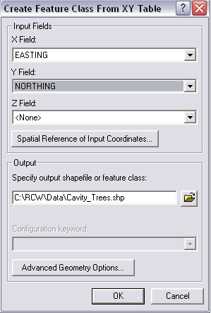

  - Use ArcToolbox or ArcCatalog to define the spatial reference information for this shapefile.
    - In ArcToolbox, fill in the dialog box found under ArcToolbox > Data Management > Projections and Transformations > Define Projection.
    - In ArcCatalog, right click on the Cavity_Trees shapefile and click Properties.
      - Click the Fields tab and click on “Shape” in the list of Field Names.
      - Under Field Properties, click on the ellipsis next to the Spatial Reference field and then select the appropriate projection.
- Import the shapefile to the RCWDataModel.mdb.
  - In ArcCatalog, expand the geodatabase to view the feature classes already in the geodatabase. If a cavity tree feature class exists, right click on it and change the name of the feature class or choose to delete the feature class. There should not be a Cavity_Tree_Points feature class in the geodatabase in order to proceed to step 2.b.
  - While still in ArcCatalog, right click on the Cavity_Trees shapefile and click Export to Geodatabase (single).
  - For output location, choose C:\RCW\Data\RCWDataModel.mdb.
  - For output feature class location, enter Cavity_Tree_Points.
  - Use the “Field Info (optional)” section of this dialog box to make sure your field names match those of the model EXACTLY. If necessary, change the names of the fields that will be in your feature class by typing in the following new field names in the “NewFieldName” column for each field. The field names must be:
    - Tree_Number
    - Cluster_Number
    - Easting
    - Northing
  - Your dialog box should look like the one below before clicking ok.

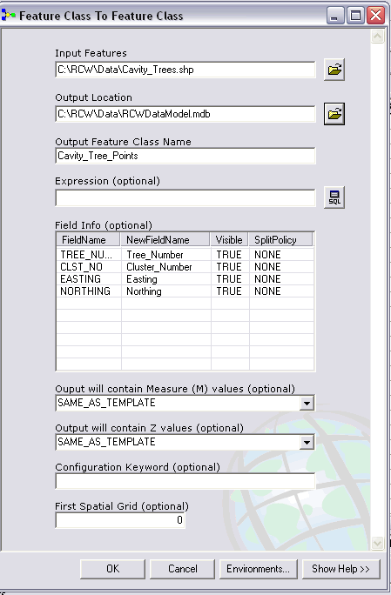

Stand Data
If you did not populate the fields in the blank geodatabase but instead have a shapefile of your stand data, follow these steps to load your data into the geodatabase:

- You must have a shapefile consisting of polygons whose attributes are the data in the following fields. The field types MUST match EXACTLY.
  - STAND_ID (Text, length = 8)
  - TYPE (Text, length = 9)
Note: The application will look for the following abbreviations in the TYPE field to identify stands that are longleaf and those that are not predominantly pine. Any abbreviation other than those listed is assigned by the application to “other pine” species. You may use your own abbreviations for pine types other than longleaf, but please use the following abbreviations for all other stand types:

    - OP or OPEN for open areas such as drop zones, fields, or roads
    - WATER for streams, ponds, or lakes
    - UHAR for upland hardwood stands
    - LHAR for lowland hardwood stands
    - OT for any other, non-pine stands
    - LL for longleaf pine stands
  - DESCRIP (Text, length = 25, description of stand type)
  - PINE_AGE (Double, age of pine stand)
  - PTPA_4_10 (Double, pine trees per acre that are <10” DBH)
  - PTPA_10_14 (Double, pine trees per acre that are 10-14” DBH)
  - PTPA_14 (Double, pine trees per acre that are ≥ 14” DBH)
  - PBA_4_10 (Double, basal area of pine trees <10” DBH)
  - PBA_10_14 (Double, basal area of pine trees 10-14” DBH)
  - PBA_14 (Double, basal area of pine trees ≥ 14” DBH)
  - HTPA_4_10 (Double, hardwood trees per acre that are <10” DBH)**
  - HTPA_10_14 (Double, hardwood trees per acre that are 10-14” DBH)
  - HTPA_14 (Double, hardwood trees per acre that are ≥ 14” DBH)
  - HBA_4_10 (Double, basal area of hardwood trees that are < 10” DBH)**
  - HBA_10_14 (Double, basal are of hardwood trees that are 10-14” DBH)
  - HBA_14 (Double, basal area of hardwood trees that are ≥14” DBH )
  - HWDMID (Double, coded values for midstory height and density, see Proceedures document))
  - SITE_INDEX (Double, site index)**
  - NO_BURNS (Short Integer, number of years since last burn)
  - TYPE_BURN (Short Integer, coded values for season of last burn, see Proceedures document)
  - HERBACEOUS_GRDCVER (Double, percent herbaceous groundcover)

**NOTE: The fields marked with ** are required for proper structure of the
stands attribute table but the data in them is not used in the analysis. Thus, you must have these fields in the attribute table but they can be empty. See also 3.e. below.

- Open ArcMap and add your stand layer to the data frame.
- Click the data loader icon . The dialog box below will open.
  - Click the down arrow next to “Select Your Stand Layer” and click on the layer that contains your stand.
  - Next, click the down arrow next to “Select field from model’s stand layer that you want to assign” and select a field from the data model to which you wish to match your stand data (e.g., STAND_ID is a field in the model).
  - Then click the down arrow next to “Select corresponding field from your stand layer” and select the field from your shapefile’s attribute table that matches the selected field in the model (e.g., Stand ID may be the field in your data).
  - Click the “Add” button and the relationship will show up in the box at the bottom of the dialog box. If you associate the wrong fields, click the “Remove Conversion” button to remove the association from the box.
  - Repeat this process until you have matched each required field in the model with a field from your shapefile’s attribute table. If you do not have some of the required fields (see step 1 above), you can choose not to associate any field from your data with that field in the model. Any fields from the model that you do not associate with fields from your data will be added to the output but will be empty. For example, if you do not have data for the field HTP_4_10, then do not make an association for this field in the data loader wizard. The application will add this field to your model but the field will be empty.
  - NOTE: Only fields of the same type will be shown in the drop down box. For example, STAND_ID is a text field. When it is selected from the model’s drop down box, only text fields from your shapefile’s attribute table will be shown in the lower drop down box.
  - Once all associations have been made, click the “Import Data” button.

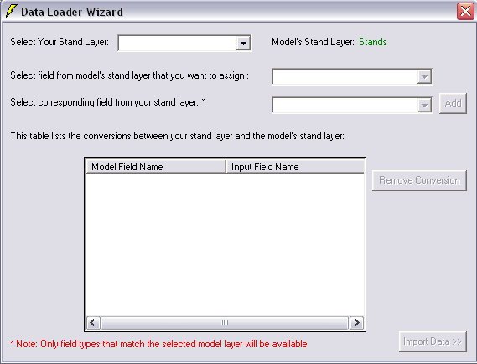

Project Outlines
If you have a shapefile of your proposed projects, follow these steps to load your data into the geodatabase:
1. In ArcCatalog, expand the geodatabase to view the feature classes already in the
geodatabase. If a Habitat_Removal feature class exists, right click on it and change the name of the feature class or choose to delete the feature class entirely. There should not be a Habitat_Removal feature class in the geodatabase in order to proceed to step 2.
2. While still in ArcCatalog, right click on the shapefile containing your project outline(s)
and click Export to Geodatabase (single).
- For output location, choose C:\RCW\Data\RCWDataModel.mdb.
- For output feature class location, enter Habitat_Removal.
- Use the “Field Info (optional)” section of this dialog box to make sure you have a field labeled “Name” that identifies each polygon with a unique project name and that you have a field labeled “Acres” that identifies the acreage of each polygon. If necessary, change the names of the fields that will be in your feature class by typing in the following new field names in the “NewFieldName” column for each field. The fields in the default habitat removal feature class are:
  - Name
  - Acres
  - Shape_Length
  - Shape_Area
- Your dialog box should look similar to the one below before clicking ok.
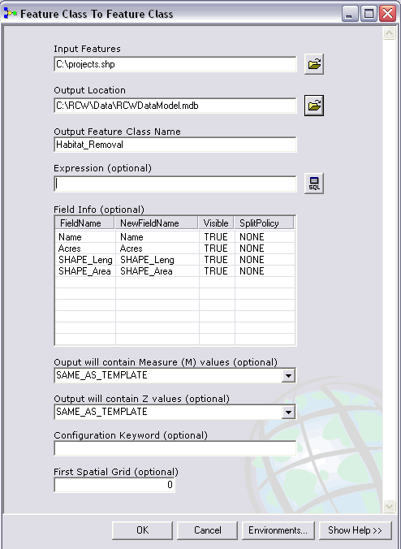

Behind the Scenes: How Stand Scores are Calculated

Recovery Standard
- Stand values for each characteristic in the Recovery Standard are compared to the values that define the scoring ranges for each characteristic in the matrix.
- A stand is assigned a score, 1 through 5, for each characteristic based on the stand’s value, and that score is then stored in the geodatabase.
- Each of these scores is multiplied by the respective characteristic’s weighting factor, a number between 0 and 1.
- These weighted scores are then summed for each stand to produce a final stand score that ranges between 1 and 5.
- The process is then repeated for each stand in the geodatabase.

Standard for Managed Stability
- Stand values for each characteristic in the Standard for Managed Stability are compared to the values that define pass/fail in the matrix.
- A stand is assigned a 1 for those characteristics where it meets the standard and a 0 for those characteristics where it does not. The exception to this rule applies to two characteristics, BA all 10”+ Pines and Total BA. The values for these characteristics are allowed to exceed the upper end of their range (70 and 80, respectively) for these characteristic if the excess in BA is due to large (>14”) trees. That is, the application will look to see if the BA for 4-10” tress is less than 20 (Total BA only) and if the BA for 10-14” trees is less than 40. For Total BA, the application will also look to see if hardwoods greater than 10” contribute no more than 10 BA. If so, the stand will pass Managed Stability for these two characteristics even though the BA exceeds the stated limit.

Behind the Scenes: How Partition Scores are Calculated

Recovery Standard
- The ½ mile foraging partitions are intersected with the stand polygons to create a new polygon feature class, Stands_Clipped.
- The attributes for this new feature class are calculated:
  - Acreage: Each polygon’s area is automatically calculated when the polygon is generated. The application will identify which unit (feet or meters) the feature class is in and use an appropriate conversion factor. The acreage is calculated using this formula (assuming meters):

ClippedStandAcreage = Shape_area (meters ) * 0.00024710436922 (acres/meter)

  - New ID: A unique ID field for the clipped stand.

ClippedStandUID = (Stand)StandID_(Partition)PartitionID

  - The following fields are transferred directly from the original Stand:
StandID
PartitionID
GQFH (score)
  - Total Pine Basal Area
    - The characteristic “Basal Area all 10”+ Pines” is calculated by summing:
(Stand)Total_Stand_PBA = (Stand)PBA_10_14 + (Stand) PBA_14
    - To determine the Total Pine Basal Area for the stand, the
(Stand)Total_Stand_PBA is multiplied by the number of acres in the stand.
  - Contiguity
    - Each clipped stand with a score >=3 is identified as a foraging stand.
    - The application automatically looks for stands within 200 feet of the stand
containing the cluster center. Working outward, each stand is marked “0” (non-contiguous) or 1 (contiguous) based on the distance between the stand and the nearest foraging stand. This method of calculation is marked as “Automated”.
    - The user may manually change the value of contiguity if there is evidence to
support this change in designation. If a stand is marked contiguous based on user input, Clipped Stand Contiguity = 1 and the method is marked as “Manual”.
- Half Mile Forage Partition Attributes are Calculated:
- TotalAcresGQFH: Sum of all the ClippedStandAcreage for stands with GQFH > 0.
- TotalAcresPine: Sum of the ClippedStandAcreage for stands with an overall score >=3.
- TotalGQFHAcresQuarterMile: Sum ClippedStandAcreage if TotalAcresGQFH>0 and store the acreage that falls within the ForagePartition_QuarterMile..
- TotalAcresContiguous: Sum the ClippedStandAcreage within the partition that have a stand score >=3 and are contiguous stand containing the cluster center.
- Half Mile Forage Partition Scores
- The Score Fields are calculated based on comparing the values calculated in 3 to the matrices found in the LKUP_ForageAssess_Default table.
- Score_TotalAcresGQFH:
- Score_TotalAcresPine
- Score_TotalAcresContiguous
- Score_TotalGQFHAcresQuarterMile
- Half Mile Forage Partition Weighted Scores
- The Weighted Score Fields are calculated by multiplying the score by the weighting factor for each characteristic as found in the LKUP_ForageAssess_Default table.
- WeightedScore_TotalAcresGQFH
- WeightedScore_Total_AcresPine
- WeightedScore_TotalAcresContiguous
- WeightedScore_TotalGQFHAcresQuarterMile

Managed Stability
- Additional attributes are added to Stands_Clipped, the new feature class calculated in 1 above:
  - Total Acres of Foraging Habitat in Partition: the sum of the acreages for all stands in the ½ mile partition that pass all the required characteristics at the stand level
  - Total Acres of Foraging Habitat within ¼ mile: the sum of the acreages for those stands in the ¼ mile partition that pass all the required characteristics at the stand level
  - Total Basal Area of Pine >=10” dbh: multiply the number of acres in each stand by it’s corresponding value for BA all 10”+ pines and then sum those totals for each stand in the ½ mile partition
  - # of contiguous foraging acres: the sum of acreages for all stands that pass the Managed Stability standard for each of the stand characteristics AND are contiguous with the cluster center. The application automatically looks for stands within 200 feet of the stand containing the cluster center. Working outward, each stand is marked “0” (non-contiguous) or 1 (contiguous) based on the distance between the stand and its nearest suitable (i.e., passes all the characteristics for stand level) neighbor. This method of calculation is marked as “Automated”. The user may manually change the value of contiguity if there is evidence to support this change in designation. If a stand is marked contiguous based on user input, Clipped Stand Contiguity = 1 and the method is marked as “Manual”.

Source Code
The RCW Analysis Application was written in Visual Basic 6.0 using the ArcGIS Engine Developer Kit. If you chose to view the source code, it can be found under \Tools\Source Code\Source.zip

Quick Reference Guide to Tool Buttons

Pointer
Zoom In
Zoom Out
Pan
Fixed Zoom In
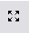Fixed Zoom Out
Back to Previous Extent
Go to Next Extent
Refresh View
Zoom to Full Extent
Identify
Measure Tool
Select Features
Select All
Clear Selected Features
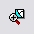Zoom to Selected Features
Foraging Assessment Wizard
Generate Cluster Centers
Create ¼ Mile Partitions
Create ½ Mile Partitions
Draw Project
Select Project
View Reports
Matrix Options
Data Loader

