# Paper Title*(Title)*

Authors Name/s per 1st Affiliation1, Authors Name/s per 2nd Affiliation2  
and Authors Name/s per 3rd Affiliation3*(Author)*

1Dept. name, name of organization, City, Country*(Affiliation)*

Emails of authors of 1st Affiliation*(Email)*

2Dept. name, name of organization, City, Country*(Affiliation)*

Emails of authors of 2nd Affiliation*(Email)*

3Dept. name, name of organization, City, Country*(Affiliation)*

Emails of authors of 3rd Affiliation*(Email)*

This is a template for a proceedings paper, based on a talk or a poster to be presented at the International Meteor Conference 2024. Besides being a template, this document also contains information for the preparation of your paper, complementing the General Instructions on the IMC web pages.*(Abstract)*

## Introduction(Heading 2)

This template provides authors with most of the formatting specifications needed for preparing electronic versions of their papers for IMC 2024. All standard paper components have been specified for three reasons: (1) ease of use when formatting individual papers, (2) automatic compliance to electronic requirements that facilitate the concurrent or later production of electronic products, and (3) conformity of style throughout the conference proceedings. Margins, column widths, line spacing, and type styles are built-in; examples of the type styles are provided throughout this document and are identified in italic type, within parentheses, following the example. Some components, such as multi-leveled equations, graphics, and tables are not prescribed, although the various table text styles are provided. The formatter will need to create these components, incorporating the applicable criteria that follow. *(Normal)*

## Ease of use

### Selecting a template *(Heading 3)*

First, confirm that you have the correct template for your paper size. This template has been tailored for output on the A4 paper size. If you are using US letter-sized paper, please close this file and start a new one with the proper paper size.*(Normal)*

### Maintaining the integrity of the specifications

The template is used to format your paper and style the text. All margins, column widths, line spaces, and text fonts are prescribed; please do not alter them. You may note peculiarities. For example, the head margin in this template measures proportionately more than is customary. This measurement and others are deliberate, using specifications that anticipate your paper as one part of the entire proceedings, and not as an independent document. Please do not revise any of the current designations.

### Prepare your paper before styling

Before you begin to format your paper, first write and save the content as a separate text file. You can use either MS Word or simpler software such a Notepad or Wordpad. Keep your text and graphic files separate until after the text has been formatted and styled. Do not use hard tabs, and limit use of hard returns to only one return at the end of a paragraph: it means that you have to press the key “Enter” after each paragraph or specific elements. Do not add any kind of pagination anywhere in the paper. Do not number text heads: the template will do that for you.

### Some common mistakes

* The word “data” is plural, not singular.
* In American English, commas, semi-/colons, periods, question and exclamation marks are located within quotation marks only when a complete thought or name is cited, such as a title or full quotation. When quotation marks are used, instead of a bold or italic typeface, to highlight a word or phrase, punctuation should appear outside of the quotation marks. A parenthetical phrase or statement at the end of a sentence is punctuated outside of the closing parenthesis (like this). (A parenthetical sentence is punctuated within the parentheses.)
* A graph within a graph is an “inset,” not an “insert.” The word alternatively is preferred to the word “alternately” (unless you really mean something that alternates).
* Do not use the word “essentially” to mean “approximately” or “effectively.”
* In your paper title, if the words “that uses” can accurately replace the word using, capitalize the “u”; if not, keep using lower-cased.
* Be aware of the different meanings of the homophones “affect” and “effect,” “complement” and “compliment,” “discreet” and “discrete,” “principal” and “principle.”
* Do not confuse “imply” and “infer.”
* The prefix “non” is not a word; it should be joined to the word it modifies, usually without a hyphen.
* There is no period after the “et” in the Latin abbreviation “et al.”
* The abbreviation “i.e.” means “that is,” and the abbreviation “e.g.” means “for example.”

## Using the template

After the text edit has been completed, the paper is ready for the template. Duplicate the template file by using the Save As command, and use the naming convention **2024-yourname-original.docx** of your paper. In this newly created file, highlight all of the contents and import your prepared text file. You are now ready to style your paper.

Please, refer to <http://office.microsoft.com/en-us/word-help/style-basics-in-word-HA102647012.aspx>for detailed information about Style basics in Word.

### Equations

The equations are an exception to the prescribed specifications of this template. You will need to determine whether or not your equation should be typed using either the Times New Roman or the Symbol font (please no other font). To create multileveled equations, it may be necessary to treat the equation as a graphic and insert it into the text after your paper is styled.

Number equations consecutively. Equation numbers, within parentheses, are to position flush right, as in (1), using a right tab stop. To make your equations more compact, you may use the solidus ( / ), the exp function, or appropriate exponents. Italicize Roman symbols, but not Greek symbols. Use a long dash rather than a hyphen for a minus sign. Punctuate equations with commas or periods when they are part of a sentence, as in

      

or in

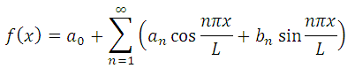 

Note that the equation is centered using a center tab stop. It means you need to press the tab Key before entering your equation to make it center and after to enter the equation number in your hierarchy of equations. Be sure that the symbols in your equation have been defined before or immediately following the equation. Use “(1),” not “Eq. (1)” or “equation (1),” except at the beginning of a sentence: “Equation (1) is ...”

### Figures and tables

Large tables may span across both columns. Table captions should be above the tables.

*Table 1* – Example of Table

|  |  |
| --- | --- |
| Table Head | Column Head |
| Row head | Value |
| Row head | Value |
| Row head | Value |
| Total Row | Total Value |

Place *figures* at the top and bottom of columns. Avoid placing them in the middle of columns. Large *figures* may span across both columns. *Figure* captions should be below the *figures*. Nonbreaking Space can be generated by “Ctrl+Shift+Space”, check the tab “special characters” under “Symbols” under “Insert”. “–“ is generated by “Ctrl+Num –“.

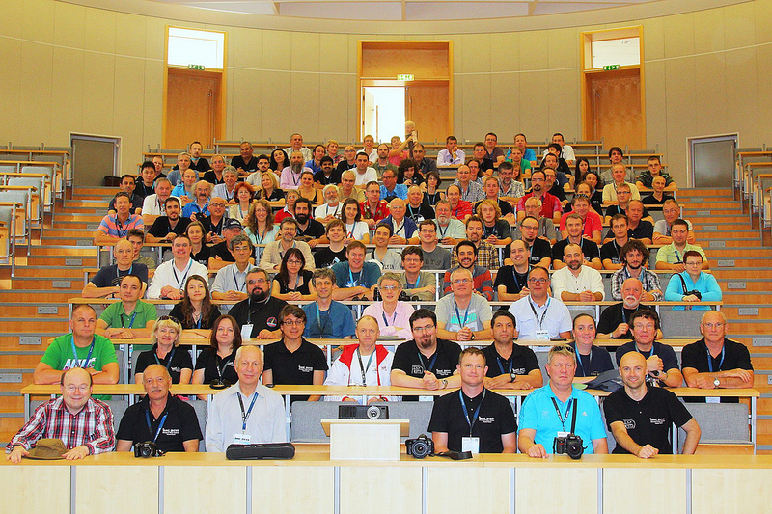

*Figure 1 –* IMC 2013, Poznan, Poland.

### Authors and affiliations

The template is designed so that author affiliations are not repeated each time for multiple authors of the same affiliation. Please keep your affiliations as succinct as possible (for example, do not differentiate among departments of the same organization). This template was designed for three affiliations. If multiple authors share the same affiliation, repeat the reference using multiple superscript numbers.

### Identify the headings

Headings, or heads, are organizational devices that guide the reader through your paper. There are two types: component heads and text heads.

Component heads identify the different components of your paper and are not topically subordinate to each other. Examples include ACKNOWLEDGEMENTS and REFERENCES, and for these, the correct style to use is “Heading 5.” Use “Figure Caption” for your Figure captions, and “Table IMC” for your tables.

Text heads organize the topics on a relational, hierarchical basis. For example, the paper title is the primary text head because all subsequent material relates and elaborates on this one topic. If there are two or more sub-topics, the next level head (uppercase Roman numerals) should be used and, conversely, if there are not at least two sub-topics, then no subheads should be introduced.

## Conclusion

There is no formal page limit, but contributions should be concise. Most contributions fit within 4 pages (as printed in the proceedings’ style), few exceed 6 pages. If you think you need more pages and can justify this, please contact [the 2024 IMC Proceedings editors](mailto:imc2014@imo.net?subject=2014%20Proceedings).

Your contribution must have a purpose, and the text of your contribution should make that clear to the reader. Just a title and a collection of pictures with captions, for example, is not acceptable.

Writing style should be formal and scientific. Avoid mixing in your own emotions in your writing, prefer written language over spoken language, and avoid abbreviations such as “don’t” or “can’t” but write “do not” and “cannot.” Scientific writing furthermore requires that statements not substantiated in your paper are supported by properly cited references. These general principles also apply to papers that are more descriptive by nature.

Use simple language. The larger part of the IMC audience does not have English as native language. Make your paper accessible to as many interested persons as possible by avoiding long sentences, difficult grammatical constructions, or fancy words. Also, avoid needless words. If you can convey a thought in five words rather than ten, go for the former.

##### Acknowledgement *(Heading 5)*

The preferred spelling of the word “acknowledgment” in America is without an “e” after the “g.” Avoid the stilted expression “one of us (R. B. G.) thanks ...”. Instead, try “R. B. G. thanks...”.

##### References

References will follow the following format for books (Rendtel and Arlt, 2011), journals (Asher, 2010) or proceedings (Egorova, 2012).

Number footnotes separately in superscripts. Place the actual footnote at the bottom of the column in which it was cited[1]. References to URL’s tend to be short lived and therefore should be rather mentioned as footnote and not among the references. Do not put footnotes in the reference list.

Always give all authors’ names in the References section; do not use “et al.”in the references.

Papers that have not been published, even if they have been submitted for publication, should be cited as “unpublished”. Capitalize only the first word in a paper title, except for proper nouns and element symbols.

For papers published in translation journals, please give the English citation first, followed by the original foreign-language citation.

Check your references with the ADS abstract service[2], incomplete and incorrect references require a lot of time from Proceeding editors for corrections.

Asher D. (2010). “International Meteor Conference 2010, September 16–19, Armagh, UK”. *WGN, Journal of the IMO*, **38**, 4–5. (Reference)

Egorova L. (2012). “Effect of ‘terminal explosion’”. In Gyssens M. and Roggemans P., editors, *Proceedings of the International Meteor Conference*, Sibiu, Romania, 15–18 September 2011. IMO, pages 19–21.

Gritsevich M., Lyytinen E., Kohout T., Moilanen J., Midtskogen S., Kruglikov N., Ischenko A., Yakovlev G., Grokhovsky V., Haloda J., Halodova P., Lupovka V., Dmitriev V., Peltoniemi J., Aikkila A., Taavitsainen A., Lauanne J., Pekkola M., Kokko P., Lahtinen P. (2014b). “Analysis of the bright fireball over Kola peninsula on April 19, 2014 followed by successful meteorite recovery campaign”. *Meteoritics and Planetary Science*, **49**, A143.

Rendtel J. and Arlt R., editors (2011). Handbook for Meteor Observers. Third edition. IMO.

1. This is a foot note.
2. <http://www.adsabs.harvard.edu/>