Considering that I am using a MySQL database and EclipseLink as a persistence provider, to have my EJB working on a remote GlassFish server, I had to:

1. Include in the lib directory of GlassFish the jars for MySQL and EclipseLink:

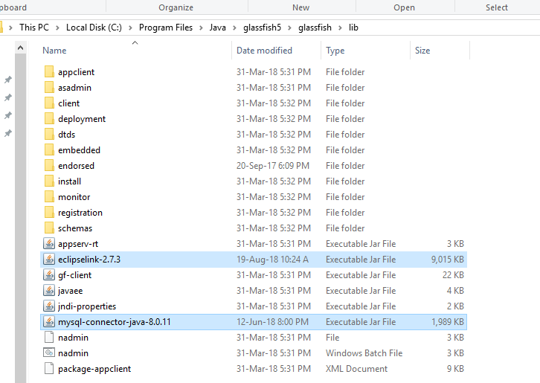

1. Create in GlassFish, under Resources/JDBC/JDBC Resources, a connection pool (I named it MySQLPool), pointing to the MySQL instance I am working with:

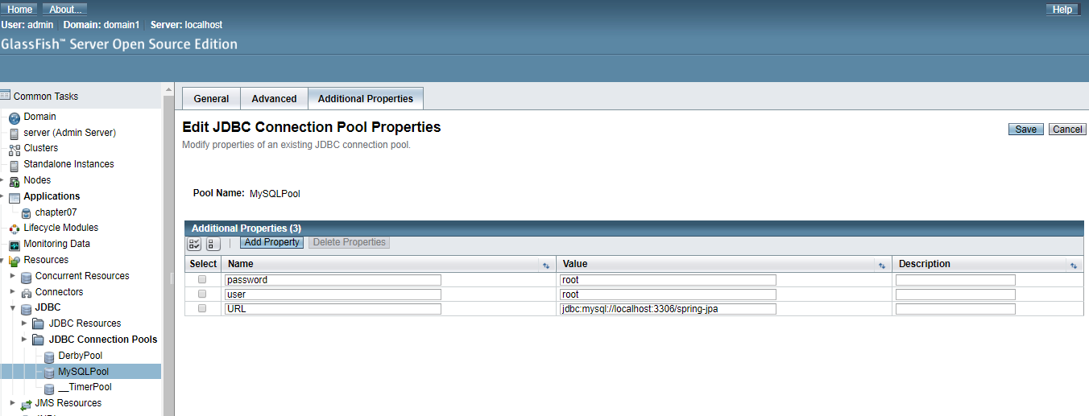

1. Create in GlassFish, under Resources/JDBC/JDBC Resources, a JDBC Resource, as here specified:

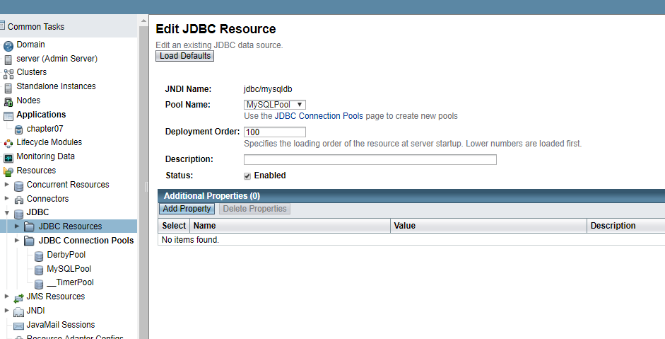

Please note that here the JNDI Name has to be in line with what I specified in the persistence.xml (java:app/jdbc/mysqldb) and that the resource is referring to the pool name created in the previous step.