MobileHCI 2011 Conference Proceedings Template
Z. Khalapyan¹, H. Tangmunarunkit², J. Selsky², E. Sakabu¹, R. Rocchio¹, D. Estrin²
¹Office of Information Technology, UCLA; ²Computer Science Department, UCLA
University of California, Los Angeles, CA
zkhalapyan|sakabu|rrocchio@oit.ucla.edu, hongsudt|selsky|estrin@cens.ucla.edu

ABSTRACT
Advances in mobile devices and web technologies have enabled users to pull and display online data from the cloud almost anywhere and anytime. At the same time, the same technologies can enable phone users to observe, collect and publish personal or community-related data to the cloud. In this paper, we describe our web-based mobile application, Mobile Web ohmage Client (MWoC), that can be used to record data entered by the user anywhere and anytime. The data will be uploaded and published to ohmage---an open-source, mobile to web platform that records, analyzes, and visualize both human-in-the-loop data, and continuous data streams passively collected from mobile phones. MWoC is a lightweight single-source and platform-independent mobile application and therefore can be run on a broader platforms compared to the more comprehensive ohmage android application. MWoC utilizes the Mobile Web Framework (MWF) for a robust cross-platform presentation and PhoneGap for accessing native devices.

Author Keywords
Mobile web application. Data collection. Experience sample. Personal data stream. Participatory Sensing.

ACM Classification Keywords
D.0. Software: General.

General Terms
Design, Documentation, Management, Experimentation.

INTRODUCTION

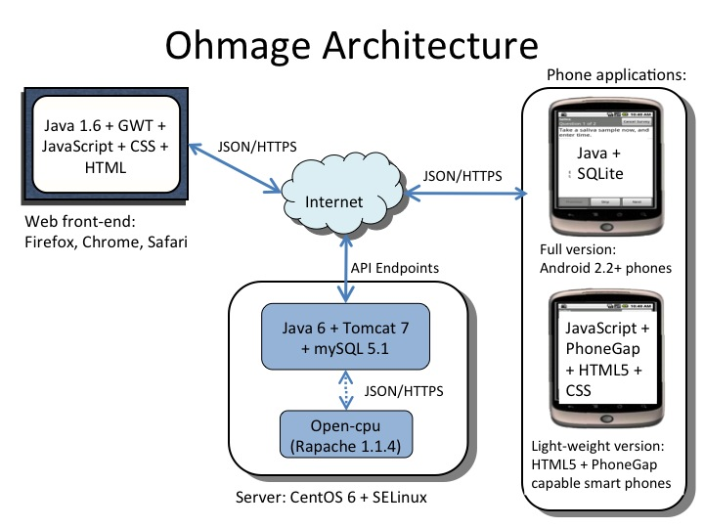
Advances in smart-phone technologies and the ubiquity of smart-phones enable smart-phones to be increasingly used as tools to observe and understand the patterns, habits and environments of individuals and communities. Ohmage[1] is an open-source, mobile to web platform that records, analyze, and visualize data from distributed mobile devices. Ohmage supports two data stream types: 1) prompted experience samples which are small scriptable survey forms for users to enter data in the field, i.e., in-the-moment experience; and 2) continuous streams of data passively collected from sensors or applications on-board the mobile device (e.g., location traces).
Ohmage users can create a data campaign which is a collection of surveys to be answered by participants. Newly defined campaigns are uploaded via a web browser and automatically become available for participation. To participate, a user login to ohmage on the phone and downloads the particular campaign(s) in which they will participate. Surveys can be initiated by the user or prompted via time/location reminders. All submitted survey responses, as well as passive continuous data streams are automatically time-stamped, ego-coded and uploaded to the ohmage server for further analysis and visualization. Via web browsers, users are able to access and visualize collected data and their analyses in real-time. Ohmage has been used in multiple behavioral research studies[1], and as a pedagogical tool in high schools [2].

Mobile web ohmage client (MwoC)

Requirements
The first version of MWoC is designed to be light-weighted and focuses only on limited features on the phone described below.
1. Authentication. Once a user login, MWoC will authenticate the user with the ohmage server. Upon successful authentication, a long-term token will be stored locally for subsequent server communication. All user data including the token will be deleted after the user logs out.
Figure 1. Ohmage Architecture shows the ohmage architecture. The server provides a RESTful APIs over the secure HTTPS protocol. All API payloads are encoded in the JSON format. In this paper, we will focus primarily on the light-weight Mobile Web ohmage Client (MwoC).

2. Data capture of prompted experience samples. Users interacts with MWoC to browse through a set of available campaigns and download ones that they want to participate. The downloaded campaigns will be stored locally on the phone for faster responsiveness and offline access. MWoC renders appropriate sequence of prompted questions based on their types (e.g. menus, number, time, free text, image, etc.) and conditions specified in the campaign XML definition. Upon survey completion, all survey responses will be time-stamped, geo-coded and uploaded to the ohmage server. During network outage, it will store survey responses locally on the phone and will try to automatically upload the data upon future launching of MWoC. Users can also perform manual upload of the data.
3. Time-based reminder. MWoC allows users to configure time-based reminders to be triggered during specific time and condition. Upon reaching triggered criteria a notification in the form of ring tone or vibration will be generated to remind users to complete their survey(s).

Design
To support single-source and platform-independent mobile application, MWoC is developed based on web-based technologies (i.e., HTML5, CSS, JavaScript), and PhoneGap[3] which is a framework that allows mobile web application to interact with native devices/applications. MWoC consists of three different components: Presentation, Business Logic, and PhoneGap integration.
1. Presentation. MWoC utilizes the Mobile Web Framework (MWF)[4] for unified mobile-based presentation. MWF is a cross-platform web framework that provides a robust presentation layer for web applications to define a single set of markup optimized for HTML5 capable mobile devices. To provide offline support, the CSS and JavaScript files provided by MWF have been extracted for individual phones and are stored locally on the device using PhoneGap. MWoC currently utilizes MWF for menu lists, buttons, double buttons, page headers/footers along with other mobile optimized UI components. DOM elements are created to resemble the MWF structure to allow flexible models for rendering list of surveys, prompts and other views.
2. Business Logic. The business logic is implemented in JavaScript. It utilizes HTML5 local storage to store data persisted across multiple pages e.g. campaign list, survey responses, etc.; PhoneGap integration to interact with native devices; and AJAX communication to interconnect with the ohmage server. The initial campaign configuration in the XML format is converted into the JSON format and stored in the localStorage. For greater flexibility, reusability, and manageability, each object such as individual campaign, a single survey, etc. is modeled with a JavaScript class that provides certain abstracted functionality and avoid the use of raw data.
3. PhoneGap Integration. PhoneGap is a HTML5 application platform that allows web-based applications to interact with the mobile phone’s native applications and devices such as camera, file system, geolocation, accelerometer, etc. This interaction is provided through a common abstracted JavaScript based API layer, along with ready-to-deploy package based on different platforms. We utilize PhoneGap APIs for image capture and GPS location without having to write platforming dependent programming language.

Discussion
Running web pages within native containers are noticeably less responsive than actual native applications. This is due to the touch event handling on certain devices that add a delay (e.g. 300 ms) before invoking the click event handler. To decrease this delay, instead of attaching events to the click events, all user interactions should be attached to the touch events such as onTouchUp and onTouchDown. Although this will adds overhead to the source code, it produces much more responsive user interfaces.
Another issue that we encountered is the automatic data upload. This functionality is not currently supported due to restrictions on background processes by some platforms such as iOS. Moreover, the current implementation of PhoneGap lacks support for atomic operation for locking data that is shared between the native code and the client side application. We will explore mechanisms such as piggybacking on allowed background events to perform automatic data upload.

Conclusion
MWoC is an alternative to its ohmage android counterpart suited for studies that focuses on gathering experienced sample data. MWoC will be deployed in a behavioral research study of health and HIV-transmission risk behaviors of gay men and used as an option in high schools for data collection and analysis lessons [4].

ACKNOWLEDGMENTS
We thank UCLA CENS and OIT for providing the opportunity for development and realization of Mobile Web ohmage Client.

REFERENCES
- J. Hicks, N. Ramanathan, H. Falaki, B. Longstaff, K. Parameswaran, M. Monibi, D. Kim, J. Selsky, J. Jenkin, H. Tangmunarunkit, D. Estring. ohmage: An Open Mobile System for Activity and Experience Sampling. Centers or Embedded Network Sensing Center Technical Report #100. www.ohmage.org.
- www.mobilizingcs.org
- phonegap.com
- mwf.ucla.edu

