Publishing react app to github pages:

<https://dev.to/yuribenjamin/how-to-deploy-react-app-in-github-pages-2a1f>

TLDR:  
1. npm install gh-pages --save-dev

2. gh-pages -d build (or add it to scripts in package.json under scripts)

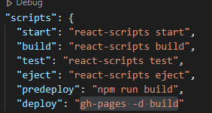

3. npm run deploy (to deploy. If you make updates, just run that alone. Optional to push code to master)

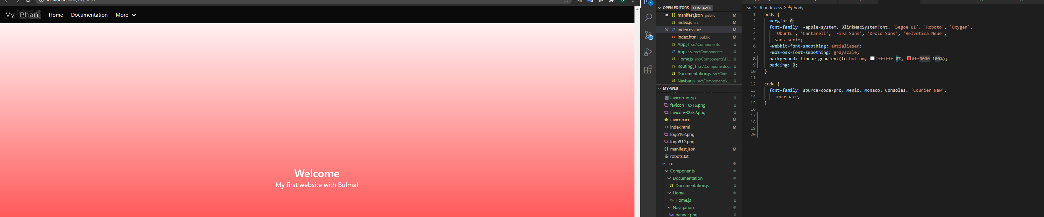

Maybe the navigation bar is taking up some of the gradient home page.. The height certainly is close the whitebox height.

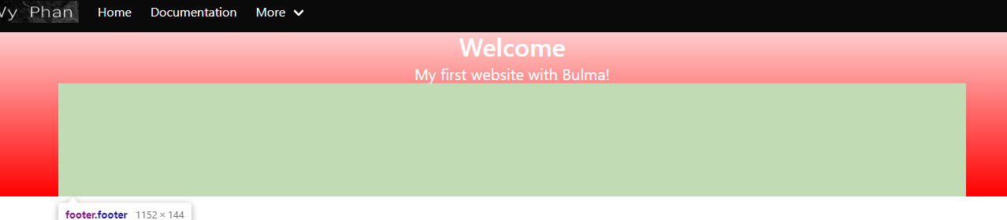

This shows that my content is simply not taking enough space when using the container class from Bulma.

Adding the height:100vh fixed it

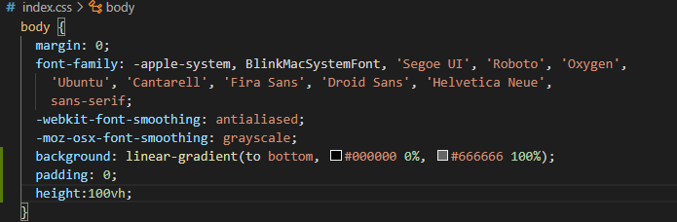

<https://stackoverflow.com/questions/47248090/react-force-background-color-full-height>

Had to remove and re-add (multiple times and refresh the page to see the changes) the import css file in index.js after changing the bulma.css file (in node_modules/bulma/css. Learned that min.css files are the same as css but the white space is removed to make it load faster.

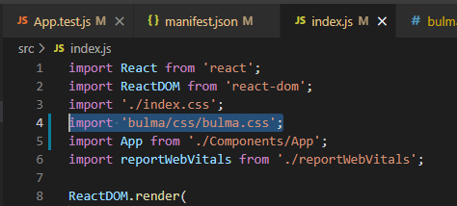

Changing the nav bar hover was weird. There’s 2 similar css listings. The one listed with non-black is the one I needed to edit:

(Looking for navbar-item:hover) <https://www.geeksforgeeks.org/what-is-greater-than-sign-selector-in-css/>

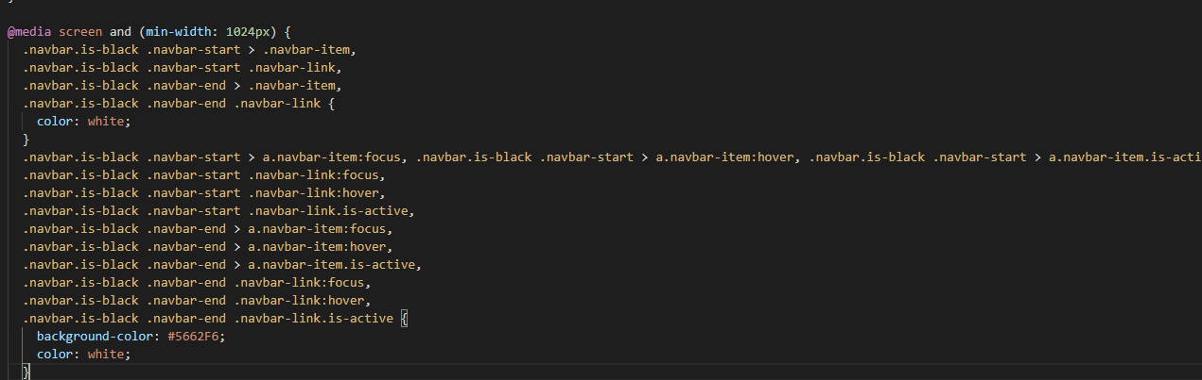

Other one that looks similar:

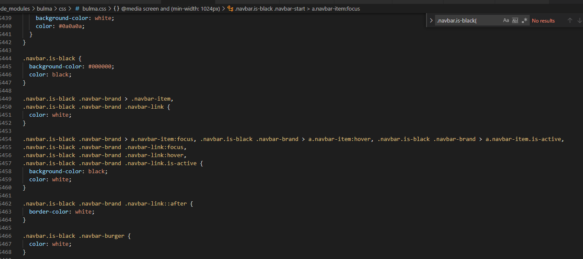

<https://reactjs.org/docs/hooks-state.html>

Tried collecting route path name to maybe work on active tab with useLocation from react-router-dom:  
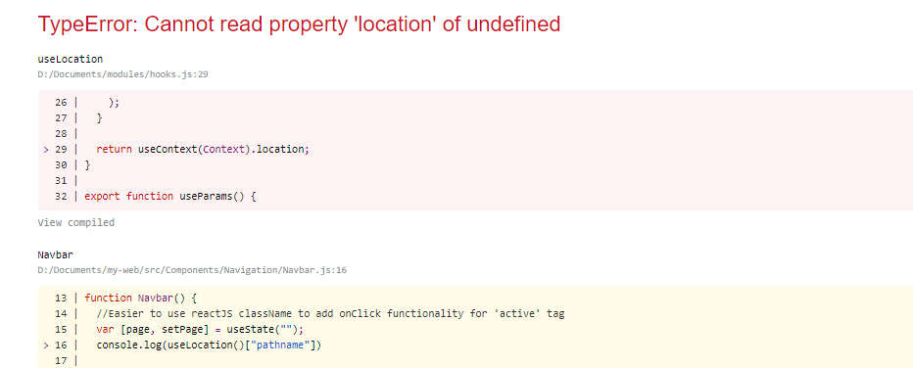

Some tags are self-enclosing like img tag:  


<https://www.pluralsight.com/guides/react-inline-styling>

[https://reactjs.org/#a-simple-component](https://reactjs.org/%23a-simple-component)

Functional vs Object react:

<https://betterprogramming.pub/react-class-vs-functional-components-2327c7324bdd>

More information on functional components:

<https://www.geeksforgeeks.org/reactjs-functional-components/>

Converting functional component for navbar (to later allow an active clock and maybe can do the active tab):  
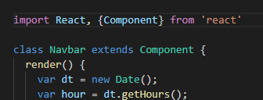 Requires to import React and Component

And to use the render() {<function stuff>}

Use className (React property) else complaints:  
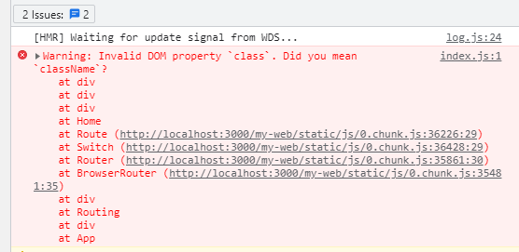

Class does work though.

Had to quote background-image (the minus symbol is an operator):

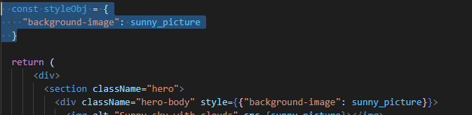

Turns out background-image in react is backgroundImage…:

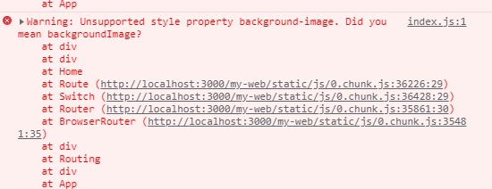

Beware the syntax! So the problem was because backgroundImage expects a url:  
<https://reactgo.com/react-background-image/>

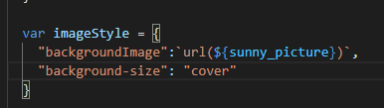

Using the $ allows you to use variables you imported.

And the ` marks are needed… not sure why. Can’t use single quotes ‘ nor double “.

This container placement in routing is making it centered horizontally (may want to remove):

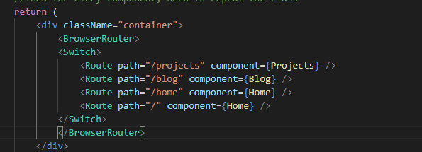



One way to make gradient colored text is making a gradient background and clipping from it:  
<https://cssgradient.io/blog/css-gradient-text/>

Apparently there are updated css names:

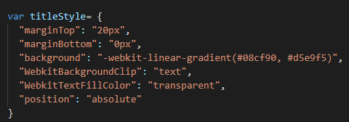

Instead of -webkit-background-clip for instance, it’s all one word as shown above.

Centered sun image when using hierarchy of hero:

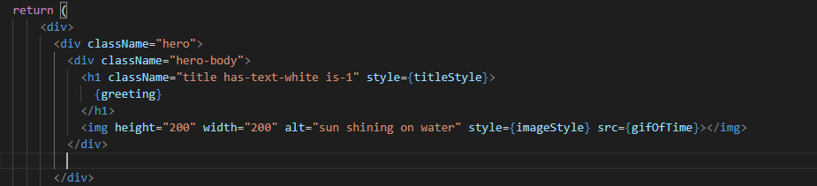Did not work when you try to stuff the first div tag with hero-body with hero.

To download a file… Can’t find documentation on the download aspect of react router’s ‘link’

<https://stackoverflow.com/questions/53424369/downloading-a-file-from-expressr-with-react-router>

Nesting routes or sub-routing:

<https://reactrouter.com/web/example/nesting>

Using “:name” does allow for sub-routing:

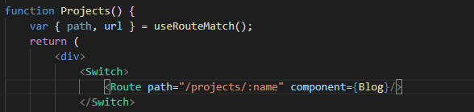

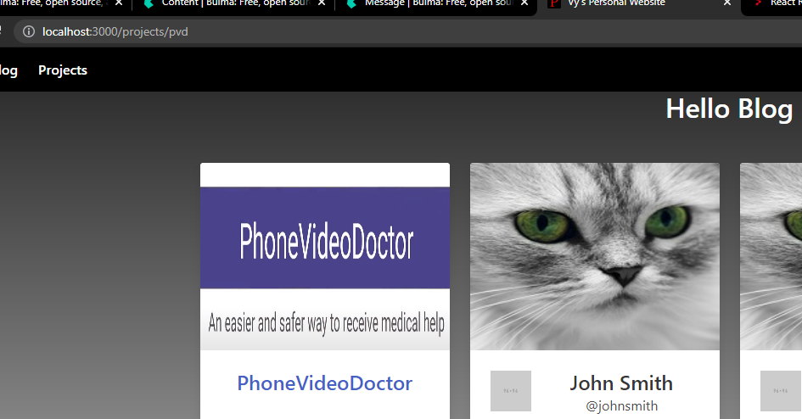

But if you use <a> tags, when clicking on home, you will get localhost:300/projects/home and it will not redirect you to Home component.. Solution is to wrap the App with Browser router:

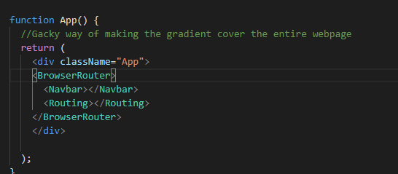

So you can use the Link component (from react-router-dom) in components. Link components need to be in BrowserRouter component.

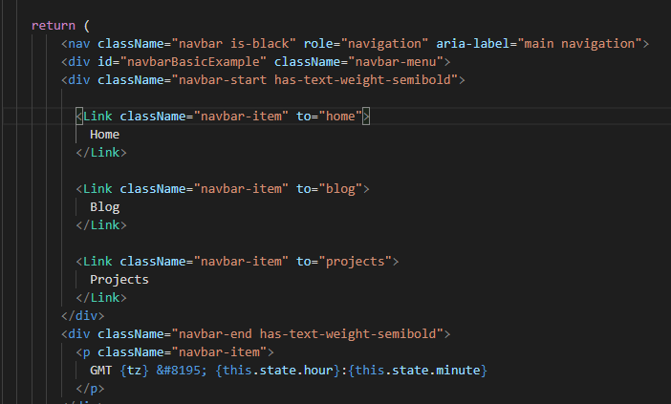

By the way, can export when defining function  


Protect routing from nesting with “/” (Relative urls vs absolute):

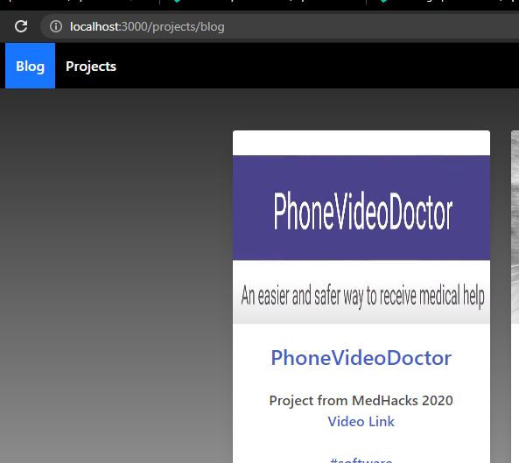

We did this for home:

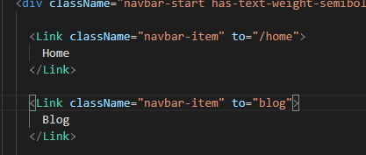

Clicking on it:

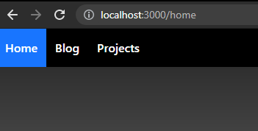

Using ‘path’ instead of ‘to’ in Route helps keep it consistent when rendering specifically /projects:

Bad:





Good:

\

Can pass props to child components:

<https://stackoverflow.com/questions/58201897/how-to-pass-data-between-functional-components-in-react>

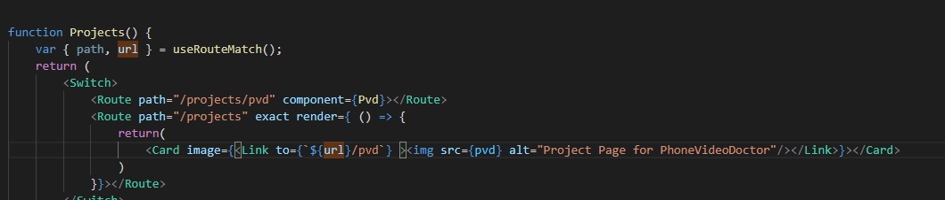

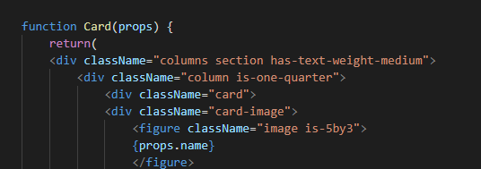

And these props as you can see can contain jsx.

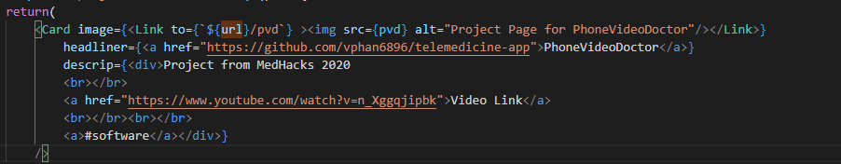

After deploying:

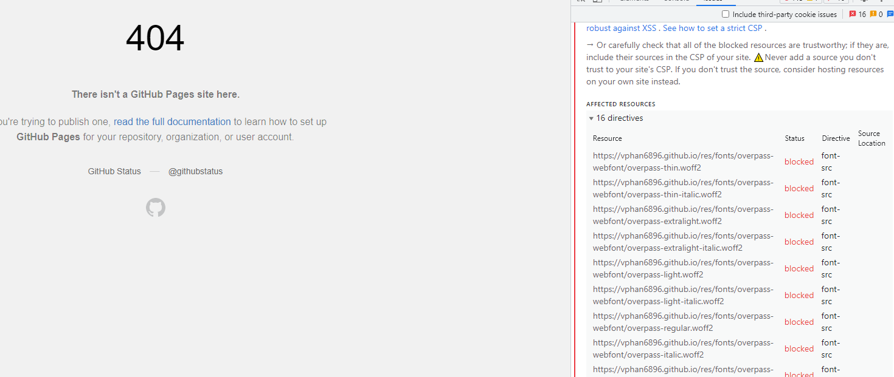

Network tab for chrome:

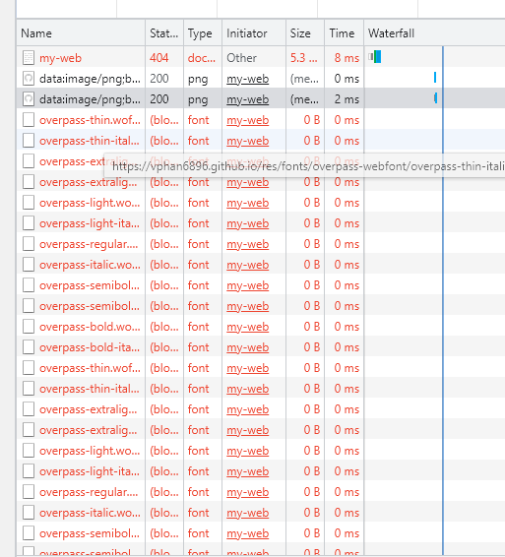

<https://stackoverflow.com/questions/45366744/refused-to-load-the-font-datafont-woff-it-violates-the-following-content>

<https://securityheaders.com/>

<https://stackoverflow.com/questions/30280370/how-does-content-security-policy-csp-work>

To use Github Pages, you need to make it public access:

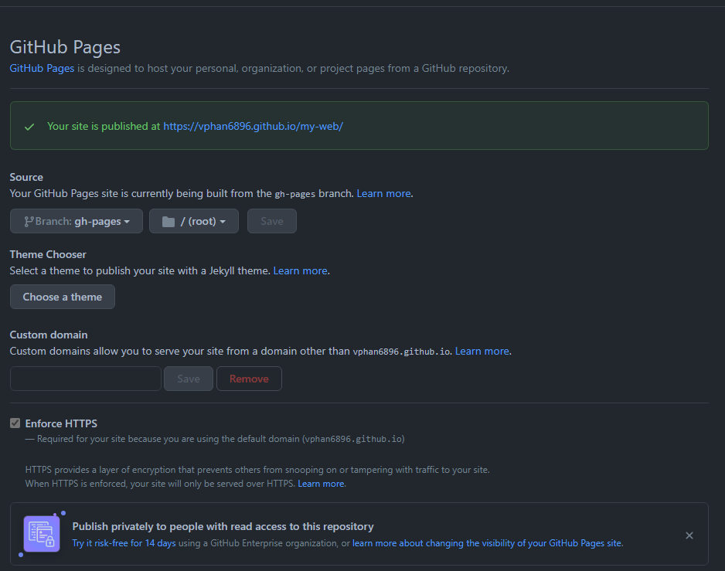

Finally.