**LOGISTIC APP DOCUMENT**

**ROOT USER**

1. **Admin Dashboard**

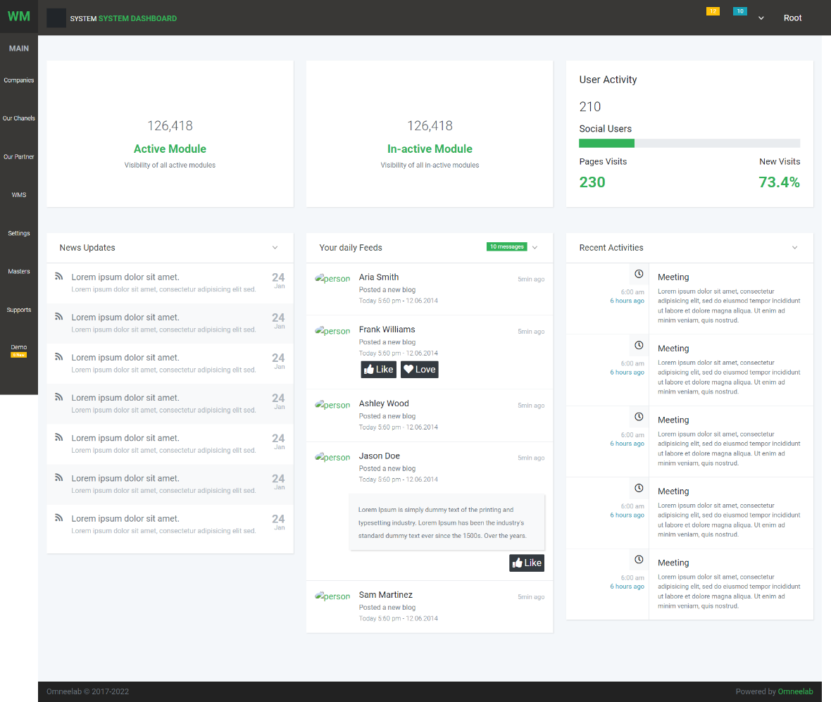

In this dashboard, we will show the companies' consolidated data.

User Profile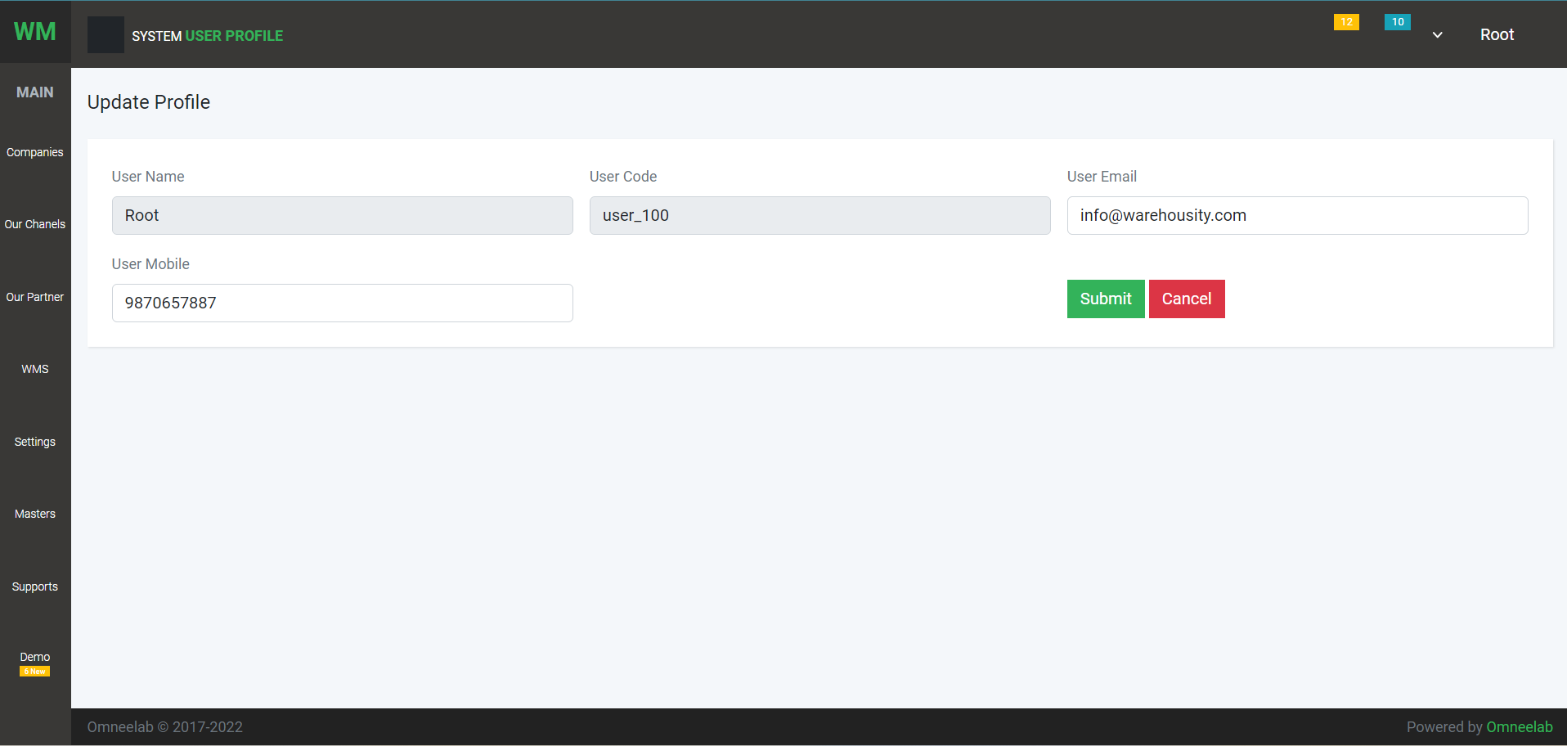: User can update profile

Change Password: User can create change password

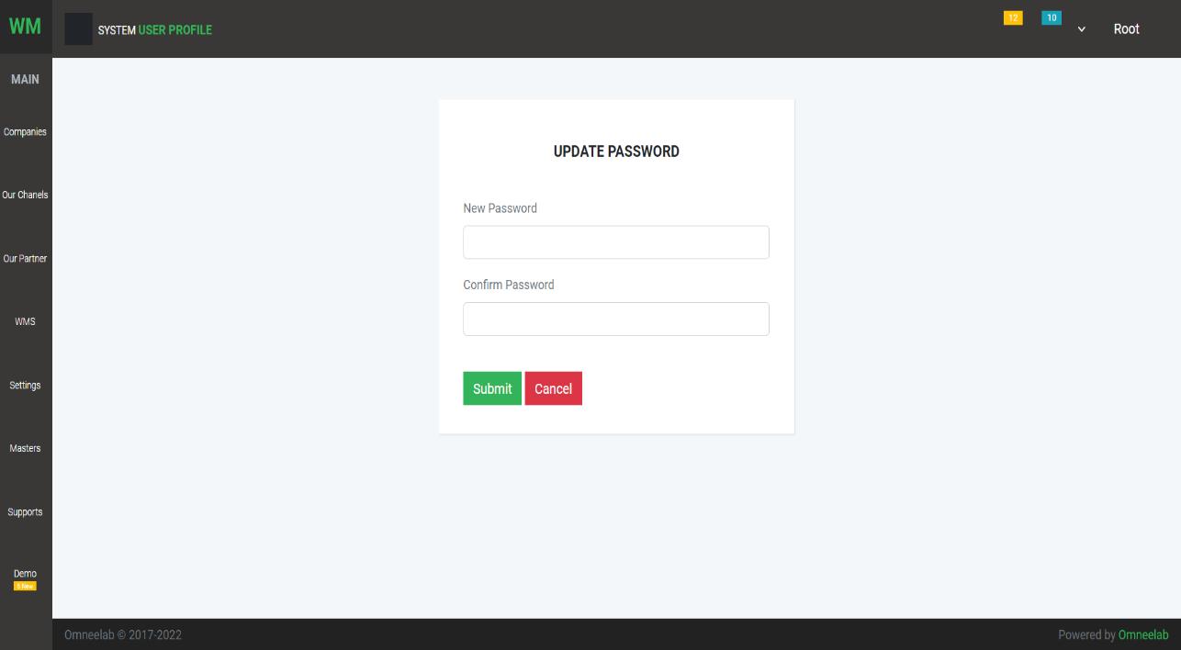

1. **Company List**
2. List of all companies that are resister in our system

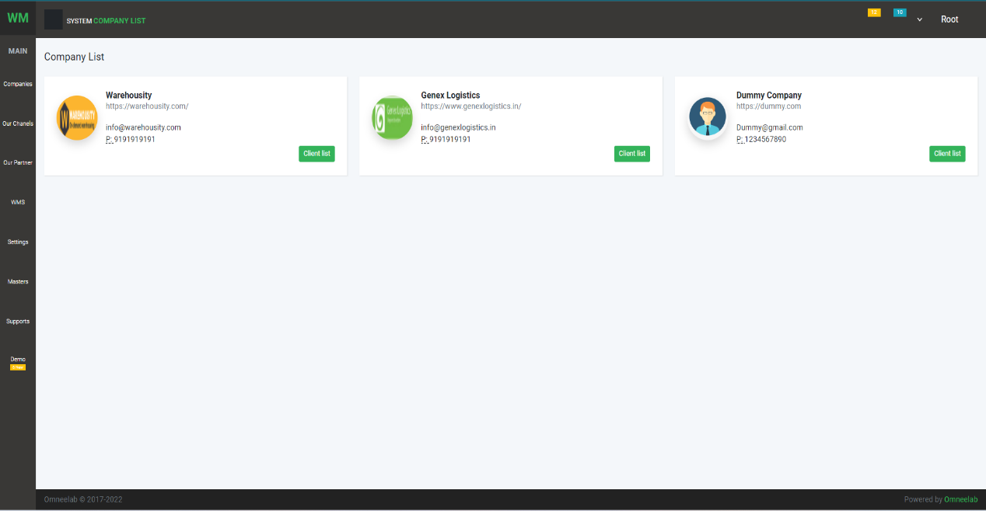

By clicking on the company name user can see the company's detail

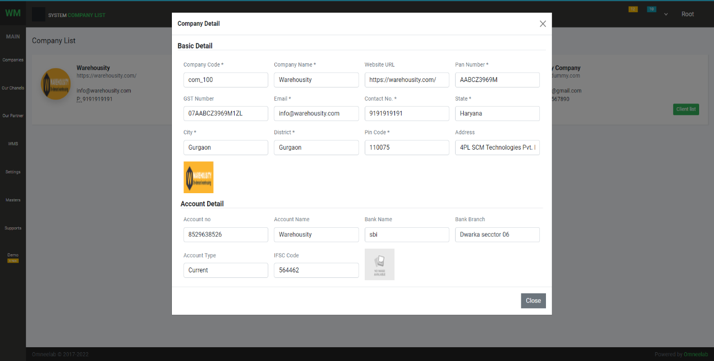

1. 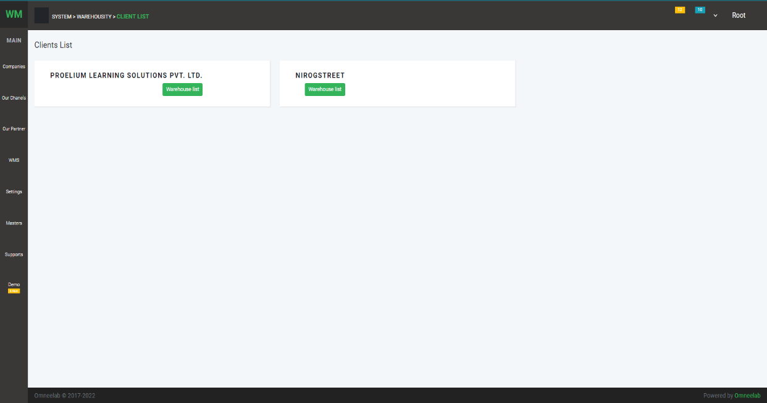Client List**:**
2. 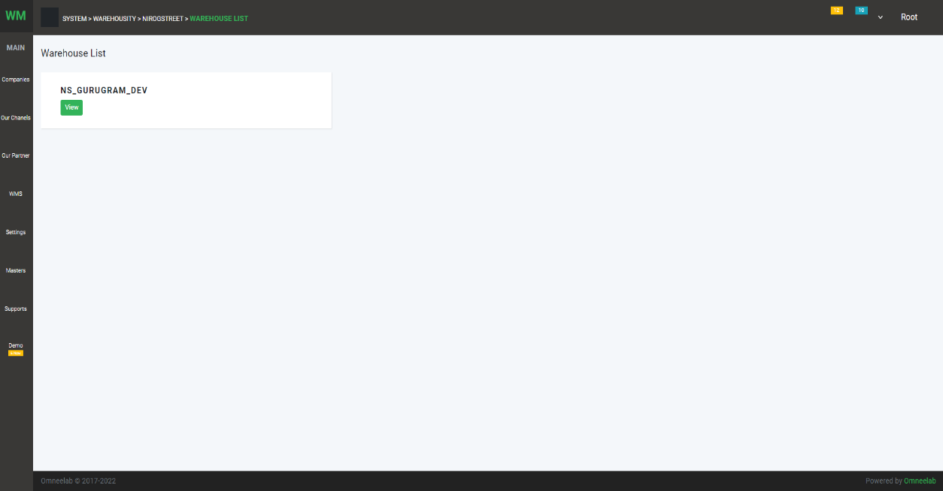Warehouse List:
3. **Our Channels :**

* 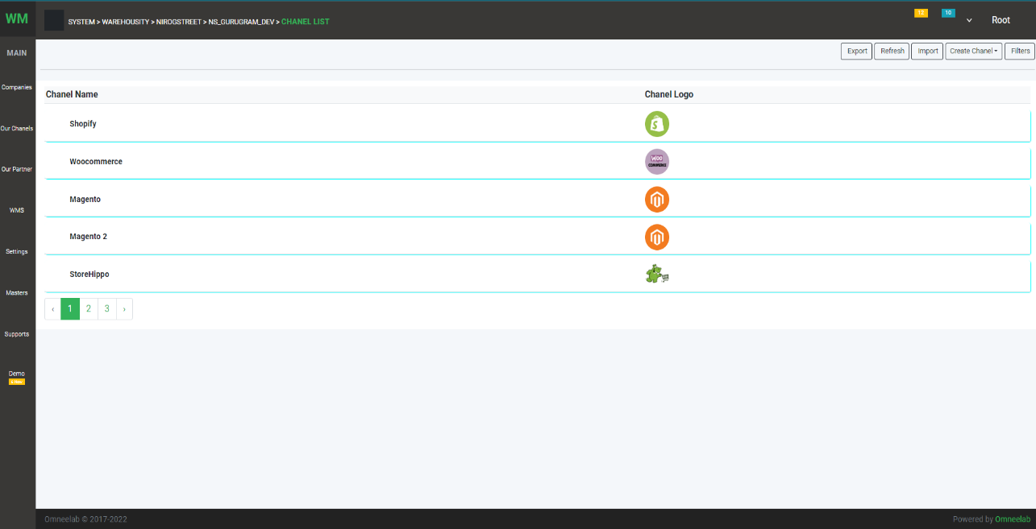List Page

On this page, user can see the channel list

* 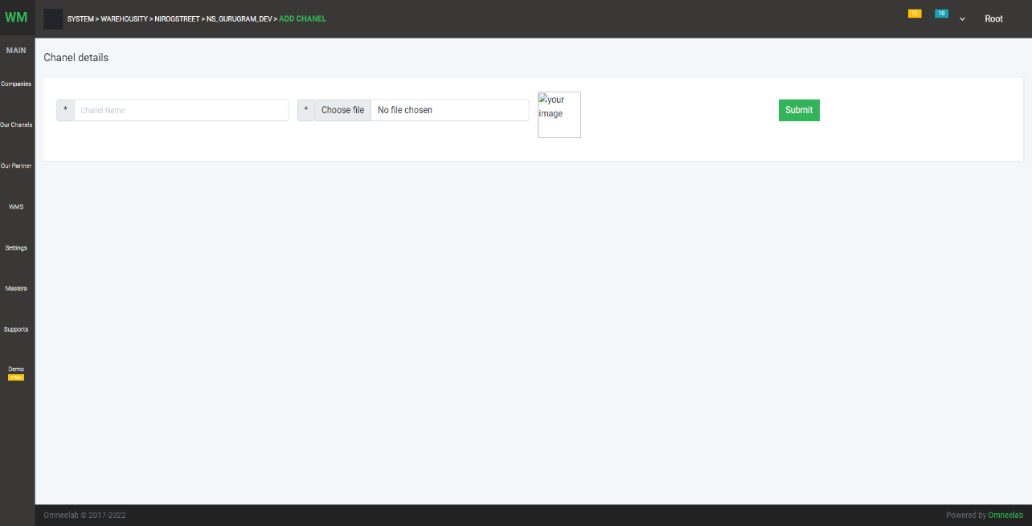Create Page

On this page, user can create the channel

1. **Our Partners:**

Partner List

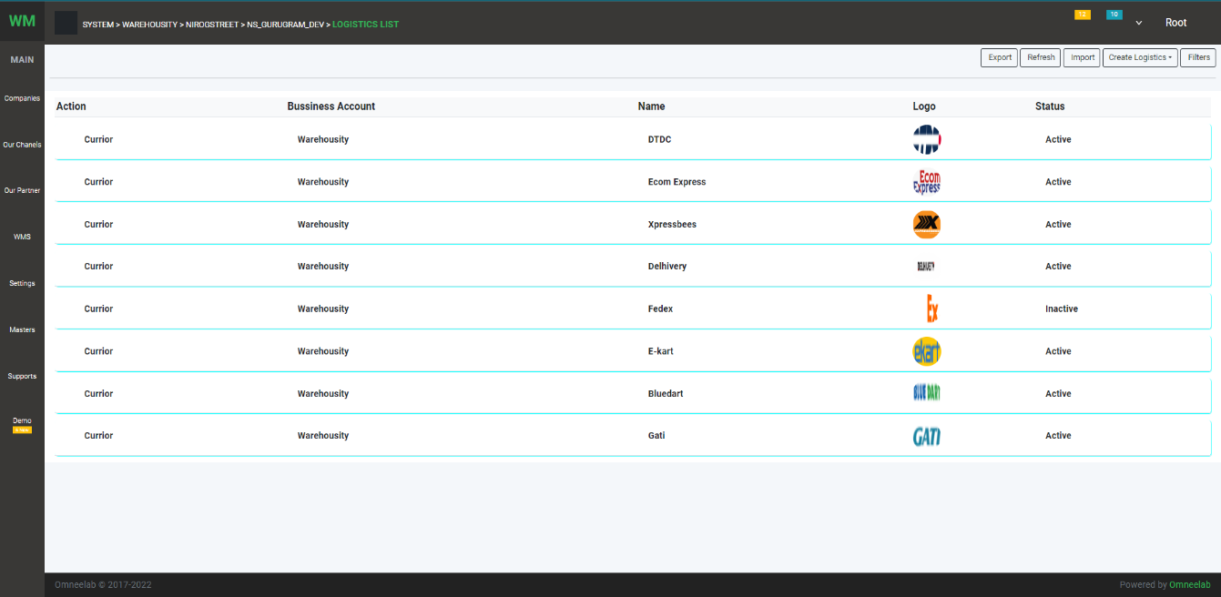

On this page, the User can see the list of partners List

Create Partner

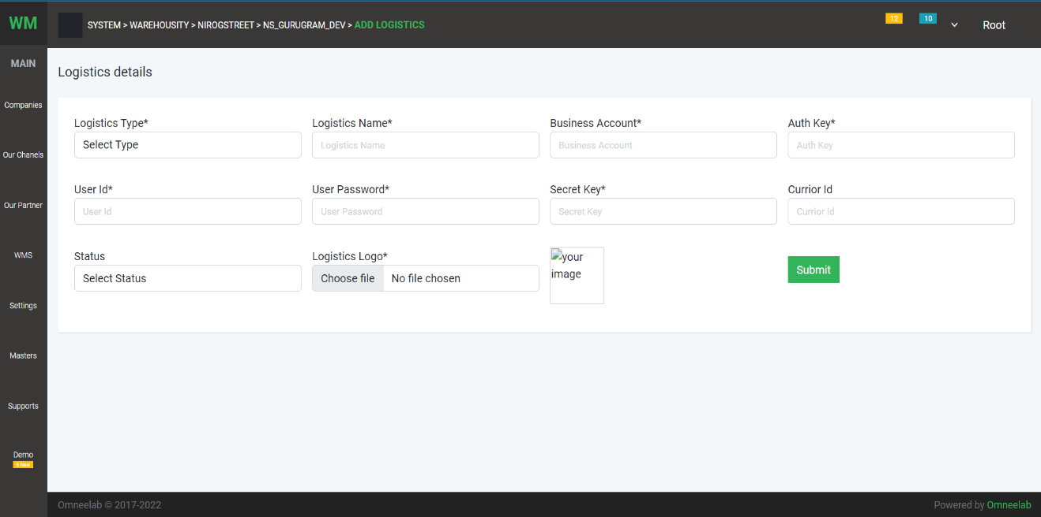

1. **WMS:**

List of wms, erps

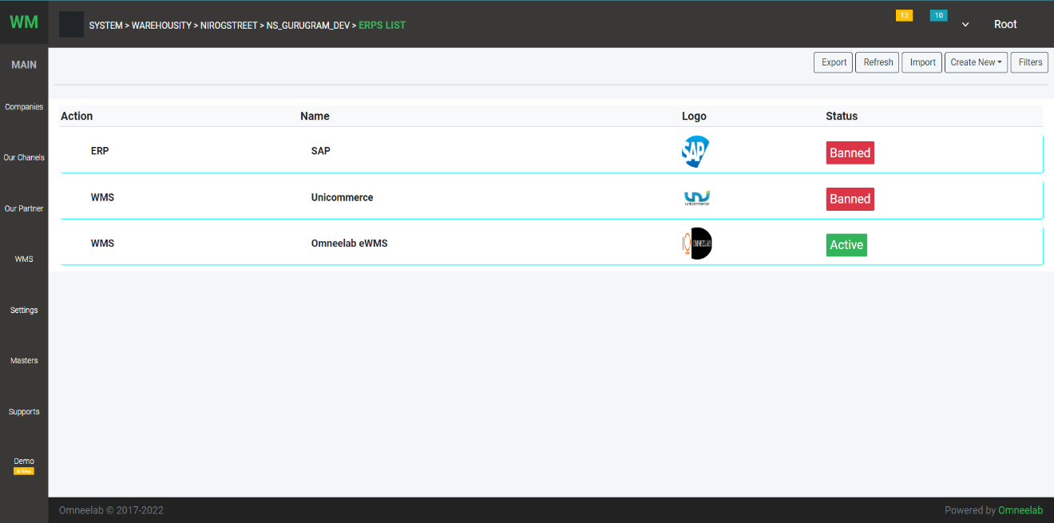

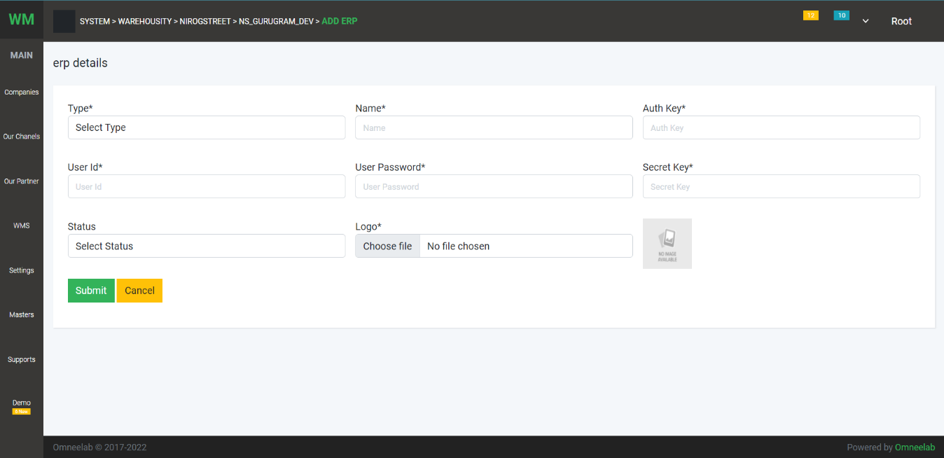 Create page:

1. **Setting:**

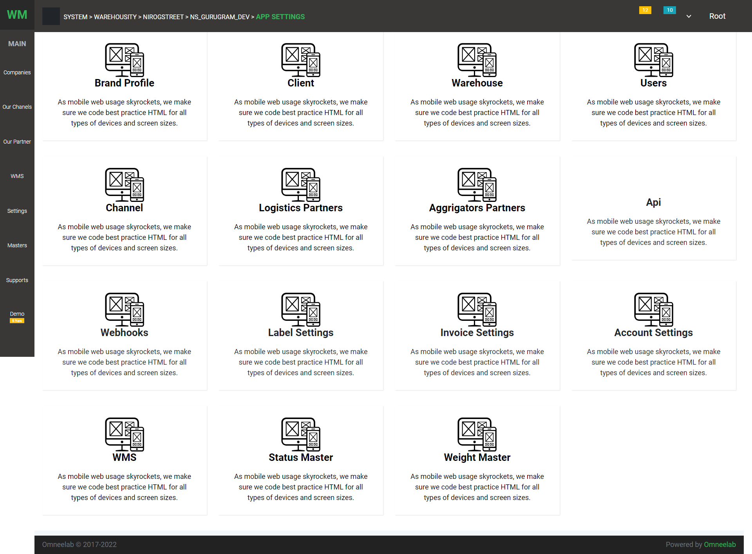List of Options:

1. Brand Profile: The user can create and view the company.

* List page:

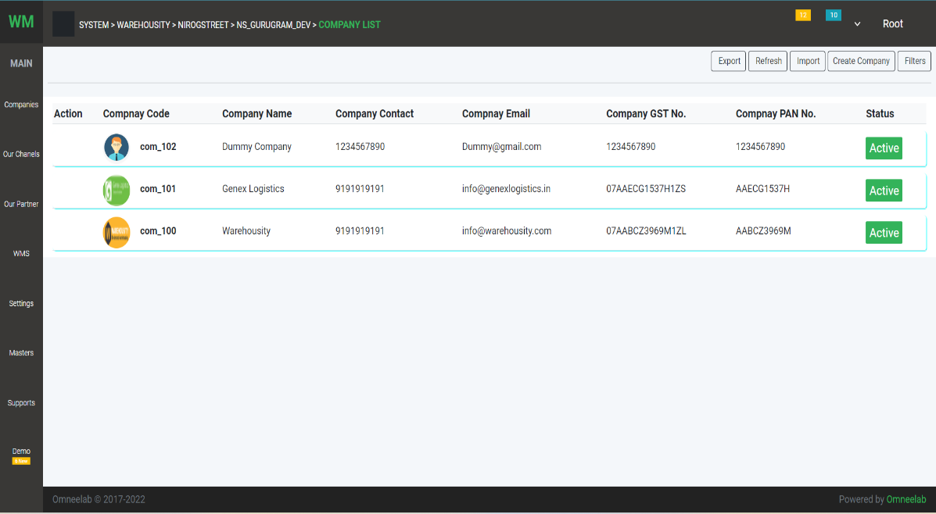

On this page, a list of all companies that are registered with **LogistcsApp**

* Create Page

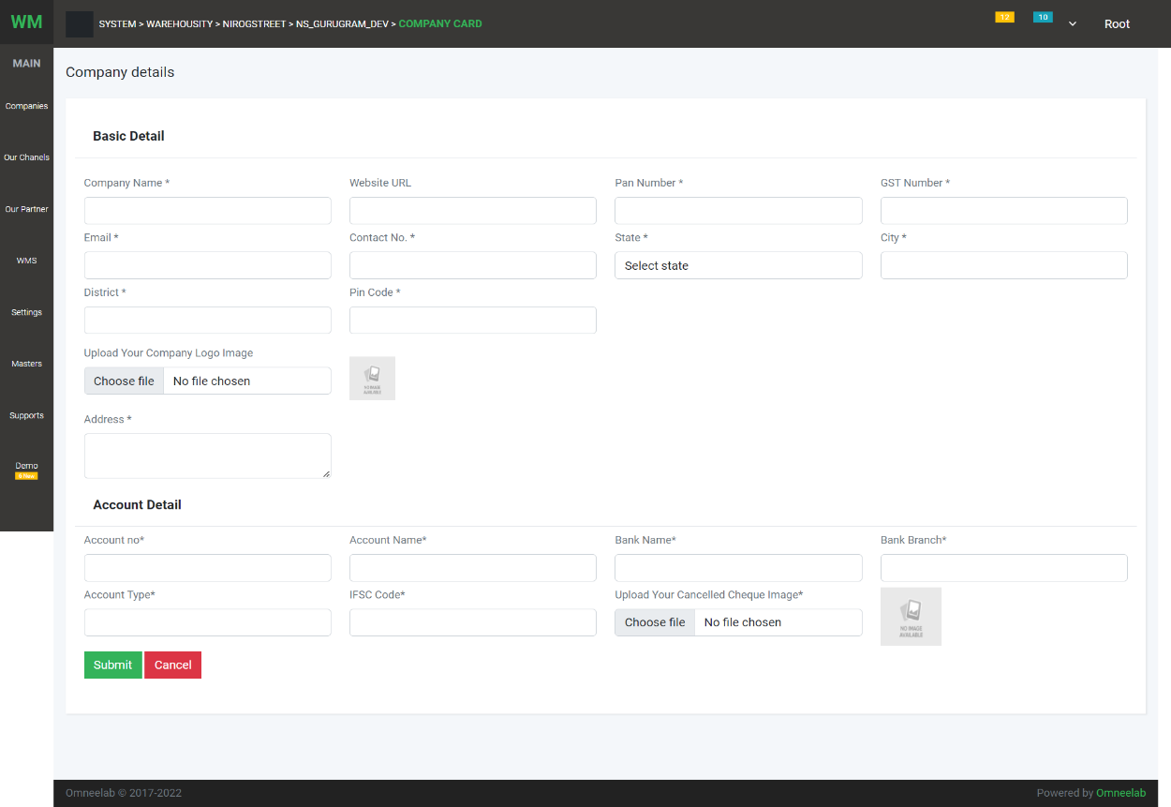

1. Client list: User can create client and see list of all clients

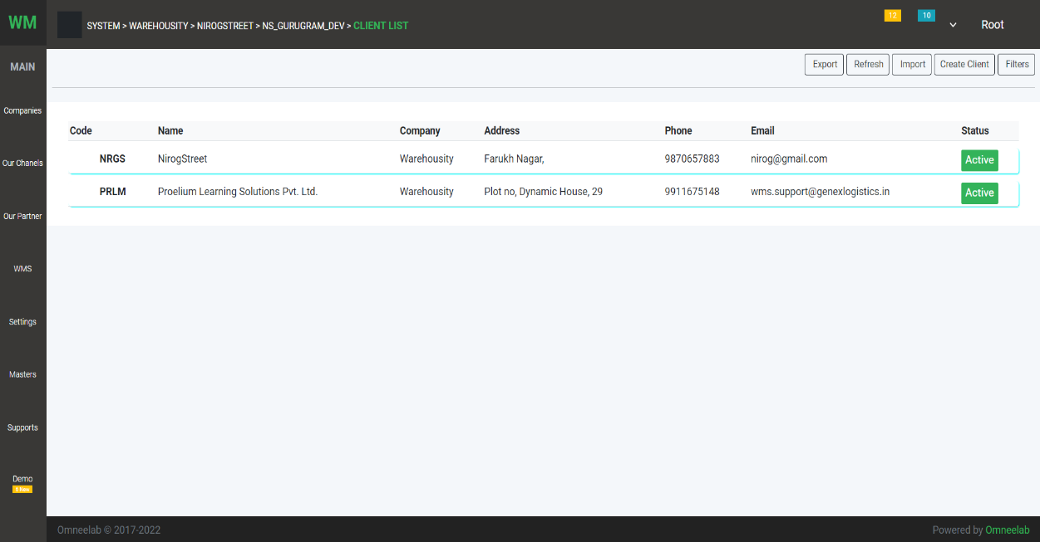 List page:

Create page

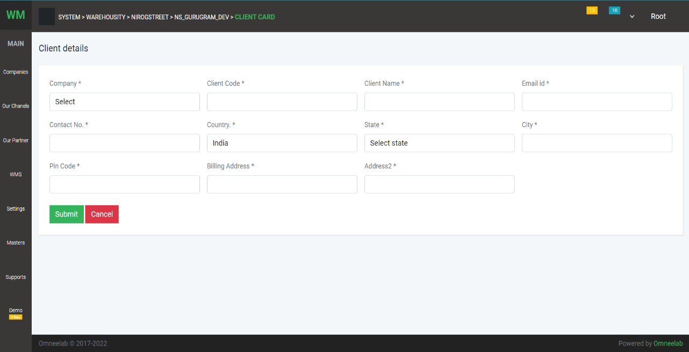

1. Warehouse: The user can create warehouse and see the list

List page

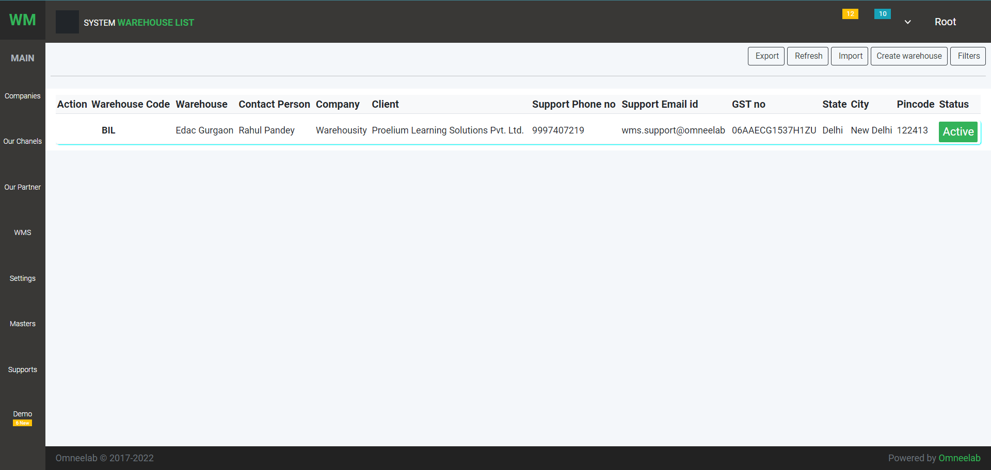

Create Page

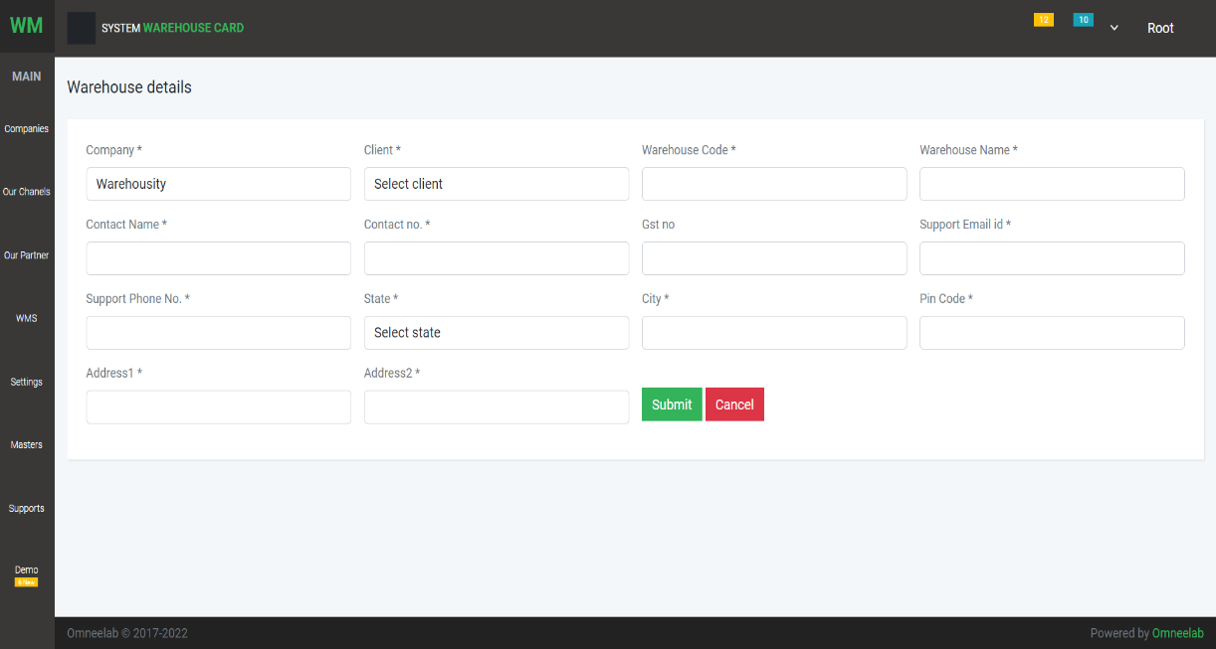

1. User List: The user can add root user, company user, client user, and warehouse user

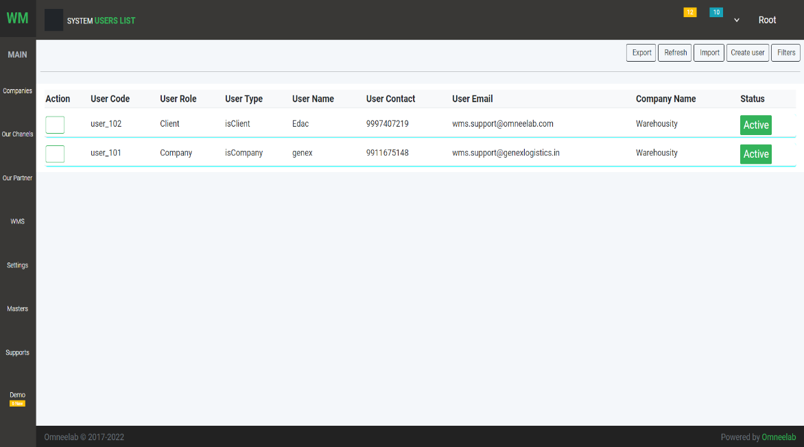List Page

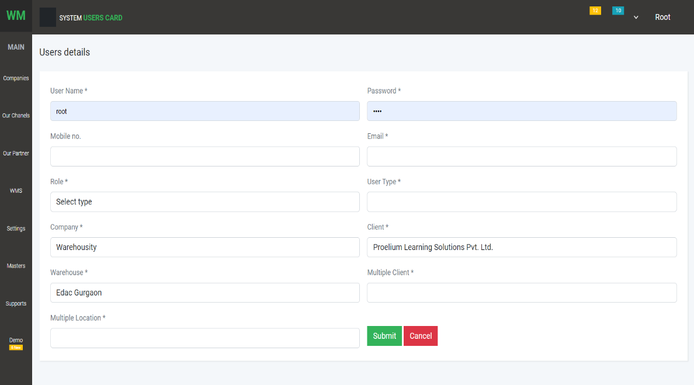Create Page

1. 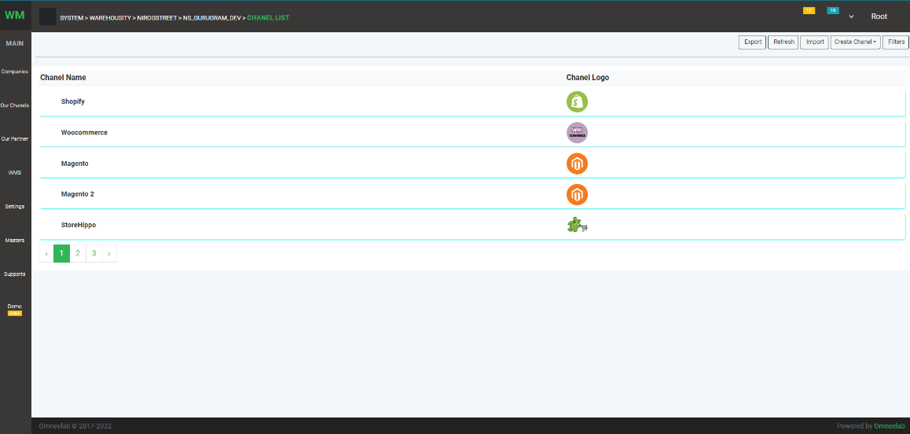Channel: On this option, list of the channel as shown above screenshot
2. Logistics Partners : On this option, list of logistics partner as show above screenshot

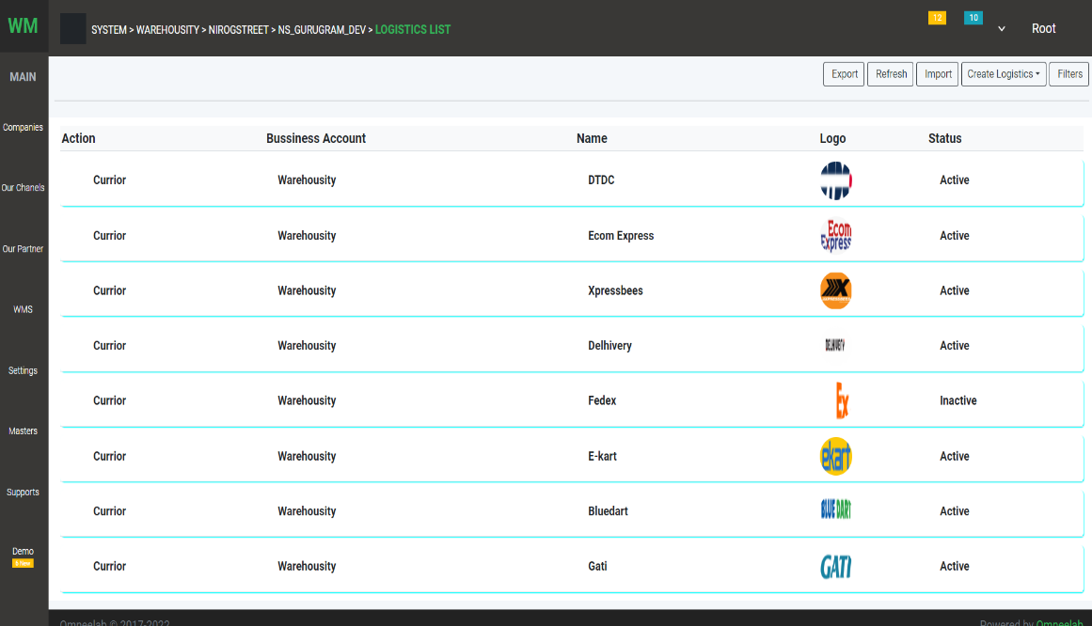

1. WMS : User can list the WMSes, ERPs

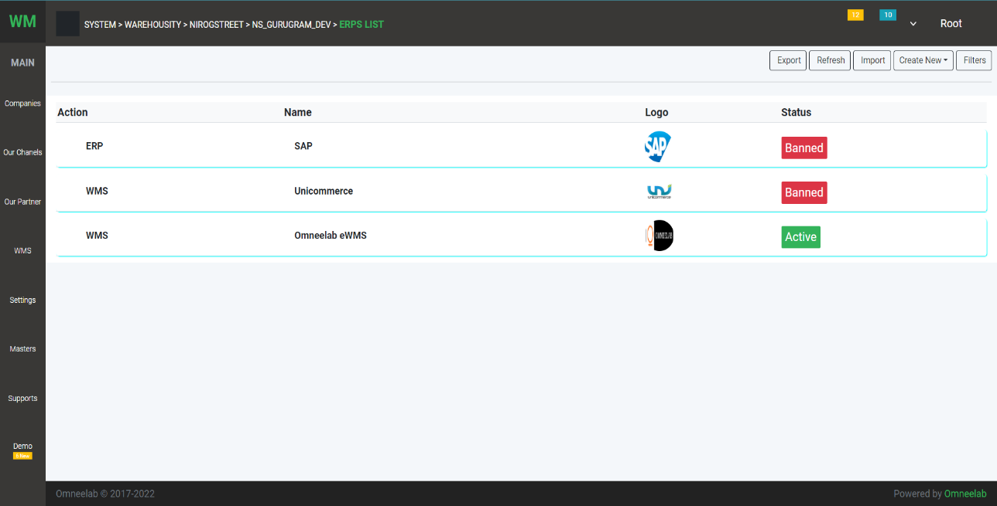

Same as shown above screenshot of WMS

1. Status Master: DSP and Aggregator Status List

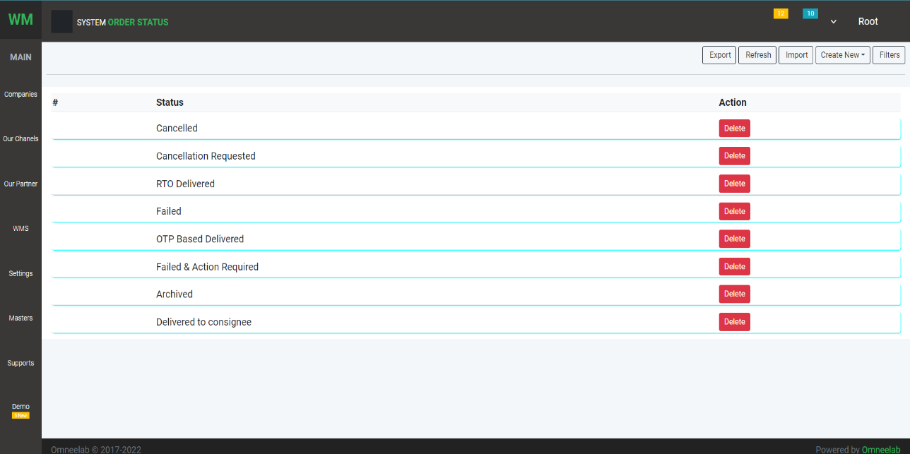List page

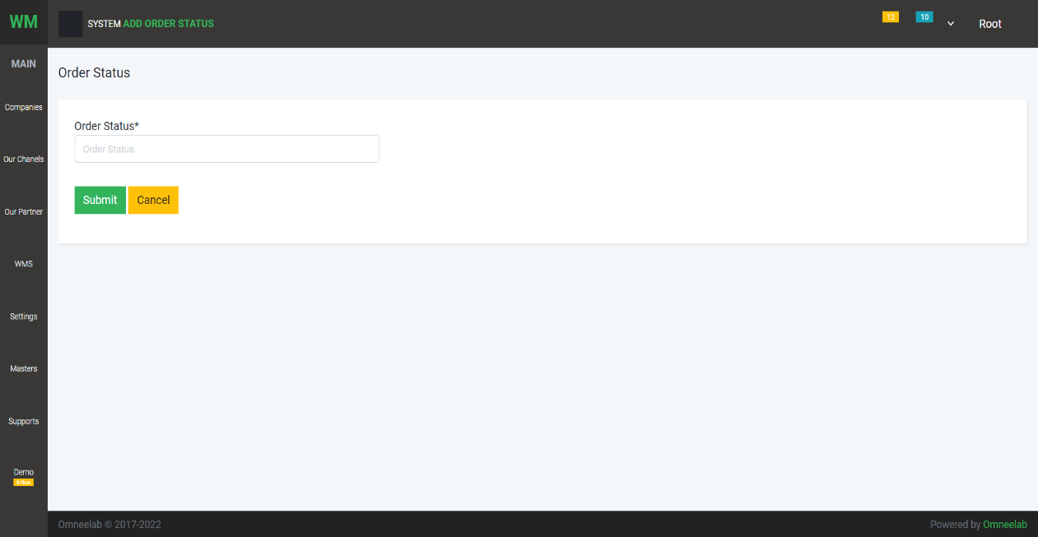Create page

1. Weight Master: In this Master User can add a weight range

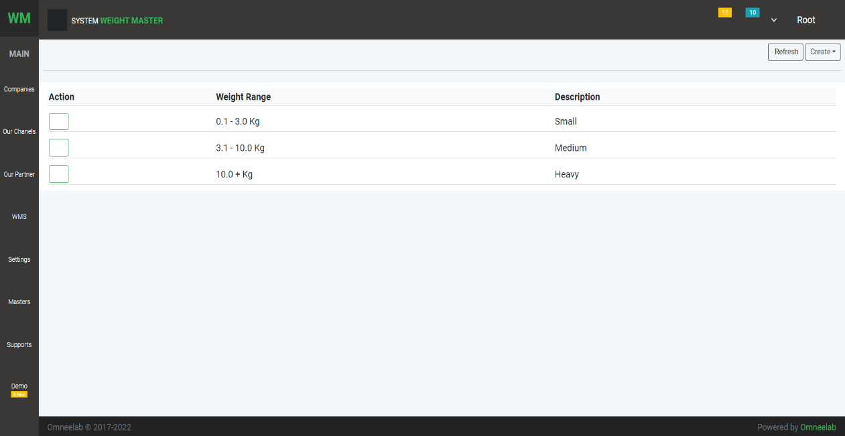 List page

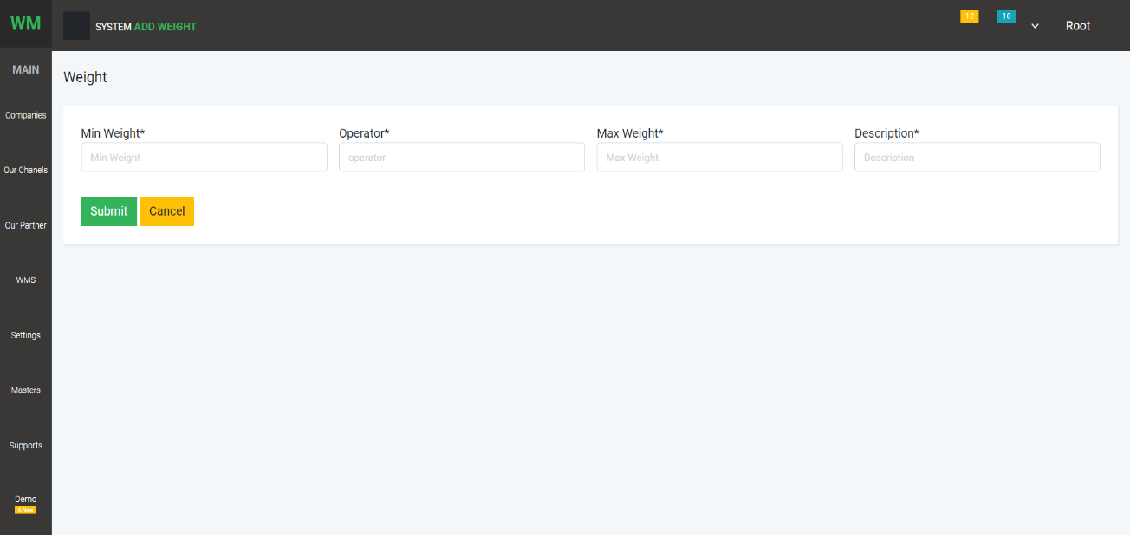 Create Page

1. **MASTERS:**

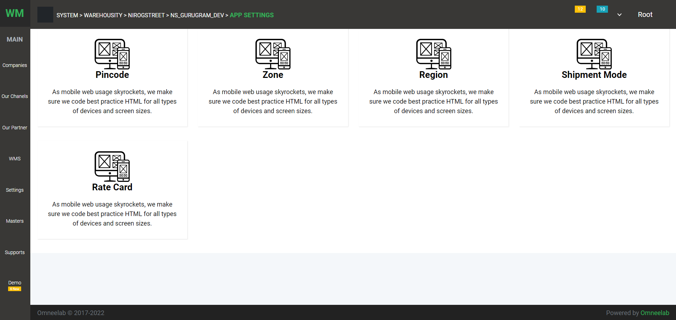

1. Pincode Master: list of import

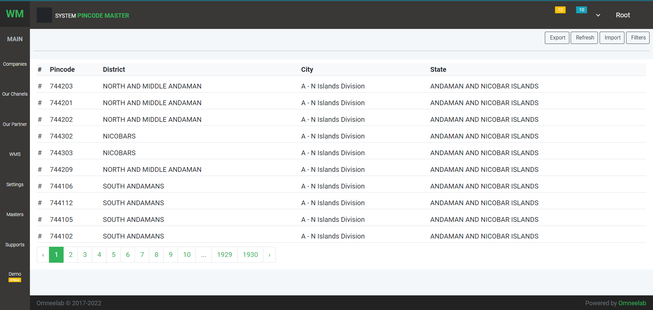

1. 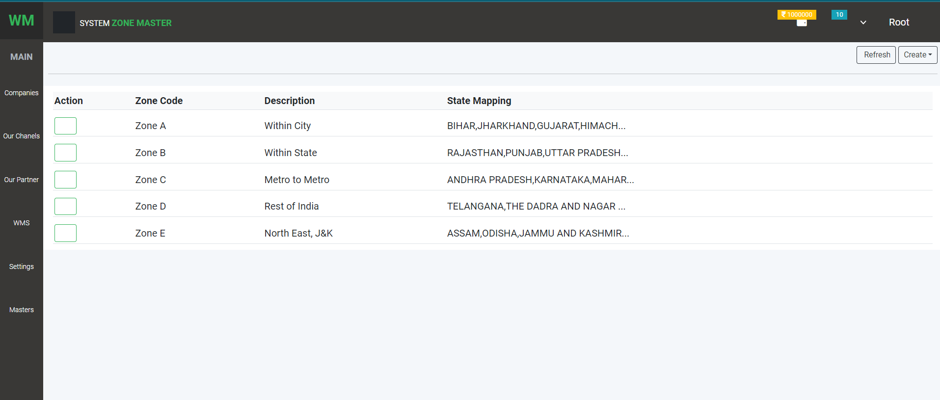Zone Master: System Zone list
2. Shipment Mode Master: list of shipment mode

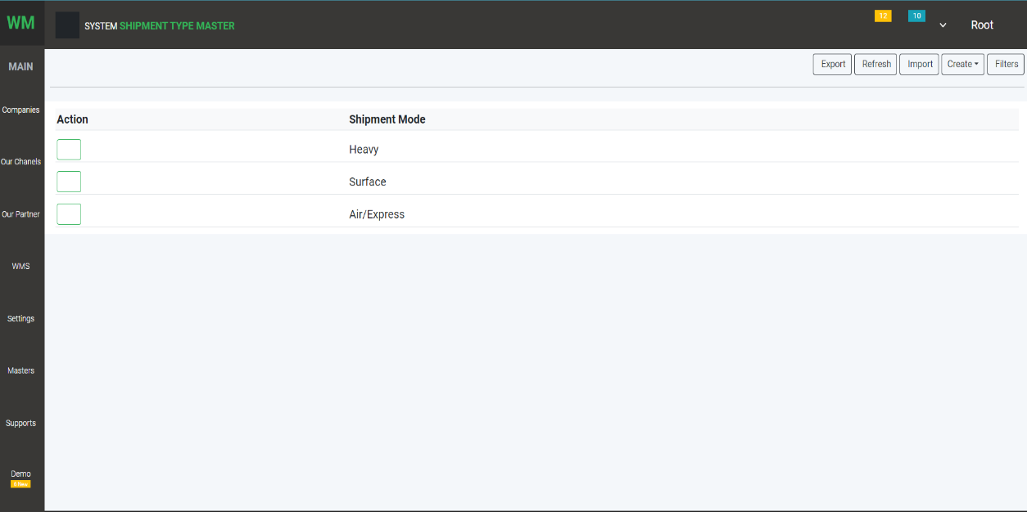

1. Rate Card: Rate contract of DSPS

