**LOGISTIC APP DOCUMENT**

**WAREHOUSE USER**

1. **Warehouse Dashboard**

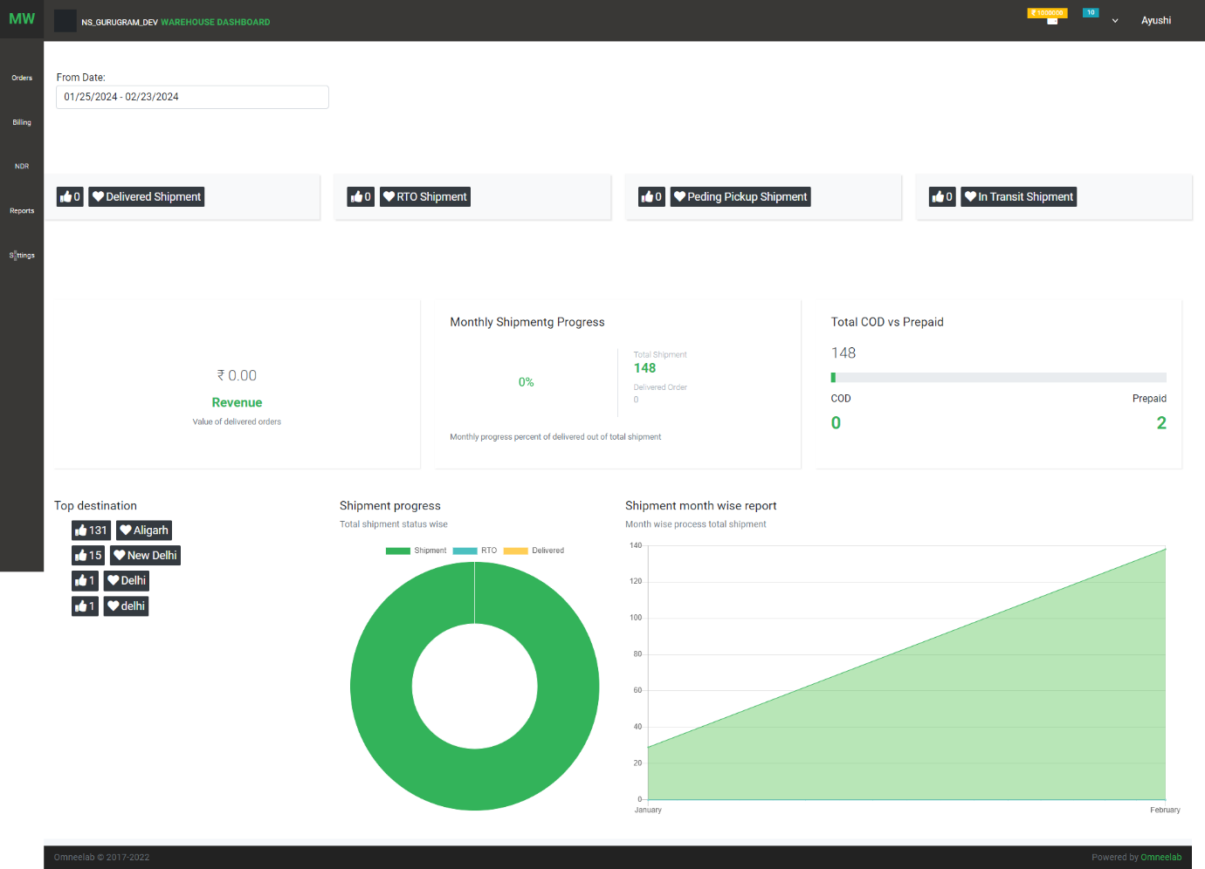

In this dashboard, we have details of all the warehouses of a client.

All data shown on a particular date interval

1. Total Delivered Shipment
2. Total Pickup Pending
3. Total RTO Shipment
4. Revenue: Total delivered shipment Invoice value.
5. Monthly Shipping Progress: show monthly progress between total shipments vs. delivered shipments
6. Total COD Vs. Prepaid: show report total cod delivered vs. prepaid delivered shipments
7. Shipping Progress: Donut chart to show total shipment, total RTO, and delivered shipments
8. Shipment month-wise report: chat that shows the progress of the month
9. **User Profile:**
10. Use can update profile

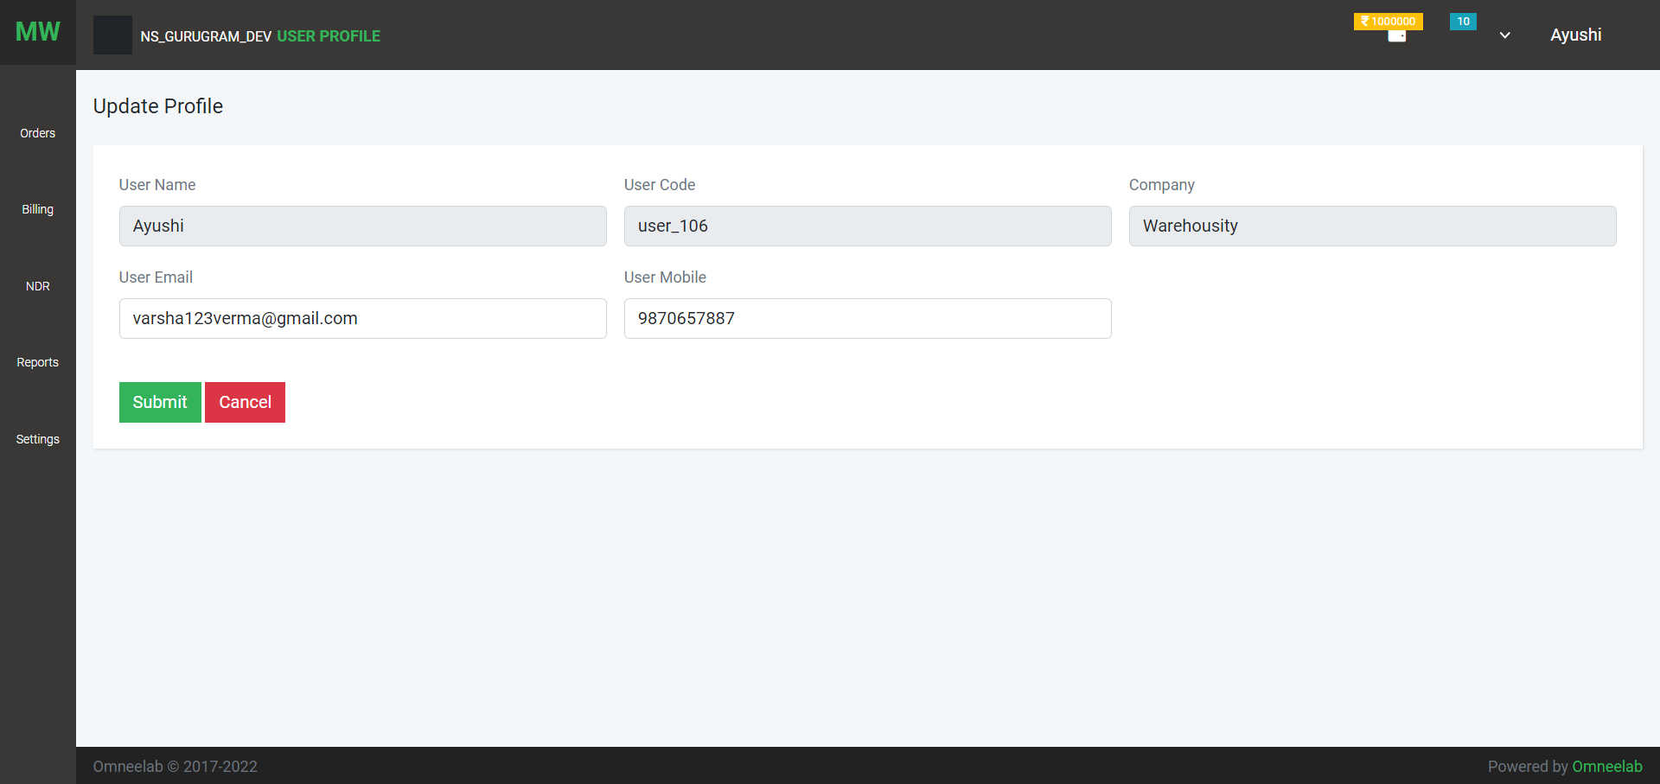

1. 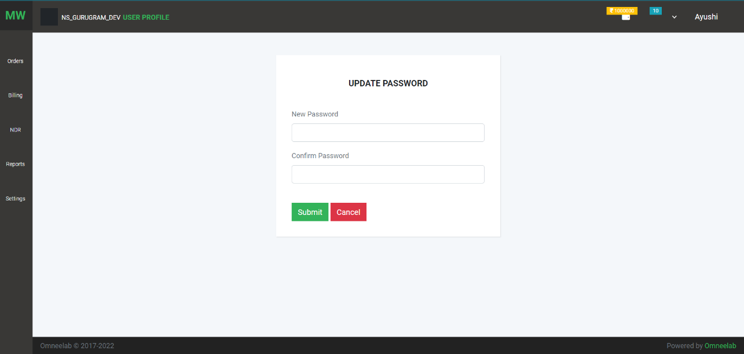Change Password:
2. 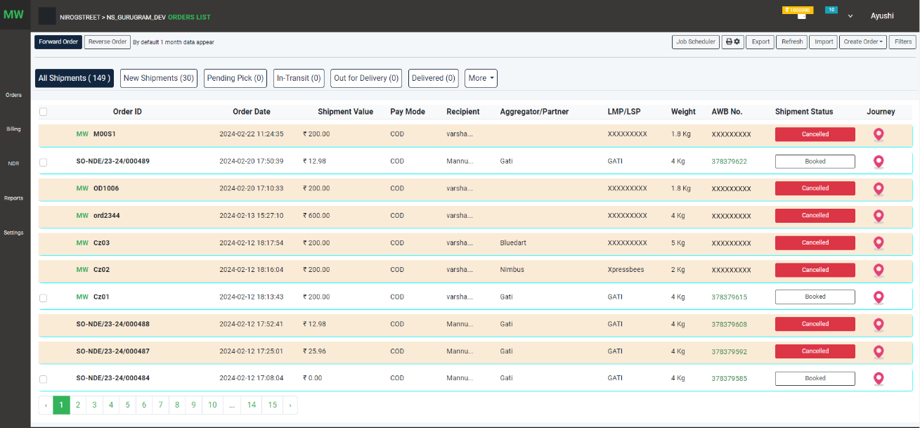**Orders**

On this page, the user can see a list of Orders

1. Two types of orders Forward Order and Reverse Order
2. Job Scheduler – New orders will be cancelled when no activity is performed within two hours
3. Print Setting - user can set label print setting that will apply to the label
4. 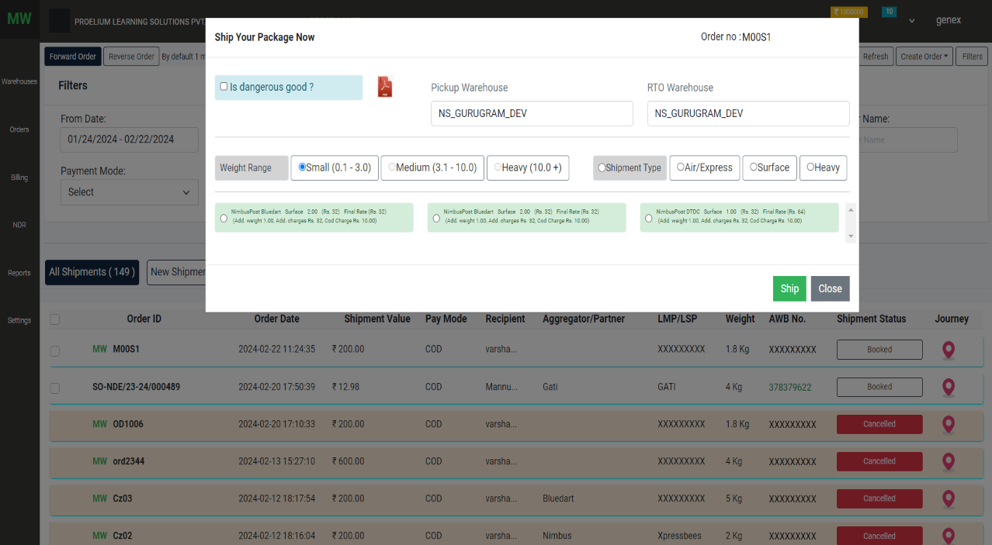DSP Selection on booked status on manual order
5. Tracking: The user can track order detail

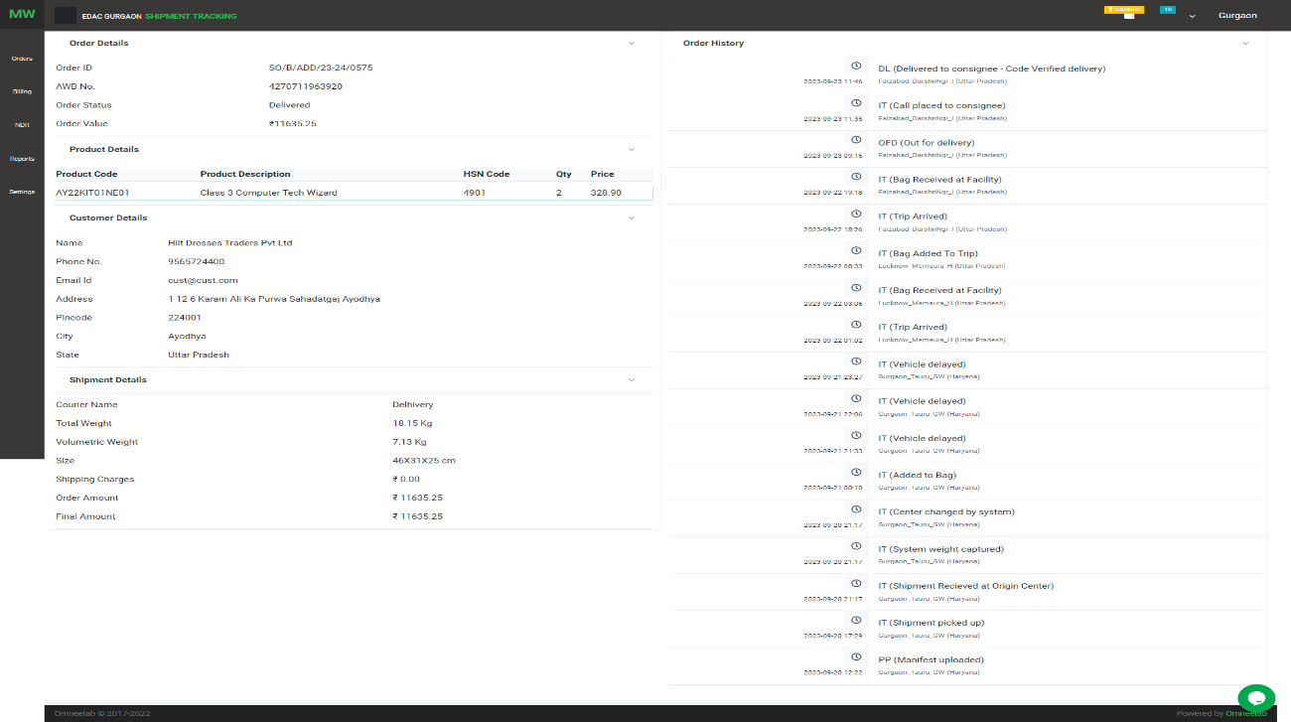

Click on AWB no tracking page

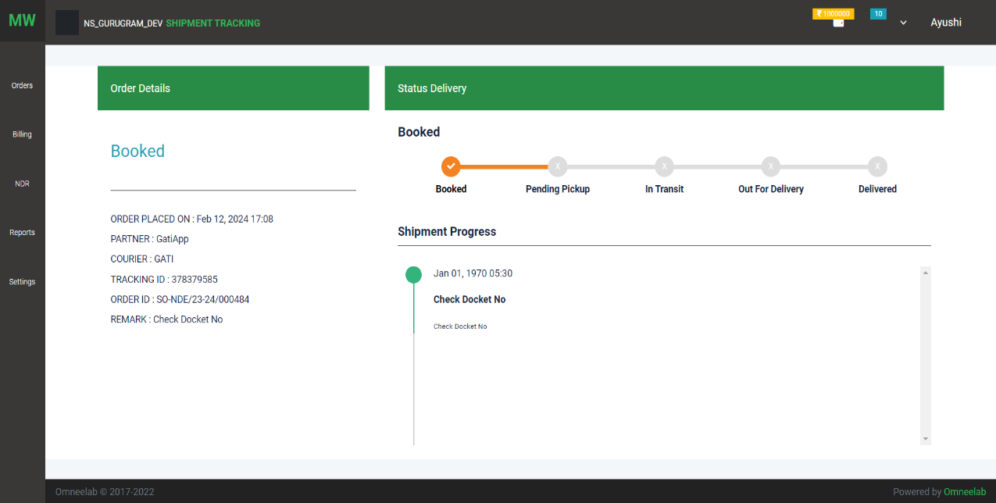

1. Create order - manual order creation

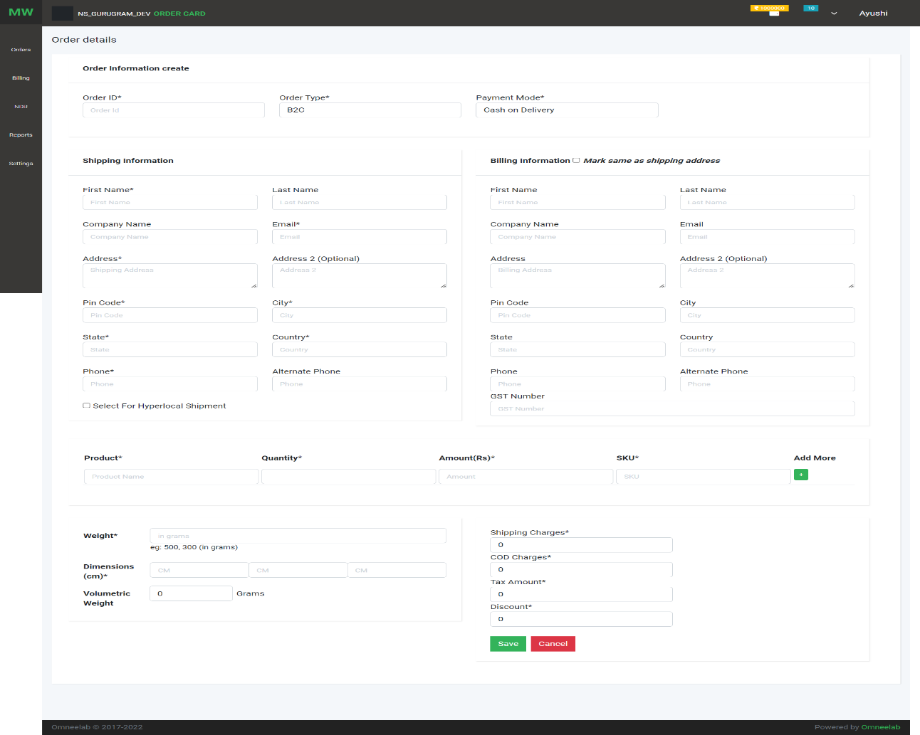

1. Order detail view page

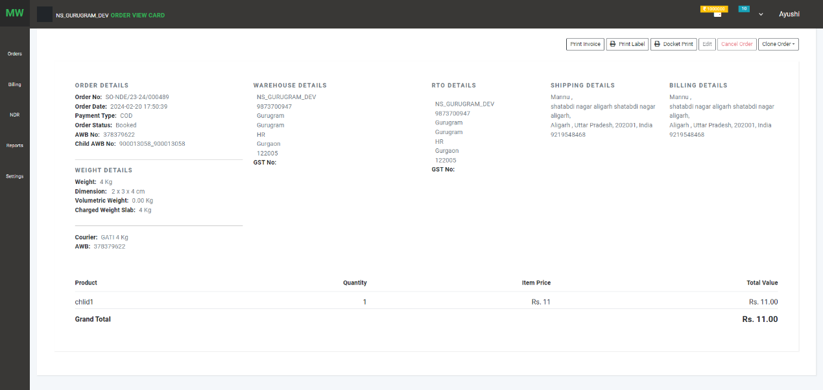

Option shown on this page:

1. 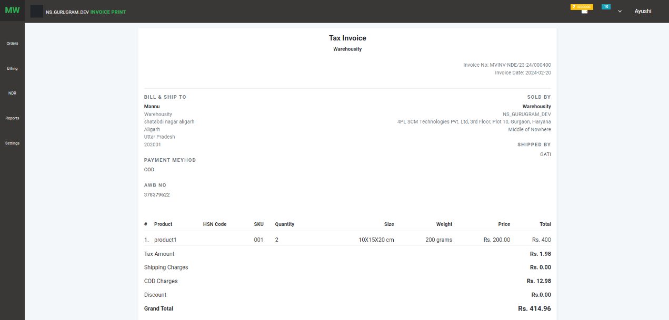Print invoice: order invoice includes order detail, consignee detail, product detail
2. Print label: download packing and ship against order
3. Docket Print: download docket details like AWB no against the order
4. Edit Order: user can edit the order before ship status on the manual order
5. Cancel order: user can cancel order before the pending pick status
6. Clone Order: user can repeat order using clone option
7. SETTING:

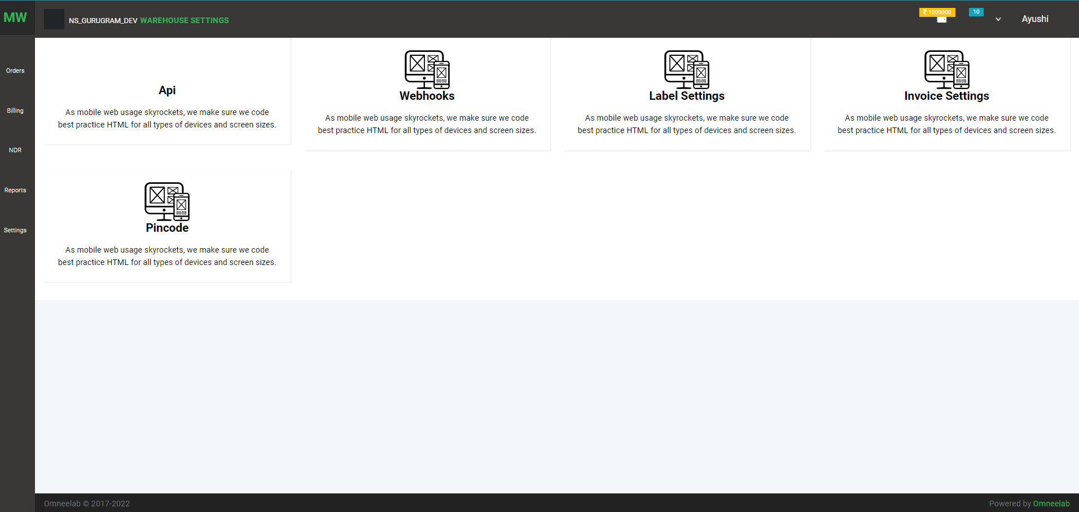

1. 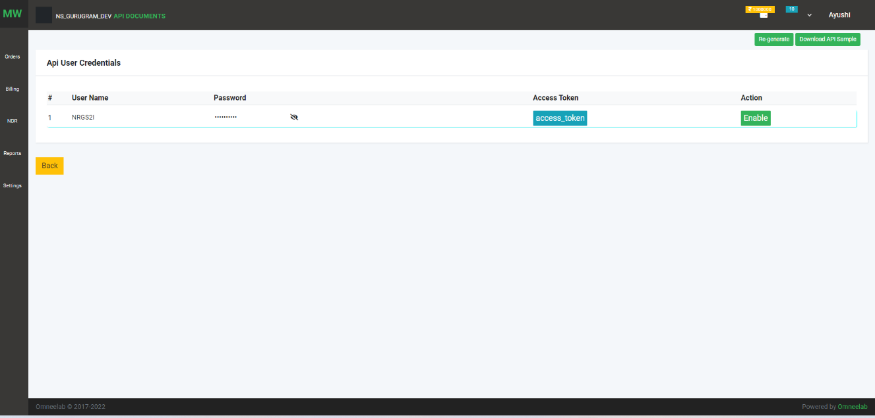API: API Document and API user creation and token generation
2. Webhook: get real-time order status

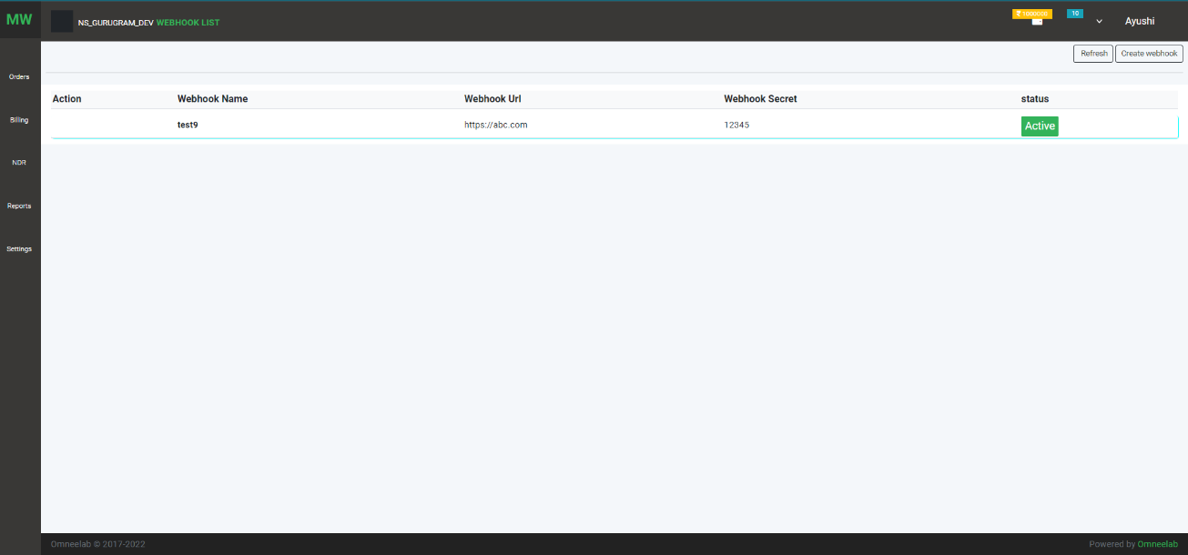

1. 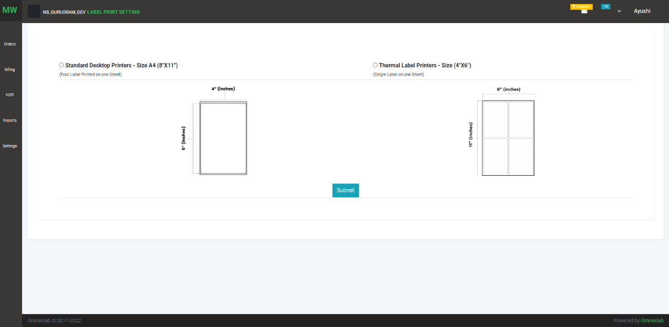Label setting: Use can set label print
2. 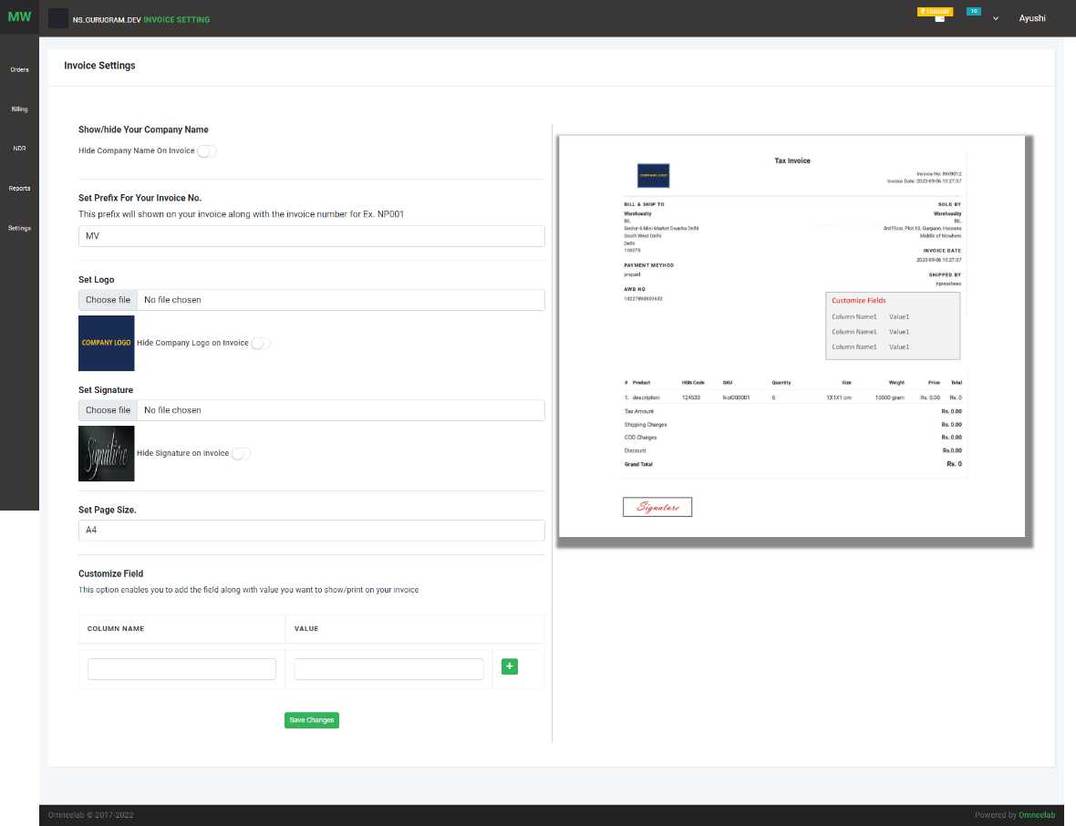Invoice Setting :

On this

1. Pincode : Pincode List

