#include <DHT.h>

#define DHTPIN 2
#define DHTTYPE DHT11

DHT dht(DHTPIN, DHTTYPE);

void setup() {
Serial.begin(9600);
dht.begin();
}

void loop() {
delay(2000);

float humidity = dht.readHumidity();
float temperature = dht.readTemperature();

Serial.print("Humidity: ");
Serial.print(humidity);
Serial.print("% Temperature: ");
Serial.print(temperature);
Serial.println(" °C");
}
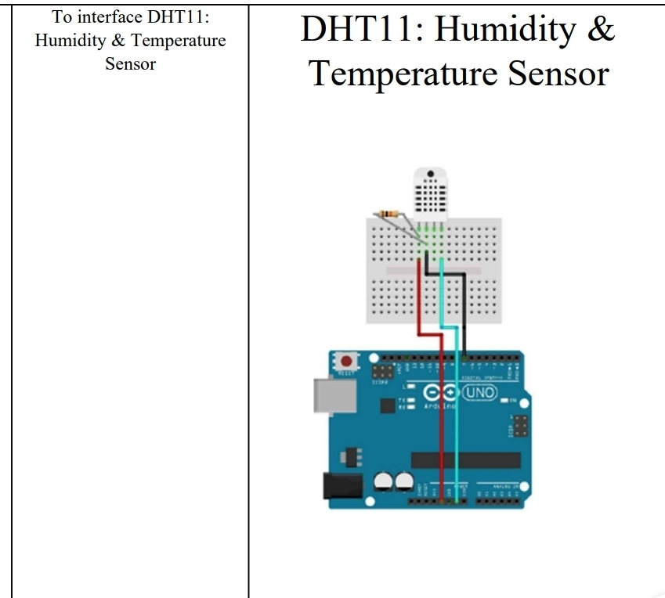
DHT11 Pin Connect To
VCC 5V
(Arduino)
GND GND
DATA Digital Pin 2

