REQUIREMENT ANALYSIS
E-COMMERCE DATABASE SYSTEM
Amazon – E-Commerce Business Process and Database Requirements

Prepared for: Database Management System
1. Understanding the E-Commerce Business Process
An e-commerce system such as Amazon is an online platform where customers can search for products, view product information, place orders, make payments, and track deliveries. Sellers add and manage products, prices, stock, and order fulfilment. A database is required to store and connect all of this information so that transactions can be processed accurately and quickly.

1. Customer Registration and Login
The customer creates an account by providing basic personal and contact details. The system stores the account information for authentication and future orders.

2. Product Search and Selection
Customers search or browse products, view descriptions, prices, ratings, availability, and seller information, and add selected items to a cart.

3. Order Placement
When the customer checks out, the system creates an order and records the ordered products, quantities, total amount, delivery address, and order status.

4. Payment Processing
The selected payment method is recorded and the payment status is updated. The system links the payment with the corresponding order.

5. Seller and Inventory Management
Sellers maintain product information, prices, stock levels, and fulfilment details. Stock should be updated when orders are placed or cancelled.

6. Delivery and Order Tracking
The order moves through statuses such as confirmed, packed, shipped, out for delivery, and delivered. Tracking information can be associated with the order.

7. Returns and Customer Support
The system may record return requests, refunds, complaints, and support interactions so that customer issues can be handled efficiently.

2. Data Required for Customer Management
The database should store the following customer-related information:
Data Category | Examples | Purpose
Customer Identification | Customer ID, Name | Uniquely identifies the customer.
Contact Details | Email, Phone Number | Used for communication, login, and order updates.
Address Details | House/Street, City, State, PIN Code, Country | Used for billing and delivery.
Account Details | Username/Email, Password Hash, Account Status | Supports secure account access and account management.
Order History | Order ID, Order Date, Items, Amount, Status | Helps customers and the business track previous purchases.
Payment Information | Payment ID, Method, Status, Transaction Reference | Stores transaction-related records without unnecessarily storing sensitive payment credentials.
Preferences | Saved addresses, communication preferences | Improves customer service and shopping experience.

3. Major Entities in the E-Commerce Database
Entity | Important Attributes | Description
Customer | Customer_ID (PK), Name, Email, Phone, Address, Account_Status | Stores customer account and contact information.
Product | Product_ID (PK), Product_Name, Description, Price, Stock, Category, Seller_ID (FK) | Stores products available for sale.
Order | Order_ID (PK), Customer_ID (FK), Order_Date, Total_Amount, Status, Delivery_Address | Represents a customer's purchase.
Payment | Payment_ID (PK), Order_ID (FK), Payment_Date, Method, Amount, Status | Stores payment transaction records linked to orders.
Seller | Seller_ID (PK), Seller_Name, Email, Phone, Address | Stores information about sellers who list products.

4. Entity Relationships
- Customer → Order: One customer can place many orders, while each order belongs to one customer.
- Order → Product: An order can contain multiple products, and a product can appear in many orders. In a complete implementation, an Order_Item/Order_Detail entity would normally resolve this many-to-many relationship.
- Order → Payment: An order can have a payment record associated with it; payment status can change during processing, refund, or cancellation.
- Seller → Product: One seller can list many products, while each product listing is associated with a seller.

5. ER Diagram
The following simplified ER diagram represents the core entities and their relationships.
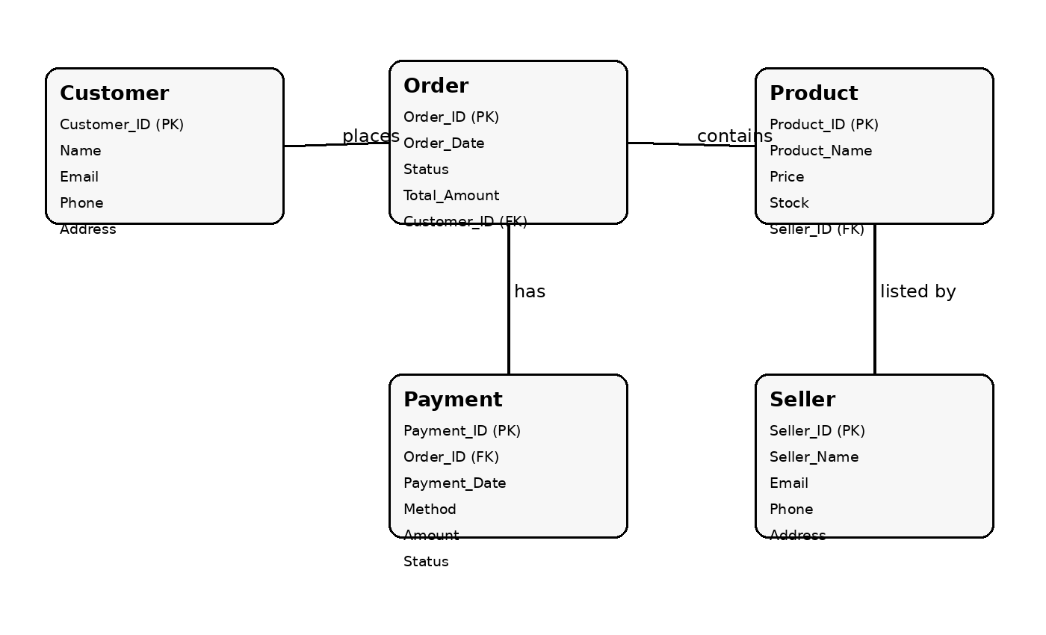
Note: For a production-level Amazon-like database, additional entities such as Order_Item, Category, Cart, Shipment, Review, Return, and Inventory would normally be included.

6. Review Questions and Answers

Why does an e-commerce system require a database?
An e-commerce system handles a large amount of structured information such as customer accounts, products, sellers, orders, payments, stock, and delivery details. A database stores this information systematically and allows fast retrieval and updating. It also helps maintain data consistency, supports multiple users and transactions, reduces duplication, and provides reliable records for business operations and reporting.

What customer details need to be stored?
Important customer details include Customer ID, name, email address, phone number, delivery and billing addresses, account status, order history, and relevant communication preferences. Payment records should be linked through transaction information and payment status. Sensitive credentials and payment secrets should be protected and should not be stored unnecessarily in plain form.

What operations should be performed on customer data?
The main operations are Create, Read, Update, and Delete (CRUD). The system should create new customer accounts, retrieve customer details when needed, update contact or address information, and deactivate/delete records according to business and legal requirements. Additional operations include authentication, searching customers, maintaining order history, validating contact information, and managing customer preferences securely.

7. Conclusion
The requirement analysis identifies the core data and business processes needed for an e-commerce database system. Customer, Product, Order, Payment, and Seller are the major entities. The database connects these entities and supports the complete customer journey from registration and product selection to ordering, payment, and delivery. This analysis provides a foundation for designing the detailed relational schema and implementing the database.

