WEEK 4 – ORDER MANAGEMENT SYSTEM
Database Management System | Documentation

1. Aim
To design an Order Management System using MySQL to store orders and ordered products, maintain relationships and constraints, and generate customer-history and sales reports.

2. Table Design

Orders
Column | Data type | Constraint | Purpose
Order_ID | INT | Primary Key, Auto Increment | Unique order identifier
Customer_ID | INT | Foreign Key, NOT NULL | Customer who placed the order
Order_Date | DATE | NOT NULL | Date of order
Total_Amount | DECIMAL(10,2) | NOT NULL, CHECK >= 0 | Total value of the order
Order_Status | VARCHAR(20) | NOT NULL, CHECK | Pending, Shipped, Delivered or Cancelled

Order_Details
Column | Data type | Constraint | Purpose
Order_Detail_ID | INT | Primary Key, Auto Increment | Unique line-item identifier
Order_ID | INT | Foreign Key, NOT NULL | Related order
Product_ID | INT | Foreign Key, NOT NULL | Ordered product
Quantity | INT | NOT NULL, CHECK > 0 | Number of units ordered
Price | DECIMAL(10,2) | NOT NULL, CHECK >= 0 | Price per unit at order time
Order_ID + Product_ID | — | UNIQUE (composite) | Prevents duplicate product lines in one order

3. Relationships and ER Diagram
Customers (1) ───── (Many) Orders
Orders (1) ───── (Many) Order_Details
Products (1) ───── (Many) Order_Details
The Order_Details table connects Orders and Products. Each order belongs to one customer, and an order can contain multiple product lines. Each product can appear in many order lines.
Text ER view: Customers [Customer_ID PK] 1 ──< Orders [Order_ID PK, Customer_ID FK] 1 ──< Order_Details [Order_Detail_ID PK, Order_ID FK, Product_ID FK] >── 1 Products [Product_ID PK]

4. Constraints Used
- PRIMARY KEY uniquely identifies every row.
- FOREIGN KEY links Orders to Customers, and Order_Details to Orders and Products.
- NOT NULL ensures required values are supplied.
- UNIQUE (Order_ID, Product_ID) prevents duplicate product entries within the same order.
- CHECK constraints prevent negative prices/totals and zero or negative quantities; Order_Status is restricted to allowed values.
- ON DELETE CASCADE removes related Order_Details automatically when an order is deleted.

5. Sample Data and Order Amount Calculation
The SQL script includes sample orders and order-detail rows. It assumes the existing Customers and Products tables contain matching IDs. Update the IDs and product prices to match your database.
Line total = Quantity × Price
Order total = SUM(Quantity × Price) for all detail rows belonging to that order.
Example: 2 units × ₹500 + 1 unit × ₹250 = ₹1,250 total for the order.

6. Order Management Operations
- Create an order for a customer and capture its generated Order_ID.
- Insert multiple product lines into Order_Details.
- Recalculate Orders.Total_Amount from the order-detail rows.
- Update Order_Status to Pending, Shipped, Delivered or Cancelled.
- Change an ordered product quantity and recalculate the order total.
- Delete cancelled orders; the related detail rows are removed by the foreign-key cascade.
- Join Customers, Orders, Order_Details and Products to display complete order information.

7. Customer Order History and Purchase Analysis
Report | Description
Customer order history | Lists each customer’s orders, dates, status and order amount.
Product-wise order report | Shows orders and quantities for each product.
Times each product was ordered | Counts distinct orders containing each product.
Total quantity sold | Adds quantities for non-cancelled orders.
Customers with maximum orders | Finds all customers tied for the highest order count.
Total spending by customer | Adds non-cancelled order amounts for each customer.
Average order value | Calculates the average amount of non-cancelled orders.
Total sales amount | Adds order totals excluding cancelled orders.

8. Query Output Screenshots
After running the SQL script in MySQL Workbench, take screenshots and insert them here. Recommended screenshots: Orders table, Order_Details table, complete order information, customer order history, product-wise report, product quantity sold, customer spending, average order value and total sales.
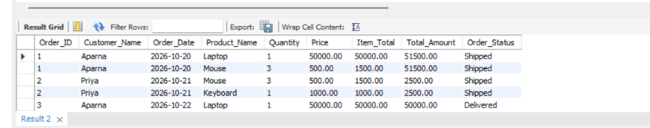
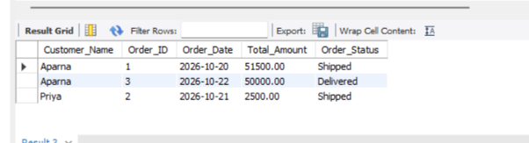
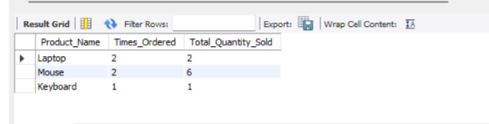
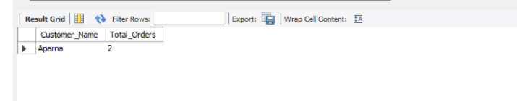
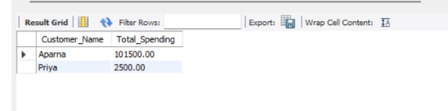
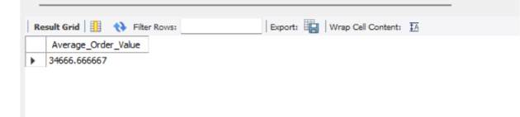
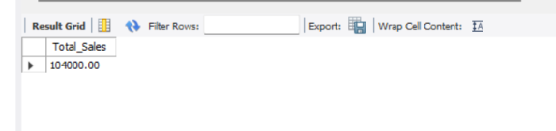
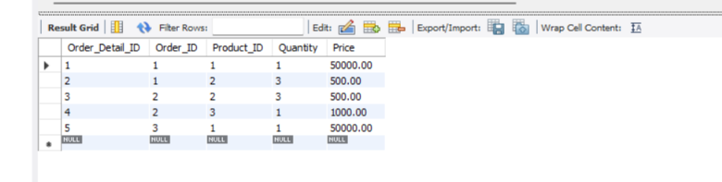

9. Conclusion
The Order Management System stores customer orders and product line items with key constraints. It supports order creation, updates, deletion of cancelled orders, total calculation, and reports for customer history, product demand and sales analysis.

