1) 1)full catelog order after order in oreder hostory

only first product is add in add tocart

2)design issue in menu

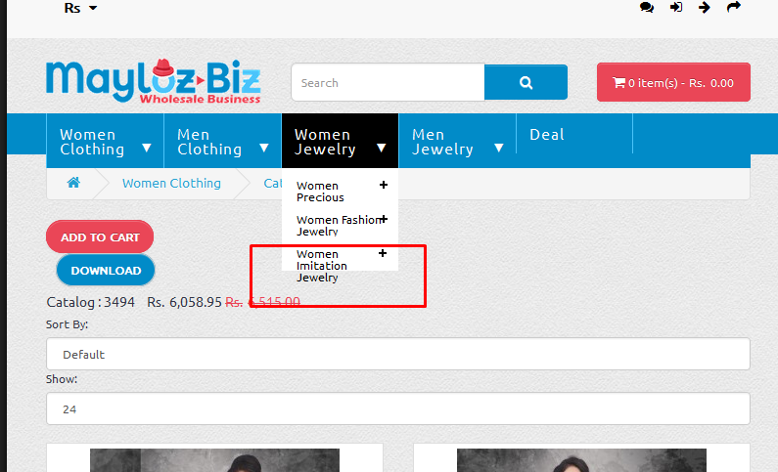

3)