MiniProjetBackEnd

Créez un projet maven

groupId : com.formation
artifactId : MiniMongoProjetBackEnd
version : 1

pom.xml

<dependencies>
<!-- mongoDB -->
<dependency>
<groupId>org.mongodb</groupId>
<artifactId>mongo-java-driver</artifactId>
<version>2.13.1</version>
</dependency>

<!-- Srping MongoDB -->
<dependency>
<groupId>org.springframework</groupId>
<artifactId>spring-core</artifactId>
<version>4.1.6.RELEASE</version>
</dependency>

<dependency>
<groupId>org.springframework</groupId>
<artifactId>spring-context</artifactId>
<version>4.1.6.RELEASE</version>
</dependency>

</dependencies>
<build>
<plugins>
<plugin>
<groupId>org.apache.maven.plugins</groupId>
<artifactId>maven-compiler-plugin</artifactId>
<version>3.1</version>
<configuration>
<source>1.7</source>
<target>1.7</target>
</configuration>
</plugin>
</plugins>
</build>

Structure

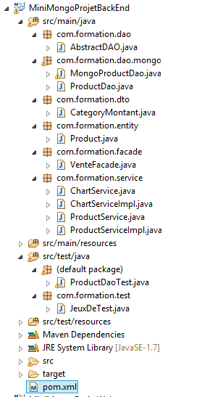

Partie DAO

Entity et Dto

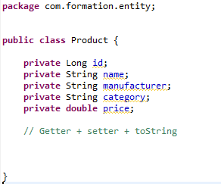

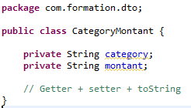

AbstractDAO

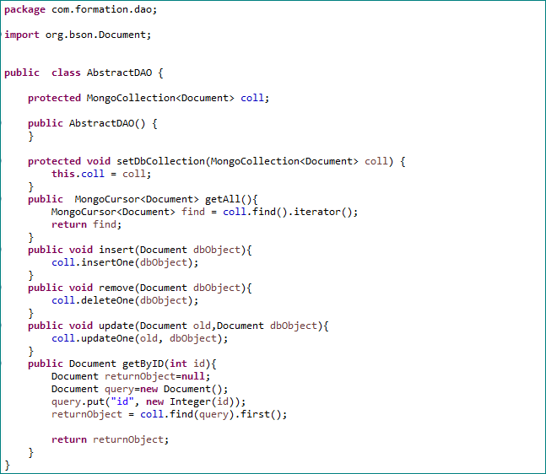

Interface : ProductDao.java

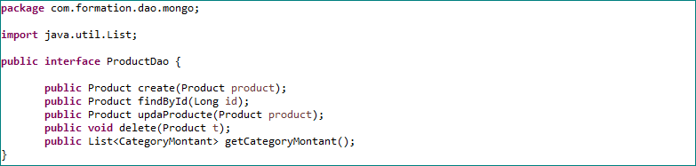

Implémentation : MongoProductDao.java

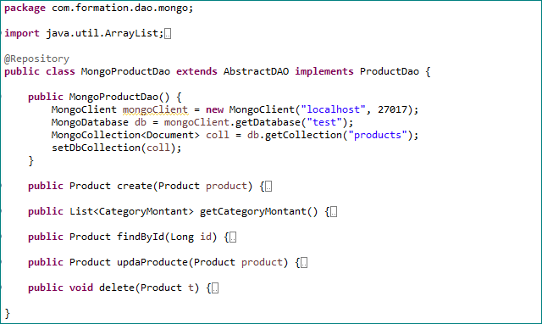

Les methodes

@Override
public Product create(Product product) {
// Construction de l'objet
Document doc = new Document("name", product.getName())
.append("manufacturer", product.getManufacturer())
.append("category", product.getCategory())
.append("price", product.getPrice());
coll.insertOne(doc);
return product;
}

@Override
public List<CategoryMontant> getCategoryMontant() {

List<Document> operations = new ArrayList<Document>();

final List<CategoryMontant> results = new ArrayList<CategoryMontant>();

Document groupFields = new Document("_id", "$category");
groupFields.put("montant", new Document("$sum", "$price"));
Document group = new Document("$group", groupFields);
operations.add(group);

AggregateIterable<Document> iterable = coll.aggregate(operations);

iterable.forEach(new Block<Document>() {
CategoryMontant cat=null;
@Override
public void apply(final Document document) {
cat=new CategoryMontant();
cat.setCategory(document.get("_id").toString());
cat.setMontant(document.get("montant").toString());
results.add(cat);
}
});

return results;
}
A FAIRE : Compléter en implémentant les autres méthodes.

Partie Service

Interfaces

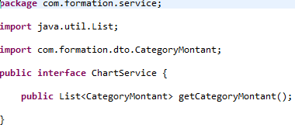

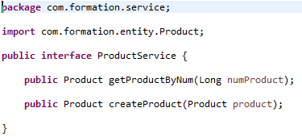

Implémentation

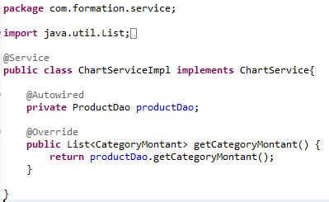

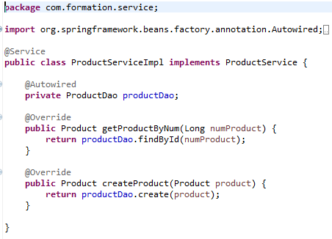

Façade

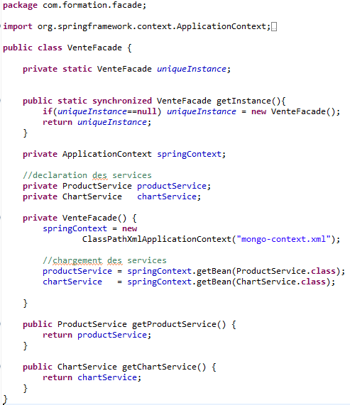

Configuration Spring

<?xml version="1.0" encoding="UTF-8"?>
<beans xmlns="http://www.springframework.org/schema/beans"
xmlns:xsi="http://www.w3.org/2001/XMLSchema-instance" xmlns:context="http://www.springframework.org/schema/context"
xsi:schemaLocation="http://www.springframework.org/schema/context
http://www.springframework.org/schema/context/spring-context-3.0.xsd
http://www.springframework.org/schema/beans
http://www.springframework.org/schema/beans/spring-beans-3.0.xsd">

<!-- To translate any MongoExceptions thrown in @Repository annotated classes -->
<context:annotation-config />

<!-- pour demander à Spring de rechercher @component -->
<context:component-scan base-package="com.formation" />

</beans>

Test

Jeu de test

package com.formation.test;

import java.util.Random;

import com.formation.entity.Product;

public class JeuxDeTest {

String[] categories = { "Tablets", "Laptops", "Cell Phones" };

public Product getProduct() {
int idCat = new Random().nextInt(categories.length);

String[] manufacturer = new String[10];
int next = 0;

switch (idCat) {
case 0:
manufacturer[0]="Apple";
manufacturer[1]="Samsung";
manufacturer[2]="Google";
manufacturer[3]="Amazon";
next=4;
break;

case 1:
manufacturer[0]="Apple";
manufacturer[1]="Toshiba";
manufacturer[2]="Acer";
next=3;
break;

case 2:
manufacturer[0]="HTC";
manufacturer[1]="Nokia";
manufacturer[2]="Samsung";
next=3;
break;

default:
break;
}

int idManu = new Random().nextInt(next);

String[] names = new String[10];
double[] price = new double[10];

String num=""+idCat+idManu;

switch (num) {
case "00":
names[0]="IPAD AIR 2";

names[1]="IPAD MINI 3";

names[2]="IPAD AVEC ÉCRAN RETINA";
price[0]=400.00;
price[1]=700.00;
price[2]=800.00;
next=3;
break;

case "01":
names[0]="SAMSUNG GALAXY TAB A";
names[1]="SAMSUNG GALAXY TAB S";
names[2]="SAMSUNG GALAXY NOTE";
names[3]="SAMSUNG GALAXY TAB 3";
names[4]="SAMSUNG GALAXY TAB 4";
price[0]=300.00;
price[1]=450.00;
price[2]=250.00;
price[3]=450.00;
price[4]=700.00;
next=5;
break;

case "02":
names[0]="HTC Nexus 9 16 Go";
names[1]="Tablette HTC Nexus 4 G";
price[0]=200.00;
price[1]=245.00;
next=2;
break;

case "03":
names[0]="Kindle Paperwhite 2014 WiFi";
price[0]=79.00;
next=1;
break;

case "10":
names[0]="Apple MacBook Pro 13,3";
names[1]="Apple MacBook Air 11,6";
names[2]="Apple MacBook Pro 15,4";
price[0]=1200.00;
price[1]=1345.00;
price[2]=1865.00;
next=3;
break;

case "11":
names[0]="Satellite L70-B-10P";
names[1]="PC Portable SATELLITE L50-B-16N";
names[2]="PC Portable Satellite L50-B-1HU";
names[3]="Satellite Pro R50-B-14U";
names[4]="PC Portable SATELLITE L50-B-16N";
names[5]="PC Portable Satellite C50-B-14F";
price[0]=458.00;
price[1]=754.00;
price[2]=895.00;
price[3]=451.00;
price[4]=1243.00;
price[5]=458.00;
next=6;
break;

case "12":
names[0]="Iconia Tab 8 Blanche W1-810-15NY";
names[1]="Iconia Tab 10 Blanche A3-A20-K79Q";
names[2]="Iconia Tab 8 + Clavier ACER ANDROID";
price[0]=458.00;
price[1]=852.00;
price[2]=795.00;
next=3;
break;

case "20":
names[0]="Desire 610 Blanc";
names[1]="DESIRE 816";
names[2]="One M8";
price[0]=458.00;
price[1]=968.00;
price[2]=245.00;
next=3;
break;

case "21":
names[0]="LUMIA 625";
names[1]="Nokia 220 Double Sim";
price[0]=456.00;
price[1]=245.00;
next=2;

case "22":
names[0]="REX 60 Bleu";
names[1]="SGH-C3050 Stratus";
names[2]="B2100 ROUGE";
names[3]="GALAXY S5 ACTIVE";
price[0]=300.00;
price[1]=785.00;
price[2]=124.00;
price[3]=785.00;
next=4;

break;

default:
break;
}
int idName = new Random().nextInt(next);

String cateorie = (categories[idCat]);
String manufacture= manufacturer[idManu];
String name=names[idName];

Product p =new Product(name, manufacture, cateorie, price[idName]);

return p;
}
}

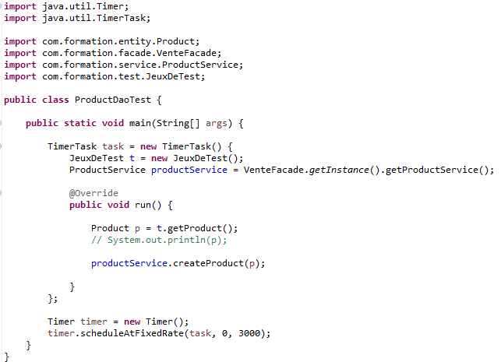

Partie Front
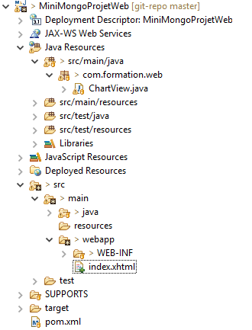

Créez un projet web_maven

groupId : com.formation
artifactId : MiniMongoProjetWeb
version : 1
packaging : war

Pom.xml

<dependencies>
<!-- JSF -->

<dependency>
<groupId>com.sun.faces</groupId>
<artifactId>jsf-api</artifactId>
<version>2.2.11</version>
</dependency>

<dependency>
<groupId>com.sun.faces</groupId>
<artifactId>jsf-impl</artifactId>
<version>2.2.11</version>
</dependency>

<dependency>
<groupId>com.formation</groupId>
<artifactId>MiniMongoProjetBackEnd</artifactId>
<version>1</version>
</dependency>

<dependency>
<groupId>org.primefaces</groupId>
<artifactId>primefaces</artifactId>
<version>5.2</version>
</dependency>

</dependencies>
<build>
<plugins>
<plugin>
<groupId>org.apache.maven.plugins</groupId>
<artifactId>maven-compiler-plugin</artifactId>
<version>3.1</version>
<configuration>
<source>1.7</source>
<target>1.7</target>
</configuration>
</plugin>
</plugins>
</build>

Web.xml

<?xml version="1.0" encoding="UTF-8"?>
<web-app xmlns="http://xmlns.jcp.org/xml/ns/javaee" xmlns:xsi="http://www.w3.org/2001/XMLSchema-instance"
xsi:schemaLocation="http://xmlns.jcp.org/xml/ns/javaee http://xmlns.jcp.org/xml/ns/javaee/web-app_3_1.xsd"
version="3.1">

<display-name>BaseJSF</display-name>
<servlet>
<display-name>Faces Servlet</display-name>
<servlet-name>Faces Servlet</servlet-name>
<servlet-class>javax.faces.webapp.FacesServlet</servlet-class>
<load-on-startup>1</load-on-startup>
</servlet>
<servlet-mapping>
<servlet-name>Faces Servlet</servlet-name>
<url-pattern>/faces/*</url-pattern>
</servlet-mapping>
<servlet-mapping>
<servlet-name>Faces Servlet</servlet-name>
<url-pattern>*.xhtml</url-pattern>
</servlet-mapping>
<welcome-file-list>
<welcome-file>index.xhtml</welcome-file>
</welcome-file-list>
</web-app>

ManagedBean

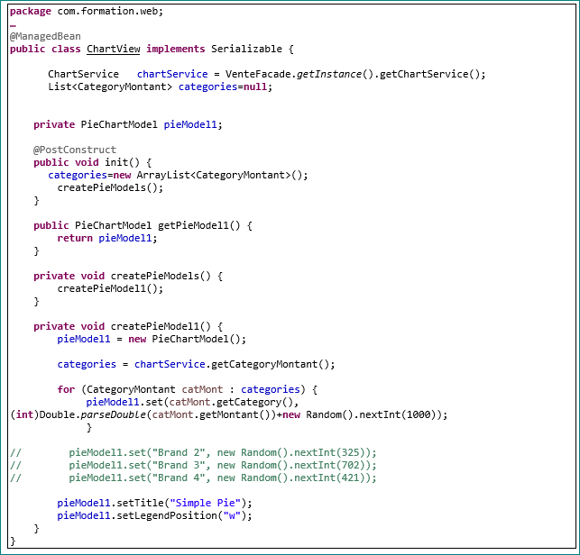

Pages
index.xhtml

<html xmlns="http://www.w3.org/1999/xhtml"
xmlns:f="http://xmlns.jcp.org/jsf/core"
xmlns:h="http://xmlns.jcp.org/jsf/html"
xmlns:p="http://primefaces.org/ui">

<h:head>
<title>JSF 2.2 Hello World</title>
</h:head>
<h:body >
<h3>JSF 2.2 Hello World Exemple - index.xhtml</h3>

<h:form>
<p:poll interval="3" update="abc" />
</h:form>

<p:chart type="pie" model="#{chartView.pieModel1}" id="abc" style="width:400px;height:300px" />

</h:body>
</html>

