Map Reduce

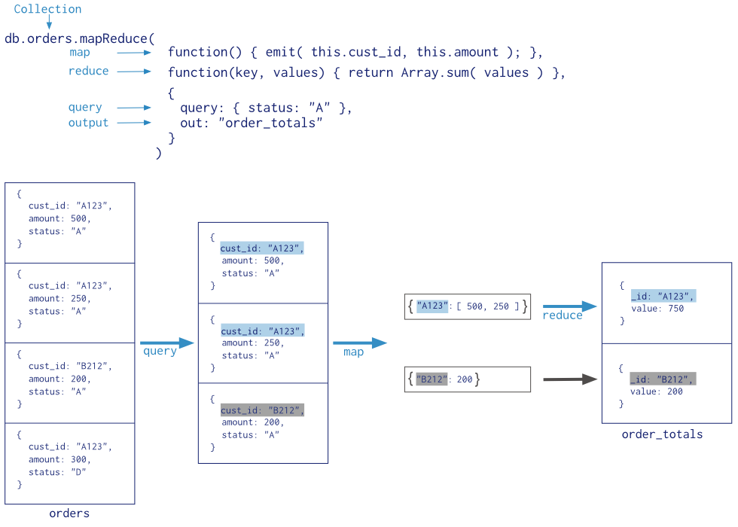

> use customer
switched to db customer

> db.orders.insert({cust_id:"A123", Amount:500, status:"A"})
> db.orders.insert({cust_id:"A123", Amount:250, status:"A"})
> db.orders.insert({cust_id:"B212", Amount:200, status:"A"})
> db.orders.insert({cust_id:"B212", Amount:300, status:"D"})
> db.orders.insert({cust_id:"A123", Amount:300, status:"D"})

> db.orders.find()
{ "_id" : ObjectId("54184428541fb1f5e350f06d"), "cust_id" : "A123", "Amount" : 500, "status" : "A" }

{ "_id" : ObjectId("5418467c541fb1f5e350f06e"), "cust_id" : "A123", "Amount" : 250, "status" : "A" }

{ "_id" : ObjectId("541846c6541fb1f5e350f06f"), "cust_id" : "B212", "Amount" : 200, "status" : "A" }

{ "_id" : ObjectId("541846e1541fb1f5e350f070"), "cust_id" : "B212", "Amount" : 300, "status" : "D" }

{ "_id" : ObjectId("54184713541fb1f5e350f071"), "cust_id" : "A123", "Amount" : 300, "status" : "D" }

Map

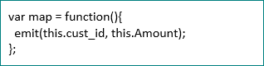

Reduce

MapReduce

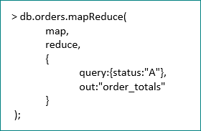

Résultats

{
"result" : "order_totals",
"timeMillis" : 31,
"counts" : {
"input" : 3,
"emit" : 3,
"reduce" : 1,
"output" : 2
},
"ok" : 1,
}

> db.order_totals.find()
{ "_id" : "A123", "value" : 750 }
{ "_id" : "B212", "value" : 200 }
>

Aggregation Framework

Nous allons faire la même chose avec l’aggrégation framework.

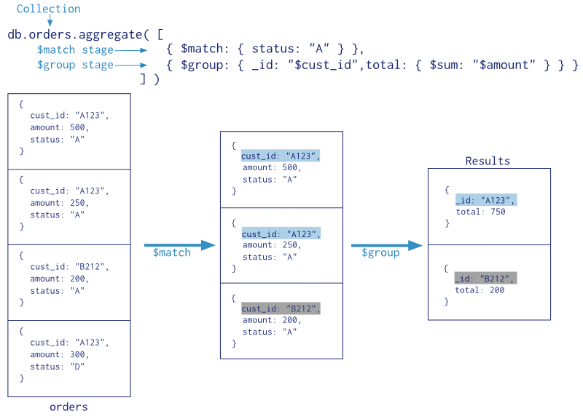

> db.orders.aggregate([{$match:{status:"A"}},{$group:{_id:"$cust_id",total:{$sum:"$Amount"}}}])
{ "_id" : "B212", "total" : 200 }
{ "_id" : "A123", "total" : 750 }

