Aggregation Framework

>mongoimport -d test -c products < products.json
connected to: 127.0.0.1
2014-04-27T08:03:06.506+0200 imported 10 objects

Aggregation simple
Trouver le nombre de produit par manufacturer.

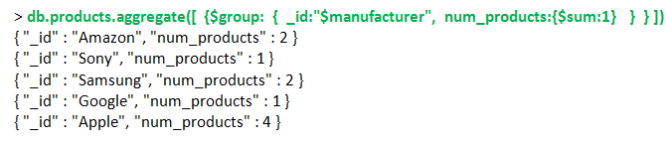

Groupe
Nombre de products de chaque manufacturer pour chaque category.

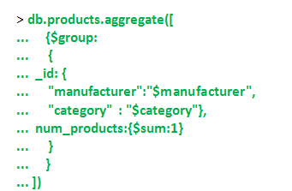

{ "_id" : { "manufacturer" : "Amazon", "category" : "Tablets" }, "num_products" : 2 }
{ "_id" : { "manufacturer" : "Apple", "category" : "Laptops" }, "num_products" : 1 }
{ "_id" : { "manufacturer" : "Google", "category" : "Tablets" }, "num_products" : 1 }
{ "_id" : { "manufacturer" : "Sony", "category" : "Laptops" }, "num_products" : 1 }
{ "_id" : { "manufacturer" : "Samsung", "category" : "Tablets" }, "num_products" : 1 }
{ "_id" : { "manufacturer" : "Samsung", "category" : "Cell Phones" }, "num_products" : 1 }
{ "_id" : { "manufacturer" : "Apple", "category" : "Tablets" }, "num_products" : 3 }

$sum
La somme des prix pour chaque mnufacturer.

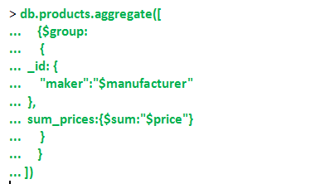

{ "_id" : { "maker" : "Amazon" }, "sum_prices" : 328 }
{ "_id" : { "maker" : "Sony" }, "sum_prices" : 499 }
{ "_id" : { "maker" : "Samsung" }, "sum_prices" : 1014.98 }
{ "_id" : { "maker" : "Google" }, "sum_prices" : 199 }
{ "_id" : { "maker" : "Apple" }, "sum_prices" : 2296 }

Write an aggregation query to sum up the population (pop) by state and put the result in a field called population.

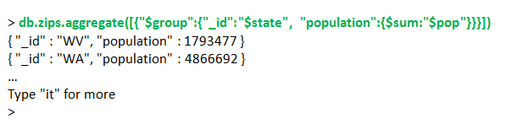

$avg

Trouver le prix moyen par category.

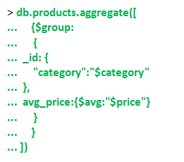
{ "_id" : { "category" : "Laptops" }, "avg_price" : 499 }
{ "_id" : { "category" : "Cell Phones" }, "avg_price" : 563.99 }
{ "_id" : { "category" : "Tablets" }, "avg_price" : 396.4271428571428 }

$addToSet
Lister les « category » par « manufacturer ». Cette liste contient des éléments uniques.

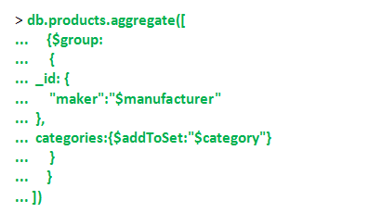

{ "_id" : { "maker" : "Amazon" }, "categories" : [ "Tablets" ] }
{ "_id" : { "maker" : "Sony" }, "categories" : [ "Laptops" ] }
{ "_id" : { "maker" : "Samsung" }, "categories" : [ "Tablets", "Cell Phones" ] }
{ "_id" : { "maker" : "Google" }, "categories" : [ "Tablets" ] }
{ "_id" : { "maker" : "Apple" }, "categories" : [ "Laptops", "Tablets" ] }

$push
Lister les « category » par « manufacturer ».

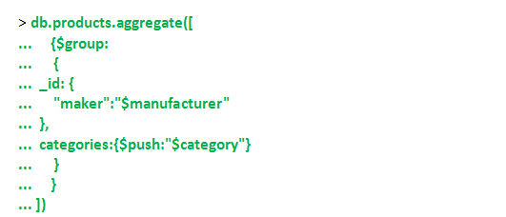

{ "_id" : { "maker" : "Amazon" }, "categories" : [ "Tablets", "Tablets" ] }
{ "_id" : { "maker" : "Sony" }, "categories" : [ "Laptops" ] }
{ "_id" : { "maker" : "Samsung" }, "categories" : [ "Cell Phones", "Tablets" ] }
{ "_id" : { "maker" : "Google" }, "categories" : [ "Tablets" ] }
{ "_id" : { "maker" : "Apple" }, "categories" : [ "Tablets", "Tablets", "Tablets", "Laptops" ] }

$max et $min
Déterminer le prix « price » maximum de chaque « manufacturer ».

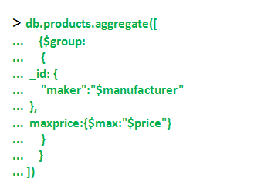

{ "_id" : { "maker" : "Amazon" }, "maxprice" : 199 }
{ "_id" : { "maker" : "Sony" }, "maxprice" : 499 }
{ "_id" : { "maker" : "Samsung" }, "maxprice" : 563.99 }
{ "_id" : { "maker" : "Google" }, "maxprice" : 199 }
{ "_id" : { "maker" : "Apple" }, "maxprice" : 699 }

$project

> db.products.findOne()
{
"_id" : ObjectId("535c9d9a3a9816733480ee86"),
"name" : "iPad 16GB Wifi",
"manufacturer" : "Apple",
"category" : "Tablets",
"price" : 499
}
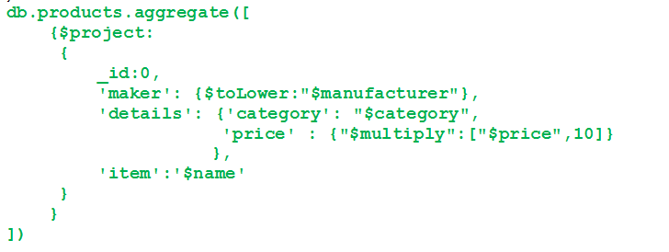

{ "maker" : "apple", "details" : { "category" : "Tablets", "price" : 4990 }, "item" : "iPad 16GB Wifi" }
{ "maker" : "apple", "details" : { "category" : "Tablets", "price" : 5990 }, "item" : "iPad 32GB Wifi" }
…

Importer zips.json

$match
Filtre n : 1

use test
> db.zips.findOne()
{
"_id" : "35004",
"city" : "ACMAR",
"loc" : [
-86.51557,
33.584132
],
"pop" : 6055,
"state" : "AL"
}

Rechercher tous les documents avec « state » egal « NY »

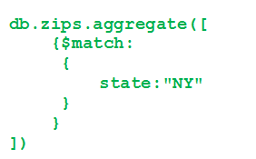

{ "_id" : "06390", "city" : "FISHERS ISLAND", "loc" : [ -72.017834, 41.263934 ], "pop" : 329, "state" : "NY" }
{ "_id" : "10001", "city" : "NEW YORK", "loc" : [ -73.996705, 40.74838 ], "pop" : 18913, "state" : "NY" }
{ "_id" : "10002", "city" : "NEW YORK", "loc" : [ -73.987681, 40.715231 ], "pop" : 84143, "state" :"NY" }

…

Rechercher la population totale par « city » de l’etat « state » de « NY »

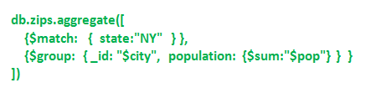

{ "_id" : "ELMIRA HEIGHTS", "population" : 7918 }
{ "_id" : "WELLSVILLE", "population" : 9645 }
{ "_id" : "WATKINS GLEN", "population" : 4584 }
{ "_id" : "VAN ETTEN", "population" : 1477 }
…

$sort

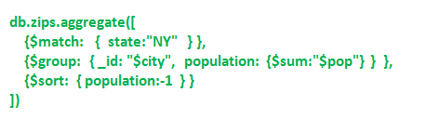

{ "_id" : "BROOKLYN", "population" : 2300504 }
{ "_id" : "NEW YORK", "population" : 1476790 }
{ "_id" : "BRONX", "population" : 1209548 }
{ "_id" : "ROCHESTER", "population" : 396013 }
….

$limit et $skip
A utiliser avec sort sinon résultat non définie.

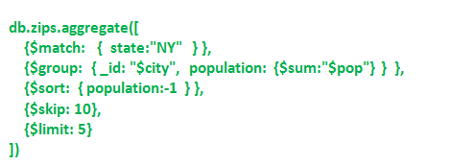
{ "_id" : "ASTORIA", "population" : 165629 }
{ "_id" : "JACKSON HEIGHTS", "population" : 145967 }
{ "_id" : "FAR ROCKAWAY", "population" : 100646 }
{ "_id" : "RIDGEWOOD", "population" : 85732 }
{ "_id" : "BINGHAMTON", "population" : 83017 }

$first et $last

Find the largest city in every state.

Phase 1 :

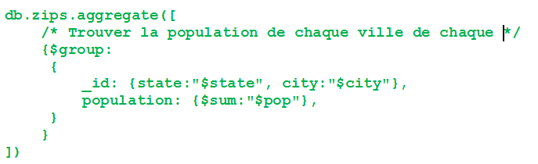
{ "_id" : { "state" : "WY", "city" : "THAYNE" }, "population" : 505 }
{ "_id" : { "state" : "WY", "city" : "SMOOT" }, "population" : 414 }
{ "_id" : { "state" : "WY", "city" : "LA BARGE" }, "population" : 606 }
….

Phase 2 :

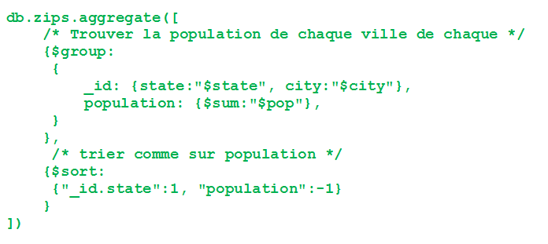

Phase 3 :

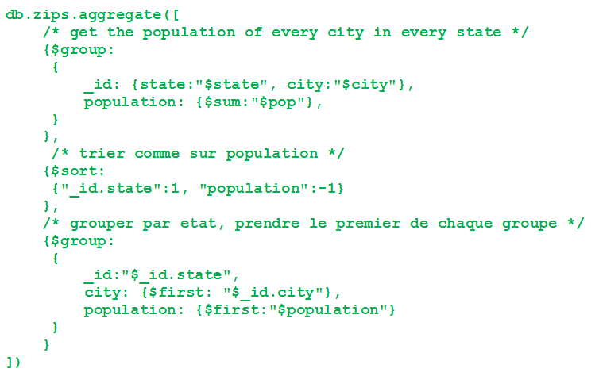

{ "_id" : "WV", "city" : "HUNTINGTON", "population" : 75343 }
{ "_id" : "WA", "city" : "SEATTLE", "population" : 520096 }
{ "_id" : "VT", "city" : "BURLINGTON", "population" : 39127 }
{ "_id" : "VA", "city" : "VIRGINIA BEACH", "population" : 385080 }
{ "_id" : "UT", "city" : "SALT LAKE CITY", "population" : 186346 }

