1)
gcc mmap.c -o mmap
gcc mcat.c -o mcat
gcc anon_mmap.c -o anon_mmap
2) echo "TEXT-TEXT-TEXT" > text.txt
3) ./mcat text.txt
Output:
TEXT-TEXT-TEXT
4) creating 1K file "test1k"
dd if=/dev/zero of=test1k bs=1K count=1
5) ./mmap test1k test_text!
Output:
Current string=
Copied "test_text!" to shared memory
Meaning:
file was empty (first 15 bites), now there is inputed text and \0
6) changeing mmap.c (adding sleep(5) ater mmap())
gcc mmap.c -o mmap
./mmap test1k test_new!
Ctrl+Z
jobs -l
Output:
[1]+ 10405 Stopped ./mmap test1k test_new!
7)
cat /proc/10405/maps
7e6dcf831000-7e6dcf832000 rw-s 00000000 08:02 6298257 /home/nelal/lab4/test1k
8) In order to get SIGBUS, we need our mapping to be bigger than our file and access memory in mapping, but out of the file.
Considering, that OS works with pages (usually 4096B)
dd if=/dev/zero of=test5b.txt bs=4096 count=1
9) Change mmap.c: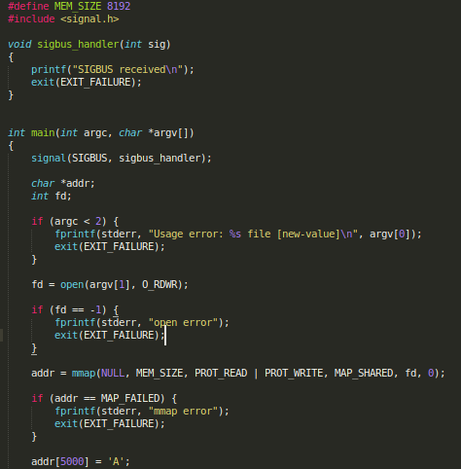
gcc mmap.c -o mmap
10) ./mmap test5b.txt aaa
SIGBUS received
11) Change mmap.c:

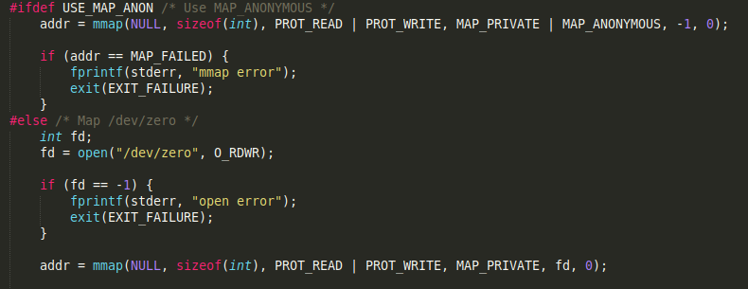

gcc mmap.c -o mmap
12) cat test1k
Outpput:
test_text!
./mmap test1k ABCDEF
cat test1k
Outpput:
test_text!
Meaning:
MAP_PRIVATE disabled applying changes in mapped memory to file on disk
13) Change mmap.c:

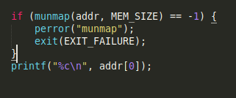

gcc mmap.c -o mmap
./mmap test1k ABCDEF
Current string=test_text!
Copied "ABCDEF" to shared memory
Segmentation fault (core dumped)
Meaning:
mapped memory is no more available and still we try to access it, so we get segffault
14) ./anon_mmap
Output:
Child started, value = 1
In parent, value = 2
Change mmap.c:
Photo1
gcc anon_mmap.c -o anon_mmap
Output:
Child started, value = 1
In parent, value = 1
Meaning:
After fork, child shares parent's mapped memory if MAP_SHARED
Sharing was disabled after changing to MAP_PRIVATE, so value remains untouched
15)
writer.c:

#include <stdio.h>
#include <stdlib.h>
#include <unistd.h>
#include <sys/mman.h>
#include <sys/stat.h>
#include <fcntl.h>

#include "semun.h"
#include "shm.h"

int main(int argc, char *argv[])
{
int semid, fd, bytes, transfers;
struct shmseg *shmp;

semid = semget(SEM_KEY, 2, IPC_CREAT | OBJ_PERMS);

if (semid == -1) {
fprintf(stderr, "semget error\n");
exit(EXIT_FAILURE);
}

if (initSemAvailable(semid, WRITE_SEM) == -1) {
fprintf(stderr, "initSemAvailable error\n");
exit(EXIT_FAILURE);
}

if (initSemInUse(semid, READ_SEM) == -1) {
fprintf(stderr, "initSemInUse error\n");
exit(EXIT_FAILURE);
}

fd = open("shared.dat", O_RDWR | O_CREAT, 0666);

if (fd == -1) {
fprintf(stderr, "open error\n");
exit(EXIT_FAILURE);
}

if (ftruncate(fd, sizeof(struct shmseg)) == -1) {
fprintf(stderr, "ftruncate error\n");
exit(EXIT_FAILURE);
}

shmp = mmap(NULL, sizeof(struct shmseg),
PROT_READ | PROT_WRITE,
MAP_SHARED, fd, 0);

if (shmp == MAP_FAILED) {
fprintf(stderr, "mmap error\n");
exit(EXIT_FAILURE);
}

close(fd);

for (transfers = 0, bytes = 0; ; transfers++, bytes += shmp->cnt) {

if (reserveSem(semid, WRITE_SEM) == -1) {
fprintf(stderr, "reserveSem error\n");
exit(EXIT_FAILURE);
}

shmp->cnt = read(STDIN_FILENO, shmp->buf, BUF_SIZE);

if (shmp->cnt == -1) {
fprintf(stderr, "read error\n");
exit(EXIT_FAILURE);
}

if (releaseSem(semid, READ_SEM) == -1) {
fprintf(stderr, "releaseSem error\n");
exit(EXIT_FAILURE);
}

if (shmp->cnt == 0) {
break;
}
}

if (reserveSem(semid, WRITE_SEM) == -1) {
fprintf(stderr, "reserveSem error\n");
exit(EXIT_FAILURE);
}

if (semctl(semid, 0, IPC_RMID, 0) == -1) {
fprintf(stderr, "semctl error\n");
exit(EXIT_FAILURE);
}

if (munmap(shmp, sizeof(struct shmseg)) == -1) {
fprintf(stderr, "munmap error\n");
exit(EXIT_FAILURE);
}

printf("Sent %d bytes (%d transfers)\n", bytes, transfers);

exit(EXIT_SUCCESS);
}

reader.c:
#include <stdio.h>
#include <stdlib.h>
#include <unistd.h>
#include <sys/mman.h>
#include <sys/stat.h>
#include <fcntl.h>

#include "shm.h"

int main(int argc, char *argv[])
{
int semid, fd, transfers, bytes;
struct shmseg *shmp;

semid = semget(SEM_KEY, 0, 0);

if (semid == -1) {
fprintf(stderr, "semget error\n");
exit(EXIT_FAILURE);
}

fd = open("shared.dat", O_RDONLY);

if (fd == -1) {
fprintf(stderr, "open error\n");
exit(EXIT_FAILURE);
}

shmp = mmap(NULL, sizeof(struct shmseg),
PROT_READ,
MAP_SHARED, fd, 0);

if (shmp == MAP_FAILED) {
fprintf(stderr, "mmap error\n");
exit(EXIT_FAILURE);
}

close(fd);

for (transfers = 0, bytes = 0; ; transfers++) {

if (reserveSem(semid, READ_SEM) == -1) {
fprintf(stderr, "reserveSem error\n");
exit(EXIT_FAILURE);
}
if (shmp->cnt == 0) {
break;
}

bytes += shmp->cnt;

if (write(STDOUT_FILENO, shmp->buf, shmp->cnt) != shmp->cnt) {
fprintf(stderr, "partial/failed write\n");
exit(EXIT_FAILURE);
}

if (releaseSem(semid, WRITE_SEM) == -1) {
fprintf(stderr, "releaseSem error\n");
exit(EXIT_FAILURE);
}
}

if (munmap(shmp, sizeof(struct shmseg)) == -1) {
fprintf(stderr, "munmap error\n");
exit(EXIT_FAILURE);
}

if (releaseSem(semid, WRITE_SEM) == -1) {
fprintf(stderr, "releaseSem error\n");
exit(EXIT_FAILURE);
}

fprintf(stderr, "Received %d bytes (%d transfers)\n",
bytes, transfers);

exit(EXIT_SUCCESS);
}

16)
#include <stdio.h>
#include <stdlib.h>
#include <fcntl.h>
#include <unistd.h>
#include <sys/mman.h>
#include <sys/stat.h>
#include <string.h>

int main(int argc, char *argv[])
{
int src_fd, dest_fd;
struct stat sb;
char *src_addr, *dest_addr;

if (argc != 3) {
fprintf(stderr, "Usage: %s src dest\n", argv[0]);
exit(EXIT_FAILURE);
}

src_fd = open(argv[1], O_RDONLY);

if (src_fd == -1) {
perror("Source file");
exit(EXIT_FAILURE);
}

if (fstat(src_fd, &sb) == -1) {
perror("fstat");
exit(EXIT_FAILURE);
}

dest_fd = open(argv[2], O_RDWR | O_CREAT | O_TRUNC, 0666);

if (dest_fd == -1) {
perror("Destination file");
exit(EXIT_FAILURE);
}

if (ftruncate(dest_fd, sb.st_size) == -1) {
perror("ftruncate");
exit(EXIT_FAILURE);
}

src_addr = mmap(NULL, sb.st_size,
PROT_READ, MAP_PRIVATE,
src_fd, 0);

if (src_addr == MAP_FAILED) {
perror("mmap source");
exit(EXIT_FAILURE);
}

dest_addr = mmap(NULL, sb.st_size,
PROT_READ | PROT_WRITE,
MAP_SHARED,
dest_fd, 0);

if (dest_addr == MAP_FAILED) {
perror("mmap destination");
exit(EXIT_FAILURE);
}

memcpy(dest_addr, src_addr, sb.st_size);

if (msync(dest_addr, sb.st_size, MS_SYNC) == -1) {
perror("msync");
exit(EXIT_FAILURE);
}

munmap(src_addr, sb.st_size);
munmap(dest_addr, sb.st_size);

close(src_fd);
close(dest_fd);

return 0;
}

