1) cc message_create.c init_queue.c -o create
2) ./create
Output:
0
Meaning:
The id of message queue we just created
3) change message_send.c
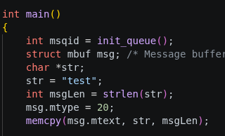

4) cc message_send.c init_queue.c -o send
5) ./send
6) sudo adduser new_user (etc.)
7) ipcs -q
Output:
------ Message Queues --------
key msqid owner perms used-bytes messages
0x0000000f 0 deb 600 4 1
Meaning:
used-bytes - amount of bytes that are currently in message queue
8) change message_receive.c
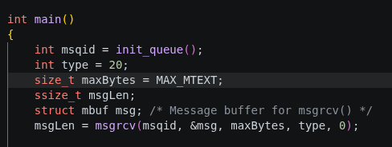

9) cc message_receive.c init_queue.c -o recieve
10) ./recieve
11) ./recieve
Output:

Meaning:
no messages of targeted type left in message queue,
so waiting till one appears
12) (new_user) ./send
(old_user)
Output:
Received: type=20; length=4; body=test
Meaning:
the desired message finally entered message queue!
13) change message_receive.c

14) change message_receive.c

15) (asked to change message_create.c, but probably init_queue.c)
change init_queue.c

16) (probably we were supposed to compile and run message_create couple of times)
cc message_create.c init_queue.c -o create
./create
./create
./create
17) cc message_rm.c -o rm_que
./rm_que 3
./rm_que 2
18) gcc message_chqbytes.c -o change_bytes
./change_bytes 1 5
19) change message_send.c

cc message_send.c init_queue.c -o send
./send
Output:
(terminal freese)
Meaning:
we try to fit message of 12 bytes in a que, where mazimum size of a message is 5 bytes

