ask-rep
(on-line repository)

Ventsislav Polimenov (1457989)
Dhiraj Narwani (1431555)
Cloud Computing COMSM0010

Contents:

- Overview
- Cloud Computing
- Planning
- Implementation
- Log In
- Database functionality
- Front-end design and implementation
- Customizing repositories
- Create repository
- Create/Upload Files
- Custom Search Engine
- Search functionality
- Trending repositories
- Results
- Future work
- Summary

- Overview

The main objective for this project is to create an online repository where users will be able to create, upload and share their files amongst other users. Users will be able to create public repositories in order to upload or create new files and store them in folders/sub-folders. The main reason for creating custom files is to allow the user to write pieces of code and if needs be whilst typing the application will recommend online code snippets to him/her. This will permit the user to search for code through the application instead of typing their query in Google.

Furthermore, these files are saved on the cloud and can be placed in new or existing repositories according to the users’ preference. The repositories are available to the public through trending repositories and the files can be viewed straight from the browser. The website also includes a login system where guests can only access repositories created by others users and also they can view the repository structure and files created in it. Alternatively, the public can sign in into the website and this connects to the users' google account. The user can then create personal repositories and customize them how they wish.

- Cloud Computing

Throughout the years we've seen a big leap in cloud computing where Google has been the prominent leader in creating robust, efficient and response applications specifically designed for the public. Ask-rep is a cloud application which targets programmers individually and those employed in IT companies.

Our goal was to create a tool for the public to access their files from anywhere they want. Instead of storing their information on a PC, the cloud allows users access information from wherever they are with fast responsive. This is highly useful for IT companies that have branches in many locations so that all data is stored in one central location and can easily be accessible and modified.

Ask-rep has specifically been designed to automatically scale as more repositories, files and folders are created. We see that as more data is included, the users' experience improves because more data is available to use. Googles' Cloud ensures scalability throughout the website and makes sure that the performance is still efficient and responsive.

Generally as scalability increases, more profit is generated due to the increase in number of users and data accessing the website. In this case the website is free to use by anyone and doesn't include a payment scheme. However, our intention was to provide a service to the public to store their information on the cloud free of charge instead of using third party applications, whereas some of these need to be purchased.

In a website, users want to make use of quick tools which accommodates their needs. By creating the custom search tool developers will save huge amounts of time searching through Google looking for code snippets. Usually when developers code, they're unsure if they are going to get stuck at a specific point. Knowing that this tool is available to them in the background, ensures that they can use it whenever they wish. Ultimately this improves the user experience and raises awareness to other developers.

Security is one of the most important aspects in cloud computing. Nowadays as more IT companies and developers make use of the cloud, more hackers are trying to break into their software. As the web increasingly gets larger and easily exposed to everyone, cloud companies focus on providing the best security.

We enforced database security such as relationships between tables including the appropriate foreign key relations. Since certain functions are restricted to users we included the necessary checks to prevent guests accessing these functions. Sessions were used to only allow users with an authorized session to create and upload files. Guests could also use the website by accessing repositories of other users and also viewing the structure and files within it. This allows anyone to use the website including those who don't wish to sign in or “become part of the website”.

Also, the client-server based model allowed us to cater for failed and success responses. This prevents the website from crashing due to random exceptions occurring.
By saving user information into the database can allow us to track unwanted users from spamming or harming the website intentionally.

We see that ask-rep mainly relies on user-generated content. As users upload their information, they are shaping and building the website. Most importantly by sharing their information with others allows others to continue build the website faster and shaping it to include a huge amount of information in a short period of time. This kind of website minimizes the amount of maintenance required so the website can solely function on user-generated content.

With cloud computing the website has low latency and reliable network connections. By increasing the number of users from different locations the website still remains robust and efficient. This spread out enables the website to expand with information and user-generated content. Google ensures their servers cater for users from all locations around the world. The appropriate servers are used depending on where the website is being accessed from. In turn this allows the website to function faster due to the minimum proximity to where users access the website.
- Planning

The project took us 57 days to finish (see Appendix) it and tasks were divided as follows:
Dhiraj Narwani
- Front-end design and implementation (HTML, CSS, JavaScript and Java code).
- Database Creation – All files, repositories, folders, users will be stored in a database.
- Sign in/out functionality – Users can login with their Google account to access restricted functionalities.
- Customizing repositories – Creating a repository where folders and sub-folders can be included.
- Upload files – Uploading existing code files with specific extensions to the database.
- Viewing files – View existing files from public repositories in the browser.

Ventsislav Polimenov
- Google Custom Search – Functionality that will query google in order to extract code tags.
- Extract code tags – Extracting code snippets through ‘code tags’ from pre-defined websites.
- Display code – Displaying code snippets in panels.
- Creating new files – Saving files as BLOBS in the database.
- Trending Repositories – List of all repositories in descending order (recent first).

- Implementation

We decided to use Google Web Tools (GWT), which makes use of Java programming language, in order to implement this project. Furthermore, we needed Java Runtime Environment 1.7 or higher, Eclipse Luna 4.4.0, Mozilla Firefox 25.0 and GWT Software Development Kit (SDK). In addition to that we created a Google Cloud application on Google Cloud from where we got the App ID, which was used for the eclipse project. Moreover, we used some external libraries that helped us to extract the code tags from the html pages. The following subsections provide detailed information about all features of our application.

Sub-sections as follows:

- Front-end design and implementation

We started off by creating the front-end design including HTML and CSS for our cloud application. This included the website theme, menu structure, logo and custom buttons. A database was needed to manage and store data such as user information.

- Database functionality

Initially we created the database locally using MySQL and created the necessary table structure. Our database consisted of 4 tables; users, repositories, folders and files. This enabled us to create a repository-like structure to manage folders/sub-folders and files. We ensured relationships between tables were set to keep the database secure. In order to deploy it onto the cloud we used Google's Cloud SQL. We created an instance which provided us with an IP address. This enabled us to connect to the cloud and import the local database through command line.

- Log In

In order to access certain functionalities of the website such as uploading and creating files users would need to sign in using their Google account. The user information is stored in the database which allows us to keep track of the files/folders/repositories they create. Also, this allows users to have their own personal repositories in a more self-managed manner.

Users who don't have a Google account or don't wish to sign in can browse through Trending Repositories created by other users. We will discuss this in section …

- Create/Edit repository

Once a user logs into the website he/she can create/edit personal repositories. In the menu there are two links; “Create Files” and “Upload Files”. By clicking on either one of them the website will redirect the user to a section where he/she could create or select an existing repository. This enables the user to create fresh repositories by adding folders/sub-folders and files. Also, it allows them to edit an existing repository they created previously and add the necessary folders/files. This data is stored in the repository table along with timestamps of when it was created or updated.

- Customizing repositories

In the repository section users can add folders and files to manage their data appropriately. They can easily navigate through existing folders in the repository by clicking on the respectful folder name. This provides the user with a repository experience where he/she could create infinite folders and easily traverse back to the root.

Alternatively they can add custom folders by clicking on “Create Folder” located beside the directory listing. The user can see the path of which folders they've accessed and the website will indicate the user the one he/she is currently accessing. The created folder will then be placed in the current directory.

The structure of the database allows the website to store folders into 1 table where each folder links to a parent folder unless it's created in the root. Once a folder is created, the timestamps is then updated for its parents and the repository that its created in. This provides the user with continuous updated data where he/she can keep track of the folders/repositories that were last accessed.

- Create/Upload/View Files

When accessing a specific repository the user can be able to create a file and write their own piece of code in the website. Instead of actually using an external application such as “eclipse” he/she can create code snippets or files and store them in their own repository. The user is provided with a code panel (text area) which includes customized tabbing so he/she can indent code like “eclipse”.

Furthermore, if the user wishes to upload a file created from an external application, he may do so by uploading single or multiple files in a specific repository. The user is restricted to 5 extensions (code languages) which are “.py, .js, .cs, .cpp and .java”. The website is using a third party library called “GWT Uploader” [3]. It allows you to handle specific events in order to improve the user experience.

In each repository the files will be listed accordingly to where the user has created them. The user can view the files' contents by clicking on the file name. He/she won't be able to download the file to their PC but only view it through the browser. This also applies to guest users who don't login into the website. The user can access others users' files and use them how they wish.

- Trending repositories

As you enter the website the first page will list you all the repositories that have recently been created. They are sorted in descending order by repository date. Guests will be able to browse through recently created repositories and view their files and folders. This provides users/guests with constantly updated information depending on how much the website is being is used. Alternatively a logged in user can view all repositories that are not created by him/her. The reason is because he/she can view the repositories when creating/uploading files so in this way we remove duplications and suggest better repositories.

- Search functionality
- Hot-Button for quick search

In order to make the user's experience with our Cloud Application, we decided to implement a hot-button for the search functionality. Once the right-arrow is pressed, the program invokes a Custom Search Engine (CSE) and send a query to Google. We also decided to provide the user with the choice of language – Java, Python, C++, and C#. At the end the query that is sent to Google through our CSE consists of the user's highlighted phrase and chosen language followed by the name of the website. However, currently the name of the website is hard-coded to be Stack Over Flow, as it is probably the best for any kind of code that one could possibly be interested at.

- Custom Search Engine

This is a function provided by Google [Google Developer Tools], so that developers can integrate customizable search engines in each and every website and also in online applications. In order to integrate this to our Cloud Application, we used the search engine' URL (placed at “googleapis.com/customsearch/”), the cx_key, which serves as an authenticator for the engine, the API_KEY provided by google, and JavaScript Object Notation (JSON) output format.

- Jsoup lib

When user's query is sent to Google, our App gets all results as links to web pages and stores them all to a certain data structure (ArrayList<String>) allocated on the Cloud. Once this process is done, the same data structure is sent to an iterator, which opens each link in order to access the html code for every web page. The iterator seeks for “<code>” tags in the “html”, when found it extracts the text in between and add it to another data structure (HashMap<String, Element>). However, for this functionality we used an external library for html stripping [2] called Jsoup.

- Code snippets rating

In order to get the best possible result for the user and satisfy his needs, we implemented a rating method, which rates the extracted code snippets before they actually get displayed for the user. The rating method works as follows. Firstly, we have some predefined language code tags that serve as language identifiers. If the language of the extracted snippet does not match the language chosen by the user, snippet is getting penalized. However, if a key word occur more than once the rating increases by 5 points.

- Displaying code snippets

For displaying the snippets we decided to use an “accordion” type of container that manages a list of sections of widgets, each with a header [1], provided by Google Web-Tool. We gather a minimum of twenty code snippets and display next to the text box assigned for coding.

- Results

As a final product we got a fully working cloud application, uploaded on Google Cloud. Users are able to create repositories with a proper repository structure, create and edit code files and also seek code through our Custom Search Engine. Code snippet results are provided by Google and examined by our rate algorithm, which finds the most appropriate snippets and display them to the user.

- Future work

As a future improvements we could implement our text editor as a panel, which detects tokens and add colours to them. Also we can integrate to it both run/compile and debug functionalities so that the it would not be just a simple text editor, but an online IDE.

Another good thing we could possibly do is to improve our rating algorithm, which is based on language classification and word occurrences. As mentioned above, the current language classification is based on a hard coded array of languages. However, we could use a more sophisticated learning technique, which can detect and understand the programming language on its own. We could also implement a word occurrences technique with better performance for better results.

- Summary

Appendix

References

[1] Class SectionStack
Source: http://www.smartclient.com/smartgwt/javadoc/com/smartgwt/client/widgets/layout/SectionStack.html

[2] Jsoup: Java HTML Parser
Source: http://jsoup.org/

[3] GWT Uploader
Source:http://www.moxiegroup.com/moxieapps/gwt-uploader

[4]

Flow Chart

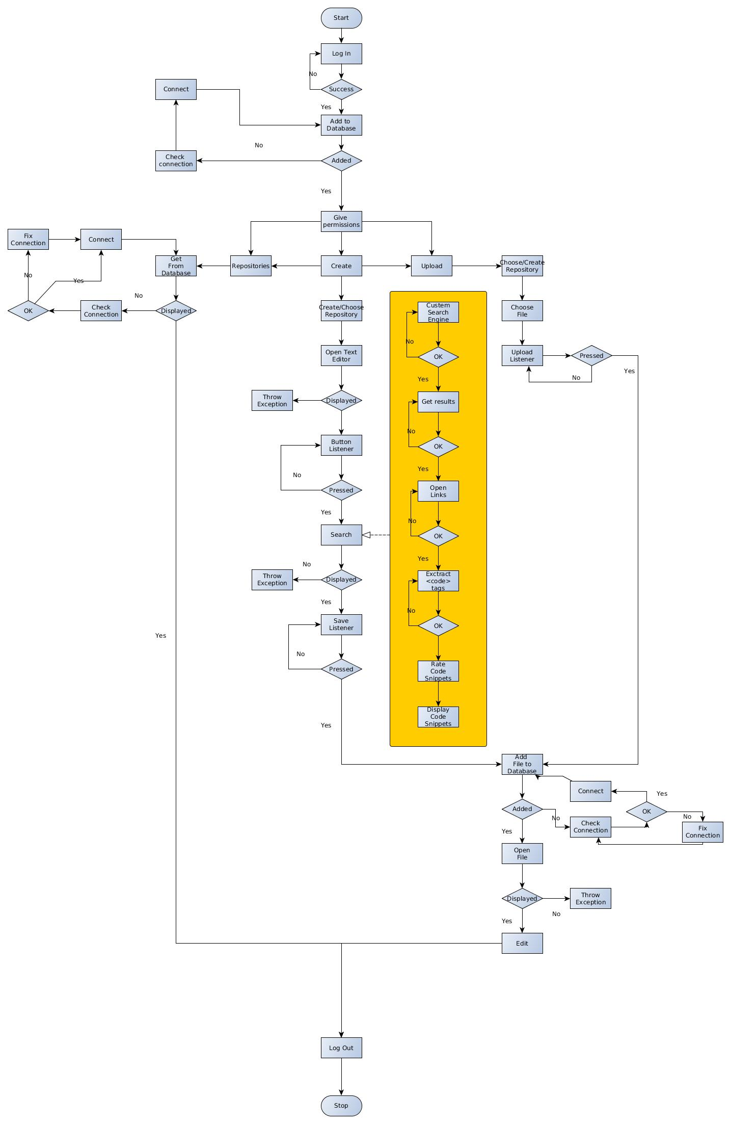
- import .jpg image of the chart diagram preferably on one column page

Gantt Chart

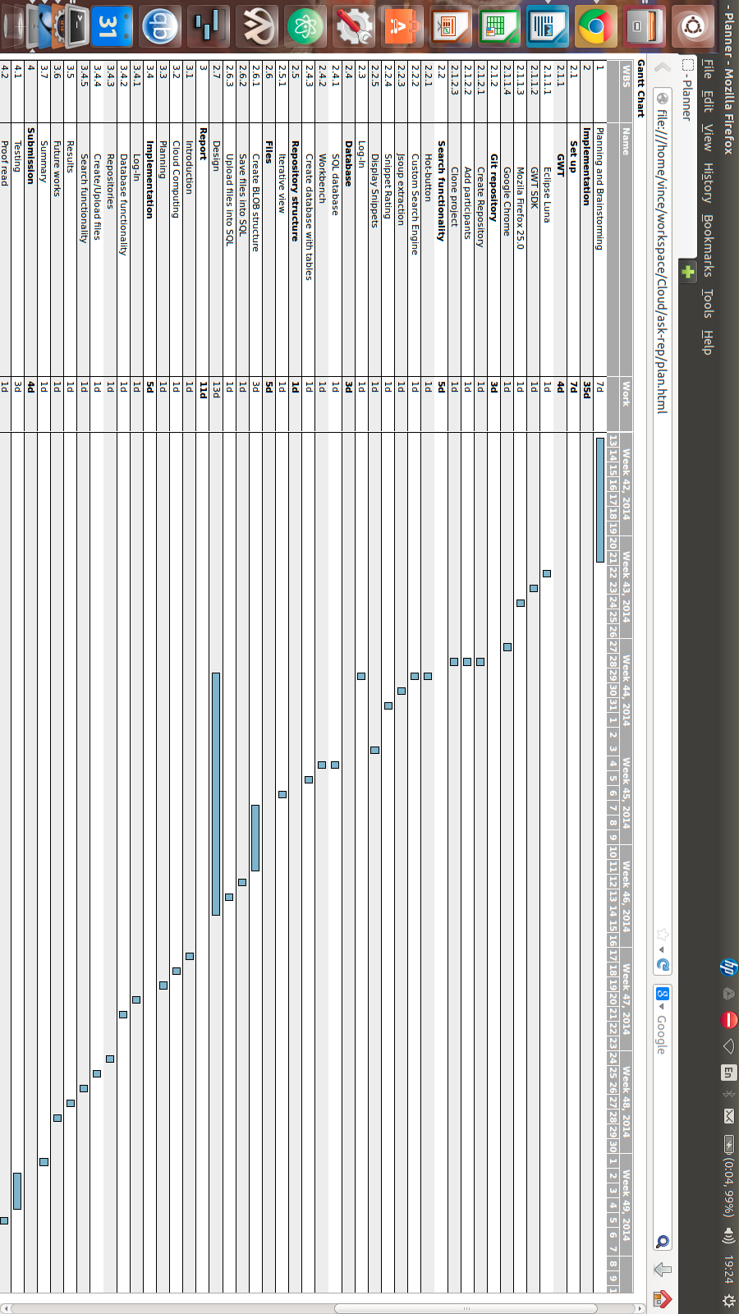
- import .html file

