**ARTIFICIAL**

**INTELLIGENCE**

**PRACTICAL WORK 2:**

**Knowledge**

**Based**

**System**

**Javier Carrascal Hernández**

**Víctor Ponce López**

**Barcelona, December 7th 2010**

**INDEX**

1. **Identification of problem 3**
   1. **Viability of KBS construction 3**
   2. **Information sources 3**
   3. **Description and goals 4**
2. **Conceptualization 6**
   1. **Concepts of domain 6**
   2. **Descomposition of the problem 11**
   3. **Process and organization 12**
3. **Formalization 13**
   1. **Initial Prototype 13**
      1. **Ontology 13**
      2. **Hierarchy graphic 16**
   2. **Evaluation and reasoning process 17**
   3. **Final Design 17**
      1. **Resolution methodology 17**
4. **Implementation 19**
   1. **Detailed ontology and classes 19**
   2. **Organization of modules 22**
   3. **Incremental methodology 27**
5. **Test 28**
   1. **Created new individuals 28**
   2. **Existing individuals 54**
   3. **Explanation of tests 65**
6. **Identification of Problem**
   1. **Viability of KBS construction**

The proposed problem asks for a **system for a gym chain** “*No pain, no gain”* able to make a recommendation of **exercises** for a week depending on several features of an individual.

The first step is to identify why a knowledge based system is necessary to solve the problem. The reasons for this are that the system has to offer flexibility with a lot of information, simulating a rational behaviour based on the observations. In the same way, the system should suit to the individual and learn about it: his profile, interests or goals, problems, weight, height… in order to give the proper program for him.

There are several ways to solve the problem because the decisions that the system has to take are not strictly given, we only have an approach or an idea of what we want to obtain. Then and before all, the problem is described and contextualized in order to see the requirements and what are the goals that the system should meet, and later we will see how we can solve these requirements and the way taken for this.

* 1. **Information sources**

The ideal ‘expert’ for this system would be a trainer or a physical educator that could explain us the set of restrictions and relations among the physical features of people and their exercises. However, we used our knowledge about this issue and our doubts have been solved by looking for them in internet and by professors. Thus, these three have been the experts for this system.

* 1. **Description and goals:**

The problem can be described and contextualized with 3 general steps: asking and obtaining knowledge of the individual, analyse the individual and the appropriated exercises for him and mount the schedule for a week depending on his daily time of dedication.

* + 1. Asking and obtaining knowledge of the individual

In this step, two kinds of data can be differentiated.

**Non-informative data:** The data which is asked by intuition or complete the data, but don’t give information to be treated by KBS.

* Some personal data like the name or last name.

**Informative data:** The data will be treated by the KBS to make the next steps. These data will give information about the constraints for the individual to assign or reject the set of exercises which the gym provides.

* Rest of personal data like the age, which give us information about if the individual is young or old.
* Goals or motivations of the individual to go to the gym.
* Routine or habits that the individual has and their characteristics which can cover some of the exercises and give us an idea of the initial difficulty or intensity for the individual.
* Physical features like the height, weight.
* Maximum and minimum pressure and information about the individual problems with his diet (excess of greases, excess of sal…)
* Temporal or fixed incapacity of the individual to do some exercises: lesions, mobility problems…
* Results of a mandatory test which the individual has to do, asking for his tiredness sensation, dizziness, muscular tension and his pulsations per minute that are calculated by a machine.
* Daily dedication of the individual in the gym.
  + 1. Analyse the individual and the appropriated exercises for him
* Calculation of the difficulty/intensity that the individual can endure from his habits. This factor may be altered by an excess or lack of the body mass of the individual or by negative results from the mandatory test (pulsations per min, sensation of tiredness, dizziness and muscular tension).
* Application of a set of filters to all the set of exercises in order to assign the set of proper exercises for the individual:
  + The first filtering to apply will be through the goal that the individual wants to achieve with the set of exercises.
  + The next filtering will be done by comparing the difficulty or intensity of the individual with the difficulty of the set of exercises.
  + Incapacity of the individual and his muscular problems are other filters to take in account in the assignment with the contraindications of the exercises.
    1. Mount the schedule for a week

This is the last step in which we have the set of appropriated exercises to the individual analysed. But in this point the system has to make a coherence planning of the exercises for a week from the daily dedication of the individual. The complexity of the planning depends on the criteria chosen, so it can be as complex and extendible as we want. However, we can consider some ideas that we think are clear: the main goals of the individual have to be considered and prioritized for the order of the exercises. For instance, if the goal of an individual is to reduce his weight, the exercises which burn more calories should be prioritized in his schedule, or an individual who wants to rehabilitate a lesion should have in his schedule the exercises that benefit the affected zone. The sense of prioritizing the exercises is due to a possible large number of exercises assigned to the individual and the fact of doing the prioritized exercises firstly, when the individual has the maximum energy.

1. **Conceptualization**

To reach a good solution of the problem, it's needed to figure out what elements must be taken into account, and the relationship existing between them. It's helpful to learn how a truly expert would do it, which means: the knowledge needed, the rules that should be used, and finally, the common sense.

* 1. **Concepts of domain:**

After reading the problem statement, we made a first list of concepts that are being taken into account, which will be showed below. At the beginning, we just make a list of concepts, without taking into account their relationship, just the data that each concept would include.

* **Goal:**  All the goals that the individual wants to achieve, which can be any combination of the following:

- Maintenance

- Get Fit

- Reduce Weight

- Musculation

- Flexibility

- Balance

- Rehabilitate

* **Diet**: A description of the user basis feeds, focusing on the defects. It can be a balanced diet without any problem, or can be a set of the following ones:

- Lack of Calcium

- lack of Vitamins

- Lack of Iron

- Excess of greases

- Excess of Sal

- Snacking

* **Basic Physical Condition:** A complete description of the physical status of the user at the beginning, which includes:

**Body mass index**: Computed with the height and weight.

**Height**

**Weight**

**Blood maxim pressure**

**Blood minim pressure**

**Muscular problems**: A list of the muscular problems that the user is experiencing, in case there are several, or none otherwise. The possible problems are showed below:

- Back pain

- Limited mobility

- Ankle sprain

- Wrist sprain

- Neck pain

- Arm pain

- Knee ligaments

* **Initial Test:** Results of an initial test that must be done by each new user once it’s arrival, in order to help the KBS to choose a proper difficulty/intensity for the user. The test consists in doing two exercises, running and biking, during ten minutes and will retrieve some useful information:

**Pulsations per minute**: Computed by the system, the range of this value should be between 100 and 180, after the test done. More would be considered as Tachycardia, and less would mean that he user is Athletic or suffers Bradycardia.

**Muscular Tension**: After doing the exercise it can be: normal, quite, or high.

**Tiredness Sensation**: Tiredness sensation of the user after the test. It can be: few, normal, quite, or huge.

**Dizziness**: Some users can experience dizziness sensation, so it could be: nonexistent, few, quite, or high.

* **Person:** Basic information of each person that joins to the gym.

**Name:** Name of the person.

**Last Name:** Last name of the person.

**Difficulty Intensity:** Difficulty/intensity that the person is ready for hold (Calculated by person and exercises features). It can be: easy, medium or hard.

**Age:** Age of the person, must be higher than sixteen.

* **Habit:** In order to establish an initial intensity of the exercises that the user should do, it’s needed to do some research of its usual habits. A user can have several habits, and they can be either beneficial or harmful. The following information is stored of each habit:

**Name of the habit**: Brief description of the habit.

**Index Duration**: This index is an internal field that represents the interval of duration used to compute the duration-intensity relation of a habit.

**Habit Class**: Specifies if is the habit is positive or negative for the health of the person.

**Duration**: Duration of activity in minutes.

**Frequency**: Frequency of activities, which can be: few, medium, quite or very high.

* **Exercise:** Each exercise have its own characteristics, and they all have the following data:

**Name of the Exercise:** Descriptive name of the exercise.

**Max Duration:** Maximum duration of the exercise, in minutes.

**Contra Indications:** Some exercises are not recommended for some kind of muscular problems. The problems, in case exist are: back pain, limited mobility, ankle sprain, wrist sprain, neck pain, arm pain, and knee ligaments.

**Difficulty Intensity:** Difficulty/intensity of the exercise. Can be: easy, medium, or hard.

**Minim duration:** Minimum duration of exercise, in minutes.

**Minim repetitions:** Minimum number of repetitions of the exercise.

**Maxim Repetitions:** Maximum number of repetitions of the exercise.

**Muscular Groups:** Muscular groups trained by the exercise. It can be a set of: deltoids, biceps, triceps, quadriceps, pectoralis, abdominal, lumbar, twins, and dorsals.

**Blood Minim Pressure:** Minimum blood pressure recommended for doing the exercise.

**Blood Maxim Pressure:** Maximum pressure recommended for the exercise.

**Number of calories burned:** Approximate number of calories burned by doing the exercise.

**Series:** Number of series of the exercises.

**Muscular Problems:** Some exercises are specially designed to rehabilitate, fortify or help to fix some muscular problems. These problems, in case they exist, can be a set of: back pain, limited mobility, ankle sprain, wrist sprain, neck pain, arm pain, and knee ligaments.

After that, we tried to establish the relationships of the concepts, make some hierarchy sub concepts, and then we obtain the following concepts schema:

* **Person:**

**Name**

**Last Name**

**Difficulty Intensity**

**Age**

**Goal**

**Basic Physical Condition**

Diet

**Initial Test**

**Habits:** Each user can have different habits with different durations and frequency. The habits can be of three types and each type is divided in subtypes.

* + - In-Work
      * Sitting
      * Weight Charge
    - Out-Work
      * Upstairs
      * HomeWork
    - Movement
      * Walk
      * Bike

**Exercises:**

* **Goal:** Each exercise must have at least one goal. It can be any combination of the values: maintenance, get fit, reduce weight, musculation, flexibility, balance, and rehabilitate.

An exercise can be classified in different types:

* Without weights: Which includes also:
  + Bike
  + Floor: Involves exercises such as abdominals, stretching and dominates.
  + Run
* With weights: This includes all the exercises related with weight charge, like biceps, triceps, quadriceps, and so.

As it will be explained later, we were doubtful, and we spent many time thinking about how to represent some concepts, like Goal, Diet, Basic Physical Information, and Habits. We didn’t know if it would be better to put them as a multi-slot or if we should make a new class with each one. Finally, some of them turned into a new class, and the rest remained as a multi-slot, because we didn’t need to store any extra data inside each sub-type of the concept.

* 1. **Descomposition of the problem**

1. Firstly, the KBS retrieves all the data needed of the person, which includes:

1.1. Specification of habits.

1.2. Identification of the basic physical condition of the individual.

1.3. Making an initial test.

2. With that information, the system performs the following actions:

2.1. Establishes the initial intensity that should be used in order to assign

the exercises.

2.2. Generates a list of all the exercises that fulfill:

2.2.1. The difficulty that the user can hold.

2.2.2. The goals of the user.

2.2.3. And also being aware of all the parameters that must be

considered, such as the muscular problems of the user, and the

blood pressure.

3. Once the list is generated, the system asks the user how many time will

dedicate (daily) to the gym, and then, makes a complete schedule taking

into account, if needed, the following parameters:

3.1. Some special goals of the user, like reduce weight and rehabilitate.

3.2. The muscular problems that the user might be suffering, assigning him

the ones which could help him to fix these problems.

4. Finally, the KBS shows:

4.1. A full description of all the data retrieved from the user.

4.2. The schedule recommended by the system.

* 1. **Process and organization**

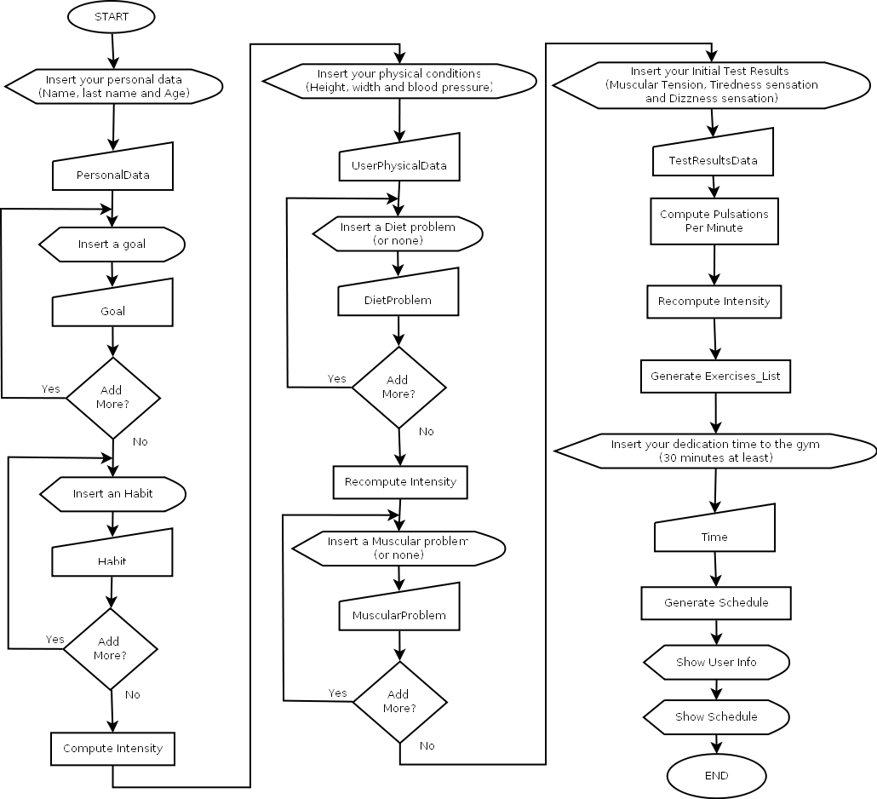

1. **Formalization**

Once we know what we need with the conceptualization of the problem and in order to begin developing the system, we need the formalization to make the specification of the problem considering all its elements and how they have to be treated.

* 1. **Initial Prototype**
     1. **Ontology**

The ontology has been created with Protégé tool, and the final main classes that we can consider to the system have been simplified to five:

* Class Person:
  + Slot age: Age of the person. Single and required.
  + Slot basicPhyCondition: Basic Physical conditions for person. Single and required.
  + Slot difficulty_intensity: Initial difficulty/intensity of person. Single and calculated by habits and some features.
  + Slot exercises: Exercises of person. Multi and required. Calculated by the whole features of the person.
  + Slot goal: Goal of the person. Multi and required.
  + Slot habits: Habits of person. Multi and not required.
  + Slot name_: Name of the person. Single and required.
  + Slot last_name: Last name of the person. Single and not required.
  + Slot test: test done by the person. Single and required.
* Class BasicPhysicalCondition:
  + Slot blood_max_pressure: Maximun pressure in mm Hg (sistolic pressure). Normal: 90-120. Sports: 75-120. : lower: Hypotension. Higher: Hypertension. Single and required.
  + Slot blood_min_pressure: Minimun blood pressure (diastolic pressure). Normal: 65-80. Sports: 45-80. : lower: Hypotension. Higher: Hypertension. Single and required.
  + Slot bodyMass: Index of body mass. Single and calculated by weight and height.
  + Slot diet: Diet of the person. Multi and required.
  + Slot height: height of person in cm. Single and required.
  + Slot muscular_problems: Muscular problems of a person. Multi and required.
  + Slot weight: weight in kg. Single and required.
* Class Habit:
  + Slot duration: Duration of activity in minutes. Single and required.
  + Slot frequency: Frequency of activities. Single and required.
  + Slot habit_class: Specifies If is the habit is positive (TRUE) or negative (FALSE) for the health of the person. Single and required.
  + Slot indexDuration: This index represents the interval of duration used to compute the duration/intensity of a habit. (1-4). Single and required.
  + Slot name_habit: Name of the habit. Single and required.
* Sub-class InWork:
  + Slot type_hab: Type of habit in work. Single and required.
* Sub-class OutWork:
  + Slot type_hab: Type of habit out work. Single and required.
* Sub-class Movement:
  + Slot type_hab: Type of habit of Movement. Single and required.
* Class Exercise:
  + Slot blood_max_pressure: Maximun blood pressure in mm Hg (sistolic pressure). Normal: 90-120. Sports: 75-120. : lower: Hypotension. Higher: Hypertension for the exercise. Single and required.
  + Slot blood_min_pressure: Minimum blood pressure in mm Hg (sistolic pressure). Normal: 90-120. Sports: 75-120. : lower: Hypotension. Higher: Hypertension for the exercise. Single and required.
  + Slot contra_indications: Contraindications of the exercise. Multi and required.
  + Slot difficulty_intensity: Difficulty of the exercise. Single and required.
  + Slot goal: Goal of the exercise. Multi and required.
  + Slot max_duration: Maximum duration of exercise. Single and required.
  + Slot min_duration: Minimum duration of exercise. Single and required.
  + Slot max_rep: Maximum number of repetitions. Single and required.
  + Slot min_rep: Minimum number of repetitions. Single and required.
  + Slot muscular_groups: Muscular groups trained by the exercise. Multi and required.
  + Slot muscular_problems: Muscular problems of a person and benefits of doing an exercise. Multi and required.
  + Slot name_ex: Name of the exercise. Single and required.
  + Slot num_cal_burned: Number of calories burned. Single and required.
  + Slot series: Series of exercises. Single and required.
* Sub-class WithoutWeights:
  + Slot type: Type of exercises without weights. Single and required.
* Sub-class Bike:
* Sub-class Floor:
* Sub-class Run:
* Sub-class WithWeights:
  + Slot type_weight: Type of weight of exercises with weights. Single and required.
* Class TestPerson:
  + Slot dizziness: Dizzines sensation of the person doing the test. Single and required.
  + Slot muscular_tension: Muscular tension of the person doing the test. Single and required.
  + Slot pulsations_per_min: Pulsations per minute of the person doing the test. Between 100-180: Normal with the test done. More: Tachycardia. Less: Athletic or bradycardia. Single and required.
  + Slot testExercises: Exercises in the test. Multi and required.
  + Slot tiredness_sensation: Tiredness sensation of the person doing the test. Single and required.

Here are explained the basic features of the slots. Their types, cardinalities and ranges are explained in the details of the ontology and classes in the implementation part.

* + 1. **Hierarchy graphic**

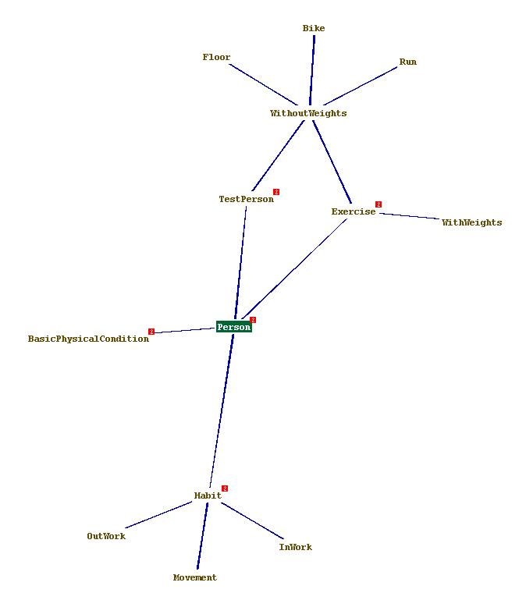

* 1. **Evaluation and reasoning process**

As the ontology shows, some concepts explained in the second part has been included as slots of a class. These are not easy decisions and lead some uncertainties.

The conflictive concepts are:

* Goal: We think it is better to include it as a multi-slot of Person and Exercise instead of a class, by the fact of it has only some values which can be treated as a symbol.
* BasicPhysicalCondition: We think that is better to be treated as a class who includes all the informative data which is informative to the gym, although the relation with the person is of 1-1. This is the reason of creating a slot into the class Person with this Instance type. In this class we also include the muscular problems and the diet as multi-slots, who are conflictive concepts too.
* TestPerson: is the concept of the initial test. The reasons of treating it as a class are similar to BasicPhysicalCondition class, in the same way of the slot added into class Person with 1-1 relation with it. In addition, the multi-slot exercises are added to this class as an instance of class Exercise, with the set of exercises to test the person. Also some physical conditions are included in this class because we don’t need them in the class BasicPhysicalCondition specially, besides it serves to specify where these conditions come.
  1. **Final Design**
     1. **Resolution methodology**

The final prototype includes the possibility of treating instances created. It can be useful for future modifications in the schedule of an existing individual or for showing mere information.

The phases of the problem explained in the conceptualization part have to have a methodology of resolution, in which the problem is decomposed in several independent and iterative parts. The problems commented will be done with this set of sub-problems:

* If the individual is not created, the following sub-problems will be treated:
* Getting all information of the individual:
  + Personal data and goal.
  + Habits of the individual.
  + Set the initial difficulty of the individual by his habits.
  + Set the basic physical condition.
    - Modify the difficulty or intensity if it’s necessary by the body mass.
  + Set the physical conditions obtained by the test done.
* Setting the exercises adapted to the individual:
  + Modify the difficulty of the individual by the previous test done.
  + Look for the exercises which meet the goals of the individual.
  + Filter the exercises obtained by comparing their intensity with the individual one.
  + Add other filtering of the exercises by looking for the muscular benefits of the exercises for the individual.
* If the individual is created in the system:
* Set all the information of the individual where is necessary.
  + Set the initial difficulty of the individual by his habits.
* Setting the exercises adapted to the individual:
  + Modify the difficulty of the individual by the existing test.
  + Look for the exercises which meet the goals of the individual.
  + Filter the exercises obtained by comparing their intensity with the individual one.
  + Add other filtering of the exercises by looking for the muscular benefits of the exercises for the individual.

1. **Implementation**
   1. **Detailed ontology and classes**
      1. **List of classes:**

CLIPS> (browse-classes)

USER

INITIAL-OBJECT

%3ACLIPS_TOP_LEVEL_SLOT_CLASS

Person

Exercise

WithoutWeights

Bike

Run

Floor

WithWeights

Habit

InWork

OutWork

Movement

TestPerson

BasicPhysicalCondition

* + 1. **Description of the classes**

**Person Class:**

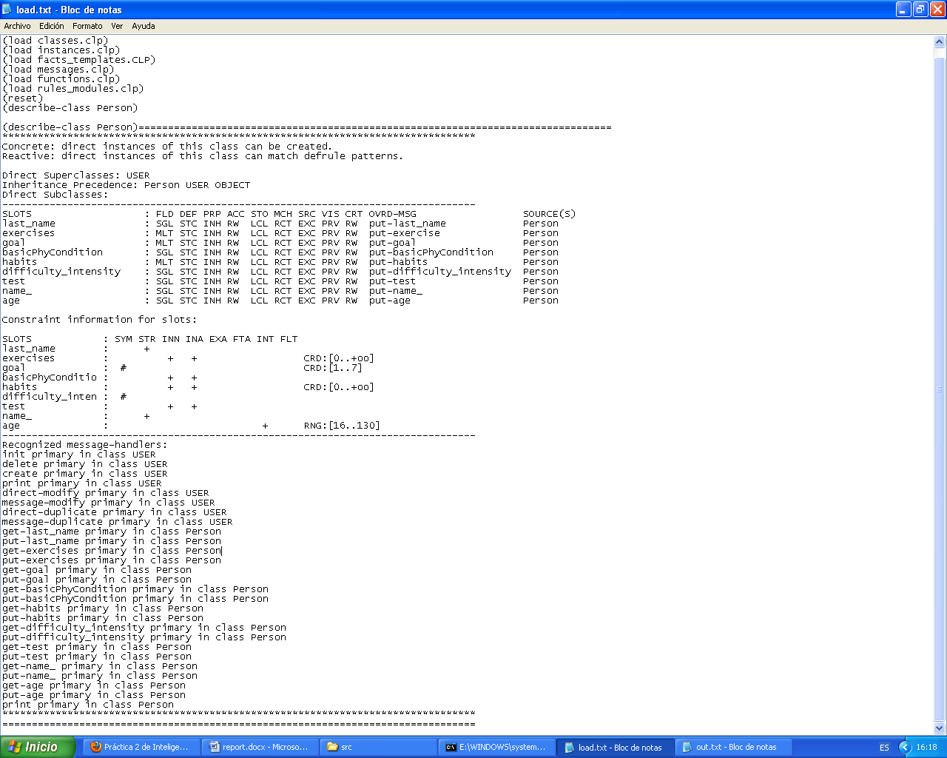

**Exercise Class:**

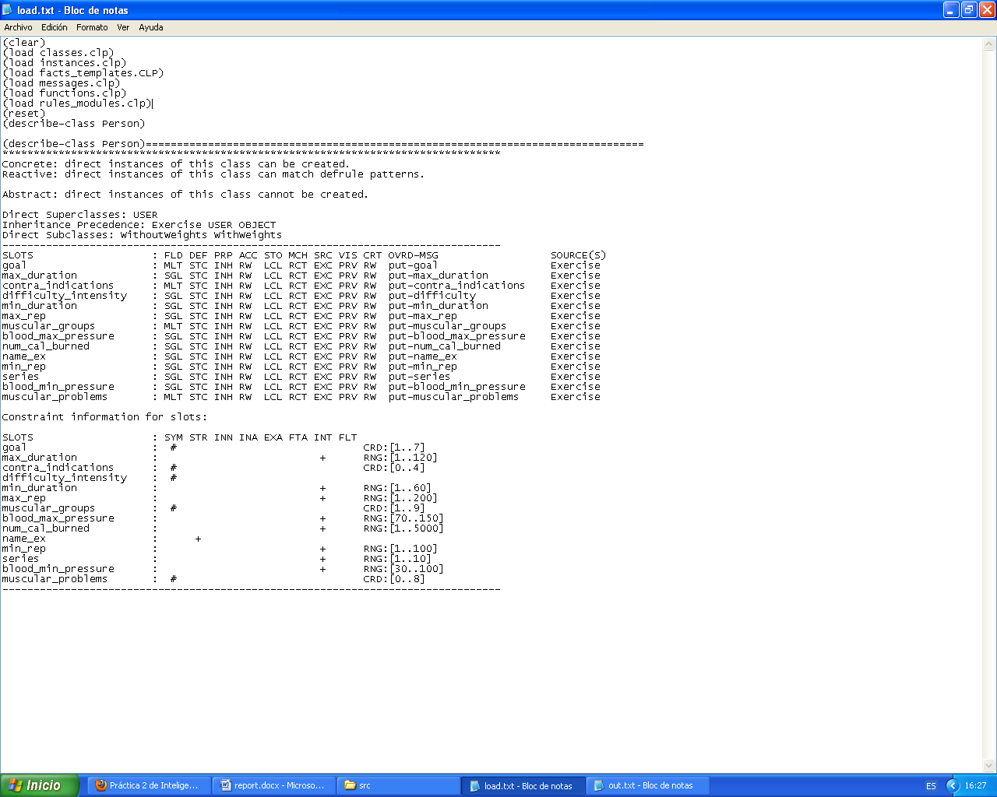

**Habit Class:**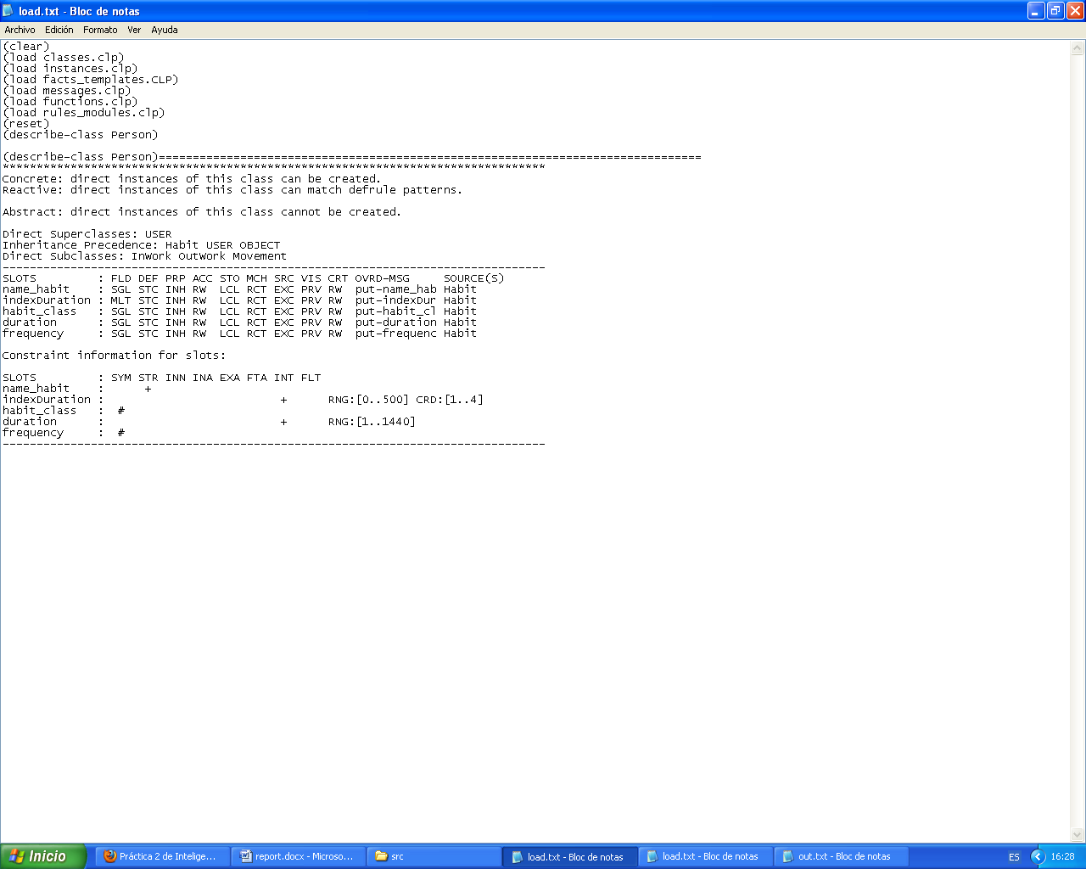

**TestPerson Class:**

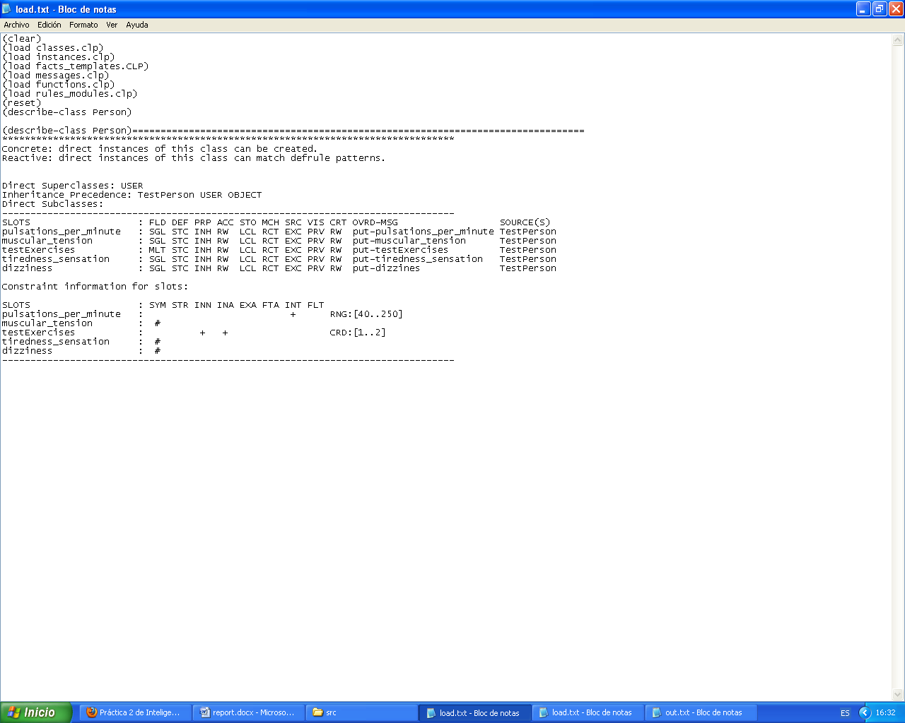

**BasicPhysicalCondition Class:**

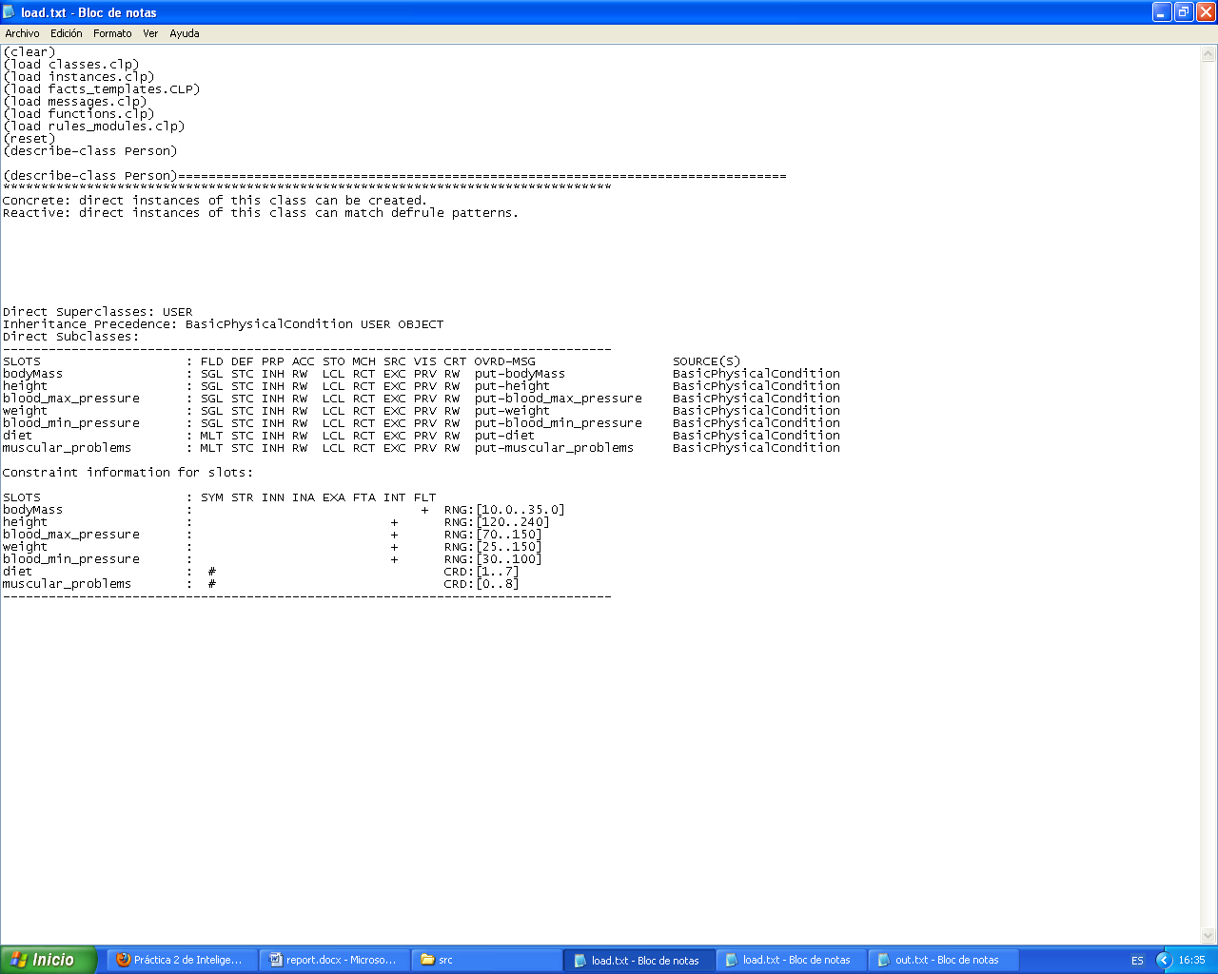

* 1. **Organization of modules**

It will be explained below how the application goes through the different modules and rules, depending on the option selected by the user.

Firstly, the application redefines the main module, and the first rule, named “start” is executed:

defrule start: The application displays a main menu in which the user must to select an option:

* Option 1: Create a new person.
* Option 2: Select an existing one.
* Option 3: Exit from the program.
* Option 1: The applications set the focus to the module “createPerson-module”.

createPerson-module: This module has a rule named “create-person”:

defrule create-person: Here, a new instance of a Person is created, and the user is asked for some personal data which is stored in a template slot and holds the following information:

(deftemplate personalData

(slot name_)

(slot last_name)

(slot age)

(multislot goal)

)

(deffacts persDat

(personalData

(name_ unknown)

(last_name unknown)

(age unknown)

(goal unknown)

)

)

After that, the system sets the focus to the module “habits-module”.

habits-module: This module contains a new rule, “set-habits”.

defrule set-habits: The user chooses its common habits, in case he has any of them, and he specifies some special characteristics, which are the duration and the frequency. They are stored in another template slot:

(deftemplate habitsPerson

(multislot habits)

)

(deffacts habs

(habitsPerson

(habits unknown)

)

)

Then, the system focuses to the “difficulty_intensity-module”.

difficulty_intensity-module: A new rule is defined:

defrule difficulty-intensity: The system calls to a function that will compute the difficulty, called “set-difficulty”, and stores the return value in the instance of the user.

Finally, the system moves on to another module:

bpc-module: The rule set-bpc is defined:

defrule set-bpc: The user answers to some questions related to its basic physical condition: height, weight, blood pressure, diet issues, and muscular problems. The system saves the entered data in a new slot with the created instance of the BasicPhysicalCondition class:

(deftemplate basicPhysicalCond

(slot basicPhyCondition)

)

(deffacts basicPC

(basicPhysicalCond

(basicPhyCondition unknown)

)

)

Once bpc module finishes, the system set the focus to “test-module”.

test-module: Defines a new rule, named “set-test”:

defrule set-test: The system asks the user for the results of the initial tests made, and stores the data in another slot:

(deftemplate testPerson

(slot pulsations_per_min)

(slot muscular_tension)

(slot tiredness_sensation)

(slot dizziness)

(multislot testExercises)

)

(deffacts testPers

(testPerson

(pulsations_per_min unknown)

(muscular_tension unknown)

(tiredness_sensation unknown)

(dizziness unknown)

(testExercises unknown)

)

)

Then, the system moves to the last module: “exercises-module”

exercises-module: And the last rule is created:

defrule set-exercises: Here, the system generates a list of exercises that fulfill the requirements of this specified user, it will also be recomputed the difficulty/intensity if needed, and a new slot will be used to store the exercises assigned to the person:

(deftemplate exercisesPerson

(multislot exercises)

)

(deffacts exsPerson

(exercisesPerson

(exercises unknown)

)

)

To conclude, the system calls to a function named “generate-schedule” which will show the final schedule that specifies the different exercises that must be done in the different days of the week, according to the user needs, and its dedication time.

* Option 2: If the user selects the option 2, the system will show a list of the predefined existing instances of persons that have already been created, and the user will be asked to choose one. Then, the system will focus on the module “existingPerson-module”

existingPerson-module: A new rule is defined:

defrule existing-person: The system computes automatically the body mass index of the existing person, and holds the user personal data, habits and basic physical condition to the slots already displayed in the option 1.

Then, the system focuses on the module “difficulty_intensity-module”.

difficulty_intensity-module: The system defines the already mentioned rule “difficulty-intensity”:

defrule difficulty-intensity: Here, the difficulty-intensity is computed and the system moves to the exercises-module, as the basic physical condition is already defined.

exercises-module: The rule set-exercises already explained is executed:

defrule set-exercises: The difficulty is recomputed according to the test results, if needed, and it is stored, with the available exercises for the user after applying the filters needed, on the previously explained slots: difficultyIntensity and exercisesPerson.

To conclude, the system calls to a function named “generate-schedule” that will do the same as explained in option 1, which is showing the detailed schedule for the current user.

* Option 3: Quits from the application.
  1. **Incremental methodology**

We have tried to follow an incremental methodology, starting from a very simple prototype and extending it until we reach to the final implementation. At the beginning we just had an initial ontology with some fields missing, that we needed to add later to make our implementation working.

For example, in the habits class, we didn’t realize at first that we would need a field to specify if a habit should be considered good or bad for the user healthy, so we added a Boolean attribute called habit_class to solve the problem. Another change that we made at the end of the development was to add a new descriptive name to the exercises, in order to show it to the user.

We also made many changes while we were developing the application, trying to consider always possible extensions of the implementation in the future.

In fact, after we finished the first working prototype, we just had the option of create a new person each time you started the program. So we decided to add a new option to allow the user the chance to select an already existing person to avoid having to insert all the data each time the application starts, and we did it in such a way that both options are totally independent. This means that either option 1 or option two, could be removed, and the remaining one would still be working properly.

Another possible extension of the program could be for example, to add new exercises or even new habits. The application should be working properly without making any changes in the existing code, it just has to be to be added the new functions, modules and rules needed to create new exercises and habits.

1. **Test**

In this section, some results of tests done are shown in order to see the functionalities and the followed way to solve the problem explained before, with the version of creating new individuals and the version of selecting existing individuals. Important facts are remarked in bold, for instance, the change of the difficulty due to some causes or the final relevant information.

* 1. **Created new individuals:**

**Test1:** Created new man with high index of body mass and a lot of excesses in his diet who have back pain and limited mobility. His main goals are rehabilitating and getting fit.

Select an option:

1. Create a new person

2. Select an existing person

3. Exit

1

Creando persona

What is your name?

John

What is your last_name?

Lup

How old are you (between 16-130)?

56

What is/are your goal/s in the gym (select one firstly)?

(maintenance get_fit reduce_weight musculation flexibility balance rehabilitate)?

reduce_weight

Do you wish to add another? (yes/no)

yes

(reduce_weight)

What is/are your goal/s in the gym (select one firstly)?

(maintenance get_fit reduce_weight musculation flexibility balance rehabilitate)?

get_fit

Do you wish to add another? (yes/no)

no

(get_fit reduce_weight)

------------------------Person Basic Information-------------------------

Name: John

LastName: Lup

age: 56 years

goal: (get_fit reduce_weight)

------------------------------Person Habits------------------------------

No habits selected

-------------------------------------------------------------------------

Insert the type of your habit?

(InWork OutWork Movement)?

Movement

walk

bike

Insert the name of your habit (if it is shown)?

(none bike walk)?

walk

What is the duration of your habit (between 0-500)?

20

What is the frequency of your habit?

(few medium quite very_high)?

few

Do you want to add another habit? yes/no

yes

Insert the type of your habit?

(InWork OutWork Movement)?

OutWork

up_stairs

hung_clothes

Insert the name of your habit (if it is shown)?

(none hung_clothes up_stairs)?

up_stairs

What is the duration of your habit (between 0-500)?

4

What is the frequency of your habit?

(few medium quite very_high)?

few

Do you want to add another habit? yes/no

yes

Insert the type of your habit?

(InWork OutWork Movement)?

InWork

sitting

weight_charge

Insert the name of your habit (if it is shown)?

(none weight_charge sitting)?

sitting

What is the duration of your habit (between 0-500)?

240

What is the frequency of your habit?

(few medium quite very_high)?

medium

Do you want to add another habit? yes/no

no

------------------------Person Basic Information-------------------------

Name: John

LastName: Lup

age: 56 years

goal: (get_fit reduce_weight)

Initial difficulty or intensity supported

(calculated by habits): medium

------------------------------Person Habits------------------------------

InWork: sitting 240 min with frequency: 'medium'

OutWork: up_stairs 4 min with frequency: 'few'

Movement: walk 20 min with frequency: 'few'

-------------------------------------------------------------------------

How tall are you (in cm) (between 120-240)?

180

How much you weigh (in kg) (between 25-150)?

92

What is your blood maximum presure (between 30-200)?

124

What is your blood minimum presure (between 30-200)?

84

What is/are the feature/s or problem/s of your kind of diet (select from this list)?

(balanced lack_calcium lack_vitamines lack_iron excess_greases excess_sal snacking)?

excess_greases

Do you wish to add another? (yes/no)

yes

(excess_greases)

What is/are the feature/s or problem/s of your kind of diet (select from this list)?

(balanced lack_calcium lack_vitamines lack_iron excess_greases excess_sal snacking)?

excess_sal

Do you wish to add another? (yes/no)

yes

(excess_sal excess_greases)

What is/are the feature/s or problem/s of your kind of diet (select from this list)?

(balanced lack_calcium lack_vitamines lack_iron excess_greases excess_sal snacking)?

lack_iron

Do you wish to add another? (yes/no)

back_pain

(lack_iron excess_sal excess_greases)

What is/are your muscular problems (select from this list)?

(none back_pain limited_mobility ankle_sprain wrist_sprain neck_pain arm_pain knee_ligaments)?

yes

You have selected something which is not shown in the list

What is/are your muscular problems (select from this list)?

(none back_pain limited_mobility ankle_sprain wrist_sprain neck_pain arm_pain knee_ligaments)?

limited_mobility

Do you wish to add another? (yes/no)

no

(limited_mobility)

**Difficulty_intensity modified to 'easy' because of bodyMass**

Re-showing person info...

------------------------Person Basic Information-------------------------

Name: John

LastName: Lup

age: 56 years

goal: (get_fit reduce_weight)

Initial difficulty or intensity supported

(calculated by habits): easy

------------------------------Person Habits------------------------------

InWork: sitting 240 min with frequency: 'medium'

OutWork: up_stairs 4 min with frequency: 'few'

Movement: walk 20 min with frequency: 'few'

--------------------Person Basic Physical Information--------------------

height: 180 cm

weight: 92 kg

index of body mass: 28.3950617283951

blood maximum pressure: 124 sistolic

blood minimum pressure: 84 diastolic

diet: (lack_iron excess_sal excess_greases)

muscular problems: (limited_mobility)

-------------------------------------------------------------------------

please answer the questions of the exercises done:

([MAIN::run_easy] [MAIN::bike_easy])

What is your muscular tension?

(normal quite high)?

normal

What is your tiredness sensation?

(few normal quite huge)?

huge

Are you dizzy?

(no few quite high)?

quite

------------------------Person Basic Information-------------------------

Name: John

LastName: Lup

age: 56 years

goal: (get_fit reduce_weight)

Initial difficulty or intensity supported

(calculated by habits): easy

------------------------------Person Habits------------------------------

InWork: sitting 240 min with frequency: 'medium'

OutWork: up_stairs 4 min with frequency: 'few'

Movement: walk 20 min with frequency: 'few'

--------------------Person Basic Physical Information--------------------

height: 180 cm

weight: 92 kg

index of body mass: 28.3950617283951

blood maximum pressure: 124 sistolic

blood minimum pressure: 84 diastolic

diet: (lack_iron excess_sal excess_greases)

muscular problems: (limited_mobility)

-----------------------Results Test Basic Exercises----------------------

exercises done: ([MAIN::run_easy] [MAIN::bike_easy])

pulsations per minute: 145

Your pulsations per min are normal

muscular tension: normal

tiredness sensation: huge

dizziness: quite

-------------------------------------------------------------------------

**Difficulty_intensity modified to 'easy' because of results of the test done**

Re-showing person info...

**------------------------Person Basic Information-------------------------**

**Name: John**

**LastName: Lup**

**age: 56 years**

**goal: (get_fit reduce_weight)**

**Initial difficulty or intensity supported**

**(calculated by habits): easy**

**------------------------------Person Habits------------------------------**

**InWork: sitting 240 min with frequency: 'medium'**

**OutWork: up_stairs 4 min with frequency: 'few'**

**Movement: walk 20 min with frequency: 'few'**

**--------------------Person Basic Physical Information--------------------**

**height: 180 cm**

**weight: 92 kg**

**index of body mass: 28.3950617283951**

**blood maximum pressure: 124 sistolic**

**blood minimum pressure: 84 diastolic**

**diet: (lack_iron excess_sal excess_greases)**

**muscular problems: (limited_mobility)**

**-----------------------Results Test Basic Exercises----------------------**

**exercises done: ([MAIN::run_easy] [MAIN::bike_easy])**

**pulsations per minute: 145**

**Your pulsations per min are normal**

**muscular tension: normal**

**tiredness sensation: huge**

**dizziness: quite**

**-------------------------------------------------------------------------**

**List of exercises filtered to assign to the schedule:**

**Triceps Easy**

**Quadriceps Easy**

**Pectorals Easy**

**Biceps Easy**

**Back Easy**

**Stretching Easy**

**Dominates Easy**

**Abdominals Easy**

**Run Easy**

**Bike Easy 10 Minutes**

**How many minutes per day can you dedicate (in minutes) (between 30 and 960)?**

**60**

**-------------------monday-------------------**

**EXERCISE: Stretching Easy**

**EXERCISE: Stretching Easy**

**EXERCISE: Pectorals Easy**

**EXERCISE: Stretching Easy**

**EXERCISE: Back Easy**

**EXERCISE: Quadriceps Easy**

**EXERCISE: Stretching Easy**

**EXERCISE: Back Easy**

**-------------------tuesday-------------------**

**EXERCISE: Run Easy**

**EXERCISE: Bike Easy 10 Minutes**

**EXERCISE: Abdominals Easy**

**EXERCISE: Triceps Easy**

**-------------------wednesday-------------------**

**EXERCISE: Pectorals Easy**

**EXERCISE: Biceps Easy**

**EXERCISE: Back Easy**

**EXERCISE: Pectorals Easy**

**EXERCISE: Quadriceps Easy**

**EXERCISE: Run Easy**

**-------------------thursday-------------------**

**EXERCISE: Run Easy**

**EXERCISE: Bike Easy 10 Minutes**

**EXERCISE: Abdominals Easy**

**EXERCISE: Triceps Easy**

**-------------------friday-------------------**

**EXERCISE: Abdominals Easy**

**EXERCISE: Biceps Easy**

**EXERCISE: Bike Easy 10 Minutes**

**EXERCISE: Stretching Easy**

**EXERCISE: Bike Easy 10 Minutes**

**EXERCISE: Stretching Easy**

**Test2:** Created new man with a normal index of body mass who wants to rehabilitate lesions and pains and gain balance and flexibility.

Select an option:

1. Create a new person

2. Select an existing person

3. Exit

1

Creando persona

What is your name?

Robbin

What is your last_name?

Walter

How old are you (between 16-130)?

31

What is/are your goal/s in the gym (select one firstly)?

(maintenance get_fit reduce_weight musculation flexibility balance rehabilitate)?

flexibility

Do you wish to add another? (yes/no)

yes

(flexibility)

What is/are your goal/s in the gym (select one firstly)?

(maintenance get_fit reduce_weight musculation flexibility balance rehabilitate)?

balance

Do you wish to add another? (yes/no)

yes

(balance flexibility)

What is/are your goal/s in the gym (select one firstly)?

(maintenance get_fit reduce_weight musculation flexibility balance rehabilitate)?

rehabilitate

Do you wish to add another? (yes/no)

no

(rehabilitate balance flexibility)

------------------------Person Basic Information-------------------------

Name: Robbin

LastName: Walter

age: 31 years

goal: (rehabilitate balance flexibility)

------------------------------Person Habits------------------------------

No habits selected

-------------------------------------------------------------------------

Insert the type of your habit?

(InWork OutWork Movement)?

Movement

walk

bike

Insert the name of your habit (if it is shown)?

(none bike walk)?

bike

What is the duration of your habit (between 0-500)?

20

What is the frequency of your habit?

(few medium quite very_high)?

medium

Do you want to add another habit? yes/no

no

------------------------Person Basic Information-------------------------

Name: Robbin

LastName: Walter

age: 31 years

goal: (rehabilitate balance flexibility)

Initial difficulty or intensity supported

(calculated by habits): medium

------------------------------Person Habits------------------------------

Movement: bike 20 min with frequency: 'medium'

-------------------------------------------------------------------------

How tall are you (in cm) (between 120-240)?

180

How much you weigh (in kg) (between 25-150)?

81

What is your blood maximum presure (between 30-200)?

122

What is your blood minimum presure (between 30-200)?

81

What is/are the feature/s or problem/s of your kind of diet (select from this list)?

(balanced lack_calcium lack_vitamines lack_iron excess_greases excess_sal snacking)?

excess_sal

Do you wish to add another? (yes/no)

no

(excess_sal)

What is/are your muscular problems (select from this list)?

(none back_pain limited_mobility ankle_sprain wrist_sprain neck_pain arm_pain knee_ligaments)?

balanced

You have selected something which is not shown in the list

What is/are your muscular problems (select from this list)?

(none back_pain limited_mobility ankle_sprain wrist_sprain neck_pain arm_pain knee_ligaments)?

knee_ligaments

Do you wish to add another? (yes/no)

yes

(knee_ligaments)

What is/are your muscular problems (select from this list)?

(none back_pain limited_mobility ankle_sprain wrist_sprain neck_pain arm_pain knee_ligaments)?

back_pain

Do you wish to add another? (yes/no)

yes

(back_pain knee_ligaments)

What is/are your muscular problems (select from this list)?

(none back_pain limited_mobility ankle_sprain wrist_sprain neck_pain arm_pain knee_ligaments)?

neck_pain

Do you wish to add another? (yes/no)

no

(neck_pain back_pain knee_ligaments)

------------------------Person Basic Information-------------------------

Name: Robbin

LastName: Walter

age: 31 years

goal: (rehabilitate balance flexibility)

Initial difficulty or intensity supported

(calculated by habits): medium

------------------------------Person Habits------------------------------

Movement: bike 20 min with frequency: 'medium'

--------------------Person Basic Physical Information--------------------

height: 180 cm

weight: 81 kg

index of body mass: 25.0

blood maximum pressure: 122 sistolic

blood minimum pressure: 81 diastolic

diet: (excess_sal)

muscular problems: (neck_pain back_pain knee_ligaments)

-------------------------------------------------------------------------

please answer the questions of the exercises done:

([MAIN::run_easy] [MAIN::bike_easy])

What is your muscular tension?

(normal quite high)?

quite

What is your tiredness sensation?

(few normal quite huge)?

normal

Are you dizzy?

(no few quite high)?

few

**------------------------Person Basic Information-------------------------**

**Name: Robbin**

**LastName: Walter**

**age: 31 years**

**goal: (rehabilitate balance flexibility)**

**Initial difficulty or intensity supported**

**(calculated by habits): medium**

**------------------------------Person Habits------------------------------**

**Movement: bike 20 min with frequency: 'medium'**

**--------------------Person Basic Physical Information--------------------**

**height: 180 cm**

**weight: 81 kg**

**index of body mass: 25.0**

**blood maximum pressure: 122 sistolic**

**blood minimum pressure: 81 diastolic**

**diet: (excess_sal)**

**muscular problems: (neck_pain back_pain knee_ligaments)**

**-----------------------Results Test Basic Exercises----------------------**

**exercises done: ([MAIN::run_easy] [MAIN::bike_easy])**

**pulsations per minute: 119**

**Your pulsations per min are normal**

**muscular tension: quite**

**tiredness sensation: normal**

**dizziness: few**

**-------------------------------------------------------------------------**

**List of exercises filtered to assign to the schedule:**

**Quadriceps Medium Level 2**

**Quadriceps Medium Level 1 (without contraindications)**

**Run Medium Level 1 (no Contraindications)**

**Triceps Medium Level 1 (without Contraindications)**

**Stretching Medium Level 1 (without Contraindications)**

**Dominates Medium Level 1 (without Contraindications)**

**Bike Medium Level 1 (without Contraindications)**

**How many minutes per day can you dedicate (in minutes) (between 30 and 960)?**

**90**

**-------------------monday-------------------**

**EXERCISE: Stretching Medium Level 1 (without Contraindications)**

**EXERCISE: Run Medium Level 1 (no Contraindications)**

**EXERCISE: Stretching Medium Level 1 (without Contraindications)**

**EXERCISE: Stretching Medium Level 1 (without Contraindications)**

**EXERCISE: Bike Medium Level 1 (without Contraindications)**

**EXERCISE: Run Medium Level 1 (no Contraindications)**

**EXERCISE: Run Medium Level 1 (no Contraindications)**

**EXERCISE: Quadriceps Medium Level 2**

**-------------------tuesday-------------------**

**EXERCISE: Run Medium Level 1 (no Contraindications)**

**EXERCISE: Triceps Medium Level 1 (without Contraindications)**

**EXERCISE: Bike Medium Level 1 (without Contraindications)**

**EXERCISE: Dominates Medium Level 1 (without Contraindications)**

**EXERCISE: Bike Medium Level 1 (without Contraindications)**

**EXERCISE: Dominates Medium Level 1 (without Contraindications)**

**EXERCISE: Dominates Medium Level 1 (without Contraindications)**

**-------------------wednesday-------------------**

**EXERCISE: Bike Medium Level 1 (without Contraindications)**

**EXERCISE: Run Medium Level 1 (no Contraindications)**

**EXERCISE: Stretching Medium Level 1 (without Contraindications)**

**EXERCISE: Stretching Medium Level 1 (without Contraindications)**

**EXERCISE: Quadriceps Medium Level 2**

**EXERCISE: Dominates Medium Level 1 (without Contraindications)**

**EXERCISE: Run Medium Level 1 (no Contraindications)**

**EXERCISE: Dominates Medium Level 1 (without Contraindications)**

**-------------------thursday-------------------**

**EXERCISE: Stretching Medium Level 1 (without Contraindications)**

**EXERCISE: Triceps Medium Level 1 (without Contraindications)**

**EXERCISE: Triceps Medium Level 1 (without Contraindications)**

**EXERCISE: Stretching Medium Level 1 (without Contraindications)**

**EXERCISE: Stretching Medium Level 1 (without Contraindications)**

**EXERCISE: Run Medium Level 1 (no Contraindications)**

**EXERCISE: Dominates Medium Level 1 (without Contraindications)**

**-------------------friday-------------------**

**EXERCISE: Stretching Medium Level 1 (without Contraindications)**

**EXERCISE: Stretching Medium Level 1 (without Contraindications)**

**EXERCISE: Quadriceps Medium Level 2**

**EXERCISE: Quadriceps Medium Level 2**

**EXERCISE: Run Medium Level 1 (no Contraindications)**

**EXERCISE: Dominates Medium Level 1 (without Contraindications)**

**EXERCISE: Run Medium Level 1 (no Contraindications)**

**EXERCISE: Run Medium Level 1 (no Contraindications)**

**EXERCISE: Quadriceps Medium Level 2**

**Test3:** Created new man with a normal index of body mass and a good fit. His habits include works with weight charging. He is also a sportsman and he wants to maintenance, musculation in order to don’t loss his fit.

Select an option:

1. Create a new person

2. Select an existing person

3. Exit

1

Creando persona

What is your name?

Alex

What is your last_name?

White

How old are you (between 16-130)?

28

What is/are your goal/s in the gym (select one firstly)?

(maintenance get_fit reduce_weight musculation flexibility balance rehabilitate)?

musculation

Do you wish to add another? (yes/no)

yes

(musculation)

What is/are your goal/s in the gym (select one firstly)?

(maintenance get_fit reduce_weight musculation flexibility balance rehabilitate)?

get_fit

Do you wish to add another? (yes/no)

yes

(get_fit musculation)

What is/are your goal/s in the gym (select one firstly)?

(maintenance get_fit reduce_weight musculation flexibility balance rehabilitate)?

maintenance

Do you wish to add another? (yes/no)

no

(maintenance get_fit musculation)

------------------------Person Basic Information-------------------------

Name: Alex

LastName: White

age: 28 years

goal: (maintenance get_fit musculation)

------------------------------Person Habits------------------------------

No habits selected

-------------------------------------------------------------------------

Insert the type of your habit?

(InWork OutWork Movement)?

Movement

walk

bike

Insert the name of your habit (if it is shown)?

(none bike walk)?

bike

What is the duration of your habit (between 0-500)?

20

What is the frequency of your habit?

(few medium quite very_high)?

quite

Do you want to add another habit? yes/no

yes

Insert the type of your habit?

(InWork OutWork Movement)?

Movement

walk

bike

Insert the name of your habit (if it is shown)?

(none bike walk)?

walk

What is the duration of your habit (between 0-500)?

20

What is the frequency of your habit?

(few medium quite very_high)?

medium

Do you want to add another habit? yes/no

no

------------------------Person Basic Information-------------------------

Name: Alex

LastName: White

age: 28 years

goal: (maintenance get_fit musculation)

Initial difficulty or intensity supported

(calculated by habits): hard

------------------------------Person Habits------------------------------

Movement: walk 20 min with frequency: 'medium'

Movement: bike 20 min with frequency: 'quite'

-------------------------------------------------------------------------

How tall are you (in cm) (between 120-240)?

190

How much you weigh (in kg) (between 25-150)?

88

What is your blood maximum presure (between 30-200)?

120

What is your blood minimum presure (between 30-200)?

79

What is/are the feature/s or problem/s of your kind of diet (select from this list)?

(balanced lack_calcium lack_vitamines lack_iron excess_greases excess_sal snacking)?

balanced

(balanced)

What is/are your muscular problems (select from this list)?

(none back_pain limited_mobility ankle_sprain wrist_sprain neck_pain arm_pain knee_ligaments)?

none

(none)

------------------------Person Basic Information-------------------------

Name: Alex

LastName: White

age: 28 years

goal: (maintenance get_fit musculation)

Initial difficulty or intensity supported

(calculated by habits): hard

------------------------------Person Habits------------------------------

Movement: walk 20 min with frequency: 'medium'

Movement: bike 20 min with frequency: 'quite'

--------------------Person Basic Physical Information--------------------

height: 190 cm

weight: 88 kg

index of body mass: 24.3767313019391

blood maximum pressure: 120 sistolic

blood minimum pressure: 79 diastolic

diet: (balanced)

muscular problems: (none)

-------------------------------------------------------------------------

please answer the questions of the exercises done:

([MAIN::run_easy] [MAIN::bike_easy])

What is your muscular tension?

(normal quite high)?

normal

What is your tiredness sensation?

(few normal quite huge)?

few

Are you dizzy?

(no few quite high)?

no

**------------------------Person Basic Information-------------------------**

**Name: Alex**

**LastName: White**

**age: 28 years**

**goal: (maintenance get_fit musculation)**

**Initial difficulty or intensity supported**

**(calculated by habits): hard**

**------------------------------Person Habits------------------------------**

**Movement: walk 20 min with frequency: 'medium'**

**Movement: bike 20 min with frequency: 'quite'**

**--------------------Person Basic Physical Information--------------------**

**height: 190 cm**

**weight: 88 kg**

**index of body mass: 24.3767313019391**

**blood maximum pressure: 120 sistolic**

**blood minimum pressure: 79 diastolic**

**diet: (balanced)**

**muscular problems: (none)**

**-----------------------Results Test Basic Exercises----------------------**

**exercises done: ([MAIN::run_easy] [MAIN::bike_easy])**

**pulsations per minute: 112**

**Your pulsations per min are normal**

**muscular tension: normal**

**tiredness sensation: few**

**dizziness: no**

**-------------------------------------------------------------------------**

**List of exercises filtered to assign to the schedule:**

**Quadriceps Hard Level 2**

**Quadriceps Hard Level 1 (without contraindications)**

**Pectoralis Hard Level 2**

**Pectoralis Hard Level 1 (without contraindications)**

**Biceps Hard Level 2**

**Biceps Hard Level 1 (without contraindications)**

**Back Hard Level 2**

**Back Hard Level 1 (without contraindications)**

**Triceps Hard Level 2**

**Triceps Hard Level 1 (without Contraindications)**

**Stretching Hard Level 2**

**Stretching Hard Level 1 (without Contraindications)**

**Dominates Hard Level 2**

**Dominates Hard Level 1 (without Contraindications)**

**Abdominals Hard Level 2**

**Abdominals Hard Level 1 (without Contraindications)**

**Run Hard Level 2**

**Run Hard Level 1 (no Contraindications)**

**Bike Hard Level 2**

**Bike Hard Level 1 (without Contraindications)**

**How many minutes per day can you dedicate (in minutes) (between 30 and 960)?**

**150**

**-------------------monday-------------------**

**EXERCISE: Triceps Hard Level 1 (without Contraindications)**

**EXERCISE: Run Hard Level 2**

**EXERCISE: Pectoralis Hard Level 2**

**EXERCISE: Run Hard Level 2**

**EXERCISE: Pectoralis Hard Level 1 (without contraindications)**

**EXERCISE: Biceps Hard Level 2**

**EXERCISE: Abdominals Hard Level 2**

**EXERCISE: Triceps Hard Level 1 (without Contraindications)**

**EXERCISE: Back Hard Level 2**

**-------------------tuesday-------------------**

**EXERCISE: Biceps Hard Level 2**

**EXERCISE: Pectoralis Hard Level 2**

**EXERCISE: Dominates Hard Level 1 (without Contraindications)**

**EXERCISE: Dominates Hard Level 2**

**EXERCISE: Pectoralis Hard Level 2**

**EXERCISE: Quadriceps Hard Level 1 (without contraindications)**

**EXERCISE: Run Hard Level 2**

**EXERCISE: Bike Hard Level 2**

**EXERCISE: Abdominals Hard Level 1 (without Contraindications)**

**EXERCISE: Back Hard Level 1 (without contraindications)**

**EXERCISE: Back Hard Level 2**

**-------------------wednesday-------------------**

**EXERCISE: Dominates Hard Level 1 (without Contraindications)**

**EXERCISE: Biceps Hard Level 1 (without contraindications)**

**EXERCISE: Back Hard Level 1 (without contraindications)**

**EXERCISE: Abdominals Hard Level 2**

**EXERCISE: Dominates Hard Level 2**

**EXERCISE: Biceps Hard Level 2**

**EXERCISE: Biceps Hard Level 1 (without contraindications)**

**EXERCISE: Back Hard Level 2**

**EXERCISE: Triceps Hard Level 2**

**EXERCISE: Abdominals Hard Level 2**

**EXERCISE: Back Hard Level 2**

**EXERCISE: Back Hard Level 2**

**EXERCISE: Biceps Hard Level 1 (without contraindications)**

**EXERCISE: Dominates Hard Level 2**

**-------------------thursday-------------------**

**EXERCISE: Dominates Hard Level 1 (without Contraindications)**

**EXERCISE: Triceps Hard Level 2**

**EXERCISE: Back Hard Level 1 (without contraindications)**

**EXERCISE: Biceps Hard Level 2**

**EXERCISE: Pectoralis Hard Level 2**

**EXERCISE: Run Hard Level 1 (no Contraindications)**

**EXERCISE: Run Hard Level 1 (no Contraindications)**

**EXERCISE: Bike Hard Level 1 (without Contraindications)**

**EXERCISE: Pectoralis Hard Level 1 (without contraindications)**

**EXERCISE: Quadriceps Hard Level 1 (without contraindications)**

**-------------------friday-------------------**

**EXERCISE: Quadriceps Hard Level 1 (without contraindications)**

**EXERCISE: Run Hard Level 2**

**EXERCISE: Triceps Hard Level 1 (without Contraindications)**

**EXERCISE: Triceps Hard Level 1 (without Contraindications)**

**EXERCISE: Pectoralis Hard Level 2**

**EXERCISE: Dominates Hard Level 1 (without Contraindications)**

**EXERCISE: Run Hard Level 2**

**EXERCISE: Dominates Hard Level 1 (without Contraindications)**

**EXERCISE: Back Hard Level 1 (without contraindications)**

**EXERCISE: Back Hard Level 1 (without contraindications)**

* 1. **Existing individuals:**

**Test4:** instance 1 Alex. He has a good fit, balanced diet and no muscular problems. He is interested in maintenance.

------------------------Person Basic Information-------------------------

Name: Alex

LastName:

age: 18 years

goal: (maintenance)

Initial difficulty or intensity supported

(calculated by habits): hard

------------------------------Person Habits------------------------------

OutWork: up_stairs 5 min with frequency: 'quite'

Movement: walk 30 min with frequency: 'medium'

--------------------Person Basic Physical Information--------------------

height: 180 cm

weight: 80 kg

index of body mass: 24.6913580246914

blood maximum pressure: 120 sistolic

blood minimum pressure: 80 diastolic

diet: (balanced)

muscular problems: (none)

-----------------------Results Test Basic Exercises----------------------

exercises done: ([bike_easy] [run_easy])

pulsations per minute: 93

You are atheltic or you have bradycardia

muscular tension: normal

tiredness sensation: few

dizziness: no

-------------------------------------------------------------------------

List of exercises filtered to assign to the schedule:

Triceps Hard Level 2

Triceps Hard Level 1 (without Contraindications)

Stretching Hard Level 2

Stretching Hard Level 1 (without Contraindications)

Dominates Hard Level 2

Dominates Hard Level 1 (without Contraindications)

Abdominals Hard Level 2

Abdominals Hard Level 1 (without Contraindications)

Run Hard Level 2

Run Hard Level 1 (no Contraindications)

Bike Hard Level 2

Bike Hard Level 1 (without Contraindications)

How many minutes per day can you dedicate (in minutes) (between 30 and 960)?

200

-------------------monday-------------------

EXERCISE: Bike Hard Level 2

EXERCISE: Triceps Hard Level 1 (without Contraindications)

EXERCISE: Triceps Hard Level 2

EXERCISE: Triceps Hard Level 2

EXERCISE: Bike Hard Level 2

EXERCISE: Triceps Hard Level 1 (without Contraindications)

EXERCISE: Dominates Hard Level 2

-------------------tuesday-------------------

EXERCISE: Stretching Hard Level 1 (without Contraindications)

EXERCISE: Triceps Hard Level 2

EXERCISE: Stretching Hard Level 1 (without Contraindications)

EXERCISE: Triceps Hard Level 2

EXERCISE: Stretching Hard Level 2

EXERCISE: Run Hard Level 1 (no Contraindications)

EXERCISE: Dominates Hard Level 2

-------------------wednesday-------------------

EXERCISE: Triceps Hard Level 1 (without Contraindications)

EXERCISE: Triceps Hard Level 1 (without Contraindications)

EXERCISE: Triceps Hard Level 2

EXERCISE: Run Hard Level 2

EXERCISE: Run Hard Level 2

EXERCISE: Triceps Hard Level 1 (without Contraindications)

EXERCISE: Triceps Hard Level 1 (without Contraindications)

-------------------thursday-------------------

EXERCISE: Run Hard Level 1 (no Contraindications)

EXERCISE: Dominates Hard Level 2

EXERCISE: Bike Hard Level 1 (without Contraindications)

EXERCISE: Abdominals Hard Level 1 (without Contraindications)

EXERCISE: Abdominals Hard Level 1 (without Contraindications)

EXERCISE: Abdominals Hard Level 2

EXERCISE: Bike Hard Level 1 (without Contraindications)

EXERCISE: Stretching Hard Level 1 (without Contraindications)

-------------------friday-------------------

EXERCISE: Abdominals Hard Level 2

EXERCISE: Triceps Hard Level 1 (without Contraindications)

EXERCISE: Abdominals Hard Level 2

EXERCISE: Bike Hard Level 2

EXERCISE: Dominates Hard Level 2

EXERCISE: Run Hard Level 2

EXERCISE: Run Hard Level 2

EXERCISE: Triceps Hard Level 1 (without Contraindications)

**Test5:** instance 7. Thin woman with a lesion who wants to rehabilitate, get fit and musculation.

------------------------Person Basic Information-------------------------

Name: Maite

LastName:

age: 25 years

goal: (musculation get_fit rehabilitate)

Initial difficulty or intensity supported

(calculated by habits): medium

------------------------------Person Habits------------------------------

No habits selected

--------------------Person Basic Physical Information--------------------

height: 162 cm

weight: 52 kg

index of body mass: 19.8140527358634

blood maximum pressure: 110 sistolic

blood minimum pressure: 70 diastolic

diet: (lack_vitamines)

muscular problems: (knee_ligaments)

-----------------------Results Test Basic Exercises----------------------

exercises done: ([bike_easy] [run_easy])

pulsations per minute: 155

Your pulsations per min are normal

muscular tension: high

tiredness sensation: normal

dizziness: no

-------------------------------------------------------------------------

Difficulty_intensity modified to 'easy' because of results of the test done

Re-showing person info...

------------------------Person Basic Information-------------------------

Name: Maite

LastName:

age: 25 years

goal: (musculation get_fit rehabilitate)

Initial difficulty or intensity supported

(calculated by habits): easy

------------------------------Person Habits------------------------------

No habits selected

--------------------Person Basic Physical Information--------------------

height: 162 cm

weight: 52 kg

index of body mass: 19.8140527358634

blood maximum pressure: 110 sistolic

blood minimum pressure: 70 diastolic

diet: (lack_vitamines)

muscular problems: (knee_ligaments)

-----------------------Results Test Basic Exercises----------------------

exercises done: ([bike_easy] [run_easy])

pulsations per minute: 155

Your pulsations per min are normal

muscular tension: high

tiredness sensation: normal

dizziness: no

-------------------------------------------------------------------------

List of exercises filtered to assign to the schedule:

Quadriceps Easy

Pectorals Easy

Biceps Easy

Back Easy

Stretching Easy

Triceps Easy

Dominates Easy

Abdominals Easy

Run Easy

Bike Easy 10 Minutes

How many minutes per day can you dedicate (in minutes) (between 30 and 960)?

45

-------------------monday-------------------

EXERCISE: Run Easy

EXERCISE: Run Easy

EXERCISE: Run Easy

EXERCISE: Quadriceps Easy

EXERCISE: Stretching Easy

-------------------tuesday-------------------

EXERCISE: Triceps Easy

EXERCISE: Biceps Easy

-------------------wednesday-------------------

EXERCISE: Bike Easy 10 Minutes

EXERCISE: Quadriceps Easy

EXERCISE: Bike Easy 10 Minutes

EXERCISE: Stretching Easy

EXERCISE: Run Easy

-------------------thursday-------------------

EXERCISE: Biceps Easy

EXERCISE: Pectorals Easy

EXERCISE: Dominates Easy

-------------------friday-------------------

EXERCISE: Quadriceps Easy

EXERCISE: Quadriceps Easy

EXERCISE: Stretching Easy

EXERCISE: Quadriceps Easy

EXERCISE: Stretching Easy

EXERCISE: Stretching Easy

**Test6:** instance 5. Man with high index of body mass and a lot of excesses in his diet who have limited mobility. His main goals are rehabilitating and reducing weight.

------------------------Person Basic Information-------------------------

Name: Kevin

LastName:

age: 30 years

goal: (reduce_weight rehabilitate)

Initial difficulty or intensity supported

(calculated by habits): easy

------------------------------Person Habits------------------------------

No habits selected

--------------------Person Basic Physical Information--------------------

height: 180 cm

weight: 102 kg

index of body mass: 31.4814814814815

blood maximum pressure: 139 sistolic

blood minimum pressure: 89 diastolic

diet: (excess_greases excess_sal snacking lack_vitamines)

muscular problems: (limited_mobility)

-----------------------Results Test Basic Exercises----------------------

exercises done: ([bike_easy] [run_easy])

pulsations per minute: 146

Your pulsations per min are normal

muscular tension: quite

tiredness sensation: huge

dizziness: high

-------------------------------------------------------------------------

Difficulty_intensity modified to 'easy' because of results of the test done

Re-showing person info...

------------------------Person Basic Information-------------------------

Name: Kevin

LastName:

age: 30 years

goal: (reduce_weight rehabilitate)

Initial difficulty or intensity supported

(calculated by habits): easy

------------------------------Person Habits------------------------------

No habits selected

--------------------Person Basic Physical Information--------------------

height: 180 cm

weight: 102 kg

index of body mass: 31.4814814814815

blood maximum pressure: 139 sistolic

blood minimum pressure: 89 diastolic

diet: (excess_greases excess_sal snacking lack_vitamines)

muscular problems: (limited_mobility)

-----------------------Results Test Basic Exercises----------------------

exercises done: ([bike_easy] [run_easy])

pulsations per minute: 146

Your pulsations per min are normal

muscular tension: quite

tiredness sensation: huge

dizziness: high

-------------------------------------------------------------------------

List of exercises filtered to assign to the schedule:

Triceps Easy

Quadriceps Easy

Pectorals Easy

Biceps Easy

Back Easy

Stretching Easy

Dominates Easy

Abdominals Easy

Run Easy

Bike Easy 10 Minutes

How many minutes per day can you dedicate (in minutes) (between 30 and 960)?

60

-------------------monday-------------------

EXERCISE: Run Easy

EXERCISE: Run Easy

EXERCISE: Run Easy

EXERCISE: Stretching Easy

EXERCISE: Run Easy

EXERCISE: Run Easy

EXERCISE: Stretching Easy

-------------------tuesday-------------------

EXERCISE: Run Easy

EXERCISE: Bike Easy 10 Minutes

EXERCISE: Abdominals Easy

EXERCISE: Triceps Easy

-------------------wednesday-------------------

EXERCISE: Back Easy

EXERCISE: Quadriceps Easy

EXERCISE: Back Easy

EXERCISE: Pectorals Easy

EXERCISE: Run Easy

EXERCISE: Pectorals Easy

-------------------thursday-------------------

EXERCISE: Run Easy

EXERCISE: Bike Easy 10 Minutes

EXERCISE: Abdominals Easy

EXERCISE: Triceps Easy

-------------------friday-------------------

EXERCISE: Back Easy

EXERCISE: Pectorals Easy

EXERCISE: Quadriceps Easy

EXERCISE: Quadriceps Easy

EXERCISE: Pectorals Easy

EXERCISE: Run Easy

* 1. **Explanation of tests**

The tests have been separated by two versions: the first 3 tests correspond to the created new individuals and the following 3 tests correspond to the existing individuals.

In the output, the set of questions and the ways followed depending on the answers can be considered, and as we comment in before we can also see the relevant information of the outputs remarked in bold.

In addition of the separation of two kinds of tests, we have considered in each one different individuals interested in different things, with different physical conditions and with different goals and problems. For all cases, the coherence in the resulting schedule can be considered, with the exercises adapted to the individuals depending on their set of features.