Control Tower — Enterprise User Manual
PM Control Tower (Control Tower) · Platform version 3.1.0 · October 2026
Audience: executive sponsors, PMO leaders, administrators, project managers and delivery teams.
Status: authoritative consolidation. Cross-references the numbered document suite (01–13) and specialist guides (AI-BYOK, FLOW import, EMAIL-REMINDERS, ANALYTICS, BUSINESS-PLAN).
Platform | Control Tower — Enterprise Project, Program & Portfolio Management
Brand lockup | Optinus Solutions × Czarnikow (header); login shows "Control Tower"
Runtime | Node ≥ 20.9 (Next.js standalone, Bun optional), Socket.IO realtime gateway
Data | SQLite (default) or PostgreSQL (Vercel/hosted deployments), Prisma schema
Scale in repo | 119 data models · 186 API route files · 209 view modules · 28 computation engines · 43 permissions · 8 role templates · 48 sidebar tabs · 100 AI features · 143 automated tests
How to read this manual. Sections 1–4 tell you what you get and how the work flows. Section 5 is the architecture with diagrams. Sections 6–7 are the business case and cost. Section 8 is setup, end to end. Statements marked [E] are estimates/assumptions, [R] are planning ranges, [V] are verified vendor/market figures (sourced in the business plan).

Table of contents
- Benefits — what the platform delivers
- Feature catalogue — every capability
- Tab linkage — every tab to its outcome
- End-to-end working design
- Architecture and diagrams
- Business case
- Cost
- Setup — installation to go-live
- Security, governance and operations
- Glossary and document index

1. Benefits — what the platform delivers
One platform, one truth. Control Tower replaces the fragmented stack (spreadsheet plans + task tool + BI extracts + slide-deck assembly) with a single system where the plan, the actuals, the money and the reporting come from the same database — so the number on the executive slide is the same number in the task list.

1.1 Benefits by stakeholder
Persona | Primary benefit | Evidence in the product
Executive / Sponsor | Real-time portfolio truth without waiting for a monthly pack; faster, better-grounded decisions | Executive Control Tower, Leadership Control Tower (20 tabs in 4 groups), Investment & Business Case (NPV/IRR/payback), EVM, alerting
PMO leader | Standardised way of working across all projects; automated status production; defensible governance | Reporting Center (library, builder, board packs, scheduled runs, subscriptions), Stage Gates, Governance, Data Integrity, 70 PMO templates
Project manager | One workspace from charter to closure — scope, schedule, cost, risk, change, status — with AI drafting the first 80% | Project Register → WBS → Schedule (CPM/Gantt/baselines) → EVM/Health/RAID/Changes, AI PM Assistant, 100-feature AI Feature Studio
Delivery team | Clear personal work surface; no tool-hopping | Boards (Kanban/Calendar/Workload), Tasks, Agile Delivery (sprints), Work Inbox, Focus Planner, Timesheets
Finance controller | Actuals that tie to the plan; forecast discipline; billing control | Financials, EVM (CPI/SPI/EAC/ETC/VAC), Clients & Billing, Expenses, Investment cases
Field / site teams | Site reality flows into the same project record | Field Operations (RFIs, daily logs, punch lists), Proofing & Approvals
Compliance / Auditor | Immutable trail, permission boundaries, evidence on demand | Audit log, RBAC (43 permissions), Integrity (freshness, evidence bundles, doctor checks)
IT / Security | Self-hosted control, no vendor lock-in, BYOK AI, standard stack | Docker/PM2/Bun/Windows-pack deployments, SQLite/Postgres, JWT + TOTP + SCIM + SSO (MSAL), encrypted AI key vault

1.2 Platform-level benefits
- Single source of truth — 119 models on one core; every tab reads and writes the same records. No reconciliation between a scheduling tool, a task tool and a BI extract.
- Effort replacement, not just tool replacement — status production, pack assembly and roll-ups are computed (engines) and rendered (Reporting Center, PPT export of 42 views) instead of being hand-built. The business case models this as the dominant cost line (PMO reporting effort: status-quo ~$480k/3yr at 100 users vs ~$60k with Control Tower) [E].
- Deterministic calculation, AI for narrative — CPM, EVM, Monte Carlo, PERT, finance and leveling are computed in code; the AI layer only narrates numbers the client computed and is forbidden (system prompt, enforced) from inventing metrics.
- Bring-your-own-key AI at zero licence cost — one provider key (Gemini default, OpenAI/Groq swappable) powers the assistant and all 100 features; no per-seat AI add-on, no subscription inside the platform, key encrypted server-side and never exposed to the browser.
- Governance by construction — RBAC on every API (43 permissions, 8 role templates), audit events on mutations, rate limiting, stage gates, change control and a data-integrity layer (freshness, evidence, doctor) make answers defensible in an audit.
- Deployment freedom — Docker Compose, bare metal (PM2/nginx), Bun, a one-click Windows pack, or Vercel + Postgres. Data stays where you put it.
- Automation of the routine — Control Automations, webhooks, integrations and the daily consolidated e-mail reminder (Microsoft Graph) keep work moving without a human chasing.

2. Feature catalogue — every capability

2.1 Portfolio & project core (Plan)
- Project Register — portfolio inventory with codes, health, owners, dates, budget.
- Requirements — requirement backlog with status and traceability to delivery.
- WBS — hierarchical work breakdown (drag-and-drop tree) that feeds schedule and cost.
- Tasks — cross-project task list with effort, assignees, due dates, status, priority.
- Agile Delivery — epics, sprints (one active per project), story points, backlog grooming, sprint board with drag-and-drop and server-recomputed committed points.
- Schedule — CPM engine (dependencies, constraints, lag), Gantt with today marker, critical path, progress fills and milestone diamonds; Milestones and Baselines snapshots for variance; Planning Lab for what-if/estimate tooling (PERT, Monte Carlo).
- Portfolios / Programs / Projects — three-level hierarchy with roll-up of health, budget and schedule across levels.

2.2 Execution (Execute)
- Boards (omni views) — the same tasks as Kanban (status lanes), Calendar (month grid, weekends shaded) and Workload (resource × week heatmap, 4–26 weeks, over-allocation red).
- Resources — resource register (avatars seeded from employee code), assignments, capacity vs demand.
- Timesheets — own time entry with draft/submit workflow, approval queue, actuals feeding cost and EVM.
- Work Inbox — personal triage of assigned actions, approvals and alerts.
- Focus Planner — personal timeboxing of the work that matters this week.

2.3 Control & finance (Control)
- Financials — budgets, costs, commitments per project/program.
- Clients & Billing — clients, invoices (server-computed totals, paid-invoice lock), expenses.
- Investment & Business Case — cases with NPV, IRR, payback, sensitivity (finance engine).
- EVM — PV/EV/AC, SPI/CPI, EAC/ETC/VAC with configurable alert thresholds.
- Health — composite health scoring and trend.
- RAID — risks, issues, assumptions, decisions with owners, severity, mitigation tracking.
- Change Control — change requests with impact and decision trail.
- Stage Gates — gate definitions, evidence, go/no-go decisions per phase.
- Governance — governance controls and compliance view for the PMO framework.
- Data Integrity — freshness signals, evidence bundles, doctor checks (orphans, deadline breaches, unassigned effort) so numbers can be trusted.
- Prioritization — weighted scoring / optimizer to rank competing investments.
- CTO Tower — technology/estate oversight view.
- Field Operations — RFIs (auto-numbered, aging), daily logs, punch lists, BIM iframe.

2.4 Strategy & knowledge
- Feedback & Roadmap — feedback posts with votes, triage into roadmap lanes.
- Docs & Knowledge — spaces, pages, markdown editor (institutional memory).
- Message Boards — threaded discussions, replies, pins (decision record).
- Proofing & Approvals — review rounds with annotations and approval decisions.

2.5 Intelligence
- Executive Control Tower — live KPIs, RAG donut, investment view, top risks, alerts, capacity, EVM bars, hours trend, governance queue.
- Leadership Control Tower — 20-tab executive/PMO pack in 4 groups.
- Reports — report suite across the portfolio.
- Reporting Center — sections: Library · My Reports · Report Builder · Board Packs · Scheduled · Subscriptions · History (template library documented at 177 report templates).
- Analytics and PMO Analytics (Insights) — trends, distributions, insights reports.
- AI PM Assistant — conversational drafting grounded in live register data.
- AI Feature Studio — 100 ranked features (f001–f100) across 10 categories, each a one-button draft generator with client-computed arithmetic (EVM, PERT, EAC/ETC/VAC, phasing, cash-flow, velocity, ratios) and an honest fallback when the AI key/quota/network is missing.
- Export — universal PowerPoint export: any of 42 views as a native 16:9 deck.

2.6 Connect
- Integration Hub — connector catalog to external systems.
- Control Automations — event/rule automations (e.g. overdue escalation).
- Notifications — in-app notification centre and preferences.
- Webhooks — outbound HTTP hooks on platform events.
- AI Connector Gateway — central AI provider routing/status.
- Extension Hub — optional capability extensions.

2.7 Administration
- Users (activate/deactivate, role change, activity), Roles (8 templates + custom, 43-permission matrix), Templates (70 PMO project templates, apply-to-new-project), Audit (server-side filtered event log with before/after JSON), Settings (env readiness, AI provider BYOK card, probes, entity counts), Fields (custom-field dictionary), Tabs (tab builder), SCIM/SSO identity integration.

2.8 Platform engines (src/lib/engines/ — 28)
cpm (critical path) · evm · montecarlo · leveling (resource) · calendars (working-day index) · finance (NPV/IRR/payback) · prioritization · scenario · rollup · executive-portfolio · leadership · steering · health · governance · benefits · doctor (data health) · freshness · evidence · identity (TOTP/SCIM) · metadata (custom fields) · custom-fields · automations · connectors · timesheet · calibration · pptx + pptx-views (export) · zip.

3. Tab linkage — every tab to its outcome
The sidebar has 8 groups and 48 tabs. Each row links: tab → route → what you do → the immediate outcome/artifact → the permission required. Section 4.3 shows how the outcomes chain end to end.

3.1 Executive
Tab | Route | What you do there | Outcome / artifact | Permission
Executive Control Tower | #/dashboard | Read live KPIs, RAG, investment, risks, alerts, capacity, EVM, governance queue | Instant portfolio situational awareness; alert-driven interventions | executive.view

3.2 Plan
Tab | Route | What you do there | Outcome / artifact | Permission
Project Register | #/register | Create/curate projects, codes, owners, budgets, dates | The portfolio inventory every other tab keys from | project.view
Requirements | #/requirements | Capture and status requirements | Scope baseline with traceability | project.view
WBS | #/wbs | Build the work breakdown tree | Scope structure feeding schedule & cost | project.view
Tasks | #/tasks | Manage work items, owners, effort, dates | Execution backlog and actuals source | project.view
Agile Delivery | #/agile | Run epics/sprints/backlog, point story cards | Sprint execution and velocity history | project.view
Schedule | #/schedule | Build CPM schedule, Gantt, critical path | Committed dates, critical path, slippage signal | project.view
Milestones | #/milestones | Plan key dates | Milestone plan feeding gates and exec view | project.view
Baselines | #/baselines | Freeze a schedule snapshot | Variance reference (plan vs actual) | project.view
Planning Lab | #/tools | Run what-if / estimate tools (PERT, Monte Carlo) | Estimate confidence ranges for commitments | project.view

3.3 Portfolio
Tab | Route | What you do there | Outcome / artifact | Permission
Portfolios | #/portfolios | Group projects into portfolios, watch roll-ups | Investment container + aggregate health | portfolio.view
Programs | #/programs | Manage program-level structure and roll-up | Programme oversight and dependency view | program.view
Projects | #/projects | Open the full project workspace (tabs per project) | The project's single operating picture | project.view

3.4 Execute
Tab | Route | What you do there | Outcome / artifact | Permission
Boards | #/boards | Move work across Kanban / Calendar / Workload views | Flow control, over-allocation spotted early | project.view
Resources | #/resources | Maintain the resource register and assignments | Capacity vs demand picture (avatars, codes) | resource.view
Timesheets | #/timesheets | Log and approve time | Actuals that drive cost and EVM | timesheet.own (+timesheet.approve)
Work Inbox | #/inbox | Triage assigned actions and approvals | Zero-miss personal throughput | inbox.use
Focus Planner | #/planner | Timebox the week | A realistic personal delivery plan | inbox.use

3.5 Control
Tab | Route | What you do there | Outcome / artifact | Permission
Financials | #/financials | Track budget/cost/commitments | Cost baseline and spend visibility | financial.view
Clients & Billing | #/clients | Manage clients, invoices, expenses | Revenue control and billing evidence | financial.view
Field Operations | #/field | RFIs, daily logs, punch lists, BIM | Site-to-office data loop | project.view
Investment & Business Case | #/investment | Build cases with NPV/IRR/payback | Fund-or-kill evidence | financial.view
EVM | #/evm | Read SPI/CPI/EAC/ETC/VAC | Objective performance measurement | evm.view
Health | #/health | Review composite health/trend | Early-warning indicator set | evm.view
RAID | #/raid | Maintain risks, issues, assumptions, decisions | Exposure register with mitigations | project.view
Change Control | #/changes | Raise and decide change requests | Scope/decision audit trail | project.view
Stage Gates | #/gates | Run gate reviews with evidence | Go/no-go decisions per phase | project.view
Governance | #/governance | Apply governance controls and review compliance | Compliance posture for the PMO framework | project.view
Data Integrity | #/integrity | Freshness, evidence bundles, doctor checks | Trust layer: "can I defend this number?" | integrity.view
CTO Tower | #/technology | Technology/estate oversight | Technology risk and investment view | integration.view
Prioritization | #/prioritization | Score and optimise competing initiatives | Ranked, defensible investment order | portfolio.view

3.6 Strategy & Knowledge
Tab | Route | What you do there | Outcome / artifact | Permission
Feedback & Roadmap | #/feedback | Capture/vote feedback, triage to roadmap | Demand-driven product/delivery direction | inbox.use
Docs & Knowledge | #/docs | Author and organise knowledge pages | Institutional memory | docs.use
Message Boards | #/boards-hub | Discuss and pin threads | Durable decision record | boards.use
Proofing & Approvals | #/proofing | Review rounds with annotations, decide | Sign-off evidence on deliverables | project.view

3.7 Intelligence
Tab | Route | What you do there | Outcome / artifact | Permission
Leadership Control Tower | #/reports/leadership | Read the 20-tab, 4-group leadership pack | Board-ready leadership reporting | reports.view
Reports | #/reports | Run the report suite | Standard analytical outputs | reports.view
Reporting Center | #/reporting | Library, builder, board packs, schedules, subscriptions | Recurring, self-service reporting (no analyst queue) | reports.view
Analytics | #/analytics | Explore trends and distributions | Insight charts for decisions | reports.view
PMO Analytics | #/insights | PMO insights hub and insights reports | Programme/portfolio diagnostics | reports.view
AI PM Assistant | #/assistant | Ask for drafts grounded in live data | First-draft status/briefs in seconds | ai.use
AI Feature Studio | #/ai-features | Trigger any of 100 ranked AI features | Domain drafts (status, risk, cost, agile…) with computed facts | ai.use

3.8 Connect
Tab | Route | What you do there | Outcome / artifact | Permission
Integration Hub | #/integrations | Configure connectors | Systems kept in sync | integration.view
Control Automations | #/automations | Define event rules (e.g. overdue escalation) | Work that happens without chasing | integration.view
Notifications | #/notifications | Preferences and notification history | Awareness without inbox noise | inbox.use
Webhooks | #/webhooks | Outbound event endpoints | Downstream system triggers | integration.view
AI Connector Gateway | #/ai-gateway | AI provider routing/status | Central AI infrastructure control | integration.view
Extension Hub | #/extensions | Enable optional extensions | Capability added without a release | integration.view

3.9 Administration (header → Settings / admin routes)
Area | Route | Outcome | Permission
Admin Center | #/admin-center | Administration landing | admin.users etc.
Users | #/admin/users | People on/offboarded, roles assigned | admin.users
Roles | #/admin/roles | Permission matrix realised per role | admin.users
Templates | #/admin/templates | New projects born standardised (70 templates) | admin.templates
Audit | #/admin/audit | Who changed what, when, with before/after | admin.audit
Settings | #/admin/settings | Env readiness, AI key (BYOK), probes, branding | admin.config
Custom fields | #/admin/fields | Metadata dictionary (schema without code changes) | admin.config
Tab builder | #/admin/tabs | Workspace composition per need | admin.config

4. End-to-end working design

4.1 The operating loop
Control Tower encodes one management loop, and every tab belongs to a stage of it:
CAPTURE PLAN EXECUTE MEASURE GOVERN DECIDE
┌─────────────┐ ┌──────────────┐ ┌──────────────┐ ┌──────────────┐ ┌──────────────┐ ┌──────────────┐
│ Register │ ───► │ Requirements │ ─────► │ Boards/Tasks │ ─────► │ Timesheets │ ─────► │ RAID/Changes │ ─────►│ Exec/Leadership│
│ Feedback │ │ WBS │ │ Agile/Sprint │ │ EVM/Health │ │ Gates │ │ Tower │
│ Field RFIs │ │ Schedule │ │ Inbox/Planner│ │ Cost/Billing │ │ Governance │ │ Investment │
└─────────────┘ │ Baselines │ │ Resources │ │ Integrity │ │ Audit │ │ Prioritization │
└──────────────┘ └──────────────┘ └──────────────┘ └──────────────┘ └──────┬───────┘
▲ │ ▲ │
└───────────── change requests ───────────┘ └──── decisions ──────┘
Data lifecycle: a project created in the Register fans out to WBS → Schedule (CPM) → Baselines; execution writes Tasks/Sprints/Timesheets; the engines compute EVM, health, cost and roll-ups; the integrity layer marks freshness and evidence; Reporting Center and the AI layer render it; decisions flow back as changes, gate outcomes and reprioritisation.

4.2 Personas in the loop (day-in-the-life)
- Team member (morning) → Work Inbox shows 3 assigned actions → Focus Planner timeboxes 2 → moves a Kanban card → logs 6.5h in Timesheets (draft → submit).
- PM (daily) → Register/Workspace update → Schedule recalculates critical path → RAID updated → Board reflects flow → Automations flag an overdue milestone → AI Feature Studio drafts the weekly status (f001) from computed facts → sends via Reporting Center schedule.
- PMO (weekly) → Leadership pack refreshed → Data Integrity doctor run → governance queue cleared → Reporting Center board pack exported (PPT) → subscriptions delivered by e-mail.
- Executive (monthly) → Executive + Leadership towers → drill to Investment/EVM → Prioritization re-ranks → gate decisions recorded → audit trail complete.

4.3 How the tabs chain (linkage end to end)
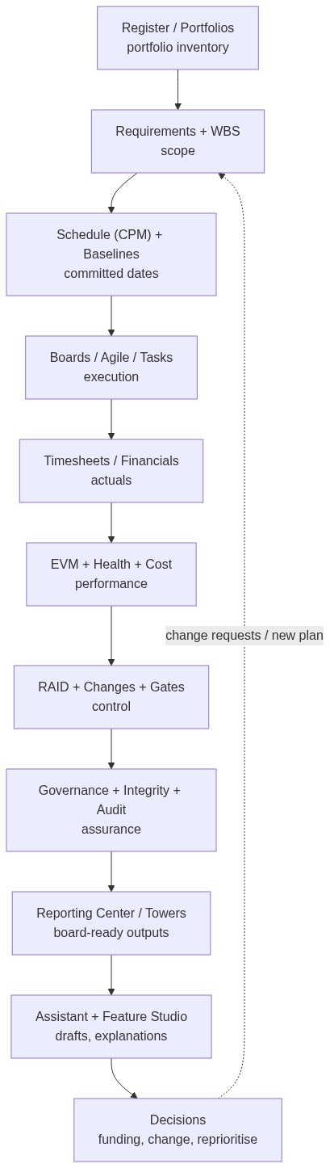
Figure 1 — How the tabs chain (linkage end to end)

4.4 System working design (runtime behaviour)
- Authentication — login issues a JWT held in an httpOnly cookie; the same secret material authenticates the realtime gateway (REALTIME_SECRET_KEY = JWT_SECRET). Optional TOTP MFA, SSO via MSAL (OIDC/Azure AD), SCIM provisioning.
- Routing — hash router (#/segment/sub); registry.tsx maps segment → view component; the shell composes sidebar + topbar + command palette (⌘K). Role-aware home route redirects users without executive.view to the first workspace they can use.
- API pipeline — every /api/** route runs: session/JWT → RBAC permission check → zod validation → business logic (engines/services) → audit event → rate limit → realtime emit → typed JSON response.
- Engines — deterministic computation (CPM, EVM, Monte Carlo, finance, roll-up, leveling…) runs server-side in TypeScript; tests assert the maths (143-test suite).
- Realtime — API publishes domain events (project:changed, audit:created, …) to the Socket.IO gateway (:3003) via an internal emit call; the browser subscribes to rooms and updates views + toast notifications without reload.
- AI — client calls askAIResult (a "use server" action): session → ai.use RBAC → rate-limit (10/min) → decrypt BYOK key from the encrypted vault → provider adapter (Gemini/OpenAI/Groq, 30s timeout) → ledger entry in AIExecution. It never throws: failures return a typed status and an honest fallback string shown in the UI.
- Persistence — Prisma over SQLite (absolute DATABASE_URL) or PostgreSQL on hosted deployments; additive db push schema sync (no migration history), reference data via seeds.

5. Architecture and diagrams

5.1 System context
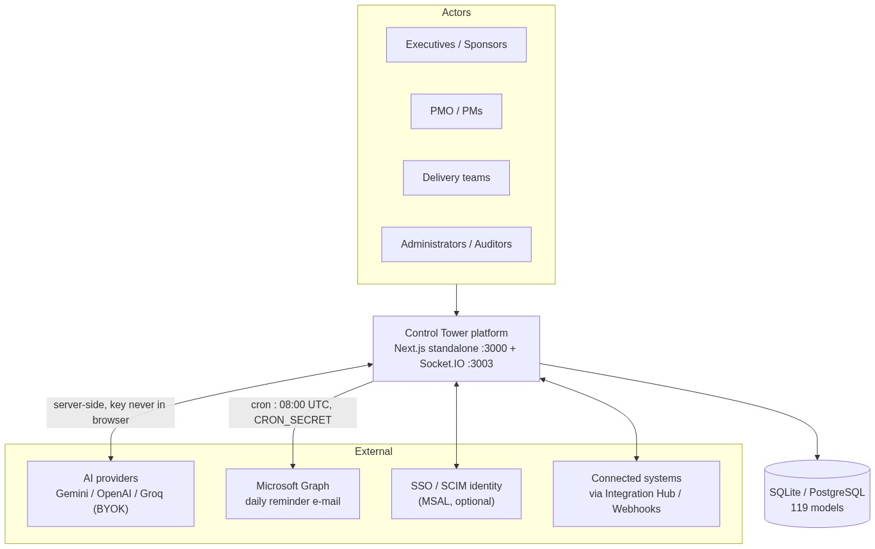
Figure 2 — System context

5.2 Layered architecture
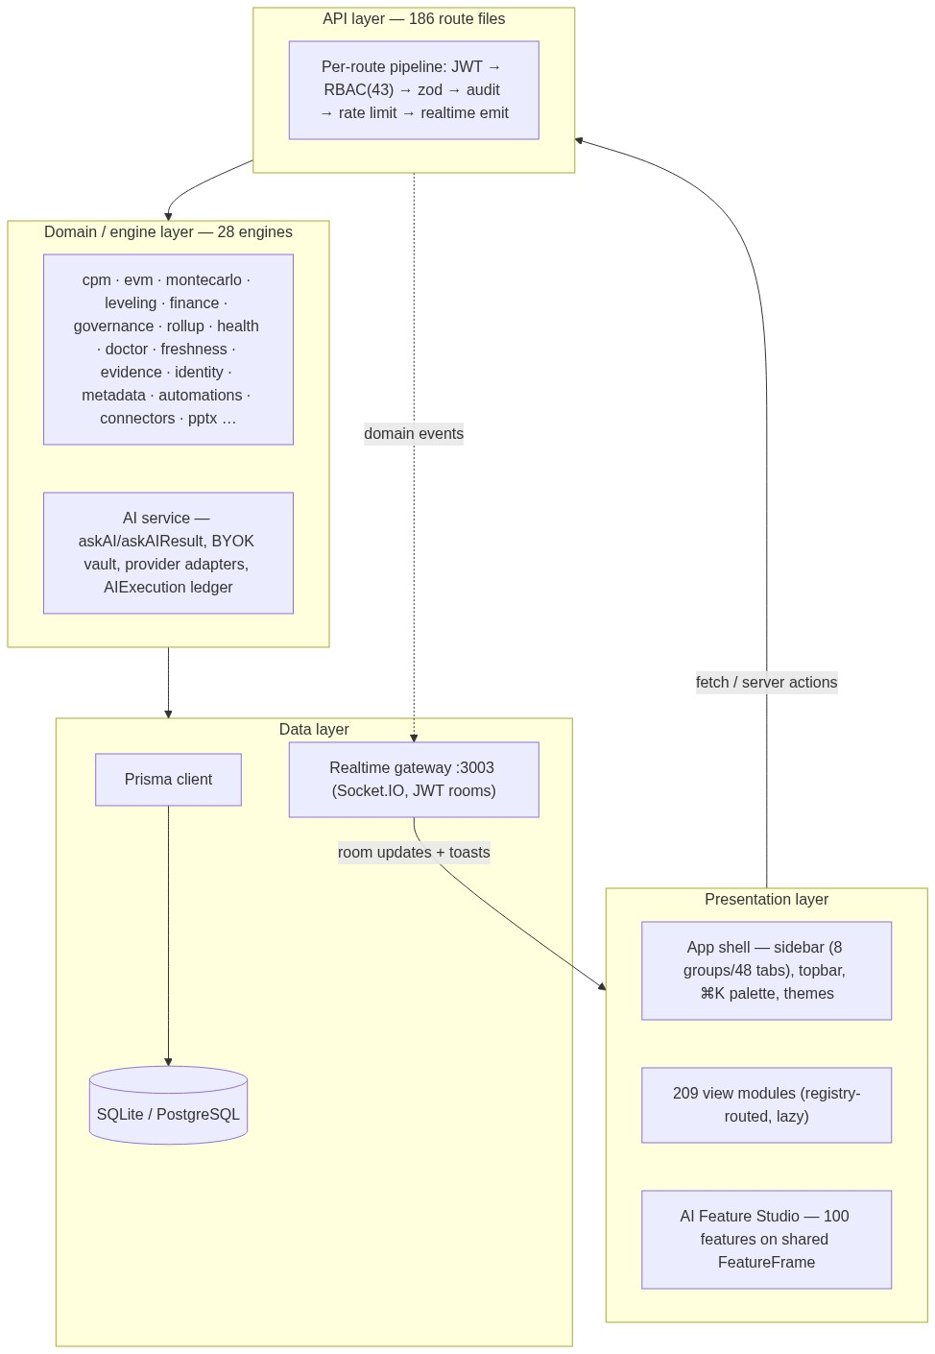
Figure 3 — Layered architecture

5.3 Deployment topology
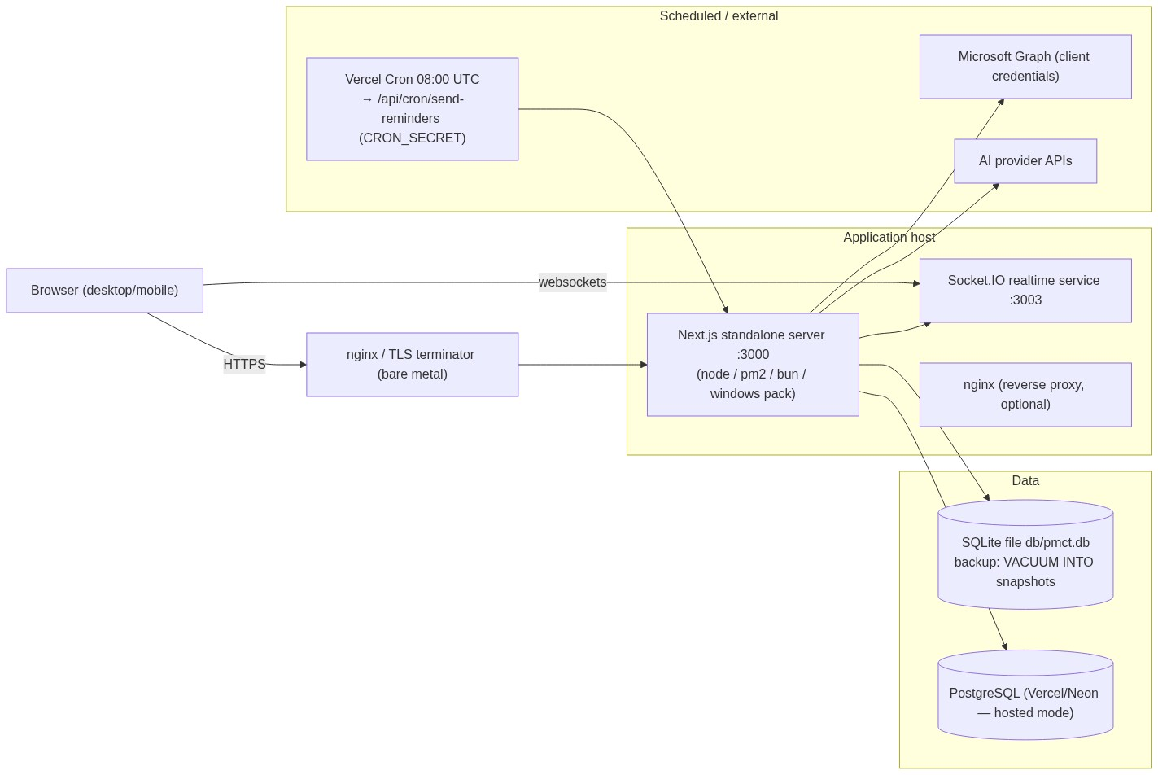
Figure 4 — Deployment topology
Deployment modes (details: docs/01-DEPLOYMENT-GUIDE.md): A Docker Compose (recommended) · B bare metal (Node 20 + PM2 + nginx) · C Bun runtime · D Windows deployment pack (one-click exe) · E Vercel + Postgres.

5.4 Request pipeline (sequence)
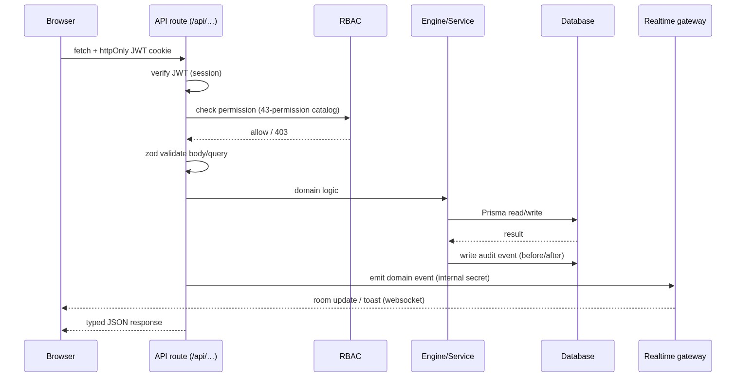
Figure 5 — Request pipeline (sequence)

5.5 Authentication & authorisation
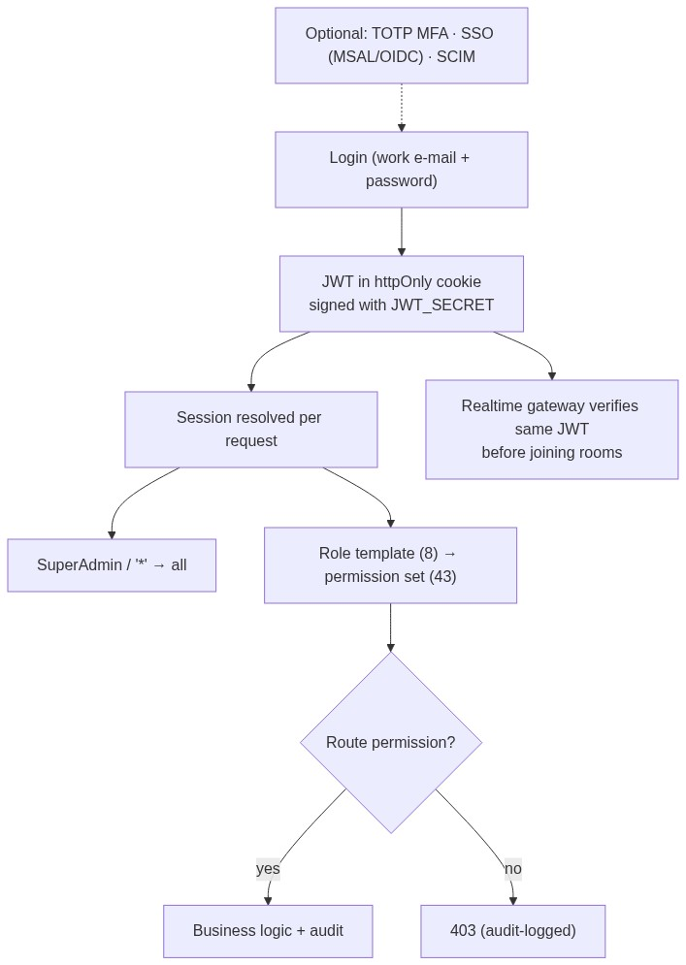
Figure 6 — Authentication & authorisation

5.6 Realtime flow
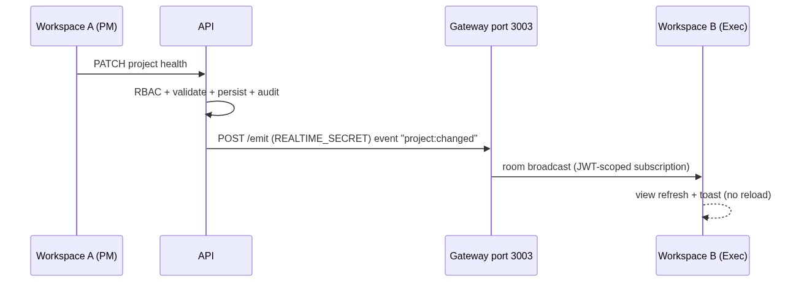
Figure 7 — Realtime flow

5.7 AI (BYOK) flow
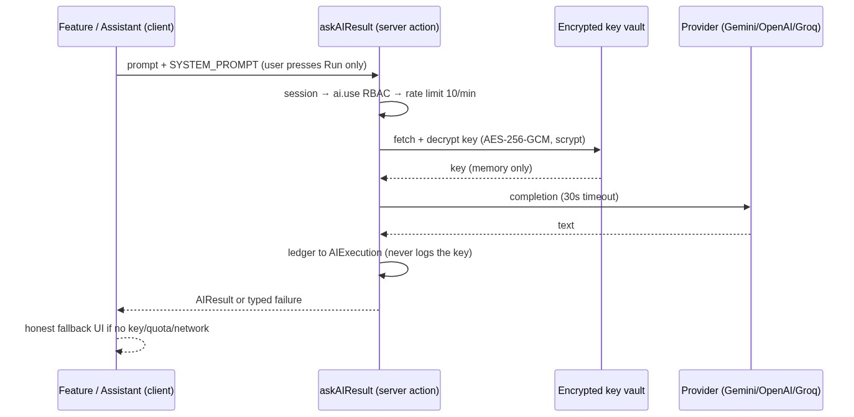
Figure 8 — AI (BYOK) flow
Rules enforced by design: no subscription/seat cost inside the platform; key never reaches localStorage or any browser code; askAIResult never throws; client-side code computes all arithmetic (EVM, PERT, EAC/ETC/VAC, phasing, cash-flow, velocity, ratios) and the model narrates computed facts.

5.8 FLOW planning-workbook import
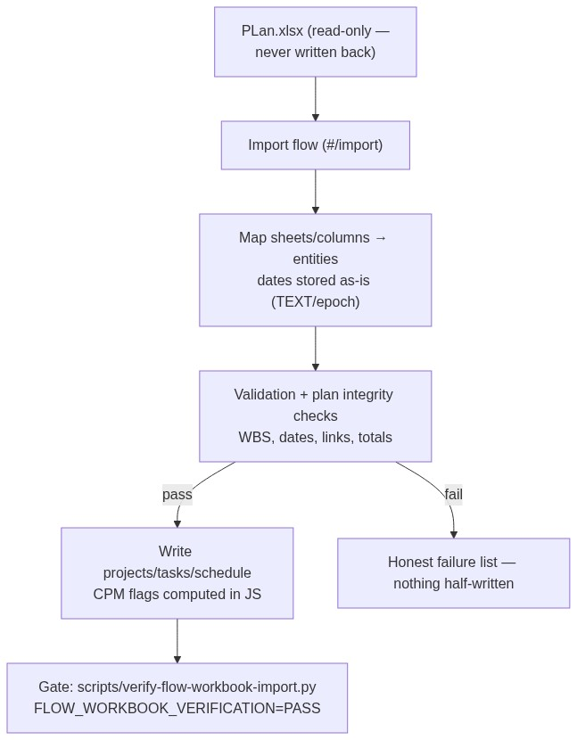
Figure 9 — FLOW planning-workbook import
Storage rule: imported workbook dates stay in their stored form (TEXT) while Prisma dates are epoch milliseconds — dates are never reformatted on write; window filtering happens in JS.

5.9 Daily reminder e-mail (cron)
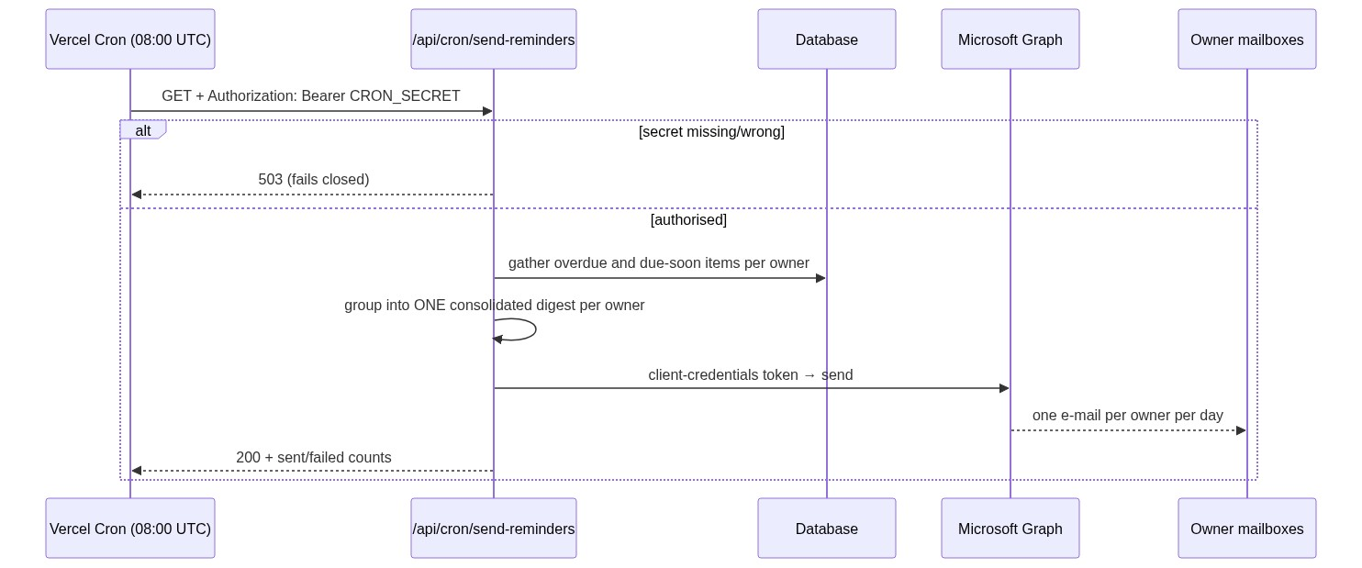
Figure 10 — Daily reminder e-mail (cron)
dryRun=1 returns the would-be e-mail without sending. Unconfigured Graph credentials deliberately return 503 (visible, not silent). Setup: docs/EMAIL-REMINDERS-GUIDE.md.

5.10 Data model overview (119 models)
Domain | Representative models
Structure | Portfolio, Program, Project, WBS node, Requirement, Milestone, Baseline
Work | Task, Sprint, Epic, Story points fields, Board lane config, Inbox item, Planner slot
Time/cost | Timesheet/entry, Budget/cost lines, Invoice(+lines), Expense, Activity
Control | Risk, Issue, Assumption, Decision, Change request, Gate, Governance record, Evidence
Quality | Integrity/freshness record, Doctor finding, Audit event, Proof round/annotation
Knowledge | Doc page, Message thread/reply, Feedback post/vote, Roadmap item
Field | RFI, Daily log, Punch item
Platform | User, Role, Permission assignments, Custom field, Template, Webhook, Automation, Integration, AI connector config, AIExecution ledger, Notification

5.11 Repository layout & build
src/
app/ Next.js app router — page.tsx (auth gate), layout, api/**/route.ts (186)
components/pmct/ shell (sidebar/topbar/palette), kit (design system), brand
views/ domain view modules (admin, plan, portfolio, execute, control,
intelligence, connect, knowledge, strategy, ai/features (100)) — 209 files
lib/ engines/ (28), ai/ (service, providers, vault), rbac, auth, audit, realtime client
prisma/ schema.prisma (119 models)
mini-services/ realtime/index.ts (Socket.IO gateway)
scripts/ seed*, sync-rbac, backup-app.ps1, verify-flow-workbook-import.py
tests/engines/ 143 deterministic tests (no DB required)
docs/ this manual + numbered suite 01–13 + specialist guides
build next build → .next/standalone (self-contained server + public/)

6. Business case

6.1 The problem
- Fragmentation — plans in one tool, tasks in another, money in spreadsheets, reporting in slides. Every hand-off is a re-keying opportunity and a reconciliation cost.
- Reporting glue is the biggest cost — status production and pack assembly consume PMO capacity that should be spent steering. The business plan models ~2 FTE of reporting effort (~$480k over 3 years at 100 users) in the status-quo stack [E].
- Slow, unsafe decisions — by the time a pack is assembled the data is stale; without RBAC/audit/evidence, answers cannot be defended in a review or audit.
- Tool sprawl cost — the same 100-user organisation spends $10k–$65k/yr on tooling alone (Jira Premium $20k, Asana $36k, MS Project P3 $41k, Aha! $81k — Year-1 TCO tables) before counting people [V/E].
- AI is either unavailable or metered per seat — competitors charge $9–$28/user AI add-ons [V], so the teams who need drafting help the most ration it.

6.2 Solution mapping
Problem | Control Tower capability | Measurable outcome
Fragmented tools | One platform, one database (119 models), 48 tabs on one core | Reconciliation work → ~0; one login
Reporting glue cost | Reporting Center (library/builder/board packs/scheduled/subscriptions), Leadership pack, PPT export (42 views), AI drafts | PMO reporting effort 0.25 FTE vs 2 FTE [E]
Stale/undefendable data | Real-time towers, Integrity layer (freshness/evidence/doctor), audit + RBAC | Decisions on current data; evidence bundles on demand
Licence sprawl | Replaces PPM + agile + docs + BI glue + field ops | See §7.5 benchmark
Metered AI | BYOK AI: assistant + 100 features at token cost only | AI adoption without procurement cycles
Adoption failure | Role-aware home, per-user inbox/planner, honest empty states, WCAG 2.2 AA | Contribution layer feeds the executive layer

6.3 Value model (illustrative calculator) [E]
Annual benefit = B1 + B2 + B3 + B4
B1 Tool consolidation = Σ(current tool subscriptions displaced)
B2 Reporting effort = (FTE_before − FTE_after) × loaded cost
B3 Faster decisions = value of earlier intervention
(fewer late gate surprises; estimate 1–2% of portfolio spend)
B4 Avoided rework = fewer data-driven errors (integrity layer + single source)
Annual cost = licence/hosting (§7) + implementation + admin time + AI tokens
ROI = (Annual benefit − Annual cost) / Annual cost
Payback = Implementation cost / Monthly benefit
Worked example — 100 users, 3-year horizon (business plan Part 12) [E]:
 | Status-quo stack | Control Tower
Subscription (3 yr) | ~$101k (Jira + Smartsheet + Power BI) | $75.6k (Business tier)
Implementation/integration/training | ~$90k | ~$52k
PMO reporting effort | ~$480k (2 FTE) | ~$60k (0.25 FTE)
Data reconciliation fixes | ~$60k | ~$5k
3-year TCO | ~$730k | ~$193k
→ ~$537k avoided over 3 years (~$179k/yr) at 100 users, before faster-decision value. Against Tier-2 PPM (Planview ~$620k, ServiceNow ~$860k for the same span) the gap widens. Sensitivity: if reporting-effort saving is only half real, payback still occurs inside year 1 on tool substitution alone.

6.4 Risks and mitigations
Risk | Mitigation
Adoption (another tool to learn) | Role-aware home, inbox-first workflow, 70 PMO templates, training pack (docs/training/), phased rollout (§8.11)
Data migration quality | FLOW workbook importer with validation + plan-integrity gate; honest failure lists
Single-vendor dependency | Self-hosted code + export (PPT, API, webhooks); no proprietary lock-in
AI accuracy | Deterministic engines compute; AI narrates; never-invent-metrics system prompt; human-in-the-loop "draft then review"
Security | RBAC/audit/rate limits/TOTP/SCIM/SSO; BYOK key vault; fails-closed cron; secrets via env only
Key-person dependency | Documented suite (01–13), runbooks, 143 automated tests as regression net

6.5 Success measures
KPI | Baseline (typical) | Target with Control Tower
Hours per monthly status pack | 40–80 h (manual) | < 8 h (scheduled + AI draft) [E]
PMO hours/week on reporting glue | ~2 FTE | ≤ 0.25 FTE [E]
Projects with a current baseline | 40–60% | ≥ 90%
Overdue items without owner | common | 0 (doctor + automations)
Tool subscriptions in the PMO stack | 4–6 | 1 + BYOK AI
Audit evidence retrieval | days | minutes (evidence bundles)

7. Cost
All figures are internal planning figures unless tagged. [V] verified vendor pricing as captured in docs/BUSINESS-PLAN-2026-2027.md Part 10 (Oct 2026), [E] estimate, [R] planning range.

7.1 What running Control Tower costs
Cost line | Self-hosted (typical) | Hosted (Vercel + Postgres) | Notes
Platform licence | $0 in your own deployment (code is yours) — or commercial tiers if procured (§7.2) | same | No per-seat metering inside the product
Infrastructure | $6–$24/mo VPS, or $0 marginal on existing Windows/server hardware [E] | Vercel Pro ~$20/mo + Postgres $0–$50/mo [E] | SQLite needs no DB server
Operations | ~2–4 h/month admin [E] | ~1–2 h/month [E] | backups are scripted (one command)
AI tokens (BYOK) | $20–$150/mo at ~5k runs/month [E] | same | Your own provider key; metered per call
E-mail reminders | $0 (Microsoft Graph inside your M365 tenant) | same | client-credentials app registration
Implementation | one-time: days, not quarters (§8) | same | business plan models $30k at 100 users for full program [E]
AI token maths [E]: each AI run ≈ 3–4k input tokens (system prompt + context) + 0.5–1k output. 5,000 runs/month ≈ 17–25M tokens/month. At mid-tier rates ($0.10–$1.50/M input, $0.40–$6/M output) that is roughly $20–$150/month — choose model/price in Administration → Settings → AI provider. Every call is ledgered (AIExecution) so spend is observable, and rate limits (10/min/user) cap runaway usage.

7.2 Commercial pricing (if procured as a product)
From the business plan (Part 14) — annual prepaid per user:
 | Starter | Professional | Business | Enterprise | Enterprise Plus
Annual | $9/user/mo (≤25) | $15 (≤100) | $21 (≤500) | $29 (≤2,000) | custom
Platform fee | — | — | — | $75k+/yr unlimited users | $150k+/yr
AI | included | included | included | included | included
SSO | — | ✓ | ✓ | ✓ | ✓ (+SCIM/MFA enforce)
Self-hosted | — | — | ✓ | ✓ | ✓ (+air-gapped)
Support | community | business hours | 8–5 | 24–5, SLA 99.5% | 24–7, SLA 99.9%, CSM
Perpetual/one-time licence from ~$75k (Part 15). AI is deliberately included (competitors charge $9–$28/user add-ons) and SSO is included from Professional (competitors gate it to Enterprise) — two repricing anchors versus the market.

7.3 Benchmark — same organisation, same year [V/E, business plan Part 11]
Year-1 TCO (subscription + AI + implementation), 100 users:
Tool | Y1 TCO | vs Control Tower
Jira Premium | $20,065 | 1.4×
Asana Advanced | $35,986 | 2.5×
Monday Pro / Smartsheet | $27,360 | 1.9×
MS Planner + Project P3 | $41,420 | 2.9×
Aha! Premium | $81,420 | 5.7×
Planview Portfolios [R] | ~$126,000 | 8.8×
ServiceNow SPM [R] | ~$240,000 | 16.7×
Primavera P6 EPPM [R] | ~$262,500 | 18.3×
Control Tower (Business) | $48,000 (incl. $30k implementation) | 1×
At 25 users: PMCT $12,000 vs Asana $8,996/Wrike $9,000/Planview ~$31,500 — and PMCT includes PPM depth (CPM/EVM/gates) those work-management tools lack. At 500+ users the platform-licence model (from $75k/yr unlimited) diverges sharply from per-seat scaling (Asana ~$180k/yr at 500 before enterprise tiers) [E].

7.4 Three-year TCO (100 users) [E, business plan Part 12]
 | Status quo stack | ServiceNow SPM | Planview | Control Tower
3-year TCO | ~$730k | ~$860k | ~$620k | ~$193k
Dominant line | PMO reporting effort $480k | subscription $360k | subscription $216k | subscription $75.6k

7.5 What you get at every price point
All tiers ship the core loop: register → WBS → CPM schedule → baselines → tasks/boards → timesheets → EVM/health/RAID/changes → governance/audit → reporting → AI. Tiers add scale (projects/portfolios), depth (prioritization optimizer, investment cases, integrity layer, 177-template reporting, automations/webhooks, connector count), and enterprise controls (SSO/SCIM/self-hosted/support SLA).

8. Setup — installation to go-live

8.1 Prerequisites
- Node.js ≥ 20.9 (or Bun, or the Windows pack which bundles everything)
- 4 GB RAM / 2 vCPU is ample for a departmental deployment [E]
- A host reachable by your users (VPS, existing Windows server, or Vercel)
- Optional: Microsoft 365 tenant (for reminder e-mails), an AI provider account (for BYOK), TLS terminator (nginx/Caddy) or Vercel HTTPS
- Read docs/.env.example — the template for .env

8.2 Choose a deployment mode
Mode | Best for | Key steps (detail: docs/01-DEPLOYMENT-GUIDE.md)
A. Docker Compose (recommended) | Servers, VMs | cp .env.example .env → set secrets → docker compose up -d → build + realtime + seeded DB
B. Bare metal (PM2 + nginx) | Existing Linux estates | npm ci → .env → npm run db:generate && npm run db:push → npm run db:seed → npm run build → pm2 start npm --name pmct -- start → proxy :3000 with TLS
C. Bun runtime | Bun shops | bun install → seed → npm run build → npm run start:bun (+ npm run realtime)
D. Windows pack | Air-gapped/on-prem one-click | unzip dist/PM-Control-Tower-Deploy-*.zip → start.cmd → health-check script; autostart included
E. Vercel + Postgres | Serverless hosting | attach Postgres (Neon), set JWT_SECRET, push schema (vercel.json build does db push + seed-if-empty), deploy

8.3 Environment variables (complete)
Variable | Required | Purpose
DATABASE_URL | yes | file:/absolute/path/to/db/pmct.db (absolute in production) or postgresql:// when hosted
JWT_SECRET | yes | 32+ random bytes (openssl rand -hex 32) — signs sessions
REALTIME_SECRET_KEY | yes | must equal JWT_SECRET — gateway verifies the same JWTs
REALTIME_SECRET | yes | shared secret for API → gateway POST /emit
REALTIME_URL / REALTIME_PORT | yes | internal gateway address (default http://127.0.0.1:3003)
PORT / HOSTNAME | defaults | standalone server bind (3000 / 127.0.0.1)
WEB_ORIGIN / PMCT_CONFIG_JSON | optional | public origin + config bootstrap (templates)
AZURE_TENANT_ID, AZURE_CLIENT_ID, AZURE_CLIENT_SECRET | for e-mail | Graph client-credentials app
MAIL_SENDER_EMAIL | for e-mail | shared mailbox that sends the digest
CRON_SECRET | for e-mail | bearer token Vercel Cron sends; route fails closed (503) without it
EVM_SPI_THRESHOLD / EVM_CPI_THRESHOLD | optional | alert thresholds (default 0.9)
Never commit .env. Secrets are read server-side only (the AI key is additionally encrypted AES-256-GCM at rest and never returned to the browser).

8.4 Initialise data
npm ci
npm run db:generate # prisma client
npm run db:push # schema sync (additive)
npm run db:seed # reference data + leadership seed
npm run seed:command-center # demo/operational dataset (clients, invoices, agile, field…)
npm run sync:rbac # upsert 43 permissions into 8 roles (no reseed)
npm run seed:integrity # integrity/evidence demo data (optional)
npm run seed:strategy # strategy/roadmap data (optional)
npm run build && npm start # production on :3000 (+ npm run realtime for :3003)

8.5 First-run checklist
- Sign in with the seeded admin (quick-account shortcuts exist on the login page for demo tenants) and change credentials immediately on real deployments.
- Roles & users — invite users (#/admin/users), assign one of the 8 role templates (Executive, PMO Administrator, Portfolio Manager, Program Manager, Project Manager, Finance Controller, Team Member, Auditor) or a custom role.
- Settings — verify env readiness (✓/! indicators), probes (realtime, database), branding.
- Import your plan — FLOW planning workbook import (never writes back to PLan.xlsx), then run python scripts/verify-flow-workbook-import.py → must print FLOW_WORKBOOK_VERIFICATION=PASS.
- AI key — Administration → Settings → AI provider (Bring Your Own Key): provider (Gemini default / OpenAI / Groq), model, write-only key, Test. Status shows masked ••••1234 only. Key is encrypted at rest; audit-logged masked.
- E-mail reminders — register the Azure AD app, fill Graph vars + MAIL_SENDER_EMAIL + CRON_SECRET, schedule cron at 08:00 UTC; test with dryRun=1.
- Backup — powershell -File scripts\backup-app.ps1 creates two date-stamped archives (pmct-backup-*.zip = DB snapshot + .env + schema; pmct-app-backup-*.zip = full source). Schedule it (Task Scheduler / CI) — restore drill documented in the operations runbook.
- Smoke test — log in as each role: sidebar shows only permitted tabs; run one report; move one board card; draft one AI feature (expect the honest "not configured" state until step 5); check zero console errors.

8.6 Verification gates (quality bar for every change)
npx tsc --noEmit # type safety (0 errors)
npx eslint . # lint (0 problems)
npm test # 143 deterministic tests (engines, RBAC, AI, calendar, CPM…)
python scripts/verify-flow-workbook-import.py # plan integrity (prints PASS)

8.7 Rollout plan (indicative) [E]
Phase | Weeks | Activity | Exit criteria
1 — Foundation | 1–2 | Deploy, secrets, roles, admin settings, backup | All roles log in; probes green
2 — Data | 2–3 | Import plan, resources, financials; integrity doctor clean | Doctor findings = 0 critical
3 — Pilot | 3–5 | 1–2 teams: boards, timesheets, RAID, first scheduled report | Pilot status pack auto-generated
4 — PMO scale-out | 5–8 | Gates, governance, Reporting Center schedules, AI key, PPT export | Monthly pack ≤ 8 h
5 — Org-wide | 8–12 | Remaining users, automations, webhooks, integrations | Adoption KPIs (§6.5) trending

9. Security, governance and operations
Security posture (summary — detail: docs/10-SECURITY-GUIDE.md) - Authentication: JWT httpOnly cookies, argon/bcrypt-class password storage, optional TOTP MFA, SSO via MSAL (OIDC), SCIM provisioning. - Authorisation: 43 permissions × 8 role templates; super-admin wildcard; enforced server-side on every route (client hiding is cosmetic, not the control). - Audit: every mutation writes an audit event with before/after JSON; audit UI has server-side filters, pagination, evidence export. - Abuse controls: per-route rate limits (auth, AI 10/min, exports), zod validation, size limits. - Secrets: env-only; AI key additionally encrypted (AES-256-GCM + per-record scrypt salt/IV), masked in UI/logs; cron fails closed without CRON_SECRET. - Transport: TLS via nginx/Caddy or Vercel; realtime authenticates with the same JWT material.
Governance. Stage gates, change control, the governance controls view, RAID discipline and the integrity layer (freshness, evidence bundles, doctor) together give the PMO a defensible control framework; the audit trail covers who-decided-what-when.
Operations (detail: docs/09-OPERATIONS-RUNBOOK.md) - Health: /api/system/ready, Settings probes, realtime LIVE indicator. - Backups: dual date-stamped archives (system + full app); SQLite snapshots via VACUUM INTO are safe while the app runs; restore drill = unpack system zip → point DATABASE_URL. - Upgrades: take backup → git/npm update → db:push (additive) → re-seed if empty → restart; keep PMCT_DIST_DIR isolation if a build runs beside a live server. - Monitoring: process manager (PM2/systemd) restarts, log files, audit/AIExecution tables for activity volume, cron response codes (200 vs 503).

10. Glossary and document index
Glossary. BYOK — bring-your-own-key (your AI provider key, encrypted server-side) · CPM — critical path method · EVM — earned value management · WBS — work breakdown structure · RAID — risks, issues, assumptions, decisions · Roll-up — aggregation up the portfolio/program tree · Integrity layer — freshness/evidence/doctor trust checks · Feature Studio — the 100 ranked AI features · Room — a realtime subscription scope.
Document index (this repo)
Doc | Use it for
14 — this manual | benefits, tab outcomes, working design, architecture, business case, cost, setup
01 Deployment | hosting modes, env, upgrades, troubleshooting
02 Admin guide | users, roles, templates, settings, metadata
03 User guide | task-level how-tos per module
04 Architecture | stack, process topology, engines, conventions
05 API reference | route contracts
06 Data model | model-by-model reference
07 RBAC matrix | permission × role matrix
08 Reference data | seed/reference datasets
09 Operations runbook | day-2 operations
10 Security | threat model, controls
11 Integrity & trust | freshness/evidence/doctor design
12 Master platform audit | capability audit evidence
AI-FEATURE-ROADMAP | all 100 AI features specified
AI-BYOK-ARCHITECTURE | AI provider/vault design
FLOW-PLANNING-WORKBOOK-IMPORT | workbook import + date rules
EMAIL-REMINDERS-GUIDE | Graph cron setup
ANALYTICS-ENGINE | analytics design
BUSINESS-PLAN-2026-2027 | pricing, benchmarks, TCO (§6–7 source)
COMMAND-CENTER-PRD | full product PRD/ERD

End of manual. Feedback → PMO Administrator; corrections land in the same numbered doc suite.

