Does winter temperature help predict respiratory surges in the Northeast?
A statistical modeling report on influenza, RSV and COVID, 2010–2026
Vitchakorn Poonyakanok
Andrew ID: vpoonyak
CMU 90-819 Python Programming II
October 2026
Repository: https://github.com/vpoonyak/Winter_Temp_NSSP

Summary
- Winter temperature describes the respiratory season but does not predict it.
- Once the seasonal cycle is removed, temperature shows no link with the size, timing or growth of surges, even allowing for changes in disease reporting.
- Adding temperature does not improve Chronos-2 forecasts.
- Chronos-2 alone cut four-week-ahead error by 26% (outpatient illness) and 31% (emergency visits) versus a naive forecast.

1. Question
Hospitals increase number of staff for winter respiratory illnesses surge. If colder winters brought bigger or earlier surges, temperature would be a cheap early warning. Studies show that cold, dry air helps influenza spread.^{1,2} My research question ask whether winter temperature relates to the size, timing or growth of influenza, RSV and COVID surges in Northeastern US (CT, ME, MA, NH, NJ, NY, PA, RI and VT), and whether it improves forecasts.

2. Data and Descriptive analysis
The data are NOAA county monthly temperatures (1895–2026),³ CDC emergency-department (ED) visit shares for influenza, RSV and COVID (2022–2026),⁴ CDC outpatient influenza-like illness (ILI) shares (2010–2026)⁵ and Census boundaries.⁶ County ED data are incomplete (none for New Hampshire; Pennsylvania and Rhode Island stop in 2024), so tests use state-level data.
Table 1 summarizes the cleaned data: no duplicate keys or missing outcomes, and only September–December 2026 temperatures are not yet published. ILINet providers change sharply over time (Figure 1), so comparisons stay within states.
Dataset | Coverage | Rows | In-season weekly share, median (IQR), % | Season peak, median (range), % | Peak week of season, median (IQR) | Typical peak
Temperature (NOAA) | 217 counties, monthly, 1895–2026 | 343,728 | Dec–Feb normal 20 (VT) to 34 °F (NJ) | Winter anomaly -5.6 to +6.9 °F (2010–26) | – | –
ILI (ILINet) | 9 states, weekly, 2010–2026 | 7,395 | 1.6 (0.9–2.8) | 4.4 (0.4–16.1) | 17 (12–19) | Jan 28
Influenza (ED) | 9 states, weekly, 2022–2026 | 1,863 | 0.9 (0.2–2.6) | 7.0 (2.8–10.2) | 13 (13–18) | Dec 31
RSV (ED) | 9 states, weekly, 2022–2026 | 1,863 | 0.2 (0.1–0.6) | 1.0 (0.6–2.8) | 13 (8–17) | Dec 31
COVID (ED) | 9 states, weekly, 2022–2026 | 1,863 | 0.9 (0.5–1.9) | 2.9 (0.7–4.9) | 13 (13–14) | Dec 31
Table 1. Datasets after cleaning. Shares are percentages of outpatient (ILI) or ED visits. Weekly values use in-season weeks (October–May); peaks use complete state-seasons (ILI 142; ED 36 per pathogen). Week 0 of the season is CDC epiweek 40 (early October). IQR, interquartile range.
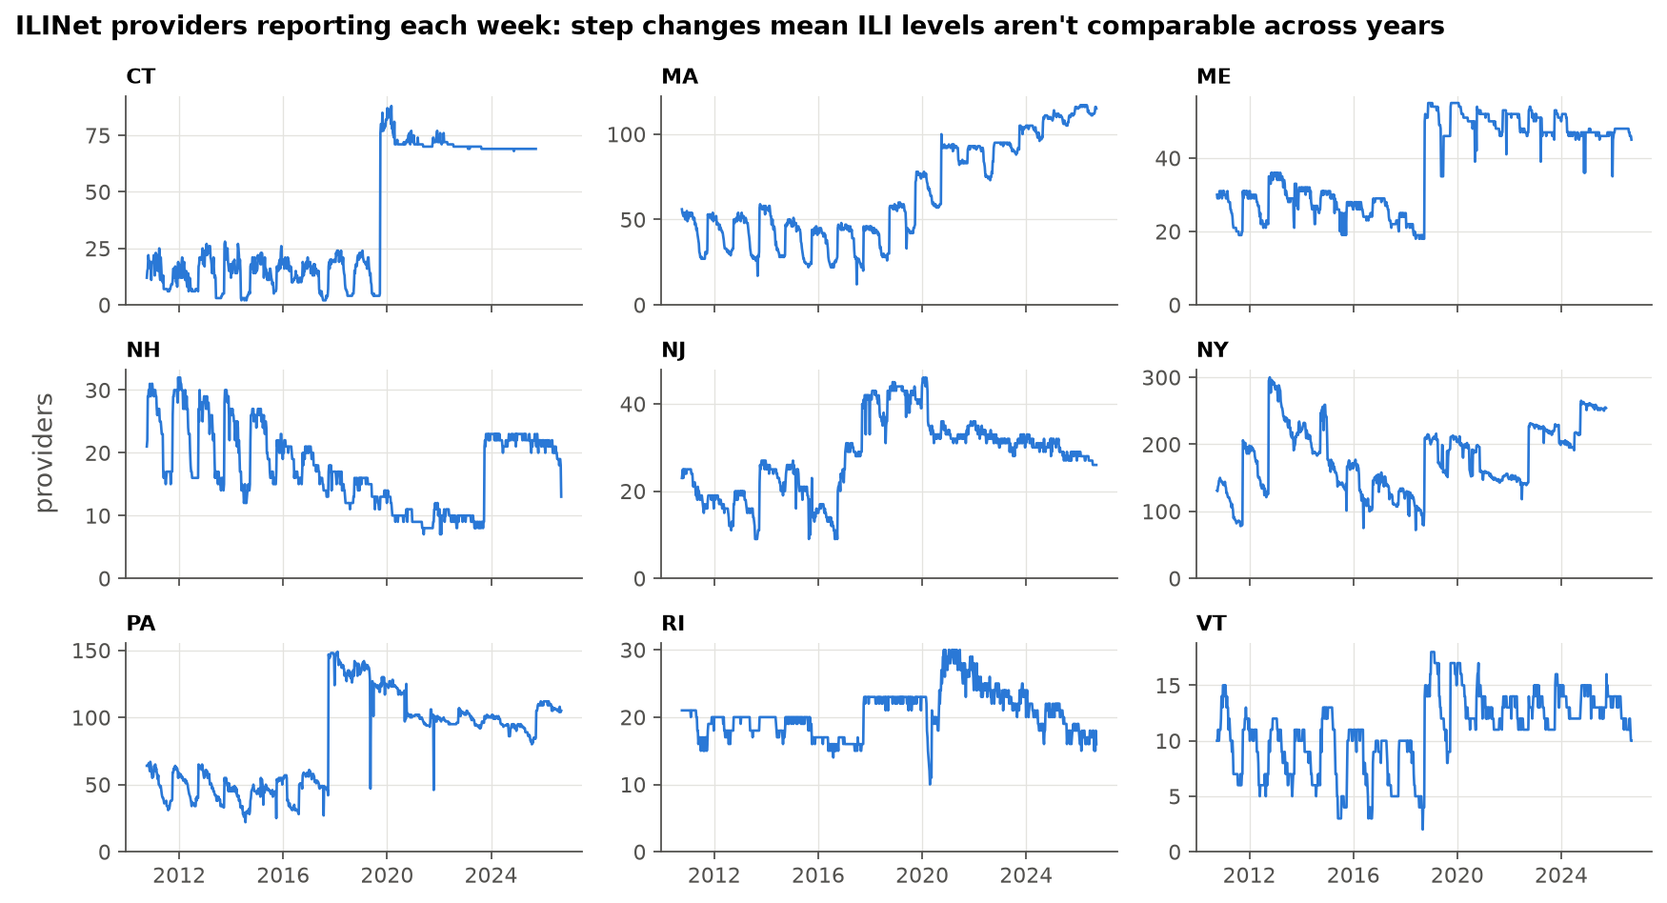
Figure 1. Weekly number of ILINet providers reporting in each state. Step changes mean ILI levels are compared only within a state.
ILI surges once every winter in every state (Figure 2), peaking at a median 4.4% of visits in late January; the regional peak ranged from 1.4% (2020-21) to 8.8% (2024-25). In ED data (Figure 3), influenza peaks highest, RSV usually rises first and COVID also has summer waves. Peaks vary more between seasons than between counties (Figure 4).
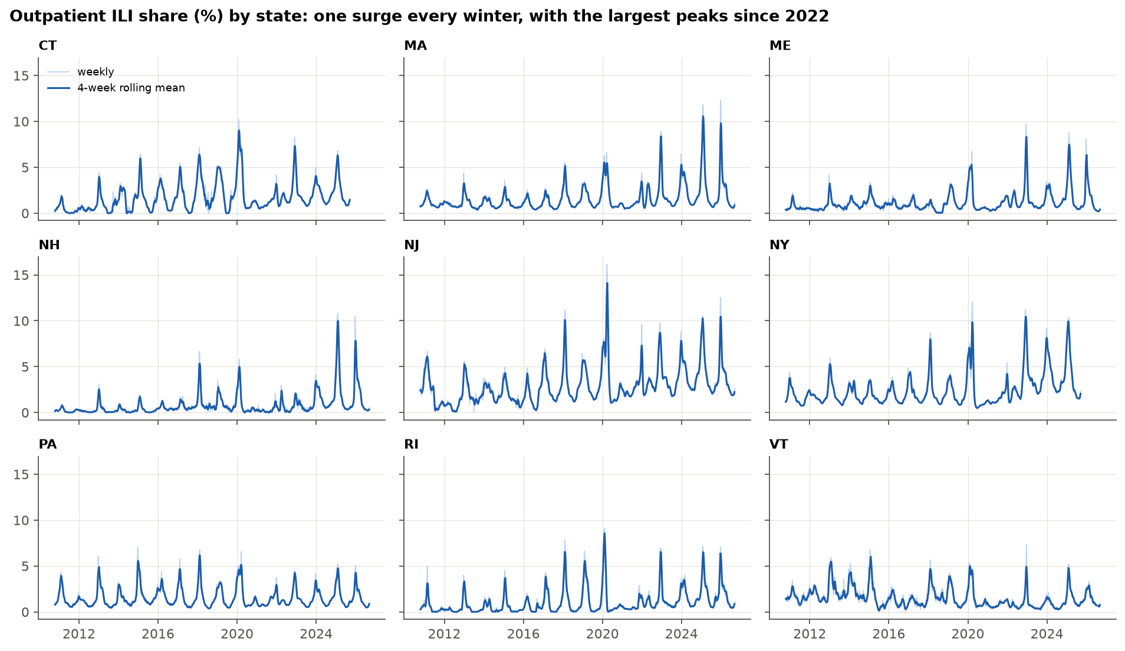
Figure 2. Weekly outpatient ILI share by state (faint) and its 4-week rolling mean (solid), October 2010 to September 2026.
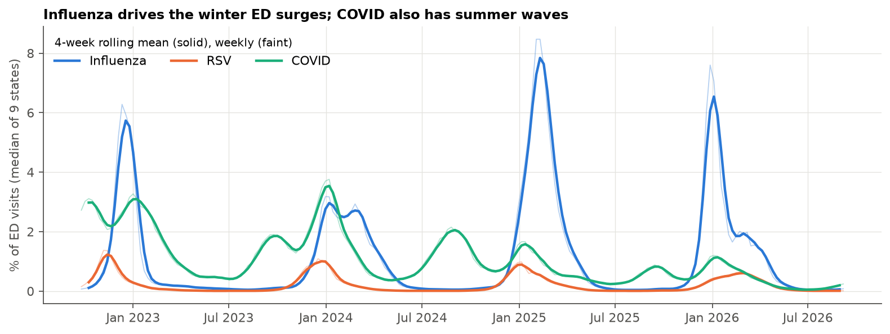
Figure 3. Share of ED visits by pathogen, median of the nine states, 2022–2026.
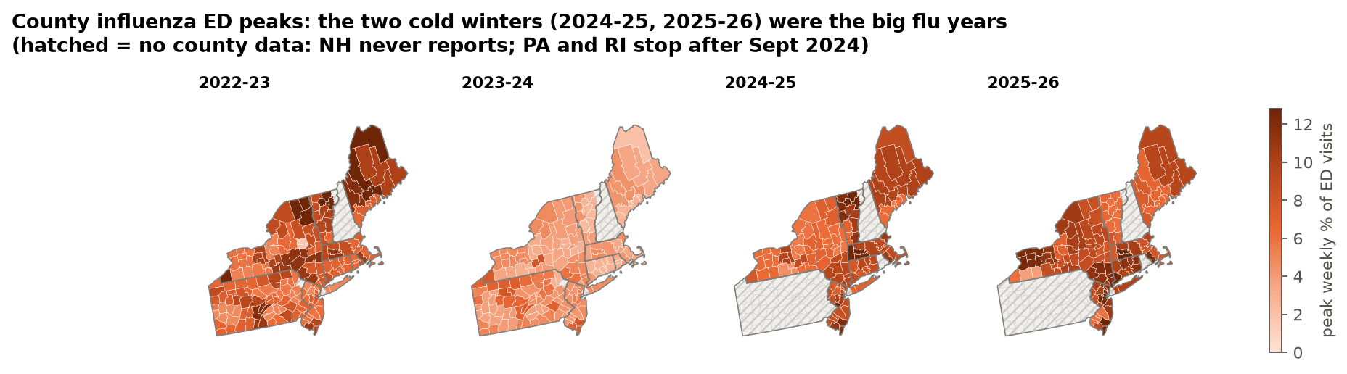
Figure 4. County peak influenza share of ED visits by season. Hatched counties have no county data.
Winter normals range from 20 °F (Vermont) to 34 °F (New Jersey). Anomalies move together across states (median correlation 0.98; Figure 5), so each winter is about one regional observation and tests treat seasons as independent.
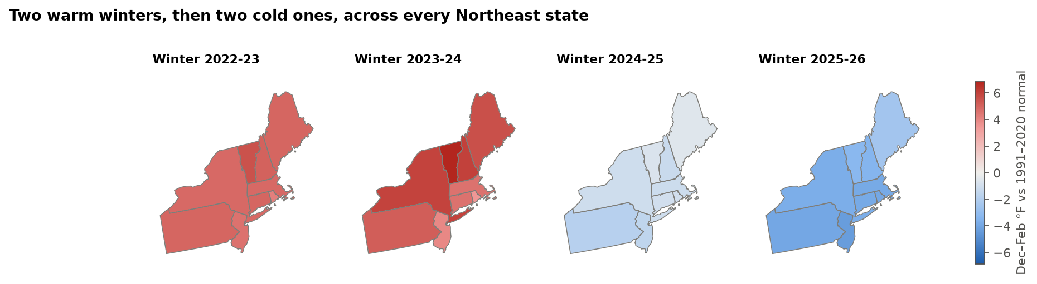
Figure 5. December–February temperature anomaly by state, relative to the 1991–2020 normal.

3. Feature engineering
Raw temperature–illness correlations mostly rediscover the calendar (Figure 8). The key feature is the temperature anomaly: temperature minus its 1991–2020 monthly normal, averaged over December–February for season-level tests. The weekly outcome is ILI growth over the next two weeks (log change), controlling for current level, recent growth, week of season and holidays.

4. Models and analysis plan
Seven pre-stated hypotheses (Table 2) are tested with methods that respect shared winters: season permutation,⁷ season-clustered errors,⁸ a paired rank test⁹ and block sign-flips, with Holm correction.¹⁰
Figure 6 shows the assumptions. Temperature anomaly is the exposure; time of year is the main confounder, setting both normal temperature and the respiratory season. Using anomalies removes that path, and within-state and within-season comparisons block the state and season-year paths. Reporting also changes over time (providers, and a 2021-22 ILI definition change¹¹), so season-level tests are re-run with reporting controls.
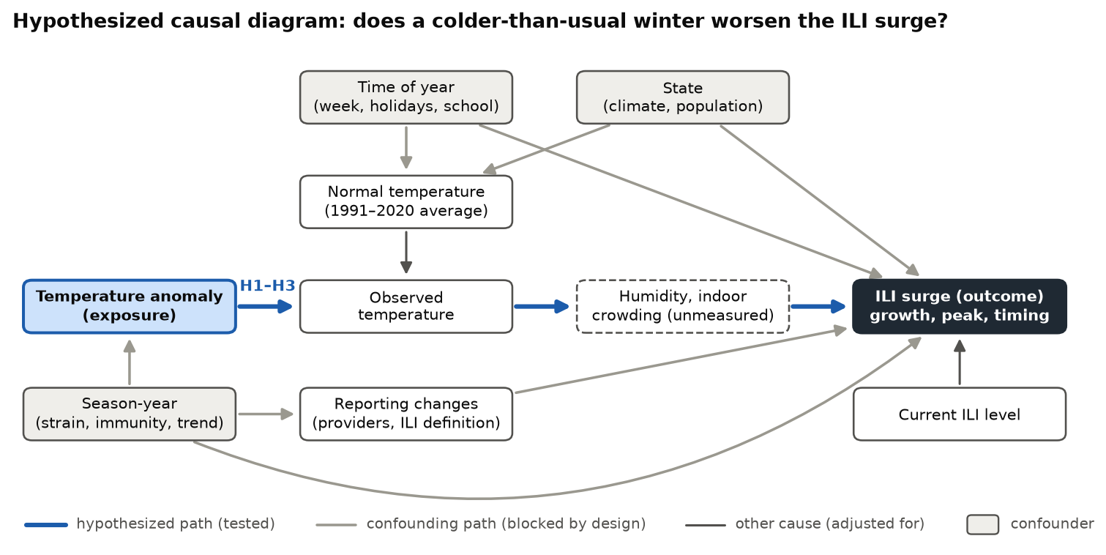
Figure 6. Assumed causal diagram. Blue arrows are the tested path; gray arrows are confounding paths, removed by using anomalies, within-state comparisons, season fixed effects or season-level permutation, and reporting controls.
Forecasts use a rolling-origin backtest. Chronos-2,¹² a pretrained model, ran without covariates, with past temperature and with actual future temperature, against persistence and climatology, scored by mean absolute error (MAE), weighted quantile loss¹³ and 80% interval coverage.

5. Results

Seasonality, not temperature
Every ILI season peaks December–February (Figure 7). Colder weeks coincide with higher ILI (Spearman ρ -0.36 to -0.60), but after removing seasonality the anomaly–growth correlation is -0.08 to 0.00 (Figure 8).
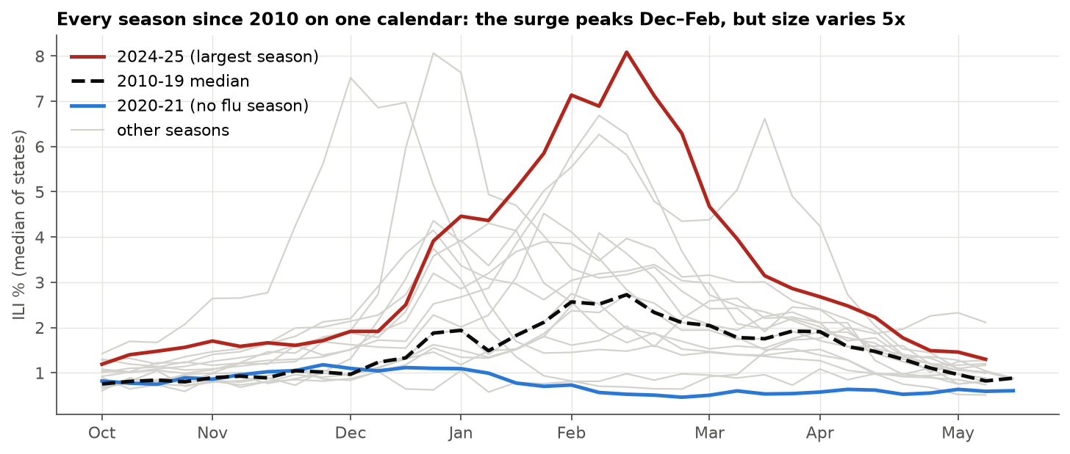
Figure 7. Median state ILI share by week of season, every season 2010–11 to 2025-26. The surge always arrives in winter; its size does not follow a fixed pattern.
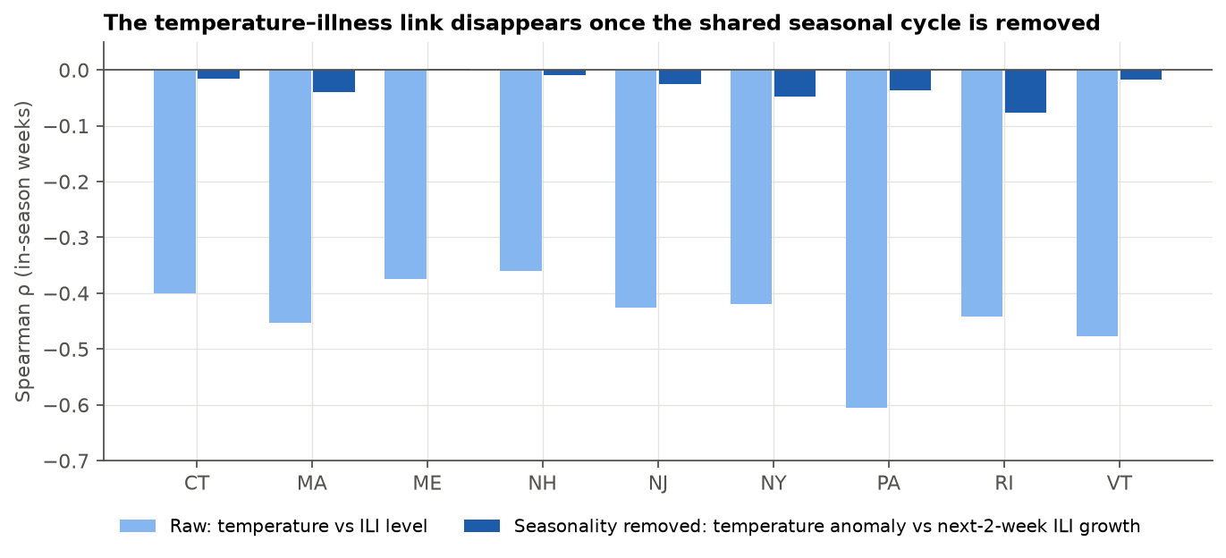
Figure 8. Raw temperature–ILI correlation (light) versus the correlation after removing the seasonal cycle (dark), in-season weeks 2010–2026.

Hypothesis tests
No temperature or timing hypothesis survives correction (Table 2). The ED period's two cold winters were its biggest influenza seasons (Figure 4), but four seasons cannot separate weather from strains. RSV peaked about four weeks before influenza in 3 of 4 seasons, but the order reversed in 2025-26.
 | Alternative hypothesis | Estimate | Test | n | Holm p | Decision
H1 | Colder winters have different peak ILI size | +0.030 pp per °F | season permutation | 135 | 1.00 | not rejected
H2 | Colder winters have different peak ILI timing | -0.205 weeks per °F | season permutation | 135 | 1.00 | not rejected
H3 | Temperature anomaly changes 2-week ILI growth | -0.0016 log per °F | OLS, season-clustered | 4387 | 1.00 | not rejected
H4 | RSV peaks before influenza (ED) | median -4.0 weeks | Wilcoxon signed-rank | 36 | 0.92 | not rejected
H5 | Temperature improves Chronos-2 (ILI) | +0.0081 pp | block sign-flip | 27 | 1.00 | not rejected
H6 | Temperature improves Chronos-2 (ED) | +0.0085 pp | block sign-flip | 54 | 1.00 | not rejected
H7 | Chronos-2 beats persistence (power check) | -0.1859 pp | block sign-flip | 27 | < 0.001 | reject
Table 2. Hypothesis tests (α = 0.05, Holm-corrected across H1–H7). Estimates: H1 pp per °F; H2 weeks per °F; H3 log growth per °F; H4 median weeks; H5–H7 MAE difference (pp).
Reporting drift is a real back-door path: the time trend correlates with both the anomaly (r = 0.28) and peak ILI (r = 0.46). Controlling for providers, trend and the definition change keeps every slope near zero (p > 0.3; Figure 9). Adding the trend nudges the peak-size slope toward "colder means bigger", so drift could hide a small effect, but none is detectable.
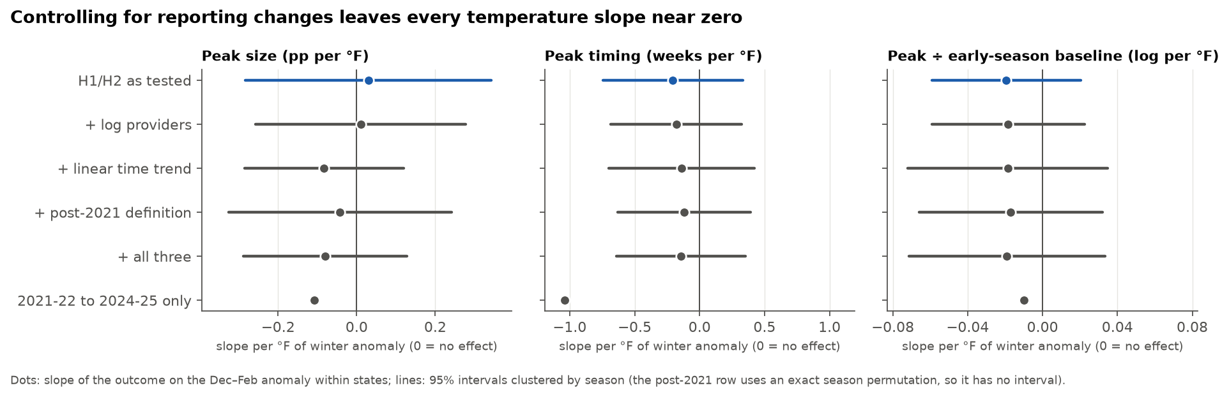
Figure 9. Temperature slopes for ILI peak size, timing and baseline-normalized peak, as tested and with reporting controls (state fixed effects; 95% intervals clustered by season). The last row uses only seasons under the current ILI definition.

Forecasting
Chronos-2 beat both baselines at every horizon (Figure 10, Table 3), cutting four-week error by 26% (ILI) and 31% (ED). Temperature, even its actual future values, did not help (H5, H6), though the same test detected Chronos-2's gain (H7). ED intervals were too narrow (70% coverage).
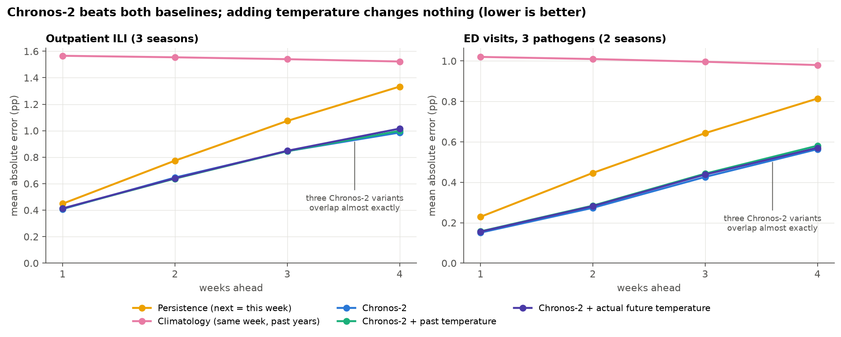
Figure 10. Rolling-origin forecast error by horizon. ILI: 9 states, 2022-23 to 2024-25. ED: 9 states × 3 pathogens, 2024-25 and 2025-26.
Model | ILI MAE | ILI WQL | ILI 80% cover. | ED MAE | ED WQL | ED 80% cover.
Persistence | 0.91 | – | – | 0.53 | – | –
Climatology | 1.55 | – | – | 1.00 | – | –
Chronos-2 | 0.72 | 0.179 | 80% | 0.35 | 0.246 | 70%
Chronos-2 + past temperature | 0.72 | 0.178 | 83% | 0.37 | 0.253 | 73%
Chronos-2 + actual future temperature | 0.73 | 0.180 | 81% | 0.36 | 0.247 | 72%
Table 3. Forecast accuracy over horizons 1–4 weeks (lower MAE and WQL are better; ideal coverage is 80%). Baselines give point forecasts only.

6. Interpretation and recommendations
Temperature is context, not a trigger. Every county's winter warmed 1.8–5.2 °F between 1986–95 and 2016–25 (Figure 11), yet temperature added no forecasting value. Planners should feed surveillance into a model such as Chronos-2, treat RSV's early rise as a prompt rather than a guarantee, and widen ED forecast intervals.
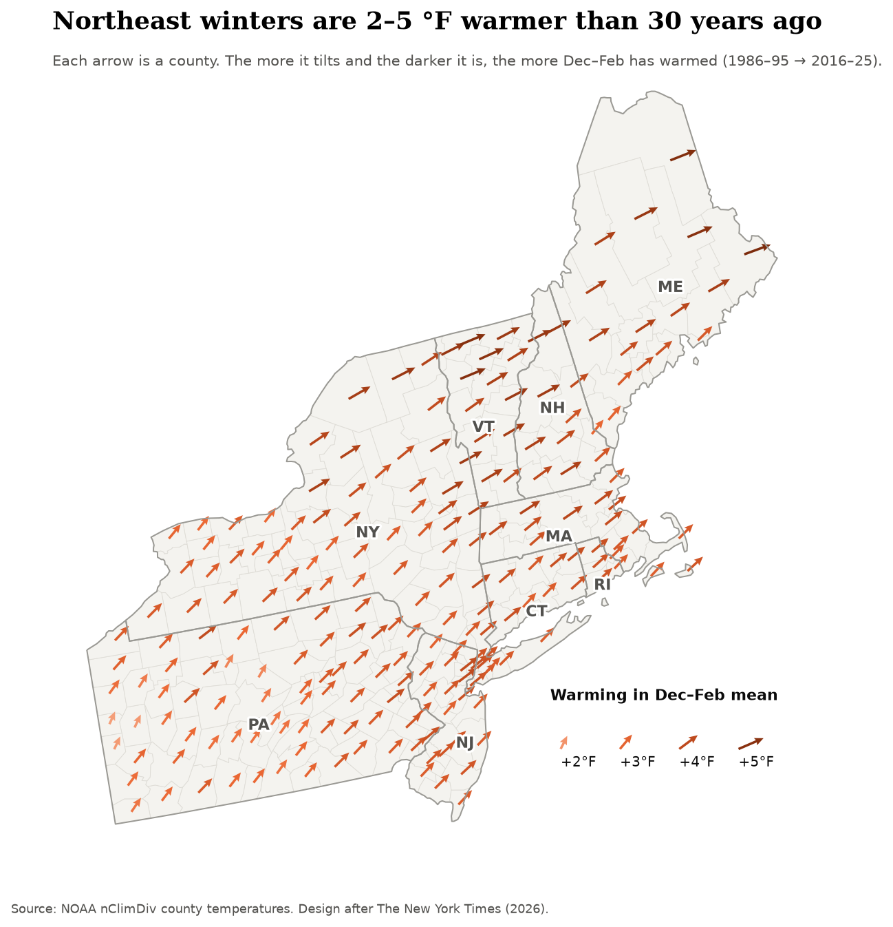
Figure 11. Change in county December–February mean temperature, 1986–95 to 2016–25. Arrow design adapted from The New York Times.¹⁴

7. Limitations
Temperature is monthly and county-averaged. Outcomes are visit shares from a changing system; care-seeking shifts and NSSP onboarding are not controlled. ED data span four seasons, Chronos-2 may have seen CDC data in pretraining, and results are ecological. Humidity^{1,2} is the next variable to test.

References
1. Lowen AC, Mubareka S, Steel J, Palese P. Influenza virus transmission is dependent on relative humidity and temperature. PLoS Pathog. 2007;3(10):e151. doi:10.1371/journal.ppat.0030151
2. Shaman J, Kohn M. Absolute humidity modulates influenza survival, transmission, and seasonality. Proc Natl Acad Sci U S A. 2009;106(9):3243-3248. doi:10.1073/pnas.0806852106
3. Vose RS, Applequist S, Squires M, et al. NOAA Monthly U.S. Climate Divisional Database (NClimDiv). Published online 2014. doi:10.7289/V5M32STR
4. Delphi Research Group, Carnegie Mellon University. NSSP emergency department visit signals (source: CDC National Syndromic Surveillance Program). Published online 2026. Accessed October 5, 2026. https://cmu-delphi.github.io/delphi-epidata/api/covidcast-signals/nssp.html
5. Delphi Research Group, Carnegie Mellon University. FluView: ILINet influenza-like illness surveillance (source: CDC ILINet). Published online 2026. Accessed October 5, 2026. https://cmu-delphi.github.io/delphi-epidata/api/fluview.html
6. U.S. Census Bureau. 2020 Cartographic Boundary Files: counties and states, 1:20,000,000. Published online 2021. Accessed October 6, 2026. https://www.census.gov/geographies/mapping-files/time-series/geo/cartographic-boundary.html
7. Good PI. Permutation, Parametric and Bootstrap Tests of Hypotheses. 3rd ed. Springer; 2005. doi:10.1007/b138696
8. Cameron AC, Miller DL. A practitioner's guide to cluster-robust inference. J Hum Resour. 2015;50(2):317-372. doi:10.3368/jhr.50.2.317
9. Wilcoxon F. Individual comparisons by ranking methods. Biometrics Bulletin. 1945;1(6):80-83. doi:10.2307/3001968
10. Holm S. A simple sequentially rejective multiple test procedure. Scand J Stat. 1979;6(2):65-70. https://www.jstor.org/stable/4615733
11. Centers for Disease Control and Prevention. U.S. Influenza Surveillance: Purpose and Methods. FluView. Accessed October 8, 2026. https://www.cdc.gov/fluview/overview/index.html
12. Ansari AF, Shchur O, Küken J, et al. Chronos-2: From univariate to universal forecasting. arXiv. Preprint posted online October 17, 2025:arXiv:2510.15821. doi:10.48550/arXiv.2510.15821
13. Gneiting T, Raftery AE. Strictly proper scoring rules, prediction, and estimation. J Am Stat Assoc. 2007;102(477):359-378. doi:10.1198/016214506000001437
14. The Editorial Board. The South and the Midwest are much hotter now [graphic]. The New York Times. September 5, 2026. Accessed October 6, 2026. https://www.nytimes.com/interactive/2026/09/05/opinion/editorials/extreme-heat-summer.html

