**Brain Tumour Detection**

**Problem Definition:**

Develop an efficient and accurate computer-aided diagnosis (CAD) system for the detection of brain tumors in medical imaging (MRI and CT scans). The system should preprocess images, localize tumors, extract relevant features, classify tumors, offer a user-friendly interface, ensure real-time processing, integrate seamlessly into medical workflows, validate its accuracy, and adhere to ethical considerations, ultimately aiding healthcare professionals in early and reliable brain tumor detection.  
  
**Proposed Solution**

The proposed solution aims to develop a robust and efficient Computer-Aided Diagnosis (CAD) system for the early detection of brain tumors in medical imaging, specifically utilizing MRI and CT scans. This system follows a well-defined methodology to accomplish this task:

**Image Acquisition**: The system begins by acquiring medical images, particularly MRI scans, as input data.

**Preprocessing:** To enhance the accuracy of tumor detection, the input image is initially processed. It is converted into a binary image using a threshold value of 0.7. This step helps in segmenting the regions of interest.

**Segmentation and Labeling:** The binary image is then subjected to a labeling function, which assigns a unique label to each connected region. This labeled image is stored in a variable called "label."

**Feature Extraction:** Region properties, such as Solidity and Area, are computed for each labeled region using the 'regionprops' function. Solidity measures the compactness of a region, and Area quantifies its size. These properties are stored in arrays, 'density' and 'area.'

**Filtering High-Density Regions:** A logical array called 'high_dense_area' is generated, marking regions where the Solidity exceeds 0.5. This identifies relatively solid shapes in the image.

**Identifying Tumor Region**: The region with the maximum area among the high-density areas is considered as the potential tumor region.

**Tumor Localization**: A binary image representing the tumor is generated by checking if each pixel in the labeled image belongs to the tumorous region identified in step 6.

**Morphological Processing:** A morphological structuring element in the shape of a 5x5 square is used to perform dilation on the tumor region. This step helps refine the tumor's boundaries.

**Visualization:** The final output is displayed to the user in a user-friendly interface, with three main components: the original brain image, the isolated tumor region, and the detected tumor boundary.

The source code provided performs these operations on a sample image. In practice, the system can be integrated seamlessly into medical workflows, allowing healthcare professionals to use it for early and reliable brain tumor detection in real-time. To ensure ethical considerations, the system should comply with all relevant data privacy and patient consent regulations, providing a secure and confidential environment for handling sensitive medical data. Moreover, the accuracy and effectiveness of the system should be rigorously validated through extensive testing and clinical trials to ensure its reliability and safety in a healthcare setting.

**Source Code**

img=imread('brain_mri.jpg');

bw=im2bw(img,0.7);

label=bwlabel(bw);

stats=regionprops(label,'Solidity','Area');

density=[stats.Solidity];

area=[stats.Area];

high_dense_area=density>0.5;

max_area=max(area(high_dense_area));

tumor_label=find(area==max_area);

tumor=ismember(label,tumor_label);

se=strel('square',5);

tumor=imdilate(tumor,se);

figure(2);

subplot(1,3,1);

imshow(img,[]);

title('Brain');

subplot(1,3,2);

imshow(tumor,[]);

title('Tumor Alone');

[B,L]=bwboundaries(tumor,'noholes');

subplot(1,3,3);

imshow(img,[]);

hold on

for i=1:length(B)

plot(B{i}(:,2),B{i}(:,1), 'y' ,'linewidth',1.45);

end

title('Detected Tumor');

**Input Image 1   
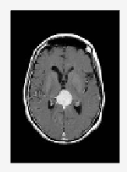  
Output Image 1**

**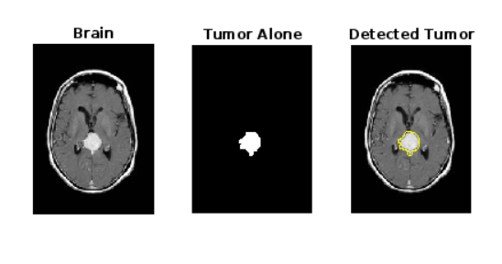  
Input Image 2**

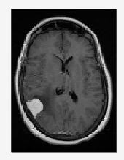

**Output Image 2  
