# Chapter 4. Integrating survival and reproduction to explain variation in climate-sensitivity of alpine mammal populations

**Introduction**

There is a great deal of interest in studying the demographic effects of weather and environment on animal populations to predict the ecological consequences of climate change. Most such research on vertebrates has tended to focus on a single species at a time (Ainley 2002; Beever et al. 2003; Schwartz and Armitage 2004). These species are often identified as ‘indicator species’ for the regions they inhabit, based on criteria chosen to ensure that they are representative of the larger animal community. However, the effectiveness of indicator species is rarely tested, and in fact, two species can react to changing weather or climate patterns in completely different ways, even if they are closely related or ecologically similar (Chapter 2). Meta-analyses have begun to reveal widespread relationships between climate change and species ranges as well as with specific life history traits (Walther et al. 2002; Parmesan and Yohe 2003; Post et al. 2009). However, unless we understand why some species are more sensitive to weather variation and average climate than others, the results of climate change research cannot be effectively generalized from one species to the next.

Weather and other external forces act on population dynamics by affecting demographic parameters (i.e. life history traits like age-specific survival and fecundity). However, a change in any one of these parameters does not necessarily influence the population growth rate, because some parameters have more influence than others (Caswell 2001). The relative importance of a given parameter, such as juvenile survival, can vary over space and time (Nichols et al. 2000; Morrison and Hik 2007), and should also depend on the life history strategy of a species. Furthermore, life history strategies themselves may also differ from one population or environment to the next (Bears et al. 2009). As a result, the demographic consequences of climate change cannot be studied or predicted without considering the role of life history.

The contributions of individual life history traits to population growth can be decomposed in a number of ways. Typically, this task is accomplished via Life Table Response Experiments (LTREs) using matrix population models, which are subject to several key assumptions that are often violated in wild populations. In particular, the assumptions of demographic and environmental stasis are rarely met. Stochastic LTREs designed for analyzing transient population dynamics have recently been developed, but these methods require data collected across a wide spatial and temporal scale, and may not always be practical (Caswell 2010; Davison et al. 2010). An alternative approach is to estimate both the population growth rate and the relative contributions of demographic parameters to that rate directly from mark-recapture data (Nichols et al. 2000; Nichols and Hines 2002). These estimates are derived and interpreted somewhat differently than the results of a standard LTRE. However, both approaches are considered retrospective analyses, and both ostensibly meet the same objective (Cooch et al. 2001). Despite calls for more study into their differences (Cooch et al. 2001), a direct comparison has not been conducted (but see Sandercock and Beissenger 2002 and Lima et al. 2003 for other comparisons of matrix models and reverse-time modeling).

In this chapter I used both LTREs and reverse-time modeling (Nichols et al. 2000) to compare the population dynamics of collared pikas and hoary marmots, two mammalian herbivores living in an alpine environment characterized by a harsh, variable winter climate. The survival rates of both species have been linked to abiotic conditions, particularly the quality and depth of snowpack and the timing of spring snowmelt (Chapter 2; Morrison and Hik 2007). Interestingly, the two species respond to variation in winter climate in very different ways. Pika survival is positively related to the length of the previous growing season, while juvenile marmot survival appears to increase during cold, snowy winters, probably as a result of their need for snowpack as insulation (Chapter 2; Morrison and Hik 2007). In addition, at a long-term study site in the Yukon, the two species appear to fluctuate in abundance independently of each other (D.S. Hik, unpublished data).

I had four main objectives in this study: 1), to compare LTRE’s and mark-recapture methods for decomposing demographic contributions to λ using field data, and assess the implications of choosing one method over the other; 2) to quantify the influence of climate-mediated variation in survival and fecundity on the population dynamics of collared pikas and hoary marmots using both methods;.and 3) to determine why populations of collared pikas and hoary marmots in a shared environment followed different trajectories, and to identify the role of life history in shaping those differences.

I hypothesized that the basic life history strategy of each species would determine which demographic parameters made the greatest contribution to population growth. Collared pikas have relatively short lives (3-5 years) and low annual survival rates (<0.5; Morrison and Hik 2007), which means that they have few reproductive opportunities.. Variation in fecundity should therefore make a greater contribution to pika population growth than survival. Hoary marmots, on the other hand, can live for 10 years or more in the wild, have relatively constant breeding probability, and take several years to reach reproductive maturity (Chapter 2). The ability of an individual marmot to contribute to the population should therefore be most sensitive to survival, especially in the younger age-classes.. These predictions, combined with the fact that winter climate is strongly linked with survival for both species, lead to the prediction that winter climate has a stronger influence on population growth rate in hoary marmots than in collared pikas.

**Methods**

Both study species, the study site, and basic capture methods for hoary marmots are described in Chapter 1. All hoary marmot social groups in the 4 km2 study area were trapped between 1999-2004, while a subset of four groups distributed amongst the South, East, and West aspects of the valley were trapped in 2007-2009. Most pikas in the study area with active haypiles were trapped each year from 1998-2009, using native vegetation as bait. Pika trapping methods are described in detail elsewhere (Franken and Hik 2004; Morrison and Hik 2007). Pikas are diurnal, highly visible, and philopatric to their territories from one year to the next, so the absence of a pika from a territory where it was active was taken as strong evidence of that pika’s death.

### Matrix model structure and parameterization

I constructed age-structured Leslie projection matrices to describe the asymptotic population dynamics of both pika and marmot populations (Caswell 2001; Keyfitz and Caswell 2005). These matrices were based on a post-birth census, as breeding occurs at the beginning of the field season and is typically not observed. Matrices were based on female demographic data, although male and female data were used to parameterize the survival estimates of non-adult marmot age-classes which are not sexually dimorphic and do not exhibit sex-bias in dispersal probability) (Barash 1989). Pikas were modeled using two age classes, while marmots were assigned four: juveniles, yearlings, two-year-olds, and sexually mature adults. Models included age-specific survival probabilities (Pi), fecundity (Mi), and fertility (Fi), where i indicates the age-class. Matrix structure and the corresponding life-cycle diagrams for hoary marmots (a) and collared pikas (b) are shown in Fig. 4-1.

Survival parameters were estimated by modeling survival as a function of year, age-class, and sex in program MARK (White and Burnham 1999), using the RMark extension in R (Laake and Rexstad 2007; R Developement Team 2009). Detection probability was modeled as a constant, and was estimated as being close to 1 for both species (0.96 ± 0.02 for marmots, 0.90 ± 0.04 for pikas). Cormack Jolly Seber (CJS) survival models were used for estimating pika survival, and for marmot survival between 1999 and 2004 (Lebreton et al. 1992).

For the latter subset of marmot data (2007-2009), survival was modeled in a robust design framework, with capture and recapture probability allowed to vary between years (Kendall and Pollock 1992). This approach was chosen because marmot trapping effort was not consistent between years, and the trapping period in 2009 was shorter than in the other two years, meaning that 2009 detection probability could not be reliably extrapolated from previous estimates. To improve marmot detection probability estimates in 2009, sampling was broken into 4 trapping sessions. Effort, time spent trapping, time of day, and weather conditions were kept as approximately constant between trapping sessions. For 2007-2008, marmot sampling was broken into two distinct trapping periods. The first period extended from snowmelt to the third week of July, when all juveniles had been born, and the second extended until the end of August. This division was chosen to ensure that essentially all individuals were present and available for capture in both periods (Nichols et al. 2000).

For both species, some juveniles could not be associated with a specific mother. In addition, not all juveniles could be sexed confidently. I therefore estimated average fecundity as the number of female juveniles plus half the number of unknown-sex juveniles divided by the number of reproductively mature females (Equation 1).

Equation 1. Formula for estimating average age-specific fecundity of hoary marmots and collared pikas.

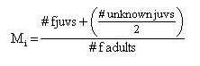

Fertility calculations for pikas differed slightly from those for marmots (Equation 2). Pika fertility was calculated as the product of the survival probability from age i to age i+1 and the average fecundity for age i+1 (Equation 2a). Marmot fertilities were the product of the probability of survival from age i to age i+1, the probability of breeding for age i+1 (from chapter 3), and the fecundity term for age i+1 (Equation 2b). Because I did not have estimates of marmot breeding probability for 2007-2009, I used the average probability from 1999-2004 for all years.

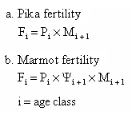Equation 2. Formulas used to calculate age-specific fertility estimates for collared pikas and hoary marmots.

Only the oldest age class was reproductively mature in both species (age 1 for pikas, and age 3 for marmots), but both matrices include fecundity terms for the next-oldest age class because of the post-birth design (Fig. 4-1; Caswell 2001). Matrices were constructed for each overwinter period in the two datasets, for total of 11 pika matrices (1998-1999 through 2008-2009) and 7 marmot matrices (1999-2000 to 2003-2004, 2007-2008, and 2008-2009).

### Matrix Model Analyses

Methods for matrix model analysis were the same for both pikas and marmots. First, the projected asymptotic population growth rate (λasym) was derived as the dominant eigenvalue of each projection matrix (Caswell 2001). I then determined the proportional contributions of demographic parameters (Pi, Mi, Fi) to λasym using a random design LTRE (Caswell 2001). In an LTRE, the relative importance of a parameter is evaluated as the product of the partial derivative of λasym with respect to that parameter (sensitivity) and the covariance of that parameter with all other parameters (Equation 3). Standard errors and confidence intervals for parameter contributions and λasym were estimated by bootstrapping with 1000 replications (Caswell 2001).

Equation 3. The formula for variance in λasym. aij and akl represent the matrix entries corresponding to the i or k row and j or l column of a Leslie matrix, over all possible values of i,j,k, and l.



For a population to grow at its projected asymptotic growth rate, several assumptions must be met. First, the population is assumed to be in stable-age distribution, meaning that all age-classes are growing at the same rate. Second, all demographic rates are assumed to be deterministic and constant, an assumption that is rarely met in wild populations living in harsh, variable environments. λasym is therefore not expected to reflect short-term or transient population dynamics (Sandercock and Beissinger 2002). However, it can still be useful as an instantaneous gauge of current demographic conditions, or of the potential lifetime fitness of an individual living in a given environment (Caswell 2001), provided that the models used to derive it adequately characterize the life history of the organism (Sandercock and Beissinger 2002).

### Reverse-time modeling

As an alternative to λasym,, I estimated a second measure of population growth rate (λ) using reverse-time mark-recapture modeling (Lebreton et al. 1992; Pradel 1996). These estimates will be referred to as λreal to differentiate them from λasym values derived from population matrices, following Sandercock and Beissinger (2002). Estimation of λ in this way allows for population growth rates to be estimated even in populations that have not been completely censused, formally incorporating detection probability (Pradel 1996).

Contributions made by demographic parameters to λreal were estimated based on seniority parameters (γ) in reverse-time mark-recapture models (Nichols et al. 2000). This technique has been described as an alternative approach to the types of questions that LTREs were designed to address (Cooch et al. 2001), but the two methods have not been directly compared using field data. A seniority parameter describes the probability that an individual present in the population at time i was also present at time i-1. In other words, it is essentially the reverse-time equivalent of survival in a standard CJS model (which is the probability that an individual alive at time i will also be alive and present at i+1).

I estimated λreal for both pikas and marmots in all years where data was available. I modeled γ in a multi-state framework for both species, with juvenile and non-juvenile age-classes as different ‘states’. The adult age-class was therefore associated with two γ parameters, γAJ (the contribution of juvenile survival to adults) and γAA (the contribution of adult survival to adults). 1- (γAJ+ γAA) = γImm is therefore an estimate of apparent immigration, or the contribution that newly captured individuals made to the current adult population. This term should closely reflect the true importance of immigration if capture probability is equal between marked and unmarked animals, and if the proportion of individuals in the population that have been captured at least once is close to 1 (Nichols et al. 2000). The three γ parameters described above will always sum to one. Impossible parameters like γJJ and γJA (the probabilities that current juveniles were in the juvenile or adult cohorts in the previous time step) were fixed at 0. Finally, I also estimated the proportional contribution of reproductive parameters (breeding probability and fecundity) at each time i as the estimated proportion of juveniles in the population at i+1 (Equation 4). These modeling methods, and the underlying theory, are described in detail in Nichols et al. (2000) and Nichols and Hines (2002).

Equation 4. Formula for estimating the proportional contribution of fecundity, breeding probability, and other reproductive parameters to λreal for any time interval from time i to time i+1. N is the number of individuals in an age class, and superscripts represent the age-class (J for juveniles, A for adults).



This approach has a potential limitation, because the four parameters described above only represent contributions to λreal for the adult population. However if the population is in stable-age distribution, λreal is the same for all age classes (Nichols et al. 2000). As an additional comparison, I also calculated time-specific γ values for pikas and marmots using basic Pradel models with no age-structure (Pradel 1996). These basic γ terms represent the proportion of the population in year i that was alive in year i-1. A value greater than 0.5 therefore indicates that survival (across all age-classes), was more important than recruitment and immigration combined (Nichols et al. 2000).

### λ Modeling

The final step in my analyses was to model λreal directly using winter climate as a linear constraint. This analysis allowed me to evaluate the relative effectiveness of reverse-time modeling and matrix models in predicting the sensitivity of population growth rate to climate-mediated changes in survival.

## 

## Results

### Projected and realized growth rates

For marmots, λasym values were more stable than λreal, and remained close to one throughout the study. In the pika population, λreal had a range similar to that of λasym (0.48-1.51 versus 0.27-1.81), but λasym was lower in 10 out of 11 time periods (mean difference = 0.3). The marmot population showed a positive realized growth rate (λreal) in 4 of 7 time intervals, while λreal for pikas increased in 7 of 11 time intervals, indicating that neither population was following a stable trajectory (Fig. 4-2). In contrast, the projected growth rate (λasym) of the pika population was negative in 9 out of 11 time intervals, suggesting a generally declining population. During the 9 years when both species were being studied, pika and marmot population growth rates were not significantly correlated (λreal: r = -0.52, p = 0.23, λasym: r = -0.18, p = 0.72).

For marmots, the highest estimate of λreal occurred during the first overwinter interval in the study. However, a smaller proportion of the population may have been captured during the first year when trapping protocols were still being developed. No such peak was observed for pikas, but the first 3 years of available pika trapping data (1995-1997) were not used. In general, λreal could be estimated with much greater precision for marmots than for pikas (Fig. 4-3).

### LTRE results

#### Marmots

The relative contribution of demographic parameters to λasym varied annually (Fig. 4-4). Juvenile survival was the single greatest contributor to variation in λasym in 3 out of 7 years (Fig. 4-4). However, two-year-old survival, adult survival, and fecundity terms made important contributions in several years (Fig. 4-4). On average, two-year-old survival had the greatest impact on λasym (Table 4-2). However, the high rank of two-year-old survival was strongly influenced by a single time interval (2003-2004) when both λasym and estimated survival rates for older age-classes were unusually low (Fig. 4-4). When the LTRE was re-run without that time period, juvenile survival appeared 4 times as important as any other model parameter (Table 2). Juvenile survival made the greatest contribution in 3 out of 4 intervals when the population was projected to increase, but contributed very little to the steep decline in λasym during 2003-2004 (Fig. 4-4).

As with most matrix models, some demographic rates like adult survival were incorporated into more than one model parameter. These lower-level demographic parameters’ importance can be evaluated as the sum of all contributions from model parameters that include them (Caswell 2001). For example, the true contribution of adult survival (contribution (P3) + contribution (F3)) was 0.22 + 0.13 = 0.35 based on all the data, and 0.079+0.131 = 0.21when 2004 was excluded. Adult survival and two-year-old survival made approximately equal contributions to λasym when all data were analyzed (PA contribution = 0.35, P2 contribution = 0.35), while the lower level fecundity parameter (MA) was somewhat less important (contribution = 0.20). When 2004 was excluded, fecundity had the second-highest lower-level parameter contribution (0.17), but that was almost four times smaller than the contribution made by juvenile survival.

#### Pikas

The results of the pika LTRE did not identify any one parameter as being consistently the most important (Fig. 4-4). Bootstrap standard errors indicate that there were no significant differences between the contributions of individual parameters (Table 4-2). However, fertility terms tended to be more important than survival (Table 4-2). Fertility terms made the greatest contributions during both years when λasym exceeded 1 (Fig. 4-4). The mean lower-level contributions of demographic rates were as follows: fecundity (.75) > juvenile survival (0.59) > adult survival (0.41).

### Reverse-time modeling

### Comparison of λreal between the adult age-class and the total population

λreal estimates for adults and for all ages were similar and significantly correlated in the hoary marmot population (r = 0.8, p = 0.03; Fig. 4-3), suggesting that it was in an approximately stable age-distribution. The two measures of population growth were not significantly correlated in the pika population (r = 0.3, p = 0.52; Fig. 4-3). For both species, the distribution of age-classes in our field data conformed reasonably well with the expected stable-age distribution associated with each matrix model (Table 4-1).

#### Marmots

The proportional contribution of γ parameters to λreal varied annually. Mean contributions were: adult survival (0.69) > fecundity (0.23) > juvenile survival (0.19) > apparent immigration (0.11). Adult survival (γAA) was the single most important parameter in all but the first time period (1999-2000) (Fig. 4-5). Juvenile survival was 2-3 times less important than adult survival in most years (Fig. 4-5). Apparent immigration contributed little to the adult population, except in 1999-2000 (Fig. 4-5). Fecundity and juvenile survival made similar contributions to λreal in most years. The ranking of individual γ parameters from the multi-state reverse-time models was not clearly related to whether λreal was increasing, decreasing or stable (Fig. 4-5). When γ was estimated for the total population, ignoring age-structure, it was greater than 0.5 in all years, indicating that most individuals in the population were survivors from previous years rather than juveniles or new immigrants (Table 5). The average value of γ with no age-structure was 0.67 (SE = 0.05). There was a strong negative relationship between γ and λreal (r = -0.91, p = 0.004), which indicates that reproduction and immigration contributed more to population growth when the population was growing most rapidly.

#### Pikas

As with the LTRE results, the reverse-time models indicated that fecundity had a greater effect on λreal than either juvenile or adult survival in most years (Fig. 4-5). However, apparent immigration accounted for almost half of the adult population growth rate on average (mean γImm = 0.43). Apparent immigration was more important than either juvenile or adult survival in 9 out of 11 years, and was the single most important demographic parameter in 4 years (Fig. 4-5). The size of the contribution made by apparent immigration was positively correlated with λreal for both adults and the total population, although this correlation was only significant for the total population (adults: r = 0.53, p = 0.09, all ages: r = 0.71, p = 0.01). However, γImm was not correlated with mean winter PDO from the most recent winter, or with winter PDO lagged by one year (PDO: r = 0.18, p = 0.59; PDOlag: r = 0.008, p = 0.98). Juvenile survival made the smallest average contribution to population growth, with an average γAJ value of 0.20. When γ was estimated for the total population, ignoring age-structure, it was less than 0.5 in 9 of 11 years (Table 4-3). The average value of γ over the entire study was 0.36 (SE = 0.06).

### Validating previously described relationships between winter climate and survival

Previous analyses of hoary marmot survival rates (Chapter 2) had not incorporated the most recent 3 years of data (2007-2009). During this period, juvenile survival was positively related with the mean winter Pacific Decadal Oscillation value (PDO), in contrast to the negative correlation between survival and PDO between 1999 and 2004 (Fig. 4-6; Chapter 2). However, winter PDO values in 2007-2009 were lower than in any year between 1999-2004. Using the linear relationship between juvenile survival and PDO during 1999-2004, predicted survival rates for both the winter of 2007-2008 and 2008-2009 exceeded 1.00. For pikas, adult survival was positively related to lagged winter PDO (Fig. 4-6; R2 = 0.37, p = 0.02). Neither juvenile or adult collared pika survival was correlated with non-lagged PDO.

### Models of climate effects on λ

For both pikas and marmots, models in which λreal varied as a function of time and sex were compared with models containing PDO and/or lagged PDO (PDOlag) as covariates. Within the marmot model set, the model containing both PDO and PDOlag had the most support and was ~3 times better at explaining variation in λreal than the model with random time variation (Table 4-3). The beta coefficients PDO and PDOlag were both negative (β-PDO = -0.24, SE = 0.04; β-PDOlag = -0.22, SE = 0.05). For pikas, models containing PDO or PDOlag had essentially no support. There was moderate support for sex-specific differences in λreal, but the best model, which included time variation but no sex effects, was twice as well supported as the best model that included sex (Table 4-3).

## Discussion

### Comparing methods for retrospective population analyses

#### Marmots

As predicted, both modeling methods identified survival as being more influential on λ than reproduction. The marmot LTRE strongly pointed to the importance of juvenile survival, as this parameter was identified as making a larger contribution to projected λ than any other (Fig. 4-4). Juvenile hoary marmots have the smallest energy reserves of any age-class, which is probably why they appear more sensitive to winter conditions than older marmots (Barash 1976). Also, the probability of juvenile overwinter survival varied widely year to year (1999-2009 values ranged from 0.10 to 0.96), so this age-class could easily represent a bottleneck to recruitment into the breeding adult population (Chapter 2). Juvenile survival, and therefore winter climate, tended to be more important when the population was increasing most rapidly, whereas the survival of older age-classes played a more substantial role when the projected population growth rate was well below one. These results are consistent with studies of yellow-bellied marmot population dynamics, which found that variation in juvenile survival exerted a strong influence on population growth (Ozgul et al. 2007a), but that the demographic parameters responsible for population growth and decline were not necessarily the same (Oli and Armitage 2004).

Although the reverse-time modeling results also identified survival parameters as being important, they indicated that the proportional effect of a change in juvenile survival on λreal for the adult population was much smaller than the effect of changing adult survival. This discrepancy could be partly the result of my decision to group all non-juvenile age-classes together. However, given that the LTRE contributions of juvenile survival were three to four times larger than those for any other parameters in some years, model-structure alone is an insufficient explanation. Another potential source of differences was the fact that γAJ reflects contributions to the adult age-class only, but because the population appeared to be in stable-age distribution in most years, seniority parameters like γAJ were reasonable indices of contributions to the total population. However, γ terms only describe the independent contributions of individual parameters to the current population (Nichols et al. 2000). LTRE contributions, on the other hand, incorporate covariance between parameters, which are rarely independent of each other (Caswell 2001). Also, γ parameters explicitly incorporate the relative abundance of individuals in each age class, while the LTRE approach assumes a stable age distribution (Nichols and Hines 2002; Cooch et al. 2001). The adult age-class accounted for close to half the marmot population in most years (Table 4-3), which is likely why adult survival made the greatest proportional contribution to λreal.

When modeled directly, the correlation between λreal and winter PDO (Table 4-4) was similar to that observed for adult survival (Chapter 2; Chapter 3), but stronger, which implies that climate-mediated changes in juvenile survival were having a substantial effect. This pattern was more consistent with the results from the LTRE than with the γ estimates, but the results from both methods were generally consistent with expectations based on hoary marmot life history.

#### Pikas

For the collared pika population, there was agreement between the LTRE and the reverse-time models in terms of the relative importance of survival and reproduction. However, the large contribution of apparent immigration to the adult pika population in most years suggests that my matrix models of pika dynamics, which assumed population closure, were unrealistic. Although it is possible to incorporate immigration into matrix models and LTREs, doing so requires modeling the immigration rate as a proportional function of the current population size (Cooch et al. 2001). There was no *a priori* reason to make such an assumption about collared pika immigration in the Ruby Range. This omission was most likely the reason that λasym was consistently lower than λreal (Fig. 4-3). Projected and realized population dynamics are not expected to be identical, but there is also no expectation that one should be biased with respect to the other as long as the underlying matrix model is properly constructed (Nichols and Hines 2002). In general, if a population is unlikely to be closed, the reverse-time approach to identifying influences on population growth is likely to be superior (Nichols and Hines 2002).

Multiple lines of evidence suggest that the apparent immigration parameter reflected actual immigration in this study. First, pika detection probability was close to 1 (Morrison and Hik 2007) and the proportion of individuals with active haypiles that escaped capture was generally low (D.S. Hik, unpublished data). Therefore, apparent immigration was unlikely to reflect individuals that were already present in the study area. Second, animals first captured as adults were genetically dissimilar to those captured as juveniles inside the study area (J. Zgurski, unpublished data). As a result, it seems reasonable to conclude that the influx of new pikas each year was responsible for maintaining a dynamic equilibrium of pika abundance over time (geometric mean λreal = 1.00).

### General comparison

Had I chosen only to model pika dynamics using Leslie matrices that ignored immigration, I would have reached an unnecessarily dire conclusion about the population’s likely fate. Although immigration could be incorporated into matrix models as a per-capita function of population size (Cooch et al. 2001), I would not have recognized the need for such models or been able to parameterize them without first using the reverse-time approach. Given the potential for such gross mischaracterizations of population dynamics, the obvious question becomes: When are LTREs likely to be the preferred method for studying variation in population growth? The most obvious answer is that the choice depends on whether transient or asymptotic dynamics are of more interest. In highly variable environments an asymptotic growth rate is expected to be less useful than a realized one (Sandercock and Beissinger 2002). However, my results suggest that asymptotic population growth rate estimates can describe annual variation in population growth in both closed and open populations, for animals with varying life histories, and despite the presence of environmental stochasticity. Basic matrix models have been shown to be adequate for describing equilibrium dynamics of marmot populations before, but those authors concluded that transient dynamics were more difficult to model, and required a more sophisticated, individual-based approach (Stephens et al. 2002). Realized and projected population growth rates of wild animal populations have only been directly compared in one other study, which concluded that the two were not significantly different but also not closely correlated (Sandercock and Beissenger 2002).

In my study, the strong correlation between λasym and λreal may be due to high detection probabilities and precision in my demographic parameter estimates. In addition, both the pika and marmot populations appeared to conform well to the stable-age distributions predicted by their respective matrix models, which helped to ensure the robustness of those models. Another possibility, which would be consistent with Stephens et al. (2002), is that annual weather variation was minor enough that the local environment was essentially in a state of dynamic equilibrium, and transient dynamics were relatively unimportant. However, this explanation seems unlikely given the amount of annual variability in winter snowpack and in the timing of spring snowmelt at my study site (Chapter 1; Chapter 2). The high correlation between λasym and λreal was particularly surprisingfor the collared pika population, given the importance of immigration for that species. Unfortunately, I do not have an adequate explanation for that result, so it is difficult to say whether matrix models without immigration terms would be similarly effective at describing the dynamics of other open animal populations.

In situations where realized and projected population growth rates are closely correlated, the choice between LTREs and reverse-time modeling may be philosophical. For example, whether juvenile or adult survival could be said to make the greater contribution to hoary marmot population dynamics in some years depends on whether one is interested more in the proportional abundance of animals derived from different parts of the life cycle (which is described by γ terms), or in the degree of covariance between demographic parameters, each other, and λ (which is incorporated into LTRE analyses). Further direct comparisons of these approaches, using both empirical and simulated data, could help to clarify which metric of contributions to population growth is more useful.

### Implications for pika and marmot population dynamics

My findings supported my overall hypothesis that life history differences would help to explain differences in the population dynamics of collared pikas and hoary marmots. This study therefore reinforces the importance of considering a species’ entire life cycle when investigating the demographic consequences of environmental change. Many studies of wildlife populations, including pika and marmot species, focus exclusively on survival, while causes of variation in reproduction are not examined as intensively (Ozgul et al. 2007b). However, reproductive parameters like fecundity and age at first reproduction can make substantial contributions to population dynamics (Dobson and Oli 2001; Oli and Dobson 2003). More widespread use of reverse-time mark-recapture methods would help to alleviate this imbalance, because these methods provide a relatively simple framework for estimating and modeling recruitment directly from mark-recapture data (Nichols et al. 2000; Pradel 1996).

Dispersal behavior also appeared important in explaining why pikas and marmots had different population dynamics. Most male hoary marmots disperse by the time they are 4 or 5 years old (T.J. Karels, unpublished data), but the impact of dispersal on population dynamics has not been previously studied for this species. Permanent dispersal from one known social group to another was uncommon over the course of this study, implying that most dispersers move at least several kilometers away from their natal territories. Given that γ Imm parameters represented the upper limit of the true contribution of immigration to population dynamics, successful long-distance dispersal events may be rare. Successful dispersal events are common in both yellow-bellied and alpine marmot populations (Van Vuren and Armitage 1994; Stephens et al. 2002) and yellow-bellied marmots are apparently capable of dispersing more than 10-15 kilometers (Floyd et al. 2005). However, dispersal success depends at least partially on the availability of vacant territories (Stephens et al. 2002), whereas marmot social group territories in the Ruby Range are quite large (up to 500-600 m in diameter), and established territories cover almost all of the suitable habitat in the study area. Immigration and emigration rates can differ between populations based on habitat characteristics and population density (Pulliam 1988) so the study population of marmots could simply have been a dispersal source rather than a sink.

Based on the proportional importance of immigration and local recruitment, it is tempting to characterize the marmot population I studied as a source, while the pika population could be seen as a sink (Pulliam 1988). However, because high levels of immigration can suppress local fecundity or increase local mortality, the characterization of the pika population as a sink is not necessarily warranted (Watkinson and Sutherland 1995). In the presence of immigration, both the pika and the marmot population appeared to be relatively stable on average (mean λreal = 1.02 for marmots, 1.00 for pikas). However, without large-scale surveys of collared pika occupancy in the surrounding habitat it is difficult to determine whether the study population of collared pikas represents a sink or is simply part of a larger, spatially structured population (e.g. Franken and Hik 2004). Such surveys would also facilitate comparison with the American pika, a closely related species that appears to display typical metpopulation dyanamics (Moilanen et al. 1998; but see Clinchy et al. 2002 for an alternative explanation), and whose distribution already appears to be shrinking due to climate change (Beever et al. 2003, 2010).

### Validation of survival models

Previous studies found that both pika and marmot survival were linearly related to winter weather conditions as indexed by the PDO (Morrison and Hik 2007, Chapter 2). Because this chapter incorporates several years of data that were not available for those analyses, I was able to examine whether relationships between pika and marmot survival and winter climate persisted over time. When all 12 years of data were considered, adult collared pika survival was still significantly positively related to winter PDO with a lag of one year, the same pattern observed by Morrison and Hik (2007). However, the relationship was somewhat weaker than they concluded, and at least one notable outlier was present. The relationship between winter PDO and hoary marmot survival changed much more dramatically, from a negative correlation to a positive one (Fig. 4-2). However, this result was not necessarily inconsistent with my previous findings (see Chapter 2). Mean winter PDO values for both 2007-2008 and 2008-2009 were more negative than at any time between 1999 and 2004 (the first period of observations). Also, a PDO value of -0.85 in the winter of 2000-2001 (the most negative value in the dataset prior to 2007) corresponded to a 0.96 probability of juvenile marmot survival. Extrapolating from the observed relationship between PDO and survival from 1999 to 2004 to include the more recent years would have resulted in nonsensical predicted survival probabilities exceeding 1.00. Consequently, the true relationship had to either become non-linear or disappear completely.

My new findings suggest that the former is the case, although two data-points are clearly insufficient to confirm this trend. Increased snowpack results in both greater winter insulation and later spring snowmelt. Although the evidence from 1999-2004 suggested that the former was more important for marmots, a tipping point may have been crossed during the last few winters in the study. This hypothesis is consistent with considerable published evidence for relationships between winter PDO, winter weather, and animal demography in the Yukon and elsewhere (Mantua et al. 1997; Moore et al. 2002; Morrison and Hik 2007; Hegel et al. 2009). Non-linear relationships between climate indices, weather variables, and animal population dynamics have only been documented in a few instances, but have important implications for projecting the ecological effects of climate change (Mysterud et al. 2001).

### Implications for alpine animals in the Yukon

Climate change is projected to increase high-elevation snowpack in the Yukon (Hegel et al. 2009). My results indicate that in the short term, such a trend would benefit hoary marmots living in high-alpine sites while collared pikas would be either relatively unaffected or negatively impacted. Because climate may affect alpine animals in the Yukon nonlinearly, such an increase could eventually have detrimental effects on both species by decreasing the length of the growing season. In addition, collared pikas are quite sensitive to heat, just like their southern relatives (Smith 1974; Beever et al. 2010), so the positive relationship between collared pika survival and temperature as indexed by PDO that was documented by Morrison and Hik (2007) is unlikely to persist beyond a certain point. However, while the effects of directional long-term climate change are difficult to predict, correlations between PDO and local weather variables more repeatable (Mantua et al. 1997). It may therefore be possible to predict periods when hoary marmot population growth rates should be higher or lower than the long-term average, although a longer time-series would be needed for validation. Of course, both population dynamics and the factors that influence them can vary spatially and as a function of elevation for small mammals (e.g. Gillis et al. 2005), so my findings should be interpreted cautiously with regard to pika and marmot populations in substantially different environments (at or near treeline, for example).

If dispersal remains an important part of pika demography in the southwest Yukon, then indirect effects of climate change could be as important as temperature and precipitation patterns, and could result in further divergence of pika and marmot responses to climate. Of particular concern is a large projected rise in treeline (Danby and Hik 2007), which means that alpine habitat patches will probably become smaller and more isolated. Whether forested habitat poses a significant dispersal barrier to either collared pikas or hoary marmots is currently unknown. Collared pikas are capable of dispersing large distances (>10 km) over forbidding landscapes like the glaciers of the St. Elias icefields, and some marmot species are capable of covering even longer distances through inhospitable desert terrain (Floyd et al. 2005), but forests could pose an equal challenge through the combination of reduced visibility and increased predation risk. I cannot determine exactly how important changes in the immigration rate of either species might be in the future based on the results in this chapter, because retrospective analyses are generally considered inappropriate for answering such questions (Caswell 2008). However, variation in immigration rates is probably more important for collared pikas than for hoary marmots, at least in habitats similar to my study area. I therefore anticipate that future reductions in connectivity, by whatever mechanism, would be more likely to threaten pika populations.

Although hoary marmots were more sensitive to winter conditions than pikas, that sensitivity did not correspond with greater annual variability in λreal. Instead, as already discussed, their geometric mean realized growth rates suggested that both populations were on track to remain relatively stable. λasym was also generally higher for marmots than for pikas, although both populations were projected to decline over time. In other words, long-term population dynamics and demographic sensitivity to climate are not necessarily related, even in environments where the climate is harsh and highly variable.

Identifying mechanistic links between climate, weather, and specific demographic parameters (Chapter 2, Chapter 3), is clearly an important step in identifying the risk posed by climate change to wildlife. However, as this study illustrates, life history must be considered as potential link between climate and demography. Although the demographic importance of life history can be decomposed for both projected and realized population growth rates, so far few researchers have examined λasym and λreal simultaneously. When there is no *a priori* reasons for selecting one metric over the other, direct comparisons can yield a more complete picture of population dynamics than either one alone, and using multiple methods of population analyses simultaneously can draw attention to violated assumptions and inadequacies in model structure. Regardless of the method, retrospective analyses cannot be used to predict the consequences of future changes in a specific life history parameter (Caswell 2008). They can, however, illuminate the mechanisms that drive population dynamics. Those mechanisms cannot be ignored when studying the ecological importance of climate, or when trying to project the effects of climate change from one species to the next. Even ecologically similar species that share the same habitat can be influenced by very different environmental and demographic forces.

Table 4-1. The actual and projected distribution of hoary marmots (a) and collared pikas (b) amongst age-classes. Data for both species are from populations in the Ruby Range, Yukon. Projected distributions are based on Leslie matrix models that assume a stable-age distribution (the proportional abundance of age-classes that would allow all segments of the population to change at the same rate).

|  |  |  |  |  |  |  |  |  |  |
| --- | --- | --- | --- | --- | --- | --- | --- | --- | --- |
| a. Hoary marmots | | |  |  |  |  |  |  |  |
|  | Projected | | | |  | Actual | | | |
| **Year** | **Age 0** | **Age 1** | **Age 2** | **Age A** |  | **Age 0** | **Age 1** | **Age 2** | **Age A** |
| 2000 | 0.15 | 0.14 | 0.14 | 0.58 |  | 0.07 | 0.33 | 0.13 | 0.48 |
| 2001 | 0.2 | 0.17 | 0.16 | 0.47 |  | 0.11 | 0.06 | 0.33 | 0.5 |
| 2002 | 0.24 | 0.2 | 0.16 | 0.4 |  | 0.32 | 0.08 | 0.05 | 0.55 |
| 2003 | 0.27 | 0.11 | 0.1 | 0.52 |  | 0.2 | 0.25 | 0.05 | 0.51 |
| 2004 | 0.24 | 0.21 | 0.22 | 0.33 |  | 0.17 | 0.17 | 0.22 | 0.44 |
| 2008 | 0.31 | 0.2 | 0.14 | 0.36 |  | 0.34 | 0.22 | 0.07 | 0.37 |
| 2009 | 0.38 | 0.05 | 0.05 | 0.52 |  | 0.16 | 0.06 | 0.29 | 0.48 |
| Mean | 0.26 | 0.15 | 0.13 | 0.48 |  | 0.2 | 0.17 | 0.16 | 0.48 |
|  |  |  |  |  |  |  |  |  |  |
|  |  | b. Collared pikas | |  |  |  |  |  |  |
|  |  |  | Projected | |  | Actual | |  |  |
|  |  | **Year** | **Age J** | **Age A** |  | **Age J** | **Age A** |  |  |
|  |  | 1998 | 0.35 | 0.65 |  | 0.35 | 0.65 |  |  |
|  |  | 1999 | 0.53 | 0.48 |  | 0.5 | 0.5 |  |  |
|  |  | 2000 | 0.29 | 0.71 |  | 0.33 | 0.67 |  |  |
|  |  | 2001 | 0.67 | 0.33 |  | 0.73 | 0.27 |  |  |
|  |  | 2002 | 0.5 | 0.5 |  | 0.54 | 0.46 |  |  |
|  |  | 2003 | 0.73 | 0.27 |  | 0.47 | 0.53 |  |  |
|  |  | 2004 | 0.7 | 0.3 |  | 0.69 | 0.31 |  |  |
|  |  | 2005 | 0.51 | 0.49 |  | 0.48 | 0.52 |  |  |
|  |  | 2006 | 0.39 | 0.61 |  | 0.32 | 0.68 |  |  |
|  |  | 2007 | 0.45 | 0.55 |  | 0.41 | 0.59 |  |  |
|  |  | 2008 | 0.24 | 0.76 |  | 0.19 | 0.81 |  |  |
|  |  | 2009 | 0.37 | 0.63 |  | 0.36 | 0.64 |  |  |
|  |  | Mean | 0.47 | 0.53 |  | 0.44 | 0.56 |  |  |

Table 4-2. Results of Life Table Response Experiments (LTREs) conducted for hoary marmot and collared pika populations in the Ruby Range, Yukon. The hoary marmot LTRE was parameterized with data collected between 1999 and 2004, and between 2007 and 2009. The collared pika LTRE includes data collected between 1998 and 2009. Values represent the proportional contributions of age-specific survival and fecundity parameters to variation in the projected population growth rate (λasym), averaged over time. SE represents 1 standard error, which was estimated by bootstrapping. The hoary marmot LTRE was run with and without the matrix representing the interval from 2003 to 2004, because trapping effort in 2004 was lower than in other years, and the reliability of parameter estimates from that period was questionable.

|  |  |  |  |
| --- | --- | --- | --- |
|  |  |  |  |
| Hoary marmots | |  |  |
|  | w/o 2004 | | |
|  | **Parameter** | **LTRE contribution** | **SE** |
|  | Juv. Surv. (P0) | 0.64 | 0.16 |
|  | Yearl. Surv. (P1) | 0.02 | 0.09 |
|  | Two-yr. Surv. (P2) | 0.09 | 0.11 |
|  | Adult Surv. (PA) | 0.08 | 0.06 |
|  | Two-yr. Fert. (F2) | 0.04 | 0.04 |
|  | Adult Fert. (FA) | 0.13 | 0.15 |
|  |  |  |  |
|  | with 2004 | | |
|  | **Parameter** | **LTRE contribution** | **SE** |
|  | Juv. Surv (P0) | 0.18 | 0.06 |
|  | Yearl. Surv. (P1) | 0.13 | 0.05 |
|  | Two-yr. Surv. (P2) | 0.28 | 0.05 |
|  | Adult Surv. (PA) | 0.22 | 0.03 |
|  | Two-yr. Fert. (F2) | 0.07 | 0.02 |
|  | Adult Fert. (FA) | 0.13 | 0.07 |
|  |  |  |  |
| Collared Pikas | |  |  |
|  | **Parameter** | **LTRE contribution** | **SE** |
|  | Juv. Surv. (PJ) | 0.18 | 0.06 |
|  | Adult Surv. (PA) | 0.07 | 0.07 |
|  | Juv. Fert. (FJ) | 0.41 | 0.14 |
|  | Adult Fert. (FA) | 0.34 | 0.13 |

Table 4-3. Seniority parameters (γ) for hoary marmots and collared pika populations in the Ruby Range, Yukon. Seniority parameters were estimated from reverse-time mark-recapture models in which all age-classes were pooled. Maximum-likelihood estimates, standard errors (SE), and lower (LCL) & upper (UCL) bounds of 95 % confidence intervals are shown.

|  |  |  |  |  |
| --- | --- | --- | --- | --- |
| Hoary marmots | |  |  |  |
|  | **Estimate** | **SE** | **LCL** | **UCL** |
| 1999 | 0.55 | 0.06 | 0.43 | 0.66 |
| 2000 | 0.66 | 0.05 | 0.56 | 0.76 |
| 2001 | 0.60 | 0.05 | 0.51 | 0.68 |
| 2002 | 0.69 | 0.05 | 0.59 | 0.77 |
| 2003 | 0.74 | 0.05 | 0.62 | 0.83 |
| 2007 | 0.58 | 0.06 | 0.45 | 0.69 |
| 2008 | 0.86 | 0.06 | 0.71 | 0.94 |
| Mean | 0.67 | 0.05 | 0.55 | 0.76 |
|  |  |  |  |  |
| Collared pikas | |  |  |  |
|  | **Estimate** | **SE** | **LCL** | **UCL** |
| 1998 | 0.31 | 0.06 | 0.21 | 0.43 |
| 1999 | 0.34 | 0.09 | 0.19 | 0.52 |
| 2000 | 0.17 | 0.06 | 0.09 | 0.31 |
| 2001 | 0.33 | 0.07 | 0.21 | 0.47 |
| 2002 | 0.40 | 0.09 | 0.25 | 0.57 |
| 2003 | 0.38 | 0.08 | 0.25 | 0.54 |
| 2004 | 0.19 | 0.05 | 0.11 | 0.30 |
| 2005 | 0.55 | 0.07 | 0.42 | 0.68 |
| 2006 | 0.41 | 0.06 | 0.30 | 0.53 |
| 2007 | 0.56 | 0.07 | 0.42 | 0.70 |
| 2008 | 0.34 | 0.06 | 0.23 | 0.47 |
| Mean | 0.36 | 0.07 | 0.24 | 0.50 |

Table 4-4. Model selection results for models of variation in realized population growth rate (λreal), for hoary marmots and collared pikas in the Ruby Range, Yukon. Models are based on data collected between 1999 and 2004, and between 2007 and 2009 for hoary marmots, and on data from 1998 through 2009 for collared pikas. Model terms were PDO (mean winter Pacific Decadal Oscillation value), PDOlag (winter PDO lagged by one year), TIME (random annual variation), SEX (males versus females), and 1 (no annual variation). ‘K’ is the number of parameters in a model, and ω is the AICc weight.

|  |  |  |  |  |  |
| --- | --- | --- | --- | --- | --- |
| Hoary marmots | |  |  |  |  |
| **Model** | **K** | **AICc** | **∆ AICc** | **ω** | **Deviance** |
| PDO+PDOlag | 9 | 1354.93 | 0 | 0.66 | 85.2 |
| TIME | 11 | 1356.86 | 1.94 | 0.25 | 82.97 |
| SEX * (PDO+PDOlag) | 12 | 1359.24 | 4.32 | 0.08 | 83.25 |
| SEX * TIME | 16 | 1363.47 | 8.55 | 0.01 | 79.01 |
| PDO | 8 | 1370.86 | 15.93 | 0 | 103.21 |
| PDOlag | 8 | 1379.2 | 24.27 | 0 | 111.55 |
| 1 | 7 | 1401.7 | 46.78 | 0 | 136.12 |
|  |  |  |  |  |  |
| Collared pikas |  |  |  |  |  |
| **Model** | **K** | **AICc** | **∆ AICc** | **ω** | **Deviance** |
| TIME | 29 | 4266.93 | 0 | 0.64 | 211.26 |
| SEX + TIME | 30 | 4268.47 | 1.54 | 0.3 | 210.66 |
| SEX * TIME | 43 | 4271.68 | 4.75 | 0.06 | 185.48 |
| PDOlag | 17 | 4278.58 | 11.65 | 0 | 248.28 |
| SEX + PDOlag | 18 | 4280.07 | 13.14 | 0 | 247.68 |
| PDO | 17 | 4281.04 | 14.11 | 0 | 250.75 |
| SEX * PDOlag | 19 | 4281.29 | 14.36 | 0 | 246.82 |
| 1 | 16 | 4282.21 | 15.28 | 0 | 253.99 |
| SEX | 17 | 4283.7 | 16.77 | 0 | 253.4 |

Figure 4-1. Projection matrices and corresponding life cycle diagrams for age-structured matrix models of hoary marmot and collared pika population dynamics. Hoary marmots were modeled using four age classes (0, 1, 2, and A), and collared pikas were modeled using 2 classes (J and A). Pi, Mi, Ψi, and Fi terms represent age-specific survival, fecundity, breeding probability, and fertility for each of i age-classes.

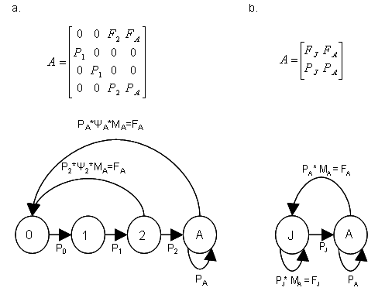

2

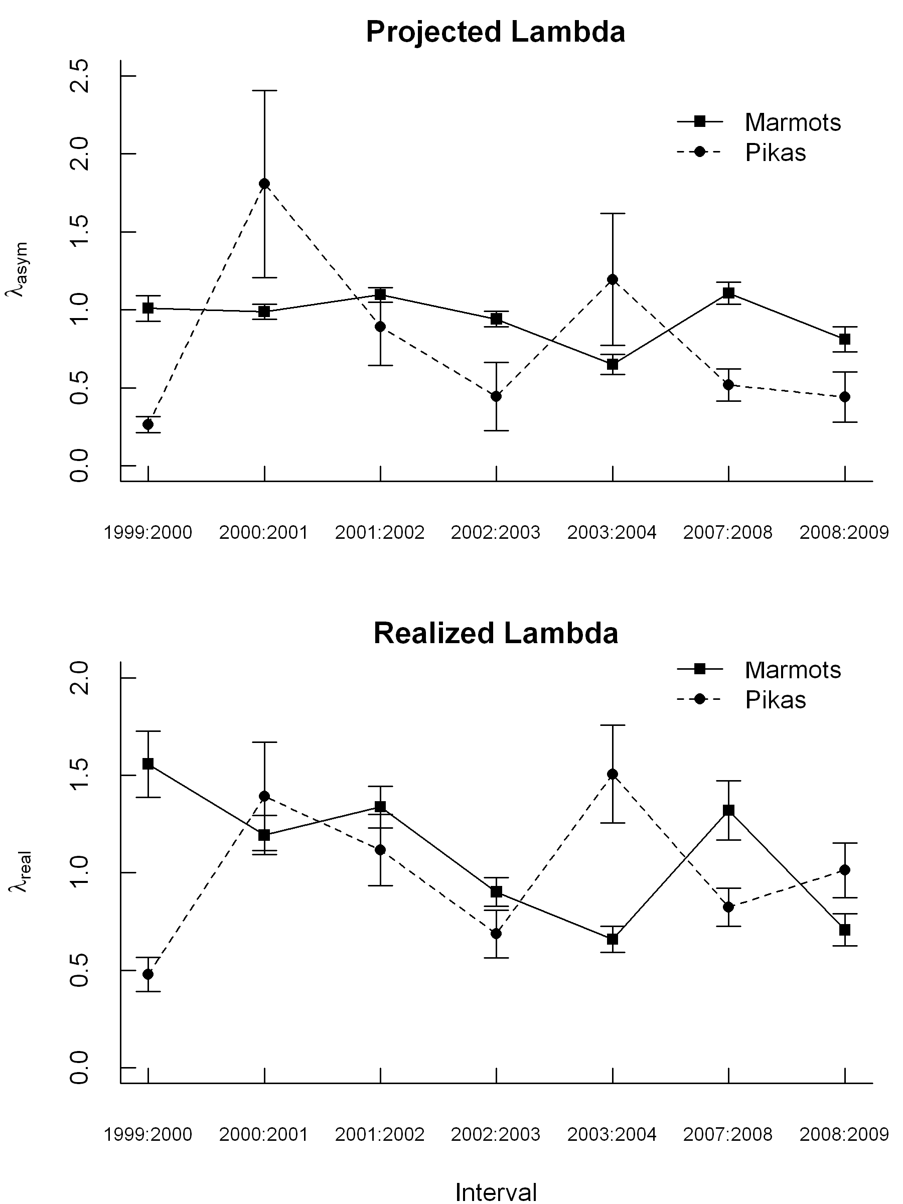

Figure 4-2. Projected population growth rate (λasym) and realized population growth rate (λreal ) for hoary marmot and collared pika populations in the Ruby Range, Yukon, from 1999-2004 and 2007-2009. λasym values were derived from Leslie matrices, while λreal was estimated using reverse-time mark-recapture models. Error bars represent 1 standard error. λasym standard errors were boostrapped, while λreal standard errors were estimated using maximum-likelihood.

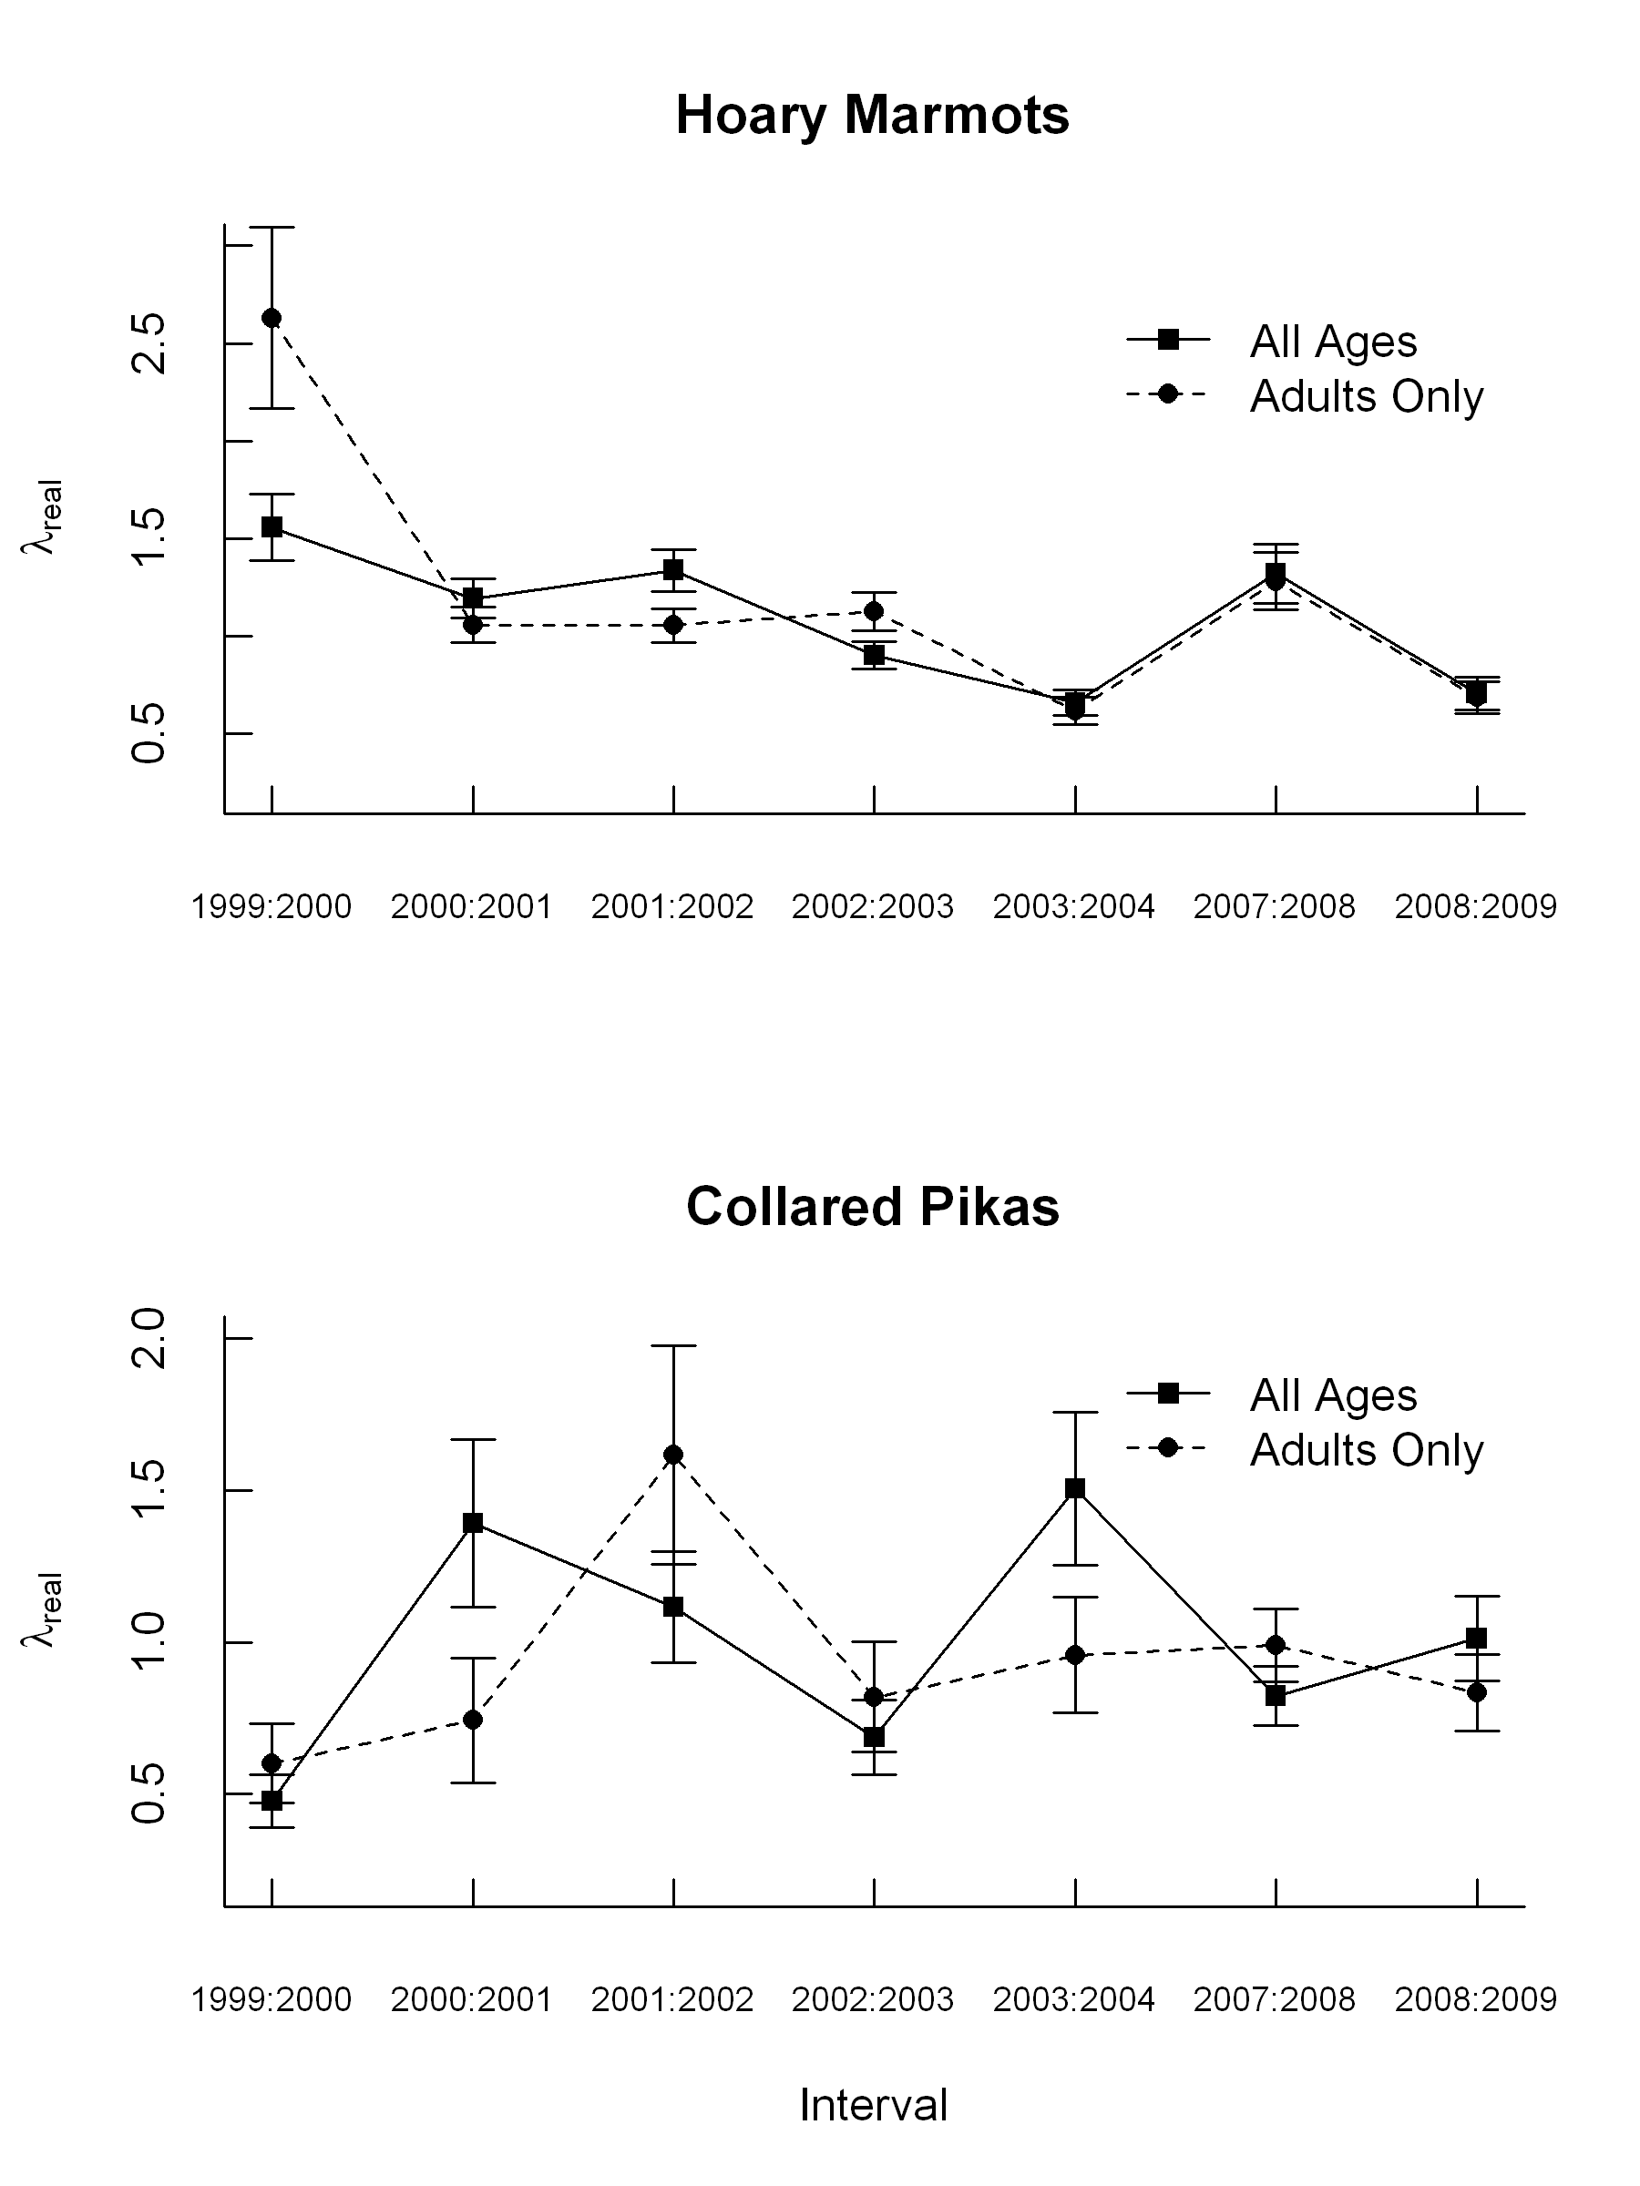

Figure 4-3. Comparison of the realized population growth rate (λreal) for all ages and for the adult age-class only, based on mark-recapture studies of collared pikas and hoary marmots in the Ruby Range, Yukon. Collared pika data are from 1999 through 2009, and hoary marmot data are from 1999 to 2004 and from 2007-2009. λreal values were estimate using reverse-time mark-recapture models. Error bars represent 1 standard error.

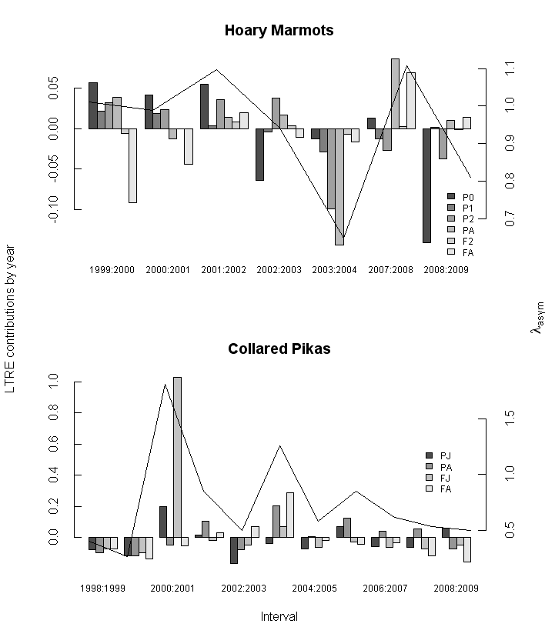

Figure 4-4. Results from Life Table Response Experiments based on long-term mark-recapture studies of hoary marmots and collared pikas in the Ruby Range, Yukon. The hoary marmot LTRE was based on population data from 1999-2004 and 2007-2009. The collared pika LTRE was based on data from 1998-2009. Each cluster of bars represents the proportional contributions made by age-specific demographic parameters to variation in projected population growth (λasym) during a specific overwinter interval. Contributions are plotted against the left y-axis. The hoary marmot models included six parameters (Juvenile survival = P0, yearling survival = P1, two-year-old survival = P2, adult survival = PA, two-year-old fertility = F2, and adult fertility = FA). The collared pika models included four parameters (Juvenile survival = PJ, adult survival = PA, juvenile fertility = FJ and adult fertility = FA The straight line shows the projected population growth rate (λasym) for each interval, which is plotted against the right y-axis.

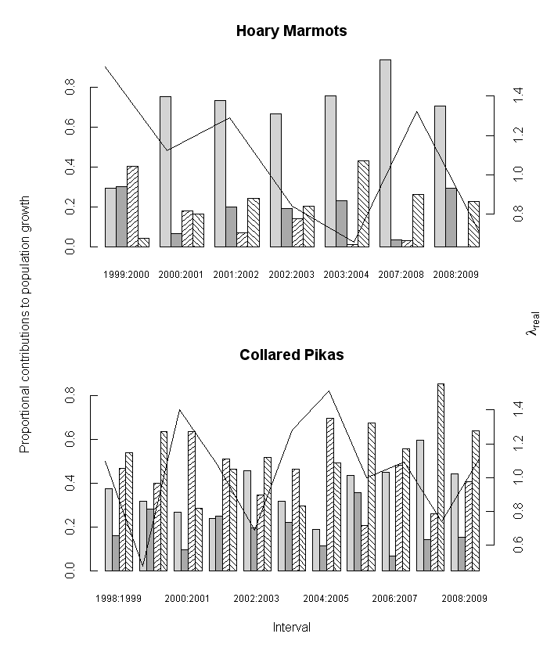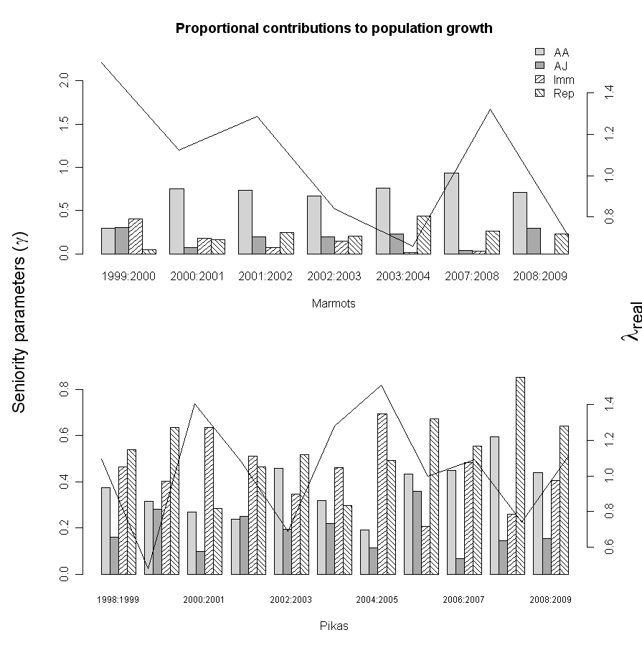

Figure 4-5. Proportional contributions of demographic parameters (Adult survival = AA, juvenile survival = AJ, apparent immigration = Imm, and reproductive parameters (breeding probability & fecundity) = Rep) to the realized population growth rate (λreal) of the adult age class, in hoary marmot and collared pika populations from the Ruby Range, Yukon. The height of each bar (plotted against the left y-axis) represents the proportional effect of a unit change in that parameter on λreal. Contributions were estimated using reverse-time modeling and methods described in Nichols et al. (2000). The solid line represents λreal (for all age-classes combined), which is plotted against the right y-axis.

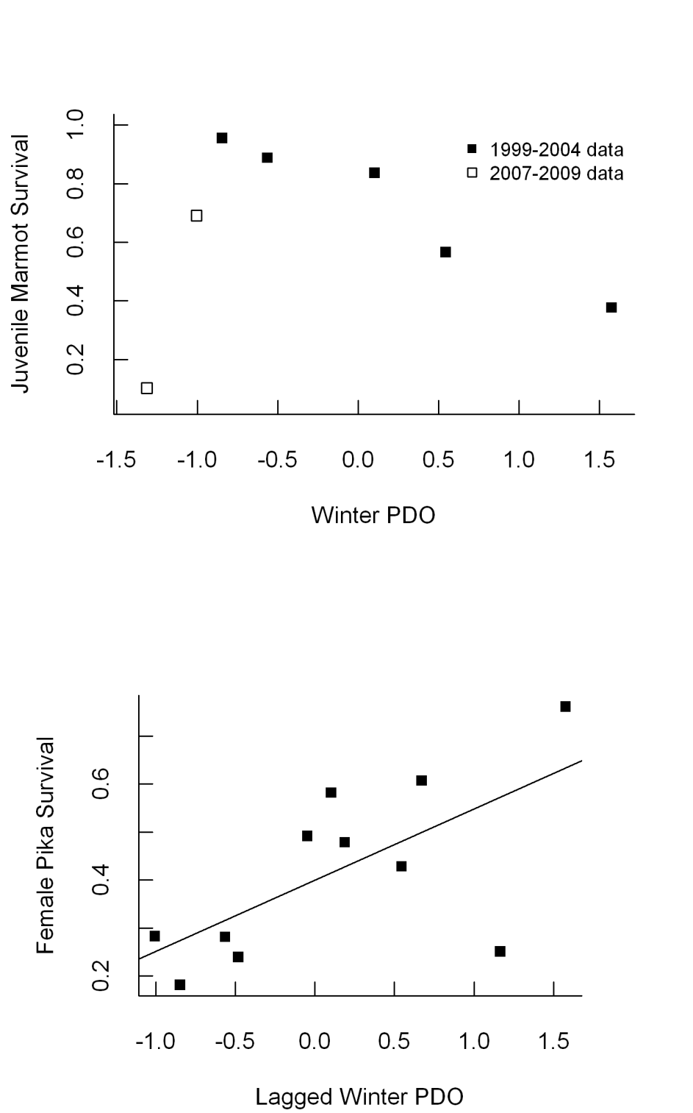

Figure 4-6. Relationships between survival parameters and the mean winter Pacific Decadal Oscillation (PDO) for hoary marmots and collared pikas in the Ruby Range, Yukon. The top panel shows winter PDO from the most recent winter plotted against the probability of juvenile hoary marmot overwinter survival. The bottom panel shows winter PDO lagged by one year plotted against adult female collared pika survival. Hoary marmot juvenile survival estimates are based on data collected between 1999 and 2004, and between 2007 and 2009. Collared pika estimates are based on data from 1998 to 2009. The solid line in the bottom panel represents the significant positive linear relationship between lagged winter PDO and (R2 = 0.37, p = 0.02).

## Literature Cited

Ainley DG (2002) The Adélie penguin: bellwether of climate change. Columbia University Press, New York.

Barash DP (1973) Habitat utilization in three species of subalpine mammals. Journal of Mammalogy 54:247-250.

Barash DP (1976) Pre-hibernation behavior of free-living hoary marmots, *Marmota caligata*. Journal of Mammalogy 57:182-185.

Barash D (1989) Marmots: social behavior and ecology. Stanford University Press, Stanford.

Bears H, Martin K, White GC (2009) Breeding in high-elevation habitat results in shift to slower life-history strategy within a single species. Journal of Animal Ecology 78:365-375.

Beever EA, Brussard PF, Berger J (2003) Patterns of apparent extirpation among isolated populations of pikas (*Ochotona princeps*) in the Great Basin. Journal of Mammalogy:37-54.

Beever EA, Ray C, Mote PW, Wilkening JL (2010) Testing alternative models of climate-mediated extirpations. Ecological Applications 20:164-178.

Caswell H (2001) Matrix population models. Sinauer Associates Sunderland, MA, USA.

Caswell H (2008) Prospective and retrospective perturbation analyses: their roles in conservation biology. Ecology 81:619-627.

Caswell H (2010) Life table response experiment analysis of the stochastic growth rate. Journal of Ecology 98:324-333.

Clinchy M, Haydon DT, Smith AT (2002) Pattern does not equal process: what does patch occupancy really tell us about metapopulation dynamics? The American Naturalist 159:351-362.

Cooch E, Rockwell RF, Brault S (2001) Retrospective analysis of demographic responses to environmental change: a lesser snow goose example. Ecological Monographs 71:377-400.

Danby RK, Hik DS (2007) Variability, contingency and rapid change in recent subarctic alpine tree line dynamics Journal of Ecology 95:352-363.

Davison R, Jacquemyn H, Adriaens D, Honnay O, de Kroon H, Tuljapurkar S (2010) Demographic effects of extreme weather events on a short-lived calcareous grassland species: stochastic life table response experiments. Journal of Ecology 98:255-267.

Dobson FS, Oli MK (2001) The demographic basis of population regulation in columbian ground squirrels. The American Naturalist 158:236-247.

Floyd CH, Van Vuren DH, May B (2005) Marmots on Great Basin mountaintops: Using genetics to test a biogeographic paradigm. Ecology 86:2145-2153.

Franken RJ, Hik DS (2004) Influence of habitat quality, patch size and connectivity on colonization and extinction dynamics of collared pikas Ochotona collaris. Journal of Animal Ecology 73:889-896.

Gillis EA, Hik DS, Boonstra R, Karels TJ, Krebs CJ (2005) Being high is better: effects of elevation and habitat on arctic ground squirrel demography. Oikos 108:231-240.

Hegel TM, Mysterud A, Ergon T, Loe LE, Huettmann F, Stenseth NC (2009) Seasonal effects of Pacific-based climate on recruitment in a predator-limited large herbivore. Journal of Animal Ecology 79:471-482.

Holmes WG (1984) Predation risk and foraging behavior of the hoary marmot in Alaska. Behavioral Ecology and Sociobiology 15:293-301.

Karels TJ, Koppel L, Hik DS (2004) Fecal pellet counts as a technique for monitoring an alpine-dwelling social rodent, the hoary marmot (*Marmota caligata*). Arctic, Antarctic, and Alpine Research 36:490-494.

Kendall WL, Pollock KH (1992) The robust design in capture–recapture studies: a review and evaluation by Monte Carlo simulation. Wildlife Populations:31–43.

Keyfitz N, Caswell H (2005) Applied mathematical demography. Springer Verlag.

Laake J, Rexstad E (2007) RMark—an alternative approach to building linear models. Appendix C in Cooch, E. and G. White, editors. Program MARK: a gentle introduction http://www. phidot.org/software/mark/docs/book.

Lebreton J, Burnham KP, Clobert J, Anderson DR (1992) Modeling survival and testing biological hypotheses using marked animals: A unified approach with case studies. Ecological Monographs 62:67. MORE?

Lima M, Stenseth NC, Leirs H, Jaksic FM (2003) Population dynamics of small mammals in semi-arid regions: a comparative study of demographic variability in two rodent species. Proceedings of the Royal Society B:1997-2007.

Mantua NJ, Hare SR, Zhang Y, Wallace JM, Francis RC (1997) A Pacific Interdecadal Climate Oscillation with Impacts on Salmon Production. Bulletin of the American Meteorological Society 78:1069-1079.

Moilanen A, Hanski I, Smith AT (1998) Long-term dynamics in a metapopulation of the American pika. The American Naturalist 152:530-542.

Moore GWK, Holdsworth G, Alverson K (2002) Climate change in the North Pacific region over the past three centuries. Nature 420:401-403.

Morrison S, Barton L, Caputa P, Hik DS (2004) Forage selection by collared pikas, *Ochotona collaris*, under varying degrees of predation risk. Canadian Journal of Zoology 82:533-540.

Morrison SF, Hik DS (2007) Demographic analysis of a declining pika *Ochotona collaris* population: linking survival to broad-scale climate patterns via spring snowmelt patterns. Journal of Animal Ecology 76:899-907.

Mysterud A, Stenseth NC, Yoccoz NG, Langvatn R, Steinheim G (2001) Nonlinear effects of large-scale climatic variability on wild and domestic herbivores. Nature 410:1096-1099.

Nichols JD, Hines JE (2002) Approaches for the direct estimation of λ, and demographic contributions to λ, using capture-recapture data. Journal of Applied Statistics 29:539-568.

Nichols JD, Hines JE, Lebreton JD, Pradel R (2000) Estimation of contributions to population growth: a reverse-time capture-recapture approach. Ecology 81:3362-3376.

Oli MK, Armitage KB (2004) Yellow-bellied marmot population dynamics: demographic mechanisms of growth and decline. Ecology 85:2446-2455.

Oli MK, Dobson FS (2003) The relative importance of life-history variables to population growth rate in mammals: Cole's prediction revisited. The American Naturalist 161:422-440.

Ozgul A, Armitage KB, Blumstein DT, Oli MK (2007a) spatiotemporal variation in survival rates: implications for population dynamics of yellow-bellied marmots. Ecology 87:1027-1037.

Ozgul A, Oli M, Olson L, Blumstein D, Armitage K (2007b) Spatiotemporal variation in reproductive parameters of yellow-bellied marmots. Oecologia 154:95-106.

Parmesan C, Yohe G (2003) A globally coherent fingerprint of climate change impacts across natural systems. Nature 421:37-42.

Post, E., M.C. Forchhammer, S. Bret-Harte, T.V. Callaghan, T.R. Christensen, B. Elberling, T. Fox, O. Gilg, D.S. Hik, T.T. Hoye, R.A. Ims, E. Jeppesen, D.R. Klein, J. Madsen, A.D. McGuire, S. Rysgaard, D. Schindler, I. Stirling, M. Tamstorf, N.J.C. Tyler, R. van der Wal, J. Welker, P.J. Wookey, N.M. Schmidt & P. Aastrup.  2009.  Ecological dynamics across the Arctic associated with recent climate change.  Science 325:1355-1358.

Pradel R (1996) Utilization of capture-mark-recapture for the study of recruitment and population growth rate. Biometrics 52:703-709.

Pulliam HR (1988) Sources, sinks, and population regulation. American Naturalist 132:652.

R Developement Team RDC (2009) R: A language and environment for statistical computing. Vienna, Austria.

Sandercock BK, Beissinger SR (2002) Estimating rates of population change for a neotropical parrot with ratio, mark-recapture and matrix methods. Journal of Applied Statistics 29:589-607.

Schwartz OA, Armitage KB (2004) Weather influences on demography of the yellow-bellied marmot (*Marmota flaviventris*). Journal of Zoology 265:73-79.

Smith AT (1974) The distribution and dispersal of pikas: influences of behavior and climate. Ecology 55:1368-1376.

Stephens PA, Frey-Roos F, Arnold W, Sutherland WJ (2002) Model complexity and population predictions. The alpine marmot as a case study. Journal of Animal Ecology 71:343-361.

Trefry SA, Hik DS (2009) Eavesdropping on the neighbourhood: collared pika (*Ochotona collaris*) responses to playback calls of conspecifics and heterospecifics. Ethology 115:928-938.

Van Vuren D, Armitage KB (1994) Survival of dispersing and philopatric yellow-bellied marmots: what is the cost of dispersal? Oikos:179-181.

Walther GR, Post E, Convey P, Menzel A, Parmesan C, Beebee TJC, Fromentin JM, Hoegh-Guldberg O, Bairlein F (2002) Ecological responses to recent climate change. Nature 416:389-395.

Watkinson AR, Sutherland WJ (1995) Sources, sinks and pseudo-sinks. Journal of Animal Ecology 64:126-130.

White GC, Burnham KP (1999) Program MARK: survival estimation from populations of marked animals. Bird Study 46:120-138.