Electronic Supplementary Material
Winter weather vs. group thermoregulation: What determines survival in hibernating mammals?
V.P. Patil, S.F. Morrison, T.J. Karels, and D.S. Hik

Appendix S1. Breakdown of a marked hoary marmot population in the southwest Yukon, by year, age-class, and sex.
Female
 | Age 0 | Age 1 | Age 2 | Adult | Total
1999 | 13 | 0 | 1 | 15 | 29
2000 | 3 | 15 | 6 | 21 | 45
2001 | 6 | 3 | 18 | 27 | 54
2002 | 21 | 5 | 3 | 35 | 64
2003 | 13 | 16 | 3 | 33 | 65
2004 | 7 | 7 | 9 | 18 | 41
Male
 | Age 0 | Age 1 | Age 2 | Age 3 | Total
1999 | 10 | 1 | 6 | 8 | 25
2000 | 3 | 13 | 2 | 14 | 32
2001 | 11 | 5 | 13 | 11 | 40
2002 | 22 | 11 | 4 | 16 | 53
2003 | 9 | 11 | 10 | 14 | 44
2004 | 11 | 6 | 8 | 6 | 31

Appendix S2. Complete set of candidate models used in analyses of hoary marmot survival in the southwest Yukon between 1999-2004. The model selection procedure used an information-theoretic approach and we provide the number of estimable parameters (K), AIC corrected for small sample size (AIC_{C}), difference between AIC_{C} and the AIC_{C} value of the best model (ΔAICc), model weighting (ω_{i}), and -2 * log Likelihood (Deviance). A ‘*’ denotes full interaction between two variables (both main effects and an interaction term). Where main effects are shown in parentheses, the model includes interaction between the inside and outside of the parentheses, but only additive effects within. Parameter descriptions are contained in Table 2.

Model | K | AICc | ΔAICc | ω_{i} | Deviance
AGE * SUB * (PDO + PDOlag) | 25 | 558.29 | 0.00 | 0.88 | 505.14
AGE * (PDO + PDOlag) | 13 | 563.95 | 5.67 | 0.05 | 537.10
Non-Juv:SEX * (PDO + PDOlag), Juv:SUB * (PDO + PDOlag) | 12 | 565.19 | 6.90 | 0.03 | 540.46
AGE * (PDO + PDOlag + Msub) | 17 | 565.57 | 7.28 | 0.02 | 530.12
AGE * (PDO + PDOlag + SUB) | 17 | 567.81 | 9.53 | 0.01 | 532.36
AGE * (PDO + PDOlag + NGroup) | 17 | 568.85 | 10.57 | 0.00 | 533.40
AGE * (PDO + PDOlag + Fsub) | 17 | 570.99 | 12.70 | 0.00 | 535.53
AGE * (PDO + PDOlag) * Ngroup | 25 | 571.89 | 13.60 | 0.00 | 518.74
AGE * TIME | 20 | 573.67 | 15.38 | 0.00 | 531.66
AGE * (PDO + PDOlag + SUB + SUBSQ) | 21 | 574.94 | 16.66 | 0.00 | 530.73
VEG * (PDO + PDOlag) | 7 | 578.75 | 20.47 | 0.00 | 564.49
PDO + PDOlag) | 4 | 583.28 | 25.00 | 0.00 | 575.19
Non-Juv:SEX * (PDO + PDOlag) + Juv:PDO + PDOlag + SUB | 10 | 584.09 | 25.80 | 0.00 | 563.57
NGroup * (PDO + PDOlag) | 7 | 587.77 | 29.48 | 0.00 | 573.51
AGE * NGroup * PDO | 17 | 593.16 | 34.88 | 0.00 | 557.71
Non-Juv:SEX * (PDO + PDOlag) + Juv:PDO + PDOlag | 9 | 593.79 | 35.50 | 0.00 | 575.37
AUF * AGE | 9 | 594.43 | 36.15 | 0.00 | 576.01
VEG * PDO | 5 | 594.45 | 36.17 | 0.00 | 584.31
PDO | 3 | 600.21 | 41.93 | 0.00 | 594.16
VEG | 3 | 607.89 | 49.61 | 0.00 | 601.84
AGE | 5 | 608.99 | 50.71 | 0.00 | 598.85
Non-Juv:SEX + Juv | 4 | 612.35 | 54.07 | 0.00 | 604.26
AGE * SUB | 9 | 614.39 | 56.11 | 0.00 | 595.98
SUB + SUBSQ | 4 | 616.89 | 58.60 | 0.00 | 608.80
NGroup | 3 | 617.25 | 58.96 | 0.00 | 611.19
Non-Juv + Juv:SUB | 4 | 617.65 | 59.36 | 0.00 | 609.56
Non-Juv:PDO + PDOlag, Juv:SUB * (PDO + PDOlag) | 8 | 621.43 | 63.15 | 0.00 | 605.10
Non-Juv:PDO + PDOlag + Juv:PDO + PDOlag + SUB | 6 | 640.42 | 82.13 | 0.00 | 628.22
Non-Juv:PDO + Juv:PDO * SUB | 5 | 640.98 | 82.70 | 0.00 | 630.84

Appendix S3. Beta coefficients from a post-hoc analysis of hoary marmot survival as a function of age-class (0, 1 year old, 2 years old, and age 3+), and the mean amount of snow on the ground during the current winter (Snow) and the previous winter (Snow_{lag}) at the Burwash Landing weather station. The model was specified as Age * (Snow + Snow_{lag}). The weather station was ~30km away from the study population and ~1400m lower in elevation. β is the beta coefficient for each parameter, SE is 1 standard error, LCL is the 95% confidence interval lower boundary, and UCL is the upper boundary. This model had an AICc of 574.82, and a ΔAICc of 16.5 compared to the top model in the original analyses. Stars show coefficients whose confidence intervals do not overlap 0.

 | β | SE | LCL | UCL
Intercept (Age 0) | -3.76 | 1.44 | -6.59 | -0.93 | *
Age 1 | -8.32 | 11.30 | -30.46 | 13.82
Age 2 | 7.25 | 2.35 | 2.64 | 11.85 | *
Age 3+ | 4.73 | 1.68 | 1.44 | 8.02 | *
Snow | 0.13 | 0.05 | 0.02 | 0.24 | *
Snowlag | 0.32 | 0.12 | 0.08 | 0.56 | *
Age 1 * Snow | 0.12 | 0.29 | -0.44 | 0.69
Age 2 * Snow | -0.39 | 0.10 | -0.59 | -0.19 | *
Age 3+ * Snow | -0.22 | 0.07 | -0.35 | -0.09 | *
Age 1 * Snowlag | 1.02 | 1.01 | -0.95 | 3.00
Age 2 * Snowlag | -0.30 | 0.18 | -0.64 | 0.05
Age 3+ * Snowlag | -0.27 | 0.14 | -0.53 | 0.00 | *

Appendix S4. Model averaged predictions of adult (age 3+) hoary marmot apparent survival as a function of mean winter Pacific Decadal Oscillation lagged by 1 year (PDO_{lag}). The 9 plots depict the predicted relationship between PDO_{lag} and survival (solid lines) under scenarios in which the minimum, mean, or maximum observed values of PDO and SUB were assumed. Dotted lines are upper and lower bounds of 95% confidence intervals.
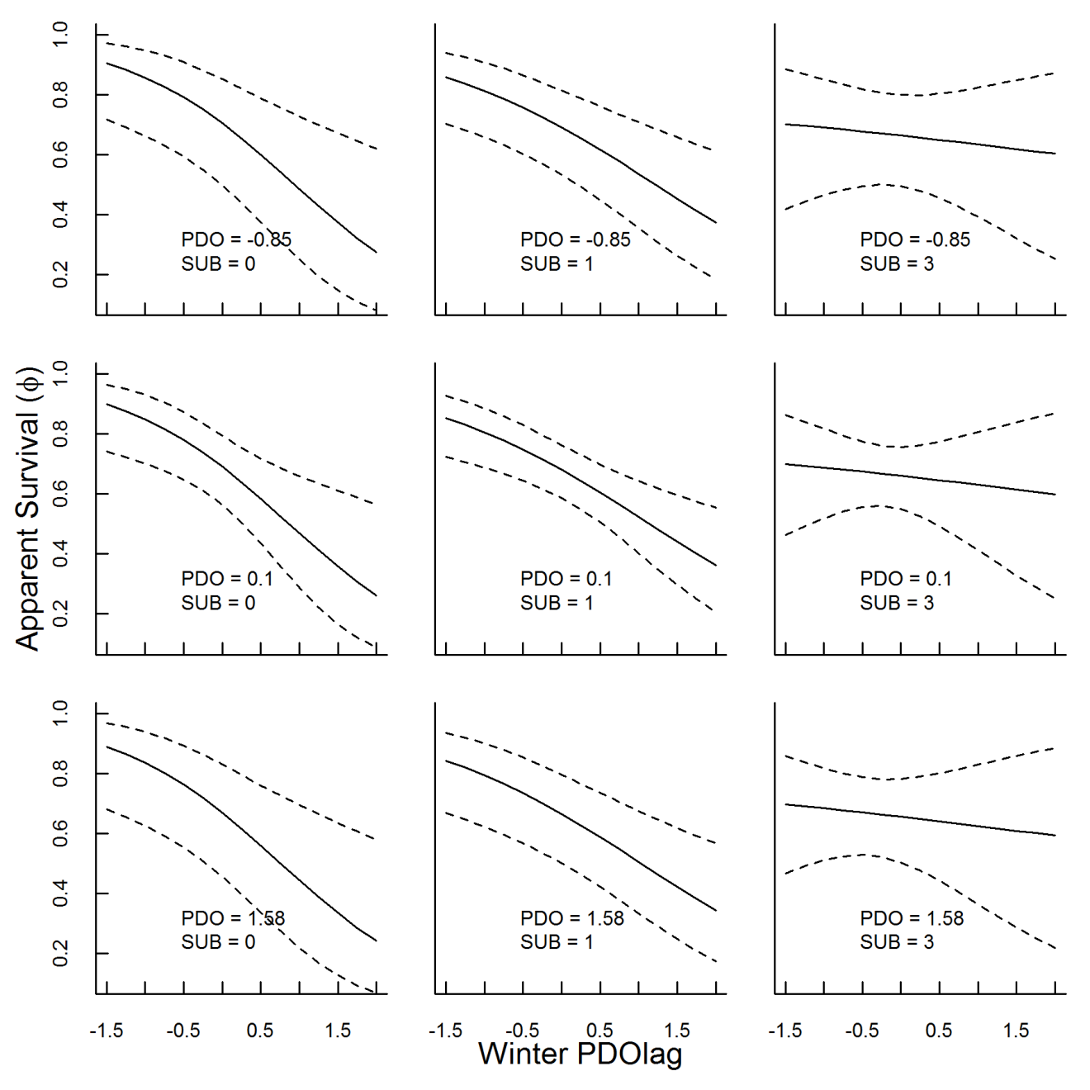

Appendix S5. Model averaged predictions of juvenile (age 0) hoary marmot apparent survival as a function of the number of subordinate adults per social group. The 9 plots depict the predicted relationship between SUB and survival (solid lines) under scenarios in which the minimum, mean, or maximum observed values of PDO and PDO_{lag} were assumed. Dotted lines are upper and lower bounds of 95% confidence intervals.
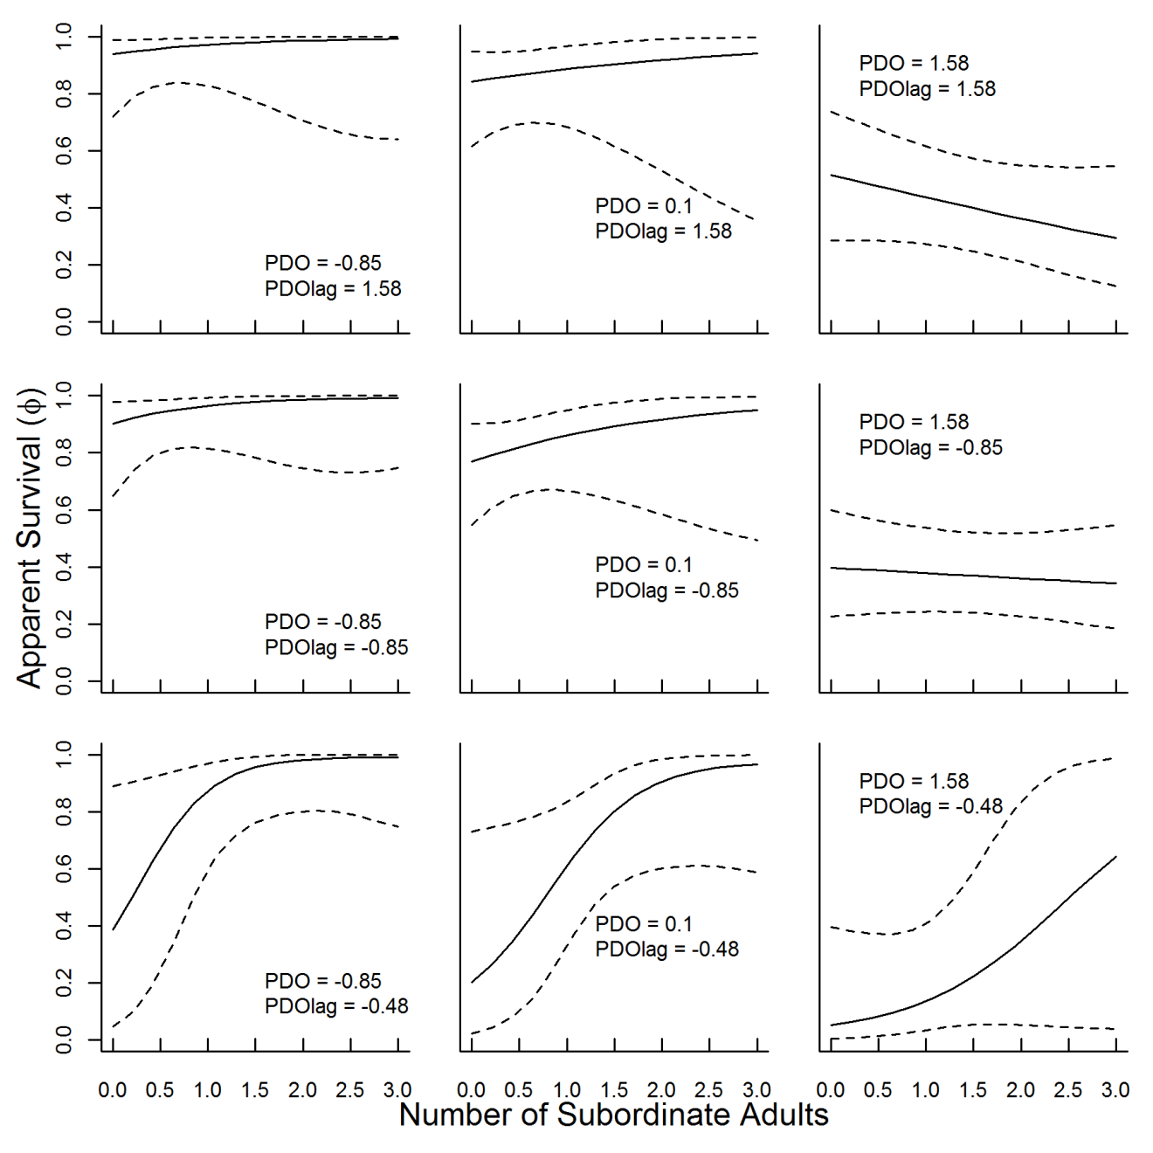

Appendix S6. Post-hoc analysis of summer and winter estimates of juvenile hoary marmot survival probabilities derived from a model with time variation by month, based on mark-recapture data from 1999-2004 in an alpine valley in southwest Yukon. Seasonal survival estimates are plotted against annual juvenile survival estimates from Fig 3. Error bars are 1 SE.
