## Winter weather vs. group thermoregulation: What determines survival in hibernating mammals?

**V.P. Patil1,2*, S.F. Morrison1, T.J. Karels1,3, and D.S. Hik1**

**1Department of Biological Sciences, University of Alberta, Edmonton, AB, T6G 2E9, Canada**

**2Present Address: Department of Biology & Wildlife, 211 Irving 1, University of Alaska Fairbanks, Fairbanks, AK, 99775.**

**3**Present Address: Department of Biology, California State University, Northridge, 18111 Nordhoff St., Northridge, CA 91330-8303, USA

* Correspondence author: E-mail: vppatil@alaska.edu

**Key Words:** climate change, cooperative breeding, hoary marmot, mark-recapture,

Pacific Decadal Oscillation, snowpack, survival, social structure

## Abstract

For socially hibernating mammals, the effectiveness of huddling as a means of energy conservation should increase with group size. However, group size has only been linked to increased survival in a few hibernating species, and the relative importance of social structure versus winter conditions during hibernation remains uncertain. We studied the relative influence of winter weather conditions, social group composition, age-structure, and other intrinsic and extrinisic factors on the overwinter survival of hoary marmots (*Marmota caligata*) in the Yukon Territory, Canada. Juvenile hoary marmot survival was negatively correlated with the mean winter (November to May) Pacific Decadal Oscillation (PDO) index. Survival in older age-classes was negatively correlated with PDO lagged by one year. Social group size and structure were weakly correlated with survival in comparison to PDO. The relationship between winter PDO and survival was most likely due to the importance of snowpack as insulation during hibernation. The apparent response of hoary marmots to changing winter conditions contrasted sharply with those of other marmot species and other mammalian alpine herbivores. The severity of winter weather may constrain the effectiveness of group thermoregulation in socially hibernating mammals.

## Introduction

Social structure can exert a powerful influence on population dynamics. The benefits of group living, which include protection from predators, joint territory defense, and opportunities for cooperative breeding, and the perceived costs, such as lost reproductive opportunities, have been well studied (Alexander et al. 1974; Blumstein and Armitage 1998; Blumstein and Armitage 1999; Jennions and Macdonald 1994) However, the net effect of group living may depend on spatial or temporal variability in environmental conditions and may be more difficult to predict (Armitage 2007; Forchhammeret al. 1998).

In strongly seasonal environments, the ability to withstand extreme cold can be an important determinant of fitness (Armitage 2007; Williset al. 2005). Sociality can be advantageous in these environments because it allows individuals to huddle with group members, reducing exposed surface area and increasing efficiency in energy expenditure (Arnold 1990; Boyles et al. 2008). Huddling efficiency should theoretically increase with group size, and is therefore a potential mechanism for expressing Allee effects (Allee 1938) because small groups may be less able to buffer the adverse effects of cold temperatures (Arnold 1990). However, large group size and huddling behaviour are by no means ubiquitous among social mammals living in harsh environments and the factors that regulate the effectiveness of these strategies remain poorly resolved (Boyleset al. 2008).

In particular, the role of group thermoregulation during hibernation has received relatively little attention (Boyleset al. 2008). Although many species that hibernate do so in groups, group size and social structure have only been shown to affect energy expenditure (Arnold 1991) and hibernation survival in a few instances (Armitage 1999; Arnold 1990), while other factors such as physiology and microclimate have often been identified as being more important (Aars and Ims 2002; Armitage and Woods 2003).

The genus *Marmota* provides a useful framework in which to investigate the interactive effects of social structure and environment on hibernating animals (Armitage 2007; Blumstein and Armitage 1998). All 14 marmot species hibernate, and with the exception of the woodchuck (*Marmota monax*), all are obligately associated with alpine and/or arctic environments with cold, snowy winters (Barash 1989). However the ranges of individual species differ considerably in the severity of environmental conditions (Davis 2005). In addition, species within *Marmota* exhibit a wide range of social systems and group sizes, from the solitary woodchucks to the hierarchical family groups of Alpine Marmots (*Marmota marmota*) (Barash 1989; Blumstein and Armitage 1998; Kyleet al. 2007).

There is some evidence linking social complexity to environmental harshness across the entire genus: woodchucks are the only marmot species that live in temperate, low-latitude habitats, while alpine marmots, which show the greatest degree of social complexity, live only at or above tree line in regions with heavy snowfall (Table 1). However, only a few marmot species have been studied intensively, and a strong relationship between social structure and hibernation survival has only been conclusively demonstrated for alpine marmots (Arnold 1990).

In this paper, we examine survival patterns of the hoary marmot (*M. caligata*), a poorly studied species distributed throughout northwestern North America. The objective of our analysis was to assess the relative support for two alternative but not mutually exclusive hypotheses about the mechanisms driving those patterns. Our first hypothesis was that survival would be determined primarily by the severity of winter weather, which we define as the combined influence of temperature and precipitation patterns during a given winter (the *Winter Intensity Hypothesis*). The alternative hypothesis was that survival would be best predicted by social group structure (the *Group Thermoregulation Hypothesis*). In particular, we hypothesized that the number of non-breeding (subordinate) adults would be important because this group has been shown to have a disproportionately large positive effect on survival during hibernation in other marmot species (Allaine et al. 2000; Arnold 1988; Arnold 1990; Blumstein and Armitage 1998; Farand et al. 2002). Support for the *Group Thermoregulation Hypothesis* would suggest that large, complex hoary marmot social groups are an adaptive strategy for surviving northern winters. Finally, we were also interested in examining the possibility that survival patterns were determined by interaction between weather and social variables. This question has special significance for wildlife living in arctic and alpine habitats, where the winter weather is extremely harsh, and climate change is projected to occur more rapidly than in many other regions of the world (Hassol 2005; Postet al. 2009).

## Materials and methods

Study species

Hoary marmots are the largest North American marmot species (Armitage 1999). They occur primarily in alpine habitat, although they can also be found in coastal tundra on the north slope of Alaska (Barash 1989). In the Yukon Territory, near the northern extent of their range, hoary marmots hibernate for 8 months of the year. Social group members hibernate communally, and social groups vary from 2 to upwards of 20 individuals (Barash 1974; Kyleet al. 2007), providing a mechanism by which group size might influence thermoregulation and overwinter survival (Holmes 1984a).

### Study area

Hoary marmots were studied from 1999 to 2004 in the Ruby Range Mountains of the southwest Yukon Territory, Canada (138° W 62° N; Fig. 1) in a 4-km2 area at an elevation of 1650–1900 m (Fig. 1). Mean winter temperatures were approximately -20 C, and snowpack depth varied between 10 and 60 cm (Table 1). In a previous study, the date of snowmelt ranged between June 24 and July 10 (Hik, unpublished data). The terrain was mostly boulder fields (36%) and vascular plants (27%), the remainder being bare ground, mosses and lichens.

Capture/recapture methods

We live-captured most marmots in the population from mid-May to August 1999 to 2004. Overall, 217 known-sex individual marmots from eleven social groups were captured and monitored over six years for a total of 523 marmot-years. The number of marked marmots in the study area increased from 66 marmots in 1999 to 146 in 2002 before declining to 80 individuals in 2004. Live-traps of various sizes (Tomahawk Live Trap Company, Tomahawk, WI) were baited with human urine (Taulman 1989) and live vegetation from the adjacent alpine meadows (Hansen 1975; Holmes 1984b). Juveniles (young-of-the-year) were captured upon emergence from the natal burrow in early- to mid-July. At first capture, all marmots were marked in each ear using No. 3 Monel tags (National Band and Tag, Newport, Kentucky) and a small piece of colored wire. A unique alphanumeric combination was dyed (Clairol Hydrience, #52 Black Pearl, Clairol Canada, Montreal, Quebec or Nyanzol-D American Colour and Chemical Corp., Charlotte, NC) into the fur above the tail to allow for individual identification up to 200 m with binoculars. Colored wires were replaced annually, and dye was reapplied as necessary at subsequent recaptures. Marmots were also resighted opportunistically by all field personnel throughout the summer, and their locations recorded according to a north-oriented grid marked at 50m intervals with wooden stakes. These locations were used to estimate individual and group home ranges.

### Survival and recapture modeling

We estimated recapture probabilities (**) and apparent survival probabilities () using Cormack-Joly-Seber (CJS) models implemented in program MARK (White and Burnham 1999) using the RMark package for *R 2.12.1* (Laake and Rexstad 2007; R Development Core Team 2007). Apparent survival reflects the combined effects of true mortality and permanent emigration from the population (Lebreton et al. 1992). However, only males age 4 and older dispersed permanently from the population during our study, based on a sample of 40 radio-tagged individuals (Karels, unpublished data). Apparent survival was therefore an unbiased estimate of true survival for all marmots except potentially for reproductively mature males. Furthermore, all permanent dispersal events occurred in mid to late June, 2-3 weeks after trapping began. It is therefore unlikely that dispersing males were not captured or resighted prior to dispersal.

### Covariates and candidate model set

We tested the influence of several intrinsic factors (sex, age, social group composition) and extrinsic factors (weather, food resources) on survival by constructing 29 candidate linear models representing *a priori* biologically plausible combinations of these covariates and their interactions. Because only 6 marmots were overlooked in one year but seen in subsequent years, we modeled detection probability (p) as a constant in all analyses. Abbreviations and definitions for all covariates are listed in Table 2.

Before models could be compared, we first evaluated the goodness of fit (GOF) of a global model (Choquet et al. 2009; White and Burnham 1999). The most general model for our data included year, sex, age, and social group affiliation. However, because not all combinations of ages and sexes were represented in all social groups in all years (Appendix S1 in ESM), we pooled individuals across social groups, resulting in a global model with the form AGE*SEX*TIME. With this model, there was potential for structural lack of fit due to systematic differences between social groups. However, using the global GOF test in program UCARE (Choquet et al. 2009), we found that the AGE*SEX*TIME model adequately fit our data (χ2 = 23.27, df = 26, p = 0.62).

We then used Akaike’s Information Criterion corrected for small sample size (AICc) to evaluate the relative support for models in the candidate set (Anderson 1994; Burnham and Anderson 2002). We ranked models according to their Akaike weights (i), and compared models using evidence ratios, which are the ratio of i values (Burnham and Anderson 2002, Anderson 2008). The relative importance of individual covariates was estimated by summing the weights for all models that included those covariates (Burnham and Anderson 2002). Estimates of the two real parameters (Ф and ρ) and their associated standard errors were then averaged across the entire model set (Buckland et al. 1997). After identifying the most important covariates in our candidate model set, we also used the covariate predictions function from the RMark package in R (Laake and Rexstad 2007; R Development Core Team 2007) to visualize their separate and interactive effects across their observed ranges of values.

Model covariates

Age and Sex

We included four age-classes in our models, juveniles (age 0), yearlings (age 1), two-year-olds, and reproductively mature adults (age 3+). Age-classes differ in body mass and fat reserves, and those differences were potentially important determinants of overwinter survival (Barash 1989). Sex was included as a covariate in some models, but because juvenile hoary marmots are not sexually dimorphic and do not disperse (Barash 1989; Karels, unpublished data), sex effects were only applied to non-juveniles.

Marmots captured after age 0 were aged using body size measurements (Karels et al. 2004). Sex was determined visually in the field, but because anal-genital distance does not differ between males and females the sex of some non-reproductive individuals was unknown (Karels pers. comm.). The mean proportion of unknown-sex individuals per year was 0.10 (SE = 0.02). These individuals were excluded from our analyses.

Winter Weather

We used the mean value of the Pacific Decadal Oscillation index (PDO) from November and May to model annual winter weather ([http://www.esrl.noaa.gov/ psd/data/climateindices](http://www.esrl.noaa.gov/%20psd/data/climateindices)). The PDO is a 20-30 year cyclic pattern of climate variation in the North Pacific Ocean that correlates well with temperature and precipitation throughout northwestern North America, with positive (warm phase) values reflecting higher-than-average sea surface temperature on the northern North American coast (Mantuaet al. 1997; Mantua and Hare 2002). Within its multi-decadal cycle, PDO also fluctuates annually, and these annual fluctuations reflect synoptic weather patterns well enough to be useful for predicting Alaskan forest fire seasons (Duffy et al. 2005), salmon production (Mantua et al. 1997), and vital rates of dall sheep (Hik and Carey 2000; Loehr et al. 2010), seabirds (Parrish and Zador 2003), songbirds (Ballard et al. 2003), and pikas (Morrison and Hik 2007).

The mean winter value of the PDO was negatively correlated with the date of spring snowmelt in an earlier study at our site (Morrison and Hik 2007), annual snow accumulation on nearby Mt. Logan (~100 km; Moore et al. 2002), and mean winter snow depth at two weather stations (Burwash Landing and Aishihik Lake) each located ~30km away from our study site but 1400m lower in elevation (r = 0.61 and 0.6 respectively for 1967-2007; Environment Canada http://www.climate.weatheroffice.ec.gc.ca/). Positive PDO values are therefore associated with early snowmelt and shallow snowpack, while negative values are associated with the opposite patterns. Our candidate model set included models containing PDO values from the winter during which survival was being assessed, as well as the previous winter, and additive effects of both. These two measures were not significantly correlated (r = 0.13, p = 0.85).

Although we expected winter weather to influence hoary marmots via its influence on snowpack, alpine marmot (*M. marmota*) survival has been shown to respond more to freezing soil in Autumn (Farand et al. 2002). We incorporated an index of Autumn frost intensity (AUF) into our models which was calculated as the minimum air temperature in September (see Farand et al. 2002). Temperature data was obtained from the Burwash Landing weather station and we adjusted these data for the difference in elevation using the standard lapse rate of 0.55o C per 100 m of elevation.

### Social structure

The social environment during hibernation was modeled using both the total number of marmots within the social group (NGroup), and the number of subordinates, which we defined as non-breeding marmots >2 years old (SUB). Estimates were based on capture and resighting data from July and August of the previous year, because dispersing males leave their natal group in mid-June (Karels, unpublished data).

In some marmot species, male and female subordinates have contrasting effects on juvenile overwinter survival (Allaine et al. 2000; Allaine and Theuriau 2004). We therefore also included models with the number of female (Fsub) and male (Msub) subordinates as covariates in our analyses. Finally, we incorporated territory-specific differences in food availability into some models by using average above-ground plant biomass per social group territory (Karels, unpublished data) as a covariate.

Most individuals were assigned to a social group based on observations of spring emergence from a common hibernaculum. If animals were not observed at emergence, we assigned social groups based on observation of social interactions and home-range overlap (Kyle et al. 2007). Individual home ranges were estimated using location data for resighted and radio-tagged marmots, which were analyzed in program Ranges V (Kenward and Hodder 1996). In a subset of marmots with known social group affiliations, group members had >75% overlap in the 95% kernel estimate of home range (Worton 1989). We therefore used 75% as a cutoff for statistical social group assignments. These assignments were then verified based on social interactions between individuals. Juveniles were assigned to the social group of their putative mother, which was subsequently verified using genetic markers (Kyle et al. 2007). Only marmots that could be confidently assigned to a social group in our study area (i.e., non-transient individuals) were included in our analyses.

## Results

### Recapture probability ()

Only six marmots (1 adult male, 5 adult females) were overlooked in one year and seen again in subsequent years. One adult male was missed in 2003, one adult female was missed in 2000 and four adult females were missed in 2002. Mark – recapture models that included sex and age classes for ** were not supported relative to a model that assumed a constant probability of recapture, suggesting that ** did not depend on sex or age. The capture probability estimated by the top model was close to 1.00 (** = 0.96  0.02).

Apparent survival ()

Apparent survival estimates varied by age-class and year (Fig. 2). Model selection revealed that one model (AGE*SUB*(PDO+PDOlag)) had substantially more support than all others (Table 3). This model was approximately 18 times more likely than the second best model, which included only age and weather effects (evidence ratio = 0.88/0.05 = 17.6; Table 3). AGE, PDO, and PDOlag terms were present in all supported models, and therefore all had summed AIC weights approximately equal to 1. The summed AIC weight for SUB was slightly lower (0.91, Table 3). No model containing SEX, NGroup, AUF, or VEG had an AIC weight >0.05 (Appendix S2 in ESM).

The mean winter PDO ranged between -0.85 and 1.57, with a mean value of 0.1. PDO was strongly negatively correlated with survival for juveniles, but not for other age-classes (Fig. 3). The average probability of juvenile apparent survival during the highest-PDO winter (PDO = 1.57) was 0.71 lower than during the lowest-PDO winter (PDO = -0.85; Fig. 3). Juvenile apparent survival was also positively correlated with mean winter snow depth from the nearest weather station ~30km away, although PDO was a substantially better predictor of survival (Appendix S3 in ESM).

Observed PDOlag values were between -0.8457 and 1.57, with a mean of -0.48. PDOlag was negatively correlated with survival for all age-classes, although the confidence intervals for juvenile survival suggested that the predicted slope was not significantly different from 0 (Fig. 3) The same change in PDOlag was also predicted to have a strong effect on adult marmots (∆survival = 0.48), and confidence intervals were smaller for adult survival estimates (Fig. 3). For adults the strength of the correlation between PDOlag and survival decreased dramatically as the number of subordinate adults increased (Appendix S4 in ESM).

Most social groups contained between 0 and 3 subordinate adults in any given year. One group contained 5 subordinates in 1999, but we limited our covariate prediction plots to SUB values between 0 and 3 to ensure that survival could be predicted with adequate precision. For juveniles, an increase from 0 to 3 subordinates was predicted to increase juvenile survival by an average of 0.79 when PDOlag was set to 1.57, its maximum observed value (Appendix S5 in ESM). However, the correlation between survival and SUB had 95% confidence intervals overlapping 0 under all combination of PDO and PDOlag, and for all age-classes (Appendix S5 in ESM).

## Discussion

The *Winter Intensity Hypothesis* was strongly supported by the data. Winter weather was the strongest predictor of annual survival, while summer food availability and the onset of autumn frost had little predictive value. Juvenile survival was highest during winters with deep snowpack, colder than average temperatures and late spring snowmelt (see Mantua and Hare 2002; Morrison and Hik 2007). This pattern suggests that insulating snowpack during hibernation was more important than the timing of spring vegetation growth in determining overwinter survival. Temperature, snow depth, and snowmelt data were unavailable at our site in all years, but PDO is a valid proxy for winter weather conditions in the Yukon (Moore et al. 2002), and was strongly correlated with snow conditions in an earlier study at our site (Morrison and Hik 2007). We also observed a positive correlation between juvenile survival and mean winter snow depth at the nearest low-elevation weather station, although PDO was a better predictor of survival (Appendix S3 in ESM). Synoptic climate indices often have better predictive power than local weather data in ecological studies, possibly because they integrate the most appropriate variables simultaneously (Hallett et al. 2004; Stenseth and Mysterud 2005).

Winter conditions from the previous year (PDOlag) were as strongly supported by model selection as PDO values from the current year, and were apparently more important than current winter conditions for adult survival. This pattern may be due to cumulative or lagged stress effects of hibernation in harsh conditions. Lagged PDO effects were most apparent in social groups with few subordinate individuals, implying that subordinates buffered the energetic costs of hibernation experienced by dominants (Armitage 1999). Surprisingly, lagged effects of winter weather were also observed in the juvenile age-class, albeit more weakly than in older marmots. We hypothesize that these lagged effects represent the influence of maternal condition. Lagged climate/maternal effects have been observed in other northern species (Boonstra and Hochachka 1997; Forchhammeret al. 1998; Inchausti and Ginzburg 1998, Sheriff et al. 2009), but they have not been addressed in the marmot literature.

The *Group Thermoregulation Hypothesis* was also supported by model selection. The positive relationship between the number of subordinate adults and juvenile survival was consistent with the hypothesis that juveniles benefit from heat produced by subordinates during arousals. However, our confidence in this relationship was < 95% under all winter weather scenarios we considered, suggesting that group thermoregulation was not as important as winter weather.

As expected, the influence of both intrinsic and extrinsic factors on survival was dependent on age. The greater sensitivity of juveniles to current winter conditions, relative to the other age-classes, was consistent with the lower body mass, fat reserves, and thermoregulatory efficiency of juveniles compared to adults, and has been observed in other marmot species (Armitage 2003; Barash 1989; Blumstein and Armitage 1998; but see Borrego et al. 2008). The effect of age-class on survival was not consistent from year to year, suggesting that variation in winter weather and social structure affected each age-class differently.

Sex effects were not supported by our analysis (AIC weight < 0.05). This result is difficult to interpret, because most adult male hoary marmots disperse, while almost all females remain with their natal group (Karels, unpublished data). As a result, adult male (age 3+) survival was potentially biased low compared to true survival (Borrego et al. 2008, Van Vuren and Armitage 1994). The lack of support for sex-differences could be due to dispersal bias being offset by a high probability of true survival for adult males, which can be up to 1.5 kg heavier than females (Barash 1989; Karels, unpublished data). However, because all known dispersal events (based on a subsample of radio-tagged marmots) occurred several weeks after resighting and recaptures began each year (Karels, unpublished data), any bias was probably minimal.

Annual vs. Winter Survival

Our analysis was conducted over an annual interval, but several lines of evidence suggest that our annual survival estimates reflect winter mortality. First, neither summer food availability or autumn frost severity were useful predictors of survival, and the negative correlation between PDO and survival strongly suggests that mortality was not due to late spring snowmelt and greenup (Morrison and Hik 2007). In a separate analysis of seasonal survival, summer survival was equal to or close to 1 throughout the study period, while winter survival estimates were not significantly different from the annual survival probabilities from our initial analysis (Appendix S6 in ESM). However, we caution that the strong relationships between PDO and juvenile survival, and between PDOlag and survival in older marmots should not be extrapolated beyond the values observed in our study. In addition, the influence of environmental factors on marmot population dynamics can vary over both space and time (Ozgul et al. 2006). Confidence in our findings would therefore be greatly strengthened by additional data from our study population and elsewhere.

Comparison with other *Marmota* species

Huddling with social group members should reduce the energetic costs of hibernation. In alpine marmot groups, juvenile survival is strongly related to the presence of subordinates (Allaine 2000; Allaine and Theuriau 2004; Arnold 1990; Arnold 1993; Farand et al. 2002). Alpine marmots arouse from hibernation simultaneously with their group mates, which greatly reduces the energetic cost of returning to normothermy (Arnold 1993). It remains unknown whether hoary marmots synchronize their arousals. However, it has been suggested that because hoary marmot adults are substantially larger than alpine marmots, they may have sufficient fat reserves to boost burrow temperatures without synchrony, albeit at a greater energetic cost (Armitage 1999). Hoary marmots may also be less effective at group thermoregulation because they may not actively care for juveniles in the burrow, as alpine marmots do (Arnold 1990), but this hypothesis currently is untestable because hoary marmots have never been observed within the burrow.

Male alpine marmot subordinates increase juvenile survival the most, presumably because they are more likely than females to obtain future breeding opportunities by remaining in the natal group, and therefore have more incentive to care for the dominant pair’s offspring (Allaine et al. 2000; Allaine and Theuriau 2004). Male alpine marmots are also constrained by their reproductive physiology to end hibernation earlier than females and produce more heat in the spring (Allaine et al. 2004; Arnold 1998). Although one of the top five models included the number of male subordinates as a covariate, that model received little support (AIC weight = 0.02; Table 3). In addition, the number of male subordinates did not have a clear positive or negative influence on juvenile survival (β = -0.04, 95% confidence interval = (-.40, 0.32)). The lack of subordinate sex effects in our study can probably be attributed to the fact that the mechanisms behind those effects in alpine marmot groups appear to be absent in our study population. Most hoary marmot subordinates are females, all of whom may be able to mate in the future, and that male subordinates have undeveloped testes and should not need to arouse earlier than females (Kyle et al. 2007).

A simultaneous comparison of social complexity and winter weather between marmot species (Table 1) suggests that the effectiveness of group thermoregulation is limited by winter severity. Alpine winters in the Yukon are characterized by both extreme cold and shallow, variable snow cover (Table 1). Snow needs to be >20 cm deep to provide effective insulation, and January snowpack depths range on either side of that threshold (Table 1; Danby and Hik 2007). Preliminary field data show a strong relationship between the number of arousals during hibernation and snow depth above hoary marmot hibernacula (r2 = 0.89; Hik and Karels, unpublished data), which suggests that thin snow cover created a more stressful burrow. With winter air temperatures often well below -20 C, changes in snow depth may overwhelm the effect of group thermoregulation on burrow conditions. In contrast, alpine marmot populations typically experience ambient winter temperatures close to or above freezing (Arnold et al. 1991) and deep, consistent snowpack. For example, the population studied by Farand et al. (2002) experienced winter snow depths of 140 cm ± 43 cm (mean ± SD). Thick snow cover at alpine marmot sites could promote a more consistent burrow temperature from one year to the next, making inter-annual variation in social structure a more important determinant of survival patterns.

Group thermoregulation has not been shown to influence survival in most marmot species, but interspecific comparisons are complicated by differences in social structure. For example, yellow-bellied marmots hibernate communally (Blumstein et al. 2004), but gain no energetic benefits from doing so, partly because their arousals are asynchronous (Armitage and Woods 2003). However, yellow-bellied marmots live in smaller, less complex social groups than either hoary or alpine marmots, which provide less potential for group thermoregulation (Armitage 2007). Olympic and Vancouver marmots are potentially more useful species for comparison, because both species are physiologically and socially similar to hoary marmots, yet experience milder winter conditions and deep snowpack (Table 1). Neither group size during hibernation or winter weather appear to affect the survival of either species, possibly because conditions are mild enough that winter thermoregulation is relatively unimportant (Table 1). These comparisons support the idea that winter severity constrains the influence of both extrinsic and intrinsic influences on survival.

Comparison with other alpine herbivores

Hoary marmots share their alpine habitat with several other mammalian herbivores, including collared pikas, thinhorn sheep, and caribou. Winter severity, as indexed by PDO, was correlated with demographic traits of all three species in the same region as our study (Hegel et al. 2009; Loehr et al. 2010; Morrison and Hik 2007). However, unlike hoary marmots, all three benefited from high-PDO winters with shallow snowpack and early spring greenup (Hegel et al. 2009; Loehr et al. 2010; Morrison and Hik 2007). Because sheep, caribou and pikas do not hibernate, a long growing season may be more important than the insulative value of the snowpack. This is particularly likely for food-hoarding animals like pikas, whose winter haypiles provide both food and insulation (Morrison and Hik 2007; Morrison et al. 2009). Deep snowpack can also decrease the mobility of larger animals like caribou, making them more susceptible to predation (Hegel et al. 2009). While overwinter survival may not be the primary driver of hoary marmot survival, the response of hoary marmot populations to extrinsic factors is apparently shaped by intrinsic traits (e.g. hibernation vs. food-hoarding).

Conclusions

Although both extrinsic and intrinsic factors affected hoary marmot survival rates, winter weather was more influential than social group size or structure. Winter snowpack from the current year, as indexed by PDO, was a powerful predictor of juvenile survival, while snowpack from the previous year was more useful for explaining survival in older age-classes. We hypothesize that lagged weather effects may carry over to juveniles through maternal condition. A comparison of our findings with the literature supports the hypothesis that aspects of winter severity, including snowpack depth, can determine the relative influence of extrinsic and intrinsic factors on marmots and other alpine animals. Understanding the range of conditions under which behavioral and social adaptations to cold can operate is important for predicting population responses to environmental change, like those projected to occur in alpine ecosystems due to global climate change.

**Acknowledgements**

Funding was provided by Environment Canada, the Natural Science and Engineering Research Council of Canada, the Yellowstone to Yukon (Y2Y) Science Grants program, the Canada Foundation for Innovation, the Canada Research Chairs Program, and the Canadian Circumpolar Institute, University of Alberta. We are also grateful to Kluane First Nations for allowing use of their land, and to the numerous field assistants who helped to trap marmots for this study. All trapping procedures were approved by the University of Alberta Biosciences Animal Policy and Welfare Committee. E. Cooch provided valuable assistance with MARK and mark-recapture analyses.

**References**

Aars J, Ims RA (2002) Intrinsic and climatic determinants of population demography: The winter dynamics of tundra voles. Ecology 83:3449-3456

Alexander RD (1974) The evolution of social behavior. Annual review of ecology and systematics 5:325-383

Allaine D, Brondex F, Graziani L, Coulon J, Till-Bottraud I (2000) Male-biased sex ratio in litters of alpine marmots supports the helper repayment hypothesis. Behavioral Ecology 11:507

Allaine D, Theuriau F (2004) Is there an optimal number of helpers in Alpine marmot family groups? Behavioral Ecology 15:916.

Allee WC (1938) The social life of animals. Norton New York

Anderson D (2008) Model based inference in the life sciences: a primer on evidence. Springer Verlag

Armitage KB (1999) Evolution of Sociality in Marmots. J Mammal 80:1-10

Armitage KB (2007) Evolution of sociality in marmots: it begins with hibernation. Rodent Societies:356-367

Armitage KB, Woods BC (2003) Group Hibernation Does Not Reduce Energetic Costs of Young yellow-bellied Marmots. Physiol and Biochem Zoology 76:888-898

Arnold W (1988) Social thermoregulation during hibernation in alpine marmots (*Marmota marmota*). J Comp Physiol B: 158:151-156

Arnold W (1990) The Evolution of Marmot Sociality: II. Costs and Benefits of Joint Hibernation. Behav Ecol Sociobiol 27:239-246

Arnold W (1993) Energetics of social hibernation. Life in the Cold: Ecological, Physiological and Molecular Mechanisms:65-80

Arnold W, Heldmaier G, Ortmann S, Pohl H, Ruf T, Steinlechner S (1991) Ambient temperatures in hibernacula and their energetic consequences for alpine marmots Marmota marmota. Journal of Thermal Biology 16:223-226

Ballard G, Geupel GR, Nur N, Gardali T (2003) Long-term declines and decadal patterns in population trends of songbirds in western North America, 1979-1999. The Condor 105:737-755

Barash D (1989) Marmots: social behavior and ecology. Stanford University Press, Stanford

Barash DP (1974) The social behaviour of the hoary marmot (*Marmota caligata*). Anim Behav 22:256-261

Blumstein DT, Armitage KB (1998) Life history consequences of social complexity a comparative study of ground-dwelling sciurids. Behav Ecol 9:8-19

Blumstein DT, Armitage KB (1999) Cooperative breeding in marmots. Oikos:369-382

Boonstra R, Hochachka M (1997) Maternal effects and additive genetic inheritance in the collared lemming Dicrostonyx groenlandicus. Evolutionary Ecology 11:169-182

Borrego N, Ozgul A, Armitage KB, Blumstein DT, Oli MK (2008) Spatiotemporal Variation in Survival of Male Yellow-bellied Marmots. Journal of Mammalogy 89:365-373

Boyles JG, Storm JJ, Brack V (2008) Thermal benefits of clustering during hibernation: a field test of competing hypotheses on *Myotis sodalis*. Funct Ecol 22:632-636

Bryant AA, Page RE (2005) Timing and causes of mortality in the endangered Vancouver Island marmot(*Marmota vancouverensis*). Can J Zool 83:674-682

Buckland ST, Burnham KP, Augustin NH (1997) Model selection: an integral part of inference. Biometrics 53:603-618

Burnham KP, Andersen DR (2002) Model selection and inference: a practical information-theoretic approach. Springer-Verlag, New York, NY

Choquet R, Lebreton JD, Gimenez O, Reboulet AM, Pradel R (2009) U CARE: Utilities for performing goodness of fit tests and manipulating capture–recapture data. Ecography 32:1071-1074

Danby R, Hik D (2007) Responses of white spruce (Picea glauca) to experimental warming at a subarctic alpine treeline. Global Change Biology 13:437-451

Davis EB (2005) Comparison of climate space and phylogeny of Marmota (*Mammalia: Rodentia*) indicates a connection between evolutionary history and climate preference. Proc R Soc Lon Ser B 272:519

Duffy PA, Walsh JE, Graham JM, Mann DH, Rupp TS (2005) Impacts of large-scale atmospheric-ocean variability on Alaskan fire season severity. Ecological Applications 15:1317-1330

Farand E, Allaine D, Coulon J (2002) Variation in survival rates for the alpine marmot (*Marmota marmota*): effects of sex, age, year, and climatic factors. Can J Zool 80:342-349

Forchhammer MC, Stenseth NC, Post E, Langvatn R (1998) Population dynamics of Norwegian red deer: density-dependence and climatic variation. Proc R SocB: 265:341-350

Griffin SC (2008) Demography and ecology of a declining endemic: The Olympic marmot. Phd Thesis, University of Washington, Seattle

Hallett T, Coulson T, Pilkington J, Clutton-Brock T, Pemberton J, Grenfell B (2004) Why large-scale climate indices seem to predict ecological processes better than local weather. Nature 430:71-75

Hansen R (1975) Foods of the hoary marmot on Kenai Peninsula, Alaska. Am Midl Nat 94:348-353

Hassol SJ (2005) Arctic Climate Impact Assessment. Cambridge University Press, Cambridge

Hegel TM, Mysterud A, Ergon T, Loe LE, Huettmann F, Stenseth NC (2009). Seasonal effects of Pacific-based climate on recruitment in a predator-limited large herbivore. Journal of Animal Ecology 79:471-482

Hik DS, Carey J (2000) Cohort variation in horn growth of Dall sheep rams in the southwest Yukon, 1969–1999. In: Biennial Symposium of Northern Wild Sheep and Goat Council.pp 88-100

Holmes WG (1984a) The ecological basis of monogamy in Alaskan hoary marmots. In: Murie JO, Michener GR (eds) Biology of ground-dwelling squirrels : annual cycles, behavioral ecology, and sociality. University of Nebraska Press, Lincoln pp 250-274

Holmes WG (1984b) Predation risk and for aging behavior of the hoary marmot in Alaska. Behav Ecol Sociobiol 15:293-301

Inchausti P, Ginzburg LR (1998) Small mammals cycles in northern Europe: patterns and evidence for a maternal effect hypothesis. Journal of Animal Ecology:180–194

Jennions MD, Macdonald DW (1994) Cooperative breeding in mammals. Trends in Ecology & Evolution 9:89-93

Karels TJ, Bryant AA, Hik DS (2004) Comparison of discriminant function and classification tree analyses for age classification of marmots. Oikos 105:575-587

Kenward R, Hodder K (1996) Ranges V: an analysis system for biological location data. Institute of Terrestrial Ecology, Dorset

Kyle CJ et al. (2007) Social structure and facultative mating systems of hoary marmots (Marmota caligata). Mol Ecol 16:1245-1255

Laake J, Rexstad E (2007) RMark—an alternative approach to building linear models. Appendix C in Cooch, E. and G. White, editors. Program MARK: a gentle introduction <http://www.phidot.org/software/mark/docs/book>

Lebreton J-D, Burnham KP, Clobert J, Anderson DR (1992) Modeling Survival and Testing Biological Hypotheses Using Marked Animals: A Unified Approach with Case Studies. Ecological Monographs 62:67.

Loehr J, Carey J, O'Hara RB, Hik DS (2010) The role of phenotypic plasticity in

responses of hunted thinhorn sheep ram horn growth to changing climate

conditions. Journal of Evolutionary Biology 23:783-790

Mantua NJ, Hare SR (2002) The Pacific Decadal Oscillation. J Oceanogr 58:35-44

Mantua NJ, Hare SR, Zhang Y, Wallace JM, Francis RC (1997) A Pacific interdecadal climate oscillation with impacts on salmon production. Bull Am Meteorol Soc 78:1069-1079

Moore GWK, Holdsworth G, Alverson K (2002) Climate change in the North Pacific region over the past three centuries. Nature 420:401-403

Morrison SF, Hik DS (2007) Demographic analysis of a declining pika Ochotona collaris population: linking survival to broad-scale climate patterns via spring snowmelt patterns. J Anim Ecol 76:899-907

Morrison SF, Pelchat G, Donahue A, Hik DS (2009) Influence of food hoarding behavior on the over-winter survival of pikas in strongly seasonal environments. Oecologia 159:107–116

Parrish JK, Zador SG (2003) Seabirds as indicators: An exploratory analysis of physical forcing in the Pacific Northwest coastal environment. Estuaries 26:1044-1057

Post E et al. (2009) Ecological Dynamics Across the Arctic Associated with Recent Climate Change. Science 325:1355

Sheriff MJ, Krebs CJ, Boonstra R (2009) The sensitive hare: sublethal effects of predator stress on reproduction in snowshoe hares. Journal of Animal Ecology 78:1249- 1258

Stenseth N, Mysterud A (2005) Weather packages: finding the right scale and composition of climate in ecology. Ecology 74:1195-1198

Taulman JF (1989) Hoary Marmots Attracted to Human Urine Sites. Northwest Nat 70:36-37

Taylor, D.A. (1997) Deep snow in British Columbia: survey implications for the National Building Code of Canada. *Canadian Journal of Civil Engineering*, **24**, 169-179

Van Vuren D, Armitage KB (1994) Survival of dispersing and philopatric yellow-bellied marmots: what is the cost of dispersal? Oikos:179-181

White GC, Burnham KP (1999) Program MARK: survival estimation from populations of marked animals. Bird Study 46:120-139

Willis CKR, Lane JE, Liknes ET, Swanson DL, Brigham RM (2005) Thermal energetics of female big brown bats (Eptesicus fuscus). Can J Zool 83:871-879

Worton BJ (1989) Kernel methods for estimating the utilization distribution in home-range studies. Ecology 70:164-168

Table 1: Summary of social systems, latitude, elevation, and winter conditions at major long-term study sites for common alpine North American and European marmot species. ‘*’ denotes columns modified from Armitage 2007.

|  |  |  |  |  |  |  |
| --- | --- | --- | --- | --- | --- | --- |
| **Species** | **Social System\*** | **Latitude** | **Elevation (m)** | **Mean Jan. Temp (C)** | **Winter Snow Depth (cm)** | **References** |
| Yellow-bellied  (*M. flaviventris*) | Female matrilines | 38° 57' | 2800-3000 | -10 | 108 ± 40 (Jan mean ± SD) | Schwartz and Armitage 2005; Rocky Mountain Biological Lab (www.RMBL.org) |
| Hoary (*M. caligata*) | Restricted Family | 61° 12' | 1600 | -26.25 | 10 - 60 (Jan range) | Kyle et al. 2007; Danby and Hik 2007; Environment Canada weather archives (http://weatheroffice.gc.ca) |
| Olympic (*M. olympus*) | Restricted Family | 48° 05' | >1400 | -1.25 | 135- 183 ( Feb mean, 1385-1600 m) | Griffin 2008; Natural Resources Conservation Service Snow Course Data (http://www.wcc.nrcs.usda.gov/) |
| Vancouver Island  (*M. vancouverensis*) | Restricted Family | 49° 24' | 700-1400 | -2.8 | 259 ± 91 (Mean max annual depth ± SD) | Bryant and Page 2005; Taylor 1997; Environment Canada (<http://www.weatheroffice.gc.ca>); |
| Alpine (*M. marmota*) | Extended Family | 45° 29' | 2300-3800 | -5.8 (daytime) | 140 ± 43 (Jan. mean ± SD) | (Farand, Allaine and Coulon 2002) |
|  |  |  |  |  |  |  |

Table 2: Names, abbreviations and descriptions of parameters used in construction of hoary marmot survival and recapture models.

|  |  |
| --- | --- |
| **Abbreviation** | **Definition and Description** |
| PDO | Mean Pacific Decadal Oscillation from November to May in the winter during which survival is being assessed. |
| PDOlag | Mean PDO in the winter prior to survival assessment |
| AGE | 4 age classes: 0, 1, 2 and 3+ years. |
| NGroup | Total number of marmots within social group |
| SUB | Number of non-breeding adults (age > 2 years) within social group |
| Msub | Number of male subordinates within social group |
| Fsub | Number of subordinates within social group |
| VEG | Mean vegetation biomass per social group based on data from 2002 and 2003. Means were used as relative measure of productivity among colonies |
| AUF | Autumn frost index ( minimum September temp; Farand et al. 2002). |
| SEX | Female vs. Male |
| TIME | Annual variation (no trend) |
| 1 | No time variation (constant) |
| **Non-Juv:** | Denotes a parameter applied only to animals > 12 months old |
| **Juv:** | Parameter applied only to animals < 12 months old |

Table 3: Summary of survival model selection for hoary marmots in southwest Yukon from 1999 to 2004. The model selection procedure used an information-theoretic approach and we provide the number of estimable parameters (**K**), AIC corrected for small sample size (**AICC**), difference between AICC and the AICC value of the best model (**ΔAICc**), model weighting (**ωi**), deviance (**Deviance**), and overdispersion parameter (**ĉ**), Model parameter abbreviations are described in Table 1. A ‘*’ denotes full interaction between two variables (both main effects and an interaction term). Where main effects are shown in parentheses, the model includes interaction between the inside and outside of the parentheses, but only additive effects within. For example, the second-best model could also be written as AGE + PDO + PDOlag + AGE*PDO + AGE*PDOlag. Only models with **ΔAICc** <10 are shown. Parameter descriptions are contained in Table 2.

|  |  |  |  |  |  |
| --- | --- | --- | --- | --- | --- |
| **Model** | **K** | **AICc** | **ΔAICc** | **ω** | **Deviance** |
| AGE * SUB * (PDO + PDOlag) | 25 | 558.29 | 0.00 | 0.88 | 505.14 |
| AGE * (PDO + PDOlag) | 13 | 563.95 | 5.67 | 0.05 | 148.89 |
| Non-Juv:SEX * (PDO + PDOlag), Juv:SUB * (PDO + PDOlag) | 12 | 565.19 | 6.90 | 0.03 | 540.46 |
| AGE * (PDO + PDOlag + MSUB) | 17 | 565.57 | 7.28 | 0.02 | 530.12 |
| AGE * (PDO + PDOlag + SUB) | 17 | 567.81 | 9.53 | 0.01 | 532.36 |

**Figure Legends**

Figure 1: Location of study area within the Ruby Range mountains of southwest Yukon, Canada (138° W 62°N).

Figure 2: Model-averaged apparent survival probability (,  1 SE) of hoary marmots in southwest Yukon from 1999 to 2004 based on a constant rate of recapture and all models with ΔAICc ≤ 7. Probabilities are shown for four age-classes: juveniles (age 0), yearlings (age 1), 2 yr. old (age 2), and adults (age 3+).

Figure 3. Model-averaged predictions of hoary marmot apparent survival as a function of winter Pacific Decadal Oscillation values from the most recent winter (PDO) and the previous winter (PDOlag), and age-class. Predictions were based on the assumption of one subordinate adult per group (the median of observed values). Predictions are shown for juveniles (Age 0), and reproductively mature adults (Age 3+). Dotted lines show the upper and lower bounds of 95% confidence intervals.

Fig. 1

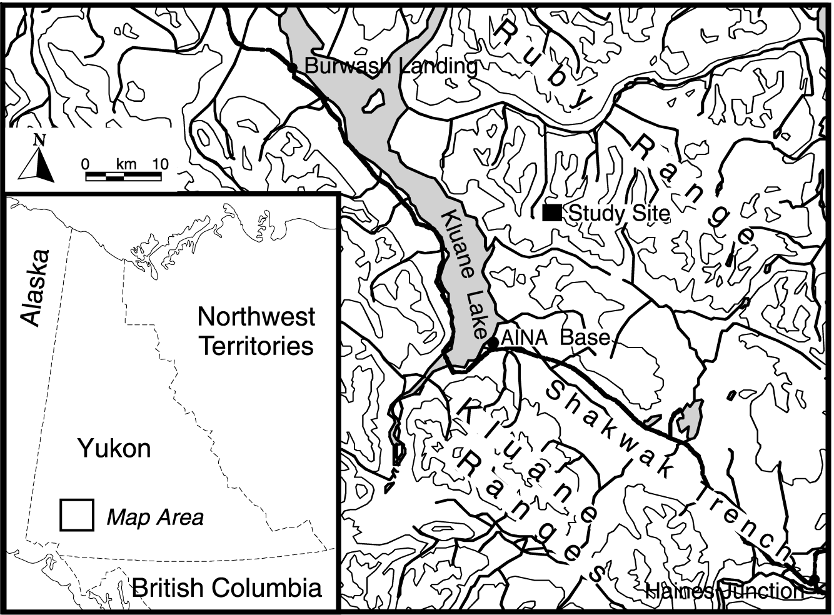

Fig. 2

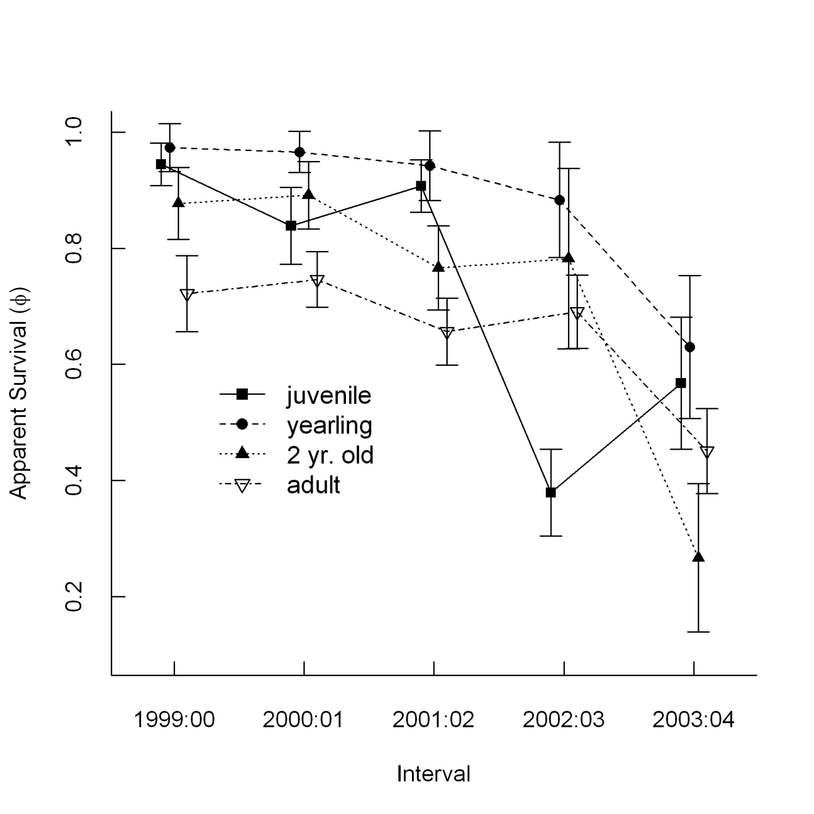

Fig. 3

