Table 1 Variable names and descriptions. A) Functional trait variables used in calculation of functional divergence (Rao) and functional composition (CWM) scores. Traits are designated as 'Effect' or 'Response' traits based on whether they predict effects of plants on ecosystem properties (biomass, productivity, litter decomposition, etc.) or the response of plants to changes in the environment. B) Variables used in structural equation models relating disturbance, functional diversity and carbon storage in plant communities of the Yukon Flats National Wildlife Refuge. Variables in Table 1B are not designated as effect or response variables to avoid confusion with the classification of effect vs. response functional traits. Variables in Table 1B marked with an '*' were treated only as dependent variables in SEM models, while those marked with '^' were treated only as independent variables. All others were simultaneously modeled as independent and dependent variables, with pathways leading to and away from them.

A.
Shrink
Rao
CWM
OLT

B.
Fire
Shrink
CWM
IdSpp
Rao
AGB/OLT
Area

Figure 1. Conceptual diagram showing A) general hypothesized direct and indirect linkages between disturbance, plant community structure, and carbon storage, and B) hypothesized relationships between all variables. Variables include shrinking trend (Shrink) time since fire (Fire), plant community zone width (Area), functional divergence (Rao), functional composition (Func Comp), idiosyncratic species effects (Id Spp), aboveground biomass (AGB) and organic layer thickness (OLT).
Table 3. Bivariate relationships between aboveground biomass per unit area (AGB), organic layer thickness (OLT), Fire history, Lake shrinking trend (Shrink), lake-margin community zone width (Size), functional divergence (Rao), functional trait composition (CWM), and the presence of idiosyncratic species (Id. Spp). CWM and Id. Spp. values are the first principal component scores from principal components analysis of community-weighted mean functional trait values and presence/absence matrices for idiosyncratic species, as described in the Methods section. All analysis are derived from general linear models with Gaussian errors.
Table 4. Model performance (% variance explained) for random forest models of aboveground biomass (AGB) and organic layer thickness (OLT) in three lake-margin plant communities of the Yukon Flats National Wildlife Refuge. Results are shown for models using plant species presence absence and community weighted mean scores for 12 functional trait variables.

Table 5. Variable importance scores from random forest models predicting above -ground biomass (AGB) and soil organic layer thickness (OLT) based on the presence/absence of vascular plant species. Species shown were ranked in the top five for at least one plant community. Species are grouped into one of six plant functional types, which characterize species with similar growth forms, and which are expected to be broadly similar in their functional traits. Variable importance values indicate the average percent increase in model mean-squared error that occurs when a predictor is omitted from the analysis. Variable importance values are shown for models using data from three plant communities: Grass/Sedge (GS), Deciduous Shrub (SH) and Upland Forest (F). Model results were used to generate species presence/absence matrices in each community. Principal components analysis on these matrices were used to generate idiosyncratic species effect scores (first principal component scores).
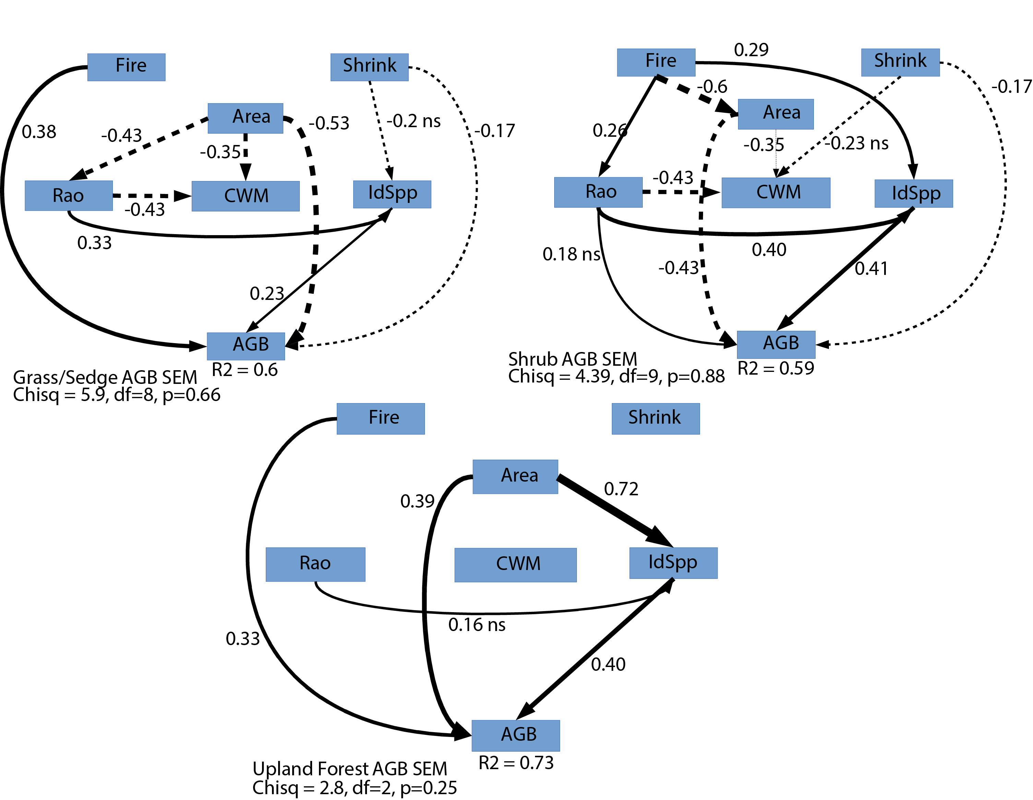
Figure 2. Path diagrams for structural equation models of relationships between shrinking trend (Shrink) time since fire (Fire), plant community zone width (Area), functional divergence (Rao), functional composition (CWM), idiosyncratic species effects (Id Spp), and aboveground biomass (AGB) in three plant communities: Grass/Sedge, Deciduous Shrub, and Upland Forest. Model variables are shown in boxes. Arrows indicate a linear causal pathway between two variables (Fire -> AGB implies that time since fire is a linear predictor of organic layer thickness). Solid arrows represent positive relationships, and dashed lines represent negative relationships. Standardized path coefficients in standard deviation units are shown for each pathway. Overall model fit was assessed with a Chi-Squared test. Non-significant test results indicate adequate model fit.
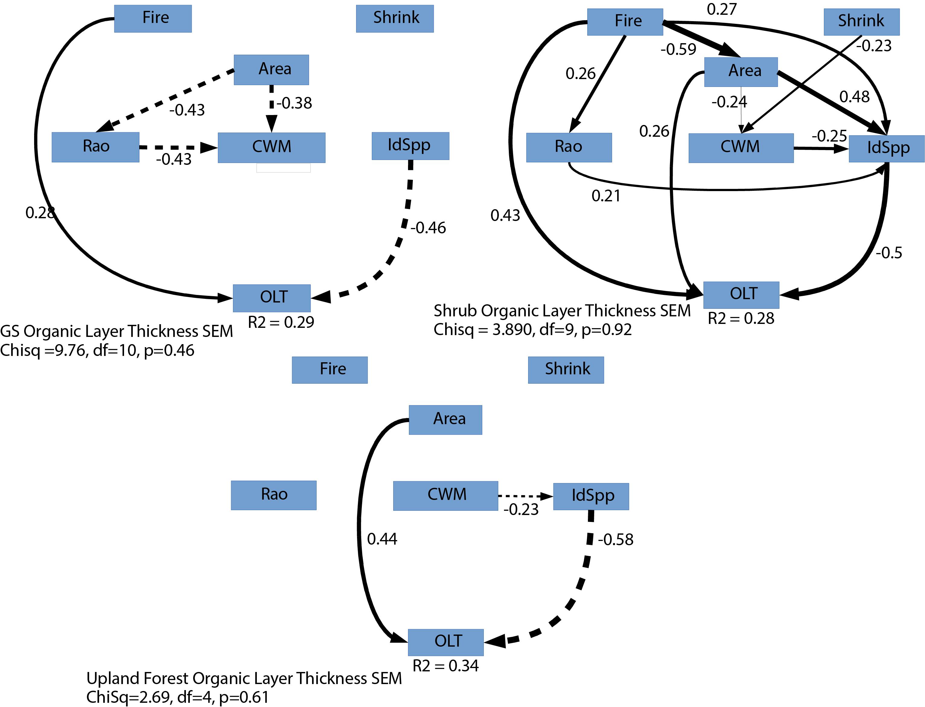
Figure 3. Path diagrams for structural equation models of relationships between shrinking trend presence (Shrink) time since fire (Fire), plant community zone width (Area), functional divergence (Rao), functional composition (CWM), idiosyncratic species effects (Id Spp), and organic layer thickness (OLT) in three plant communities: Grass/Sedge, Deciduous Shrub, and Upland Forest. Model variables are shown in boxes. Arrows indicate a linear causal pathway between two variables (Fire -> OLT implies that time since fire is a linear predictor of organic layer thickness). Solid arrows represent positive relationships, and dashed lines represent negative relationships. Standardized path coefficients in standard deviation units are shown for each pathway. Overall model t was assessed with a Chi-Squared test. Non-significant test results indicate adequate model fit.
Table 6. Summary of direct and indirect path coefficients for structural equation models of aboveground biomass (AGB) and organic layer thickness (OLT) (See Figure 3, Figure 4). Results are separated by plant community type: Grass/Sedge (GS), Deciduous Shrub (SH), and Upland forest (F). Values are standardized coefficients, which reflect the expected change in the response variable (in standard deviations) if the predictor is increased by one standard deviation. Direct influence values are the coefficients for direct paths between the predictor and response. Indirect influence values are the product of all path coefficients for a multi-segment path linking two variables. Finally, the total influence of a predictor is the sum of all direct and indirect coefficients. Mediating variables are the intermediate variables in a multi-segment pathway linking two variables. Predictor variables are time since fire (Fire), lake shrinking trend (Shrink), community area (Area), functional divergence (Rao), and idiosyncratic species scores (Id. Spp.). Id. Spp. values are the first principal component scores from principal components analysis of community-weighted mean functional trait values and presence/absence matrices for idiosyncratic species, as described in the Methods section.

Table 2. Summary of above- and below-ground characteristics for Grass/Sedge (GS), Shrub (SH), and Upland Forest (F) lake-margin plant communities in the Yukon Flats National Wildlife Refuge. Variable abbreviations are: aboveground biomass (AGB), organic layer thickness (OLT), vascular species richness (Rich), plant trait functional divergence (Rao), community-weighted mean trait scores (CWM), and idiosyncratic species scores (IdSpp). Means and standard errors (SE) are shown for all lakes, significantly shrinking lakes, and stable lakes with no long-term trend in area. Significant differences between shrinking and stable lakes were evaluated using t-tests.

Figure 5. Community-weighted mean functional trait value PCA results. Results of a principal component analysis of community-weighted mean functional trait values for Grass/Sedge communities adjacent to lakes in the Yukon Flats National Wildlife Refuge. Axes indicate the strength of correlation between measured variables and the first (horizontal) and second (vertical) principal component scores. The horizontal and vertical locations of arrow tips indicate correlation scores for each variable. Closely-grouped arrows indicate sets of functional traits that co-vary across lakes. The first (horizontal) axis corresponds to a suit of four traits that primarily characterizes deciduous shrubs, including woodiness, rapid re-growth following disturbance, and tolerance to relatively dry conditions in the Yukon Flats floodplain.

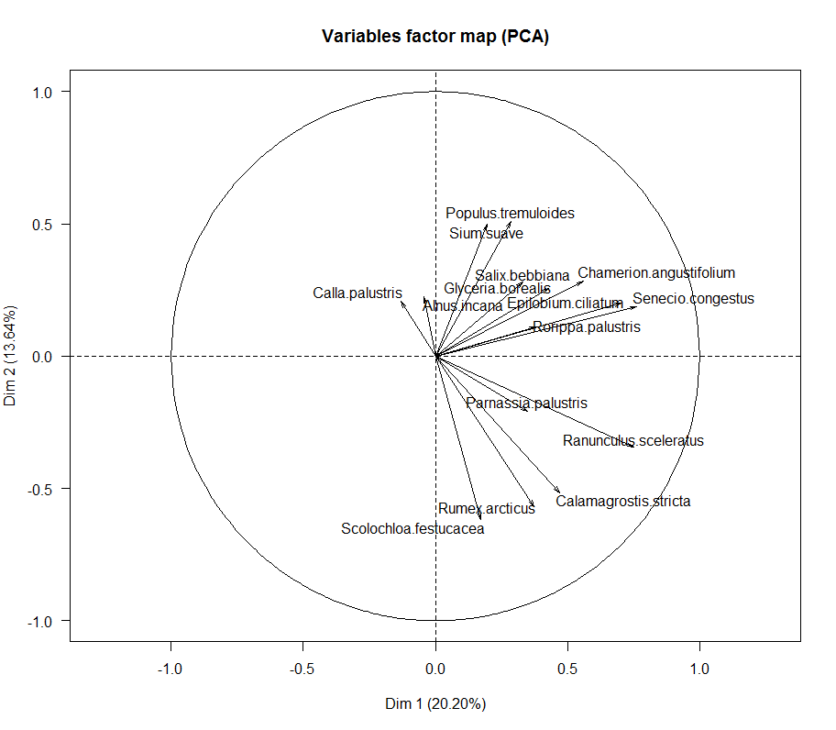
Figure 2. Idiosyncratic species PCA results. Results of a principal component analysis of plant species presence/absence data from lakes in the Yukon Flats National Wildlife Refuge. Species used in the analysis were identified as strong individual predictors of above-ground biomass (AGB) in a random forest regression tree analysis. These species are referred to as ‘idiosyncratic species’ in the text. Axes indicate the strength of correlation between measured variables and the first (horizontal) and second (vertical) principal component scores. The horizontal and vertical locations of arrow tips indicate correlation scores for each variable. Closely-grouped arrows indicate sets of functional traits that co-vary across lakes. The first (horizontal) axis corresponds to a suit of four traits that primarily characterizes deciduous shrubs, including woodiness, rapid re-growth following disturbance, and tolerance to relatively dry conditions in the Yukon Flats floodplain.

