Table 1. Names and descriptions for functional trait variables used in structural equation models relating disturbance, functional diversity and carbon storage in plant communities of the Yukon Flats National Wildlife Refuge. Traits are designated as 'Effect' or 'Response' traits based on whether they predict effects of plants on ecosystem properties (biomass, productivity, litter decomposition, etc.) or the response of plants to changes in the environment.

A.

B.

Figure 1. Conceptual diagram showing A) general hypothesized direct and indirect linkages between disturbance, plant community structure, and carbon storage, and B) hypothesized relationships between all variables. Variables include drying trend presence (Drying) time since fire (Fire), plant community size (Area), functional divergence (Func Div), functional composition (Func Comp), idiosyncratic species effects (Id Spp), aboveground biomass (AGB) and organic layer thickness (OLT).
Table 2. Bivariate relationships between aboveground biomass (AGB), organic layer thickness (OLT), Fire history, Lake shrinkage history, community area, functional divergence (Rao), functional trait composition (CWM), and the presence of idiosyncratic species (Id. Spp). CWM and Id. Spp. values are the first principal component scores from principal components analysis of community-weighted mean
functional trait values and presence/absence matrices for idiosyncratic species, as described in the Methods section. All analysis are derived from general linear models with gaussian errors.
Table 3. Model performance (% variance explained) for random forest models of aboveground biomass and organic layer thickness in three lake-margin plant communities of the Yukon Flats national Wildlife Refuge. Results are shown for models using plant species presence absence and community weighted mean scores for 12 functional trait variables.

Figure 2. Variable importance plots from random forest models predicting above-ground biomass (top panel) and soil peat thickness bottom panel based on the presence/absence of vascular plant species. Species which were ranked in the top five for at least one plant community are shown. Variable importance values indicate the average percent increase in model mean-squared error that occurs when a particular predictor is omitted from the analysis. Variable importance values are shown for models using data from three plant communities: grass/sedge (GS), deciduous shrub (SH) and upland forest (F). Model results were used to generate presence/matrices of species in the top five for each community (referred to as idiosyncratic species). Principal components analysis on these matrices were used to generate idiosyncratic species effect scores (first principal component scores).
Figure 3. Path diagrams for structural equaiton models of above-ground biomass (AGB) and organic layer thickness (OLT) in three plant communities: Grass/Sedge, Deciduous Shrub, and Upland Forest. Model variables are shown in boxes. Arrows indicate a linear causal pathway between two variables (Fire -> OLT implies that time since fire is a linear predictor of organic layer thickness). Standardized path coefficients are shown for each pathway. Standardized coecients give the expected change in the response variable (in standard deviations) if the predictor is increased by one standard deviation. Overall model t was assessed with a Chi-Squared test. Non-signicant test results indicate that the model adequately ts the variance-covariance structure of the data.

Figure 4. Path diagrams for structural equation models of soil peat thickness in three plant communities: Grass/Sedge, Deciduous Shrub, and Upland Forest. Model variables are shown in boxes. Arrows indicate a linear causal pathway between two variables (Fire -> OLT implies that time since fire is a linear predictor of organic layer thickness). Standardized path coefficients are shown for each pathway. Standardized coefficients give the expected change in the response variable (in standard deviations) if the predictor is increased by one standard deviation. Overall model t was assessed with a Chi-Squared test. Non-signicant test results indicate that the model adequately ts the variance-covariance structure of the data.
Table 4. Summary of direct and indirect path coefficients for structural equation models of aboveground biomass (AGB) and Peat thickness (See Figure 3, Figure 4). Results are separated by plant community type: Grass/Sedge (GS), Deciduous Shrub (SH), and Upland forest (F). Values are standardized coefficients, which reflect the expected change in the response variable (in standard deviations) if the predictor is increased by one standard deviation. Direct influence values are the coefficients for direct paths between the predictor and response. Indirect influence values are the product of all path coefficients for a multi-segment path linking two variables. Finally, the total influence of a predictor is the sum of all direct and indirect coefficients. Mediating variables are the intermediate variables in a multi-segment pathway linking two variables. Predictor variables are time since fire (Fire), lake drying status, community area, functional divergence (Rao), and idiosyncratic species scores (Id. Spp.). Id. Spp. values are the first principal component scores from principal components analysis of community-weighted mean functional trait values and presence/absence
matrices for idiosyncratic species, as described in the Methods section.

Table 5. Comparison of mean vascular plant species richness between shrinking and non-shrinking (stable) lakes across three lake-margin terrestrial plant communities in the Yukon Flats National Wildlife Refuge. Values are means with standard errors in parentheses. Differences in means between lake types were tested with T-statistics for each plant community.

Figure 5. Community-weighted mean functional trait value PCA results. Results of a principal component analysis of community-weighted mean functional trait values for lakes in the Yukon Flats National Wildlife Refuge. Arrows indicate the strength of correlation between functional trait variables and the first two PCA axes. Closely-grouped arrows indicate sets of functional traits that co-vary across lakes.

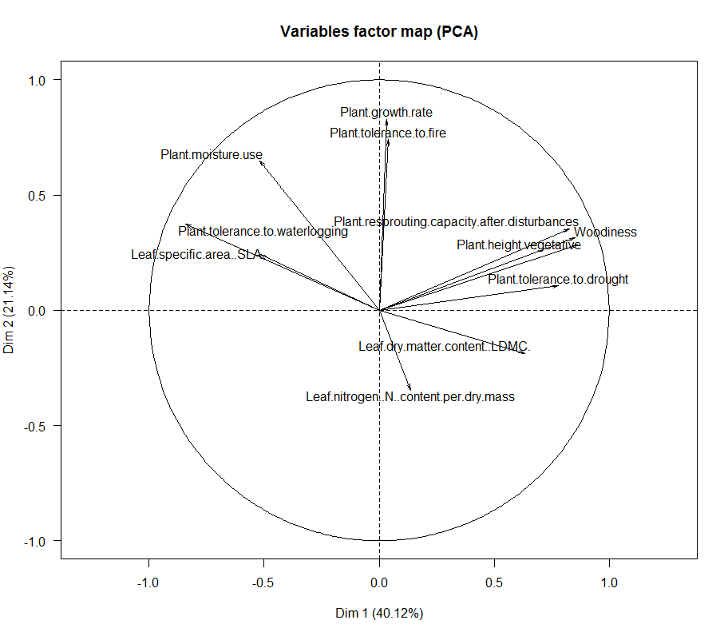
Figure 6. Aboveground biomass idiosyncratic species PCA results. Results of a principal component analysis of plant species presence/absence data from lakes in the Yukon Flats National Wildlife Refuge. Species used in the analysis were identified as strong individual predictors of above-ground biomass (AGB) in a random forest regression tree analysis. These species are referred to as ‘idiosyncratic species’ in the text. Arrows indicate the strength of correlation between species and the first two PCA axes. Closely-grouped arrows indicate sets of species that tend to co-vary across lakes.

