**Plant biodiversity as a mediator of disturbance effects on carbon storage in boreal Alaskan lakes**

**Introduction**

At high latitudes, the effects of climate warming are expected to include increasingly frequent and intense disturbances (Soja et al 2007). In boreal ecosystems, the primary disturbance agent is wildfire, which is a major determinant of community composition, successional dynamics and organic carbon (C) stocks (Balshi et al 2007; Jonsson and Wardle 2010; O'Donnell et al. 2011). Warming has also been linked to reductions in lake size and abundance throughout boreal Alaska and the circumpolar north over the last 50 years (Roach et al 2011). Lake shrinkage has been particularly pronounced in Alaskan National Wildlife Refuge lands, which contain thousands of lakes and wetlands that have been set aside to preserve their "biological integrity, diversity and health" (Meretsky et al 2006). Drying trends vary across the state, but some boreal Alaskan refuges have lost an average of 3% of their surface water per year since 1980 (Roach et al 2013). Lakes are more likely to have dried in areas that have burned in recent decades, which suggests that shrinking trends are partially an effect of changing fire regimes (Roach et al 2013), but sustained lake shrinkage could be an important new influence on ecosystem dynamics in the surrounding landscape (Riordan et al. 2006).

Boreal lakes have strong hydrological ties with lake-margin wetlands, indicating that lake shrinkage should be associated with losses in wetland area (Whitehouse and Bayley 2005). Lakes and lake-margin wetlands provide critical breeding habitat for North American waterfowl, and reductions in their abundance are projected to drive local and regional declines in waterfowl diversity (Roach and Griffith 2015). However, shrinking lakes could also have more subtle effects on wetland communities. Boreal wetlands are local plant biodiversity hotspots, including species and growth forms that cannot be found in more abundant upland forest habitat (Whitehouse and Bayley 2005). Plant species diversity could increase in response to lake shrinkage as lake-margin wetlands expand into newly exposed bare soil, but local species losses could also occur as lake shrinkage changes the soil moisture, pH, and other physical variables that govern growing conditions within existing communities. The extent of the effect of lake drying on plant diversity is unknown, partly because plant diversity is a much lower management priority than the maintenance of wildlife populations and their habitat (USFWS 1987).  
 Plant traits (such as woodiness, relative growth rate, and specific leaf area) can control ecosystem properties like C storage, as well as their sensitivity to disturbance (Díaz et al 2007; Cadotte et al 2011), indicating that plant diversity and community composition may be undervalued in boreal Alaskan wetlands. The ecological significance of this diversity can be captured by characterizing plant communities in terms of functional diversity, which is the distribution of functionally important species and traits (Tilman 2001). Functional diversity encompasses three components: (1) the relative abundance of individual traits (functional composition), (2) the variation in trait values (functional divergence, sometimes referred to as functional diversity in other studies; Mason et al. 2005), and (3) the distribution of 'idiosyncratic species' that possess unique trait assemblages and may have effects on ecosystem function that are disproportionate to their abundance (Conti and Díaz 2013).

Understanding plant communities by the basis of their functional diversity may be key to improving predictions of C storage in boreal Alaskan wetlands under changing disturbance regimes. Wildfires can rapidly remove massive amounts of C stored in soils and plant biomass, while reduced soil moisture due to lake shrinkage could accelerate decomposition of soil organic matter and reduce the potential for it to re-accumulate (Schimel et al 2011). However, C cycling may also be related to plant functional traits (De Deyn et al 2008; Conti and Díaz 2013). For example, rates of plant growth and biomass production are major determinants of soil organic matter accumulation, while woodiness and tissue nutrient contents regulate decomposition (De Deyn et al 2008). In addition, plant traits can moderate the effects of disturbance by controlling the level of plant mortality that occurs after a disturbance event and the rate of recovery by the plant community (Conti and Díaz 2013).

There are two primary hypotheses that link functional diversity to C storage. According to the mass-balance hypothesis, ecosystem function is determined by the most abundant traits, or the traits of the most abundant species. This hypothesis predicts that functional composition and idiosyncratic species should be the best predictors of ecosystem processes related to the accumulation and breakdown of organic matter (Grime 1998). In contrast, the niche complementarity hypothesis predicts that processes like biomass production, and therefore inputs to soil C, will be maximized at high functional divergence, because resources will be used more efficiently when distributed among species with diverse ecological requirements and roles (Trenbeith 1975). At the same time, increased diversity in rooting depth profiles could allow for belowground C inputs over a larger fraction of the thawed soil profile and increased total root biomass production (Steinbeiss et al 2008). Both of these hypotheses represent mechanistic pathways that would allow plant communities to mediate the effects of disturbance on above- and belowground C storage. However, their relative importance appears to be ecosystem-specific, and relationships between functional diversity and disturbance effects have rarely been examined in natural systems or at regional or greater spatial scales (Conti and Díaz 2013).

Boreal soils represent one of the largest pools of organic C in the world, the majority of which is concentrated in lakes and wetlands (Benoy et al 2007). These soils are able to accumulate and store C effectively due to a combination of low temperatures, which reduce decomposition, and the presence of permafrost, which impedes drainage and creates saturated, anoxic soils (Gorham 1991; McGuire and Anderson 2009). Although the majority of boreal C is locked away in deep, stable permafrost deposits, a significant fraction can be found in surface organic layers, which are composed of partially decomposed vegetation, or peat (Gorham 1991). The belowground C stored in peat is strongly affected by the accumulation, death, and decomposition of aboveground biomass (AGB; Chapin et al 2009; Conti and Díaz 2013). In addition to being a major source of C inputs to soil organic matter, AGB can affect decomposition through its chemical composition, and by altering the physical soil environment through shading, insulation, and moisture usage (Chapin et al 2009; Conti and Díaz 2013). AGB also functions as a source of forage and/or cover for moose, small mammals, and other wildlife.

Our objective was to determine whether functional diversity mediates the effects of lake drying and wildfire on above- and belowground C storage in boreal Alaskan wetlands, using field data from a large-scale biodiversity survey combined with information on C storage in the Yukon Flats National Wildlife Refuge, an 11,000,000 acre wetland complex. We sought to identify which of three components of functional diversity (functional composition, functional divergence, and idiosyncratic species) were most influential. To accomplish this objective, we follow a published framework (Díaz et al 2007), in which the effects of environmental forces and functional diversity components on ecosystem properties are assessed in three steps: 1) separate models for each component, 2) a combined model to assess relative importance, and 3) an investigation of nonlinear and interactive effects (referred to as ‘discontinuous effects’ in the referenced paper). We add to that work by outlining a robust analytical approach for identifying non-linear and interactive relationships between functional diversity, disturbance, and above- and belowground C storage using a combination of machine learning algorithms and structural equation modeling.  
 We evaluated two general alternative hypotheses: 1) Disturbance directly alters the C sink strength of lake-margin wetlands through changes to the physical environment alone (i.e. the effects of plant diversity on C storage cannot be explained by intermediate changes in plant functional diversity). Mechanisms for these direct effects could include removal of C through combustion as well as changes to physical variables like soil moisture, which can influence rates of new biomass production, respiration, and decomposition. 2) Disturbance effects are mediated by changes in plant community structure and the distribution of functional characteristics (Fig. 1A). The concepts of disturbance and functional diversity were each represented by multiple variables in our analysis, which allowed us to assess the relative importance of functional composition and functional divergence as predictors of C storage, and simultaneously test whether apparent effects of lake drying on ecosystem properties could be explained by the association of drying trends with fire history (Fig. 1B).

We carried out this analysis in three lake-margin plant communities (Herbaceous Grass/Sedge, Deciduous Shrub, and Upland Forest) that represent a gradient of increasing distance from the lake edge and were expected to reflect a gradient of increasing potential functional diversity. In terms of the overall relationship between disturbance and C storage, we predicted that lake drying would lead to increased AGB in near-shore Grass/Sedge communities, with similar but weaker effects in the Deciduous Shrub community, and no change in upland forest biomass (Chapin et al 2009). We also predicted that lake drying would result in increased decomposition and reduced near-surface soil C in the formerly saturated soils of the Grass/Sedge community, which occurred immediately adjacent to the water's edge (Chapin et al. 2011). These predictions derived from previous findings that productivity and decomposition rates show parabolic responses to moisture, and that decomposition tends to respond to changes in soil moisture more strongly than plant biomass production (Chapin et al 2011). We predicted fire frequency to be correlated with functional divergence and composition (Jonsson and Wardle 2010), and to be negatively correlated with C storage in all community types (Grosse et al 2011). For our functional diversity hypotheses, we predicted that the relative importance of functional diversity as a mediator of disturbance effects and the relative support for the niche complementarity hypothesis would both be highest in the upland forest, which had the most complex canopy structure and therefore the greatest potential for niche differentiation among plant species (Conti and Díaz 2013).

As far as we know, our study is one of the first to examine the influence of functional diversity in natural systems at the landscape scale. We illustrate how accounting for plant community characteristics can improve our ability to predict the effects of climate-driven disturbance on ecosystem dynamics. We also provide insight into the mechanisms linking spatial patterns of C storage and wildlife habitat structure, which could be used to re-evaluate conservation and management priorities for Alaskan National Wildlife Refuges.

**Methods**  
*Study Area*  
 We chose the Yukon Flats National Wildlife Refuge (YFNWR) in northeastern Alaska as our study area. The YFNWR encompasses ~10 million acres surrounding the Yukon River floodplain, consists of a complex mosaic of lakes, wetlands, and upland forest (Gallant 1998), and is not connected to the road system. This region is uniquely appropriate for studying the ecological consequences of lake drying in Alaska, because lake drying trends within the refuge span the full range of variation observed across the state (Roach et al 2013). The ~40,000 lakes scattered throughout YFNWR are strongly associated with the presence of discontinuous permafrost, which prevents drainage and promotes ponding of surface water (Roach et al 2011). Many of these lakes are associated with concentric rings of Grass/Sedge fens, surrounded by shrub bog communities dominated by *Salix* species.

*Diversity sampling*  
 We surveyed plant communities at 66 lakes between 2010 and 2011. We selected candidate focal lake sites from a GIS layer of floatplane-landable lakes using a Generalized Random Tessalation Stratified (GRTS) design, ensuring that our sample sites were a spatially balanced, representative random sample of the study area (Stevens and Olsen 2004). Sampling efforts were divided between two strata that had opposite regional lake area trends since 1985 (Roach et al 2013). Lakes that could not be accessed by floatplane were replaced with the nearest landable lake. All lakes within a 1km radius of the focal lake centroid that could be accessed within 14 days were sampled as satellite lakes. This design allowed us to include small, unlandable lakes in our sample, and to account for the potential effects of spatial autocorrelation between nearby lakes in our analyses.   
 The primary objective of our sampling campaign was to characterize vascular plant diversity and community composition. We established four perpendicular 100m survey transects at each site, oriented at a random azimuth to the lake centroid. Each transect began at the lake edge, which we defined as the point where the soil surface was not covered by standing water. We then recorded and identified all vascular species located within 5m of the transect line. Specimens that could not be identified in the field were pressed and sent back to the University of Alaska Fairbanks for identification. We also estimated species percent cover using a series of 25 5m-radius vegetation plots distributed within a 50 by 100m grid centered on a randomly selected transect at each site. Finally, we delineated transitions between plant community types, which occurred in concentric rings surrounding lakes, based on the plant growth form (herbaceous, deciduous shrub, or tree) with >50% cover. We averaged the width of each community type across the four transects, and used these measurements to generate buffers around each lake in arcMap 10.0. These buffers provided an estimate of the area occupied (m2) by different community types within the surveyed area at each lake.

*Fire History*  
 We estimated the time since the most recent fire at all sample lakes by overlaying lake locations with a GIS map of historical fire perimeters from 1950 to the present (fire.ak.blm.gov). Because only 1/3 of all sample sites had burned within that timeframe (n=35), we represented fire history as an ordinal variable: 1 = < 5 years since fire, 2 = < 10 years, 3 = < 25 years, 4 = < 50 years, and 5 >= 50 years.

*Lake Trends*  
 We estimated trends in lake area between 1979 and the present using a time series of 22 Landsat satellite images. These images were converted to shapefile lake maps in ArcMap 10.0 as part of a larger study on long-term lake trends in the YFNWR (Rover et al 2012). After extracting area measurements for each lake in each year where imagery could be obtained, we fit linear models with the form ‘Lake Area = B1*Year+B2*Day of year (Roach et al 2011). Lakes with significant model F statistics and significant negative Year coefficients were characterized as shrinking. We assessed statistical significance using an alpha cutoff of 0.05. Our lake sample included 16 significantly decreasing lakes, representing 12% of the total sample population. This proportion was similar to the total proportion of drying lakes in the YFNWR, which was recently estimated at ~10% using similar methodology (Rover et al 2012). 22 lakes decreased in area between 1979 and the present, but did not have significant decreasing trends due to large interannual fluctuations in lake area. Because these fluctuations represent flood events that could have their own effects on community composition and carbon stocks, these lakes were excluded from this analysis. Three lakes had significant increasing trends, and were also excluded. Increasing lakes represent a small fraction of the total landscape (<3%) in YFNWR and elsewhere in Alaska (Rover et al 2012).

*Soil C and AGB sampling*  
 Logistical constraints prevented us from collecting soil and AGB samples at all sites. Instead, we selected 15 lakes for intensive sampling, and correlated measurements at these lakes with remote-sensing products to generate maps of soil organic C content and AGB for the entire sample population. The 15 lakes were originally selected to represent a balanced sample among three lake types: Decreasing, Stable, and Fluctuating. However, the full time-series of lake areas were not available prior to field sampling, and these lake-type designations were based on a pilot analysis using six hand-digitized area measurements per lake. After re-analyzing lake area data according to the methods described above, we found that our sample consisted of four decreasing lakes, 6 stable lakes, 4 fluctuating lakes, and 1 increasing lake, which was excluded from analysis as described above.   
 To sample the soil C and AGB, we visited each of these lakes within a two-week window from Aug 1-Aug 14 in 2011 and 2012, which corresponded approximately to the period of peak biomass accumulation in our study area (Mack et al 2008). Eight lakes were sampled in 2011 simultaneously with our vegetation surveys, and seven lakes originally surveyed in 2010 were revisited in 2012 for soil and biomass collection. We stratified soil and AGB sampling across three community types: Grass/Sedge, deciduous shrub, and upland forest. Within each community type, we harvested understory AGB from 5-10 randomly located 20cm x 50cm quadrats. Within each quadrat, we harvested all live and dead biomass, including green moss, woody debris, and leaf litter. Samples were kept cool and flown out of the field within 3 days before being frozen prior to analysis. We then dried samples for 3 days at 60º C before weighing (Shaver and III 1991; Mack et al 2008). We also measured shrub (<3m tall) and tree stem density along a randomly located 60m transect in each plant community. Transects were broken into 6 10m cells. We then counted all deciduous shrub stems within 5m of the transect line in each cell, and harvested 10 randomly located stems per community type. All stem material was dried for 5 days at 60º C before being weighed. We also estimated tree density in each cell using a third nearest neighbor angle-order estimator, which is a robust alternative to plot-based density estimates (Engeman et al 1994; Sheil et al 2003), and calculated tree biomass using allometric equations (Bond-Lamberty et al 2002; Yarie and Kane 2007).  
 We collected three 20cm soil cores from each plant community using a specially designed 4.4 cm diameter fitting for a Makita power drill, which minimized compression in organic horizons. Horizon depths and weights were recorded in the field, and samples were kept cool in permafrost pits for a maximum of 3 days before being flown out and stored at -20C prior to analysis. After returning from the field, we dried samples at 60C before measuring % C and N with a Costech CHN analyzer. Bulk density was estimated by measuring the dry weight of a known-volume subsample for each horizon in each core. We then calculated soil C content as %C * bulk density * layer thickness (Johnson et al 2011).  
 In addition to these soil cores, we characterized soil horizons by recording the depths of fibric organic, humic organic, mineral, and frozen soil layers in pits dug along the four vegetation survey transects at all 130 lakes. In 2010, soil pits were dug at the lake edge and at the upland forest boundary. In 2011, we also dug additional pits located in the center of each plant community type (n=58).  
 We compared average biomass estimates from field sampling to estimates derived from a recently published raster map of AGB for the YFNWR, which modeled biomass based on spectral reflectance indices from Landsat imagery (Ji et al 2012). We estimated mean mapped AGB by averaging biomass values for all pixels that overlapped buffer polygons representing plant communities after weighting values based on the degree of overlap. We then regressed field biomass estimates against mapped estimates for each plant community type to validate the mapped values, which we used to represent mean AGB for all communities at all 130 lakes.  
 Horizon thickness is commonly used as a proxy for soil C content per unit area (Johnson et al 2011). We used a recently published 30m-resolution map of organic layer thickness (OLT) in the Yukon River Basin to estimate average C content per unit area (Pastick et al 2014). Average OLT estimates were derived with the same methods used to determine average AGB.

*Functional diversity and functional composition*  
 We calculated plant functional trait diversity based on five effect traits and five response traits (Table 1). These traits were selected based on their potential to influence rates of organic C accumulation and decomposition, and on their relevance for predicting plant community responses to lake-related disturbance. We developed separate trait matrices for all species found in each plant community, using a combination of field data, literature searches, and a query from the TRY functional trait meta-database (www.try-db.org; Kattge et al. 2011). We chose not to remove species with missing trait data from our analysis. Instead, we filled data gaps using multiple imputation, as implemented in the mice R package (Taugourdeau et al 2014). Multiple imputation methods have been shown to yield more robust datasets than either case deletion or simple gap-filling methods in functional diversity studies, as long as the proportion of species with missing data does not exceed ⅓ for each variable. We confirmed that there was sufficient data to retain each functional trait variable before proceeding.   
 We estimated functional trait divergence using Rao's quadratic entropy (Rao 1982), which is derived by calculating the multivariate distance between each species pair in a community, and weighting these distance scores by the proportional abundance of each species (Equation 1).

Equation 1: 

pi, ji = proportional abundance of species i, j. Dij = multivariate distance between species i, j.

Gower's distance formula was used to accommodate the presence of both continuous and categorical trait variables in our dataset (Roscher et al 2012). Functional trait composition was estimated by 1) calculating the community-weighted mean (CWM) of functional trait values, for all species present at a given lake and community type, and 2) extracting the first principal component score from a PCA of CWM functional trait values (Roscher et al 2012). Community-weighted mean trait values were an average over all species present, weighted by species abundance.

We used the random forest algorithm to identify potential idiosyncratic species that were strong predictors of above- and belowground C (Cutler et al 2007). We ran separate random forest models AGB and OLT in each community type, with binary presence/absence variables for all plant species as predictors. Variables were ranked based on their average individual effect on model mean squared error (Archer and Kimes 2008). Since the presence of many unimportant predictors can suppress model performance, we sequentially removed the 5 lowest-ranking variables and re-ran models until we arrived at a model with maximum predictive power (Strobl et al 2007). Model results were used to construct reduced species presence matrices. We then calculated idiosyncratic species scores for each community and response variable as the first principal component of a species presence/absence PCA.

*Structural equation modeling*  
 We used structural equation modeling (SEM) to evaluate hypotheses about the network of causal relationships linking lake drying, plant community traits, and C storage. The SEM modeling framework facilitates the testing of hypotheses about direct and indirect influences, and makes it possible to explicitly account for causal relationships between predictor variables (Grace and Anderson 2010). These features make SEM modeling a more appropriate tool for addressing our research questions than more common statistical techniques like general linear models in which unaccounted-for covariance between predictors can have a dramatic influence on parameter estimates (Grace et al 2014)  
 The first step in our modeling process was to graphically represent our a priori hypotheses about the network of causal relationships that might drive variation in above- and belowground C (Fig. 1). Concepts such as disturbance, functional diversity, and C storage were represented by measured variables, producing a hypothetical network of influence that could be directly compared against data. A directed arrow from one variable to another (x -> y) represents the hypothesis that ‘y is a linear function of x’ (Fig. 1b).   
 We fit this network to our data with the lavaan package in R using the LISREL method, and assessed model fit by comparing the observed variance-covariance structure of the data to a modeled variance-covariance matrix using a Chi-squared test (Grace and Anderson 2010; Rosseel 2012). A significant test statistic implied inadequate model fit, meaning there were missing structural relationships between variables. If the initial model had inadequate fit, we added biologically plausible paths sequentially based on modification index values (Chaudhary et al 2009). Once we obtained a model with adequate fit, we assessed our hypotheses by examining the standardized path coefficients linking variables. Standardized coefficients are essentially z-transformed coefficients, and reflect the expected number of standard deviations that the response will change when a predictor is changed by one standard deviation (Grace 2006). The product of all path coefficients in an indirect pathway (e.g. lake drying -> plant diversity -> AGB) represents the coefficient for the entire pathway, and the sum of all indirect and direct path coefficients linking two variables indicates the total influence of the predictor on the response. Finally, we also assessed the predictive power of our hypotheses by examining model R2 values for each response variable.

**Result**

*Bivariate relationships*

*Vegetation*

AGB per unit area was significantly positively related to the length of time since the most recent wildfire (Table 2). Grass/Sedge and Deciduous Shrub communities adjacent to drying lakes also had significantly lower AGB per unit area compared to similar communities near stable lakes. . Community area (width of community zones surrounding lakes) was the best single predictor of AGB per unit area in all communities, with R2 values ranging from 0.33 to 0.54). Area was negatively associated with AGB per unit area in Grass/Sedge and Deciduous Shrub communities, but was positively correlated with biomass in the forest. Lake shrinking was not significantly associated with AGB per unit area in the upland forest community. Functional divergence (Rao's quadratic entropy) was significantly positively correlated with AGB per unit area in Grass/Sedge and Deciduous Shrub communities, but not in the Upland Forest. Functional composition, as measured by the first principal component score from a PCA of community-weighted mean (CWM) functional trait values, was not significantly associated with biomass in any plant community.

However, the first principal component from a PCA of idiosyncratic plant species presence/absence was significantly correlated with AGB in all three communities communities (Id. Spp variable; Table 2). Id. Spp scores were positively correlated with the distribution of most idiosyncratic species . However, only four species had correlation coefficients > 0.5 (Figure 6).

*Soils*

Peat thickness, a proxy for surface (0-30cm) soil C content per unit area, was not significantly predicted by bivariate relationships with any variable, except that the first principal component from a PCA of plant species presence/absence data was significantly correlated with peat depth in deciduous Deciduous Shrub communities (R2 = 0.24, p<0.001; Table 2). Idiosyncratic species scores for peat thickness were primarily associated with a suite of four forb and graminoid species (Appendix 1: IdSpp PCA plots).

*Using random forest models of idiosyncratic species to predict above- and belowground C*

Random forest models using only community-weighted mean functional trait values were poor predictors of AGB (Figure 2). However, random forest models of AGB as a function of species presence/absence were more successful, explaining 43% of variance in the Grass/Sedge community, 54% in the Deciduous Shrub community, and 65% in the fores. The optimal model for each community included 15 species, although the top five species accounted for over half the variance explained in all cases (% variance explained = 36 for Grass/Sedge, 29 for shrub, and 49 for the upland forest. *Chamerion angustifolium*, a post-disturbance colonizing forb, was the top predictor of Grass/Sedge AGB, while the top predictor in the Deciduous Shrub community was the dwarf shrub *Arctostaphylos rubra*, and the best predictor of forest AGB was the dwarf evergreen shrub *Linnaea borealis* (Figure 2). In general, herbaceous species were more strongly associated with variation in biomass in the Grass/Sedge community, while woody plants had high variable importance values in the shrub and forest communities, although all growth forms could be found in all communities (Figure

Peat thickness, like AGB, was not well predicted by community weighted mean functional trait values, with CWM random forest models explaining less than 1% of variance in peat thickness in all plant communities. Random forest models of species presence absence were more successful, explaining 30% of variance in peat thickness in the grass sedge community, 11% of variance in shrub peat thickness, and 2% of variance forest peat thickness. All top predictors of Grass/Sedge peat thickness were herbaceous species, including several plants found in emergent wetlands and floating vegetation mats, such as *Calla palustris* and *Menyanthes trifoliata* (Figure 2). Deciduous shrubs were top predictors of both shrub and forest peat thickness (*Salix pulchra* and *Rosa acicularis*, respectively, while the only tree species in the list, *Picea glauca*, was only a top predictor of peat thickness in the upland forest (Figure 2).

*Structural equation modeling of relationships linking lake drying, plant community traits, and C storage*

*Aboveground C storage (AGB)*

In all communities, AGB was significantly associated with both disturbance

history (time since fire, lake drying status) and plant functional diversity variables (Rao's quadratic entropy and idiosyncratic species distributions). Structural equation models (SEM) explained more than half of observed variation in AGB in all communities (R2= 0.57 for Grass/Sedge, 0.56 for the Deciduous Shrub community, and 0.71 for the upland forest community; Figure 3). All SEM models adequately captured the underlying variance-covariance structure in the data, as indicated by non-significant Χ2 tests(Figure 3).

Time since fire was positively correlated with AGB in all communities, although this effect was strongest in the Grass/Sedge community (Table 3). The apparent influence of fire on shrub biomass was weak (standardized path coefficient=0.07; Table 3). However, SEM results did not capture a clear unimodal relationship between shrub biomass and fire return interval (need figure for this). Fire history had a direct influence on biomass in the Grass/Sedge community, while its influence was at least partially mediated by changes in functional diversity in both the shrub and forest communities.

Lake drying was significantly associated with reduced biomass per unit area in both the Grass/Sedge and Deciduous Shrub communities. In both cases, effects of lake drying on biomass did not appear to be mediated by functional diversity. Lake drying status was not significantly predicted by time since fire (Figure 3).

Community size (area) was the strongest direct influence on AGB per unit area in all communities (Figure 3). Small Grass/Sedge and Deciduous Shrub communities had relatively high biomass density, whereas community size and AGB were positively correlated in the upland forest. Strong positive relationships between area and idiosyncratic species effects in the shrub and forest communities also indicated that larger communities were more likely to include idiosyncratic species with strong influences on biomass. These indirect, idiosyncratic species effects were opposite in sign but weaker than the direct effects of change in area.

Idiosyncratic species effects were the only components of functional diversity with direct influence on AGB, and were only apparent in the shrub and forest plant communities. Idiosyncratic species scores were significantly correlated with Rao's quadratic entropy scores, which represent functional divergence in all plant communities. In the Grass/Sedge and Deciduous Shrub community, idiosyncratic species were more likely to occur in communities with high functional divergence, but forest plant communities showed the opposite relationship. Rao's quadratic entropy was not consistently predicted by any other variable, but increased with increasing time since fire in the Deciduous Shrub community. Functional trait composition, as measured by CWM scores, was not strongly associated with biomass in any community.

Peat thickness *(OLT)* structural equation model results

Structural equation models explained a moderate amount of variation in Grass/Sedge peat thickness (R2 = 0.37), but performed poorly in the shrub and forest communities (R2 = 0.04 and 0.1 respectively; Figure In the Grass/Sedge plant community, peat thickness increased with time since fire, community size, and functional divergence, and was negatively associated with the presence of idiosyncratic species (Table 3). Only community size and idiosyncratic species directly affected peat thickness (Figure 4). No significant pathways linked lake drying history with peat thickness (Figure 4). The effects of fire history and community size were both at least partially mediated by functional diversity variables. Functional divergence was positively correlated with peat thickness, because Grass/Sedge communities with high functional divergence were less likely to contain idiosyncratic species (Figure 4).

Although the structural equation model of Deciduous Shrub community peat thickness had adequate fit based on a non-significant chi-squared test (Figure 4), we did not find evidence for any direct or indirect pathways linking peat thickness with fire history, lake drying, and functional diversity. However, a non-significant pathway (p=0.07) linked idiosyncratic species scores with peat thickness (Figure 4). Fire history and lake drying status influenced all three components of functional diversity via direct and indirect pathways (Figure 4). Rao's quadratic entropy and Idiosyncratic species scores were both negatively correlated with time since fire in the Deciduous Shrub community, while CWM scores, which are associated with woodiness, were weakly positively associated. (Figure 4). Shrub communities near drying lakes had lower functional divergence (Rao) compared to stable sites, and lake drying was also negatively associated with the presence of idiosyncratic species (Figure 4).

In the forest community, time since fire and lake drying status both had weak effects on peat thickness that were mediated by functional diversity, especially by changes in the distribution of idiosyncratic species (Table 3). Peat thickness was also negatively associated with community size (area), functional divergence (Rao) and idiosyncratic species scores. Functional diversity effects were stronger drivers of peat thickness than either lake drying status or fire history (Table 3).

**Discussio**

*Overview*

*Disturbance effects on C storage*

Our findings supported the hypothesis that lake drying is a significant influence on C storage in lake-margin plant communities of interior Alaska. Herbaceous and shrub wetlands near drying lakes had significantly reduced AGB per unit area relative to areas with stable lakes, which could translate to reduced forage availability for herbivores as well as lower organic soil C stock, while drying Deciduous Shrub communities had significantly thinner soil organic layers (Table 4). Although lakes within an area that burned in within fire scars from the past 60 years area more likely to dry than unburned lakes (Roach et al 2013), the probability of drying was not related to time since fire over more recent time scales (Fig. 3, Fig. 4). In addition, lake drying appears to represents a distinct form of disturbance whose influence on C stocks cannot be explained as an indirect effect of increased fire frequency (Fig. 3, Fig. 4). As predicted, the effects of lake drying were most apparent in herbaceous and shrub wetland plant communities that occur in close proximity to the lake shore, whereas lake drying had no effect on either above- or below-ground C in the upland forest community, which was presumably hydrologically isolated from adjacent lakes (Table 4). Overall, lake drying appeared more tightly linked to AGB than to the much larger C stocks stored in organic soil (Fig. 3, Fig. 4). Lake drying trends can only be calculated over a few decades (Roach et al 2011; Rover et al 2012), and this timespan may not be sufficient to show the effects of lake drying on soil peat accumulation.

In addition to being a poor predictor of belowground C, lake drying was a relatively minor component of the local disturbance regime in our study area. Fire history was a stronger predictor of both above- and belowground C stocks in the Grass/Sedge and Deciduous Shrub communities, despite the clear sensitivity of both communities to lake drying (Table 4). Wildfire is widely recognized as the dominant disturbance agent in interior Alaska (Harden et al 2000; Balshi et al 2007) and our analysis suggests that this continues to be true at the landscape scale even in regions like the Yukon Flats, which show pronounced lake drying trends (Riordan et al 2006; Roach et al 2011). Surprisingly, the only C pool that was not significantly associated with time since fire in our analysis was the upland forest organic layer. The effects of wildfire on OLT in the boreal forest are well established (Harden et al 2000). However, our analysis used a relatively coarse measure of fire history that did not include estimates of severity or timing, both of which regulate the amount of surface organic material removed during boreal forest fires (Kasischke and Johnstone 2005). In addition, the upland forest community category in our analysis included a spectrum of forest types ranging from pure black spruce stands to mixed aspen-birch forests, which are associated with a similar diversity of soil profiles (Johnson et al 2011), as evidenced by the significant pathways linking functional trait values, idiosyncratic species distributions, and forest OLT (Fig. 4).

*Functional diversity mediation*

The mediation hypothesis, which predicts that disturbance effects are mediated by changes in plant community structure and the distribution of functional characteristics, was not well-supported, with significant indirect pathways linking disturbance to C storage only being detected in the Deciduous Shrub community (Fig. 3, Fig. 4). This result was consistent with our prediction that the importance of functional diversity as a mediator of disturbance effects would be positively correlated with mean functional divergence, which varied significantly across plant communities and was highest in the Deciduous Shrub community (F2,157 = 10.1, p<0.0001; mean Rao's quadratic entropy = 15.37 in Shrub, 13.43 in Grass/Sedge, and 8.00 in Forest). Although we initially predicted that trait divergence would play the largest role in the upland forest, where productivity could be driven by efficient light competition across multiple canopy levels (De Deyn et al 2008), the Deciduous Shrub community tends to contain a variety of woody and non-woody growth forms due to its position as a zone of transition between herbaceous fens and upland forest (Whitehouse and Bayley 2005).

Of the two disturbance types we examined, the mediation hypothesis was only supported for fire history (Fig. 3, Fig. 4). Lake drying was not significantly correlated with any functional diversity variable in any community, although it was linked with shrub functional composition (CWM) and with Grass/Sedge idiosyncratic species effects via non-significant pathways. The lack of interaction between drying trends and functional diversity variables, particularly functional divergence, was surprising because drying lakes have significantly higher vascular plant species richness in both Grass/Sedge and Deciduous Shrub communities (Table 5). This discrepancy underscores the need to consider the influence of functional traits, rather than species diversity alone (Mayfield et al 2010), when examining disturbance-diversity relationships.

*Functional diversity hypotheses*

Effects of functional diversity on ecosystem processes are most commonly explained as evidence for either the niche complementarity hypothesis or the mass-balance hypothesis (Sandra and Cabido 2001). Our results provided support for both hypotheses depending on the response variable in question. AGB increased with functional divergence scores (Rao’s quadratic entropy) in all communities (Table 4). The standard explanation for this pattern, according to the niche complementarity hypothesis, is that a diverse array of functional niches allowed plant communities to use resources more efficiently (Díaz et al 2007). However, the pathway linking functional divergence with biomass was mediated by the idiosyncratic species variable, which was the only functional diversity variable that was directly correlated with AGB in any community. In other words, communities with high functional trait divergence were more likely to contain species with disproportionate influence on total biomass (Díaz et al 2007).

Unlike AGB, soil OLT was positively correlated with CWM scores in both the shrub and forest communities, which indicates that thickness was associated with the abundance of functional traits associated with woody vegetation (woodiness, plant height, leaf dry matter content; Fig. 5). As with apparent functional divergence effects in our biomass models, the pathways linking CWM to OLT were mediated by idiosyncratic species effects. We interpret this relationship to mean that the disproportionate effects of particular species on OLT can be associated with individual traits, specifically those traits that help determine the decomposability and lability of dead plant organic matter (Steinbeiss et al 2008; Conti and Díaz 2013) ⁠.

Overall, our results highlight the importance of idiosyncratic species effects as the dominant functional diversity component. Like the mass balance hypothesis, the idiosyncratic species hypothesis suggests that ecosystem properties are driven by specific traits, but further suggests that any one trait is less important than the unique combinations that occur in particular species (Conti and Díaz 2013). Our ability to resolve the true importance of trait divergence versus mean trait values could have been improved by considering within-species trait variation, potentially by incorporating genetic diversity into our analysis (Albert et al 2011). However, most high-resolution studies of functional diversity deal with species-poor, often experimentally constructed plant communities (Sandra and Cabido 2001). In landscape-scale field studies of remote and/or diverse ecosystems, idiosyncratic species analysis may be an efficient strategy for evaluating the importance of functional diversity, while also identifying particular species for more detailed trait measurements or experimental work.

Functional diversity is commonly estimated by measuring the diversity and abundance of plant functional types, which are groups of species with similar growth habits and the assumption of similar functional trait assemblages (Chapin et al 1996; Wullschleger et al 2014). Recent work has called the functional type approach into question by demonstrating that random functional type designations can outperform a priori classification systems in their ability to predict ecosystem properties (Wright et al 2006). The dangers of relying on functional type-level functional diversity estimates are evident in our idiosyncratic species analyses, which show that even within a single plant functional type (e.g. deciduous shrubs, forbs, or graminoid; Fig. 2), species differ widely in their ability to predict AGB versus OLT, and their relative importance/predictive power also varied between communities. Typical growth form-based plant functional type categories such as ‘deciduous shrub’ or ‘graminoid’ contain species that have divergent functional trait assemblages (Petchey and Gaston 2002). Even the unique suite of traits represented by a single species has different implications for C storage depending on the community in which it occurs (Conti and Díaz 2013; Fig. 2), which demonstrates the inadequacy of a purely species-based approach to examining interaction between biodiversity and ecosystem function (Mayfield et al 2010).

*Carbon storage/Area Relationships*

Community size, which was estimated as the width of concentric vegetation bands surrounding each lake, was one of the strongest predictors of both above and belowground C in our analyses (Table 4). These effects could not be explained in terms of area-diversity relationships, since direct pathways between area and AGB/OLT were stronger than indirect, functional diversity-mediated pathways in all models (Table 4). In addition, when area was correlated with functional divergence, the sign of this relationship was negative, as opposed to the near universal phenomenon of positive species diversity-area relationships (Table 4; Whittaker and Triantis 2012). We suggest this negative relationship, and the negative relationship observed between community size and AGB in both Grass/Sedge and Deciduous Shrub communities (Fig. 3), can be explained as edge effects. As already noted, deciduous Deciduous Shrub communities in the Yukon Flats are often characterized by infilling of both Grass/Sedge and forest plant species. Similarly, the outer edges of Grass/Sedge communities typically contain shrub propagules and spruce or aspen seedling. The edge effect hypothesis is further supported by our idiosyncratic species random forest models, which identified species that were characteristic of adjacent communities as top predictors of AGB in all three communities. For example, top-ranked species in the Grass/Sedge community included a tree *Populus tremuloides* and a deciduous shrub *Salix bebbiana*, while all top species in the upland forest biomass models were forbs (*Galium boreale*), graminoids (*Carex concinna*), or shrubs (*Linnaea borealis*, *Salix pseudomonticola*) (Fig. 2). Area-diversity relationships, though seen a cornerstone of species-based biodiversity research (Whittaker and Triantis 2012), have not been as widely discussed in the functional diversity literature. Our findings illustrate the need to explicitly consider patch size and spatial structure in analysis of functional diversity-ecosystem function relationships.

*Conclusions*

Our objectives were designed to provide relevant information for managers tasked with developing appropriate land exchange plans and other management strategies for drying boreal landscapes. In this context, two overarching messages emerge from this study. First, although lake drying has measurable and sometimes dramatic effects on organic C sequestration and other functional values provided by boreal wetland ecosystems, the biological significance of these effects is related to other landscape characteristics. Specifically, fire history and the diversity & composition of local plant communities are stronger predictors of above- and below-ground C than drying trends in lake-margin plant communities, even in regions that have experienced rapid and widespread drying over the last 30 years.

Our second major take-home message is that although plant diversity has historically been a low management priority in Alaskan wildlife refuges and other wetland-dominated landscapes (USFWS and Others 1987), the functional diversity of plant communities appears to play an important role in regulating multiple valuable ecosystem characteristics such as C sequestration and availability of forage and cover for wildlife. However, ecosystem properties like belowground C storage and forage availability do not necessarily co-vary in space, and respond differently to changes in functional diversity and disturbance regime. In addition, neither plant functional diversity or C storage variables correspond to spatial patterns of waterfowl biodiversity, which is a priority in most managed Alaskan wetland complexes. Waterfowl species richness is positively related to lake size in these environments, but not to rates of lake drying (Roach and Griffith 2015), and is positively correlated with herbaceous wetland size, meaning that wetlands supporting high waterfowl diversity also have relatively low biomass density and forage/cover availability for other species. If the goal of management is to maximize multiple functional values (e.g. C storage, plant and animal diversity) simultaneously, heterogeneous landscapes containing both drying and stable lakes as well as a diverse range of disturbance histories may provide better value than homogeneous patches dominated by large, stable lakes and wetlands.

**Literature Cited**

Albert CH, de Bello F, Boulangeat I, Pellet G, Lavorel S, Thuiller W (2011) On the importance of intraspecific variability for the quantification of functional diversity. Oikos 121:116–126. doi: 10.1111/j.1600-0706.2011.19672.x

Archer KJ, Kimes R V (2008) Empirical characterization of random forest variable importance measures. Comput Stat Data Anal 52:2249–2260. doi: 10.1016/j.csda.2007.08.015

Balshi MS, McGuire AD, Zhuang Q, Melillo J, Kicklighter DW, Kasischke E, Wirth C, Flannigan M, Harden J, Clein JS, Burnside TJ, McAllister J, Kurz WA, Apps M, Shvidenko A (2007) The role of historical fire disturbance in the carbon dynamics of the pan-boreal region: A process-based analysis.

Benoy G, Cash K, McCauley E, Wrona F (2007) Carbon dynamics in lakes of the boreal forest under a changing climate. Environ Rev 15:175–189. doi: 10.1139/A07-006

Bond-Lamberty B, Wang C, Gower S (2002) Aboveground and belowground biomass and sapwood area allometric equations for six boreal tree species of northern Manitoba. Can J For Res 32:1441–1450. doi: 10.1139/X02-063

Cadotte MW, Carscadden K, Mirotchnick N (2011) Beyond species: functional diversity and the maintenance of ecological processes and services. J Appl Ecol no–no. doi: 10.1111/j.1365-2664.2011.02048.x

Chapin F, McFarland J, David McGuire A, Euskirchen ES, Ruess RW, Kielland K (2009) The changing global carbon cycle: linking plant-soil carbon dynamics to global consequences. J Ecol 97:840–850. doi: 10.1111/j.1365-2745.2009.01529.x

Chapin FS, Bret-Harte MS, Hobbie SE, Zhong H (1996) Plant functional types as predictors of transient responses of arctic vegetation to global change. J Veg Sci 7:347–358.

Chapin FS, Matson PA, Vitousek P (2011) Principles of terrestrial ecosystem ecology. Springer Science & Business Media

Chaudhary VB, Bowker M a, O’Dell TE, Grace JB, Redman AE, Rillig MC, Johnson NC (2009) Untangling the biological contributions to soil stability in semiarid shrublands. Ecol Appl 19:110–22.

Conti G, Díaz S (2013) Plant functional diversity and carbon storage--an empirical test in semi-arid forest ecosystems. J Ecol 101:18–28.

Cutler D, Jr TE, Beard K (2007) Random forests for classification in ecology. Ecology 88:2783–2792.

De Deyn GB, Cornelissen JHC, Bardgett RD (2008) Plant functional traits and soil carbon sequestration in contrasting biomes. Ecol Lett 11:516–31. doi: 10.1111/j.1461-0248.2008.01164.x

Díaz S, Lavorel S, de Bello F, Quetier F, Grigulis K, Robson TM (2007) Incorporating plant functional diversity effects in ecosystem service assessments. Proc Natl Acad Sci U S A 104:20684–9. doi: 10.1073/pnas.0704716104

Engeman RM, Sugihara RT, Pank LF, Dusenberry WE (1994) A comparison of plotless density estimators using Monte Carlo simulation. Ecology 75:1769–1779.

Gallant AL (1998) Ecoregions of Alaska. DIANE Publishing

Gorham E (1991) Northern peatlands: role in the carbon cycle and probable responses to climatic warming. Ecol Appl 1:182–195.

Grace J, Anderson T (2010) On the specification of structural equation models for ecological systems. Ecol … 80:67–87.

Grace JB (2006) Structural equation modeling and natural systems. Cambridge University Press

Grace JB, Adler PB, Stanley Harpole W, Borer ET, Seabloom EW (2014) Causal networks clarify productivity-richness interrelations, bivariate plots do not. Funct Ecol 28:787–798. doi: 10.1111/1365-2435.12269

Grime J (1998) Benefits of plant diversity to ecosystems: immediate, filter and founder effects. J Ecol 86:902–910.

Grosse G, Harden J, Turetsky M, McGuire AD, Camill P, Tarnocai C, Frolking S, Schuur EAG, Jorgenson T, Marchenko S, Romanovsky V, Wickland KP, French N, Waldrop M, Bourgeau-Chavez L and Striegl RG (2011) Vulnerability of high-latitude soil organic carbon in North America to disturbance. J Geophys Res 116:G00K06. doi: 10.1029/2010JG001507

Harden JW, Trumbore SE, Stocks BJ, et al (2000) The role of fire in the boreal carbon budget. Glob Chang Biol 6:174–184. doi: 10.1046/j.1365-2486.2000.06019.x

Ji L, Wylie BK, Nossov DR, et al (2012) Estimating aboveground biomass in interior Alaska with Landsat data and field measurements. Int J Appl Earth Obs Geoinf 18:451–461.

Johnson KD, Harden J, McGuire a. D, et al (2011) Soil carbon distribution in Alaska in relation to soil-forming factors. Geoderma 167-168:71–84. doi: 10.1016/j.geoderma.2011.10.006

Jonsson M, Wardle D a (2010) Structural equation modelling reveals plant-community drivers of carbon storage in boreal forest ecosystems. Biol Lett 6:116–9. doi: 10.1098/rsbl.2009.0613

Kasischke ES, Johnstone JF (2005) Variation in postfire organic layer thickness in a black spruce forest complex in interior Alaska and its effects on soil temperature and moisture. Can J For Res 35:2164–2177. doi: 10.1139/x05-159

Mack MC, Treseder KK, Manies KL, et al (2008) Recovery of Aboveground Plant Biomass and Productivity After Fire in Mesic and Dry Black Spruce Forests of Interior Alaska. Ecosystems 209–225. doi: 10.1007/s10021-007-9117-9

Mayfield MM, Bonser SP, Morgan JW, et al (2010) What does species richness tell us about functional trait diversity? Predictions and evidence for responses of species and functional trait diversity to land-use change. Glob Ecol Biogeogr 19:423–431. doi: 10.1111/j.1466-8238.2010.00532.x

McGuire A, Anderson L (2009) Sensitivity of the carbon cycle in the Arctic to climate change. Ecol … 79:523–555.

Meretsky VJ, Fischman RL, Karr JR, et al (2006) New Directions in Conservation for the National Wildlife Refuge System. 56:135–143.

Pastick NJ, Rigge M, Wylie BK, et al (2014) Distribution and landscape controls of organic layer thickness and carbon within the Alaskan Yukon River Basin. Geoderma 230-231:79–94. doi: 10.1016/j.geoderma.2014.04.008

Petchey OL, Gaston KJ (2002) Functional diversity (FD), species richness and community composition. Ecol Lett 5:402–411. doi: 10.1046/j.1461-0248.2002.00339.x

Rao C (1982) Diversity and dissimilarity coefficients: a unified approach. Theor Popul Biol 43:24–43.

Riordan B, Verbyla D, McGuire AD (2006) Shrinking ponds in subarctic Alaska based on 1950–2002 remotely sensed images. J Geophys Res 111:G04002.

Roach J, Griffith B, Verbyla D, Jones J (2011) Mechanisms influencing changes in lake area in Alaskan boreal forest. Glob Chang Biol 17:2567–2583.

Roach JK, Griffith B (2015) Climate-induced lake drying causes heterogeneous reductions in waterfowl species richness. Landsc Ecol 30:1005–1022. doi: 10.1007/s10980-015-0207-3

Roach JK, Griffith B, Verbyla D (2013) Landscape influences on climate-related lake shrinkage at high latitudes. Glob Chang Biol 19:2276–84. doi: 10.1111/gcb.12196

Roscher C, Schumacher J, Gubsch M, et al (2012) Using plant functional traits to explain diversity-productivity relationships. PLoS One 7:e36760. doi: 10.1371/journal.pone.0036760

Rosseel Y (2012) lavaan : An R Package for Structural Equation. 48:

Rover J, Ji L, Wylie BK, Tieszen LL (2012) Establishing water body areal extent trends in interior Alaska from multi-temporal Landsat data. Remote Sens Lett 3:595–604.

Sandra D, Cabido M (2001) Vive la diff é rence : plant functional diversity matters to ecosystem processes. 16:646–655.

Schimel JP, Wetterstedt JÅM, Holden P a., Trumbore SE (2011) Drying/rewetting cycles mobilize old C from deep soils from a California annual grassland. Soil Biol Biochem 43:1101–1103. doi: 10.1016/j.soilbio.2011.01.008

Shaver G (1986) Woody stem production in Alaskan tundra shrubs. Ecology 67:660–669.

Shaver G, III FC (1991) Production: biomass relationships and element cycling in contrasting arctic vegetation types. Ecol Monogr 61:1–31.

Sheil D, Ducey MJ, Sidiyasa K, Samsoedin I (2003) A new type of sample unit for the efficient assessment of diverse tree communities in complex forest landscapes. J Trop For Sci 15:117–135.

Soja AJ, Tchebakova NM, French NHF, et al (2007) Climate-induced boreal forest change: Predictions versus current observations. Glob Planet Change 56:274–296. doi: 10.1016/j.gloplacha.2006.07.028

Steinbeiss S, Beßler H, Engels C, et al (2008) Plant diversity positively affects short-term soil carbon storage in experimental grasslands. Glob Chang Biol 14:2937–2949. doi: 10.1111/j.1365-2486.2008.01697.x

Stevens DL, Olsen AR (2004) Spatially Balanced Sampling of Natural Resources. J Am Stat Assoc 99:262–278. doi: 10.1198/016214504000000250

Strobl C, Boulesteix A, Zeileis A, Hothorn T (2007) Bias in random forest variable importance measures: illustrations, sources and a solution. BMC Bioinformatics 8:25. doi: 10.1186/1471-2105-8-25

Tarnocai C, Canadell JG, Schuur E a. G, et al (2009) Soil organic carbon pools in the northern circumpolar permafrost region. Global Biogeochem Cycles 23:1–11. doi: 10.1029/2008GB003327

Taugourdeau S, Villerd J, Plantureux S, et al (2014) Filling the gap in functional trait databases: use of ecological hypotheses to replace missing data. Ecol Evol 4:944–958. doi: 10.1002/ece3.989

Tilman D (2001) Functional diversity. Encycl Biodivers 3:109–120.

Trenbeith B (1975) Biomass productivity of mixtures. Adv Agron 26:177.

USFWS, Others (1987) Final Yukon Flats National Wildlife Refuge comprehensive conservation plan, environmental impact statement, and wilderness review. US Fish Wildl. Serv. Anchorage, Alaska, USA

Whitehouse HE, Bayley SE (2005) Vegetation patterns and biodiversity of peatland plant communities surrounding mid-boreal wetland ponds in Alberta, Canada. Botany 83:621–637.

Whittaker RJ, Triantis KA (2012) The species-area relationship: an exploration of that “most general, yet protean pattern”1. J Biogeogr 39:623–626. doi: 10.1111/j.1365-2699.2012.02692.x

Wright JP, Naeem S, Hector A, et al (2006) Conventional functional classification schemes underestimate the relationship with ecosystem functioning. Ecol Lett 9:111–20. doi: 10.1111/j.1461-0248.2005.00850.x

Wullschleger SD, Epstein HE, Box EO, et al (2014) Plant functional types in Earth system models: past experiences and future directions for application of dynamic vegetation models in high-latitude ecosystems. Ann Bot 114:1–16. doi: 10.1093/aob/mcu077

Yarie J, Kane E (2007) Aboveground biomass equations for trees of Interior Alaska. For. Sci.

Table 1. Names and descriptions for functional trait variables (effect and response traits) used in structural equation models relating disturbance, functional diversity and carbon storage in plant communities of the Yukon Flats National Wildlife Refuge.

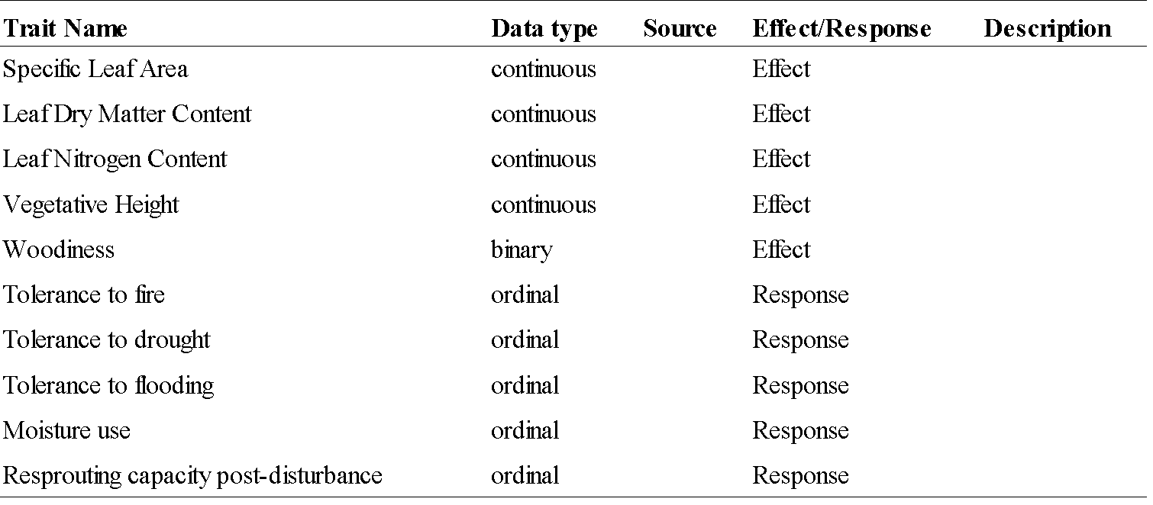

A.



B.

Figure 1. Conceptual diagram showing A) general hypothesized direct and indirect linkages between disturbance, plant community structure, and carbon storage, and B) hypothesized relationships between all variables. Variables include drying trend presence (Drying) time since fire (Fire), plant community size (Area), functional divergence (Func Div), functional composition (Func Comp), idiosyncratic species effects (Id Spp), aboveground biomass (AGB) and organic layer thickness (OLT).

Table 2. Bivariate relationships between aboveground biomass (AGB), Peat thickness, Fire history,

Lake shrinkage history, community area, Functional divergence (Rao), functional trait composition

(CWM), and the presence of idiosyncratic species (Id. Spp). CWM and Id. Spp. values are the first

principal component scores from principal components analysis of community-weighted mean

functional trait values and presence/absence matrices for idiosyncratic species, as described in the

Methods section. All analysis are derived from general linear models with Gaussian errors.

Table 3. Model performance (% variance explained) for random forest models of aboveground biomass and organic layer thickness in three lake-margin plant communities of the Yukon Flats national Wildlife Refuge. Results are shown for models using plant species presence absence and community weighted mean scores for 12 functional trait variables.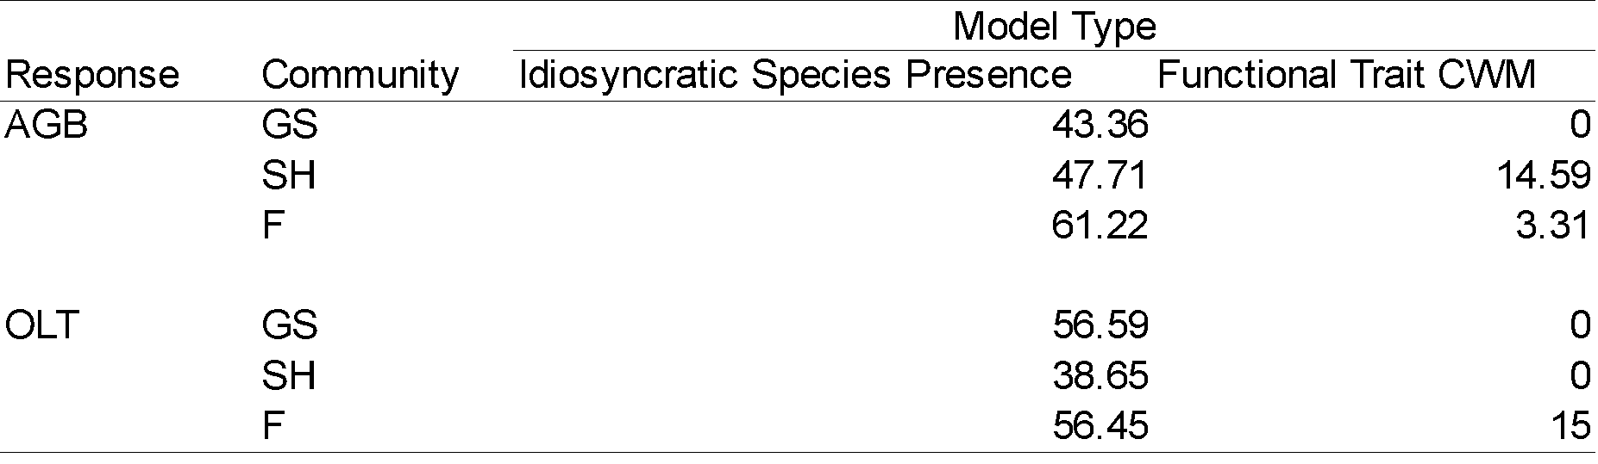

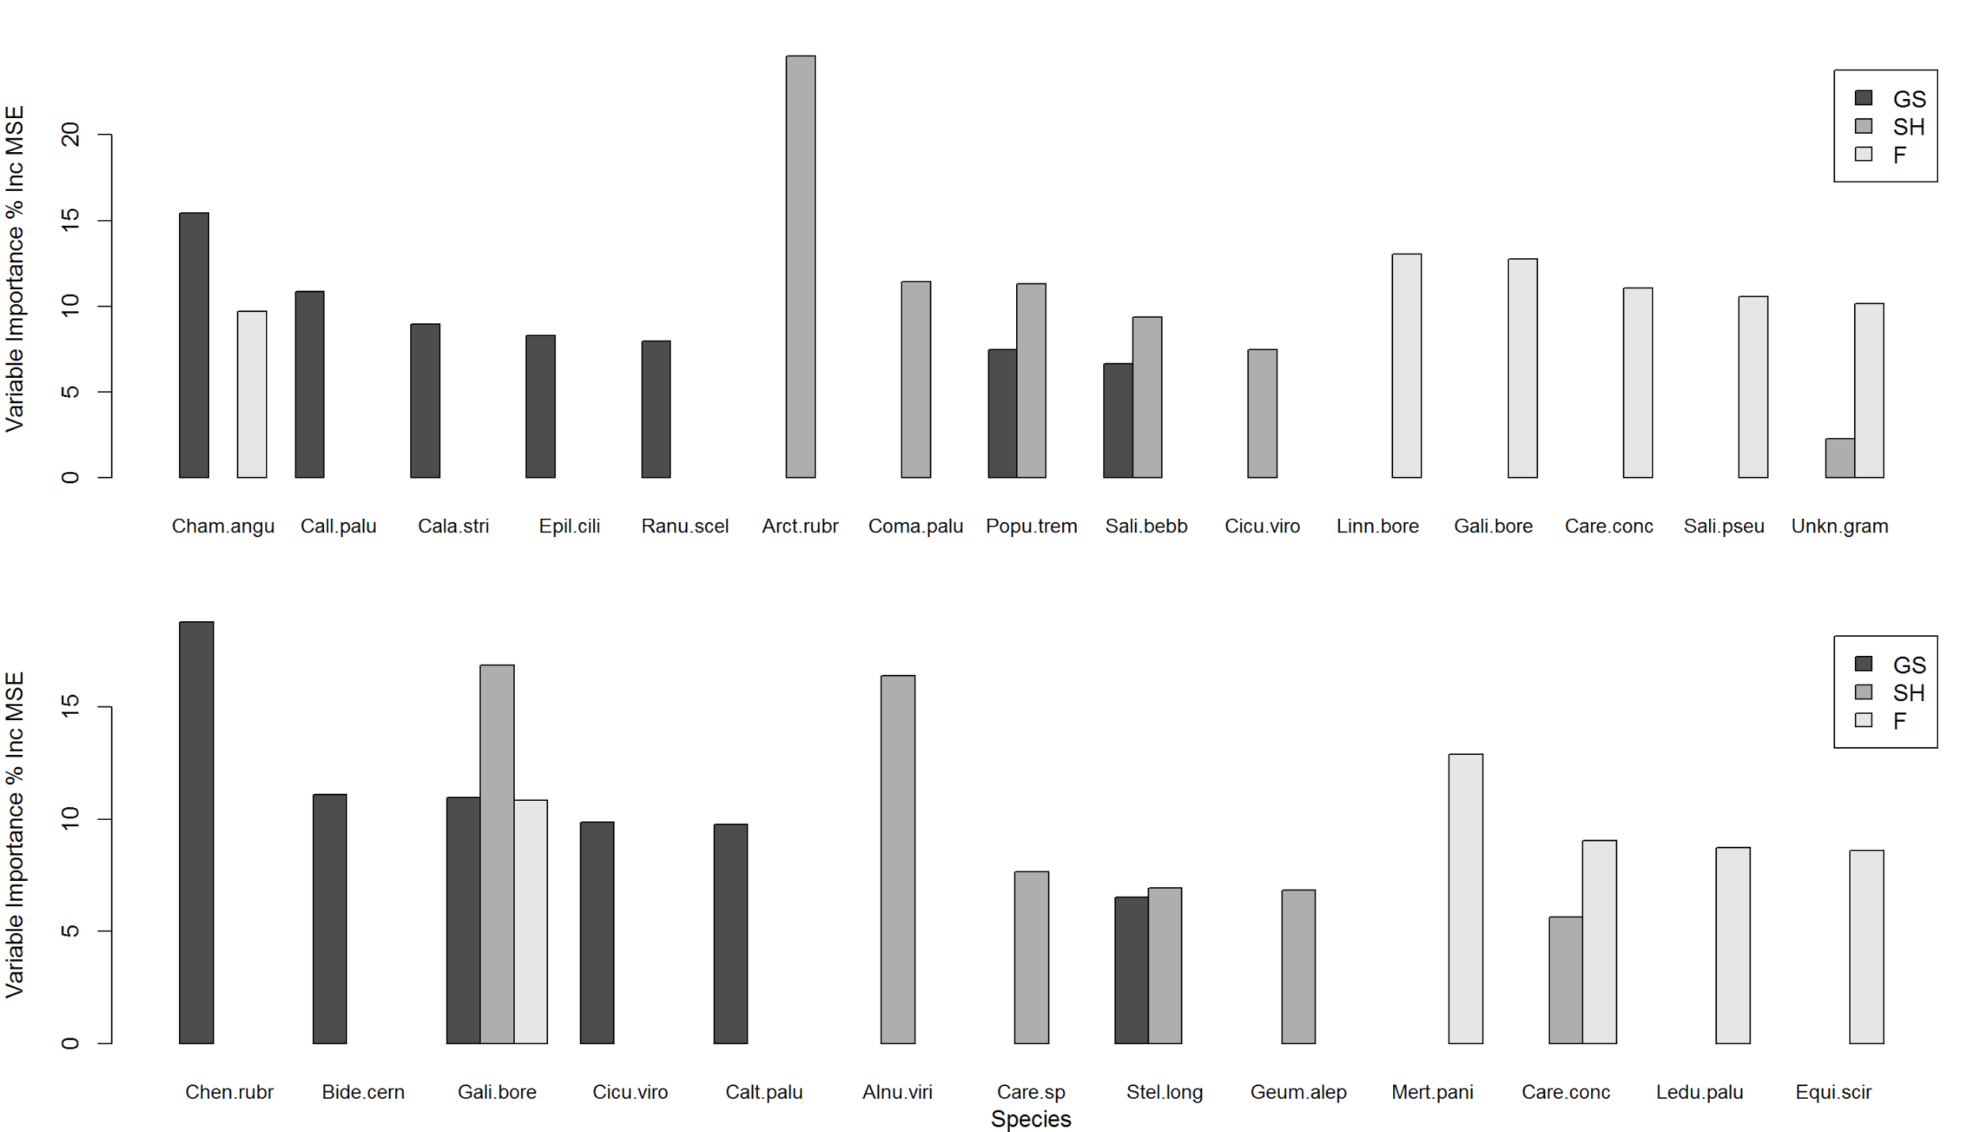

Figure 2. Variable importance plots from random forest models predicting above-ground biomass (top panel) and soil peat thickness bottom panel based on the presence/absence of vascular plant species. Species which were ranked in the top five for at least one

plant community are shown. Variable importance values indicate the average percent increase in model mean-squared error that

occurs when a particular predictor is omitted from the analysis. Variable importance values are shown for models using data from

three plant communities: Grass/Sedge (GS), deciduous shrub (SH) and upland forest (F). Model results were used to generate

presence/matrices of species in the top five for each community (referred to as idiosyncratic species). Principal components analysis

on these matrices were used to generate idiosyncratic species effect scores (first principal component scores).

F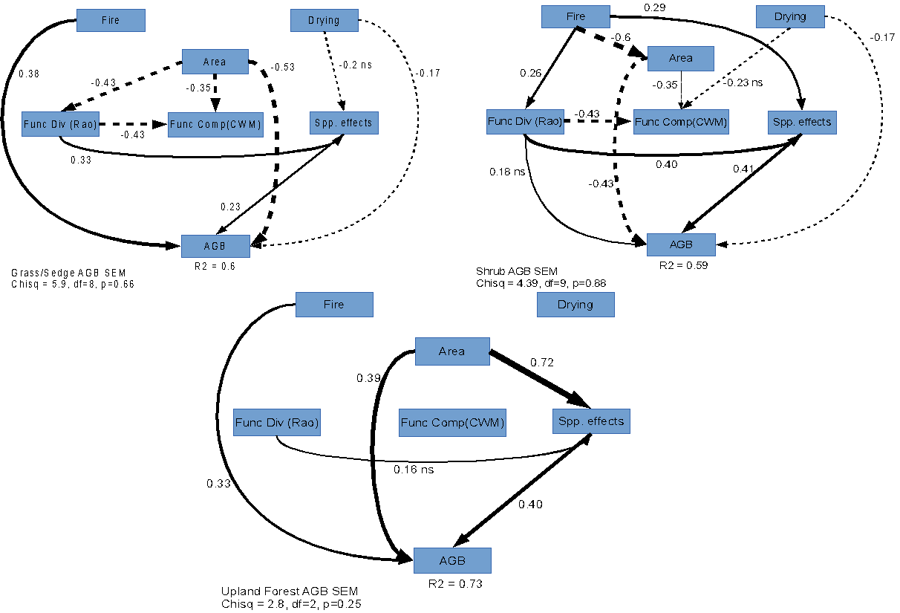igure 3. Figure 3. Path diagrams for structural equation models of above-ground biomass (AGB) and organic layer thickness (OLT) in three plant communities: Grass/Sedge, Deciduous Shrub, and Upland Forest. Model variables are shown in boxes. Arrows indicate a linear causal pathway between two variables (Fire -> OLT implies that time since fire is a linear predictor of organic layer thickness). Standardized path coefficients are shown for each pathway. Standardized coeficicients give the expected change in the response variable (in standard deviations) if the predictor is increased by one standard deviation. Overall model t was assessed with a Chi-Squared test. Non-significant test results indicate that the model adequately ts the variance-covariance structure of the data.



Figure 4. Path diagrams for structural equation models of soil peat thickness in three plant communities: Grass/Sedge, Deciduous Shrub, and Upland Forest. Model variables are shown in boxes. Arrows indicate a linear causal pathway between two variables (Fire -> OLT implies that time since fire is a linear predictor of organic layer thickness). Standardized path coefficients are shown for each pathway. Standardized coefficients give the expected change in the response variable (in standard deviations) if the predictor is increased by one standard deviation. Overall model t was assessed with a Chi-Squared test. Non-significant test results indicate that the model adequately ts the variance-covariance structure of the data.

Table 4. Summary of direct and indirect path coefficients for structural equation models of aboveground biomass (AGB) and Peat thickness (See Figure 3, Figure 4). Results are separated by plant community type: Grass/Sedge (GS), Deciduous Shrub (SH), and Upland forest (F). Values are standardized coefficients, which reflect the expected change in the response variable (in standard deviations) if the predictor is increased by one standard deviation. Direct influence values are the coefficients for direct paths between the predictor and response. Indirect influence values are the product of all path coefficients for a multi-segment path linking two variables. Finally, the total influence of a predictor is the sum of all direct and indirect coefficients. Mediating variables are the intermediate variables in a multi-segment pathway linking two variables. Predictor variables are time since fire (Fire), lake drying status, community area, functional divergence (Rao), and idiosyncratic species scores (Id. Spp.). Id. Spp. values are the first principal component scores from principal components analysis of community-weighted mean functional trait values and presence/absence

matrices for idiosyncratic species, as described in the Methods section.

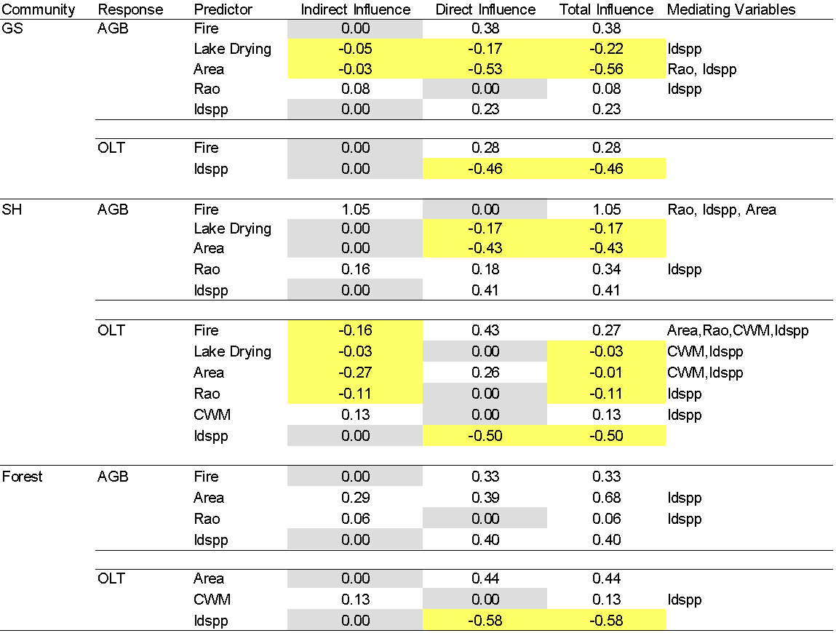

Table 5. Comparison of mean vascular plant species richness between shrinking and non-shrinking (stable) lakes across three lake-margin terrestrial plant communities in the Yukon Flats National Wildlife Refuge. Values are means with standard errors in parentheses. Differences in means between lake types were tested with t-statistics for each plant community.

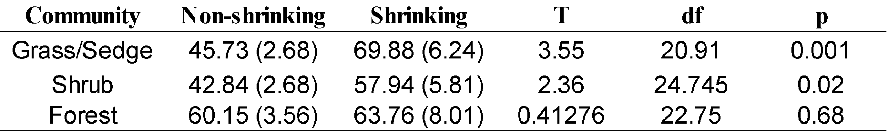

Figure 5. Community-weighted mean functional trait value PCA results. Results of a principal component analysis of community-weighted mean functional trait values for lakes in the Yukon Flats National Wildlife Refuge. Arrows indicate the strength of correlation between functional trait variables and the first two PCA axes. Closely-grouped arrows indicate sets of functional traits that co-vary across lakes.