PRD Genie Architecture Write-up
  - A governed multi-agent path from authoritative evidence to planning-ready delivery

Problem summary
NeuronForge PMs and TPMs manually reconcile product briefs, meeting transcripts, stakeholder notes, and clarifications before creating PRDs and delivery backlogs. This process is slow, inconsistent, and difficult to audit because evidence, decisions, and downstream artifacts can drift apart. PRD Genie creates a governed path from authoritative evidence to planning-ready documentation while retaining human approval, visible uncertainty, and source-to-delivery traceability.

Architecture diagram
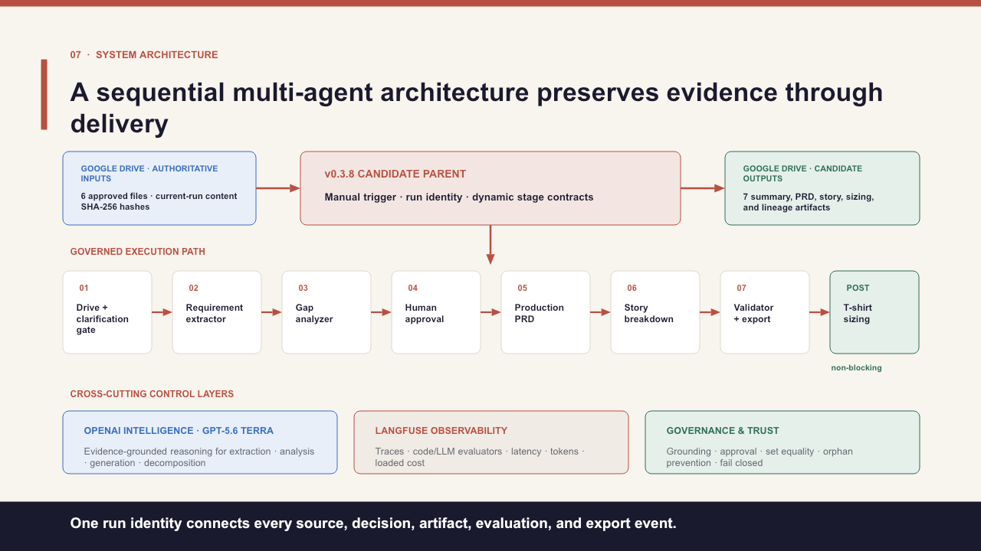
Figure 1. Approved v0.3.8 system architecture: six Google Drive inputs, a manual n8n parent, seven governed stages, non-blocking sizing, OpenAI intelligence, Langfuse observability, and fail-closed governance.

Tool selection rationale
Category | Selection and rationale
Workflow | n8n Cloud — visual parent/child orchestration, Drive integration, deterministic code nodes, and exportable JSON.
Intelligence | OpenAI GPT-5.6 Terra — constrained extraction, analysis, document generation, decomposition, and advisory sizing.
APIs / storage | Google Drive — controlled source intake and run-specific delivery with file identity, hashes, and receipts.
Observability | Langfuse — correlated traces, evaluator results, latency, token usage, and fully loaded cost.
Evidence | GitHub, Obsidian, and vjra.us — reproducibility, working documentation, and evaluator-facing access.

Orchestration pattern and justification
Sequential parent/child pipeline with conditional fail-closed branches. Each stage depends on a validated upstream contract: intake → extraction → gap analysis → human approval → PRD → stories → reconciliation/export. Clarification, rejection, validation failure, and revision stop or redirect the run. Specialized children remain independently testable while one parent run identity connects every source, decision, artifact, evaluation, and delivery event.

Agent and control responsibilities
Stage | Input → output | Responsibility and key rules
Drive + clarification | Files → hashed evidence | Verify the current-run source set; preserve provenance; stop for missing inputs.
Requirement Extractor | Evidence → requirements | Extract only supported facts and exact values; never invent missing content.
Gap Analyzer | Requirements → gaps / route | Expose ambiguity and conflicts; route insufficient evidence to clarification.
Human Approval | Evidence + gaps → dispositions | Authorize scope and decisions; no approval means no production generation.
Production PRD | Approved evidence → PRD | Generate only approved content; preserve IDs; mark controlled unknowns.
Story Breakdown | PRD → Epics / Features / Stories | Preserve lineage and hierarchy; reject duplicates, orphans, and unsupported detail.
Validator + Export | Artifacts → authorized delivery | Reconcile sets and mappings; Agreement Gate fails closed before export.
T-shirt Sizing | Stories → advisory sizing | Return size, confidence, and guidance; remain non-blocking and non-committal.

Cost analysis
Formal baseline execution 11901: 545,467 tokens and $1.474409 fully loaded (59,922 generation tokens / $0.228024; 485,545 tokens across 41 evaluator calls / $1.246385). At one fully evaluated run per user per week: approximately $0.21 per user per day and $6.38 per user per month. Cost controls are code-first validation, no duplicate semantic scoring, stage-specific judges, and lighter routine monitoring after approval.

Evaluation strategy and production metrics
• Accuracy and completeness: 100% governed ID reconciliation from source through export, with zero orphaned records.
• Trustworthiness: zero unsupported claims and hallucination ≤ 0.15 at every governed semantic stage.
• Usefulness and efficiency: planning artifacts accepted without rework, reviewer time saved, latency, adoption, and fully loaded cost per run.
Method: T1–T12 ground truth; schemas, exact-value and set controls; Langfuse code, faithfulness, hallucination, and sizing-reasonableness evaluators; and a fail-closed Agreement Gate.

Testing observations and fixes
• Typed contracts and explicit insufficient-information behavior prevented vague, contradictory, incomplete, and empty inputs from becoming polished unsupported outputs.
• Early semantic failures prompted tighter prompts, strict current-trace correlation, and a hold-for-human-review path for incomplete or failing scores.
• Stable IDs, set equality, bidirectional lineage, and final reconciliation closed duplicate, dropped-mapping, and orphan risks.
• Removing duplicate semantic scoring reduced evaluator overhead without weakening coverage.
ACCEPTED RESULT Execution 11901 completed in 2m 33.201s, authorized release, reconciled 145/145 citation dispositions with zero orphaned governed records, delivered seven validated artifacts, and sized 11/11 stories. Execution 11958 remains supplementary demonstration evidence.

