Jsonl File generated
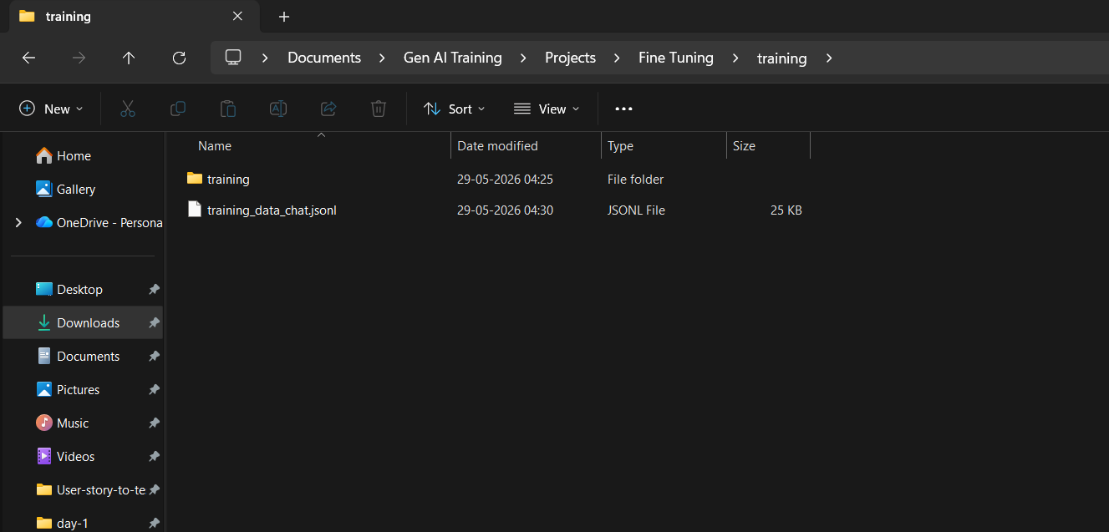
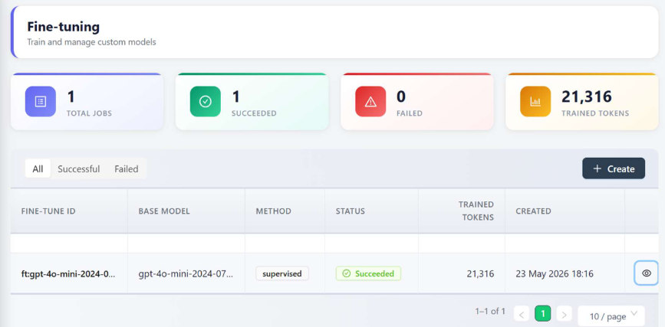
Updated AI Extension with the new FT model name
using new Model named test leaf 1.0 in leaftaps page
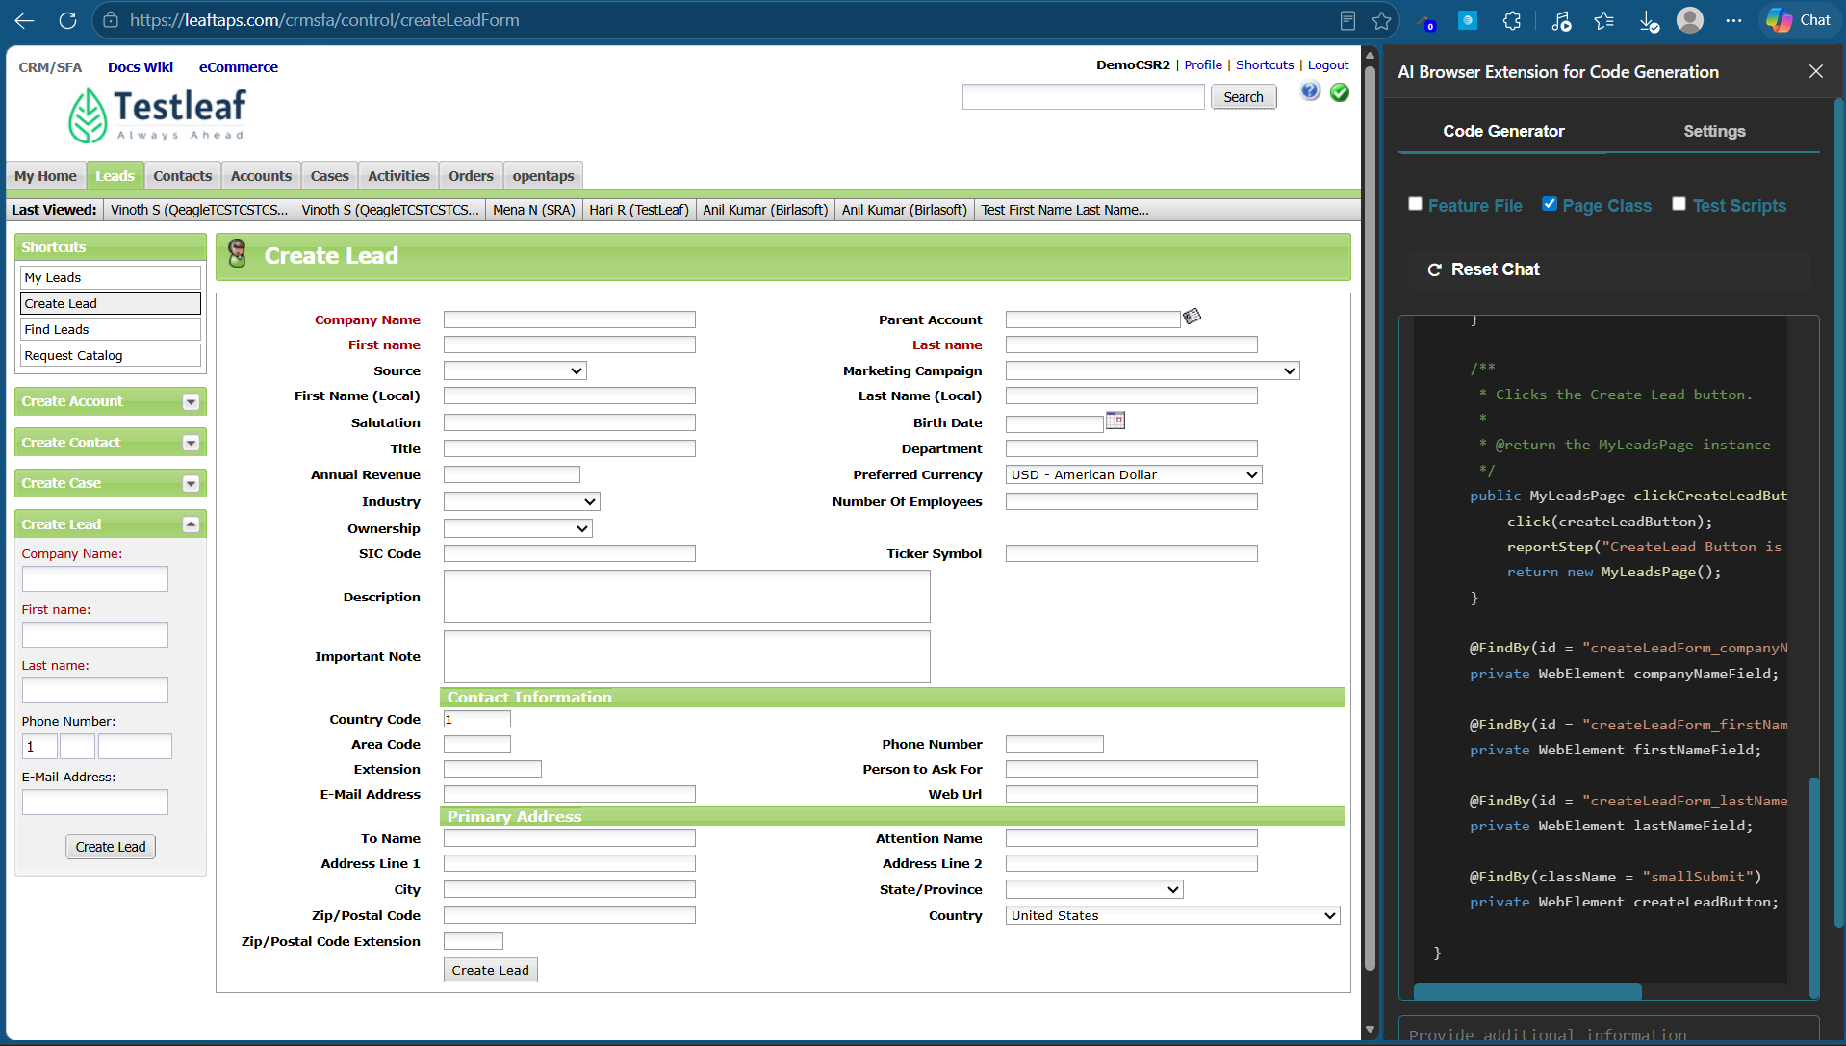
Generated code as per framework/dataset
Code GeneratorSettings
Feature File Page Class Test Scripts
Reset Chat

package com.testleaf.pages;

import org.openqa.selenium.WebElement;
import org.openqa.selenium.support.FindBy;
import org.openqa.selenium.support.PageFactory;
import com.testleaf.selenium.api.base.ProjectSpecificMethods;

/**
* Page Object for Create Lead Page
*/
public class CreateLeadPage extends ProjectSpecificMethods {

/**
* Initializes the CreateLeadPage with the current driver.
*/
public CreateLeadPage() {
PageFactory.initElements(driver, this);
}

/**
* Enters the company name.
*
* @param compName the company name to enter
* @return the current CreateLeadPage instance
*/
public CreateLeadPage enterCompanyName(String compName) {
clearAndType(companyNameField, compName);
reportStep(compName + " company name is entered", "pass");
return this;
}

/**
* Enters the first name.
*
* @param firstName the first name to enter
* @return the current CreateLeadPage instance
*/
public CreateLeadPage enterFirstName(String firstName) {
clearAndType(firstNameField, firstName);
reportStep(firstName + " first name is entered", "pass");
return this;
}

/**
* Enters the last name.
*
* @param lastName the last name to enter
* @return the current CreateLeadPage instance
*/
public CreateLeadPage enterLastName(String lastName) {
clearAndType(lastNameField, lastName);
reportStep(lastName + " last name is entered", "pass");
return this;
}

/**
* Clicks the Create Lead button.
*
* @return the MyLeadsPage instance
*/
public MyLeadsPage clickCreateLeadButton() {
click(createLeadButton);
reportStep("CreateLead Button is clicked", "pass");
return new MyLeadsPage();
}

@FindBy(id = "createLeadForm_companyName")
private WebElement companyNameField;

@FindBy(id = "createLeadForm_firstName")
private WebElement firstNameField;

@FindBy(id = "createLeadForm_lastName")
private WebElement lastNameField;

@FindBy(className = "smallSubmit")
private WebElement createLeadButton;

}
Copy
InspectGenerate
Using the ai extension in salesforce login page
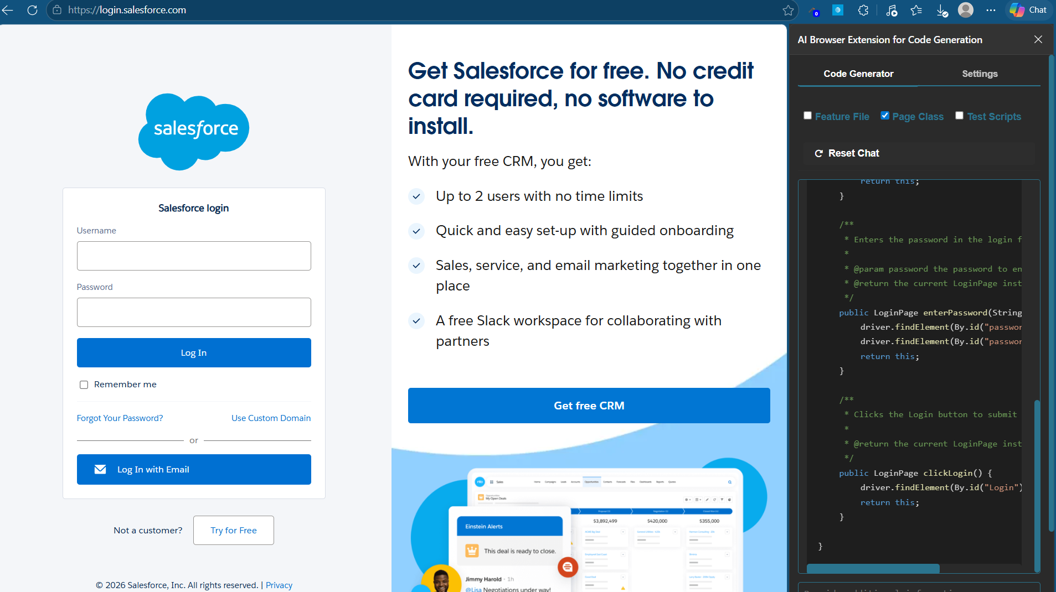
generated code is as per data set
Code GeneratorSettings
Feature File Page Class Test Scripts
Reset Chat
Please select some DOM on the page first.

package com.testleaf.pages;

import org.openqa.selenium.By;
import org.openqa.selenium.remote.RemoteWebDriver;

/**
* Page Object representing the Salesforce Login Page.
* Provides methods to interact with the login form elements.
*/
public class LoginPage extends AbstractPage {

/**
* Initializes a new instance of the LoginPage class.
*
* @param driver The WebDriver instance to use for interactions.
*/
public LoginPage(RemoteWebDriver driver) {
super(driver);
}

/**
* Enters the username in the login form.
*
* @param username The username to enter.
* @return The current LoginPage instance.
*/
public LoginPage enterUsername(String username) {
clearAndType(locateElement("username"), username);
reportStep(username + " username is entered", "pass");
return this;
}

/**
* Enters the password in the login form.
*
* @param password The password to enter.
* @return The current LoginPage instance.
*/
public LoginPage enterPassword(String password) {
clearAndType(locateElement("password"), password);
reportStep("Password is entered", "pass");
return this;
}

/**
* Clicks the Login button to submit the login form.
*
* @return A new HomePage instance after login.
*/
public HomePage clickLogin() {
click(locateElement("Login"));
reportStep("Login button is clicked", "pass");
return new HomePage(driver);
}

/**
* Clicks the Remember Me checkbox in the login form.
*
* @return The current LoginPage instance.
*/
public LoginPage clickRememberMe() {
click(locateElement("rememberUn"));
reportStep("Remember Me checkbox is clicked", "pass");
return this;
}

/**
* Checks if the Remember Me checkbox is selected.
*
* @return true if the checkbox is selected, false otherwise.
*/
public boolean isRememberMeSelected() {
return isSelected(locateElement("rememberUn"));
}

/**
* Checks if the login error message is displayed.
*
* @return true if the error message is displayed, false otherwise.
*/
public boolean isErrorMessageDisplayed() {
return isDisplayed(locateElement("error"));
}

/**
* Gets the error message displayed on the login page.
*
* @return The error message text.
*/
public String getErrorMessage() {
return getText(locateElement("error"));
}

/**
* Gets the username field value from the login form.
*
* @return The username field value.
*/
public String getUsernameValue() {
return getAttributeValue(locateElement("username"), "value");
}

/**
* Gets the password field value from the login form.
*
* @return The password field value.
*/
public String getPasswordValue() {
return getAttributeValue(locateElement("password"), "value");
}

/**
* Gets the Login button text.
*
* @return The Login button text.
*/
public String getLoginButtonText() {
return getText(locateElement("Login"));
}

/**
* Gets the Remember Me checkbox label text.
*
* @return The Remember Me label text.
*/
public String getRememberMeLabelText() {
return getText(locateElement("rememberUn"));
}

/**
* Gets the Remember Me checkbox status.
*
* @return The Remember Me checkbox status.
*/
public String getRememberMeCheckboxStatus() {
return isSelected(locateElement("rememberUn")) ? "selected" : "not selected";
}

/**
* Gets the username field label text.
*
* @return The username field label text.
*/
public String getUsernameLabelText() {
return getText(locateElement("usernamelabel"));
}

/**
* Gets the password field label text.
*
* @return The password field label text.
*/
public String getPasswordLabelText() {
return getText(locateElement("password"));
}
}
Copy
InspectGenerate

