AMRITA SCHOOL OF ENGINEERING, BENGALURU
DEPARTMENT OF ELECTRONICS & COMMUNICATION ENGINEERING
B.TECH. V SEMESTER (ECE AND EAC) AY 2026-2027
ASSIGNMENT FOR 23ECE302 VLSI DESIGN
SYSTEM DESIGN FOR 23ECE383 VLSI DESIGN LABORATORY
REPORT
JULY TO NOVEMBER 2026

DESIGN AND SIMULATION OF A LOW-POWER CMOS OPERATIONAL AMPLIFIER WITH A CASCADE SECOND STAGE (FIG. 2) IN 45 nm gpdk045 TECHNOLOGY

Submitted by
REGISTER NUMBER | NAME | SIGNATURE WITH DATE
[TO FILL: register number] | [TO FILL: name] | [TO FILL]
[TO FILL: register number] | [TO FILL: name] | [TO FILL]
[TO FILL: register number] | [TO FILL: name] | [TO FILL]
[TO FILL: register number] | [TO FILL: name] | [TO FILL]

BATCH NUMBER: [TO FILL]

FACULTY EXAMINER SIGNATURE WITH EVALUATION DATE: ____________________

TITLE OF THE SYSTEM DESIGN PROJECT:
Design and Simulation of a Low-Power CMOS Operational Amplifier with a Cascade Second Stage (Fig. 2 of the reference paper) in 45 nm gpdk045 Technology: Schematic, Sizing, PVT Analysis and Layout.

TITLE OF THE PAPER:
Low-Power CMOS Operational Amplifier Design in 45nm Technology

DETAILS OF THE PAPER (SOURCE OF THE TITLE):
- Authors: Debjyoti Chowbey and Ratul K. Baruah, Department of Electronics and Communication Engineering, Tezpur University, Tezpur, India.
- Published in: 2025 Devices for Integrated Circuit (DevIC), 5-6 April 2025, Kalyani, India, pp. 528-533. IEEE, ISBN 979-8-3503-9110-7.
- DOI: 10.1109/DevIC63749.2025.11012572 (IEEE Xplore).
- Circuit assigned to this project: Fig. 2 of the paper, "Cascade Second Stage Topology for improved gain in weak inversion region" (assigned by Dr. Kaveri Hatti). Only this circuit (16 transistors, a bias current source and a load capacitor) is implemented here. The 29-transistor full design of the paper (Fig. 3) is outside the scope of this project.
- Paper specification targets (Table I of the paper): VDD = 2.0 V, power consumption < 20 µW, open-loop gain >= 60 dB, GBW >= 2.0 MHz, slew rate >= 2.5 V/µs, phase margin >= 50°, rail-to-rail input common-mode range and output swing.
- Headline results claimed by the paper (for the full Fig. 3 design, not for Fig. 2 alone): gain 66.85 dB, GBW 2.31 MHz, power 12.5 µW, slew rate 2.5 V/µs. These are quoted for reference only and are not the results of this project.

CIRCUIT DIAGRAM:
The circuit implemented is Fig. 2 of the paper: a differential input stage whose outputs are copied by current mirrors into a cascoded (cascade) second stage that drives the output node.
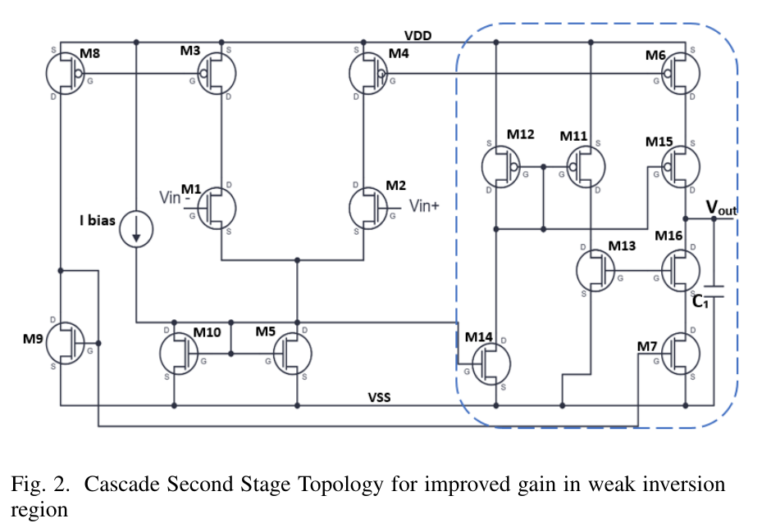
Figure 1: Fig. 2 of the reference paper [1] (cascade second-stage topology), reproduced for reference.
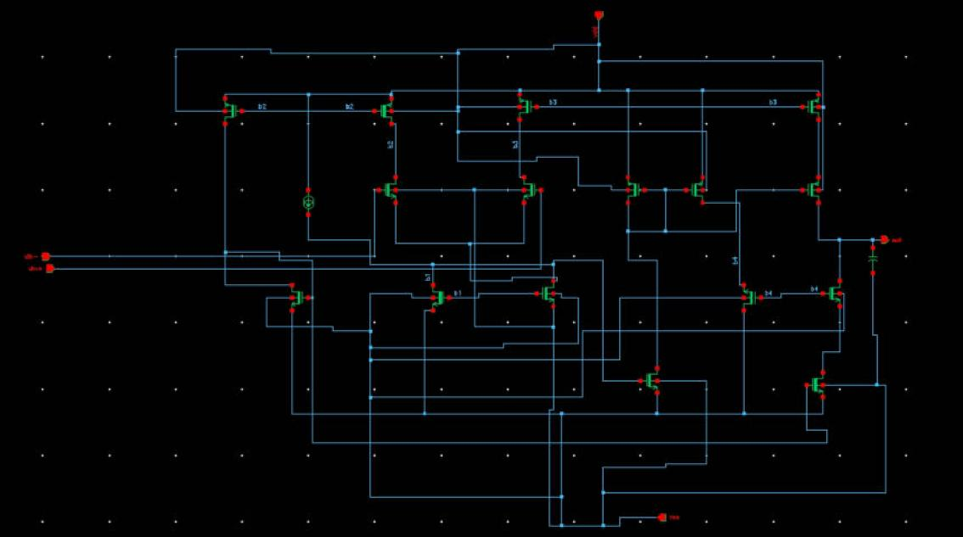
Figure 2: Virtuoso schematic of Sld_80/Low_AmpSd_base (the unsized circuit): 16 transistors M0-M15, the bias source I0 (2 uA), the load capacitor C0 (1 pF) and the pins out, vdd, vss, vin+ and vin-.
Table 1 lists the connectivity of the circuit as built in Virtuoso (taken from the Spectre netlist of the schematic; D = drain, G = gate, S = source, B = body). The Virtuoso device names differ from the paper's names; the mapping below was inferred from the topology.
Virtuoso | Paper | Type / role | D, G, S, B nets | W / L baseline | W / L sized
M9 | M1 | NMOS input pair, vin- [g45n2svt] | b2, vin-, b1, vss | 320n / 150n | 1.6u / 150n
M10 | M2 | NMOS input pair, vin+ [g45n2svt] | b3, vin+, b1, vss | 320n / 150n | 1.6u / 150n
M8 | M3 | PMOS diode load (b2) [g45p2svt] | b2, b2, vdd, vdd | 320n / 150n | 320n / 150n
M11 | M4 | PMOS diode load (b3) [g45p2svt] | b3, b3, vdd, vdd | 320n / 150n | 320n / 150n
M7 | M8 | PMOS mirror of M8 into M2 [g45p2svt] | net14, b2, vdd, vdd | 320n / 150n | 320n / 150n
M12 | M6 | PMOS pull-up mirror [g45p2svt] | net48, b3, vdd, vdd | 320n / 150n | 640n / 300n
M15 | M15 | PMOS cascode pull-up [g45p2svt] | out, net28, net48, vdd | 320n / 150n | 640n / 300n
M13 | M12 | PMOS diode (cascode bias) [g45p2svt] | net28, net28, vdd, vdd | 320n / 150n | 320n / 150n
M14 | M11 | PMOS mirror of M13 (b4) [g45p2svt] | b4, net28, vdd, vdd | 320n / 150n | 320n / 150n
M3 | M14 | NMOS sink for M13 [g45n2svt] | net28, b1, vss, vss | 320n / 150n | 320n / 150n
M2 | M9 | NMOS diode (net14) [g45n2svt] | net14, net14, vss, vss | 320n / 150n | 320n / 150n
M6 | M7 | NMOS pull-down [g45n2svt] | net39, net14, vss, vss | 320n / 150n | 640n / 300n
M5 | M16 | NMOS cascode pull-down [g45n2svt] | out, b4, net39, vss | 320n / 150n | 640n / 300n
M4 | M13 | NMOS diode (b4) [g45n2svt] | vss, b4, b4, vss | 320n / 150n | 320n / 150n
M0 | M10 | NMOS bias diode (b1) [g45n2svt] | b1, b1, vss, vss | 320n / 150n | 320n / 150n
M1 | M5 | NMOS tail / bias (shorted to b1) [g45n2svt] | b1, b1, vss, vss | 320n / 150n | 320n / 150n

Table 1: device connectivity and sizes (from the Spectre netlists of the baseline and sized schematics; I0 = isource 2 µA from vdd to b1, C0 = 1 pF from out to vss).
Net names: b1 is the bias/tail node, b2 and b3 are the diode-connected PMOS load nodes, b4 is the bias node for the lower cascode, net14 is the diode node of the NMOS mirror M2, net28 is the bias node of the upper cascode, net48 and net39 are the intermediate nodes of the upper and lower cascode branches. Ibias = 2 µA flows from vdd into b1 (I0) and the load capacitor C0 = 1 pF sits between out and vss.

THEORY AND WORKING PRINCIPLE:
Why low power and why moderate/weak inversion. The power dissipation of a circuit is P = VDD x Itotal (eq. (1) of the paper), so low power requires a small supply, a small total current, or both. In the 45 nm node the supply headroom is small, so the paper biases the transistors in weak or moderate inversion, where the drain current is exponentially related to the gate-source voltage (eq. (2) of the paper) and the transconductance per unit current is highest. The price is lower speed and a larger device area [1].
Working of the circuit as built. The numbering below uses the Virtuoso names, with the paper's names in brackets.
1. Bias. A 2 µA current source (I0) feeds the node b1. The diode-connected NMOS devices M0 (M10) and M1 (M5) are tied to b1 and set the bias voltage; M3 (M14) has its gate on b1 and mirrors the bias current into the cascode bias branch. As drawn in the paper, the tail node of the input pair and the bias node b1 are the same node, so the tail current follows the bias branch.
2. Differential input stage. The NMOS pair M9 (M1, vin-) and M10 (M2, vin+) shares the source node b1. Their drains feed the diode-connected PMOS loads M8 (M3, node b2) and M11 (M4, node b3). A differential input voltage steers the tail current between the two branches, so the branch currents become unequal.
3. Mirrors to the output stage. M7 (M8) mirrors the left-branch current (gate b2) into the diode-connected NMOS M2 (M9, node net14); M6 (M7) mirrors net14 and becomes the pull-down current. On the other side, M12 (M6) mirrors the right-branch current (gate b3) and becomes the pull-up current. The output current is therefore proportional to the difference of the two branch currents, which is the "push-pull" action the paper describes for Fig. 1.
4. Cascode (cascade) second stage. The pull-up mirror M12 is stacked with the cascode device M15 (gate on net28), and the pull-down mirror M6 is stacked with the cascode device M5 (M16, gate on b4). Cascoding raises the output resistance seen at out because the cascode device shields the mirror transistor from the output voltage swing. The bias voltages for the cascodes come from two diode-connected devices: the PMOS M13 (M12) on node net28, whose current is sunk by M3 and which sets the gate of the upper cascode M15; and the NMOS M4 (M13) on node b4, which receives a copy of that current through the mirror M14 (M11) and sets the gate of the lower cascode M5. The paper states that this raises the gain by raising the output resistance without extra power [1].
5. Load. The load capacitor C0 = 1 pF at the output sets the dominant pole of the amplifier.
Gain expression. For the Fig. 1 push-pull stage the paper gives (eq. (3)) A_v = gm1 (S6/S4) / (gds6 + gds7), where gm1 is the transconductance of the input pair, S6/S4 is the mirror size ratio and gds are the output conductances at the output node. For the cascode version, eq. (4) of the paper expresses the gain in terms of the bias currents, the mirror ratio b = (M6 to M4 size ratio), the thermal voltage Vt, the channel-length-modulation factors lambda_n and lambda_p and the subthreshold slope factors n_n and n_p. It reads A_v = (I_M5 / 2 I_M7) x (b / (n_n V_t^2)) x 1 / (lambda_p^2 n_p + lambda_n^2 n_n). In words: the gain is (input-pair gm x current ratio) x (output resistance), and the cascode increases the output resistance roughly from r_o to gm x r_o x r_o on each side (standard result, see [4]). In weak inversion gm = I_D / (n Vt), so the input-pair gm is limited by the bias current, and more gain has to come from the output resistance.
Dynamic (adaptive) tail biasing. The paper's full design (Fig. 3, not implemented here) adds extra mirrors that boost the tail current when a differential input is present (eqs. (5)-(9) of the paper). This is out of scope for this project.
Why sizing changes the results (reasoning used for the sizing step). The sizing applied in this project had two ideas: (i) widen the input pair M9/M10 from 320 nm to 1.6 µm at the same length of 150 nm, which increases the W/L of the pair five times so the pair operates at a higher gm/I_D (more weakly inverted) and gives more transconductance, and therefore more gain and a higher GBW (GBW is about gm / (2 pi CL) for a single dominant pole at the output); (ii) lengthen the output and cascode devices M5, M6, M12 and M15 from 150 nm to 300 nm, with the width doubled to 640 nm so that W/L stays the same (about 2.13), which reduces channel-length modulation (larger r_o) and therefore increases the output resistance and gain. The results in Table 2 agree with the direction of these arguments (gain and GBW went up, delay went down), but the measured power also went up. A likely cause, not verified by a separate simulation, is that the tail node of the input pair is the bias node b1 (as drawn in the paper), so the pair current is not fixed by a tail current source: a wider pair conducts more current at the same gate voltage and the total supply current rises.

TOOL & TECHNOLOGY USED:
- Operating system and computer: Red Hat Linux lab workstation, accessed remotely.
- Cadence Virtuoso 6.1.8 (64-bit): Schematic Editor for entry, Analog Design Environment ADE L for DC, AC and transient analyses and the calculator for measurements, Spectre as the circuit simulator (relative tolerance 1e-3, temperature 27 C unless stated otherwise).
- Layout: Virtuoso Layout Suite XL, with connectivity-driven layout from the schematic and the Virtuoso Space-based Router for routing.
- Verification: Assura DRC was run on the layout. Assura LVS and Quantus parasitic extraction are part of the tool set but were not run in this project because of the submission time.
- Technology: gpdk045, the Cadence 45 nm generic PDK. Devices: nmos2v (model g45n2svt) and pmos2v (model g45p2svt), the thick-oxide 2 V devices. Baseline size W = 320 nm, L = 150 nm, m = 1 for every transistor. Supply VDD = 2.0 V. Model sections available: tt, ff, ss, fs, sf, mc. All DC, AC and transient results (without sizing, with sizing and post-layout) use section mc; tt, ss and ff are used only for the PVT analysis.
- Library and cells: library Sld_80 with cells Low_AmpSd (op-amp, schematic and symbol), Low_AmpSd_base (unsized backup), low_amp1 (DC and AC test bench) and low_amp1_tran (unity-gain follower transient test bench).
Test benches.
- low_amp1: V0 = 2 V on vdd; vss at ground; V2 on vin+ with a DC value equal to the trip-point bias (1.028 V baseline, 1.016089 V sized) and AC magnitude 1; V3 on vin- = 1 V DC. Used for the DC sweep and the AC analysis. The 1 pF load C0 and the 2 µA bias source I0 are inside Low_AmpSd.
- low_amp1_tran: unity-gain follower (out tied to vin-); vpulse on vin+ from 0.8 V to 1.2 V, delay 1 µs, rise and fall time 10 ns, pulse width 10 µs, period 20 µs; transient stop time 40 µs, moderate accuracy. Used for delay, average power and PVT.
- Measurement method (the same for both versions): delay tp = average of tPLH and tPHL, measured between the 1.0 V crossings of the input and the output; average supply current from the calculator expression average(IT("/V0/PLUS")); power = VDD x average current; PDP = power x tp. For AC, the expressions dB20(VF("/out")) and phase(VF("/out")) were plotted with a 1 Hz to 1 GHz sweep at 20 points per decade.

SCREENSHOT OF THE SIMULATOR BASED CIRCUIT IMPLEMENTATION:
Baseline (unsized) circuit, all transistors W = 320 nm, L = 150 nm.
Figure 3: Virtuoso schematic of Sld_80/Low_AmpSd_base (the unsized circuit): 16 transistors M0-M15, the bias source I0 (2 uA), the load capacitor C0 (1 pF) and the pins out, vdd, vss, vin+ and vin-.
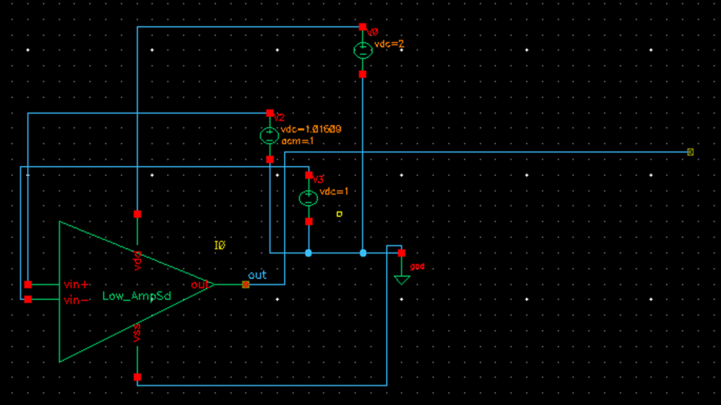
Figure 4: Test bench low_amp1 (DC and AC): supply V0 = 2 V, inputs V2 on vin+ and V3 on vin-, and the Low_AmpSd symbol. The picture shows the test bench as used for the sized circuit: V0 = 2 V, V2 = 1.016 V with AC magnitude 1 and V3 = 1 V; for the recorded baseline results V2 was set to the baseline trip-point value 1.028 V (with AC magnitude 1).
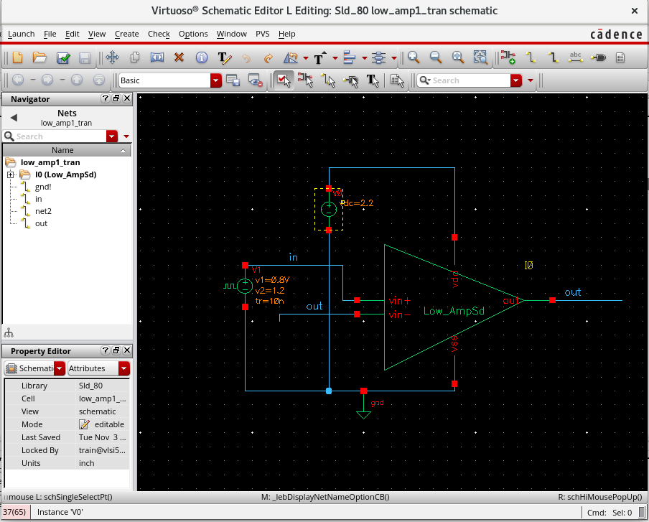
Figure 5: Test bench low_amp1_tran (transient): unity-gain follower (out tied to vin-), supply V0 and a pulse source V1 on vin+ (0.8 V to 1.2 V, delay 1 us, rise and fall 10 ns, width 10 us, period 20 us). In this picture V0 shows 2.2 V, the value left from PVT case B; the nominal runs use V0 = 2 V. The same bench is used for the baseline and the sized circuit.

SCREENSHOT OF THE OUTPUT WAVEFORM OBTAINED FROM THE SIMULATOR (DC AND TRANSIENT):
Baseline results (without sizing).
DC. The DC sweep of vin+ (vin- = 1 V) shows a sharp, smooth S-shaped transition with the trip point at vin+ of about 1.028 V (read from the plot). At V2 = 1.028 V the output is 1.13 V DC (mid-rail) and the supply current of V0 is 7.943 µA, i.e. a DC power of 2 V x 7.943 µA = 15.886 µW (meets the < 20 µW target).
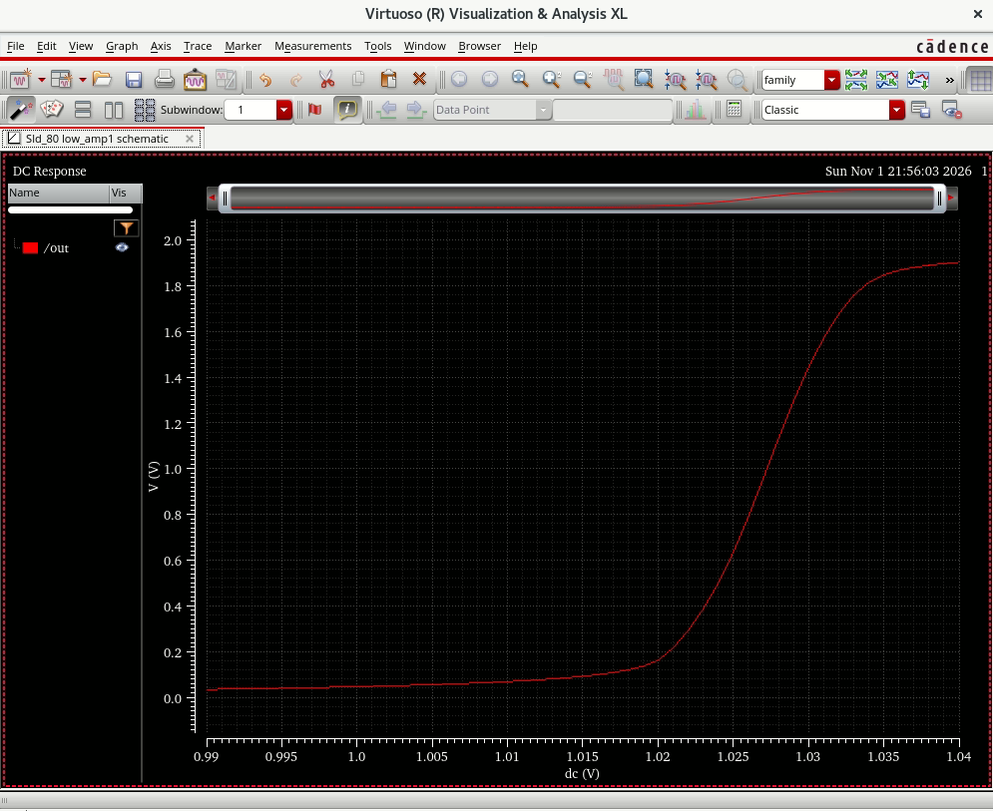
Figure 6: Baseline DC sweep of vin+ (vin- = 1 V), out versus dc: sharp transition; out crosses 1.0 V at vin+ of about 1.028 V (trip point).
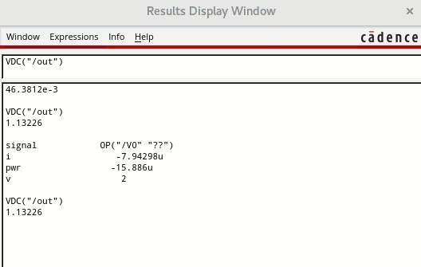
Figure 7: Baseline DC operating point at V2 = 1.028 V: out = 1.13226 V; supply source V0: i = -7.94298 uA, pwr = -15.886 uW (the first line, 46.3812 mV, is the output of an earlier run at V2 = 1 V).
AC. DC gain 44.6 dB (marker at 1.26 Hz), -3 dB point about 4 kHz, GBW (0 dB crossing) about 0.7 MHz (marker 708 kHz at -0.255 dB), phase -89.74° at 707.9 kHz, so the phase margin is about 90.3°. The gain is about 15 dB short of the 60 dB target and the GBW is about three times short of 2 MHz.
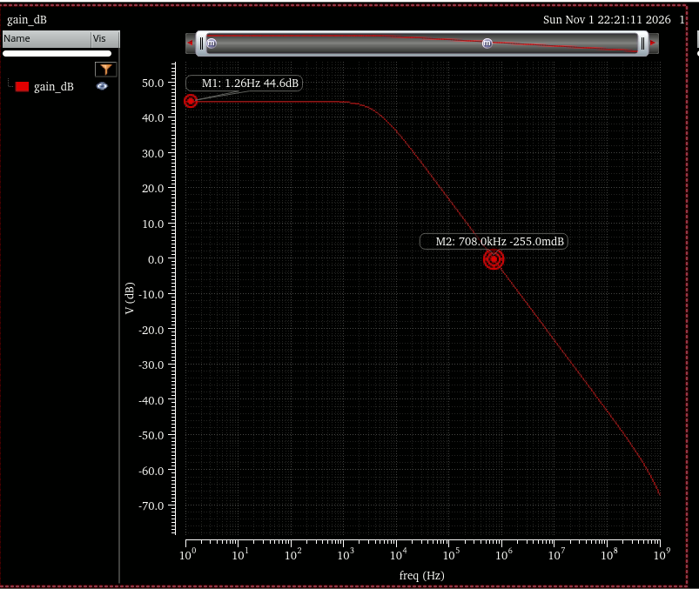
Figure 8: Baseline AC gain (gain_dB = dB20(VF("/out"))): marker M1 at 1.26 Hz reads 44.6 dB (DC gain); marker M2 at 708.0 kHz reads -255 mdB (0 dB crossing, GBW about 0.7 MHz).
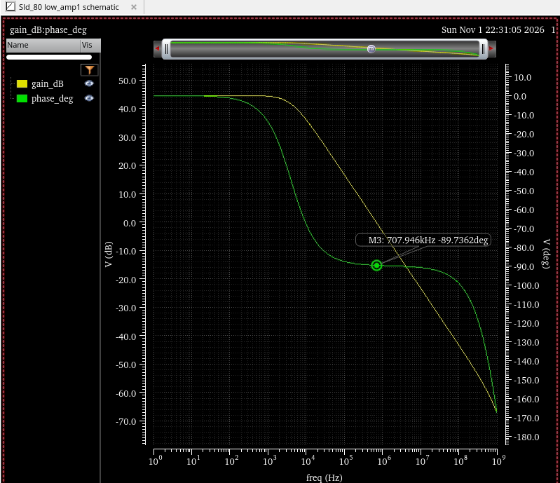
Figure 9: Baseline AC gain and phase: marker M3 on the phase curve at 707.946 kHz reads -89.7362 deg, so the phase margin is 180 - 89.74 = about 90.3 deg.
Transient. In the unity-gain follower the output settles about 28 mV below the input (systematic offset, consistent with the DC trip point at 1.028 V). The rising edge is fast and the falling edge is slow because the pull-down is weak with a bias current of only 2 µA. With the input crossing 1.0 V at 1.005 µs (rising) and 11.015 µs (falling), the output crosses 1.0 V at 1.1762 µs and 11.2699 µs, giving tPLH = 171.2 ns, tPHL = 254.9 ns and tp = 213 ns. The average supply current is -12.3356 µA (sign: current flows out of the + terminal of V0), so the transient average power is 2 V x 12.3356 µA = 24.67 µW (above the 20 µW target; the DC-bias power was 15.886 µW). PDP = 24.67 µW x 213 ns = 5.26 pJ.
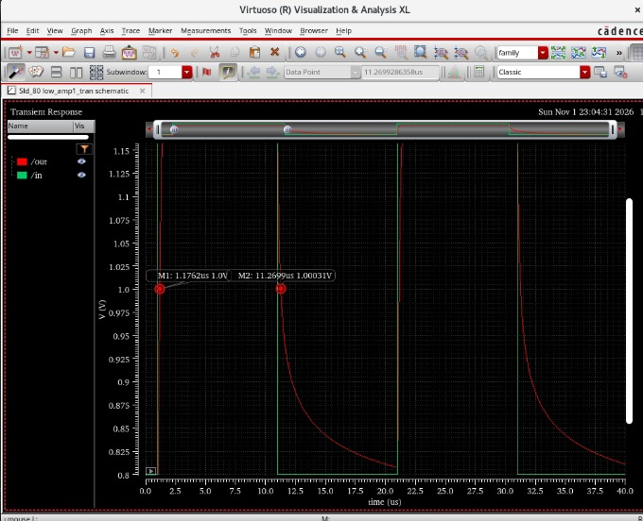
Figure 10: Baseline transient (unity-gain follower): markers on the output at 1.0 V, M1 = 1.1762 us (rising) and M2 = 11.2699 us (falling). With the input crossing 1.0 V at 1.005 us and 11.015 us this gives tPLH = 171.2 ns and tPHL = 254.9 ns.
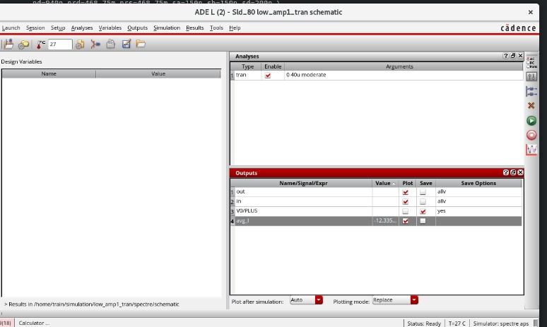
Figure 11: ADE L outputs table of the baseline transient run: the expression average(IT("/V0/PLUS")) gives -12.335... uA in the Value column (full value -12.3356 uA).

SCREENSHOT OF THE CIRCUIT BASED ON SIZING CONCEPT:
Sizing v1 (applied to Sld_80/Low_AmpSd; the unsized circuit is kept as Low_AmpSd_base):
- Input pair M9 and M10: W = 1.6 µm, L = 150 nm (was 320 nm / 150 nm).
- M5, M6 (NMOS) and M12, M15 (PMOS): W = 640 nm, L = 300 nm (was 320 nm / 150 nm).
- All other transistors unchanged (320 nm / 150 nm); Ibias still 2 µA; C0 = 1 pF.
These values were verified in the Spectre netlist of the sized schematic. The sized circuit is biased at vin+ = 1.016089 V (out = 0.981 V at that bias) for the AC and transient runs; the baseline bias was 1.028 V.
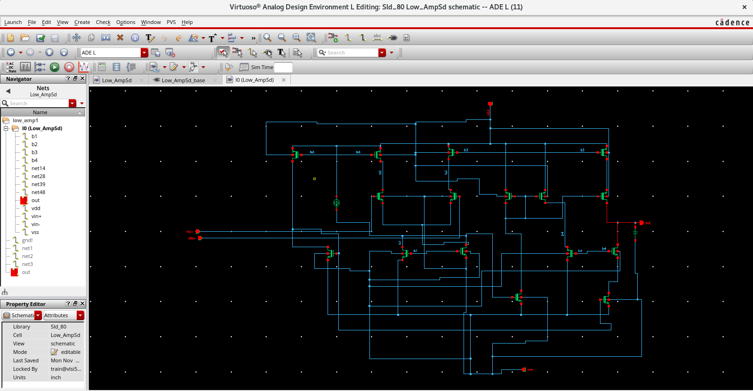
Figure 12: Schematic of Sld_80/Low_AmpSd (the sized circuit), opened from instance I0 of the test bench: 16 transistors, I0, C0 and the pins vdd, vss, vin+, vin- and out. The sized W and L values are listed in Table 1 and shown in the netlist excerpt below.
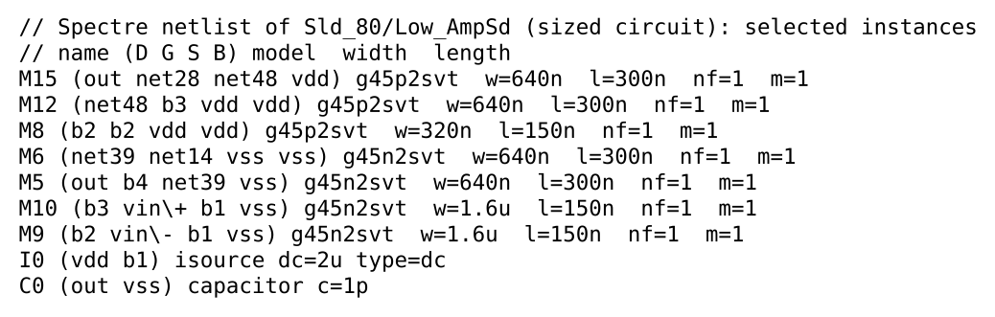
Figure 13: Excerpt of the Spectre netlist of the sized circuit: M9 and M10 (input pair) w = 1.6u, l = 150n; M5, M6, M12 and M15 w = 640n, l = 300n; M8 shown for comparison (unchanged, 320n / 150n).
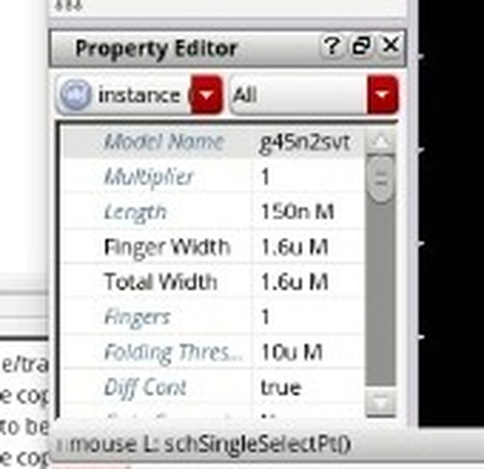
Figure 14: Property Editor of M9 in the sized schematic: Length 150n, Finger Width 1.6u, Total Width 1.6u, 1 finger, model g45n2svt.
The sizes of M5, M6, M12 and M15 (w = 640n, l = 300n) are shown in the netlist excerpt above.
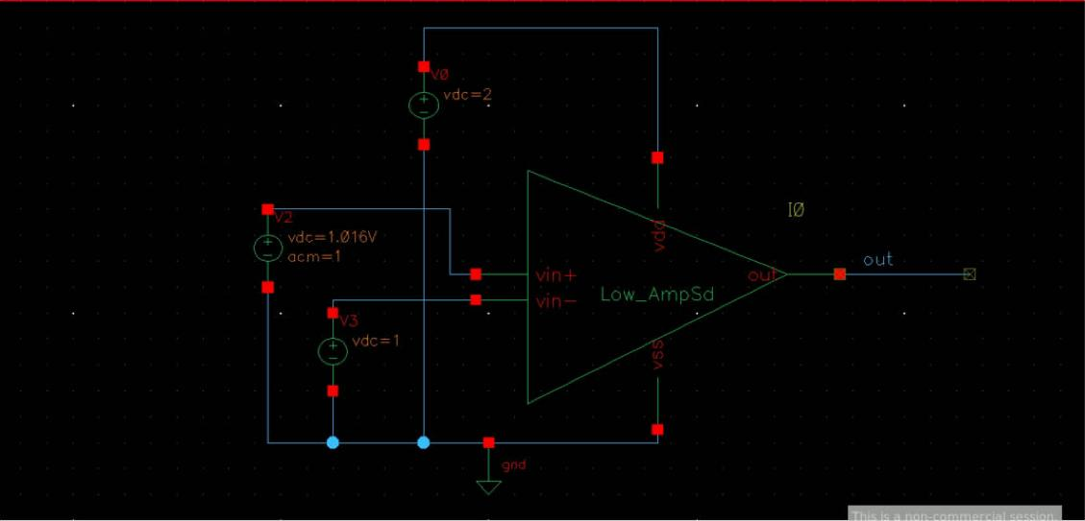
Figure 15: Test bench low_amp1 with the sized Low_AmpSd: V2 on vin+ = 1.016 V (bias used for the AC and transient runs, 1.016089 V) with AC magnitude 1, V3 = 1 V, V0 = 2 V.
The transient test bench of the sized circuit is the same low_amp1_tran bench shown in the previous section; its Low_AmpSd symbol resolves to the sized Low_AmpSd schematic.

SCREENSHOT OF THE OUTPUT WAVEFORM OBTAINED FROM THE SIMULATOR FOR THE CIRCUIT WITH SIZING CONCEPT (DC AND TRANSIENT):
Results with sizing.
DC. Trip point at vin+ = 1.016094 V (marker M4 in Figure 16, out = 1.000859 V), from a sweep of vin+ from 0.9 V to 1.125 V with vin- = 1 V. The AC and transient runs below were taken with V2 = 1.016089 V.
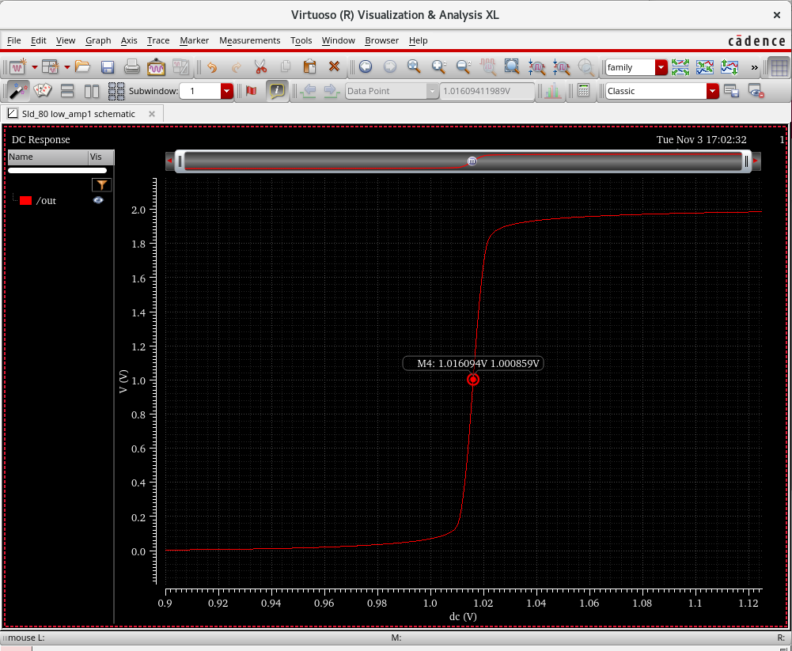
Figure 16: DC sweep of the sized circuit (V2 on vin+ swept 0.9 V to 1.125 V, vin- = 1 V, 27 C): marker M4 at vin+ = 1.016094 V where out = 1.000859 V. The AC and transient runs of this report were taken with V2 = 1.016089 V (see text).
AC. DC gain 46.64 dB, GBW 1.725 MHz, phase -90.002° at 1.721 MHz, so the phase margin is about 90.0°. Compared with the baseline: +2.04 dB gain and GBW about 2.4-2.5 times larger, phase margin unchanged. The gain is still 13.36 dB below the 60 dB target and the GBW is 0.28 MHz below the 2 MHz target.
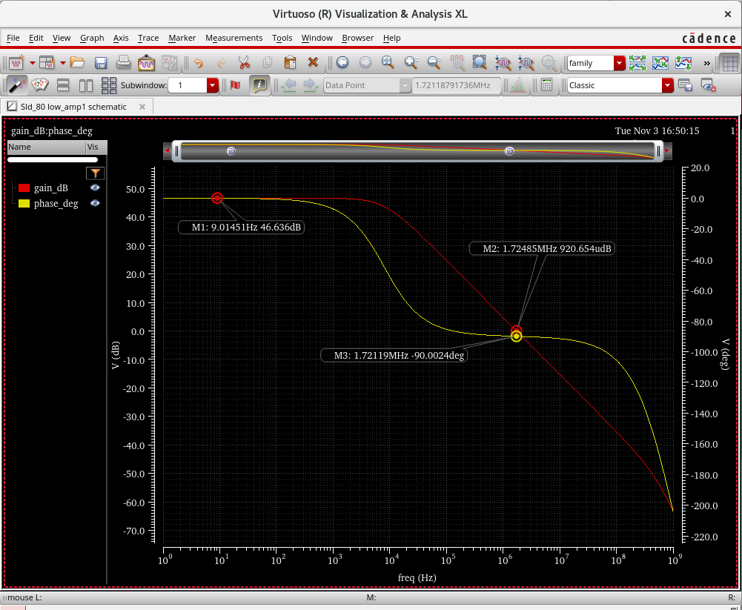
Figure 17: AC gain (red) and phase (yellow) of the sized circuit: M1 at 9.01 Hz reads 46.636 dB (DC gain); M2 at 1.72485 MHz reads 920.654 udB (0 dB crossing, GBW = 1.725 MHz); M3 at 1.72119 MHz reads -90.0024 deg (phase margin = about 90.0 deg).
The markers for the 0 dB crossing (1.725 MHz) and the phase at that frequency (-90.002 deg) are in the figure above.
Transient (model section mc). tPLH = 79.5 ns, tPHL = 118.1 ns, tp = 98.8 ns; average current -16.354 µA, power 2 V x 16.354 µA = 32.71 µW; PDP = 3.23 pJ. The rising edge is now much faster than the falling edge (79.5 ns against 118.1 ns).
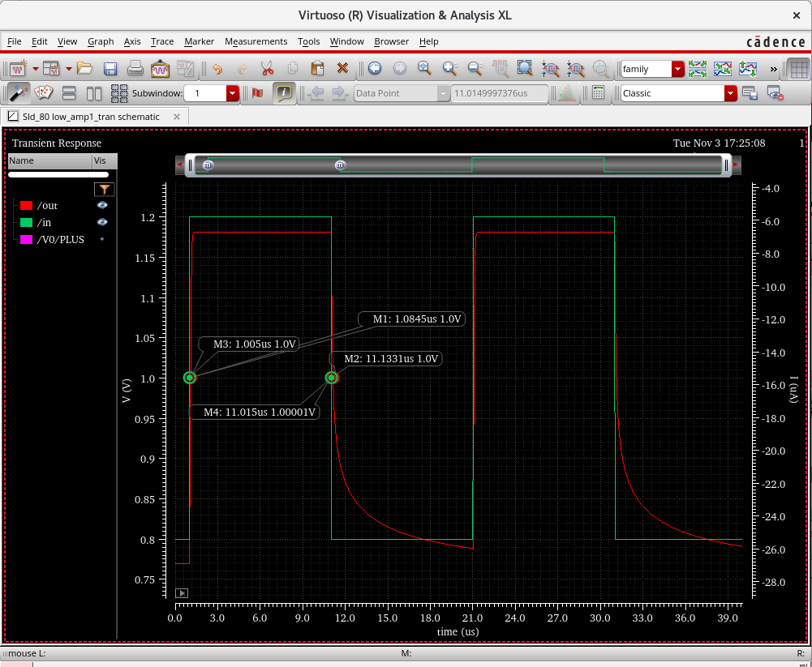
Figure 18: Transient of the sized follower: markers at 1.0 V on the input (M3 = 1.005 us rising, M4 = 11.015 us falling) and on the output (M1 = 1.0845 us rising, M2 = 11.1331 us falling), giving tPLH = 79.5 ns and tPHL = 118.1 ns (tp = 98.8 ns). The red trace is /out and the green trace is /in.
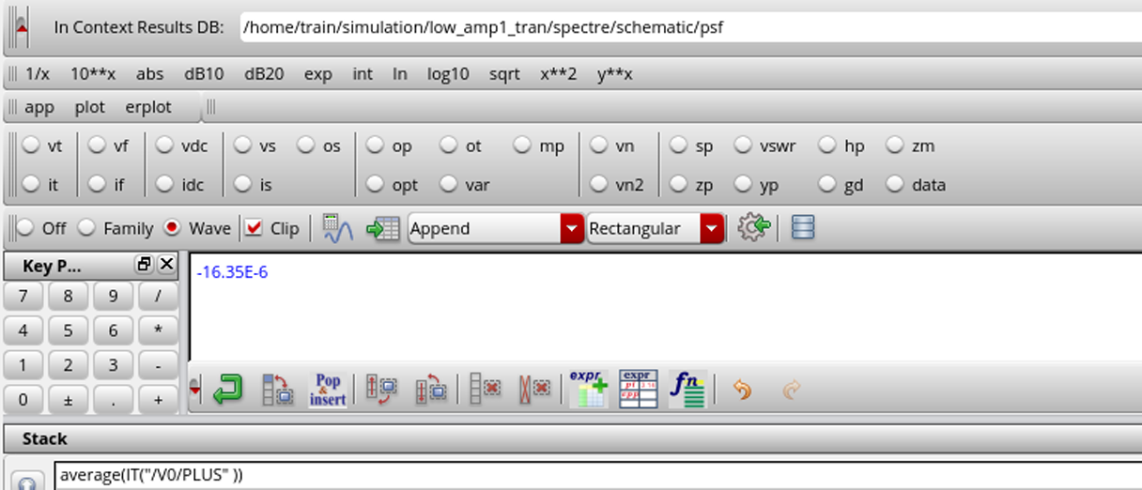
Figure 18 (continued): Average supply current of the sized follower from the Virtuoso calculator: average(IT("/V0/PLUS")) = -16.35E-6 A, i.e. -16.35 uA, so the power is about 32.7 uW.
For reference only, the PVT nominal run of the sized circuit (model section tt, 27 °C, 2.0 V) gives tPLH = 82.1 ns, tPHL = 119.7 ns, tp = 100.9 ns, average current -16.227 µA, power 32.45 µW and PDP 3.27 pJ (see the PVT section).

PROVIDE THE VALUES FOR THE FOLLOWING ALONG WITH THE SCREENSHOTS AS PROOF:
Table 2: without and with sizing (same measurement method and model section mc for both columns).
Parameter | Value without sizing | Value with sizing | Change
Power calculation: transient average power (2 V x average supply current) | 24.67 µW (avg. current 12.3356 µA) | 32.71 µW (avg. current 16.354 µA) | +32.6 %
Power calculation: DC-bias power at the trip point | 15.886 µW (7.943 µA) | not measured
Delay calculation: tPLH | 171.2 ns | 79.5 ns
Delay calculation: tPHL | 254.9 ns | 118.1 ns
Delay calculation: tp = (tPLH + tPHL)/2 | 213 ns | 98.8 ns | -53.6 %
Power Delay Product (PDP = P x tp) | 5.26 pJ | 3.23 pJ | -38.6 %
DC gain | 44.6 dB | 46.64 dB | +2.04 dB
GBW | about 0.7 MHz | 1.725 MHz | about 2.4-2.5x
Phase margin | about 90.3° | about 90.0° | about the same
Trip point (vin+ for out = 1.0 V) | 1.028 V | 1.016089 V | -11.9 mV

Proof screenshots: power S09 and S20; delay S08 and S19; gain and GBW S05, S06, S16, S17.
Comparison with the paper specification (Table I of the paper).
Parameter | Specification | Without sizing | With sizing | Status after sizing
Supply VDD | 2.0 V | 2.0 V | 2.0 V | met
Power | < 20 µW | 24.67 µW (transient avg.); 15.886 µW (DC) | 32.71 µW (transient avg.) | not met in transient
Open-loop gain | >= 60 dB | 44.6 dB | 46.64 dB | not met (13.36 dB short)
GBW | >= 2.0 MHz | about 0.7 MHz | 1.725 MHz | not met (0.28 MHz short)
Phase margin | >= 50° | about 90.3° | about 90.0° | met
Slew rate | >= 2.5 V/µs | not measured | not measured | not evaluated
ICMR, output swing | rail-to-rail | not measured | not measured | not evaluated

SCREENSHOT OF THE PVT ANALYSIS:
PVT (process, voltage, temperature) analysis was run on the sized circuit with the follower test bench low_amp1_tran, changing the model section, the temperature and VDD together. The corner sections available in the gpdk045 model file are tt, ff, ss, fs, sf and mc.
Case | Section | Temp | VDD | tp | Power | PDP
Nominal | tt | 27 °C | 2.0 V | 100.9 ns (tPLH 82.1, tPHL 119.7) | 32.45 µW (avg. current 16.227 µA) | 3.27 pJ
A: slow | ss | 125 °C | 1.8 V | 194.0 ns (tPLH 153.8, tPHL 234.3) | 16.32 µW (avg. current 9.065 µA) | 3.17 pJ
B: fast | ff | -40 °C | 2.2 V | 51.9 ns (tPLH 39.4, tPHL 64.4) | 77.51 µW (avg. current 35.23 µA) | 4.02 pJ
C: tt, 125 °C, 2.0 V | tt | 125 °C | 2.0 V | not run | not run | not run

Power at each corner = (VDD of that corner) x (average current). Observations: the delay changes by about 1.9 times between the nominal and the slow corner (194.0 ns / 100.9 ns) and the fast corner is about 2 times faster than the nominal one (51.9 ns), so over the three cases the delay spans about 3.7 times. The power changes by about 4.7 times between the slow and the fast corner (77.51 µW / 16.32 µW). Power is the weak point: the 20 µW target is met only at the slow corner (high temperature and low VDD). The PDP varies much less (3.17 pJ to 4.02 pJ). Case C was not run.
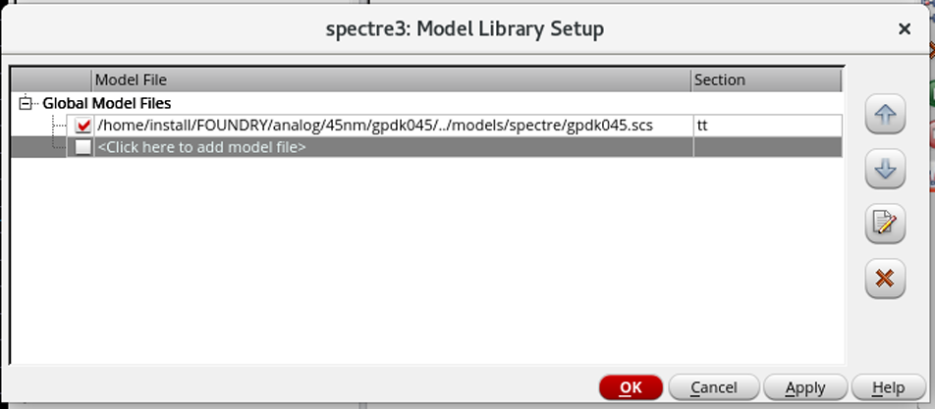
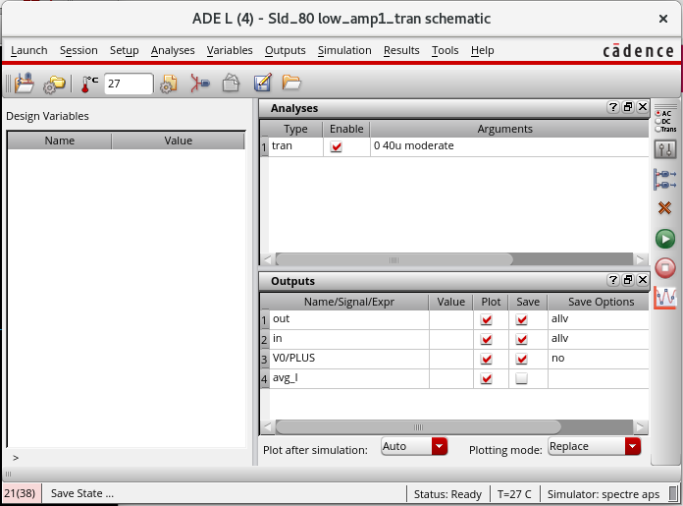
PVT setup (S21): (a) Model Library Setup form with the gpdk045.scs section set to tt; (b) ADE L window of low_amp1_tran with the temperature 27 C, the tran analysis (0 to 40u, moderate) and the outputs out, in, /V0/PLUS and avg_I. V0 = 2 V for the nominal case.
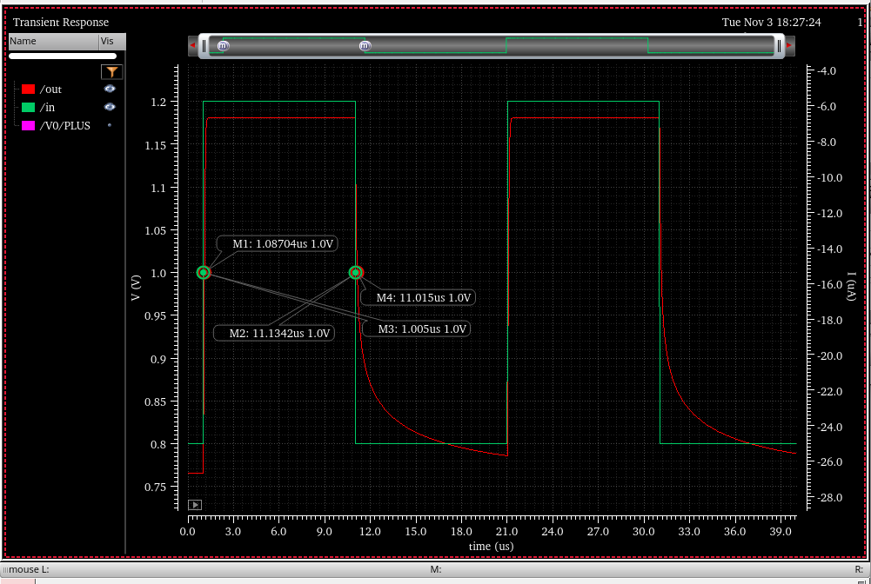
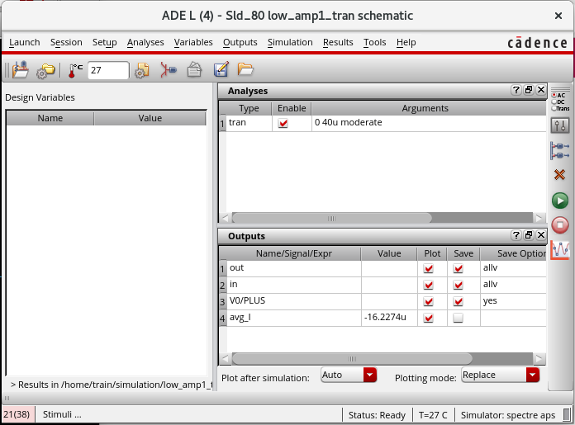
PVT nominal case (tt, 27 C, V0 = 2.0 V) (S22): markers at 1.0 V on the input (M3 = 1.005 us rising, M4 = 11.015 us falling) and on the output (M1 = 1.08704 us rising, M2 = 11.1342 us falling), giving tPLH = 82.0 ns and tPHL = 119.2 ns (tp = 100.6 ns). Second picture: ADE L Outputs table of the same run with avg_I = -16.2274 uA (average of the supply current), i.e. 2 V x 16.2274 uA = 32.45 uW.
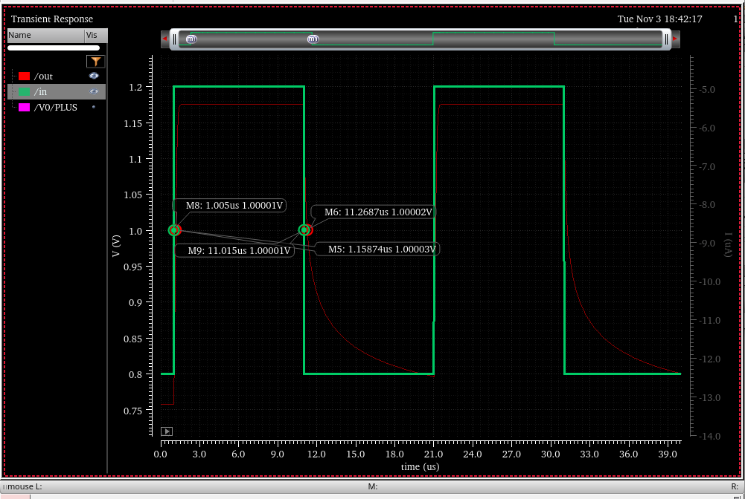
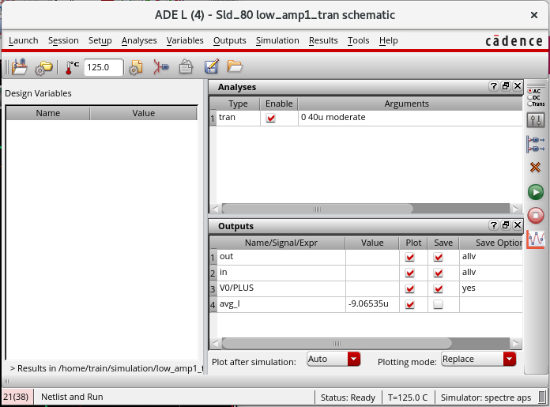
Figure 19: PVT case A (ss, 125 C, VDD = 1.8 V): markers at 1.0 V on the input (M8 = 1.005 us rising, M9 = 11.015 us falling) and on the output (M5 = 1.15874 us rising, M6 = 11.2687 us falling), giving tPLH = 153.7 ns and tPHL = 253.7 ns (tp = 203.7 ns). Second picture: ADE L window with T = 125.0 C and avg_I = -9.06535 uA.
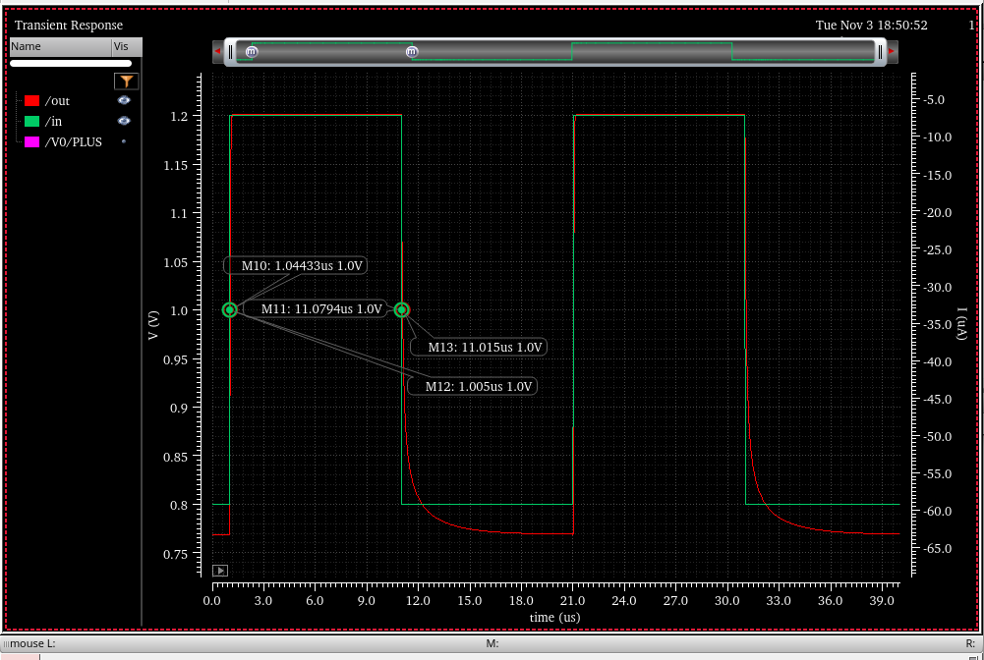
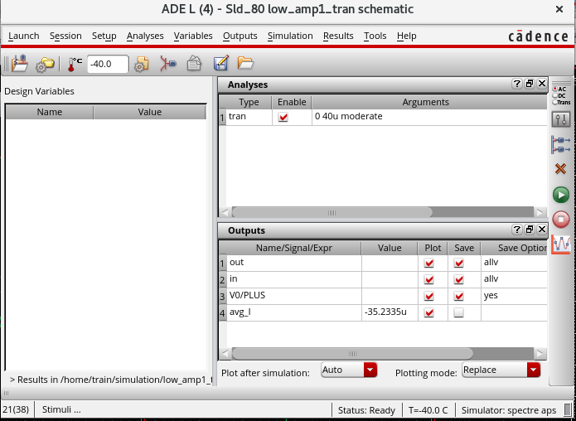
Figure 20: PVT case B (ff, -40 C, VDD = 2.2 V): markers at 1.0 V on the input (M12 = 1.005 us rising, M13 = 11.015 us falling) and on the output (M10 = 1.04433 us rising, M11 = 11.0794 us falling), giving tPLH = 39.3 ns and tPHL = 64.4 ns (tp = 51.9 ns). Second picture: ADE L window with T = -40.0 C and avg_I = -35.2335 uA.
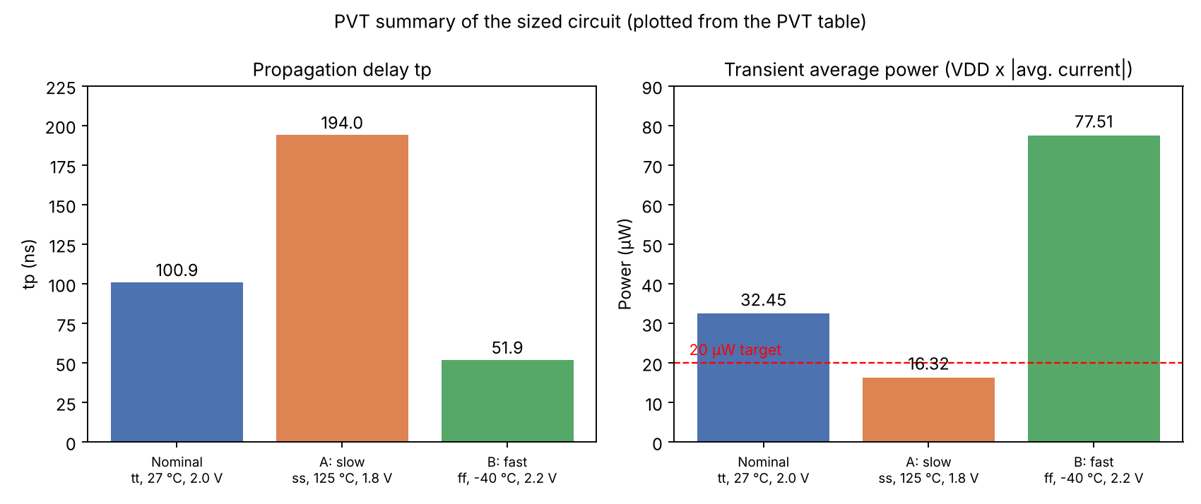
Figure 21: Summary of the PVT runs of the sized circuit, plotted from the values in the PVT table .

SCREENSHOT OF THE LAYOUT:
Layout of the sized circuit (Sld_80/Low_AmpSd/layout). The layout view was created with Layout XL (Launch -> Layout XL -> Create New; Connectivity -> Generate -> All From Source) in the gpdk045 technology.
- Placement: three rows following the floorplan sketch: top PMOS row M7, M8, M11, M12, M15, M13, M14; middle NMOS row M0, M9, M10, M1, M3 (M9 under M8 and M10 under M11 so that the input pair sits below its loads); bottom NMOS row M2, M6, M5, M4.
- Pins: Metal1 pins, vdd at the top, vin- and vin+ on the left, out on the right and vss at the bottom.
- Rails: vdd rail at the top and vss rails (a strap between the middle and bottom rows and a rail at the bottom, joined by a vertical link at the right edge), all on Metal1 drawing.
- Device parameters: body tie type Detached; PMOS top tap and NMOS bottom tap; gate connection PMOS bottom and NMOS top. A single merged Nwell rectangle covers the whole PMOS row.
- Routing: Route -> Automatic Routing -> All Nets routed the 11 signal nets (11/11, 0 opens, 0 shorts); vdd and vss were routed as selected nets (2/2, 0 opens, 0 shorts). The Annotation Browser reports connectivity 0/0 (no incomplete nets, no shorts).
- DRC (Assura, rules file assuraDRC.rul): the error count went from about 50 at the first run to 13 after the fixes described in the problems section. The remaining 13 errors (listed below) were not fixed within the available time.
- LVS (Assura) and parasitic extraction (Quantus) were not run because of the submission time, so there is no LVS result and no post-layout simulation. The layout has been checked for connectivity (Layout XL: no incomplete nets, no shorts) and partly for design rules (13 DRC errors left).
DRC status at the end of the work (13 errors left): OXIDETHK.SP.1 (1 error, thick-oxide active spacing >= 0.16 µm), CONT.SE.3 (2, gate contact to active >= 0.06 µm), CONT.SE.4 (2, 1.8 V gate contact to active >= 0.07 µm), METAL1.SP.1.1 (3, >= 0.06 µm), METAL1.SP.1.2 (2, >= 0.1 µm), METAL1.SP.1.3 (3, wide-metal spacing >= 0.25 µm).
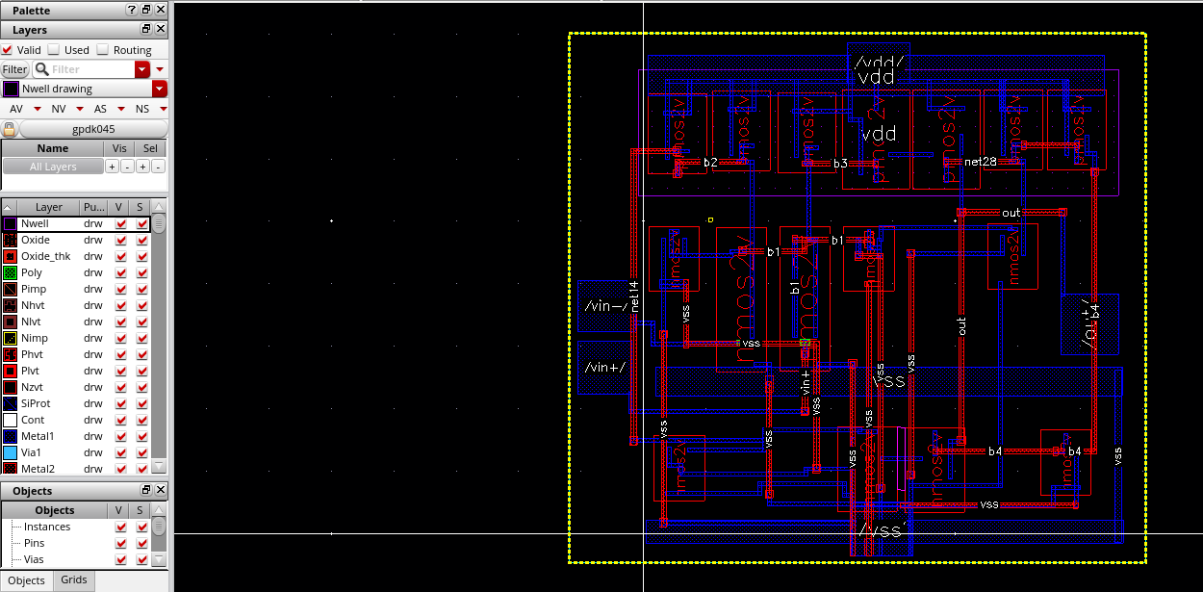
Figure 22: Layout of Sld_80/Low_AmpSd (all levels shown): PMOS row on top, two NMOS rows below, vdd and vss rails and strap on Metal1, pins on the boundary, routed signal nets with their labels.
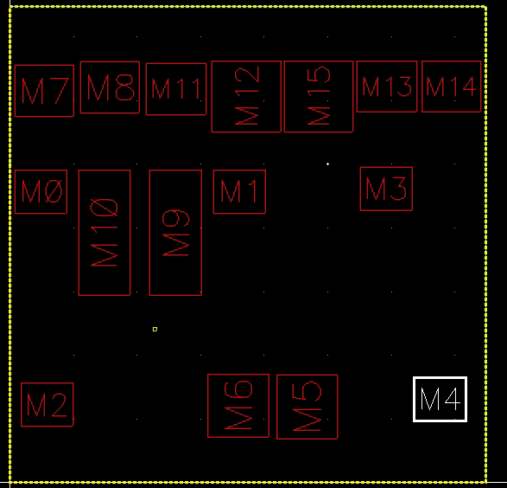
Figure 23: Placement of the 16 transistors with instance names (before routing): top PMOS row M7, M8, M11, M12, M15, M13, M14; middle NMOS row M0, M9, M10, M1, M3; bottom row M2, M6, M5, M4.
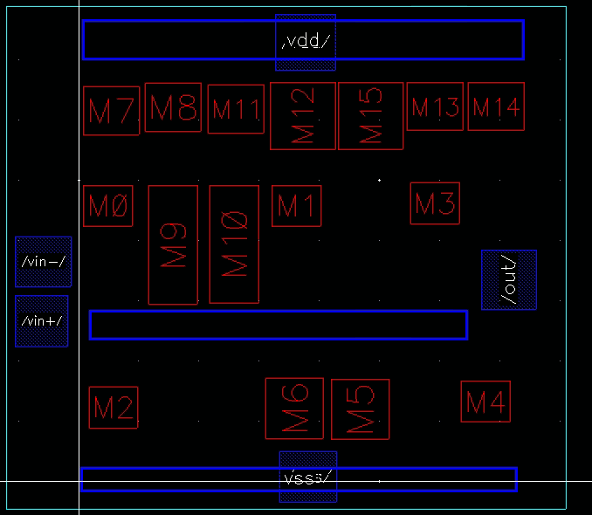
Figure 24: Pins (vin-, vin+, out, vdd, vss) and the Metal1 rails: vdd rail at the top, vss strap in the middle and vss rail at the bottom (before routing).
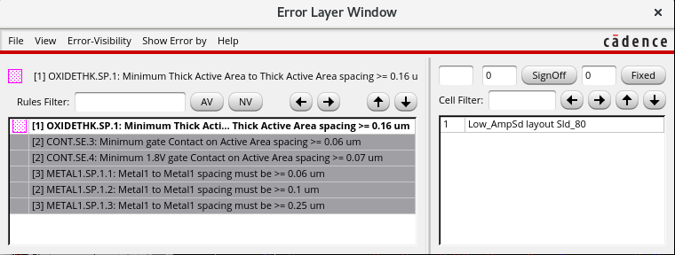
Figure 25: Assura DRC error list after the fixes (run drc4, Error Layer Window): OXIDETHK.SP.1 (1), CONT.SE.3 (2), CONT.SE.4 (2), METAL1.SP.1.1 (3), METAL1.SP.1.2 (2), METAL1.SP.1.3 (3): 13 errors left.
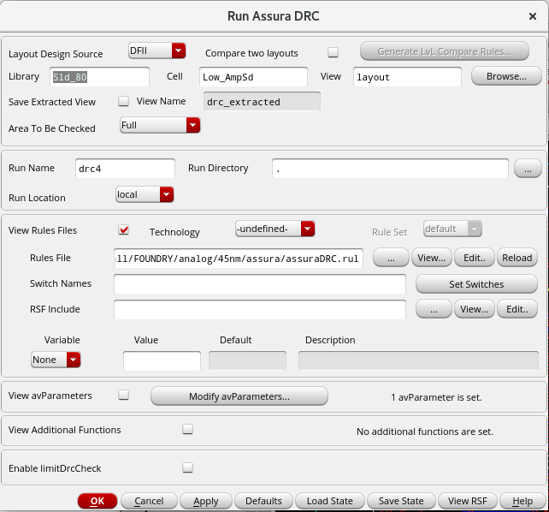
Figure 26: Assura Run DRC form: library Sld_80, cell Low_AmpSd, view layout, rules file /home/install/FOUNDRY/analog/45nm/assura/assuraDRC.rul.
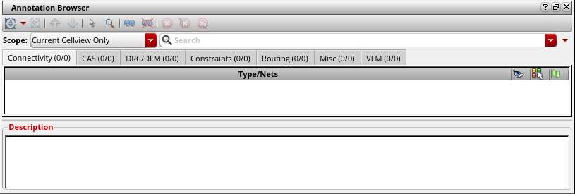
Figure 27: Annotation Browser after routing: Connectivity (0/0), i.e. no incomplete nets and no shorts (router summary: 11/11 signal nets and 2/2 power nets routed with 0 opens and 0 shorts).

SCREENSHOT OF THE OUTPUT WAVEFORM OBTAINED FROM THE SIMULATOR FOR THE LAYOUT:
Post-layout simulation was not performed. It needs the LVS check and the parasitic extraction (Quantus), which were not completed in the available time. The schematic (pre-layout) results of the previous sections are therefore the results reported here.

Expected effect (not verified): the extracted view adds wire resistance and capacitance, so the post-layout GBW and delay would be expected to be somewhat worse than the schematic values.

ANY OTHER RELEVANT INFORMATION:
Deviations from the paper and limitations.
1. Only Fig. 2 of the paper is implemented (16 transistors, Ibias and a load capacitor). The paper's headline figures (66.85 dB, 2.31 MHz, 12.5 µW) belong to the full Fig. 3 design with dynamic tail biasing and cannot be compared one-to-one with these results.
2. The paper reports no transistor sizes for Fig. 2 and no bias current in the text extracted for this project. W = 320 nm, L = 150 nm (baseline) and Ibias = 2 µA are choices made in this project.
3. gpdk045 thick-oxide (2 V) devices g45n2svt and g45p2svt were used, with VDD = 2.0 V as in Table I of the paper.
4. The paper's Fig. 2 omits some gate connections. The mirror diode connections were added following the paper's text (nets b1 to b4), and an NMOS input pair was used. The device mapping between Virtuoso names and the paper names is inferred from the topology.
5. The tail node of the input pair is shorted to the bias node b1, as it appears in the paper's drawing. An alternative reading (tail node separated from the bias node) was considered and not applied because the circuit works as drawn.
6. The gain, GBW and phase margin are measured with the 1 pF load C0 inside Low_AmpSd. A phase margin of about 90° means the response is close to a single-pole roll-off up to the unity-gain frequency.
7. Process corners ss and ff were available and used for the PVT analysis; no corner limitation affected the study. The corner cases fs and sf, the nominal-voltage hot case (Case C) were not simulated.
8. Slew rate, PSRR, CMRR, ICMR and output swing (Table I and Section III of the paper) were not evaluated in this project.
9. Inconsistency inside the paper: the phase margin is 57.78° in Section III-A and 68° in the Conclusion.
10. Delay definition used: propagation delay tp = (tPLH + tPHL)/2 between the 1.0 V crossings of the input and output of a unity-gain follower. The faculty may expect a different definition (for example settling time).
11. The simulation results are from the schematic (pre-layout) circuit except where marked as post-layout.

CONCLUSION:
The Fig. 2 cascade second-stage amplifier of the reference paper was recreated in Cadence Virtuoso with the gpdk045 45 nm PDK. After correcting the bias source, the floating mirror gates and the input-pair type, the baseline circuit (all devices 320 nm / 150 nm, Ibias = 2 µA) gave a DC gain of 44.6 dB, a GBW of about 0.7 MHz, a phase margin of about 90°, a propagation delay of 213 ns and a transient average power of 24.67 µW (PDP 5.26 pJ).
Sizing (input pair widened to 1.6 µm, output and cascode devices lengthened to 300 nm) improved the gain by 2.04 dB to 46.64 dB, raised the GBW to 1.725 MHz (about 2.4-2.5 times), cut the delay by 53.6 % to 98.8 ns and reduced the PDP by 38.6 % to 3.23 pJ, at the cost of 32.6 % more power (32.71 µW). The sized circuit still misses three paper targets: the gain is 13.36 dB below 60 dB, the GBW is 0.28 MHz below 2 MHz and the transient power is above 20 µW. These misses are partly expected because the paper's headline numbers belong to the larger Fig. 3 design, and the bias current and sizes of Fig. 2 are not given in the paper, so they were chosen here.
The PVT study shows a large spread: the delay goes from 51.9 ns at the fast corner to 194.0 ns at the slow corner (about 3.7 times) and the power changes by about 4.7 times between the slow and the fast corner; the power target is met only at the slow corner. The layout was placed and routed with no open or shorted nets (Layout XL connectivity check 0/0), and the Assura DRC error count was brought from about 50 down to 13 remaining errors (OXIDETHK.SP.1, CONT.SE.3, CONT.SE.4 and the Metal1 spacing rules), which were not fixed in the available time. LVS, parasitic extraction and post-layout simulation were not carried out and remain as future work.

PROBLEMS FACED DURING THE IMPLEMENTATION:
1. VSS check-and-save error in the schematic.
2. Warning about a hanging out wire in a test bench.
3. Output stuck at 1.9989 V and flat for all vin+ (0 to 2 V) in the DC sweep.
4. Schematic changes not showing up in the netlist (stale netlist).
5. Gain far below the paper (44.6 dB against 60 dB) and GBW below 2 MHz in the baseline.
6. The direct-plot function gave empty windows for the AC plots in this installation.
7. Layout: five router shorts after drawing the rails.
8. Layout: 16 open body (B) terminals.
9. Layout: 40 gate-contact spacing errors from router-placed contacts.
10. Layout: 6 Nwell spacing errors.
11. Layout: about 50 DRC errors at the first run, with 13 remaining at the end of the work (OXIDETHK.SP.1, CONT.SE.3, CONT.SE.4, METAL1.SP.1.1, METAL1.SP.1.2, METAL1.SP.1.3).
12. LVS and PEX: not run because of the submission time. The schematic contains the ideal parts I0 (idc, 2 µA) and C0 (pcapacitor, 1 pF), which do not exist in the layout, so an Assura LVS run would report them as unmatched unless they are excluded or moved into the test benches. This was identified but not carried out.

PROBLEMS RESOLVED USING SOLUTIONS:
Each item gives problem -> cause -> solution.
1. VSS check-and-save error -> problem with the vss pin and the wire attached to it -> set the pin direction to inputOutput and redrew the wire onto the pin.
2. Hanging out wire warning -> the out wire in the test bench has no further connection -> harmless; kept for plotting the output.
3. Output stuck at 1.9989 V, flat for all vin+ -> the Spectre netlist showed three causes: (a) the bias source had no DC value, so Ibias was 0 A; (b) four floating gate nets (net4, net10, net44, net33) because the mirrors were not diode-connected; (c) the input pair M9 and M10 were PMOS instead of NMOS -> (a) set the idc source to 2 µA, (b) labelled the nets b1, b2, b3, b4 so that the mirrors are diode-connected, (c) changed the cell of M9 and M10 from pmos2v to nmos2v (Q -> Cell Name) with the body on vss.
4. Stale netlist -> a second ADE L session was attached to the Low_AmpSd cell -> ADE was used only from low_amp1 and the netlist was regenerated (Simulation -> Netlist -> Recreate).
5. Shorted tail node (decision) -> the paper's drawing has a dot joining the tail node and the bias node -> the circuit works as drawn, so the paper's drawing was followed and the alternative was not applied.
6. Gain and GBW below target -> the unsized devices have small gm and small output resistance -> sizing v1 (see the sizing section) raised gain to 46.64 dB and GBW to 1.725 MHz; the remaining gap is reported honestly in the conclusion.
7. Empty plot windows for AC -> the direct-plot function of this installation did not produce a plot -> the outputs were set up as expressions in ADE L (Outputs -> Setup) using dB20(VF("/out")) and phase(VF("/out")).
8. Router shorts (5) -> the rails were first drawn on the Metal1 fill purpose instead of the drawing purpose (the router does not treat fill-purpose shapes as wires to avoid, so it ran its own wires across them) -> the rails were redrawn on Metal1 drawing.
9. Open body terminals (16) -> the transistors had no body connection -> body taps (Bodytie Type = Detached) were added on every transistor.
10. Gate-contact spacing errors (40) -> the router placed M1_PO contacts too close to the active area -> set the pcell Gate Connection parameter to Top for NMOS and Bottom for PMOS.
11. Nwell spacing errors (6) -> every PMOS had its own n-well and the wells were too close -> drew one merged Nwell rectangle over the whole PMOS row.
12. Remaining DRC errors -> not resolved in the available time: 13 errors were left after Route -> Fix Violations (which had already removed VIA1.X.1). The planned fixes were local Metal1 spacing corrections and moving the gate contacts.
13. LVS with ideal I0 and C0 -> not carried out (see problem 12). Planned solution: move I0 and C0 into the test benches and bring the bias node out as an ibias pin, or exclude them from the comparison with an LVS-ignore property.

ANY OTHER COMMENT:
- The results above come from a simple one-step sizing; further sizing rounds were not done. Ideas that were not tried: lengthening more devices or increasing the mirror ratio of M12 against M11 for more gain (at the cost of more power), and a smaller Ibias to reduce power (at the cost of GBW).
- All numbers in this report are taken from the recorded simulation results. Items that were not measured or not completed (the DC-bias power of the sized circuit, the remaining DRC errors, LVS, parasitic extraction and post-layout simulation) are stated as such in the text.
- The student work was done on a lab workstation; the netlists of the baseline and the sized circuit are kept in the project folder for reference.

REFERENCES:
[1] D. Chowbey and R. K. Baruah, "Low-Power CMOS Operational Amplifier Design in 45nm Technology," in Proc. 2025 Devices for Integrated Circuit (DevIC), Kalyani, India, 5-6 Apr. 2025, pp. 528-533, doi: 10.1109/DevIC63749.2025.11012572.
[2] Cadence Design Systems, Inc., Virtuoso Analog Design Environment, Virtuoso Schematic and Layout Suite, Spectre Circuit Simulator, Assura Physical Verification and Quantus Extraction documentation, as installed with the tools on the lab workstation.
[3] Cadence Design Systems, Inc., Generic Process Design Kit gpdk045 (45 nm) documentation and model files, as provided on the lab workstation (/home/install/FOUNDRY/analog/45nm/).
[4] P. Allen and D. Holberg, CMOS Analog Circuit Design, Oxford University Press, 2016 (as cited in [1]); used for the cascode output resistance and weak-inversion transconductance concepts.

