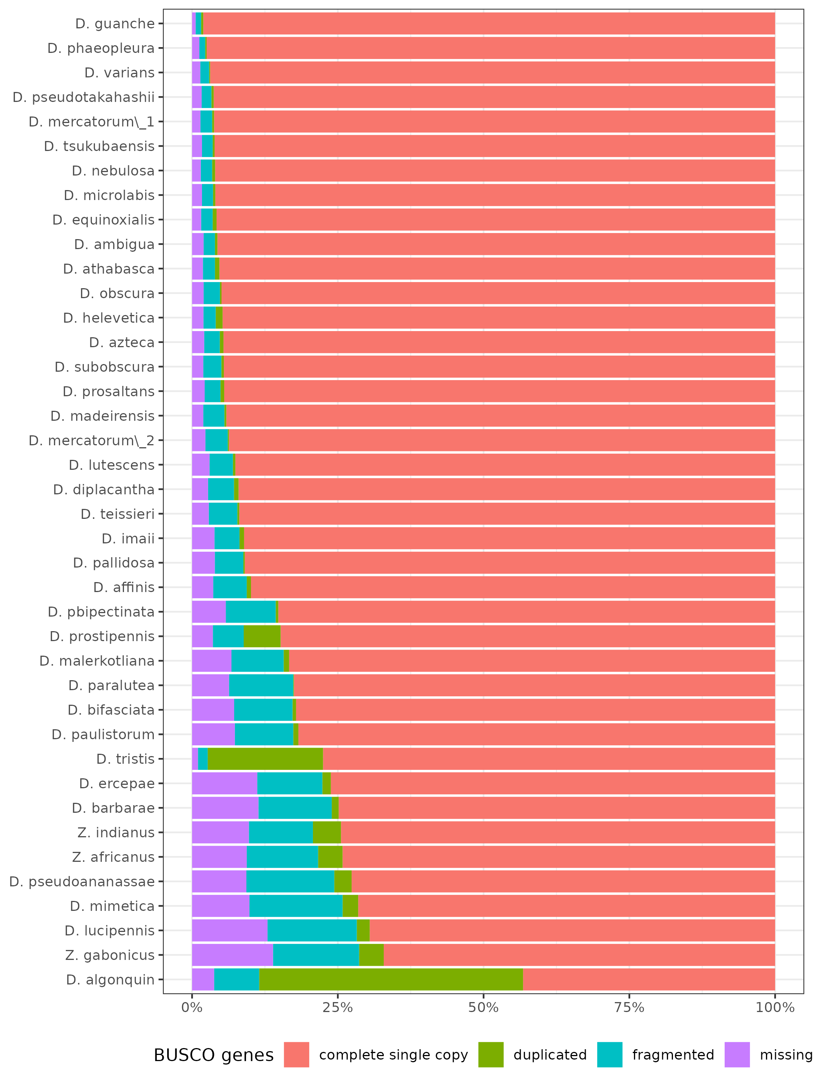

**Figure 1: BUSCO statistics of *Drosophila* homemade assemblies.** Results were obtained for 3285 dipteran BUSCO genes. Note that due to a high percentage of duplicates *D. algonquin* and *D. tristis* assemblies were not further considered.

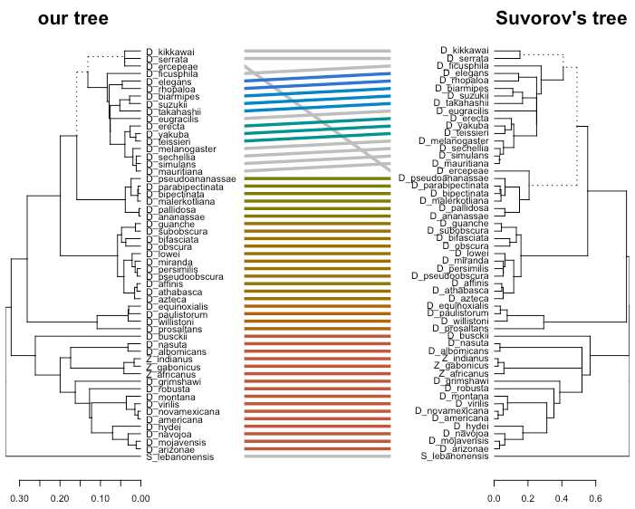

**Figure 2: Tanglegram comparing the established phylogeny with the one of Suvorov et al. (2020).**  Are represented the 55 species common to both studies.

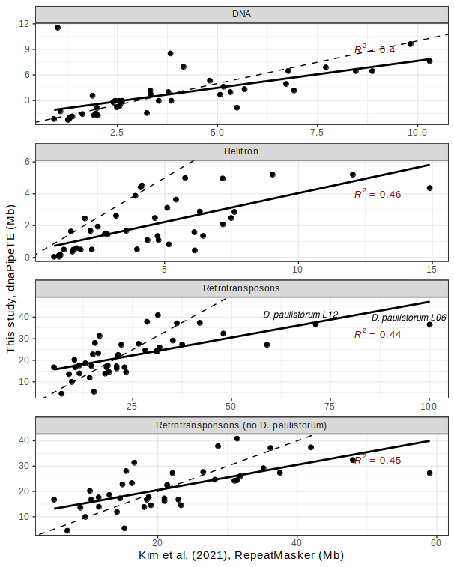

**Figure 3:** **Comparison of TE abundance estimates between Kim et al., 2021 and this study.** Each panel corresponds to a TE category. For the last panel, outliers estimates from *D. paulistorum* were filtered out. Dashed and plain lines correspond to y=x and regression line. R2 is indicated in red.

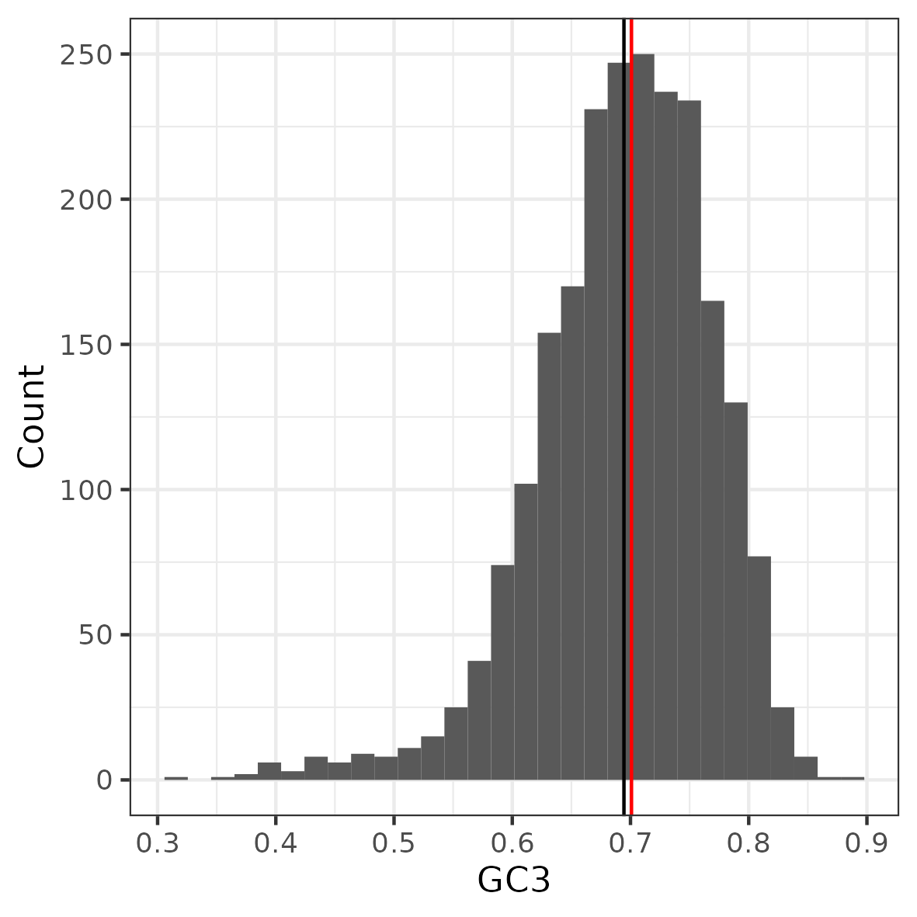

**Figure 4: Gene GC3 distribution.** Mean and median are indicated in black and red respectively.

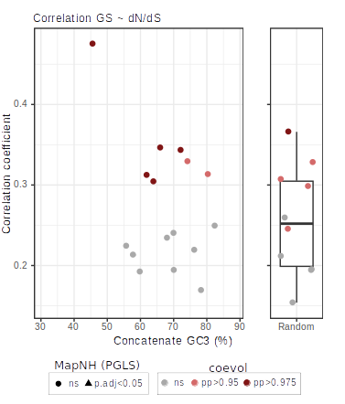

**Figure 5: Correlation coefficients between GS and dN/dS as a function of GC3. The dots/triangles indicate the median GC3 for each concatenate.** Correlation coefficients were estimated using coevol. Strongly and very strongly supported positive correlations are indicated in light and dark red respectively (pp>0.975 and pp>0.95). Triangles denote significant correlations found using PGLS (p. adj < 0.05).

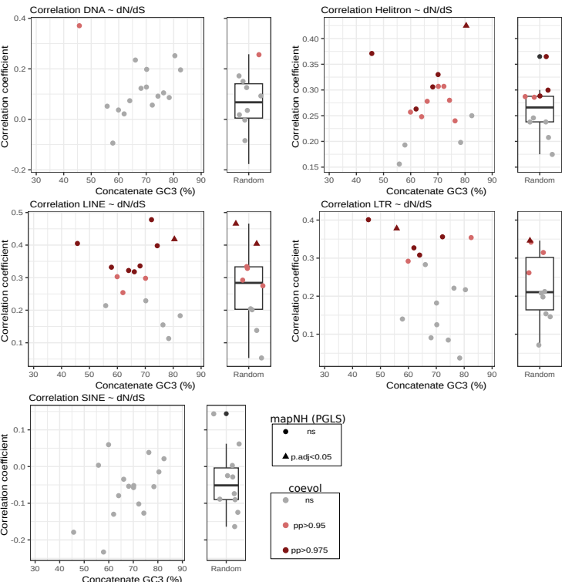

**Figure 6: Correlation coefficients between TE type abundances and dN/dS as a function of %GC3.** The dots/triangles indicate the median %GC3 for each concatenate. Correlation coefficients were estimated using coevol. Strongly and very strongly supported positive correlations are indicated in dark red and light red respectively (pp>0.95 and pp>0.975). Triangles denote significant correlations found using PGLS (p. adj < 0.05).

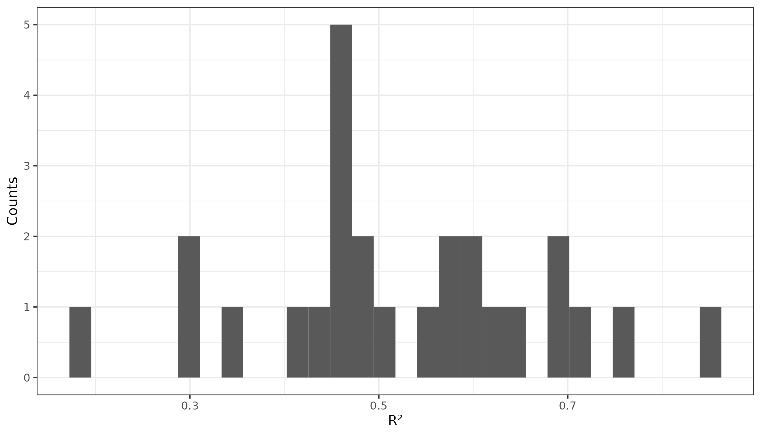

**Figure 7: Histogram of R-squared values obtained for the linear models describing the relation between coevol and bpp per branch dN/dS for each concatenate.**

**Figure 8: Correlations between coevol and bpp per branch dN/dS estimate for six randomly sampled concatenates. Plain line corresponds to the modeled linear relationship and dashed line to y=x.**

