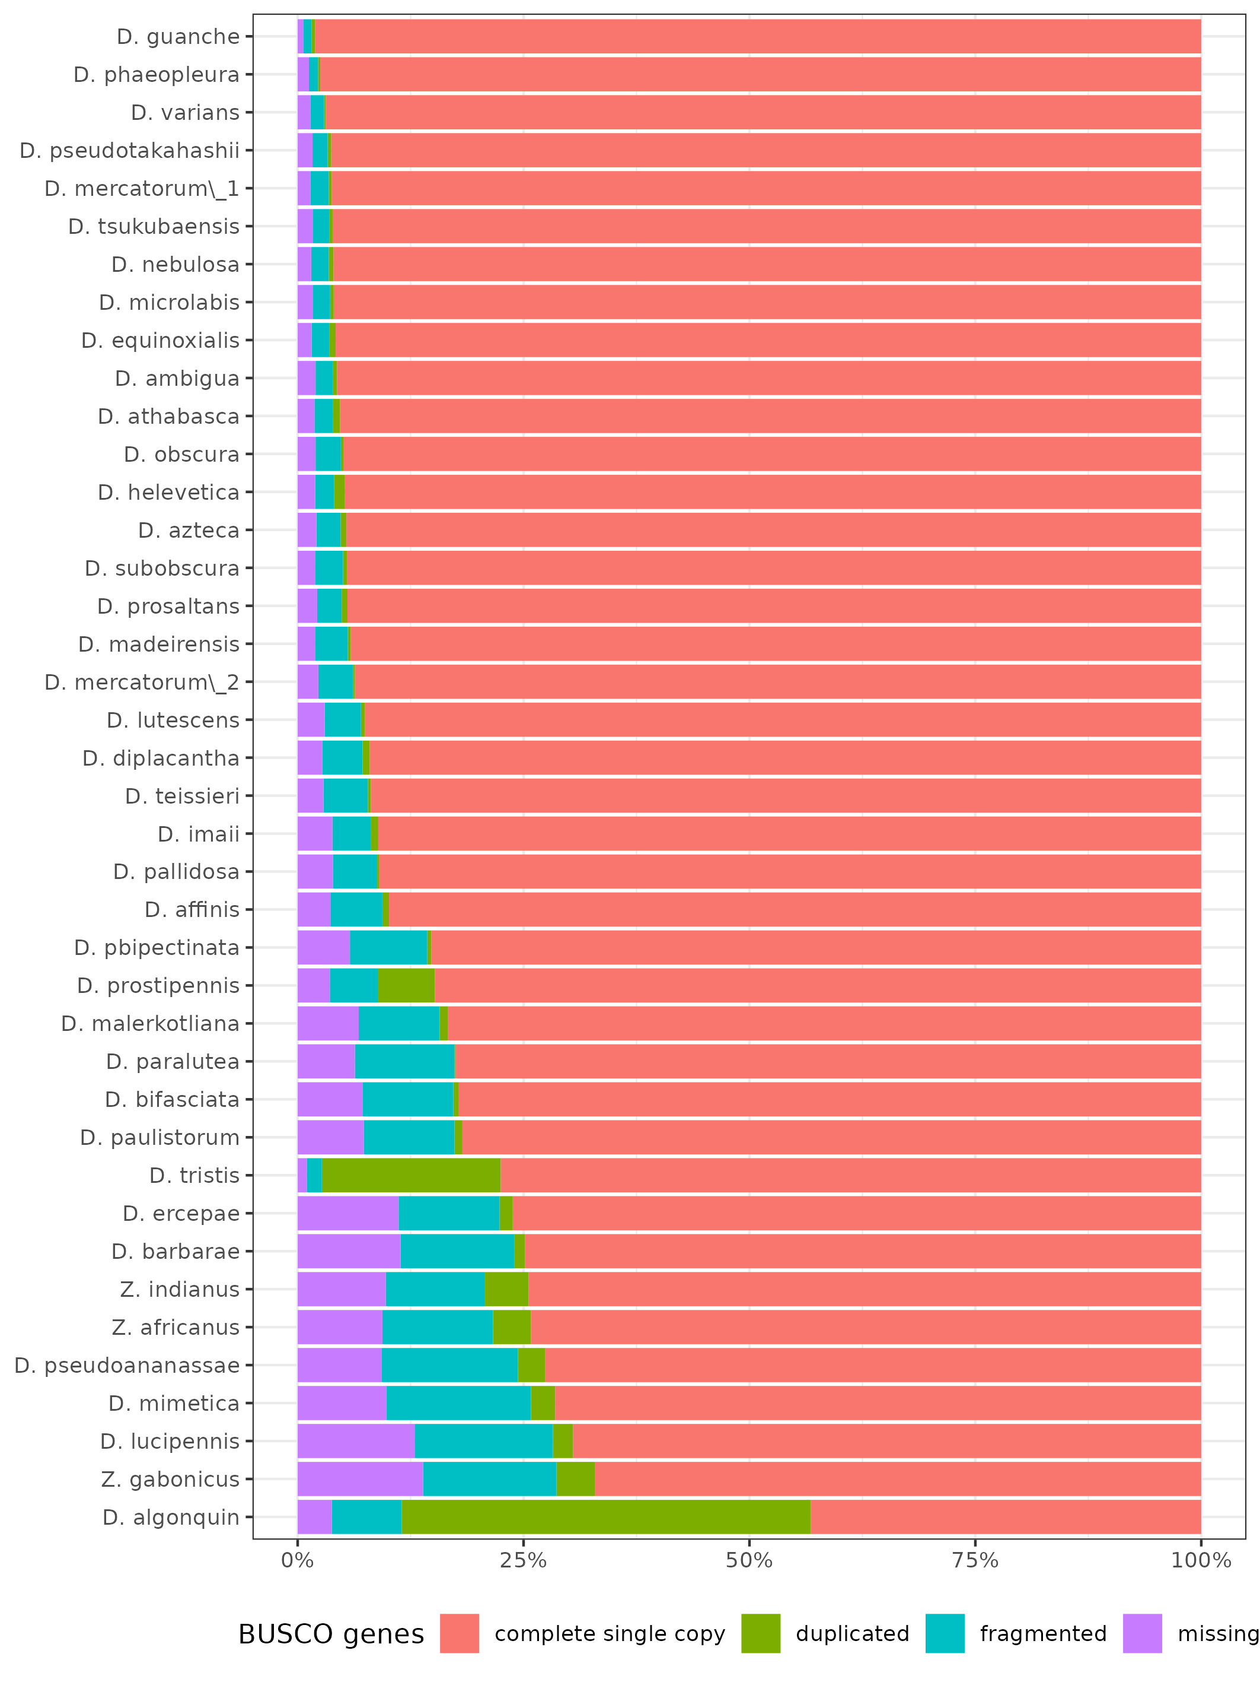Figure 1: BUSCO statistics of Drosophila homemade assemblies. Results were obtained for 3285 dipteran BUSCO genes. Note that due to a high percentage of duplicates D. algonquin and D. tristis assemblies were not further considered.

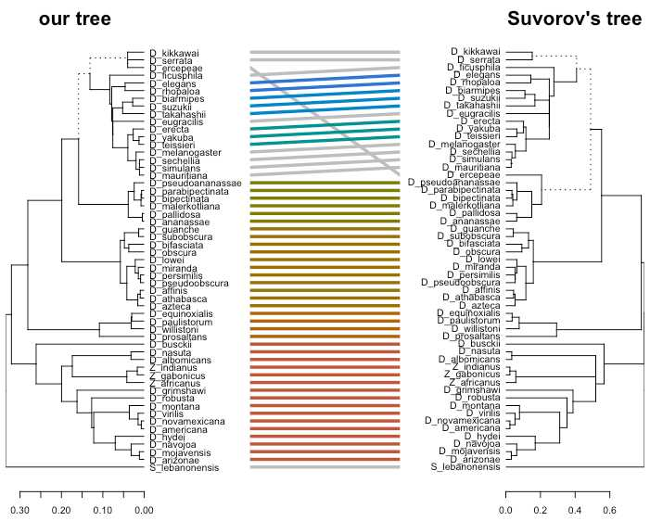Figure 2: Tanglegram comparing the established phylogeny with the one of Suvorov et al. (2020). Are represented the 55 species common to both studies.

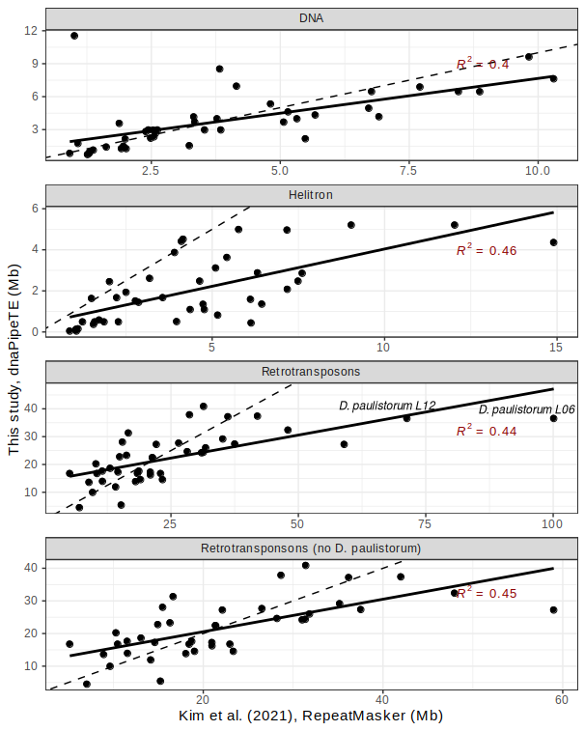Figure 3: Comparison of TE abundance estimates between Kim et al., 2021 and this study. Each panel corresponds to a TE category. For the last panel, outliers estimates from D. paulistorum were filtered out. Dashed and plain lines correspond to y=x and regression line. R² is indicated in red.

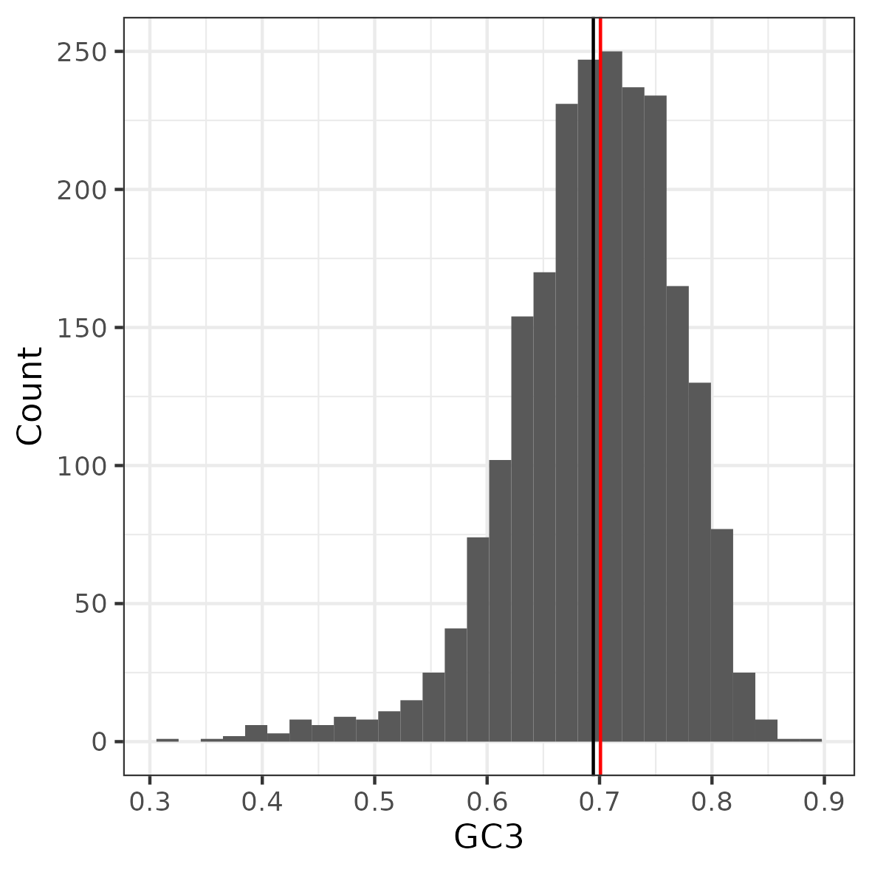Figure 4: Gene GC3 distribution. Mean and median are indicated in black and red respectively.

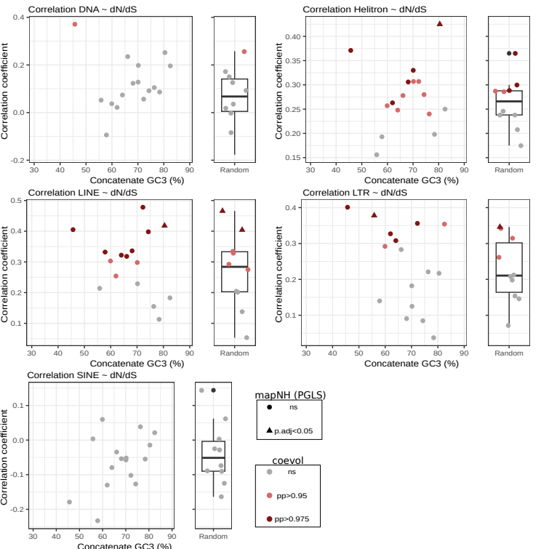Figure 5: Correlation coefficients between TE type abundances and dN/dS as a function of %GC3. The dots/triangles indicate the median %GC3 for each concatenate. Correlation coefficients were estimated using coevol. Strongly and very strongly supported positive correlations are indicated in dark red and light red respectively (pp>0.95 and pp>0.975). Triangles denote significant correlations found using PGLS (p. adj < 0.05).

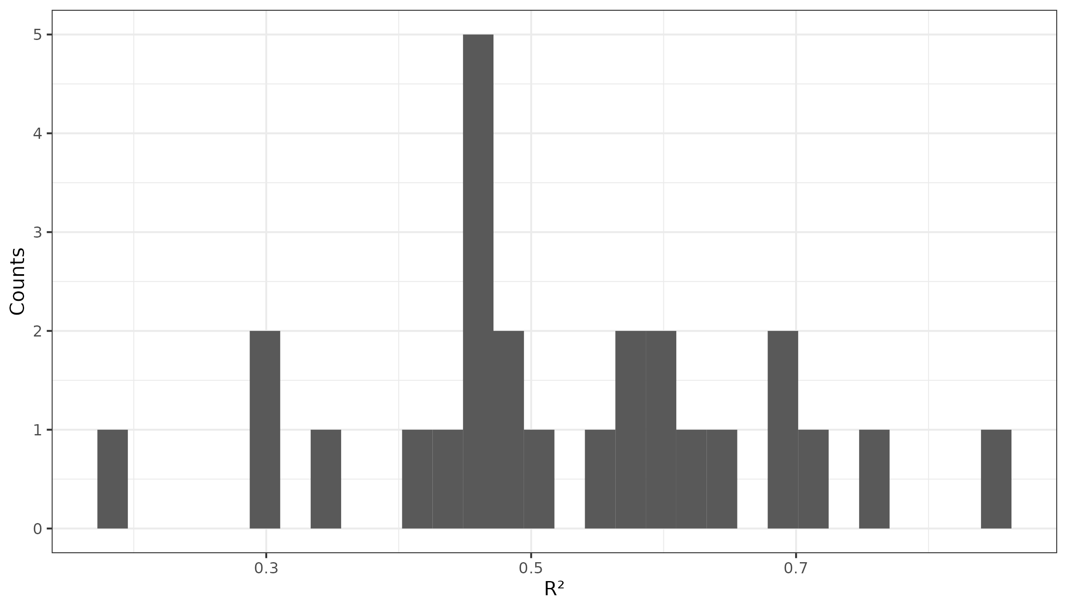Figure 6: Histogram of R-squared values obtained for the linear models describing the relation between coevol and bpp per branch dN/dS for each concatenate.

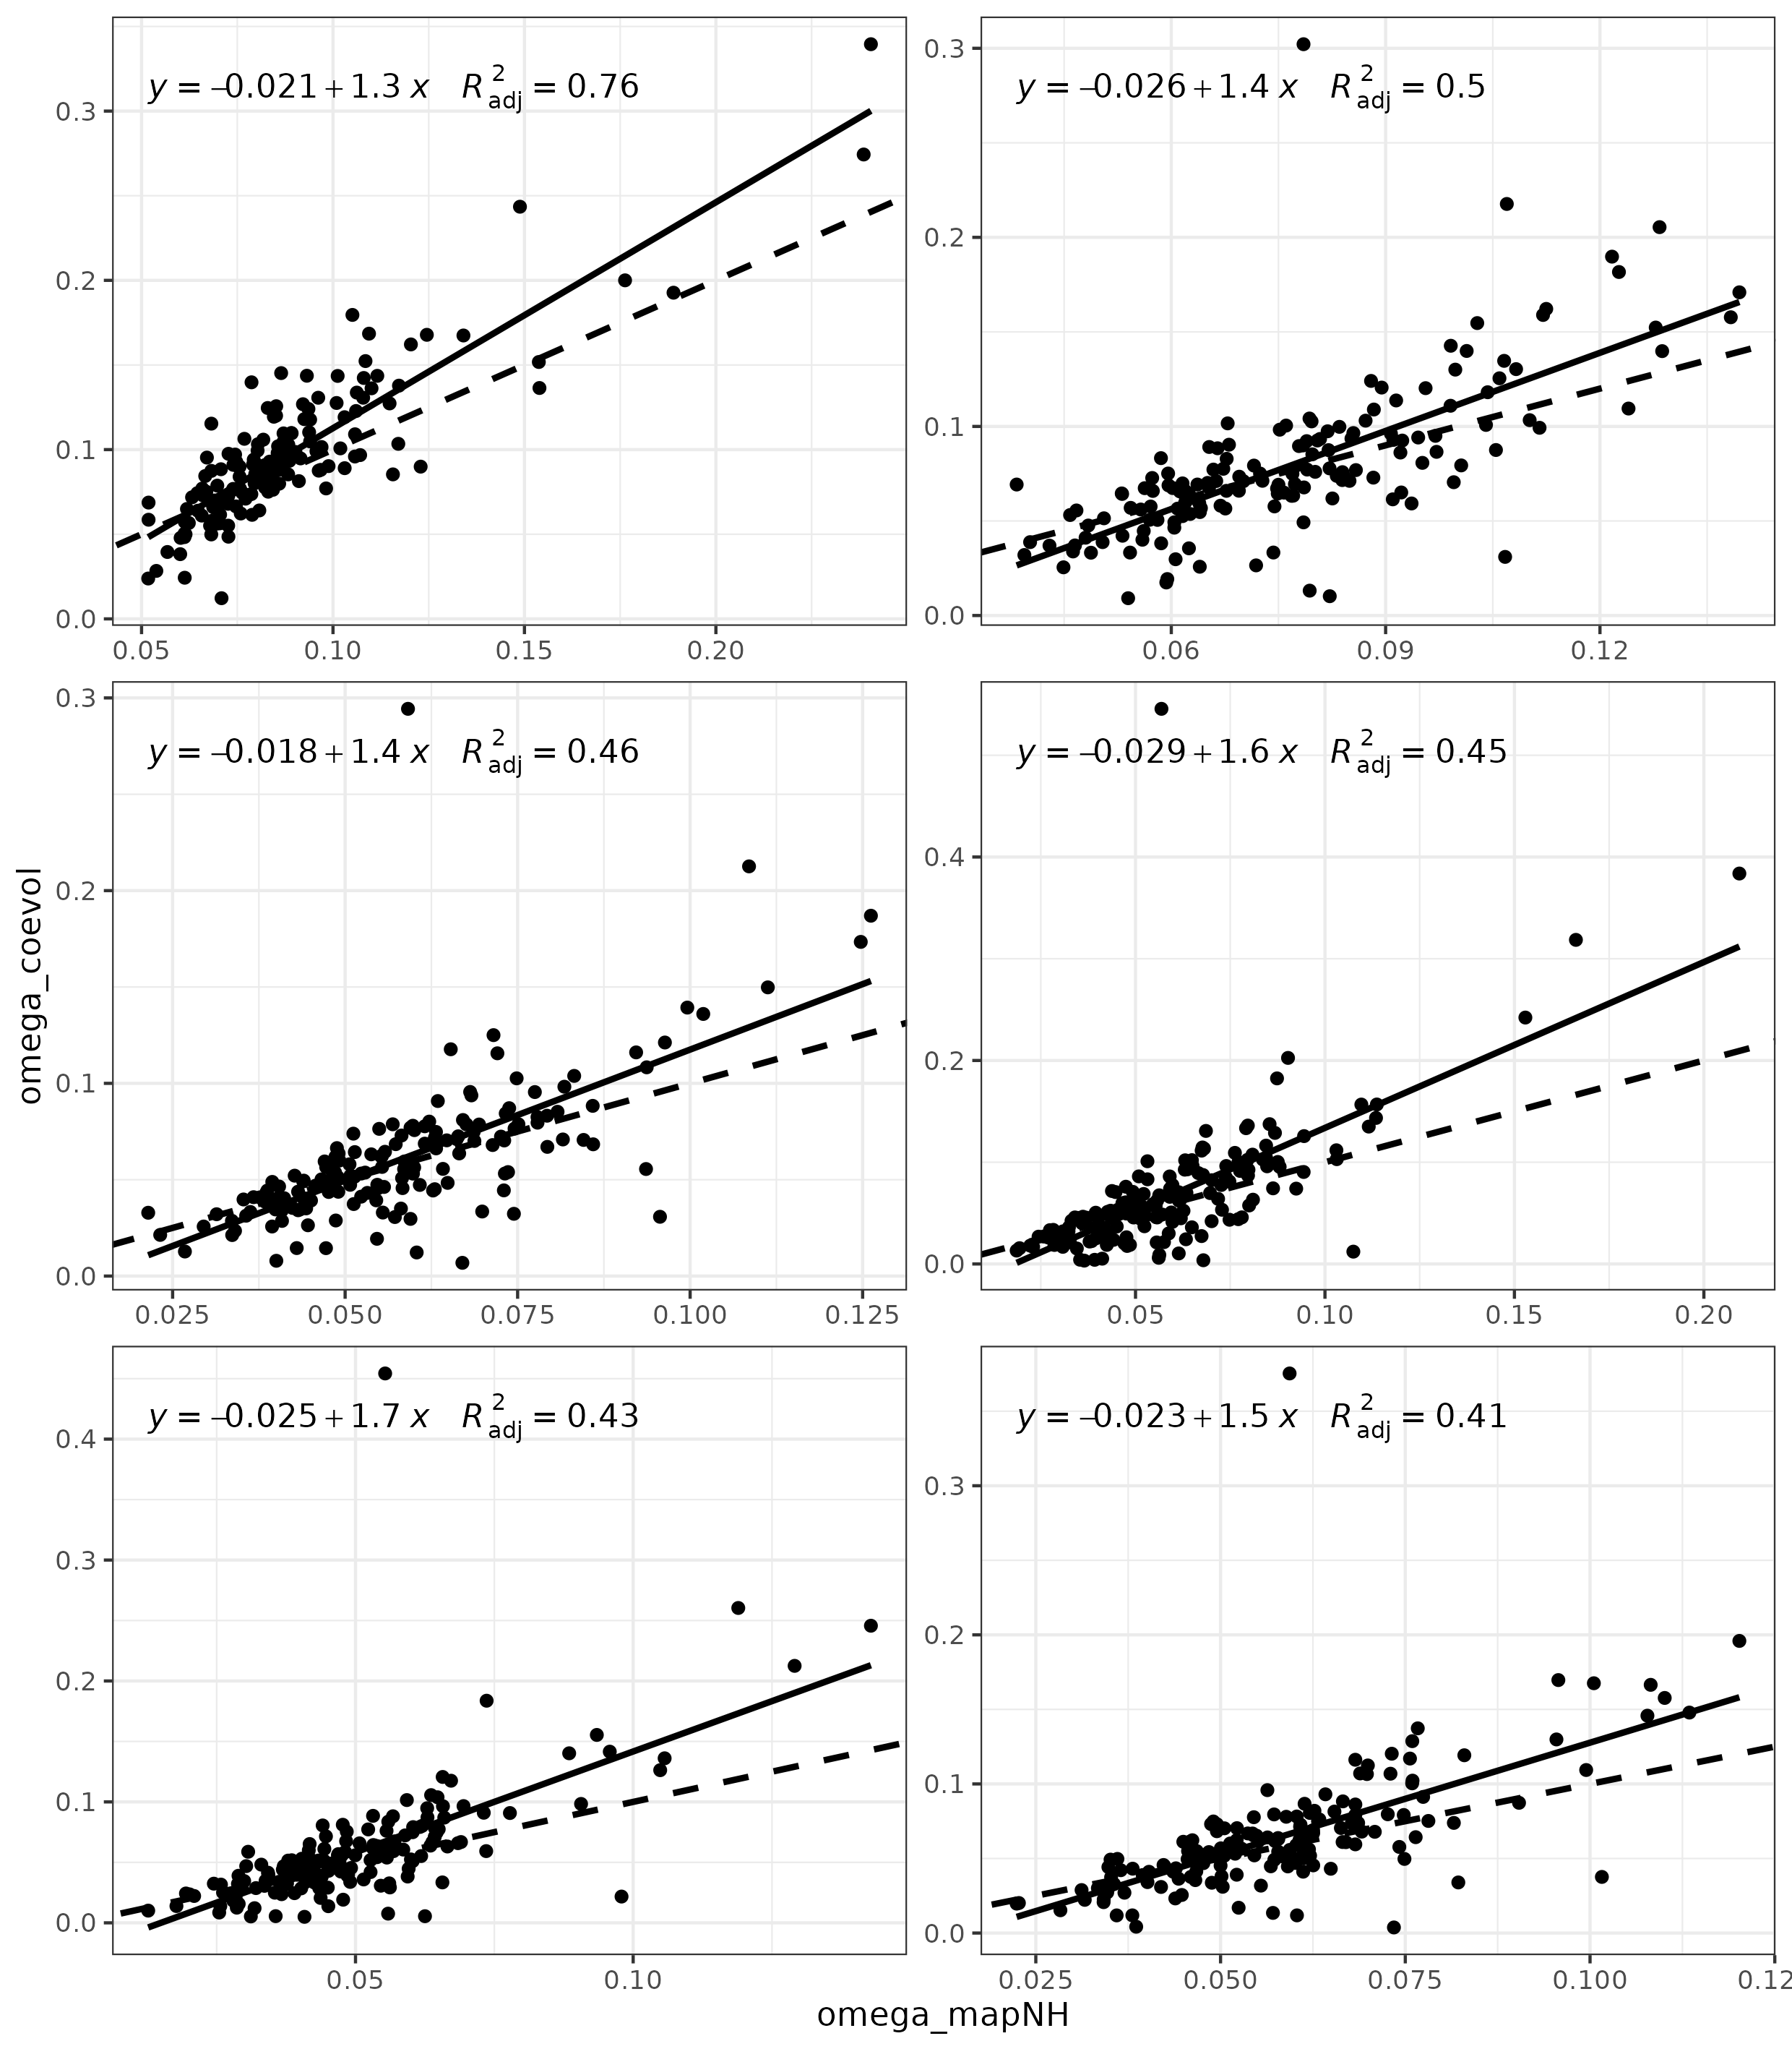Figure 7: Correlations between coevol and bpp per branch dN/dS estimate for six randomly sampled concatenates. Plain line corresponds to the modeled linear relationship and dashed line to y=x.

