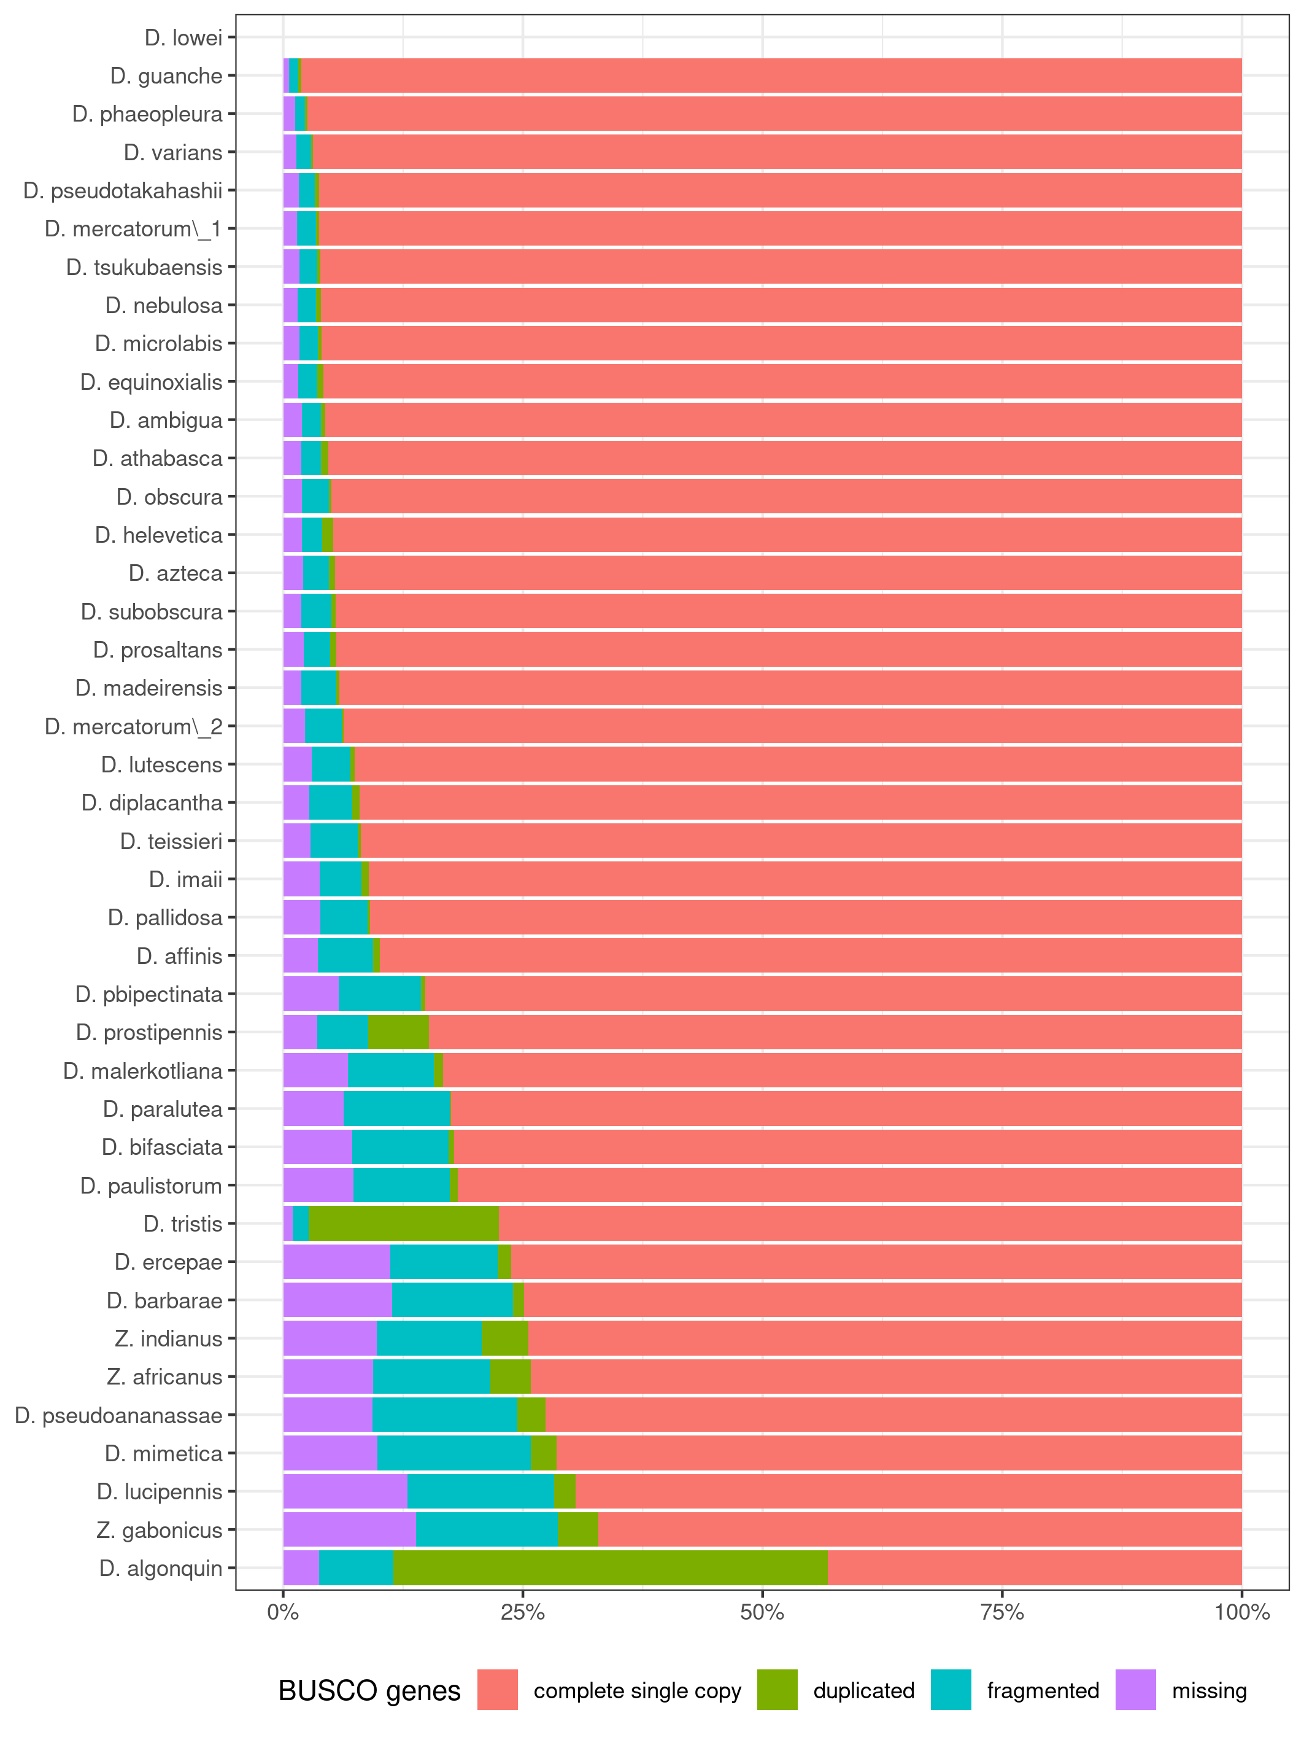Figure 1: BUSCO statstics of homemade assemblies. Note that due to poor quality D. algonquin, D. lowei and D. tristis assemblies were not further considered.

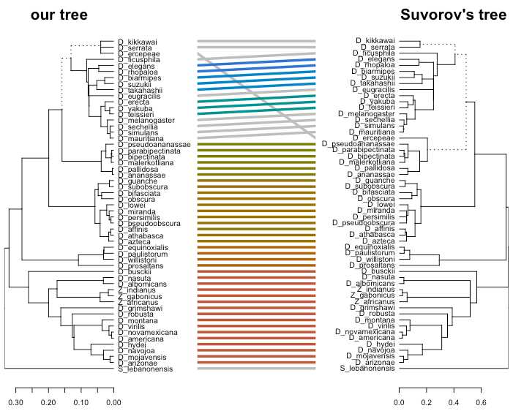Figure 2: Tanglegram comparing the established phylogeny with the one of Suvorov et al. (2020). Are represented the 55 species common to both studies.

