eCLINIC – INSTALL GUIDE

- Hardware/ Software Requirements
- Hardware
- A minimum computer system that will help you access all the tools in the courses is a Pentium 4 or better
- 512 MB of RAM or better
- HDD 10G free space available or better
- Software
- Operating system: Windows 8 (or higher if possible)
- Netbeans 8.02 or higher
- JDK 1.8 or higher (1.8 recommend)
- SQL Server 2012 or higher
- JDBC Driver 4

- Database file set up
- At first, extract file F2_131507T0_GROUP1-ECLINIC.7z. After extracted, there will be 2 subfolders: DIST_ECLINIC and SQL_File.
- Secondly, to run the software, you need to attach our database in database folder into your SQL Server application as follows:
- Step 1: Open SQL Server Management Studio
- Step 2: Attach the database: right Click into Database, select Attach
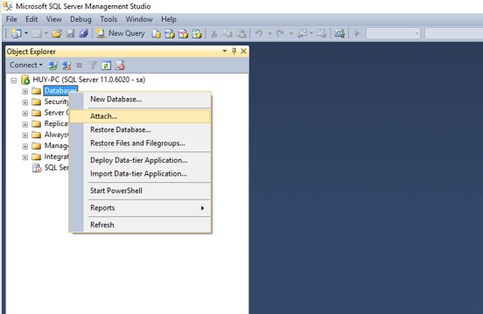

- Step 3: Click into Add, select file: eClinic.mdf from folder SQL_File which has been extracted at the beginning, and then click OK.
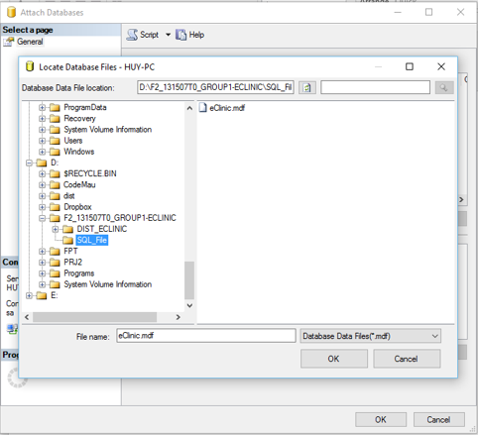

If no error display, install database file successfully!

***Note: If there is error, please do as following instruction:
- Go to folder SQL_File
- Right click into file eClinic.mdf, click Property → Security →Edit Permission, Full Control.
- Click OK
- Do the same with eClinic_log.ldf

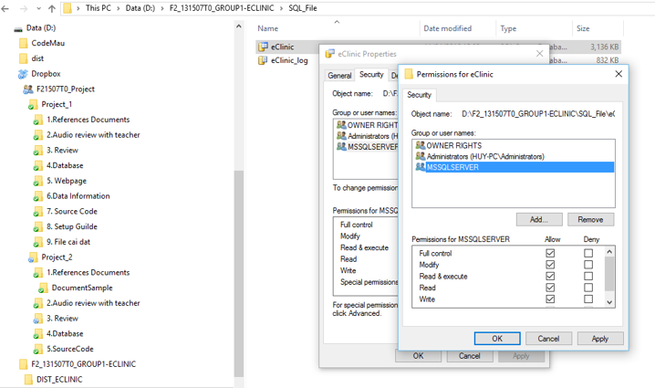

- Setup microsoft sql server tcp/ip connection and port
Application needs a connection to MS SQL database through TCP/IP, therefore if TCP/IP of MSSQLSERVER is disabled, data cannot be retrieved and in that case, application will be invalid.
Steps taken to enable TCP/IP of MSSQLSERVER:
- Click on Start Menu → All Programs → Microsoft SQL Server 2012 → Configuration Tools → SQL Server Configuration Manager.
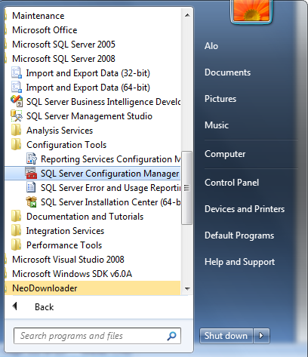

- On SQL Server Configuration Manager window, click on SQL Server Configuration Manager (Local) → SQL Server 2012 Network Configuration → Protocols for MSSQLSERVER, check whether TCP/IP is disabled or enabled. If enabled, assure that TCP/IP Port is set to 1433 and exit SQL Server Configuration Manager. If disabled, go to next step.

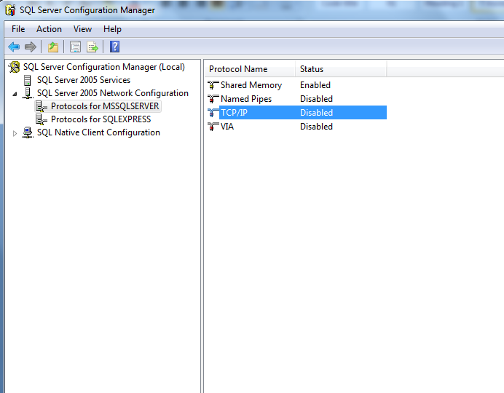

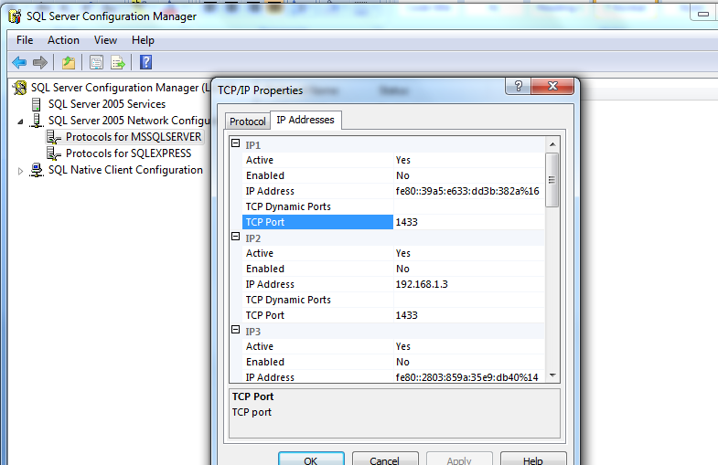

- Click on SQL Configuration Manager (Local) → SQL Server 2012 Services and stop.
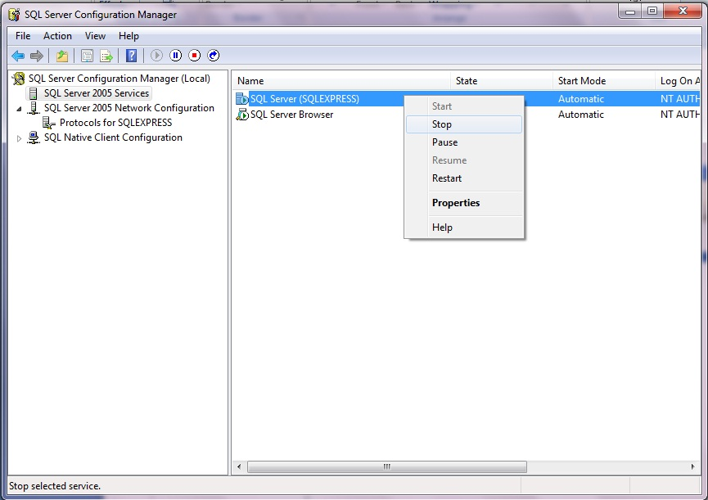

- Click on SQL Server Configuration Manager (Local) → SQL Server 2012 Network Configuration → Protocols for MSSQLSERVER and enable TCP/IP if it is disable, assure that TCP/IP Port is set to 1433.
- Restart MSSQLSERVER in SQL Server Services. And done.
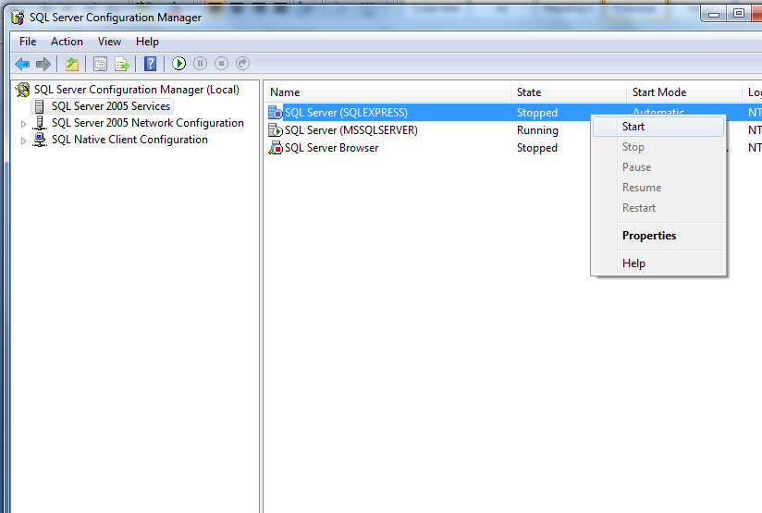

- Run the application
Execute file Project2_eClinic.jar from folder DIS_ECLINIC

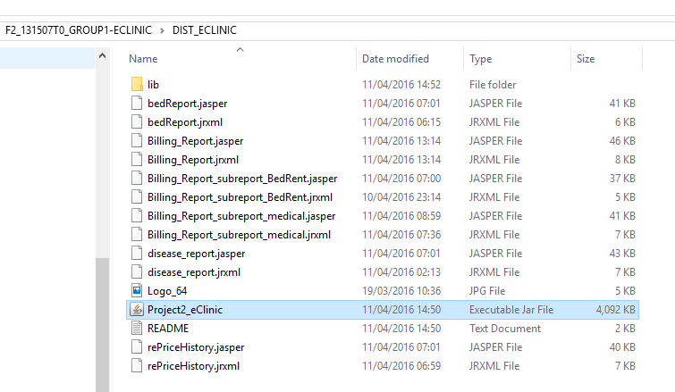
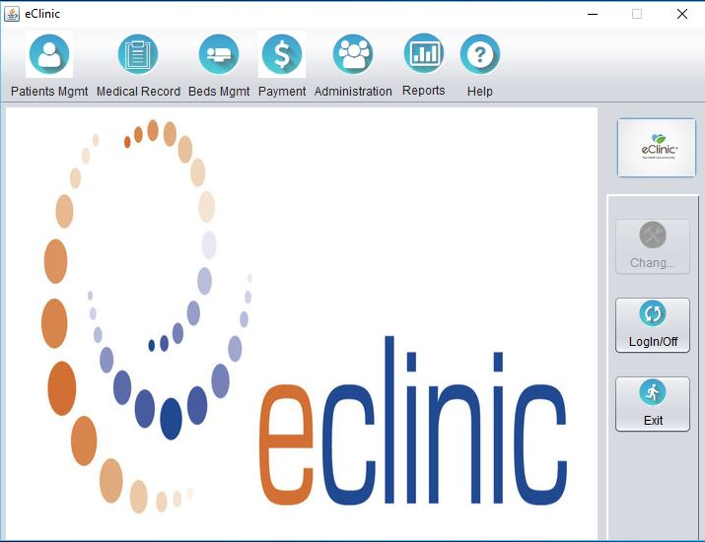
Main Form

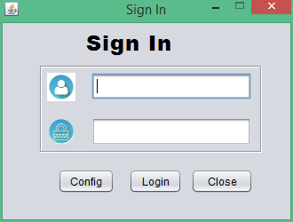
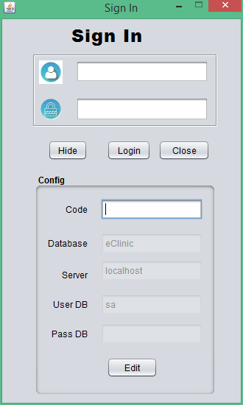
Sign In

Code to edit Configuration: 123456789

Login to application: eClinic
- Username Admin: huytran
Password: 123456
Role: Admin

- Username Receptionist: duyvu
Password: 123456
Role: Receptionist

- Username Nurse: duyetvu
Password: 123456
Role: Nurse

- Username General Affair Staff: phuongvo
Password: 123456
Role: GA Staff

