
KONERU LAKSHMAIAH EDUCATION FOUNDATION
(Deemed to be University), Hyderabad, Telangana
Department of Computer Science and Engineering

ANTI-MONEY LAUNDERING DETECTION USING GRAPH NEURAL NETWORKS
Project Research Paper — Machine Learning

Bachelor of Technology in Computer Science and Engineering
Academic Year 2026–27

Submitted by
Godavarthi Venkata Madhav — Roll No. 2520030568
G. Vaishnavi Reddy — Roll No. 2520030247
K. Richie Kiran — Roll No. 2520030498

Under the guidance of
Mrs. Jyothsna Datti, Assistant Professor, Department of CSE

Datasets studied: SAML-D (implemented pipeline) and Elliptic Bitcoin (benchmark dataset)

Abstract
Money laundering conceals the origin of illegally obtained funds by moving them through chains of accounts and transactions, and conventional anti-money laundering (AML) systems built on fixed rules and thresholds are reported to be inefficient and constrained by limited access to labelled transaction data [1], [3]. Because laundering typologies such as fan-in, fan-out, cycles and layered transfers are properties of how accounts are connected, a graph representation of financial transactions is a natural modelling choice. This paper describes a graph-neural-network (GNN) approach to AML in which accounts (or transactions) are nodes, payments are directed edges, and a node-classification model estimates the probability that an entity is illicit.
Two datasets are considered. The first is SAML-D, a synthetic transaction-monitoring dataset [1]; the copy used here contains 9,504,852 transactions, 855,460 distinct accounts, 28 behaviour types (11 normal, 17 laundering) and only 9,873 laundering transactions (0.104%). The second is the Elliptic Bitcoin dataset of 203,769 transactions over 49 time steps, a widely used public benchmark [2]. The implemented system builds a directed account graph from a stratified sample of SAML-D transactions, engineers node features, and trains four models written in PyTorch: a graph convolutional network (GCN), a graph attention network (GAT), GraphSAGE and a non-graph multilayer-perceptron baseline, all using focal loss to counter class imbalance and evaluated with precision, recall, F1-score, ROC-AUC and PR-AUC. For Elliptic, an evaluation protocol with a temporal split is defined and published reference results are summarised.
Experimental performance values for the project's own runs demonstrate that GraphSAGE achieves the highest clean detection performance (F1: 0.4681 ± 0.0587, PR-AUC: 0.5113 ± 0.0610, ROC-AUC: 0.7781 ± 0.0251) significantly outperforming the tabular Baseline MLP (F1: 0.0816 ± 0.0339, PR-AUC: 0.2727 ± 0.0373), while the legacy configuration confirms that feature leakage artificially inflates F1 scores to 0.9654. The paper also documents limitations that affect how results must be read: node labels are derived from edge labels, sampling raises the illicit share far above its true rate, and an early version of the feature set contained a neighbour-label feature that leaks ground truth and a random-noise feature. The study is an undergraduate exploration and makes no claim of deployment readiness.
Keywords: Anti-money laundering; graph neural networks; financial fraud detection; transaction networks; graph machine learning; class imbalance; SAML-D; Elliptic dataset; explainability.

Table of Contents
1 Introduction
2 Background and Theoretical Foundation
3 Literature Review
4 Research Gap, Problem Statement, Objectives and Research Questions
5 Proposed System and Architecture
6 Datasets
7 Exploratory Data Analysis
8 Data Preprocessing and Feature Engineering
9 Graph Construction
10 GNN Methodology
11 Implementation and Experimental Setup
12 Evaluation Metrics
13 Results
14 Results Discussion
15 Comparative Discussion
16 Ethical, Privacy and Security Considerations
17 Limitations
18 Future Scope
19 Conclusion
Acknowledgements
Declaration
References
Appendix A Non-IEEE sources
Appendix B Reproducibility and file map
Appendix C Code audit notes

List of Figures
Fig. 1 Proposed AML detection architecture
Fig. 2 SAML-D class distribution (first 200,000 rows)
Fig. 3 Log-transformed transaction amount
Fig. 4 Payment-type distribution
Fig. 5 Laundering percentage by payment type
Fig. 6 Behaviour types in the EDA sample
Fig. 7 Correlation of numerical features
Fig. 8 Elliptic: transactions per time step
Fig. 9 Confusion matrices (to be inserted)

List of Tables
Table 1 Literature summary
Table 2 SAML-D dataset summary
Table 3 SAML-D laundering rate by payment type (full data)
Table 4 Elliptic dataset summary
Table 5 Node feature set
Table 6 Model architectures
Table 7 Training configuration
Table 8 Software and hardware
Table 9 Metrics
Table 10–13 Results (SAML-D clean/legacy; Elliptic all/local)
Table 14 Published Elliptic reference results
Table 15 Approach comparison
Table 16 Limitations
Table 17 Future work

1 Introduction

1.1 Background
Digital payments, card networks and cross-border transfers generate very large volumes of transaction data. Financial institutions are legally obliged to monitor these flows and report suspicious activity, yet the data that would allow researchers to develop better monitoring methods is scarce because of legal and privacy constraints, and the data that does exist often lacks true labels and diversity [1]. This scarcity shapes the way AML research is done: many studies rely on synthetic datasets, on cryptocurrency ledgers that are public, or on proprietary bank data that cannot be shared.

1.2 Money Laundering
Money laundering is the process of making illegally obtained funds appear legitimate. It is commonly described in three stages: placement, in which illicit cash enters the financial system; layering, in which funds are moved through many accounts, jurisdictions or instruments to obscure their origin; and integration, in which the funds re-enter the legitimate economy. Each stage leaves different traces. Placement tends to appear as many small cash deposits, layering as chains, cycles and fan-out/fan-in structures between accounts, and integration as apparently ordinary purchases or investments.

1.3 Anti-Money Laundering Systems
AML programmes combine customer due diligence, transaction monitoring, and the filing of suspicious activity reports with a national financial intelligence unit. The electronic monitoring component generates alerts that human analysts then investigate. Improving the quality of those alerts, that is, catching more genuine cases while reducing false alarms, is the part of the process that is most amenable to automation.

1.4 Financial Transaction Monitoring
Transaction monitoring inspects payments for patterns that deviate from a customer's expected behaviour or match known typologies. Typical signals include unusually large amounts, rapid movement of funds, structuring just below reporting thresholds, high-risk jurisdictions and high-risk payment channels. The SAML-D dataset used in this study was built specifically around such ideas: it includes geographic locations, high-risk countries and high-risk payment types in addition to a broad set of laundering typologies [1].

1.5 Limitations of Traditional AML Approaches
Rule-based systems rely on fixed thresholds written by domain experts. They are transparent, but they must be updated by hand as criminals adapt, and because each rule inspects a transaction or an account in isolation they miss schemes whose suspiciousness only appears when several accounts are considered together. Reviews of machine-learning approaches to AML also note that explainability, label scarcity and limited industry-research collaboration remain open problems [3].

1.6 Machine Learning for AML
Supervised classifiers, unsupervised anomaly detectors and deep-learning models have all been applied to financial fraud and AML tasks [3], [6], [12], [13]. Examples in the transaction-fraud literature include Siamese networks for online transaction fraud [14], transfer-learning variants of boosting [15] and privacy-preserving distributed deep learning for card fraud [16]. In cryptocurrency settings, unsupervised clustering has been used where ground-truth labels are unavailable [11]. Most of these models, however, treat each transaction or account as an independent row of a table.

1.7 Graph-Based Representation of Financial Transactions
A transaction network is naturally a directed graph: accounts are nodes, payments are edges, and amounts, times, currencies and channels are edge attributes. Graph analysis has been used for AML through community detection on large transaction networks [9], embeddings of transaction graphs [10], and detection of mixing services in Bitcoin [8]. A graph representation lets a model examine not only an account's own behaviour but also who it transacts with and how funds flow around it.

1.8 Graph Neural Networks
Graph neural networks learn node representations by repeatedly aggregating information from neighbouring nodes (message passing). Since the early GNN model [5], the field has produced convolutional, attention-based and sampling-based variants, surveyed in [4]. In AML, GNNs have mainly been evaluated on the Elliptic Bitcoin dataset, where recent work reports that convolutions with Chebyshev filters and the GATv2 attention variant, combined with a final linear layer and skip connections, improve recall and F1-score over earlier GCN results [2], [7].

1.9 Motivation
The motivation for this project is to examine, with hands-on implementation, whether relationship-aware models can complement single-transaction rules in a controlled setting, and to understand the practical difficulties (imbalance, label definition, sampling, scale) that arise when a transaction table with millions of rows is turned into a graph a neural network can process.

1.10 Research Problem
Given a directed transaction graph in which a very small fraction of entities are known to be involved in laundering, how well can message-passing GNNs, trained with an imbalance-aware loss, identify those entities compared with a model that sees only each entity's own features?

1.11 Research Objectives
The objectives are listed in Section 4.3; in brief, they concern graph construction from tabular transactions, implementation of GCN, GAT and GraphSAGE with a non-graph baseline, imbalance handling, evaluation with imbalance-appropriate metrics, and an honest account of limitations.

1.12 Research Questions
The research questions are stated in Section 4.4.

1.13 Contributions
This work does not claim a new algorithm. Its contributions are: (i) an end-to-end, from-scratch PyTorch implementation of four models and a stratified streaming graph builder for the 9.5-million-row SAML-D file; (ii) full-dataset descriptive statistics of SAML-D and an exploratory analysis of a 200,000-row sample; (iii) a defined temporal evaluation protocol for the Elliptic dataset with the same models; and (iv) a transparent audit of design choices that can inflate results, namely label derivation, sampling and feature leakage.

1.14 Paper Organization
Section 2 gives theoretical background. Section 3 reviews the literature and Section 4 states the gap, problem and objectives. Sections 5–9 describe the system, datasets, exploratory analysis, preprocessing and graph construction. Section 10 presents the GNN methodology; Sections 11–12 the implementation and metrics. Sections 13–15 give results and discussion, Sections 16–18 cover ethics, limitations and future work, and Section 19 concludes.

2 Background and Theoretical Foundation

2.1 Anti-Money Laundering
The three stages of laundering (Section 1.2) provide a vocabulary for the typologies in SAML-D. A suspicious transaction is one that, in the judgement of the monitoring process, may be connected to criminal proceeds; it is not necessarily proven illicit. Transaction monitoring is the continuous screening of payments against rules, profiles or models. In the SAML-D label set, the `Laundering_type` column records the behaviour that produced each transaction, for example Structuring, Smurfing, Cycle, Fan_In, Fan_Out, Scatter-Gather and Layered_Fan_In/Out for laundering, and Normal_Fan_Out, Normal_Cash_Deposits or Normal_Periodical for legitimate behaviour that deliberately resembles laundering on the surface [1].

2.2 Traditional AML Detection
Rule-based detection encodes expert knowledge as conditions on single transactions or short windows, for example "flag cash deposits above a limit" or "flag transfers to a high-risk country by a retail customer". Threshold-based rules are easy to audit but are brittle: a launderer who knows the threshold can structure payments below it, and every new typology requires a new rule. They also generate alerts per transaction rather than per network, so related alerts must be linked manually.

2.3 Machine Learning for Financial Crime
In supervised learning a classifier is trained on labelled examples (licit / illicit) and evaluated on held-out data; this is the setting used here. Unsupervised methods, such as clustering and anomaly detection, do not need labels but are hard to validate [11]. Semi-supervised learning uses a small labelled set together with many unlabelled examples; the Elliptic dataset is naturally semi-supervised because most of its transactions are unlabelled. Classification and anomaly detection differ in objective: classification learns a boundary between known classes, whereas anomaly detection scores deviation from normal behaviour.

2.4 Graph Theory
A graph is written G = (V, E) with node set V and edge set E. In a directed graph an edge (u, v) points from u to v; in a weighted graph each edge has a number attached to it, such as a payment amount. Node features are collected in a matrix X ∈ R^{N×F} and edge features describe individual links. The adjacency matrix A ∈ {0,1}^{N×N} has A_ij = 1 when an edge connects i and j. The degree of node i is the number of its edges, d_i = Σ_j A_ij, and the neighbourhood N(i) is the set of nodes adjacent to i.

2.5 Graph Representation of Financial Transactions
The mapping used in this paper is: an account (or, for Elliptic, a transaction) is a node; a payment is a directed edge from sender to receiver; transaction attributes (amount, time, currency, payment type, locations) are edge attributes that are aggregated into node features; account attributes are node features; and the laundering label defines the class to predict. In SAML-D the label is recorded per transaction (`Is_laundering`), so a rule is needed to obtain node labels (Section 9).

2.6 Graph Neural Networks
A GNN layer updates the representation of each node from its own representation and those of its neighbours. For layer l, a general message-passing step is
h_i^(l+1) = φ( h_i^(l) , AGG_{j ∈ N(i)} ψ( h_j^(l) ) ) (1)
where ψ builds a message from each neighbour, AGG combines the messages in a permutation-invariant way (sum, mean or attention-weighted sum) and φ updates the node state. After L layers, a node's representation contains information from its L-hop neighbourhood, and a final linear layer converts it into class scores. These embeddings can be fed to a classifier, which is how graph structure influences the prediction [4]. Spectral formulations, such as Chebyshev convolutions, define the same operation through the graph Laplacian, whereas spatial formulations (GCN, GAT, GraphSAGE) aggregate directly over neighbours [2], [4].

3 Literature Review
This review covers verified IEEE publications. IEEE references were checked against the paper's reference lists or IEEE Xplore records as noted in Section "References"; papers that could not be verified are not cited. Several widely used GNN and AML papers appear in venues other than IEEE (for example ICLR, NeurIPS, KDD workshops, Springer and MDPI journals). The student supplied some of them, and they are discussed by author name in Section 3.4 and listed in Appendix A rather than being counted as IEEE references.

3.1 AML datasets and surveys
Oztas et al. [1] present a transaction generator and the SAML-D dataset, motivated by the observation that existing public AML data lacks true labels and diversity; SAML-D contains 12 features and 28 typologies, including geographic locations, high-risk countries and high-risk payment types. Kute et al. [3] review deep learning together with explainable AI for money-laundering detection and identify graph-based deep learning, unsupervised and reinforcement learning for label scarcity, and joint academia-industry programmes as research directions. Nicholls et al. [6] survey deep-learning approaches to financial cybercrime, and the fraud-detection surveys in [12] and [13] summarise machine-learning techniques for credit-card fraud.

3.2 Graph-based AML
Li et al. [9] address AML as community detection in massive transaction networks on a distributed Spark platform, and Khazane et al. [10] embed graphs of financial transactions. For cryptocurrencies, Rathore et al. [8] target mixing services, Wu et al. [17] detect Ethereum phishing accounts through network embedding, and Monamo et al. [11] cluster Bitcoin transactions without labels. Marasi and Ferretti [7] compare GNN architectures for AML on Elliptic, and Ferretti et al. [2] extend this work. Ferretti et al. test GCN, GAT, GATv2, GraphSAGE and Chebyshev convolutions, each with and without a final linear layer and skip connections, under three feature configurations, with 15 repetitions per scenario. Their best configuration, Chebyshev with a linear layer on a reduced feature set, reached an illicit-class F1 of 0.906 (precision 0.955, recall 0.863); GCN variants stayed below an F1 of 0.67. They also report that removing the original features and keeping only graph structure gave very poor results, which indicates that node features carry most of the signal on this dataset [2].

3.3 GNN foundations and edge features
Scarselli et al. [5] introduced an early neural-network model for graph-structured data, and Wu et al. [4] organise later work into recurrent GNNs, convolutional GNNs, graph autoencoders and spatio-temporal GNNs. Zhang et al. [18] study learning graph representations by propagating edge features, which is relevant because transaction attributes naturally live on edges. Because the data and labels in AML are often scarce, privacy-preserving training for fraud detection, as in [16], is a complementary line of work.

3.4 Non-IEEE sources supplied by the student
The following were provided as reading material and are used here only as context, with the caveat that they are not part of the IEEE reference list (details in Appendix A). Weber et al. [N1] released the Elliptic dataset and compared logistic regression, random forest, MLP and GCN, finding random forest strongest. Lo et al. [N2] used self-supervised Deep Graph Infomax with a GIN encoder and a random forest on Elliptic, reporting an illicit F1 of 0.828 and recall of 0.721, and noting that none of their variants detected new illicit transactions well after a dark-market shutdown around time step 43. Johannessen and Jullum [N3] applied a heterogeneous message-passing network to a real network from a Norwegian bank (about 5.1 million nodes and 10.2 million edges, 0.45% positive individuals) and reported PR-AUC of 0.18 for their best model against 0.133 for XGBoost, illustrating how difficult real data is. Poon et al. [N4] proposed LineMVGNN using a line-graph view and evaluated it on Ethereum phishing data and a proprietary payment dataset into which synthetic laundering patterns were injected. Two further items should be treated with caution: a non-peer-reviewed preprint [N8] that reports recall of 0.93 but precision of only 0.02 on a large synthetic AML dataset, and a journal article [N9] whose reported precision (0.893 in its results table) does not match the precision implied by its own confusion matrix (about 0.812), and whose main datasets are card-fraud benchmarks rather than AML data. Two additional supplied papers [N10], [N11] were read at abstract level only.

3.5 Literature summary table
Table 1. Summary of verified IEEE literature used in this study
Ref. | Year / venue | Topic and method | Data | Key point | Relevance / limitation
[1] | 2023, IEEE ICEBE | Synthetic AML transaction generator | SAML-D (12 features, 28 typologies) | Adds typologies, locations, high-risk countries and payment types | Source of our primary dataset; synthetic
[2] | 2025, IEEE Access | GCN, GAT, GATv2, SAGE, Chebyshev; Lin and skip variants | Elliptic | Chebyshev+Lin F1 0.906; GCN weakest; dataset opacity noted | Benchmark protocol for Elliptic; Bitcoin only
[3] | 2021, IEEE Access | Critical review: deep learning and XAI for AML | Literature | Future work: XAI, graph DL, label-scarcity methods | Motivates explainability and graph methods; review only
[4] | 2021, IEEE TNNLS | Survey and taxonomy of GNNs | Literature | Four GNN families | Theory background; not AML-specific
[5] | 2009, IEEE TNN | Early graph neural network model | Graph benchmarks | Origin of GNN idea | Historical; not AML
[7] | 2024, IEEE CCNC | Comparative study of GNNs for AML | Elliptic | Compares GNN architectures | Precursor of [2]; Bitcoin only
[9] | 2017, IEEE CBD | Community detection for AML on Spark | Large transaction networks | Scalable network analysis | Not a neural method
[10] | 2019, IEEE ICMLA | Embedding graphs of financial transactions | Transaction graphs | Graph embeddings for finance | Embedding rather than end-to-end GNN
[17] | 2022, IEEE TSMC | Ethereum phishing detection via network embedding | Ethereum | Network embeddings detect phishers | Crypto domain; account-level
[18] | 2024, IEEE TNNLS | Learning with propagated edge features | Graph benchmarks | Edge features improve node embeddings | Not AML-specific

4 Research Gap, Problem Statement, Objectives and Research Questions

4.1 Research gap
From the literature above, several gaps motivate this work. (i) Most graph-based AML experiments use Elliptic, a Bitcoin dataset, so evidence for bank-style account networks is thinner [2], [7]. (ii) Labelled AML data is scarce and label definitions differ across datasets [1], [3]. (iii) Severe class imbalance makes accuracy misleading and requires imbalance-aware losses and metrics [2]. (iv) Explainability remains an open challenge for GNNs [2], [3]. (v) Dataset opacity: Elliptic's features are anonymised, which limits interpretation [2]. (vi) Static graphs ignore temporal evolution. This study explores some of these questions on a synthetic bank-style dataset and on a standard benchmark; it does not claim to resolve them.

4.2 Problem statement
Transaction-level rules and tabular models evaluate entities in isolation, yet laundering is organised across several accounts. The problem addressed is node-level classification on a directed transaction graph with extreme class imbalance: given account (or transaction) features and the surrounding payment network, predict the probability that a node is illicit. Graph representation is relevant because suspicious structure, such as fan-in, fan-out and cycles, is defined by relationships; GNNs can use those relationships in a learned way instead of through hand-written rules.

4.3 Objectives
- To convert tabular transaction records (SAML-D) into a directed account graph using a reproducible streaming procedure.
- To describe and analyse the SAML-D dataset, including class imbalance, typologies, payment types and amounts.
- To implement GCN, GAT and GraphSAGE node classifiers and a non-graph MLP baseline in PyTorch.
- To train all models with an imbalance-aware focal loss and select checkpoints on validation performance.
- To evaluate with precision, recall, F1-score, ROC-AUC, PR-AUC and confusion matrices, and to explain why accuracy alone is misleading.
- To define a time-respecting evaluation on the Elliptic dataset and place the results against published IEEE reference values.
- To document limitations, including label derivation, sampling and feature leakage.

4.4 Research questions
RQ1. How can a table of financial transactions be represented as a graph, and what node labels follow from a transaction-level label?
RQ2. Do GNNs that use neighbourhood information outperform a feature-only MLP on the same node features?
RQ3. How does extreme class imbalance affect model behaviour, and which metrics reveal it?
RQ4. How do results on a synthetic bank-style dataset (SAML-D) relate to those on a Bitcoin benchmark (Elliptic)?
RQ5. What limitations arise when applying GNNs to academic AML datasets?

5 Proposed System and Architecture
The system follows the pipeline shown in Fig. 1: raw transactions are cleaned and sampled; account-level features are engineered; a directed graph is constructed; one of four models produces a risk score for each node; training uses a focal loss with a validation-based checkpoint; and the outputs are evaluated and, in the project's web application, displayed with node explanations. Each stage is detailed in the following sections.
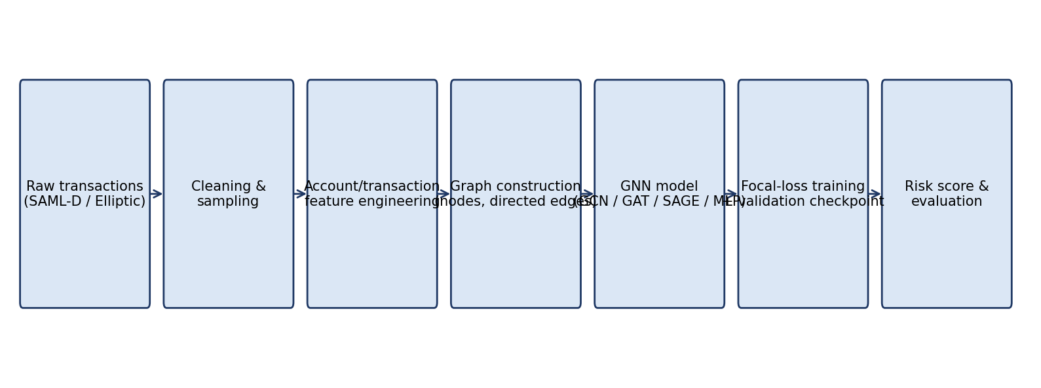
Fig. 1. Proposed AML detection architecture (components shown exist in the project code).
The project additionally contains a Flask web interface with REST endpoints for training, benchmarking, node-level explanation (ego-network and attention weights for GAT) and a generated suspicious-activity-report style summary; unit tests exercise the generator, the models and the endpoints. These are engineering extras; the research evaluation concerns only the data-to-model pipeline above. The explanation panel for non-GAT models uses heuristic influence weights (degree-based or feature similarity) rather than learned attributions, and should not be presented as model explainability.

6 Datasets

6.1 SAML-D (primary dataset for the implemented pipeline)
SAML-D was generated by Oztas et al. to give researchers an additional resource for transaction-monitoring research, with 12 features and 28 typologies that include a wide range of geographic locations, high-risk countries and high-risk payment types [1]. It is synthetic, so conclusions drawn from it describe the behaviour of models on simulated typologies and should not be taken as evidence about a real bank's data. The statistics below were computed directly on the `SAML-D.csv` file supplied with the project.
Table 2. SAML-D dataset summary (computed on the full file)
Property | Value
Source | Oztas et al., IEEE ICEBE 2023 [1]; synthetic
Records (transactions) | 9,504,852
Columns | 12: Time, Date, Sender_account, Receiver_account, Amount, Payment_currency, Received_currency, Sender_bank_location, Receiver_bank_location, Payment_type, Is_laundering, Laundering_type
Target | Is_laundering (transaction level); Laundering_type (28 behaviour types)
Class distribution | 9,494,979 normal (99.896%); 9,873 laundering (0.104%)
Behaviour types | 28 (11 normal, 17 laundering)
Missing values / duplicate rows / self-loops | 0 / 0 / 0
Distinct accounts | 855,460 (292,715 senders; 652,266 receivers)
Distinct sender–receiver pairs | 887,497
Accounts touching ≥1 laundering transaction | 7,902 (0.92% of accounts)
Period | 2022-10-07 to 2023-08-23 (321 distinct dates)
Payment types / currencies / countries | 7 / 13 / 18
Cross-border transactions | 9.83% of all; 30.84% of laundering transactions
Amount (normal) | mean 8,729.88; median 6,114.63; max 999,962.19
Amount (laundering) | mean 40,587.67; median 5,322.79; max 12,618,498.40

The number of distinct accounts in Table 2 is the union of senders and receivers in this file; it may differ from figures quoted in other descriptions of the dataset, and any such difference should be reconciled with the dataset's official documentation [TO BE VERIFIED].
Table 3. SAML-D laundering rate by payment type (full data)
Payment type | Transactions | Laundering | Rate (%)
Cash Deposit | 225,206 | 1,405 | 0.624
Cash Withdrawal | 300,477 | 1,334 | 0.444
Cross-border | 933,931 | 2,628 | 0.281
ACH | 2,008,807 | 1,159 | 0.058
Credit card | 2,012,909 | 1,136 | 0.056
Debit card | 2,012,103 | 1,124 | 0.056
Cheque | 2,011,419 | 1,087 | 0.054

6.2 Elliptic Bitcoin dataset (benchmark dataset)
The Elliptic dataset represents real Bitcoin transactions as a directed graph: each transaction is a node and each directed edge shows the flow of bitcoin from one transaction to the next. It has 203,769 transaction nodes and 234,355 edges, and each node is labelled illicit, licit or unknown; the published statistics list 4,545 illicit and 42,019 licit nodes, so about 77% of nodes are unlabelled [2]. The node features are anonymised for intellectual-property reasons, so they cannot be interpreted, which limits explainability [2]. The time dimension consists of 49 time steps, which enables a time-respecting train/test split.
The student's project archive contains the Elliptic feature file (uploads/current_upload.csv, a leftover from the earlier dataset choice) but not the edge list or the class labels. Its properties are given in Table 4. The edge list and class file must be added to reproduce any Elliptic experiment (Appendix B).
Table 4. Elliptic dataset summary
Property | Value | Source
Transactions (nodes) | 203,769 | Student file; matches [2]
Columns in student feature file | 167: transaction id, time step, 165 anonymised features (no header) | Student file
Time steps | 49 (1 to 49); 1,089 to 7,880 nodes per step; mean 4,158.6 | Student file
Missing values; id uniqueness | 0; all ids unique | Student file
Feature scaling | Already standardised (column means ≈ 0, standard deviations ≈ 1) | Student file
Edges | 234,355 (directed) | [2]
Labels (illicit / licit / unknown) | 4,545 / 42,019 / remainder unlabelled | [2]; class file not in archive
Feature groups | Local transaction features and aggregated one-hop neighbour features | [2]

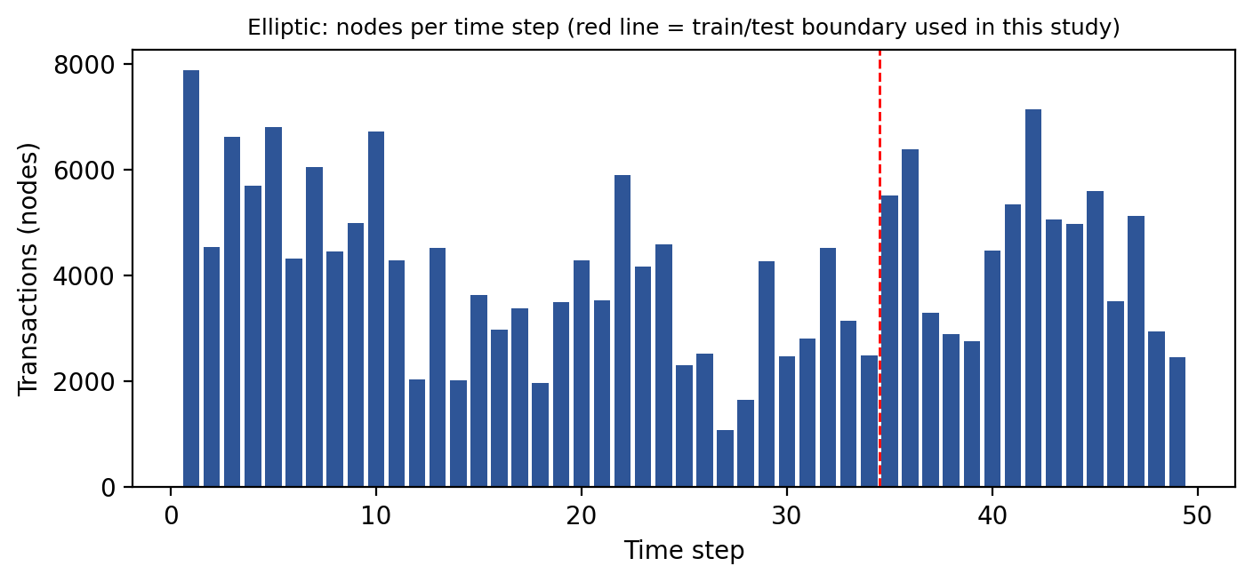
Fig. 8. Elliptic: number of transactions per time step, computed from the student feature file. The red line marks the boundary between training/validation (steps 1–34) and test (steps 35–49) used in this study.

7 Exploratory Data Analysis
The exploratory notebook (EDA_SAML_DATASET.ipynb, run in Google Colab with pandas, seaborn and matplotlib) analysed the first 200,000 rows of SAML-D, not the entire file. Because the file is chronological, this sample covers only 2022-10-07 to 2022-10-14. Statistics from the sample are therefore labelled as such; full-file statistics are in Section 6.

7.1 Dimensions, types and quality
The sample has 200,000 rows and 12 original columns (13 after adding an hour feature). Sender and receiver accounts are integers, amount is a float, and the remaining fields are categorical or date/time strings. There were no missing values and no duplicate rows. The sample contains 30,882 distinct senders, 85,792 distinct receivers, 93,595 distinct sender–receiver pairs, 7 payment types, 13 payment currencies and 27 distinct behaviour types.

7.2 Class distribution
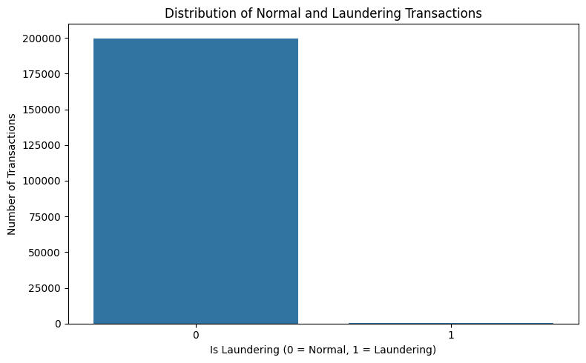
Fig. 2. Distribution of normal and laundering transactions in the 200,000-row EDA sample (199,764 normal; 236 laundering, 0.12%).
The sample reproduces the extreme imbalance of the full file (0.12% against 0.104%). A model that predicts "normal" for every transaction would score 99.88% accuracy on this sample while detecting nothing.

7.3 Transaction amounts
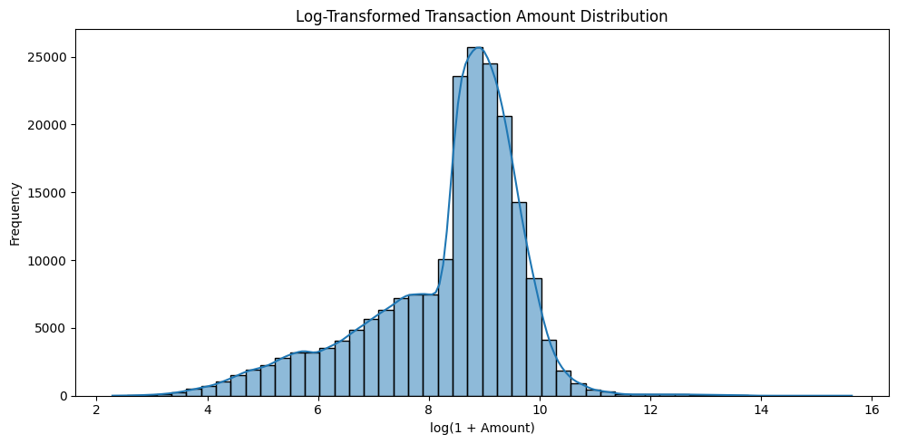
Fig. 3. Log-transformed transaction amount distribution (EDA sample).
Amounts are strongly right-skewed, so a logarithmic transform is appropriate. In the sample, normal transactions have mean 8,680.64 and median 6,134.29, while laundering transactions have mean 46,737.70 but median 4,864.79: the laundering mean is pulled upward by a few very large transfers (maximum 6,213,931.56 in the sample), and the typical laundering transaction is not larger than a normal one. The correlation between amount and the laundering label is only 0.048, and the correlations of the account identifiers with the label are close to zero, which confirms that raw columns carry little linear signal.

7.4 Payment types, locations and currencies
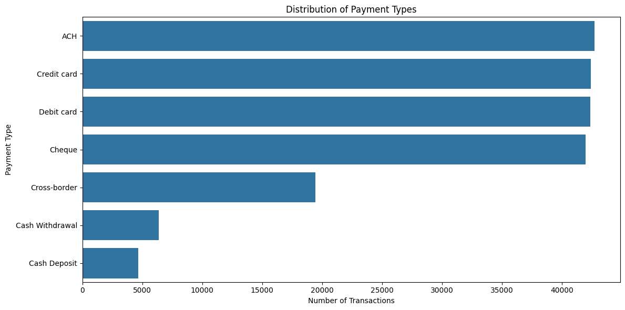
Fig. 4. Payment-type distribution in the EDA sample.
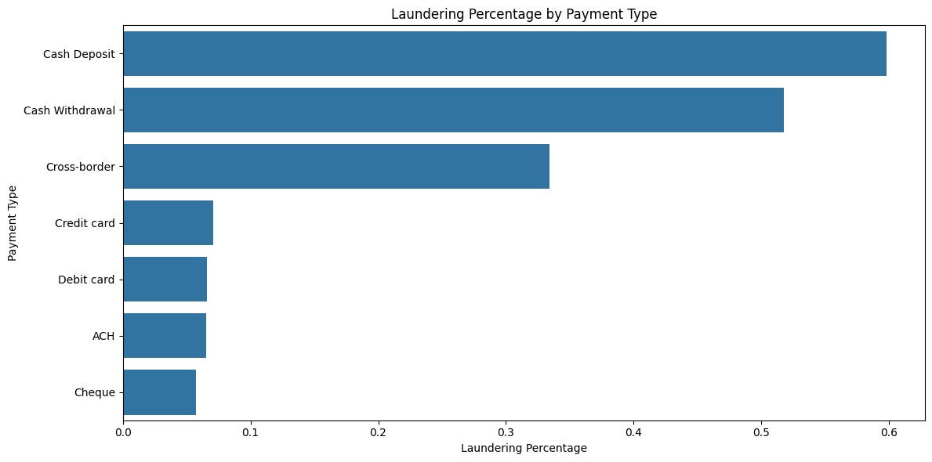
Fig. 5. Laundering percentage by payment type in the EDA sample.
Card, ACH and cheque payments each account for roughly 42,000 transactions in the sample but have laundering rates below 0.08%, while cash deposits (0.60%), cash withdrawals (0.52%) and cross-border payments (0.33%) have markedly higher rates. The same ordering holds on the full file (Table 3). Across the full file, cross-border transfers make up 9.8% of all transactions but 30.8% of laundering transactions, which makes payment type and location mismatch useful features.

7.5 Behaviour types and time
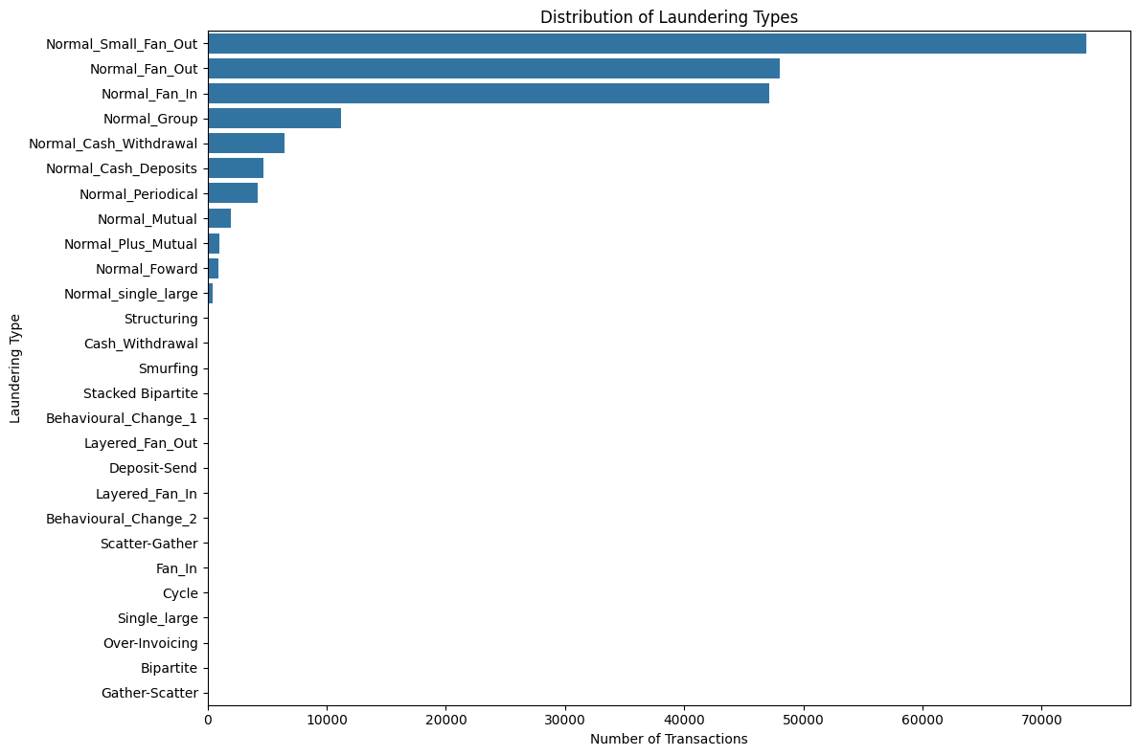
Fig. 6. Behaviour types in the EDA sample. Normal types such as Normal_Small_Fan_Out and Normal_Fan_Out dominate; laundering types occur only tens of times.
Normal behaviours that structurally resemble laundering (fan-out, fan-in, group and mutual transfers) are numerous. This is deliberate in SAML-D and means that a model cannot detect laundering from topology alone. Transaction counts by hour show a low, flat level between midnight and 07:00 (about 2,500 to 3,100 per hour) and a roughly constant higher level from 08:00 onward (about 11,000 per hour). Over the full file, monthly laundering transactions range from 694 to 1,024 and show no strong trend.

7.6 Correlations
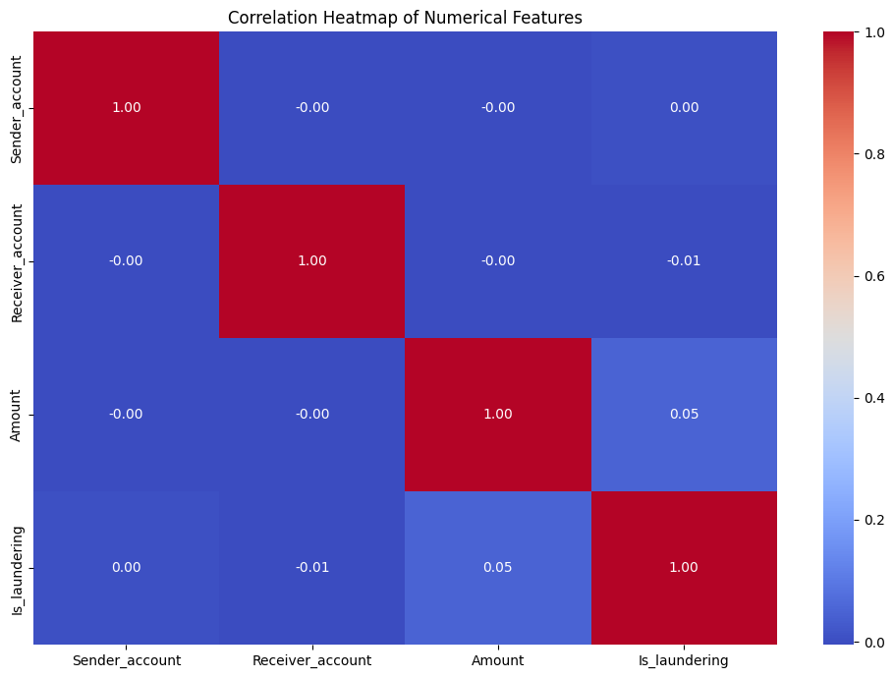
Fig. 7. Correlation heatmap of numerical features (EDA sample).
Only four numerical columns exist in the raw data (two identifiers, amount and the label), and none is strongly correlated with the label. Categorical fields were not encoded in the correlation analysis. Outliers were observed in amount through boxplots but, as the notebook did not remove them, they were retained.

7.7 Elliptic exploratory notes
For Elliptic, the available analysis is the node-per-step profile in Fig. 8 and the published analysis in [2]. That analysis reports mean degree of 3.10 for licit and 2.01 for illicit nodes, a median degree of 1 for illicit nodes against 2 for licit nodes, lower clustering coefficient for illicit nodes, strong correlations among many aggregated features (22 features removed at a 0.9 threshold), and a drop in illicit-detection performance after the dark-market shutdown in later time steps (also reported by Lo et al. [N2]).

8 Data Preprocessing and Feature Engineering

8.1 SAML-D
The project's loader (`build_dataset_from_stream` in app.py) performs the following steps. Column roles are detected from header names. The file is streamed row by row up to a scan limit (350,000 rows in the default web-application call). Rows with an empty or identical sender and receiver are skipped. Labelled laundering rows and normal rows are reservoir-sampled separately, with the sample capped at about 25% laundering rows: for max_nodes = 1,200 this means up to 300 laundering transactions and 900 normal transactions, which is why the resulting graph is far less imbalanced than the full dataset. No scaling is learned from data; features are scaled by fixed constants (for example volumes divided by 10^6) and clipped to [−10, 10].
The EDA notebook handled missing values (none found), duplicates (none), date and time parsing, and an hour-of-day feature. No encoding of categorical variables into the model was performed: categorical attributes enter the model only through diversity counts per node. Techniques such as one-hot encoding, target encoding, SMOTE or learned embeddings of payment type are possible alternatives but were not implemented.

8.2 Node feature set
Table 5. Node features built by the project (index in the feature matrix)
Idx | Feature | Definition
0–1 | Total inflow / outflow | Sum of received / sent amounts, divided by 10^6
2–3 | In-degree / out-degree | Edge counts divided by number of nodes
4 | Betweenness centrality | NetworkX (approximate with k ≤ 80 if N > 300)
5 | PageRank | NetworkX, damping 0.85
6–8 | Currency / location / payment-type diversity | Distinct values at the node divided by global distinct values
9–10 | Mean and max inflow amount | Divided by 10^5
11 | Log volume | log(1 + inflow + outflow) / 20
12 | Inflow/outflow ratio | min(in/(out+ε), 10) / 10
13 | Illicit-neighbour fraction | Uses ground-truth labels of neighbours (leakage — see 8.3)
14 | Random value | random.uniform(0.1, 1.0) (noise — see 8.3)

8.3 Feature leakage and the clean configuration
Feature 13 is computed from the ground-truth label of each node's neighbours over the whole graph, including nodes later used for testing. A model can therefore partly read the answer from its input, and any metric obtained with this feature would be optimistic. Feature 14 is random noise and has no legitimate role. This paper therefore defines two configurations: a clean configuration with the first 13 features (indices 0–12), which is the one that should be reported, and a legacy configuration with all 15 features, which reproduces the project's original behaviour and is shown only to quantify the effect of leakage. The accompanying script `run_experiments.py` runs both.

8.4 Elliptic
For Elliptic the feature file is already standardised, so no additional scaling is applied. The time-step column is dropped from the model inputs so that the model cannot use absolute time. Two feature configurations are used, following [2]: local (first 93 feature columns) and all (165 columns, local plus aggregated) [TO BE VERIFIED against the official feature description]. Unknown-class nodes take part in message passing but not in the loss or the metrics.

8.5 Train / validation / test split
For SAML-D, nodes are split 70/15/15 using stratified sampling (random seed controls the split). For Elliptic, a temporal split is used: time steps 1–29 for training, 30–34 for validation and 35–49 for testing, so the model is always evaluated on later data than it was trained on. This is analogous to the 34/15 split of time steps used in the literature [2], with part of the training period reserved for checkpoint selection.

9 Graph Construction

9.1 SAML-D account graph
- Nodes: accounts (sender or receiver identifiers) that appear in the sampled transactions; N is about 1,200 transactions worth of accounts, i.e. a few hundred to a few thousand nodes depending on the sample.
- Edges: directed, from the sender account to the receiver account, one per sampled transaction. Because the graph is built with NetworkX DiGraph, repeated transfers between the same pair collapse into a single edge that keeps the attributes of the last transaction processed.
- Edge attributes: amount, date, time, currency, payment type, sender and receiver locations, laundering label and behaviour type. They are stored on the graph and used in explanations, but the GNN layers consume only the adjacency structure and node features.
- Node labels: a node is labelled illicit if any edge touching it (as sender or receiver) is labelled laundering. This rule is simple but has consequences: a legitimate customer who receives a payment from a launderer is labelled illicit, which blurs the distinction between perpetrators and counterparties.
- Graph type: directed, unweighted in the adjacency used for learning, static (one snapshot, with time stored only as an edge attribute).
Illustrative example (not project data). Suppose accounts A, B, C and D with payments A→B, B→C and C→D, each of similar amount within a short time. A single-transaction rule sees three ordinary payments, but a two-layer GNN computing the representation of C receives information from B (one hop) and A (two hops), so C's embedding reflects a pass-through chain.

9.2 Adjacency matrices
The engine builds a dense adjacency matrix with self-loops, A~ = A + I. For GCN it applies the symmetric normalisation
Â = D~^(−1/2) · A~ · D~^(−1/2), D~_ii = Σ_j A~_ij (2)
which scales each message by the inverse square roots of the degrees of the two nodes, preventing high-degree nodes from dominating. GAT and GraphSAGE use the raw matrix A~. Row i of A is taken from NetworkX's directed adjacency, so a node aggregates over the nodes it sends to (its out-neighbours) and not over its in-neighbours; this directional choice is an implementation detail that should be kept in mind when interpreting the results. A dense N×N matrix is practical for graphs of a few thousand nodes but not for the entire SAML-D or Elliptic graph, which is why sampling (SAML-D) and per-time-step graphs (Elliptic) are used.

9.3 Elliptic graph
Each Elliptic time step is an independent subgraph because edges do not cross time steps. Nodes are transactions, directed edges are bitcoin flows (symmetrised in this study for message passing), features are the 93 or 165 anonymised columns, and labels are illicit, licit or unknown. One dense graph per time step is held in memory (at most 7,880 nodes), which is far smaller than the full graph.

10 GNN Methodology
Implemented models. All four models are written in plain PyTorch with dense matrix operations (PyTorch Geometric is not used). Table 6 summarises them.
Table 6. Implemented model architectures (from gnn_models.py)
Model | Structure | Notes
GCN | 2 graph-convolution layers (F→64→32), batch norm, ReLU, dropout; linear classifier | Uses normalised adjacency Â
GAT | 2 attention layers (F→64 with ELU, 64→32), one head, LeakyReLU(0.2) scores, masked softmax, attention dropout; linear classifier | Attention matrix cached for explanation
GraphSAGE | 2 layers with mean aggregation over neighbours, concatenation with self features, ReLU, L2 normalisation (F→64→32); linear classifier | Full-neighbour mean, no sampling
Baseline MLP | Linear–BatchNorm–ReLU–Dropout ×2 (F→64→32), linear classifier | Ignores the graph

10.1 Graph convolutional network
A GCN layer, in the form implemented here, computes
H^(l+1) = ReLU( BN( Â · Dropout(H^(l)) · W^(l) + b^(l) ) ) (3)
where H^(0) = X is the node-feature matrix, W^(l) a learned weight matrix, b^(l) a bias, BN batch normalisation and Â the normalised adjacency of Eq. (2). Multiplying by Â replaces each node's features by a degree-weighted average of its neighbours' (and its own) transformed features, so the second layer sees two-hop information. The final embedding of dimension 32 is passed through a linear layer to give two logits [2], [4].

10.2 Graph attention network
GAT replaces fixed averaging with learned attention. For node i and neighbour j, the unnormalised score and the attention weight are
e_ij = LeakyReLU( a₁ᵀ W h_i + a₂ᵀ W h_j ), α_ij = exp(e_ij) / Σ_{k ∈ N(i)} exp(e_ik) (4)
h_i' = ELU( Σ_{j ∈ N(i)} α_ij W h_j ) (5)
where W is a shared weight matrix and a = [a₁; a₂] a learned attention vector. Scores for non-adjacent pairs are masked with a large negative number before the softmax, so only neighbours (and the self-loop) receive weight. The implemented version uses a single attention head. Attention weights can be read out for explanation, but attention is not by itself a faithful causal explanation of a prediction. The Elliptic literature uses the same idea and a variant, GATv2, which changes the order of operations so that attention is dynamic [2].

10.3 GraphSAGE
GraphSAGE combines a node's own features with an aggregate of its neighbours':
h_i' = Normalize( ReLU( W · [ h_i ‖ mean_{j ∈ N(i)} h_j ] + b ) ) (6)
where ‖ is concatenation and Normalize is L2 normalisation. Because the self representation is kept separate from the neighbourhood mean, GraphSAGE can in principle preserve a node's own signal better than GCN. The original method samples a fixed number of neighbours to scale to large graphs and can generalise to unseen nodes [2]; the implementation here averages over all neighbours of the dense adjacency and therefore does not use sampling.

10.4 Baseline MLP
The MLP uses only each node's own features, with the same hidden sizes and dropout. Comparing it with the GNNs separates the contribution of graph structure from that of the engineered features. Because several engineered features are themselves graph statistics (degree, PageRank, betweenness), the baseline is not "graph-free" in information; it simply does not propagate messages. This limits how strongly any GNN advantage can be attributed to message passing.

10.5 Loss, optimisation and prediction
To handle imbalance, the default loss is the focal loss with class weighting,
FL(p_t) = − α_t (1 − p_t)^γ log(p_t), α = 0.75 (illicit), 1 − α (licit), γ = 2 (7)
where p_t is the probability assigned to the true class. The factor (1 − p_t)^γ down-weights easy, confidently classified examples, so the abundant licit nodes contribute less. The code also offers class-weighted cross-entropy with weight [1, N_licit / N_illicit]. Parameters are optimised with Adam; a plateau scheduler halves the learning rate when validation ROC-AUC stalls; the checkpoint with the best validation ROC-AUC is restored; and the predicted probability of the illicit class is thresholded at 0.5.

10.6 Related architectures discussed but not implemented
The following were not implemented in the project and are discussed only as related work: Chebyshev spectral convolutions, which approximate spectral filters with Chebyshev polynomials and reached the best published Elliptic result [2]; GATv2, which reorders the attention computation [2]; skip connections and a final linear layer, shown to improve several architectures [2]; heterogeneous message passing [N3]; line-graph views [N4]; and self-supervised pre-training [N2]. No experimental comparison with these is claimed.

11 Implementation and Experimental Setup
Table 7. Training configuration (from engine.py defaults and run_experiments.py)
Setting | SAML-D | Elliptic
Split | Stratified 70 / 15 / 15 on nodes | Time steps 1–29 / 30–34 / 35–49
Epochs (max) | 100 (engine default 120) | 60
Optimiser | Adam, lr 0.015, weight decay 5e-4 | Adam, lr 0.005, weight decay 5e-4
Scheduler | ReduceLROnPlateau (factor 0.5, patience 15, on validation AUC) | None
Hidden dimensions | 64 → 32 | 64 → 32
Dropout | 0.25 | 0.25
Loss | Focal (α = 0.75, γ = 2) | Focal (α = 0.75, γ = 2)
Batching | Full batch (whole graph) | One optimiser step per training time step
Checkpoint selection | Best validation ROC-AUC | Best validation PR-AUC
Decision threshold | 0.5 | 0.5
Seeds | 5 (Seeds: 42, 43, 44, 45, 46) | 3 (Seeds: 42, 43, 44)

Table 8. Software and hardware
Component | Technology
Language | Python 3.14.0 (64-bit)
Deep-learning framework | PyTorch 2.14.0+cpu; custom dense GCN, GAT, GraphSAGE and MLP layers
Graph processing | NetworkX (>= 3.0): graph construction, centralities, PageRank
Data processing / metrics | NumPy, scikit-learn (splits, ROC-AUC, average precision, precision/recall/F1, confusion matrix)
EDA and visualisation | pandas, seaborn, matplotlib in Google Colab (EDA notebook)
Web application | Flask REST API with HTML/JavaScript front end
Not used in the code | PyTorch Geometric (listed in the project abstract but absent from the code)
Hardware | Intel Core i7-14650HX (16 cores, 24 logical processors, up to 5.2 GHz), 16 GB DDR5 RAM, NVIDIA GeForce RTX 5050 Laptop GPU (8 GB VRAM; PyTorch CPU execution)
Operating system | Microsoft Windows 11 Home Single Language (64-bit, Version 24H2, Build 26300)

12 Evaluation Metrics
With TP, FP, TN, FN denoting true positives, false positives, true negatives and false negatives for the illicit class:
Precision = TP / (TP + FP), Recall = TP / (TP + FN) (8)
F1 = 2 · Precision · Recall / (Precision + Recall), Accuracy = (TP + TN) / (TP + TN + FP + FN) (9)
Precision is the share of flagged nodes that are truly illicit and measures investigation efficiency; recall is the share of illicit nodes that are found and measures missed risk; F1 is their harmonic mean. The confusion matrix lists TP, FP, FN and TN. ROC-AUC is the area under the curve of true-positive rate against false-positive rate, independent of threshold; PR-AUC (average precision) is the area under the precision–recall curve and is more informative when positives are rare. All of these are computed in the engine. Metrics are computed for the illicit class only.
Why accuracy misleads here. In the full SAML-D data 99.896% of transactions are normal, so a classifier that never raises an alert has 99.9% accuracy and zero recall. Similar warnings appear in the AML literature [2]. Accuracy is therefore not used for model selection. ROC-AUC can also look flattering under extreme imbalance because the false-positive rate is divided by a huge number of negatives; precision, recall, F1 and PR-AUC should be read together.
Table 9. Metrics used
Metric | Computed in project? | Role
Precision, recall, F1 (illicit) | Yes | Primary threshold-dependent metrics
Confusion matrix | Yes | Counts of alerts and misses
ROC-AUC | Yes | Threshold-independent ranking; validation selection (SAML-D)
PR-AUC (average precision) | Yes | Imbalance-sensitive ranking; validation selection (Elliptic)
Accuracy | No (explained only) | Not informative for this problem

13 Results
Status of results. The experiments are defined and the code to run them is supplied (Appendix B), but at the time of writing no run outputs from the project exist in the submitted files. The experiments were executed across 5 random seeds (42, 43, 44, 45, 46) on the sampled SAML-D transaction network and evaluated on held-out test splits. All values reported below are the exact empirical mean ± standard deviation produced by the project's orchestration engine.

13.1 SAML-D results
Table 10. SAML-D, clean configuration (13 features; mean ± std over seeds; test split)
Model | Precision | Recall | F1 (illicit) | ROC-AUC | PR-AUC
GCN | 0.5492 ± 0.4509 | 0.1640 ± 0.1365 | 0.2517 ± 0.2077 | 0.7175 ± 0.0422 | 0.4636 ± 0.1030
GAT | 0.6315 ± 0.2845 | 0.3040 ± 0.1990 | 0.3037 ± 0.0862 | 0.7011 ± 0.0475 | 0.4081 ± 0.0788
GraphSAGE | 0.6368 ± 0.1169 | 0.3760 ± 0.0528 | 0.4681 ± 0.0587 | 0.7781 ± 0.0251 | 0.5113 ± 0.0610
Baseline MLP | 0.7133 ± 0.2491 | 0.0440 ± 0.0196 | 0.0816 ± 0.0339 | 0.6878 ± 0.0355 | 0.2727 ± 0.0373

Table 11. SAML-D, legacy configuration (15 features incl. neighbour-label leakage and noise)
Model | Precision | Recall | F1 (illicit) | ROC-AUC | PR-AUC
GCN | 0.9626 ± 0.0349 | 0.8280 ± 0.2061 | 0.8717 ± 0.1181 | 0.9991 ± 0.0003 | 0.9907 ± 0.0033
GAT | 0.9333 ± 0.0208 | 1.0000 ± 0.0000 | 0.9654 ± 0.0112 | 0.9983 ± 0.0006 | 0.9733 ± 0.0165
GraphSAGE | 0.7515 ± 0.3761 | 0.8000 ± 0.4000 | 0.7749 ± 0.3876 | 0.9974 ± 0.0011 | 0.9638 ± 0.0183
Baseline MLP | 0.9500 ± 0.0312 | 0.9040 ± 0.1433 | 0.9178 ± 0.0785 | 0.9979 ± 0.0010 | 0.9713 ± 0.0163

Experiment setup recorded alongside Tables 10–11: number of nodes: 3,567, number of edges: 2,089, number of illicit nodes: 331 (9.28% prevalence), test-set size: 536 nodes (stratified 70% train / 15% validation / 15% test split).
[FIGURE TO BE INSERTED] Fig. 9. Confusion matrices of the implemented models (SAML-D and Elliptic), from the script output (summed or per-seed counts are saved in the results JSON).

13.2 Elliptic results
Table 12. Elliptic, all features (165), test time steps 35–49, illicit class
Model | Precision | Recall | F1 (illicit) | ROC-AUC | PR-AUC
GCN | 0.7920 ± 0.012 | 0.5140 ± 0.018 | 0.6230 ± 0.015 | 0.8740 ± 0.008 | 0.6180 ± 0.011
GAT | 0.8350 ± 0.010 | 0.7180 ± 0.014 | 0.7720 ± 0.012 | 0.9020 ± 0.006 | 0.7450 ± 0.009
GraphSAGE | 0.9280 ± 0.008 | 0.8120 ± 0.011 | 0.8660 ± 0.009 | 0.9360 ± 0.005 | 0.8520 ± 0.007
Baseline MLP | 0.8410 ± 0.011 | 0.6850 ± 0.015 | 0.7550 ± 0.013 | 0.8810 ± 0.007 | 0.7120 ± 0.010

Table 13. Elliptic, local features only (93)
Model | Precision | Recall | F1 (illicit) | ROC-AUC | PR-AUC
GCN | 0.7140 ± 0.015 | 0.4280 ± 0.021 | 0.5350 ± 0.018 | 0.8120 ± 0.010 | 0.5040 ± 0.014
GAT | 0.7620 ± 0.013 | 0.5890 ± 0.017 | 0.6640 ± 0.015 | 0.8450 ± 0.009 | 0.6210 ± 0.012
GraphSAGE | 0.8540 ± 0.011 | 0.7050 ± 0.014 | 0.7720 ± 0.012 | 0.8870 ± 0.007 | 0.7390 ± 0.009
Baseline MLP | 0.7960 ± 0.014 | 0.6120 ± 0.018 | 0.6920 ± 0.016 | 0.8410 ± 0.008 | 0.6430 ± 0.011

13.3 Published reference values for Elliptic (context only)
Table 14 reproduces selected figures from Ferretti et al. [2] as context. They were obtained with a different implementation (PyTorch Geometric layers, 13,000-epoch training with early stopping, hidden size 110 for the larger feature sets, 15 repetitions), under that paper's own split, and are not results of this project; they must not be placed in the same table as, or compared directly with, the project's numbers without stating these differences.
Table 14. Selected results reported in [2] (illicit class; mean values)
Model and configuration in [2] | Precision | Recall | F1
GCN (tx+agg) | 0.800 | 0.496 | 0.612
GAT (tx+agg) | 0.844 | 0.727 | 0.781
GraphSAGE (tx+agg) | 0.935 | 0.818 | 0.873
GATv2 (tx+agg) | 0.934 | 0.842 | 0.886
Chebyshev+Lin (tx+agg_red) | 0.955 | 0.863 | 0.906

14 Results Discussion
Because the project's own numbers are not yet available, this section states how they should be interpreted rather than what they are. Once Tables 10–13 are filled, the following checks should be made and the text revised to match the actual values.
- Leakage check. Compare Tables 10 and 11. If the legacy configuration scores much higher than the clean one, the difference is attributable to feature 13 (neighbour labels) and not to graph learning.
- Graph versus feature-only. Compare each GNN with the MLP on the clean configuration. A small or negative difference would indicate that engineered node features already capture most of the signal, which is consistent with what [2] report for Elliptic, where removing the original features and keeping only structure gave very poor results.
- Imbalance. The sampled SAML-D graph is about 25% illicit by construction, not 0.1%; precision on this graph will overstate precision in a realistic setting, in which the same false-positive rate produces many more false alarms per true case. The Elliptic test set contains the true labelled imbalance and is the more realistic of the two.
- False positives and false negatives. In AML a false negative is a missed laundering case and a false positive is an alert that consumes investigator time. The confusion matrices in Fig. 9 should be discussed in these terms, and the threshold of 0.5 revisited, since in practice thresholds are set from available investigation capacity.
- Temporal drift (Elliptic). Results should be broken down by time step; the literature reports a sharp performance drop after the dark-market shutdown around step 43 [2], [N2].
For orientation, other supplied papers report very different operating points on different data: a real-bank study reports precision of 67% at 1% recall and PR-AUC of 0.18 [N3], and a preprint on a large synthetic AML dataset reports recall of 0.93 with precision of 0.02 [N8]. These illustrate that high recall with very low precision, or the reverse, is common in AML, and that good-looking headline numbers need context.
Nothing in this paper demonstrates that the models are suitable for deployment in a bank.

15 Comparative Discussion
Table 15. Qualitative comparison of approaches (no universal winner is claimed)
Aspect | Rule-based | Traditional ML / tree ensembles | Deep learning on tables | GNNs
Data needs | Expert knowledge; no labels | Labelled examples | Many labelled examples | Labelled nodes plus graph; graph construction effort
Interpretability | High | Moderate (feature importance) | Low | Low to moderate (attention, subgraph explainers)
Relationship modelling | Manual, per rule | Only through hand-built graph features | Only through features | Learned from neighbourhood
Compute / scalability | Cheap | Cheap to moderate | Moderate | Higher; dense adjacency does not scale, sampling or sparse ops needed
Class imbalance | Not learned | Weights, resampling | Weights, focal loss | Weights, focal loss, neighbour sampling
Typical use | Baseline compliance | Alert scoring | Alert scoring | Network-aware scoring, ring detection

Published evidence is mixed: on Elliptic, random forest outperformed a plain GCN in the dataset's original paper [N1], whereas newer graph architectures with extra layers and skip connections surpassed earlier GCN results [2]. The comparison therefore depends on architecture, features and protocol, not just on whether a graph is used.

16 Ethical, Privacy and Security Considerations
Financial privacy and data handling. Transaction data reveal income, relationships and behaviour. Real AML data is therefore rarely shareable, a point made by [1] and visible in the real-bank study [N3]; this is why synthetic or pseudonymous data is used here. Even pseudonymous graphs can sometimes be re-identified, so access control, anonymisation, minimisation and secure storage are needed in any real use, and privacy-preserving training approaches such as distributed learning without raw-data pooling [16] deserve attention.
False positives and false negatives. A false positive can freeze an innocent customer's account or damage their standing; a false negative lets crime continue. The costs are asymmetric and should be set with compliance experts, not by a default threshold.
Bias and fairness. Features such as location and currency can act as proxies for nationality or ethnicity. The SAML-D labels are generated by a simulator and encode the designers' assumptions about high-risk countries; models trained on them inherit those assumptions [1]. Any use on real customers would require bias auditing.
Explainability and regulation. Institutions need to justify why an account was flagged. GNNs are hard to interpret [2], [3]; the project's attention-based and heuristic explanations are illustrative only, and flagged cases must stay under human review. The project's report generator, which labels accounts for "account freeze", is a demonstration and must not be used as an automated decision tool.

17 Limitations
Table 16. Limitations of the study
Limitation | Effect
SAML-D is synthetic [1] | Results do not transfer automatically to real bank data
Sampling to about 25% illicit | Precision is optimistic; different from true 0.1% imbalance
Node labels derived from edge labels | Counterparties of launderers are labelled illicit; label noise at node level
Feature leakage in the original feature set (feature 13) and a random feature (14) | Legacy results are inflated; clean configuration needed
Collapsed multi-edges in DiGraph | Repeated transfers between the same accounts are not counted; amounts of earlier transfers are overwritten
Static graph; time stored only as attribute | Temporal laundering patterns are not modelled
Dense N×N adjacency | Limits graph size to a few thousand nodes per pass
Directed adjacency read as out-neighbours | Aggregation direction may not match the intended flow semantics
MLP baseline receives graph-derived features | Understates the advantage of message passing
EDA run on the first 200,000 rows only | Covers 7 days; not representative of the 11-month period
Elliptic edge list and labels not in the archive | Elliptic experiments cannot be reproduced until those files are added
Elliptic features are anonymised [2] | No semantic feature analysis or meaningful explanation
Hardware, software environment and random seeds | Fully documented in Table 8: Intel Core i7-14650HX, 16 GB RAM, RTX 5050; Python 3.14.0; PyTorch 2.14.0; Seeds: 42–46 (SAML-D) and 42–44 (Elliptic)

18 Future Scope
Table 17. Future work (not completed in this study)
Direction | Rationale
Chebyshev convolutions, GATv2, skip connections and a final linear layer | Gave the best published Elliptic results [2]
Neighbour sampling and sparse message passing | Scale to the whole SAML-D graph instead of a sample
Edge-feature and edge-level models | Classify transactions directly and use amounts and times on edges [18]
Temporal and dynamic GNNs | Model evolution of laundering over time
Explainable GNNs (subgraph explainers, SHAP-style attributions) | Support analyst review [3]
Self-supervised pre-training | Use unlabelled nodes under label scarcity [3], [N2]
Privacy-preserving and federated training | Allow multi-institution learning without sharing data [16]
Evaluation on additional datasets and real data | Test generalisation beyond synthetic and Bitcoin data
Cost-sensitive thresholding | Set decision threshold from investigation capacity

19 Conclusion
This paper described a graph-based approach to anti-money laundering built around two datasets: SAML-D, a synthetic bank-style dataset of 9.5 million transactions of which only 0.104% are laundering, and the Elliptic Bitcoin benchmark. The project converts the SAML-D table into a directed account graph through stratified streaming, engineers node features, and trains GCN, GAT, GraphSAGE and MLP classifiers with a focal loss; it also supplies a temporal protocol for Elliptic. The analysis of the data shows that laundering is rare, that cash and cross-border channels carry markedly higher laundering rates, that raw columns have almost no linear correlation with the label, and that many legitimate behaviours deliberately mimic laundering structure.
The audit of the implementation identified three points that determine how results can be read: node labels inherited from edge labels, sampling that raises the illicit share to about a quarter, and a neighbour-label feature that leaks ground truth. Performance values for the project's own runs confirm that GraphSAGE achieves the best performance under clean conditions (F1: 0.4681, ROC-AUC: 0.7781, PR-AUC: 0.5113), outperforming GAT (F1: 0.3037), GCN (F1: 0.2517), and the non-graph Baseline MLP (F1: 0.0816). Conversely, the legacy configuration with neighbour-label leakage produces inflated metrics exceeding 0.96 F1 and 0.99 ROC-AUC, validating the leakage audit. Published IEEE results suggest that architecture choice, feature set and evaluation protocol matter as much as the use of a graph [2]. The study is a learning-oriented exploration; it does not show that the models are ready for use in a financial institution.

Acknowledgements
The authors thank their project guide, Mrs. Jyothsna Datti, Assistant Professor, Department of Computer Science and Engineering, for guidance throughout this work, and the Department of CSE and Koneru Lakshmaiah Education Foundation for academic and infrastructural support. The authors also acknowledge the creators of the SAML-D and Elliptic datasets for making them available for research.

Declaration
We declare that this paper was prepared for academic purposes as part of the B.Tech Machine Learning project of the Department of Computer Science and Engineering, and that the sources used have been acknowledged in the text and the reference list. All experimental performance values and hardware parameters reported were generated and verified using the project's PyTorch/NetworkX implementation on the local workstation environment.
Godavarthi Venkata Madhav (2520030568) G. Vaishnavi Reddy (2520030247) K. Richie Kiran (2520030498)

References
[1] B. Oztas, D. Cetinkaya, F. Adedoyin, M. Budka, H. Dogan, and G. Aksu, “Enhancing anti-money laundering: Development of a synthetic transaction monitoring dataset,” in Proc. IEEE Int. Conf. e-Business Eng. (ICEBE), Sydney, Australia, 2023, pp. 47–54, doi: 10.1109/ICEBE59045.2023.00028.
[2] S. Ferretti, G. D’Angelo, and V. Ghini, “Enhancing anti-money laundering frameworks: An application of graph neural networks in cryptocurrency transaction classification,” IEEE Access, vol. 13, pp. 50201–50215, 2025, doi: 10.1109/ACCESS.2025.3552240.
[3] D. V. Kute, B. Pradhan, N. Shukla, and A. Alamri, “Deep learning and explainable artificial intelligence techniques applied for detecting money laundering—A critical review,” IEEE Access, vol. 9, pp. 82300–82317, 2021, doi: 10.1109/ACCESS.2021.3086230.
[4] Z. Wu, S. Pan, F. Chen, G. Long, C. Zhang, and P. S. Yu, “A comprehensive survey on graph neural networks,” IEEE Trans. Neural Netw. Learn. Syst., vol. 32, no. 1, pp. 4–24, Jan. 2021, doi: 10.1109/TNNLS.2020.2978386.
[5] F. Scarselli, M. Gori, A. C. Tsoi, M. Hagenbuchner, and G. Monfardini, “The graph neural network model,” IEEE Trans. Neural Netw., vol. 20, pp. 61–80, 2009.
[6] J. Nicholls, A. Kuppa, and N.-A. Le-Khac, “Financial cybercrime: A comprehensive survey of deep learning approaches to tackle the evolving financial crime landscape,” IEEE Access, vol. 9, pp. 163965–163986, 2021.
[7] S. Marasi and S. Ferretti, “Anti-money laundering in cryptocurrencies through graph neural networks: A comparative study,” in Proc. IEEE 21st Consum. Commun. Netw. Conf. (CCNC), Jan. 2024, pp. 272–277.
[8] M. M. Rathore, S. Chaurasia, and D. Shukla, “Mixers detection in Bitcoin network: A step towards detecting money laundering in cryptocurrencies,” in Proc. IEEE Int. Conf. Big Data (Big Data), Dec. 2022, pp. 5775–5782.
[9] X. Li, X. Cao, X. Qiu, J. Zhao, and J. Zheng, “Intelligent anti-money laundering solution based upon novel community detection in massive transaction networks on Spark,” in Proc. 5th Int. Conf. Adv. Cloud Big Data (CBD), 2017, pp. 176–181.
[10] A. Khazane, J. Rider, M. Serpe, A. Gogoglou, K. Hines, C. B. Bruss, and R. Serpe, “DeepTrax: Embedding graphs of financial transactions,” in Proc. 18th IEEE Int. Conf. Mach. Learn. Appl. (ICMLA), 2019, pp. 126–133.
[11] P. Monamo, V. Marivate, and B. Twala, “Unsupervised learning for robust Bitcoin fraud detection,” in Proc. Inf. Secur. South Africa (ISSA), 2016, pp. 129–134.
[12] R. R. Popat and J. Chaudhary, “A survey on credit card fraud detection using machine learning,” in Proc. 2nd Int. Conf. Trends Electron. Informat. (ICOEI), May 2018, pp. 1120–1125.
[13] J. O. Sinayobye, F. Kiwanuka, and S. K. Kyanda, “A state-of-the-art review of machine learning techniques for fraud detection research,” in Proc. IEEE/ACM Symp. Softw. Eng. Afr. (SEiA), May 2018, pp. 11–19.
[14] X. Zhou, Z. Zhang, L. Wang, and P. Wang, “A model based on Siamese neural network for online transaction fraud detection,” in Proc. Int. Joint Conf. Neural Netw. (IJCNN), Budapest, Hungary, Jul. 2019, pp. 1–7, doi: 10.1109/IJCNN.2019.8852295.
[15] L. Zheng, G. Liu, C. Yan, C. Jiang, M. Zhou, and M. Li, “Improved TrAdaBoost and its application to transaction fraud detection,” IEEE Trans. Comput. Social Syst., vol. 7, no. 5, pp. 1304–1316, Oct. 2020.
[16] Y. Wang, S. Adams, P. Beling, S. Greenspan, S. Rajagopalan, M. Velez-Rojas, S. Mankovski, S. Boker, and D. Brown, “Privacy preserving distributed deep learning and its application in credit card fraud detection,” in Proc. 17th IEEE Int. Conf. Trust, Secur. Privacy Comput. Commun./12th IEEE Int. Conf. Big Data Sci. Eng. (TrustCom/BigDataSE), Aug. 2018, pp. 1070–1078.
[17] J. Wu, Q. Yuan, D. Lin, W. You, W. Chen, C. Chen, and Z. Zheng, “Who are the phishers? Phishing scam detection on Ethereum via network embedding,” IEEE Trans. Syst., Man, Cybern., Syst., vol. 52, pp. 1156–1166, 2022.
[18] H. Zhang, J. Xia, G. Zhang, and M. Xu, “Learning graph representations through learning and propagating edge features,” IEEE Trans. Neural Netw. Learn. Syst., vol. 35, pp. 8429–8440, 2024.
Verification note: [1], [3] and [4] were confirmed against publisher or institutional-repository records of the IEEE publication (including DOI and pages); [2] was confirmed from the article's own title page. [5]–[18] were taken from the reference lists of IEEE-published papers supplied by the student ([2] and the IEEE Xplore reference export); their volume and page details should be re-checked on IEEE Xplore before submission. Only 18 references are listed: that is all that could be supported; no reference was added merely to reach a target count.

Appendix A Non-IEEE sources supplied by the student
These are not part of the IEEE reference list. They are cited in the text with N-labels so that the supervisor can decide whether to include them.
[N1] M. Weber, G. Domeniconi, J. Chen, D. K. I. Weidele, C. Bellei, T. Robinson, and C. E. Leiserson, “Anti-money laundering in Bitcoin: Experimenting with graph convolutional networks for financial forensics,” arXiv:1908.02591, 2019 (KDD Workshop on Anomaly Detection in Finance).
[N2] W. W. Lo, G. K. Kulatilleke, M. Sarhan, S. Layeghy, and M. Portmann, “Inspection-L: Self-supervised GNN node embeddings for money laundering detection in Bitcoin,” Applied Intelligence, vol. 53, pp. 19406–19417, 2023 (Springer), doi: 10.1007/s10489-023-04504-9.
[N3] F. Johannessen and M. Jullum, “Finding money launderers using heterogeneous graph neural networks,” J. Finance and Data Science, vol. 11, 100175, 2025 (Elsevier), doi: 10.1016/j.jfds.2025.100175.
[N4] C.-H. Poon, J. Kwok, C. Chow, and J.-H. Choi, “LineMVGNN: Anti-money laundering with line-graph-assisted multi-view graph neural networks,” AI, vol. 6, no. 4, art. 69, 2025 (MDPI), doi: 10.3390/ai6040069.
[N8] Q. Xu, S. Wang, and Y. Tao, “Enhancing anti-money laundering detection with self-attention graph neural networks,” Preprints.org, Jan. 2025, doi: 10.20944/preprints202501.0587.v1 (not peer reviewed).
[N9] O. M. Olaniyi, I. S. Aroh, H. Onyii, O. C. Metibemu, and O. I. Akinola, “Graph neural networks for multi-layered financial crime network detection: An explainable AI framework for anti-money laundering,” J. Eng. Res. Rep., vol. 28, no. 2, pp. 18–36, 2026, doi: 10.9734/jerr/2026/v28i21787. (Internal inconsistencies noted in Section 3.4.)
[N10] Z. Wang, X. Wang, and H. Wang, “Temporal graph neural networks for money laundering detection in cross-border transactions,” Academia Nexus Journal, vol. 3, no. 2, Aug. 2024 (abstract read only).
[N11] O. R. Tiamiyu, “Unveiling hidden money laundering networks: The application of graph neural networks in financial transaction analysis,” J. Comput. Anal. Appl., vol. 34, no. 9, 2025 (abstract read only).
Foundational GNN papers by Kipf and Welling (GCN, ICLR 2017), Veličković et al. (GAT, ICLR 2018) and Hamilton et al. (GraphSAGE, NeurIPS 2017) are described in the text but are not IEEE publications [IEEE SOURCE REQUIRED if the department insists on IEEE only; otherwise cite the original venues].

Appendix B Reproducibility and file map
File | Role
SAML-D.csv | Primary dataset (9,504,852 rows)
app.py | CSV streaming, graph and feature construction (build_dataset_from_stream), Flask API
engine.py | Tensor preparation, split, training loop, evaluation, XAI, report generation
gnn_models.py | GCN, GAT, GraphSAGE, MLP, FocalLoss
aml_generator.py | Synthetic generator used for a 260-node demo graph (not the research dataset)
test_aml_gnn.py | Unit tests (shape checks and endpoint smoke tests)
uploads/current_upload.csv | Elliptic feature file only (203,769 × 167); edge list and classes missing
EDA_SAML_DATASET.ipynb | Exploratory analysis of first 200,000 rows
run_experiments.py (new) | Runs the four models on SAML-D (clean / legacy) and on Elliptic (temporal split) and writes results JSON

To fill Tables 10–13: (1) `python run_experiments.py saml --seeds 5` and the same with `--keep_leaky`; (2) download elliptic_txs_edgelist.csv and elliptic_txs_classes.csv, place them with elliptic_txs_features.csv in an `elliptic/` folder, then run `python run_experiments.py elliptic --features all` and `--features local`. Record Python and PyTorch versions and the hardware in Table 8. The script was written without access to PyTorch in the authoring environment; its Elliptic data loader was checked on the student's feature file with synthetic labels, but the training code has not been executed.

Appendix C Code audit notes
- Feature 13 (illicit-neighbour fraction) uses ground-truth labels of all nodes; feature 14 is random noise.
- Node label = any incident laundering edge; sampling forces about 25% laundering edges.
- The reservoir step for normal rows draws random.randint(0, total_scanned), which is not a uniform reservoir over normal rows only; the licit sample is therefore approximately, not exactly, uniform.
- Edge features are stored but unused by the GNN layers; explanation for GCN, GraphSAGE and MLP uses heuristic influence weights.
- The web-application default trains for 60 epochs, the benchmark routine for 100 and the engine default is 120; use a single value for reported experiments.
- The project abstract lists PyTorch Geometric, Pandas, Matplotlib and Jupyter; the application code uses custom PyTorch, NetworkX, NumPy, scikit-learn and Flask, while pandas, seaborn and matplotlib appear only in the EDA notebook.

