A CASE-STUDY BASED REPORT
ON
ANTI-MONEY LAUNDERING DETECTION USING GRAPH NEURAL NETWORKS FOR FINANCIAL TRANSACTION ANALYSIS
submitted in partial fulfilment of the requirements for the Course
MACHINE LEARNING
BACHELOR OF TECHNOLOGY
in
A.Y.: 2026-27
by
Name: G V MADHAV 2520030568
Name: G VAISHNAVI REDDY 2520030247
Name: K RICHIE KIRAN 2520030498
Under the Esteemed guidance of
Mrs. JYOTHSNA DATTI
Assistant Professor, Dept. of CSE




INDEX
Abstract 3
Introduction 4
Background 4
Motivation for the Project 4
Overview of the Work Carried Out 4
Scope and Responsible-Use Statement 5
Problem Statement 6
Case-Study Scenario 6
Central Case-Study Question 6
Formal Problem Definition 6
Objectives that Guide the Study 6
Assumptions and Limitations 7
Dataset and Exploratory Data Analysis 8
About the Dataset 8
Purpose of EDA 8
Preparation Steps Actually Performed 8
EDA Exploration - Implementation 9
Summary of EDA Findings 12
Algorithm Selection and Implementation 13

Conclusion 15

1. ABSTRACT
Money laundering has become an increasingly sophisticated financial crime that enables illegal activities such as fraud, terrorism financing, corruption, and cybercrime. Conventional Anti-Money Laundering (AML) systems rely primarily on predefined rules and manual investigation, which makes them less effective at identifying complex and evolving laundering patterns. With the rapid growth of digital banking and cryptocurrency transactions, there is a growing need for detection methods that analyse interconnected financial networks rather than evaluating transactions in isolation.
Graph Neural Networks (GNNs) are well suited to this challenge because they model financial ecosystems as graphs, where accounts or transactions are nodes and the money flows between them are edges. This case study examines AML detection using GNN-based techniques, including Graph Convolutional Networks (GCN), Graph Attention Networks (GAT), and GraphSAGE. The literature indicates that these models capture structural and contextual information within transaction networks, allowing them to identify suspicious activity that traditional machine learning methods often overlook.
The study uses the Elliptic Bitcoin Dataset, a widely adopted benchmark containing 203,769 transactions (nodes) and 234,355 payment-flow connections (edges). Exploratory Data Analysis (EDA) shows that only 4,545 transactions (2.23%) are labelled illicit, 42,019 (20.62%) are labelled licit, and 157,205 (77.15%) are unlabelled, revealing severe class imbalance and a large unlabelled portion that favours semi-supervised graph learning. Despite promising results in the literature, challenges remain, including class imbalance, limited availability of real-world labelled data, scalability to massive transaction graphs, privacy constraints, and the need for explainable predictions that support regulatory compliance. Emerging directions such as temporal graph neural networks, heterogeneous graph learning, self-supervised representation learning, and explainable AI aim to improve both detection capability and model transparency. Overall, GNNs offer a transformative, relationship-aware approach to AML that enables earlier identification of illicit activity while reducing false positives.

2. INTRODUCTION

2.1 Background
Money laundering is one of the major financial crimes affecting banks, financial institutions, businesses, and digital payment platforms around the world. It involves disguising money obtained from illegal activities to make it appear to have originated from legitimate sources. As financial systems have become increasingly digital, criminals have developed more complicated methods of moving money through multiple accounts, transactions, organisations, and geographical locations. These activities involve many interconnected transactions, making suspicious behaviour difficult to identify using conventional techniques.
Anti-Money Laundering (AML) systems are designed to monitor financial activity and identify transactions or customers that may be associated with illegal activity. Traditional AML systems generally depend on predefined rules, transaction thresholds, customer profiles, and manually designed risk indicators. Although rule-based systems are useful for known patterns, they have difficulty detecting new and complex laundering techniques and produce a significant number of false positives, increasing the workload for investigators and financial institutions.
Machine learning has been introduced to learn patterns from historical transaction data, but many conventional models treat each transaction as an independent data point and ignore the relationships between them. Money laundering often involves groups of accounts moving funds through a chain of transactions, so a single transaction can look normal while the surrounding structure is suspicious. A financial transaction network is naturally a graph: accounts or wallets are nodes, transactions are edges, and attributes such as amount and time are attached to them. Graph Neural Networks (GNNs) learn from a node's own features and from information propagated by its neighbours, which makes them a natural fit for relationship-aware AML detection.

2.2 Motivation for the Project
- Rule-based AML systems generate many false alerts and miss novel laundering strategies.
- Illicit activity is typically organised across chains and clusters of transactions, which isolated-record classifiers cannot see.
- Illicit transactions are extremely rare (about 2% of the Elliptic dataset), so detection quality must be judged on precision, recall and F1-score rather than accuracy.
- Financial institutions need models that can eventually be explained to regulators, motivating interpretable graph learning.

2.3 Overview of the Work Carried Out
The work carried out in this case study covers the following stages: (i) selecting the Elliptic Bitcoin transaction dataset as a realistic, labelled AML benchmark; (ii) loading the node-feature, class-label and edge-list files; (iii) performing Exploratory Data Analysis covering dataset size, class distribution, missing values, feature distributions, outliers, feature correlation and graph connectivity; (iv) summarising the findings that influence model design; and (v) selecting suitable GNN architectures (GCN, GraphSAGE and GAT) with a Random Forest baseline for the implementation phase. The EDA was implemented in Python using Pandas, NumPy, Matplotlib and Seaborn.

2.4 Scope and Responsible-Use Statement
The scope of this study is limited to analysing publicly available, anonymised Bitcoin transaction data to demonstrate how graph-based machine learning can support suspicious-transaction detection. The dataset contains no personal or identifying information about real individuals. Model outputs are intended only as decision-support signals to prioritise cases for human investigators; they must not be used as the sole basis for accusing, penalising or denying services to any person or organisation. Any real-world deployment would require human review, bias and fairness auditing, explainability, and compliance with applicable financial-crime regulations and data-protection laws.

3. PROBLEM STATEMENT

3.1 Case-Study Scenario
A cryptocurrency compliance team at a digital-asset exchange monitors hundreds of thousands of Bitcoin transactions. Existing rule-based filters flag transactions that exceed fixed thresholds or match known patterns, but they produce many false positives and fail to catch laundering carried out through chains of small, seemingly ordinary payments. Investigators have manually confirmed only a small fraction of transactions as illicit or licit; the vast majority remain unlabelled. The team needs an intelligent system that uses the structure of the transaction network, not just individual transaction attributes, to rank transactions by suspicion so that scarce investigator time is spent on the highest-risk cases.

3.2 Central Case-Study Question
Can a Graph Neural Network that learns from both transaction features and the surrounding transaction graph identify illicit Bitcoin transactions more effectively than a feature-only machine learning model, despite severe class imbalance and a large proportion of unlabelled data?

3.3 Formal Problem Definition
Let G = (V, E, X) be a directed transaction graph, where V is the set of transactions (|V| = 203,769), E is the set of directed payment-flow edges (|E| = 234,355), and X is the node-feature matrix with one 165-dimensional feature vector (plus a time-step index) for each transaction. Each node v has a label y(v) in {illicit, licit, unknown}. Using the labelled subset V_L (46,564 nodes), the task is to learn a function f(G, X) that predicts the probability that a transaction is illicit, so that the labels of the unlabelled nodes can be inferred. This is a node-level binary classification problem on a graph with partially labelled nodes.

3.4 Objectives that Guide the Study
- To study and understand the structure, size and label distribution of the Elliptic Bitcoin transaction graph.
- To perform EDA that identifies class imbalance, missing values, outliers, feature correlations and connectivity patterns.
- To represent transactions as a graph and prepare node features, labels and edge indices for GNN training.
- To select appropriate GNN architectures (GCN, GraphSAGE, GAT) and compare them against a feature-only baseline.
- To evaluate models using precision, recall, F1-score and accuracy with particular attention to minimising false positives under class imbalance.

3.5 Assumptions and Limitations
- The Elliptic dataset is assumed to be a representative proxy for real laundering behaviour; labels are derived from known entity categories and are not guaranteed to be perfect.
- Only 22.85% of transactions are labelled, and the 77.15% unlabelled transactions are excluded from supervised loss computation.
- The features are anonymised and standardised, so individual features cannot be interpreted in business terms.
- Illicit transactions are rare (2.23% of all nodes), which makes accuracy a misleading metric and requires imbalance-aware training.
- Bitcoin is a pseudonymous cryptocurrency; findings may not transfer directly to bank account-level AML data.
- This stage of the study is based on EDA; model performance figures are produced in the implementation phase.

4. DATASET AND EXPLORATORY DATA ANALYSIS

4.1 About the Dataset
The Elliptic Bitcoin Dataset is a publicly available benchmark released by Elliptic for studying illicit-activity detection on a cryptocurrency transaction graph. Each node is a Bitcoin transaction and each directed edge represents a flow of Bitcoin from one transaction to another. The dataset is distributed as three files, summarised below.
File | Content | Size observed in EDA
elliptic_txs_features.csv | Transaction ID, time step and anonymised features (no header row) | 167 columns (txId + time step + 165 features)
elliptic_txs_classes.csv | Label of each transaction: 1 = illicit, 2 = licit, unknown | 203,769 rows, 2 columns (txId, class)
elliptic_txs_edgelist.csv | Directed edges between transactions (txId1 to txId2) | 234,355 rows, 2 columns

The 165 features comprise local features describing the transaction itself and aggregated features summarising the transaction's neighbourhood. The data is organised into 49 time steps, and all feature values are anonymised and standardised, which protects privacy but limits interpretability.

4.2 Purpose of EDA
The purpose of EDA in this project is to understand the data before building the GNN. Specifically, EDA is used to verify the structure and size of the three data files, quantify the class imbalance, check data quality (missing values), inspect feature distributions and outliers, measure redundancy between features, and characterise graph connectivity. These findings directly guide choices such as the loss function, the evaluation metrics, the treatment of unlabelled nodes, and the choice of GNN architecture.

4.3 Preparation Steps Actually Performed
- Imported the Python libraries Pandas, NumPy, Matplotlib and Seaborn.
- Loaded the class labels (203,769 rows) and the edge list (234,355 rows) into Pandas DataFrames.
- Read a sample of the features file to inspect its columns, and processed the full file in chunks of 50,000 rows to keep memory usage low.
- Checked missing values chunk-by-chunk; only 15 missing values were found in total.
- Mapped the class codes to readable names (1 = Illicit, 2 = Licit, unknown = Unknown) for plotting.
- Selected six representative features (columns 3 to 8 of the features file, referred to here as F1 to F6) for distribution, outlier and correlation analysis.
Note: the features file has no header row, so it must be loaded with header=None (and the first two columns named txId and time_step) when preparing data for modelling, so that the first transaction is not consumed as a column header.

4.4 EDA Exploration - Implementation
The main EDA steps and the observations they produced are described below.
(a) Dataset dimensions and class distribution.
classes = pd.read_csv('elliptic_txs_classes.csv')
edges = pd.read_csv('elliptic_txs_edgelist.csv')
print(classes['class'].value_counts())

Class | Count | Share of all nodes | Share of labelled nodes
Unknown | 157,205 | 77.15% | -
Licit (2) | 42,019 | 20.62% | 90.24%
Illicit (1) | 4,545 | 2.23% | 9.76%
Total | 203,769 | 100% | 46,564 labelled

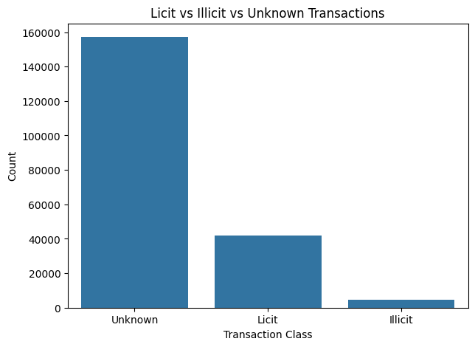
Figure 1: Licit vs Illicit vs Unknown transactions
Among labelled transactions, licit nodes outnumber illicit nodes by roughly 9.2 to 1, and illicit nodes make up only about 2% of the whole graph. This is a severely imbalanced problem in which a model that always predicts "licit" would score high accuracy while detecting no crime.
(b) Missing values.
for chunk in pd.read_csv('elliptic_txs_features.csv', chunksize=50000):
current_missing = chunk.isnull().sum() # accumulated across chunks

Only 15 missing values were found across all 167 feature columns, with at most one missing value in any column. This is negligible and can be handled by simple mean or median imputation or by dropping the affected rows, so data quality is high.
(c) Feature distributions.
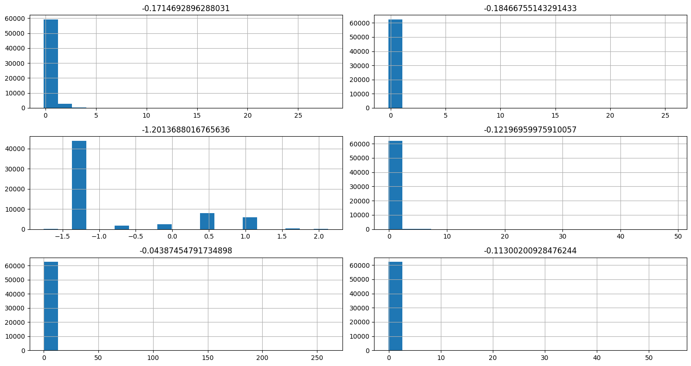
Figure 2: Histograms of six selected transaction features (F1-F6)
Most selected features are extremely right-skewed: the bulk of transactions lie close to zero while a small number take very large values (reaching 25 to over 250 on the standardised scale). F3 differs, showing a multi-modal, discrete-like pattern between about -1.5 and 2. Heavy tails mean that unusual transactions stand out sharply from typical ones, which is useful for detection but can destabilise training if left unchecked.
(d) Outlier analysis.
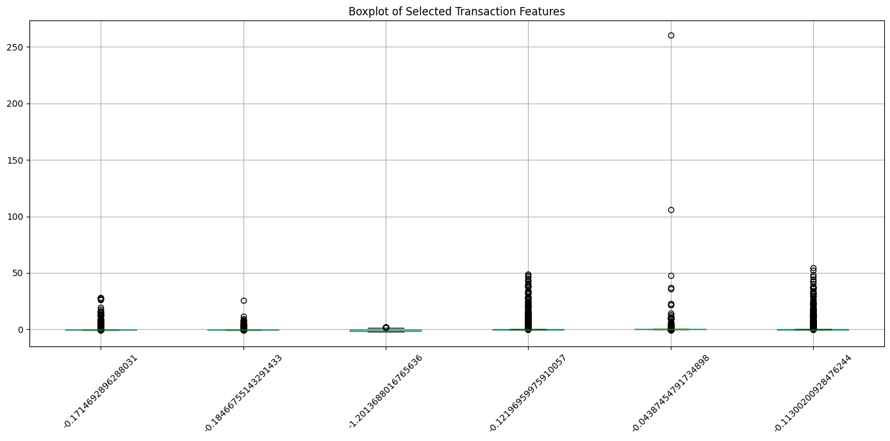
Figure 3: Boxplot of selected transaction features
The boxplots show compact boxes near zero with long upper whiskers and many outliers, including individual extreme points above 100 and near 260. In an AML setting such outliers may be genuinely suspicious behaviour (for example, unusually large or high-activity transactions), so they should not be removed blindly; robust scaling or normalisation is preferable to deletion.
(e) Feature correlation.
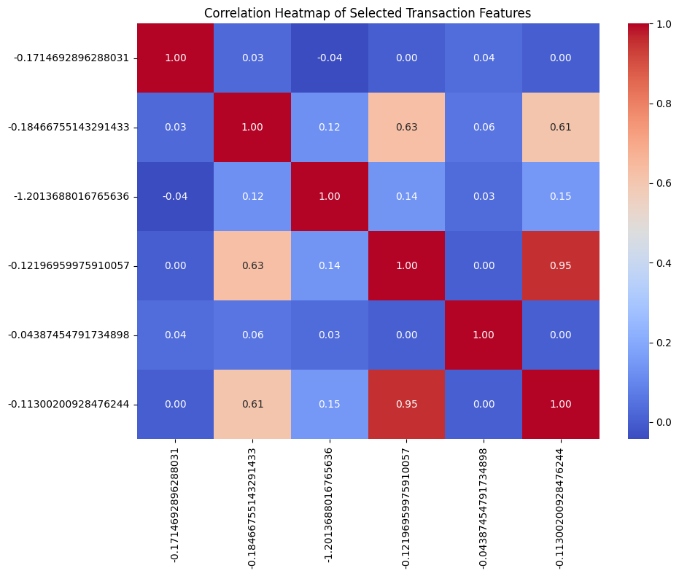
Figure 4: Correlation heatmap of selected features
Most feature pairs are only weakly correlated (close to 0), meaning they carry largely independent information. Notable exceptions are F4 and F6 (correlation 0.95), and F2 with F4 (0.63) and F6 (0.61). The very strong F4-F6 relationship shows redundancy that could be reduced with feature selection or dimensionality reduction, although neural models can tolerate it.
(f) Graph connectivity.
print(edges.iloc[:,0].nunique(), edges.iloc[:,1].nunique())
print(source_counts.mean(), destination_counts.mean())

Graph measure | Value
Total directed edges | 234,355
Unique source transactions | 166,345
Unique destination transactions | 148,447
Average outgoing connections per source | 1.41
Average incoming connections per destination | 1.58

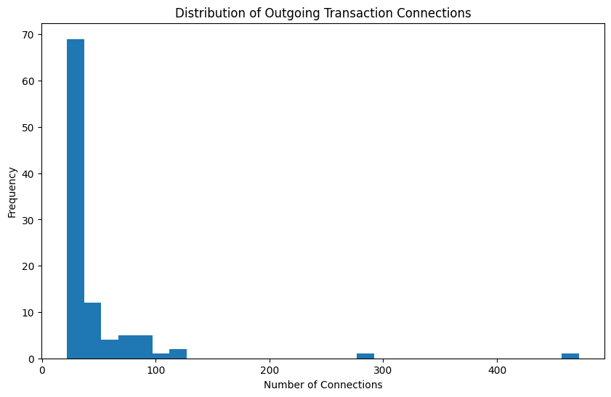
Figure 5: Distribution of outgoing transaction connections
The graph is sparse: on average a transaction connects to only about 1.4 to 1.6 others. A few hub transactions have very large numbers of connections (up to several hundred in the top-100 sample shown). Sparsity suits message-passing GNNs because each node has few neighbours, while hub nodes could be inspected as potentially important intermediaries.

4.5 Summary of EDA Findings
Finding | Evidence | Implication for modelling
Severe class imbalance | 2.23% illicit, 20.62% licit, 77.15% unknown | Use weighted or focal loss; evaluate with precision, recall and F1, not accuracy
Large unlabelled portion | 157,205 unknown nodes | Train on labelled nodes only; GNN message passing still uses unlabelled neighbours (semi-supervised)
High data quality | 15 missing values in total | Simple imputation is sufficient
Skewed features with outliers | Long tails, values above 100 | Use robust scaling; retain outliers as potential signals
Feature redundancy | F4-F6 correlation 0.95 | Consider feature selection or dimensionality reduction
Sparse graph with hubs | Average degree about 1.4 to 1.6 | Message-passing GNNs are efficient; hubs merit inspection

5. ALGORITHM SELECTION AND IMPLEMENTATION

5.1 Why Graph Neural Networks
Standard classifiers such as Logistic Regression or Random Forest use only a transaction's own features. In the Elliptic dataset, illicit behaviour is revealed by how a transaction is connected to others. GNNs use message passing: in each layer, a node aggregates the representations of its neighbours and combines them with its own, so after k layers a node's embedding reflects its k-hop neighbourhood. This lets the model learn relationship-aware patterns that feature-only models cannot.

5.2 Candidate Algorithms
Algorithm | Core idea | Why it is considered
Random Forest (baseline) | Ensemble of decision trees on node features only | Strong non-graph baseline to show the benefit of graph structure
GCN (Graph Convolutional Network) | Normalised averaging of neighbour features | Simple, efficient benchmark for node classification on sparse graphs
GraphSAGE | Samples and aggregates a fixed number of neighbours | Scales to large graphs and supports mini-batch training on 203,769 nodes
GAT (Graph Attention Network) | Learns attention weights over neighbours | Can focus on the most suspicious neighbours; attention supports interpretability

GraphSAGE is selected as the primary scalable model, with GCN and GAT as comparison models and Random Forest as the baseline. Implementation uses PyTorch and PyTorch Geometric, with Scikit-learn for metrics.

5.3 Implementation Plan
- Data preparation: Load the features file with header=None, name the columns, and join features with class labels on txId.
- Graph construction: Map txId values to contiguous node indices, convert the edge list to a 2 x E edge_index tensor, and build a PyTorch Geometric Data object.
- Pre-processing: Standardise or robust-scale features, impute the few missing values, and encode labels (illicit = 1, licit = 0); mark unknown nodes so they are excluded from the loss.
- Train/test split: Use a time-based split on the 49 time steps (earlier steps for training, later steps for testing) to avoid leakage and to mimic real deployment.
- Model: Two to three message-passing layers with ReLU, dropout and a final classification layer; Adam optimiser; class-weighted cross-entropy to handle imbalance.
- Evaluation: Precision, recall, F1-score of the illicit class, accuracy and confusion matrix, comparing each GNN with the Random Forest baseline.
Illustrative core of the GraphSAGE model (to be run in the implementation phase):
import torch, torch.nn.functional as F
from torch_geometric.nn import SAGEConv

class SAGE(torch.nn.Module):
def __init__(self, in_dim, hid=128, out=2):
super().__init__()
self.c1 = SAGEConv(in_dim, hid)
self.c2 = SAGEConv(hid, out)
def forward(self, x, edge_index):
x = F.dropout(F.relu(self.c1(x, edge_index)), 0.5, self.training)
return self.c2(x, edge_index)

loss = F.cross_entropy(out[train_mask], y[train_mask], weight=class_weights)

Model results (precision, recall and F1-score of each algorithm) will be reported once training is completed in the implementation phase of the project.

6. CONCLUSION
This case study addressed anti-money laundering detection by representing financial transactions as a graph and applying Graph Neural Networks. EDA of the Elliptic Bitcoin dataset (203,769 transactions and 234,355 edges) established the key characteristics that shape the solution: extreme class imbalance (2.23% illicit versus 20.62% licit), a large unlabelled majority (77.15%), high data quality with only 15 missing values, heavily skewed features with meaningful outliers, some redundant features, and a sparse graph with a few high-degree hubs.
These findings justify a semi-supervised, relationship-aware approach. GraphSAGE, GCN and GAT were selected against a Random Forest baseline, with imbalance-aware training and precision, recall and F1-score as the main evaluation measures. Compared with rule-based systems and feature-only models, GNNs offer a way to capture coordinated, multi-hop laundering behaviour while aiming to reduce false positives.
Future work includes training and comparing the selected models, using temporal GNNs to exploit the 49 time steps, heterogeneous graphs for richer entity types, explainable AI techniques such as GNNExplainer for regulatory transparency, and real-time transaction monitoring.

Signature of the Team members

