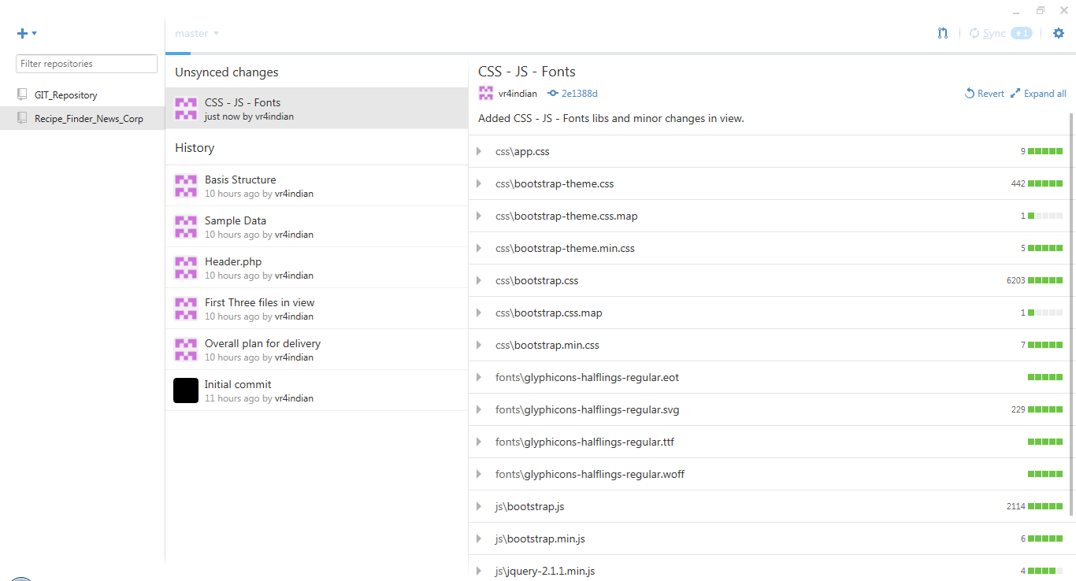

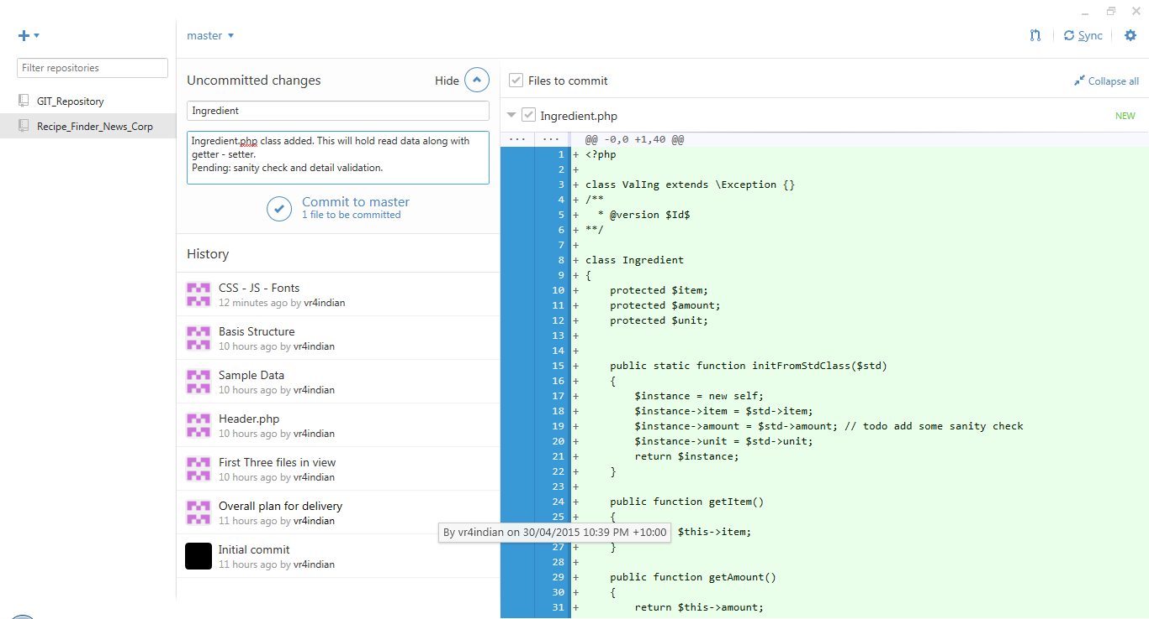

Test 1 [ Negative Scenario ]:

JSON: Four Recipes

CSV: Low amount for both

Expected: Order Takeout

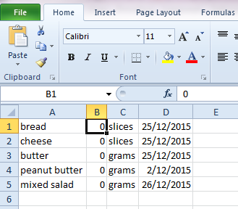

JSON:

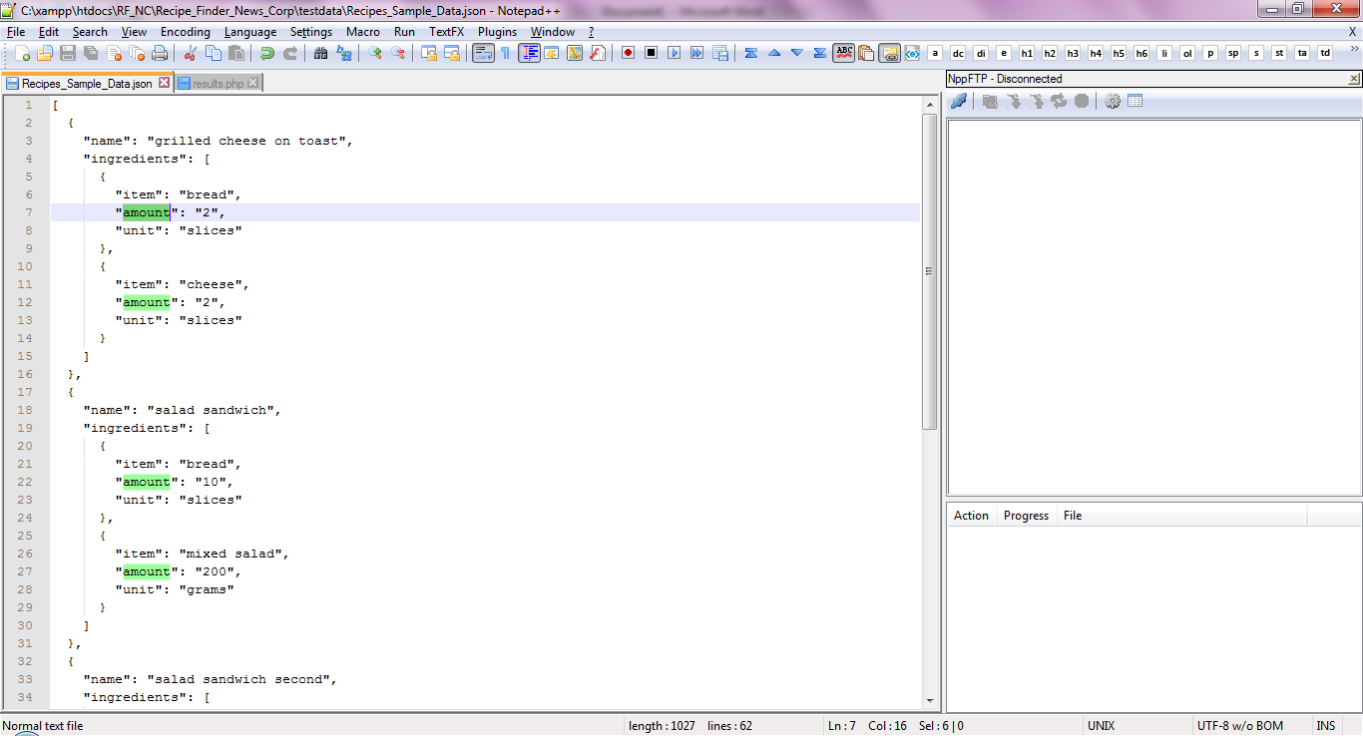

Browser:

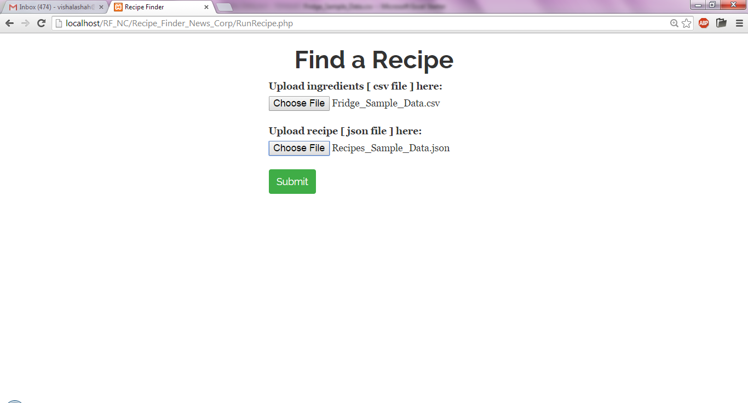

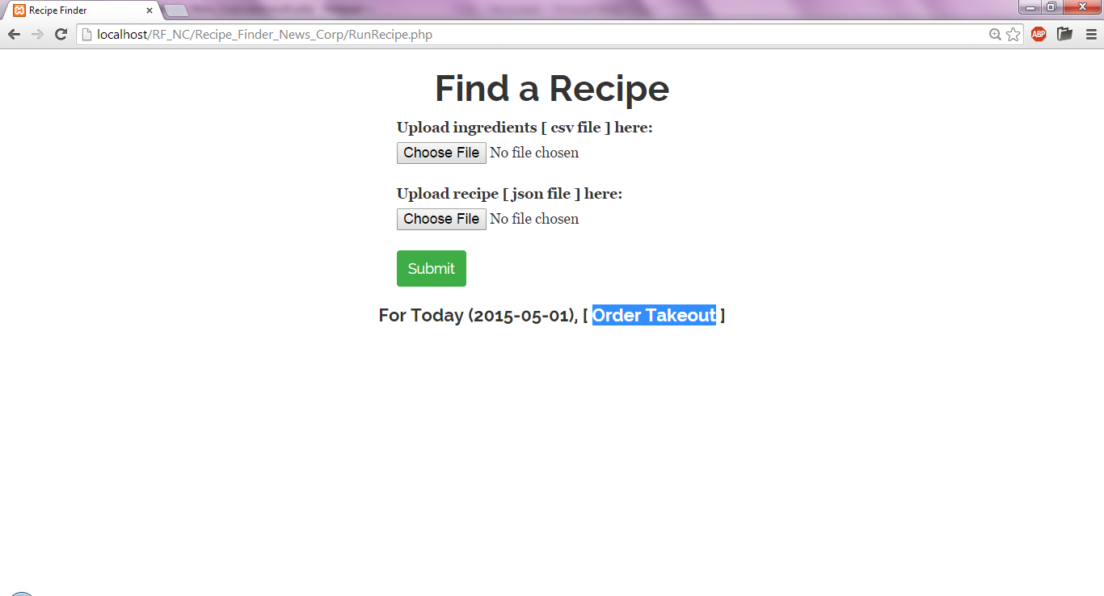

Test 2 [Positive Case]

JSON: Four Recipes

CSV: Enough amount for both

Expected: Closest match [salad sandwich third]

1: grilled cheese on toast : Matched

2: salad sandwich: Insufficient quantity

3: salad sandwich second : Insufficient quantity

4: salad sandwich third : Matched and nearest

