IPL DATA ANALYTICS
End-to-End Data Analytics Project Report
Python • MySQL • SQL • Power BI

1. Project Overview
The IPL Data Analytics project is an end-to-end data analytics solution designed to analyze Indian Premier League match-level and ball-by-ball delivery data. The project combines Python for data inspection and cleaning, MySQL for structured data storage and SQL analysis, and Power BI for interactive visualization and dashboard development.

2. Project Objective
The primary objective is to transform raw IPL datasets into reliable, analysis-ready data and derive meaningful insights about matches, players, teams, venues, seasons, scoring patterns, boundaries, wickets, and bowling performance.
- Clean and validate IPL match and delivery data.
- Store the cleaned datasets in a relational MySQL database.
- Use SQL to answer important cricket-performance questions.
- Build interactive Power BI dashboards for business-style data storytelling.
- Identify trends and performance patterns that can be communicated clearly in a portfolio.

3. Tools and Technologies
- Python – data inspection, cleaning, transformation, and preparation.
- Pandas – tabular data processing and validation.
- MySQL Community Server – database storage and querying.
- MySQL Workbench – SQL development and analysis.
- Power BI Desktop – interactive dashboard and visualization.
- CSV – source and cleaned data exchange format.

4. Dataset Description
The project uses two principal datasets:
- Matches: match-level information such as match ID, season, stage, date, venue, city, teams, and toss information.
- Deliveries: ball-by-ball information including match ID, batting team, bowling team, striker, bowler, batsman runs, total runs, and dismissal information.
The loaded matches dataset contained 1,158 match records. The deliveries dataset contained 134,190 delivery records after the data preparation/import workflow.

5. Data Cleaning and Preparation
The raw data was inspected before analysis to understand its structure, data types, missing values, duplicate records, and field consistency. Cleaning was performed before loading the analysis-ready data into MySQL.
- Inspected dataset shape, columns, and data types.
- Checked for missing and inconsistent values.
- Identified and handled duplicate records during the cleaning workflow.
- Standardized fields required for SQL and Power BI analysis.
- Converted relevant date and numeric fields to appropriate formats.
- Saved cleaned data for reproducible downstream analysis.

6. MySQL Database and SQL Analysis
The cleaned data was loaded into MySQL and analyzed using SQL queries. The analysis focused on player performance, bowling performance, team scoring, wicket patterns, and match trends.

6.1 Top Run Scorers
Player scoring was calculated by grouping deliveries by striker and summing batsman runs. The analysis was used to produce a Top 10 Run Scorers visualization.

6.2 Boundary Analysis
The project counted deliveries where batsman runs were 4 or 6 and grouped them by striker. This provided a measure of boundary-hitting performance.

6.3 Top Wicket Takers
Wickets were analyzed using dismissal type. Run outs and other dismissals that should not be credited to the bowler were excluded when calculating bowler wicket totals.

6.4 Bowling Economy
Bowling economy was calculated as runs conceded per six legal delivery-equivalents. A minimum-ball threshold was used to avoid ranking bowlers with very small samples.

6.5 Team Scoring
Team scoring was calculated by grouping deliveries by batting team and summing total runs. Team run rate and average scoring measures were also used in the dashboard.

6.6 Wicket-Type Analysis
Dismissal types were grouped and counted to understand the distribution of caught, bowled, run out, lbw, stumped, and other dismissal categories present in the dataset.

7. Power BI Dashboard
The cleaned MySQL data was successfully imported into Power BI using the MySQL connector. The dashboard was organized across multiple pages to separate overall match information, player performance, team analysis, and broader IPL insights.

7.1 KPI Cards
- Total Matches: 1,158
- Total Deliveries: 134,190
- Total Runs: 313,374
- Batsman Runs: 295,670

7.2 Main Dashboard Visuals
- Matches Played by Season
- Top 10 Run Scorers
- Top 10 Wicket Takers
- Top 10 Teams by Matches Played
- Matches by Stage
- Top 10 Venues by Matches Played
- Top 10 Bowlers by Economy Rate
- Top 10 Batsmen by Fours
- Top 10 Teams by Total Runs
- Top 10 Teams by Average Runs per Match
- Top 10 Batsmen by Boundaries
- Average Runs per Delivery
- Total Runs by Season
- Average Runs by Season
- Total Wickets by Season
- Top 10 Players by Total Runs

7.3 Interactive Analysis
Slicers were added for season, team, and city to support interactive exploration of the data. The dashboard was designed to allow users to move from high-level KPIs to player, team, venue, and seasonal analysis.

8. Key Project Metrics
Metric | Value
Total Matches | 1,158
Total Deliveries | 134,190
Total Runs | 313,374
Batsman Runs | 295,670

9. Insights and Interpretation
- The dashboard provides a consolidated view of IPL match, player, team, and venue performance.
- Top-run-scorer and top-wicket-taker rankings make it possible to compare individual player contributions.
- Boundary analysis highlights players with strong four- and six-hitting performance.
- Economy-rate analysis identifies bowlers who were comparatively efficient over a sufficiently large sample.
- Seasonal visuals help identify changes in match volume and scoring patterns over time.
- Venue analysis highlights locations that hosted a large number of matches.
- Team-level scoring analysis provides a direct comparison of aggregate and average batting performance.

10. Project Workflow
- Collect raw IPL datasets.
- Inspect the data using Python and Pandas.
- Clean, validate, and prepare the datasets.
- Load cleaned data into MySQL.
- Run SQL queries for player, team, bowling, wicket, and match analysis.
- Connect MySQL to Power BI.
- Create calculated measures and interactive visuals.
- Validate Power BI KPI values against SQL results.
- Format the dashboard for portfolio presentation.

11. Project Folder Structure
data_analytics/
├── data/
├── images/
├── powerbi/
├── python/
├── reports/
└── sql/

12. Conclusion
This project demonstrates a complete data analytics workflow from raw data preparation to database analysis and interactive visualization. By combining Python, MySQL, SQL, and Power BI, the project converts IPL data into a structured analytical product that can support exploratory analysis and clear data storytelling. The completed dashboard provides a strong portfolio example of practical data cleaning, SQL querying, data modeling, DAX measures, visualization, and insight generation.

13. Future Improvements
- Add match-winner and team win-percentage analysis where reliable winner data is available.
- Add player strike-rate and bowling-strike-rate measures using clearly defined minimum sample thresholds.
- Add season and team comparison pages with drill-through functionality.
- Publish the dashboard to Power BI Service if appropriate.
- Add automated data refresh and a repeatable ETL pipeline for future IPL seasons.

14. Skills Demonstrated
- Data Cleaning and Preparation
- Python and Pandas
- SQL and MySQL
- Data Validation
- Data Modeling
- DAX Measures
- Power BI Visualization
- Dashboard Design
- Analytical Thinking
- Data Storytelling

18. Uploaded Results Evidence
The uploaded Results.pdf contains four Power BI result pages. These pages are reproduced below as figures so that the report can be understood without opening the separate PDF.
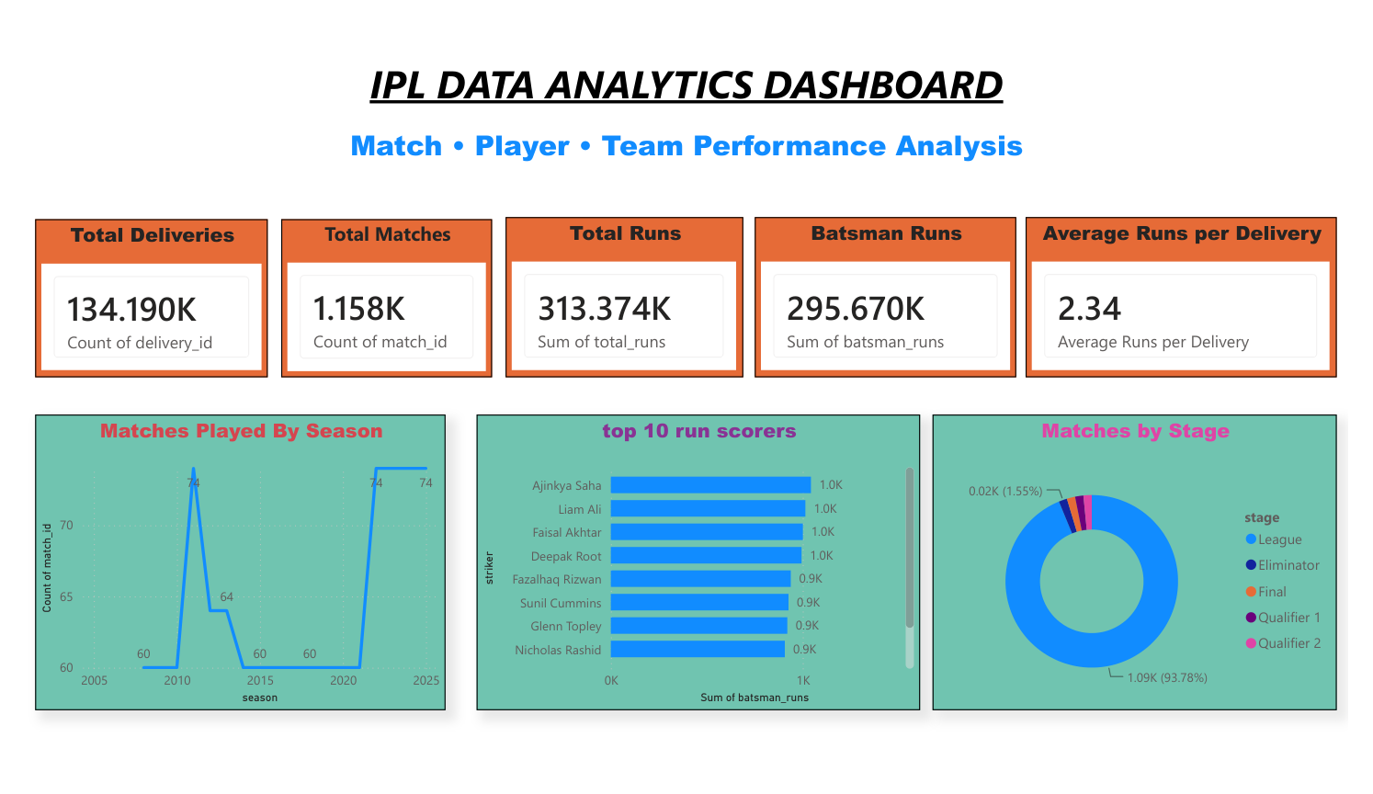
Figure 5. IPL Overview dashboard: KPI cards, season trend, run scorers, stage distribution, and average runs per delivery.

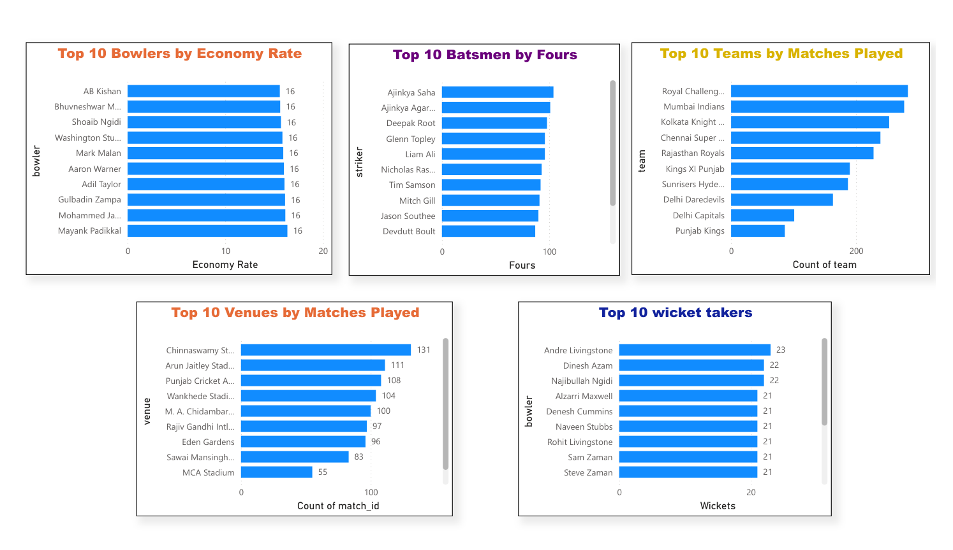
Figure 6. Player and venue analysis: bowling economy, batsmen by fours, venues, wicket takers, and teams by matches played.

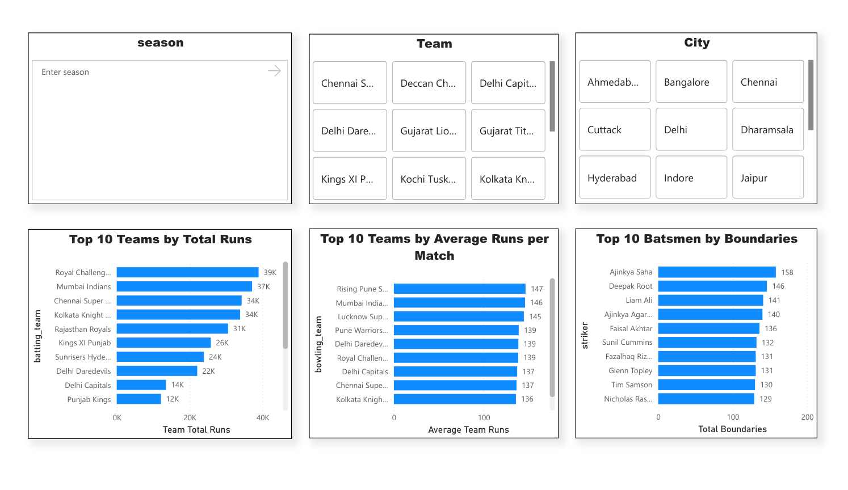
Figure 7. Team Analysis: season, team, and city slicers; team total runs, average team runs per match, and boundary analysis.

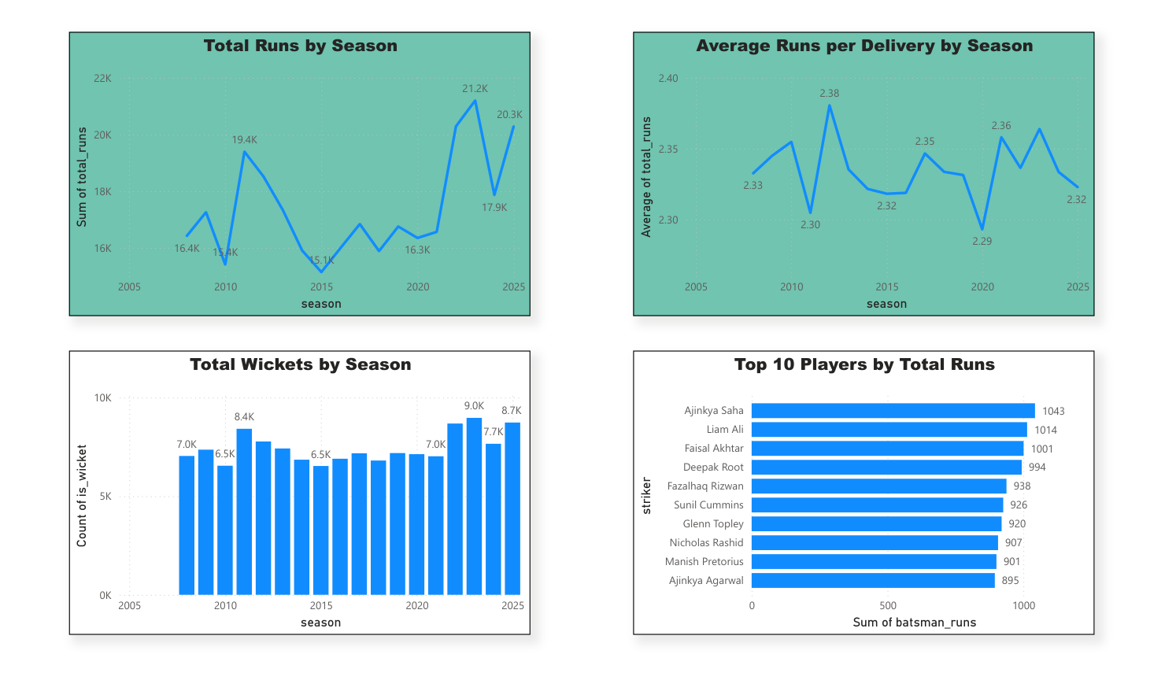
Figure 8. IPL Insights: total runs by season, average runs per delivery by season, wickets by season, and top players by total runs.

