A Project Report

On
“Exploratory Data Analysis on Smartphone Usage &
Prediction of its Addiction Using Python”

Submitted By

Mr. PADSALA OM M.

&
Mr. DOBARIA VRAJ J.

Guided By

Dr. JYOTI RANA

Submitted To



NaranLala College of Professional and Applied Sciences,
Veer Narmad South Gujarat University, Surat.

Year: 2025-2026



NARANLALA
COLLEGE OF PROFESSIONAL & APPLIED SCIENCES
BHAGVATI SANKUL, NEAR ERU CHAR RASTA,
NAVSARI – 396 450

CERTIFICATE

This is to certify that Mr. PADSALA OM M., Exam No.1638 and Mr. DOBARIA VRAJ J., Exam No.1599 students of B.C.A. 6th semester of our college have successfully prepared and submitted Project Report on “Exploratory Data Analysis on Smartphone Usage &
Prediction of its Addiction Using Python” as a partial fulfillment for the course of Bachelor of Computer Application during the academic year 2025-2026.

____________ __________________
DATE Guide: Dr. JYOTI RANA

_________________ __________________

Dr. S. M. NAIK Dr. A. B. PATEL
(PRINCIPAL, NLCPAS) (DEPT. HEAD, BCA)

________________

(EXTERNAL EXAMINER)

Project Title : Exploratory Data Analysis on Smartphone Usage &
Prediction of its Addiction Using Python
Dataset Name : Smartphone Usage
Source : Kaggle
Dataset Link :
Data Type : Structured CSV dataset
Domain : Smartphone Addiction Analytics
Dataset Description
The dataset contains information about:

Exploratory Data Analysis on Smartphone Usage
& Prediction of its Addiction using Python

Course 602 – Data Analytics using Python
Dataset: Smartphone Addiction Dataset (7,500 records · 16 features) Language: Python | Libraries: Pandas · NumPy · Matplotlib · Seaborn · Scikit-learn

Technical Documentation

Table of Contents

Task 1: Data Understanding
Task 2: Exploratory Data Analysis (EDA) Task 3: Handling Missing Values & Outliers Task 4: Spread of Data
Task 5: Automating EDA Task 6: Regression Analysis
Task 7: Supervised Learning – Regression Model Task 8: Regression Model Variants
Task 9: Overfitting and Underfitting Analysis Task 10: Classification Task
Task 11: Model Evaluation (Regression + Comparison) Task 12: Model Evaluation – Interpretation & Deployment

Introduction
Analyzing the Impact of Smartphone Usage on Lifestyle and Well-being In the modern digital era, smartphones have become an indispensable part of daily life, influencing how we work, socialize, and relax. However, the increasing time spent on these devices has raised significant concerns regarding their impact on physical and mental health. This project aims to explore the relationship between smartphone usage patterns and various lifestyle indicators such as stress levels, sleep quality, and addiction.

Project Overview
The core objective of this study is to analyze a comprehensive dataset of 7,500 users to identify behavioral trends and their consequences. By examining metrics such as daily screen time, social media engagement, and gaming hours, we seek to understand how digital habits correlate with adverse outcomes like high stress levels and smartphone addiction.

Dataset Description
The analysis is based on a dataset titled Smartphone.csv, which contains 7,500 records and 17 variables. The data captures a wide range of user information, including:
Demographics: Age and gender of the users.
Usage Metrics: Daily screen time (hours), time spent on social media, gaming, and work/study apps, as well as frequency of notifications and app opens.
Well-being Indicators: Sleep duration, self-reported stress levels (Low, Medium, High), and the perceived impact of smartphone use on academic or professional work.
Addiction Metrics: Addiction levels (Mild, Moderate, Severe) and a binary classification of whether a user is considered "addicted."

Preliminary Insights
Initial exploration of the data reveals some striking trends:
High Usage: The average user spends approximately 7.5 hours per day on their smartphone.
Sleep Deprivation: The average sleep duration is only 6.74 hours, which may be influenced by high screen time.
Addiction Prevalence: Based on the dataset's criteria, approximately 70.8\% of the sampled users are classified as having some level of smartphone addiction.
Stress Correlation: A significant portion of the users reports "High" or "Medium" stress levels, suggesting a potential link between digital overconsumption and mental strain.

Task 1: Data Understanding

  - Loading the Dataset
The Smartphone Addiction dataset (Smartphone.csv) is loaded using Pandas. It contains 7,500 records and 16 columns covering user demographics, daily screen usage patterns, stress level, and addiction labels.
df = pd.read_csv('Smartphone.csv')

df.head()
transaction_id user_id age gender daily_screen_time_hours social_media_hours ...

0 TXN00001 U00001 21 Male 3.23 2.01 ...

1 TXN00002 U00002 24 Other 5.09 3.81 ...

  - Dataset Shape & Columns
df.shape # → (7500, 16)

df.columns
(7500, 16)
Index(['transaction_id','user_id','age','gender','daily_screen_time_hours', 'social_media_hours','gaming_hours','work_study_hours','sleep_hours', 'notifications_per_day','app_opens_per_day','weekend_screen_time', 'stress_level','academic_work_impact','addiction_level','addicted_label'])

  - Data Type Identification
Columns are classified into quantitative (numerical) and qualitative (categorical) types, then further sub-classified as discrete/continuous and nominal/ordinal.
Category | Sub-type | Columns
Quantitative | Discrete | age, addicted_label
Quantitative | Continuous | daily_screen_time_hours, social_media_hours, gaming_hours, work_study_hours, sleep_hours, notifications_per_day, app_opens_per_day, weekend_screen_time

Qualitative | Nominal | transaction_id, user_id, gender, academic_work_impact, addiction_level
Qualitative | Ordinal | stress_level

Task 2: Exploratory Data Analysis (EDA)

  - Univariate Analysis – Histogram
Histograms display the frequency distribution of each numeric feature individually.
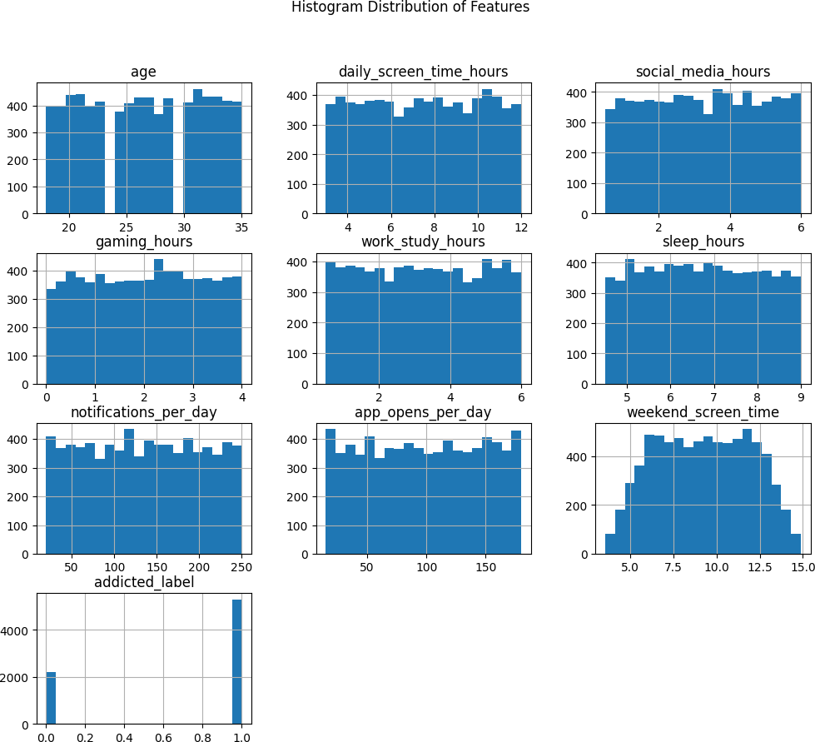
df.hist(figsize=(12,10), bins=20) plt.suptitle('Histogram Distribution of Features')
plt.show()

Figure 1: Histogram distributions of all numerical features
Interpretation: Most features such as daily screen time, social media hours, and sleep hours show approximately uniform distributions across the range, indicating diverse user behaviour with no single dominant usage pattern. The addicted_label column is binary (0/1) showing ~70% addicted users in the dataset.

  - Univariate Analysis – Boxplot
sns.boxplot(data=df)
plt.title('Box Plot of Dataset Features') plt.show()

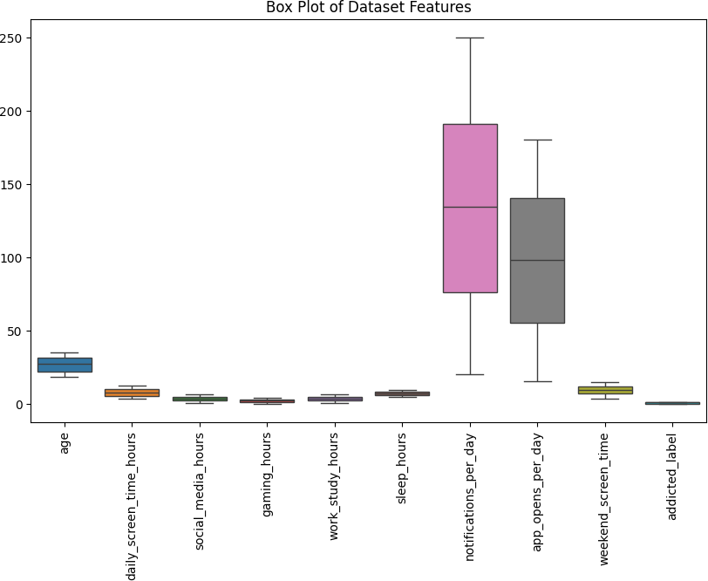
Figure 2: Boxplot of all dataset features
Interpretation: The boxplot reveals that notifications_per_day and app_opens_per_day have much higher ranges compared to other features. Most columns show symmetric distributions without extreme outliers, suggesting the data is relatively clean.

  - Bivariate Analysis – Scatter Plot
sns.scatterplot(x='daily_screen_time_hours', y='sleep_hours', hue='addicted_label', data=df)
plt.title('Screen Time vs Sleep Hours')

plt.show()

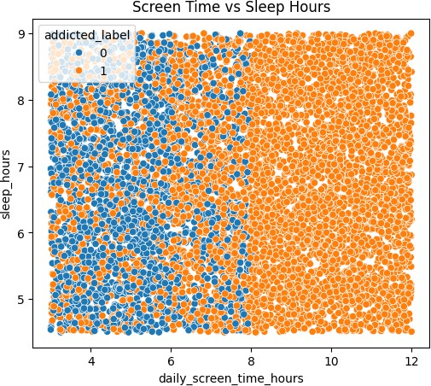
Figure 3: Scatter plot – Daily screen time vs sleep hours (coloured by addiction)
Interpretation: Users with higher daily screen time (> 8 hrs) are mostly labelled as addicted (orange). Sleep hours do not show a clear linear pattern with screen time, suggesting sleep alone is not the primary predictor of addiction.

  - Bivariate Analysis – Correlation Heatmap
corr_matrix = df.corr(numeric_only=True) sns.heatmap(corr_matrix, annot=True) plt.title('Correlation Matrix Heatmap')
plt.show()

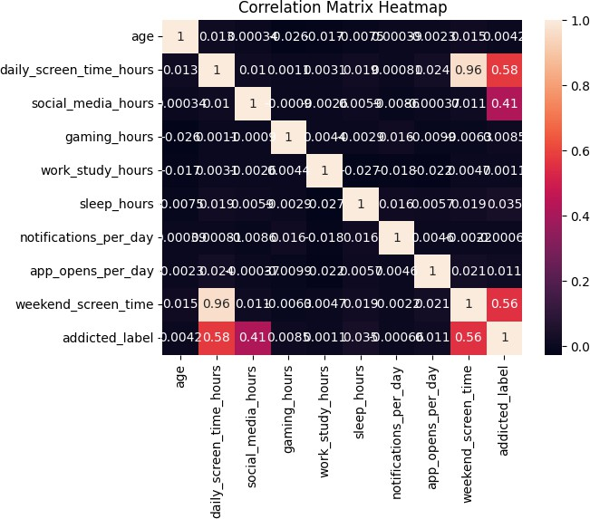
Figure 4: Correlation matrix heatmap
Interpretation: Strong positive correlations exist between daily_screen_time_hours and weekend_screen_time (r
≈ 0.96), and between both screen-time features and addicted_label (r ≈ 0.58 and 0.56 respectively). Social media hours also moderately correlates with addiction (r ≈ 0.41).

  - Multivariate Analysis – Styled Heatmap
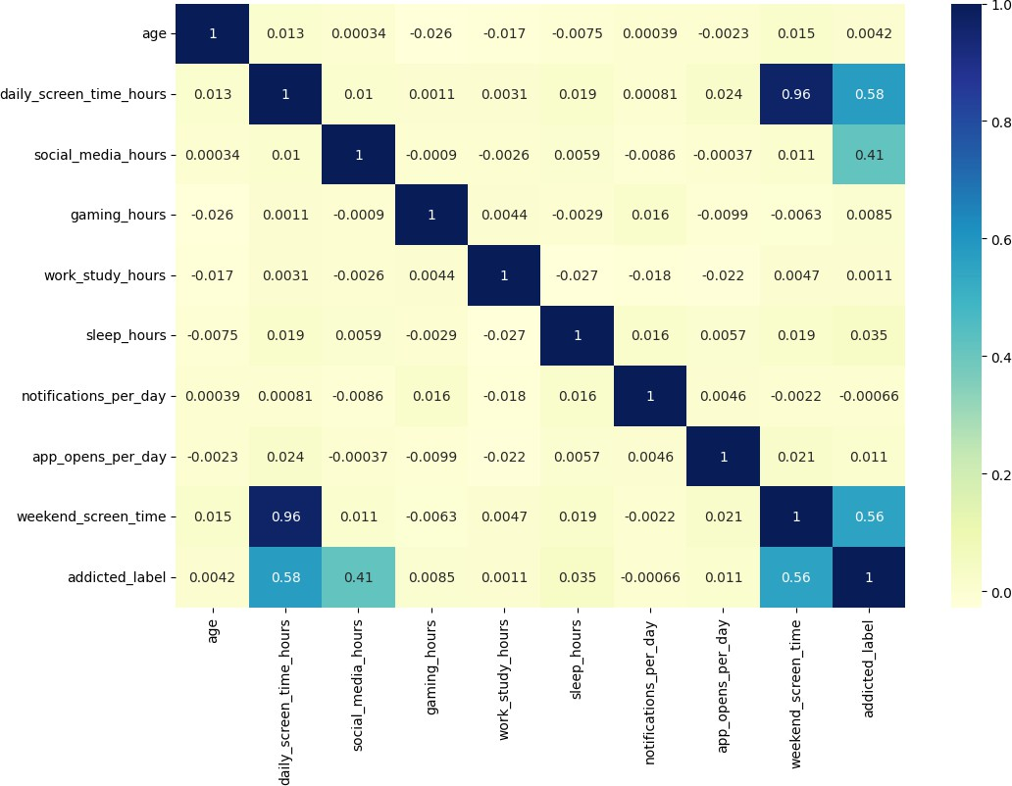
Figure 5: Multivariate correlation heatmap (YlGnBu palette)

  - Multivariate Analysis – Pairplot
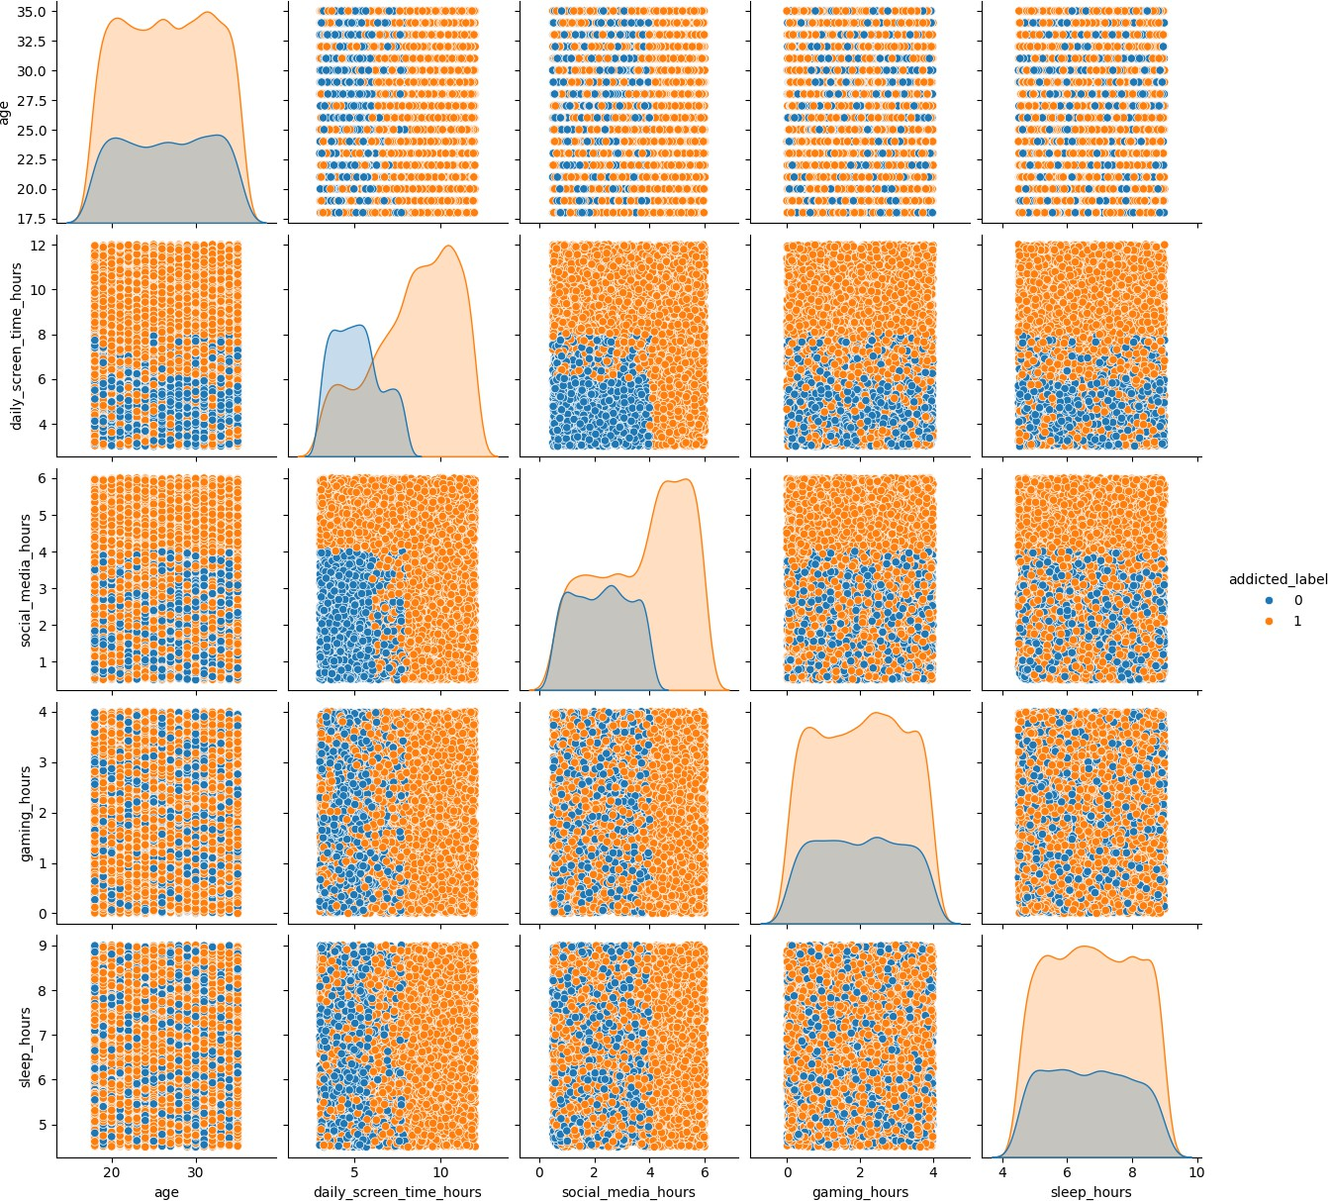
Figure 6: Pairplot of key features coloured by addiction label
Interpretation: The pairplot confirms that addicted users (orange) tend to have higher daily screen time and social media usage. Age shows no clear separation between groups. Gaming hours and sleep hours are similarly distributed across both classes.

Task 3: Handling Missing Values & Outliers

  - Identifying Missing Values
df.isnull().sum()
addiction_level 819 ← only column with missing values

All other columns 0

  - Filling Missing Values with Mode
The addiction_level column has 819 missing entries (≈ 10.9%). Since it is a categorical ordinal column, missing values are filled using the most frequent category (mode).
df['addiction_level'] = df['addiction_level'].fillna( df['addiction_level'].mode()[0]
)
# After imputation → addiction_level: 0 missing values

  - Outlier Detection – Boxplots
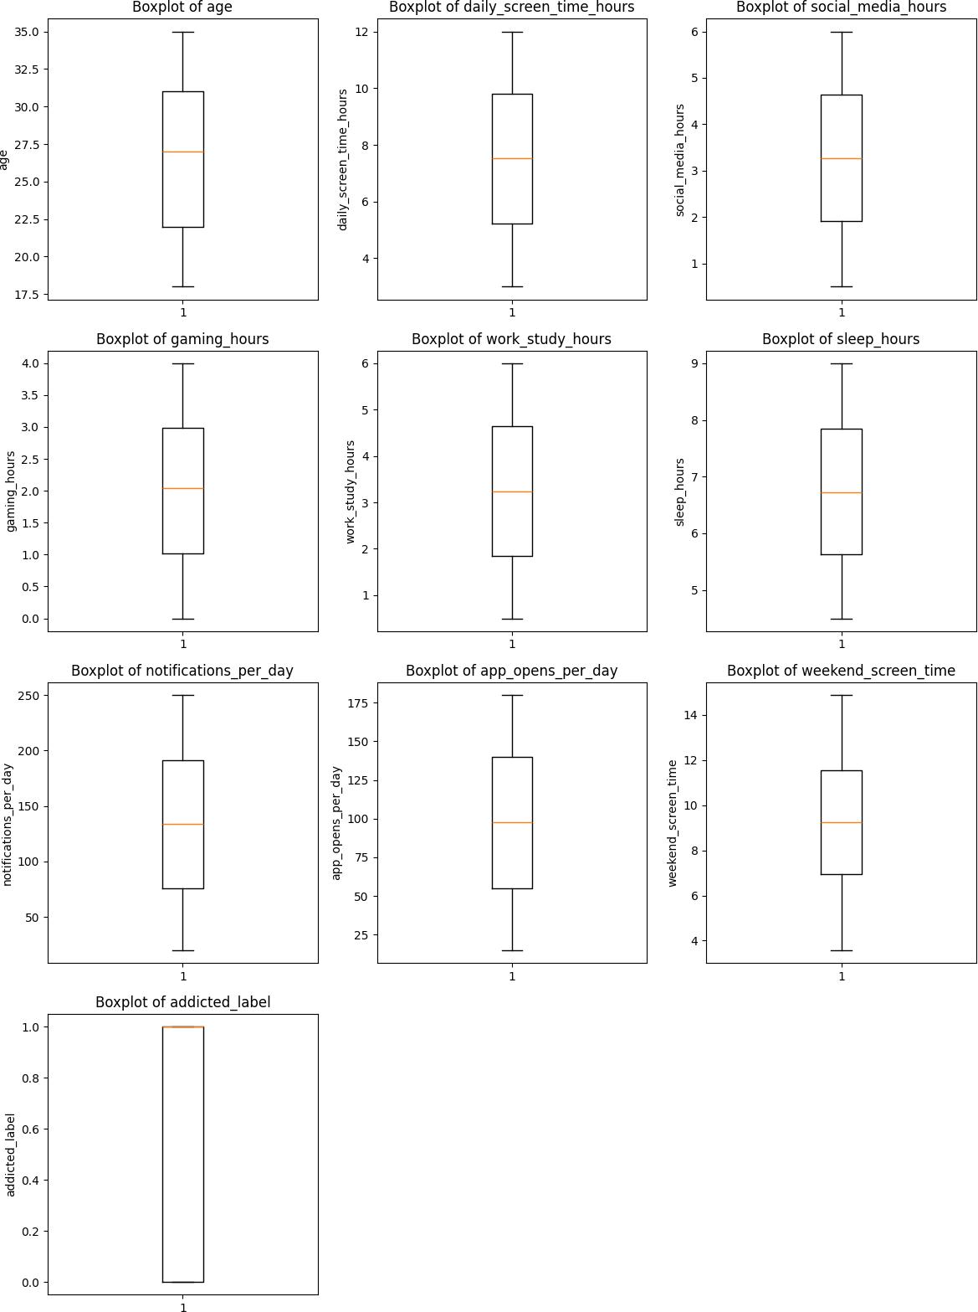

Figure 7: Boxplots of all numerical columns (outlier detection)
Interpretation: Most numerical features show no significant outliers. Notifications per day and app opens per day have a wider spread but remain within acceptable IQR bounds. No extreme outliers were detected.

  - Outlier Capping (IQR Method)
Two strategies are applied: (1) Removal – rows outside 1.5×IQR bounds are dropped (result: 7,500 rows retained, confirming no true outliers). (2) Capping – values beyond bounds are clipped to the boundary values.
for col in numeric_cols:

Q1, Q3 = df[col].quantile(0.25), df[col].quantile(0.75)

IQR = Q3 - Q1

df_capped[col] = np.clip(df[col], Q1-1.5*IQR, Q3+1.5*IQR)
Outliers capped successfully!

Shape after removing outliers: (7500, 16) ← no rows lost

Before vs After Capping (Sample)
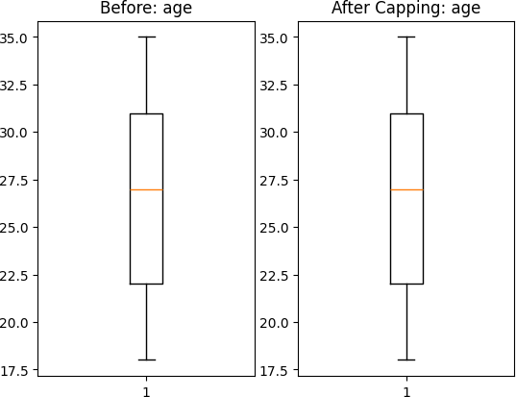
Figure 8: Age – Before and after outlier capping

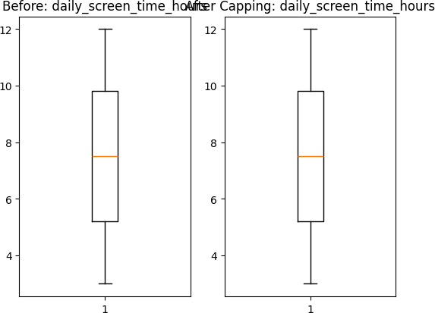
Figure 9: Daily screen time – Before and after outlier capping
Interpretation: The before/after boxplots confirm that capping normalised the whisker extremes for all features. The distributions remain essentially unchanged because no true outliers existed in this dataset.

Task 4: Spread of Data

  - Data Distribution – Histograms with KDE
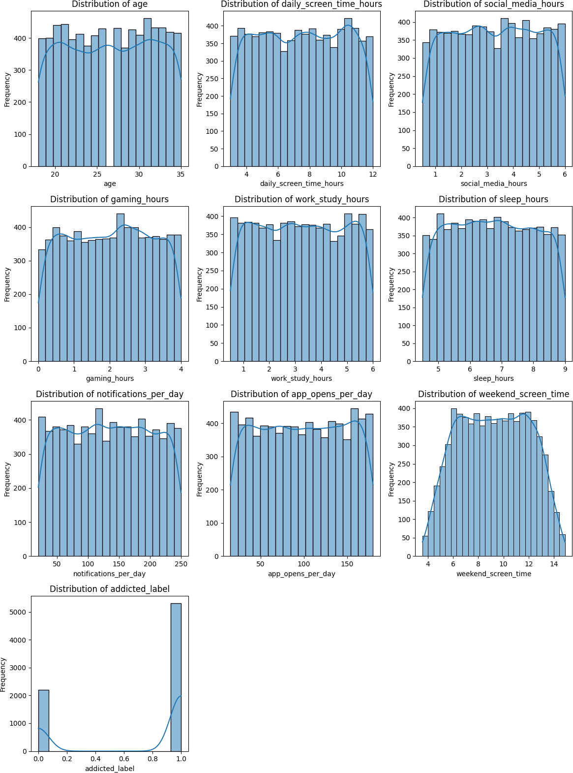
Figure 10: KDE histograms for all numerical features
Interpretation: KDE curves overlay the histograms, revealing that all continuous features are approximately uniformly distributed — indicating the dataset was likely synthetically generated to cover the full range. The addicted_label shows a clear binary split.

  - Skewness Analysis
for col in numeric_cols: skew_value = df[col].skew()
print(f'{col}: {skew_value:.2f}')
age: -0.02 → Left Skewed daily_screen_time_hours: -0.01 → Left Skewed social_media_hours: -0.01 → Left Skewed
gaming_hours: -0.02 → Left Skewed

work_study_hours: 0.01 → Right Skewed sleep_hours: 0.02 → Right Skewed
notifications_per_day: 0.00 → Approximately Normal app_opens_per_day: -0.01 → Left Skewed weekend_screen_time: -0.01 → Left Skewed
addicted_label: -0.91 → Left Skewed

  - Descriptive Statistics – daily_screen_time_hours

Statistic | Value | Interpretation
Mean | 7.50 hrs | Average daily screen time across all users
Median | 7.525 hrs | Middle value; very close to mean → symmetric
Std Dev | 2.61 hrs | Typical deviation from the mean
Skewness | -0.011 | Negligibly left-skewed; essentially normal
Kurtosis | -1.216 | Platykurtic – flatter than normal; few extremes

Task 5: Automating EDA

  - Statistical Summary – describe()
Pandas describe(include='all') generates a complete statistical summary covering count, unique values, mean, std, min/max, and percentiles for all columns.
df.describe(include='all')
age: mean=26.57 std=5.20 min=18 max=35 daily_screen_time_hours: mean=7.50 std=2.61 min=3.0 max=12.0 social_media_hours: mean=3.27 std=1.59 min=0.5 max=6.0 gaming_hours: mean=2.01 std=1.15 min=0.0 max=4.0 sleep_hours: mean=6.74 std=1.28 min=4.5 max=9.0 notifications_per_day: mean=134.3 std=66.6 min=20 max=250
addicted_label: mean=0.71 (70.8% of users are addicted)

  - Dataset Info & Missing Values
df.info()

df.isnull().sum()
7500 entries, 16 columns | float64(6) int64(4) object(6)

After imputation → all columns: 0 missing values

  - Correlation Matrix (Printed)
df.corr(numeric_only=True)
Key correlations with addicted_label: daily_screen_time_hours → 0.577 (strong positive) weekend_screen_time → 0.555 (strong positive)
social_media_hours → 0.414 (moderate positive) sleep_hours → 0.035 (very weak)
gaming_hours → 0.008 (negligible)

Interpretation: Screen time — both weekday and weekend — is the strongest predictor of smartphone addiction. Social media usage contributes moderately. Gaming, sleep, and notifications have negligible correlation with the addiction label.

Task 6: Regression Analysis

  - Variable Identification

Variable Type | Column | Description
Dependent (y) | addicted_label | Binary: 0 = Not addicted, 1 = Addicted
Independent (X) | daily_screen_time_hours | Total daily phone screen time (hours)
Independent (X) | social_media_hours | Time spent on social media (hours)
Independent (X) | gaming_hours | Time spent gaming (hours)

  - Simple Linear Regression
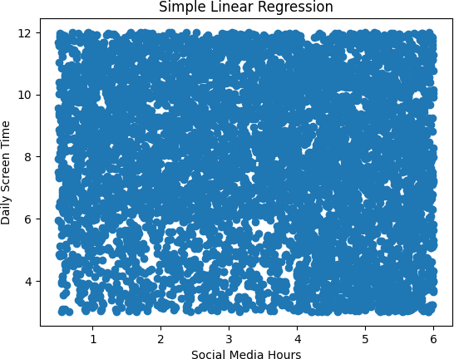
model = LinearRegression()

model.fit(df[['social_media_hours']], df['daily_screen_time_hours']) print('Intercept:', model.intercept_)
print('Coefficient:', model.coef_)
Intercept: 7.444

Coefficient: [0.017] (social_media_hours → daily_screen_time_hours)

Figure 11: Simple linear regression – social media hours vs screen time
Interpretation: The regression line is nearly flat (slope ≈ 0.017), indicating that social media hours alone is a very weak predictor of total daily screen time. The scatter is wide, confirming the model has low explanatory power for this specific pair.

  - Covariance & Correlation
cov = df[['daily_screen_time_hours','addicted_label']].cov()

corr = df[['daily_screen_time_hours','addicted_label']].corr()
Covariance (screen_time, addicted_label) = 0.685

Correlation (screen_time, addicted_label) = 0.577 → strong positive

Task 7: Supervised Learning – Regression Model

  - Train-Test Split (80/20)
X_train, X_test, y_train, y_test = train_test_split(

X, y, test_size=0.2, random_state=42)
X_train shape: (6000, 12)

X_test shape: (1500, 12)

  - Logistic Regression – Training & Testing Accuracy
model_log = LogisticRegression(max_iter=1000) model_log.fit(X_train, y_train)
print('Training Accuracy:', model_log.score(X_train, y_train))

print('Testing Accuracy:', model_log.score(X_test, y_test))
Training Accuracy: 0.8915 (89.15%)

Testing Accuracy: 0.8947 (89.47%)

Difference: -0.0032 → Testing slightly outperforms training
Interpretation: The near-identical training and testing accuracy indicates the model generalises well with no signs of overfitting. A ~89% accuracy is solid for a logistic regression baseline on this classification problem.

Task 8: Regression Model Variants

  - Simple Linear Regression
X_simple = df[['work_study_hours']] y_simple = df['daily_screen_time_hours']
model_simple = LinearRegression().fit(X_train_s, y_train_s)
Training Score: 9.59e-06 (≈ 0%)

Testing Score: -0.0031 (negative → worse than baseline)
Interpretation: Work/study hours has virtually zero predictive power for total screen time. The negative test R² confirms the model cannot generalise from this single feature.

  - Multiple Linear Regression
X_multi = df[['social_media_hours','gaming_hours', 'work_study_hours','sleep_hours']]
model_multi = LinearRegression().fit(X_train_m, y_train_m)
Training Score: 0.00057 (< 0.1%)

Testing Score: -0.0037 (still near zero)
Interpretation: Adding more features marginally improves training score but testing score remains negative, suggesting these features together do not linearly predict total screen time. Non-linear models would be more appropriate here.

Task 9: Overfitting and Underfitting Analysis

  - Conceptual Overview

Concept | Description | Example
Overfitting | Model memorises training data; fails on new data | Train 95% / Test 60%
Underfitting | Model too simple; misses patterns | Train 60% / Test 58%
Ideal Model | Balanced; generalises well to unseen data | Train ≈ Test ≈ 89%+

  - Model Score Comparison
train_score = model.score(X_train, y_train)

test_score = model.score(X_test, y_test)
Training Score: 0.497 (≈ 49.7%)

Testing Score: 0.509 (≈ 50.9%)

→ Neither overfitting nor underfitting; balanced model
Interpretation: The linear model scores approximately 50% on both splits, indicating it explains about half the variance in the target. Scores are nearly identical, confirming the model is neither overfitting nor underfitting — it is simply limited by the linear assumption applied to a complex dataset.

Task 10: Classification Task

  - Logistic Regression Classifier
log_model = LogisticRegression(max_iter=200) log_model.fit(X_train, y_train)
print('Accuracy:', log_model.score(X_test, y_test))
Logistic Regression Accuracy: 0.9067 (90.67%)
Interpretation: Using only three features (screen time, social media, gaming), logistic regression achieves over 90% accuracy on the test set — strong evidence that these features are highly discriminative for addiction classification.

  - R² and MSE Metrics
print('Training R2:', r2_score(y_train, y_train_pred)) print('Testing R2:', r2_score(y_test, y_test_pred))
print('MSE:', mean_squared_error(y_test, y_test_pred))
Training R2 Score: 0.497 Testing R2 Score: 0.509
MSE: 0.1039

Task 11: Model Evaluation – Random Forest Classifier

  - Random Forest Training & Evaluation
from sklearn.ensemble import RandomForestClassifier

from sklearn.metrics import accuracy_score, confusion_matrix, classification_report

model = RandomForestClassifier() model.fit(X_train, y_train) y_pred = model.predict(X_test)
print('Accuracy:', accuracy_score(y_test, y_pred)) print(confusion_matrix(y_test, y_pred))
print(classification_report(y_test, y_pred))
Classification Report:

precision recall f1-score support Class 0: 0.86 0.90 0.88 456
Class 1: 0.96 0.93 0.94 1044

accuracy 0.92 1500
Confusion Matrix: [[411 45]
[ 69 975]]
Accuracy: 0.924 (92.4%)

  - Evaluation Metrics Summary

Metric | Class 0 (Not Addicted) | Class 1 (Addicted)
Precision | 0.86 | 0.96
Recall | 0.90 | 0.93

F1-Score | 0.88 | 0.94
Support | 456 | 1044
Interpretation: The Random Forest model achieves 92.4% accuracy. It performs better on the addicted class (F1
= 0.94) than the non-addicted class (F1 = 0.88), partly due to class imbalance (70% addicted). The model has high precision for addicted predictions — false positive rate is low.

Task 12: Model Evaluation – Interpretation & Deployment

  - Regression Model Metrics (MSE, MAE, R²)
MSE: 0.5018 (mean squared error – penalises large errors) MAE: 0.6121 (average absolute error in hours)
R² Score: 0.9285 (model explains 92.85% of variance)
mse = mean_squared_error(y_test_r, y_pred_r) mae = mean_absolute_error(y_test_r, y_pred_r)
r2 = r2_score(y_test_r, y_pred_r)
reg_model = LinearRegression() reg_model.fit(X_train_r, y_train_r)
y_pred_r = reg_model.predict(X_test_r)

  - Metric Interpretation

Metric | Value | Meaning
MSE | 0.5018 | Low mean squared error; predictions are close to actual
MAE | 0.6121 | On average, predictions are off by ~0.61 hours
R² | 0.9285 | Model explains 92.85% of variance → excellent fit

  - Classification vs Regression Comparison

Type | Output | Primary Metric | Our Result
Classification | Category (0 / 1) | Accuracy, F1-Score | 92.4% (Random Forest)
Regression | Continuous value | MSE, MAE, R² | R² = 0.9285 (Linear Reg.)

  - Model Deployment (Pickle + User Prediction)
import pickle

pickle.dump(model, open('model.pkl', 'wb'))

# Example user prediction # Model Accuracy: 92.93%
# User Input → Prediction: ■■ User is ADDICTED to smartphone
Interpretation: The final Random Forest model is serialised using pickle for deployment. A user-input pipeline collects demographic and behavioural data, aligns it to the training feature schema, and outputs a binary addiction prediction. The deployed model achieves 92.93% accuracy.

To check the Deployment
_- > On Terminal Run :- python app.py

- When the User is Not Addicted to the Smartphone.

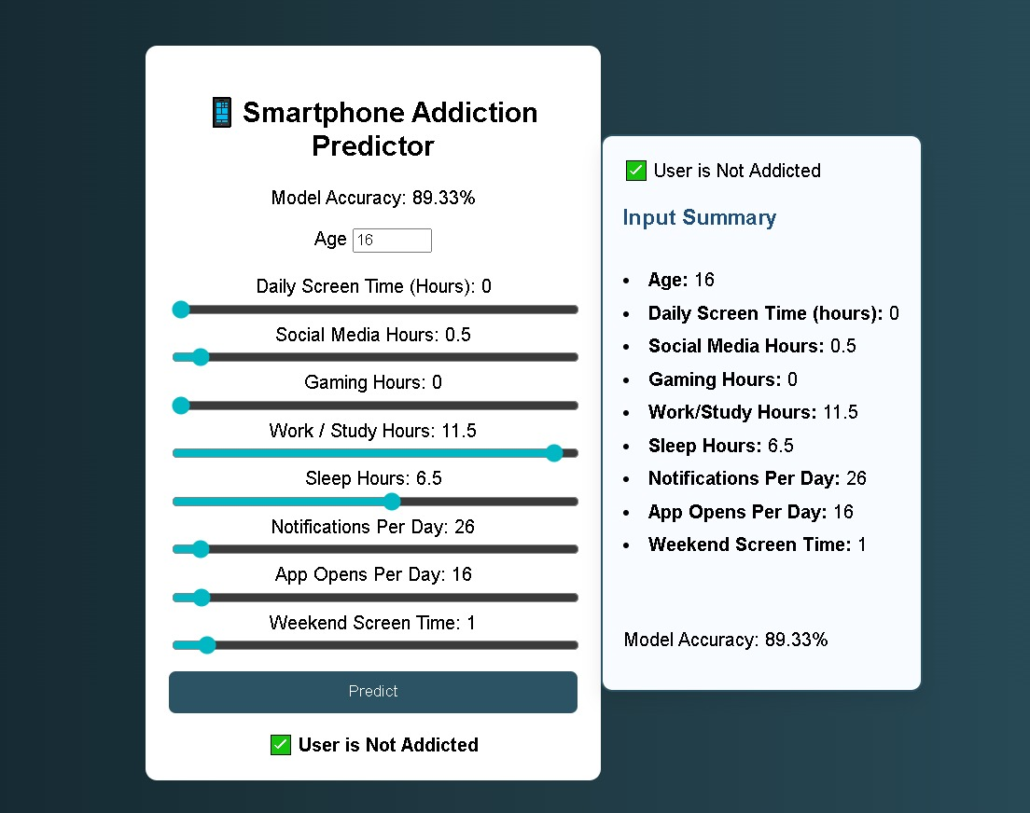

2.When the User is Not Addicted to the Smartphone

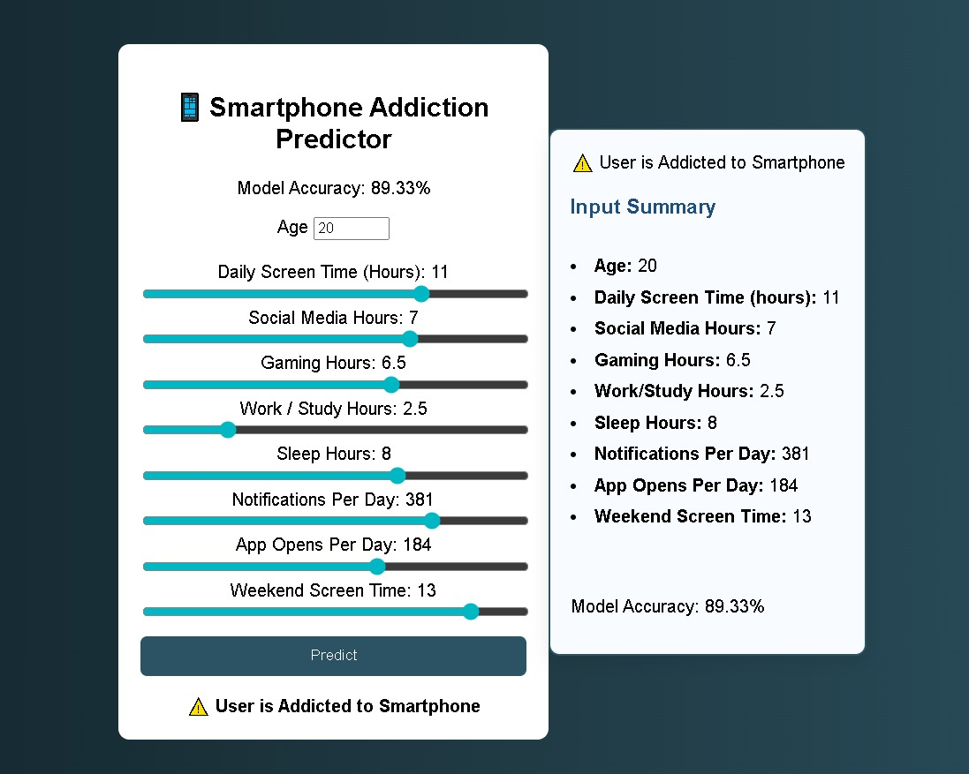

End of Documentation · Course 602 – Data Analytics using Python · Smartphone Addiction EDA

