Software Engineering Practical List
1. Allocation of project definition and analysis. Allocation of project title.
- Define problem statement and Write a project abstract (Short description of project minimum 150 words).
2. Prepare SRS for given system with given template(Theory)
- Introduction
  - Purpose
  - Scope
  - References
- Overall Project Description
- Problem Statement
- Proposed Solution
- Objective of the Project
- Scope of the Project
- Functional Requirements
  - Software Requirements
  - Hardware Requirements
  - Database Requirements
- Non-Functional Requirement
  - Performance Requirements
  - Security Requirements
  - Safety Requirements
  - Scalability Requirements
- Design
  - Control Flow Diagram
  - ER Model
3. Prepare UML diagrams.
Prepare Use-case diagram for given project.
Prepare Activity diagram for given project.
Prepare Sequence diagram for given project.
4. DFD (Data Flow Diagram)
1. Prepare DFD level 0 (context) diagram for given project
DFD 0 level 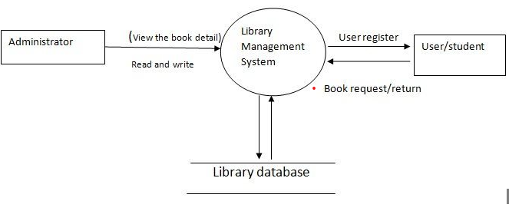

2. Prepare E R diagram for a given project

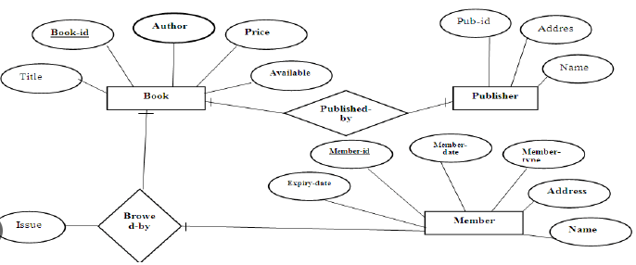 Example of Library management system

5. Compute Function Point Value for a project with the following domain characteristics: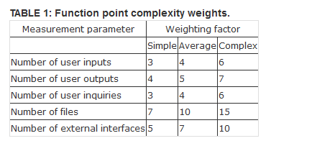
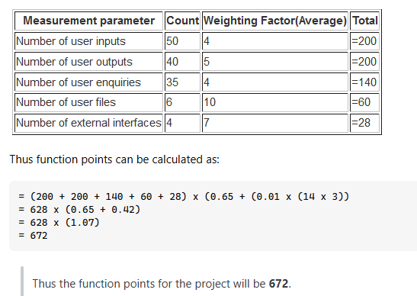
FP = Count-total * [0.65 + 0.01 * ∑(f_{i})]
Number of user input: 5
Number of user output: 5
Number of users enquires: 6
Number of ƒles: 5
Number of external interfaces: 5 Assume that all the complexity adjustment values are simple. Where Σ (Fi) =25
6. Basic COCOMO Model: The first level, Basic COCOMO can be used for quick and slightly rough calculations of Software Costs. This is because the model solely considers based on lines of source code together with constant values obtained from software project types rather than other factors which have major influences on the Software development process as a whole. It requires to calculate the efforts which are required to develop in three modes of development that are organic mode, semi-detached mode, and embedded mode.
The basic COCOMO estimation model is given by the following expressions:
E = ax (KLOC)b
D = c x (Effort)d
P = effort/time
Where,
E is effort applied in person-months.
D is development time in months.
P is the total no. of persons required to accomplish the project.
The constant values a,b,c, and d for the Basic Model for the different categories of the system
Software Project | A | B | C | D
Organic | 2.4 | 1.05 | 2.5 | 0.38
Semi-Detached | 3.0 | 1.12 | 2.5 | 0.35
Embedded | 3.6 | 1.20 | 2.5 | 0.32

Example;Consider a software project using semi-detached mode with 300 Kloc .find out effort estimation, development time, and person estimation.
7.Write a test case for the Login page.

