Basic UNIX Commands/General Purpose Utility Commands
CMDs with SS:
- cal && cal -hjy
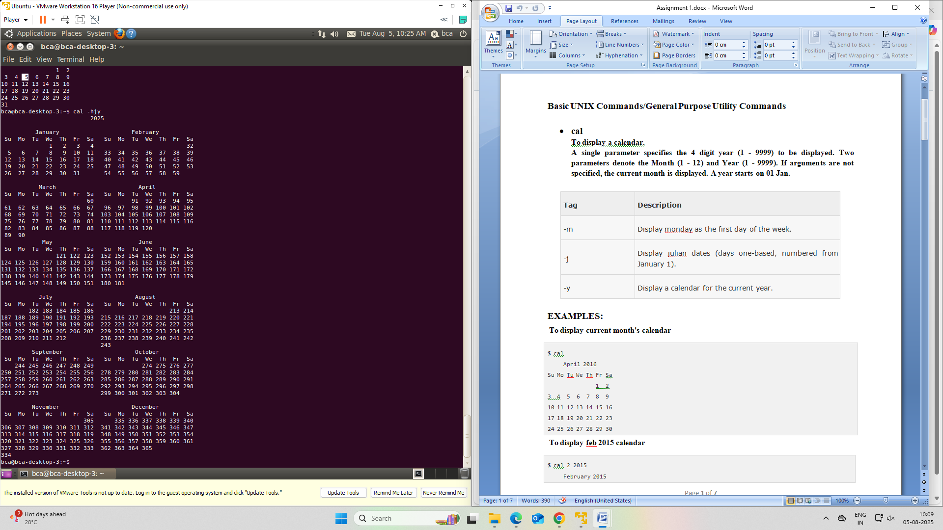

- date
Use to display system date.
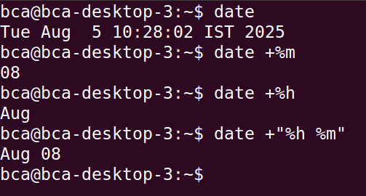
- echo
Use to display a message
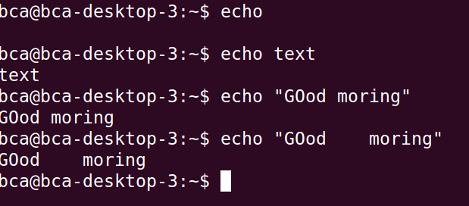

- bc
Use as a calculator
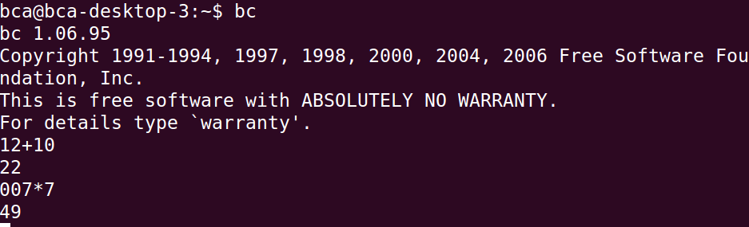

- script
Use to record the session
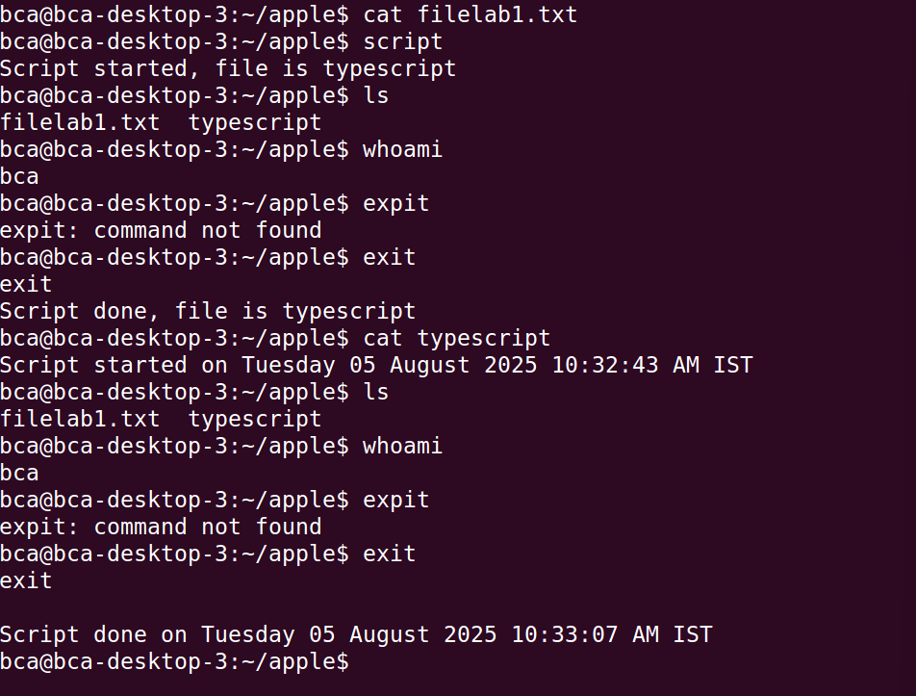

- passwd
Used to change the password
Passwd = vraj123
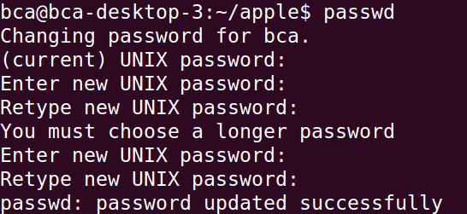

- who
Give listing of users.
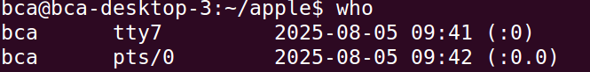

- uname
Simply displays name of the operating system
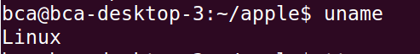
- tty
Give details about terminal
Needs no argument value
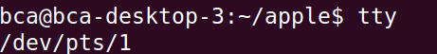

- clear
to clear terminal window
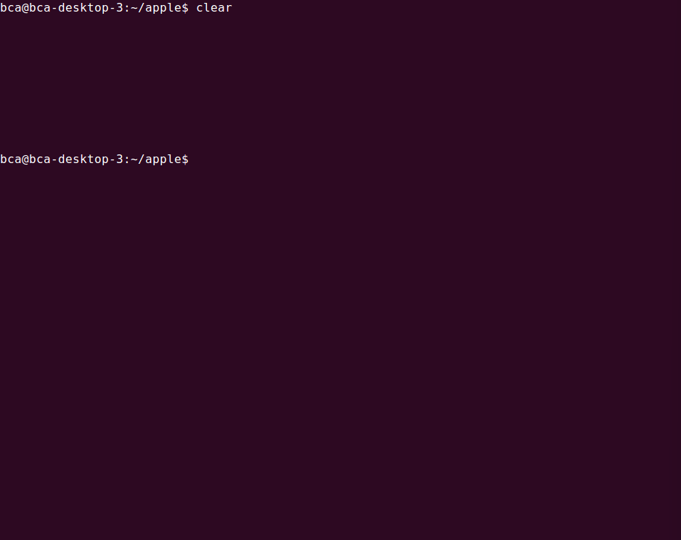

- man command
Provides help on command
Eg. man ls
q = for exit(quit)

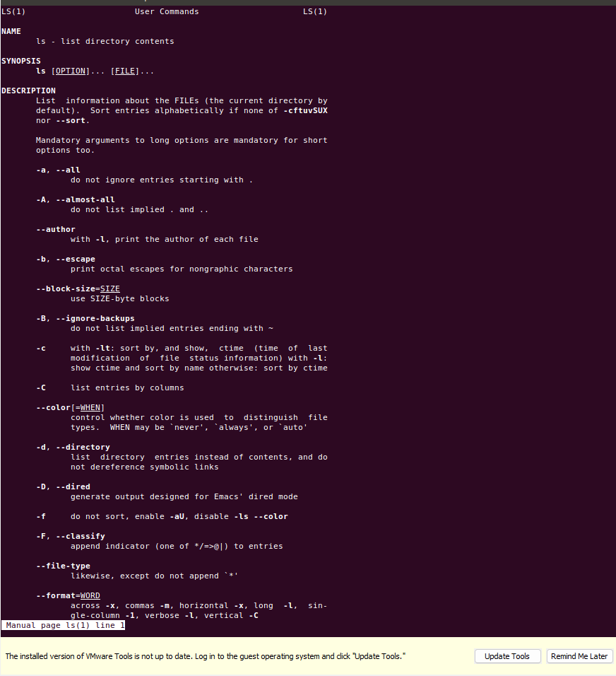

- whatis:
Displays use of command
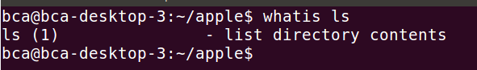

- printf
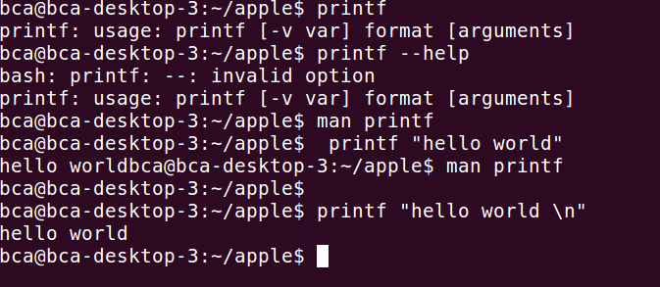
- history
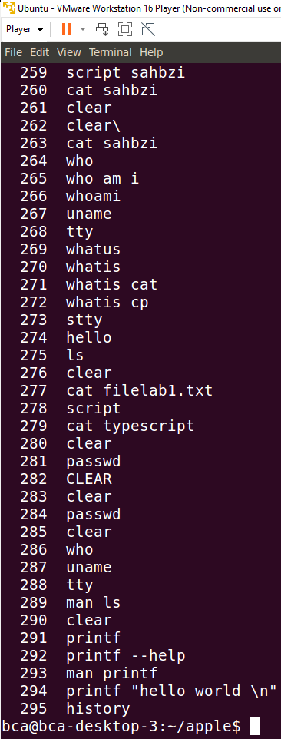

- stty
displays and setting terminal characteristics
