Assignment No.2

- pwd
Use to know current working directory.

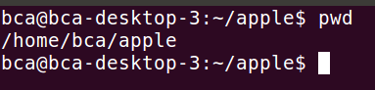

- cd
Use to change the current directory

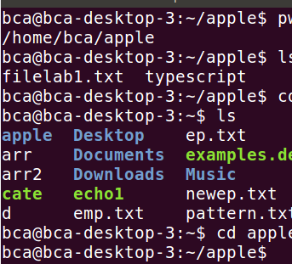

To Move Upward Directory, use cd .. or cd\
- mkdir
Use to create directories.

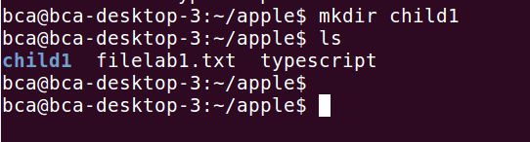

- rmdir
Use to remove directories

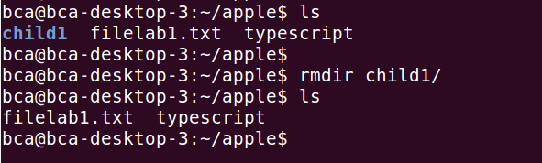

- ls
Give a list of all filenames in the current directory

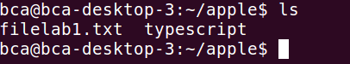

- cat
Used to create a file and also used to open file content

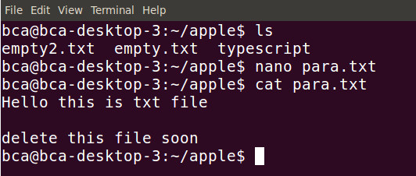
- cp
Used to copying files
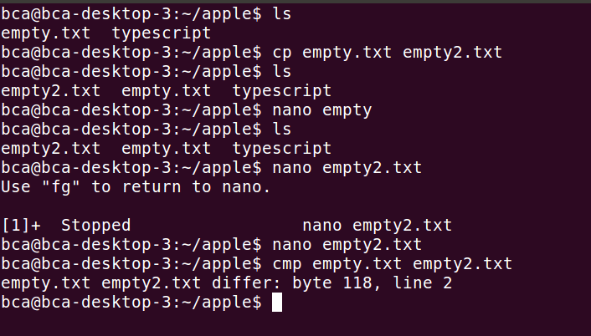

- rm
Used to delete one or more files.



- mv
it renames or moves files.

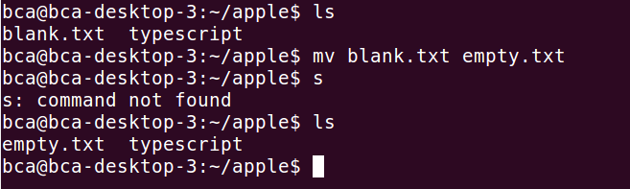

- file
Used to determine the type of file
Syntax:
$file [filename]

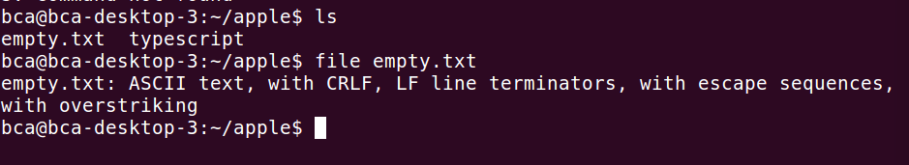
- wc
Counts lines, words and characters

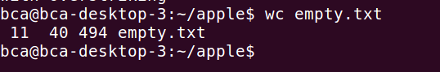

- od
Displays octal data
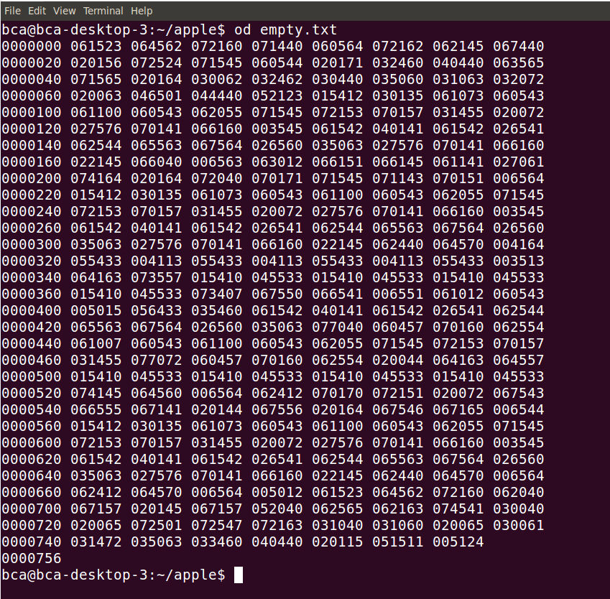

- cmp
Used to compare to files and gives position of first mismatch as a result

Example:


- comm
Find common between two files.
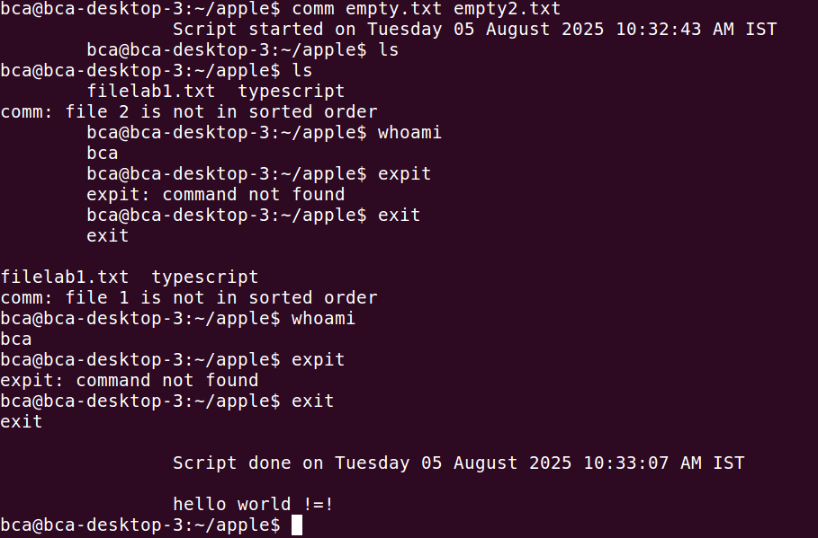

- diff
Used to display file differences and also tells which lines in one file have to be changed to make the two files identical

Example:
