Assignment No. 03 – VI Editor (VIM)

Vi filename :
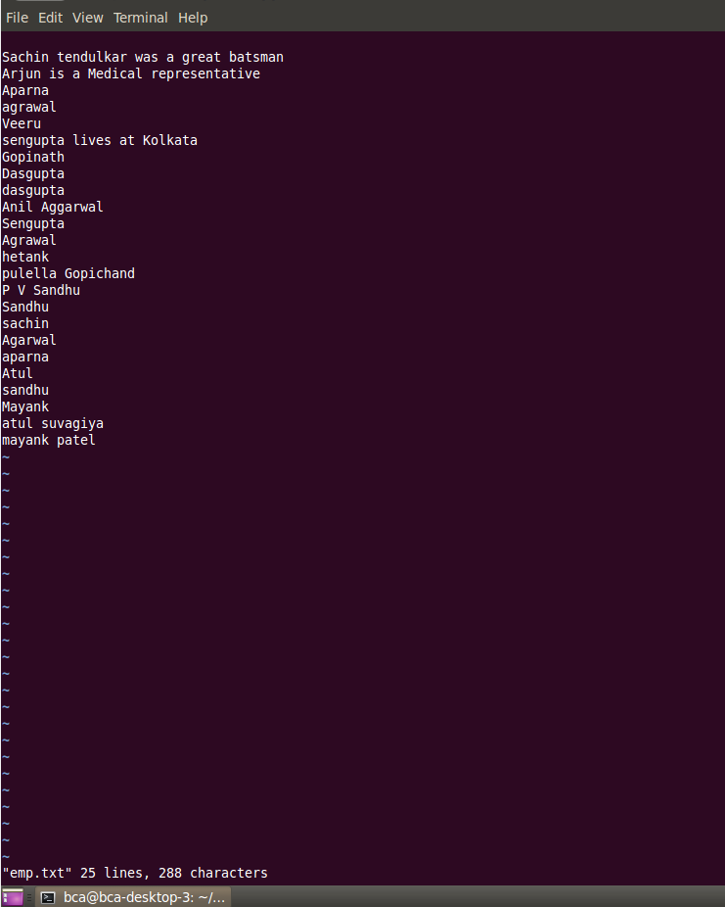

Exit ( write and quit )
:wq
Exit : 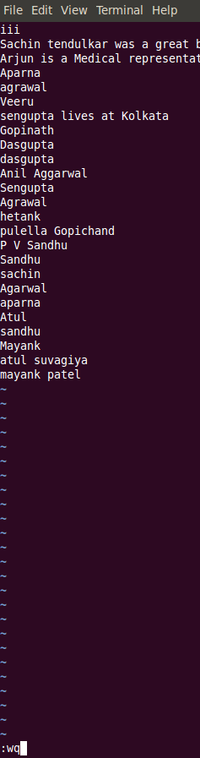

📄 VI Editor Cheatsheet Table
Assignment No.03 – File Editing Using vi

📌 Modes in VI Editor
Mode | Description
Command Mode | Default mode for navigation, editing, saving, etc.
Insert Mode | Used to insert text; enter using i, a, o, etc.

🚀 Starting and Exiting vi
Command | Description
vi filename | Opens existing or creates a new file
:x | Save and exit
:wq | Save and quit
:q | Quit without saving

⌨️ Cursor Movement
Command | Moves Cursor...
h | Left
l | Right
j | Down
k | Up
0 | To beginning of line
$ | To end of line
w | To beginning of next word
b | To beginning of previous word
:0 or 1G | To first line of file
:n or nG | To line number n
:$ or G | To last line of file

📝 Insert or Add Text
Command | Action
i | Insert before cursor
I | Insert at beginning of current line
a | Append after cursor
A | Append at end of current line
o | Open new line below
O | Open new line above

✏️ Change Text
Command | Action
r | Replace character under cursor
R | Overwrite characters from cursor onwards
s | Replace current character and enter insert mode
S | Delete entire line and enter insert mode

❌ Delete Text
Command | Action
x | Delete character under cursor
X | Delete character before cursor
D | Delete from cursor to end of line
dd | Delete current line
ndd | Delete n lines from current line

📋 Copy (Yank) and Paste
Command | Action
yy | Yank (copy) current line
nyy | Yank next n lines including current
p | Paste after cursor
P | Paste before cursor

🔍 Searching
Command | Action
/string | Search forward for string
?string | Search backward for string
n | Next match in same direction
N | Next match in opposite direction

↩️ Undo
Command | Action
u | Undo last action
nu | Undo n previous actions

⚙️ Advanced VI Commands
Command | Action
J | Join current line with the next
:w newfile | Save buffer to newfile
:12,35w smallfile | Write lines 12–35 to smallfile
:1,10s/helo/hello/g | Replace helo with hello in lines 1–10

